LANGUAGE GAMES
IN POLICY, EMPIRICAL RESEARCH AND DESIGN
Vilnius, Lithuania 2nd WHO International Housing and Health Symposium 2004-09-28

Delft, 2004-08-04
Prof.dr.ir. Taeke M. de Jong
chair Technical Ecology and Methodology
chair Regional Design
University of Technology Delft, Faculty of Architecture
T.M.deJong@bk.tudelft.nl
For full paper and presentation: www.bk.tudelft.nl/urbanism/team > publications > 2004

Different language games during a meeting
Decision-making demands a reduction into discussable topics that can be tested against what is collectively considered desirable. The chairman of a meeting, and its administrative participants in the decision-making process, reduce reality to points on the agenda. And not everything gets a place on the agenda. The first concern of every participant in the decision-making process is ensuring that the points important to him or her be included on it.
During the meeting, an extensive reduction takes place, in which at least location, time and content of appointments and agreements are recorded. The minutes testify to this process of reduction. They do not need to be a completely accurate historical representation of the meeting, with all agenda points and the discussions and considerations that these points invoke, as long as everyone can approve of this account afterwards. It may have even been reduced to the form of agreements, during the next meeting. And here the term 'agreements' refers to where and when things are to take place in the future. Thus in the mode of what is desirable, there is a case of two reductions of the polymorph and confusing reality: a reduction to sort, and a reduction to place and time.

One can also discern these two kinds of reduction in other language-games regarding what one knows what one is capable of, in the modes of the probable and possible. These, however, wind up looking different, and this leads to confusion of terms between the sectors, and to significant methodological differences.
 | Choosing | Knowing | Being able to
Modes: | Desirable | Probable | Possible
Sectors: | Management | Science | Technique
Education: | LLM. | Doctor | Engineer
Activities: | Policy | Empirical Research | Design
Reductions Towards
sort: | Agenda | Variables | Legend
place and / or time: | Arrangements | Relationships | Tolerances
Fig. 1 Language games
The empirical researcher plays an important rôle in the inventory process. (S)he reduces her or his reality not into points on the agenda, but rather into variables. These are nameable characteristics, be they verbal, denumerable, numerable, or measurable , which can take on different or changing values without negating the designation of the given characteristic. This is a reduction to sort: a dissection (analysis) of perceptions about actual objects reduced to 'characteristics' that can be represented and put into operation for studying. This reduction of perceptions allows for differences or changes (specifically between 'values') in only one direction ('dimension') per variable.

The rest of the perception is excluded as a result of the processes of naming and delineation (definition), and is often presumed to be the same (ceteris paribus). This unspoken, undifferentiated quality of 'the rest' is only penetrated when a characteristic can be designated a variable in the excluded area. As long as this remains impossible, Wittgenstein's (1919) rule applies: "Wovon mann nicht sprechen kann, darüber muss mann schweigen".
Any sense of doubt regarding the acceptability of this kind of reduction can be witnessed, according to the later Wittgenstein(1953), in the post-modern discussion on the contextuality of 'general' statements (which, if only for that reason, are no longer 'general') and the differential thinking it has resulted in since Derrida (1972).

The empirical reduction to place and/or time
The reduction to place and/or time is then the (mathematically documented) simulation of the relationship between variables in order to find a similarity with reality. The researcher will not rest with the fact that every variable can take on any arbitrary value: instead (s)he looks for relationships among these variables in order to further limit their ability to move, with the goal of being able to make predictions, constructing a 'probable future'.
If, after all, possible future characteristics of objects (variables) are supposed to be able to take on values independent from eachother (as is sometimes required or caused by design), then there are no longer any expectations one can rely on.Relationships between variables pre-suppose a far-reaching reduction to place and/or time, not always acceptible for designers. Indeed, relating two variables demands a sequential (denumerable) and corresponding arrangement of values in both variables. Legend units in a drawing do not.

If in the set of perceived values Y from the variable y, for example, any value is twice as big as that of the same position in x (the first position is 1, the second position is 2, the third position is 3, etc.) in every counted position in this variable (the first position is 2, the second position is 4, the third position is 6, etc.), then this is documented in a mathematical "equation" (y=2x). This relation would become inconceivable if one were to compare the 1 in X with the 6 in Y, and then the 2 and X with the 2 in Y. Sequentiality tacitly pre-supposes a fixed sequence in one space or another (differences) or in time (changes). Without such an internally denumerable spatial or temporal order, every relationship between variables would become impossible.

There is, however, in this seemingly self-evident form of reasoning, something else pre-supposed between the lines, something designers are not always able to deal with: a likeness in distance or duration between the values within one variable (intervals). The values are not only made denumerable (numerically varying only in their position) but also countable (computationally the same in the spacing of their sub-divisions).
Counting pre-supposes equality in the elements being counted. Thus this is fundamentally insufficient, if only on the basis of the elements' different spatial and temporal positions in reality.

If, for example, a programme of requirements for a building is compiled this way, the designer can find opportunities in the formation of the image to combine or analyse numbered and computed functions into new functions (categories) that were not provided for in the variables (and their implicit and largely traditional delimitation) initially chosen. These must first be designated again in new variables in order to relate them then to the customer's list of desires, which list has since been changed by the design. This demands the necessary conceptual abilities from all participants.

One can logically conclude that "if x=1, then y=2". Yet this does not establish any causal relationship: "doubling x causes a doubling of y" (think of the temporal proportion between the number of storks and births that was once demonstrated in Sweden) . In empiricism, the step from logical to causal conclusion is often made too easily, and on closer inspection it has something mystical to it (Hawkins, 1937).

Reductions that go too far for the design
These methods of reducing and representing reality have turned out to be unusually fruitful in almost every scientific field, except that of formulating the image in design. The epistemological limits of these 'scientific methods' are greater than many realise, and are often too big for 'integral' (and differentiating) highly context sensitive designers. Designers are not called in to recreate what already exists, but rather to create new possibilities that do not yet exist in a given context. Furthermore, this method is subject to the law of diminishing marginal returns, now that most of the globally generalisable relationships between nameable and named variables have been elucidated. What now remains are more and more context-dependent local problems. And with this, more (and more varied) causes, or should we more cautiously call 'conditions', are leading to new possibilities within this context. The desired possibilities here form part of a much bigger collection of possibilities which may be useful at some point in the lifespan of an architectural object, yet which cannot be provided for in the programme of present desires. These same causes then lead, even as a result of minute variations in material and social conditions, to various results (chaos theory), or the same consequence is elicited by various causes (many roads lead to Rome). These problems with the empirical method have been studied not only in architectural and urban design, but in organisation theory and ecology as well .

Design language
Creativity means leaving out at least one self evident tacit supposition. We found a systematic way to examine hidden presuppositions in science and technology. We provisionally call it 'conditional analysis' and use it in ecology, design, education and in making computer programs. It has more to do with possibilities than with probabilities or necessities . It gives some insight in the boundaries of imagination and thus design.

It is based on the simple comparison of two concepts A and B, putting the question 'could you imagine A without B?' and the reverse question. Temporarily we take in consideration only the pairs of concepts that make possible a different answer on both questions.
As soon as we can imagine A without B but B not without A we call A a (semantic) condition for B. As soon as we find a concept C that we cannot imagine without B but B without C we can, we have semantically a 'conditional range' of concepts ABC out of which the hypothesis emerges that we cannot imagine C without A, but in the reverse we can. Though introspective, these comparisons turned out to give consensus based on a possibility of falsification. The first consequence of this conditional analysis is, that C can not be defined without using B and B not without C. Conditional analysis can clarify a ‘definition space’ of concept C.

Let us for instance analyse conditionally the ecological concepts Abiotic, Biotic and Cultural phenomena (A, B and C). I cannot imagine cultural phenomena without biotic ones (because culture presupposes at any time living people and functioning brains), but biotic phenomena without cultural I can (for instance plants). I cannot imagine biotic phenomena without abiotic phenomena, but abiotic phenomena without biotic I can (for instance light, air, water, soil). So the hypotheses to be controlled are: 'I cannot imagine cultural phenomena without abiotic phenomena, but abiotic phenomena without cultural I can.'. If we confirm that hypotheses we can draw a conditional scheme like this:
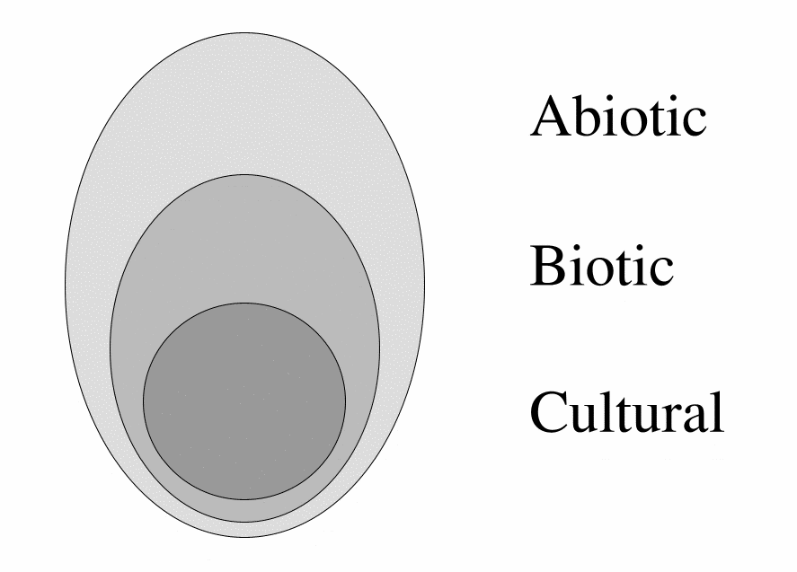
Jong (1972)
Fig. 2 The ABC model
It seems to be a Venn diagram out of set-theory. But it is not, because set-theory presupposes more than the concept of presupposition itself. It presupposes for example the concept of 'element' and any equality of the elements (according to the criterion of the set). Conditional analysis as applied on 200 concepts in science and technology by Jong (1992) supposes less.
A semantic Venn diagram does not yet need these and perhaps other presuppositions. The drawn borders are no inward formulated borders of sets and elements, but outward boundaries of eventually vague and continuous conception. The ABC model represents phenomena outside culture, but is itself a concept and thus culture.

This raises the philosophical question whether there is any difference between mental 'preconception' (presupposition, assumption) and material 'precondition' (prerequisite) at all. The environmental crisis taught us however that there appeared preconditions for life we did not preconceive beforehand. We consider 'environment' in an ecological sense as the set of conditions for life, known or yet unknown.

Anthropocentric and ecocentric thinking
Let us now try to draw two very different ecological presuppositions that have a direct influence on the way people design a landscape or townscape: 'Man is part of nature' and 'Nature is only a human concept'; ecocentrism and anthropocentrism.
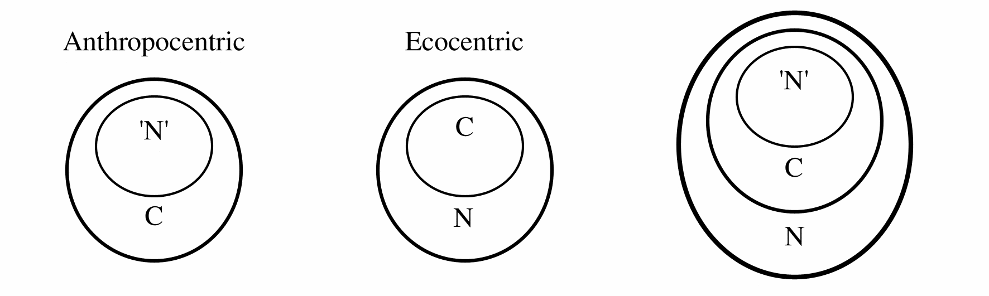
Fig. 3 Presuppositions about the relation between culture and nature
Both suppositions contain a paradox. The anthropocentric way of thinking would imply that physics and biology ('N') cannot find anything new from experiment or observation that is not already included in the existing set of concepts (C) or its combinations (idealistic position). Wittgenstein (1919) said: 'The boundaries of our world are the boundaries of our language.', and: 'About which you cannot speak you have to be silent.' It was a reason to suspect him of mysticism.
The ecocentric view however would imply that we cannot communicate such observations. To take these observations serious, we have to regard them as a not yet cultural part of the natural world N (materialistic position).

Let us now consider culture (C) as an intermediate between the picture ('N') and the portrayed in the natural world (N). Wittgenstein supposes that the picture and and the portrayed have their 'logical form' in common.
Formal logic however cannot cope with expressions like exclamations, questions, proposals (like designs) and orders: they have no logical form. That is what occupied the later Wittgenstein (1953). In my opinion these linguistic expressions are the very solution to the paradox of ecocentric thinking. Questions are the definition of an emptiness at the boundaries of knowledge, proposals and designs are excursions in an unknown, but nevertheless imaginable and perhaps possible future world.

This brings me to a specification of culture, creativity, science and art. Culture is the set of preconceptions in communication. Suppose we had to explicate all presuppositions of our communication before we could start with it, in that case we would seldom have time to communicate. Fortunately we don't have to explicate every time all these preconceptions, we simply take them for granted and call them culture. That is easy, but it also keeps 'self-evident' concepts out of discussion. Creativity just starts with disclaiming these apparently self-evident preconceptions, science starts with doubting them.
Art is a ripple at the outside boundary of culture denying conventional and adding unconventional presuppositions by poièsis (making). We need art or technique to make new concepts outside conventional language.
Science on itself does not provide that.

Probable and possible futures
Probable ecological, economical and cultural futures are gloomy from a viewpoint of inevitable environmental developments. But are the probable futures the only ones that we have to take in consideration? Empirical research is limited to the probable futures. Design, or technical research is limited to the broader set of possible ones.
I cannot imagine the probable without the possible. The reverse I can. What is probable must be by definition possible.
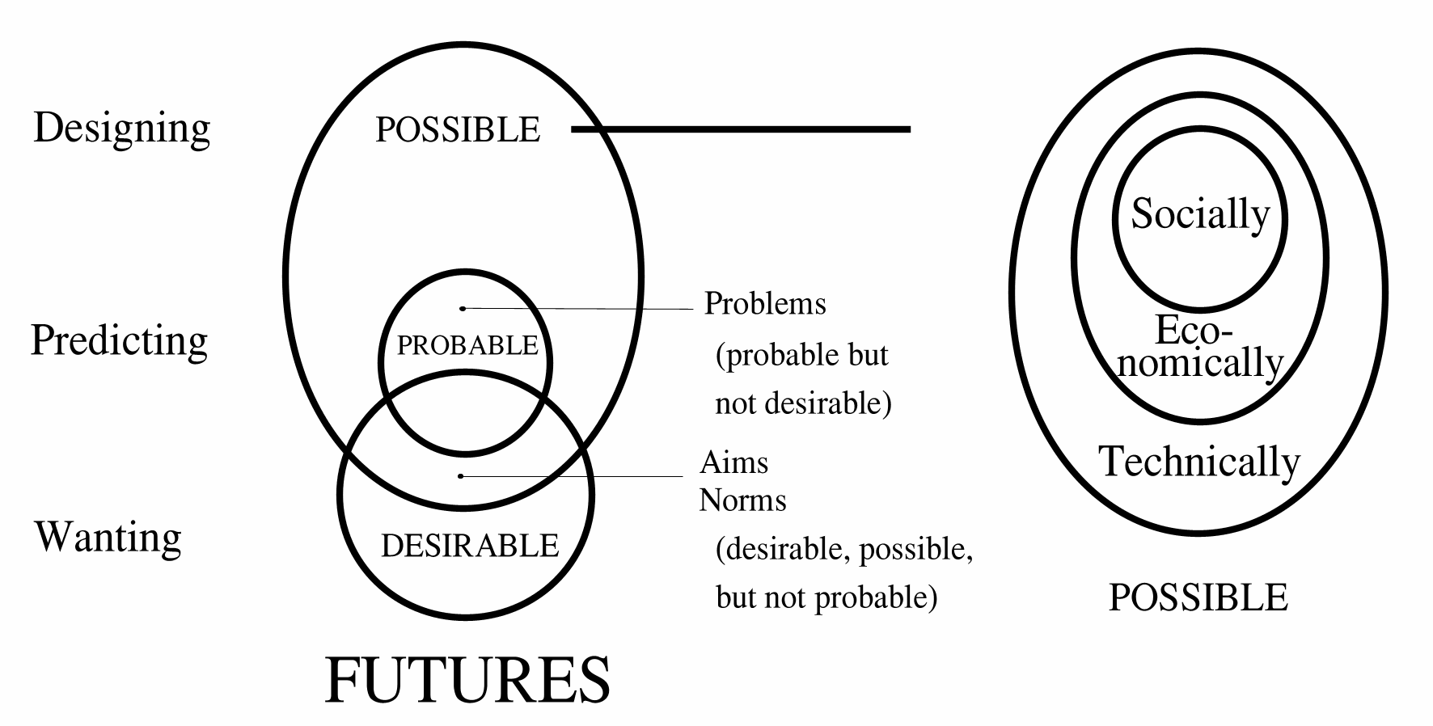
Fig. 4 The modality of the possible
Predicting probable futures requires causal thinking on an empirical basis. We cannot predict possible futures as far as they are not probable: we have to design them. They are invisible for probability-calculations. They are fundamentally ab-normal, outside the 95%-area of probability. Designs cannot be calculated or predicted. If so, they would no longer be designs. Design produces possibilities, conditions, freedom of choice, difference.
Designers celebrate exceptions like evolution of life does.

Every line a designer draws is a precondition for further drawing, but not a cause for the rest of the design process. In the same way the performance of the resulting building, the behaviour of its inhabitants, is not caused or even necessarily aimed by the designer, but only made possible in a universum of possibilities opened by the design. Every line a computerprogrammer writes is a condition for the rest of the program, but not the cause of its performance. On the other hand one single missing line can 'ceteris paribus' be called the 'cause' of its break-down. In the same way global life has no single cause, but many conditions of which lacking one on a single place and moment can indeed cause the death of an individual. Special conditions of sunlight, moist and minerals do not cause special life-forms (let alone that they can be aimed by norms of sunlight, moist and minerals per location), they only make different life-forms possible. The relation conditional < > causal has its analogies in the dualities possible < > probable, designing < > predicting, means-directed < > aim-directed, and probably ecocentric < > antropocentric.

Fields of problems and objectives for policy, research and design
The field of expected problems often recorded by research is defined by probable futures we do not want. The field of aims, possible by design is defined by the desirable futures we do not consider to be probable (see Fig. 5). Policy looks for windows of opportunity to select solvable problems from that field of problems to be entered on an agenda that promises success in terms of realisable aims.
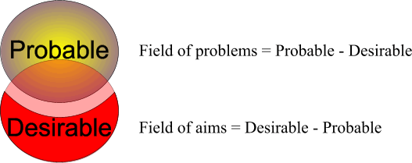
Fig. 5 Defining problems and aims
But how to define the fields of probable and desirable futures?
Many companies design extreme scenario's. Often they take two dimensions in consideration:
- national or continental policy running from executing or controlling private initiatives (!) to own initiative (!) and
- national or continental economy running from decline (-) to growth (+),
mostly resulting in 4 scenario's (see fig. Fig. 6). They set ceteris paribus parameters for empirial research about context and give a frame for decisions. A project proposal with positive effects in all scenario’s is accepted.

However, national policy could be full of initiative while European policy could restrict itself to executing or controlling these initiatives. Global economy could be growing while national economy is declining. So, scenarios have to be made more explicit in supposed levels of scale. Moreover, economy and policy are not the only sectors to be taken in account to define probable futures. After all, scenarios can differ in supposed culture (for instance running from traditional to experimental on different levels of scale), technology, ecology and distribution of activities in space and time. To make more explicit scenario's in the field of possible futures I made a computer programma called FutureImpact (see Fig. 7).
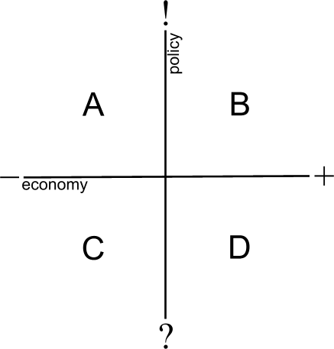 | 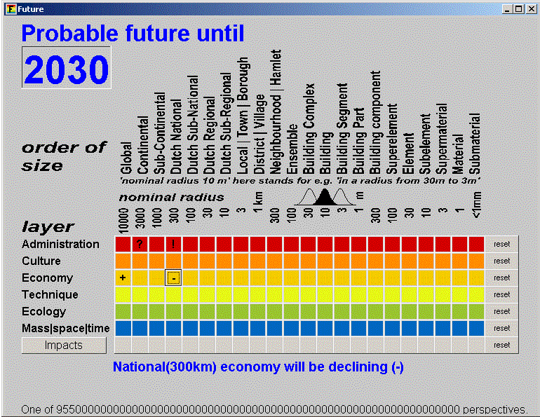
Fig. 6 Example of 4 scenario’s based on extreme alternatives for government and economy | Fig. 7 Scenario A from Fig. 6 made scale-explicit by the FutureImpact programme (Jong, 2004)
A similar second menu of this programme registers the scale of your project and its possible impacts within the supposed future context. You are asked to locate the expected and desired impacts of your project.
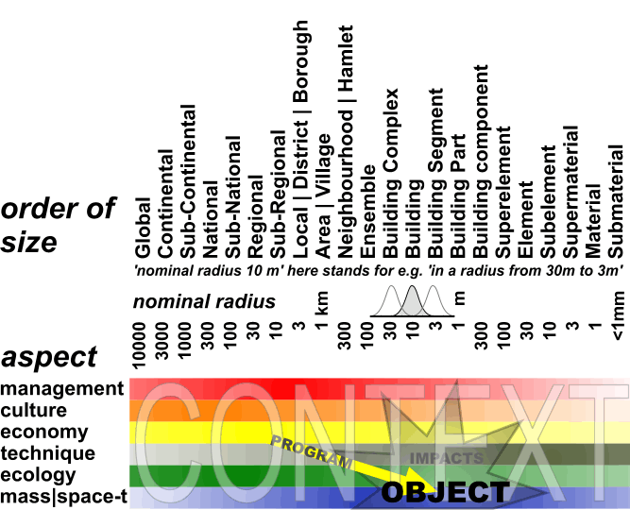
Fig. 8 The object of your project and its (desired) impacts
A wizard button forces the programme to write a priliminary study proposal. To do so, the programme subtracts your futures into fields of problems and aims as shown in Fig. 5. In the produced text you can add considerations you had filling in both menus.

The future context of your project makes possible to evaluate the impact of the project. The impact after all will change when context changes. Empirical research mostly does not take other changes of context in consideration (ceteris paribus supposition) than foreseen in a limited number of scenarios. For a design changing contexts are important, because a building, a neighbourhood, a district, a city always has to function in changing contexts. This ability to function in different contexts is called 'robustness'. And context is nothing else then a set of conditions.

Causal discourse as part of conditional reasoning
What kind of thinking do we need for design study to reach robustness of design?
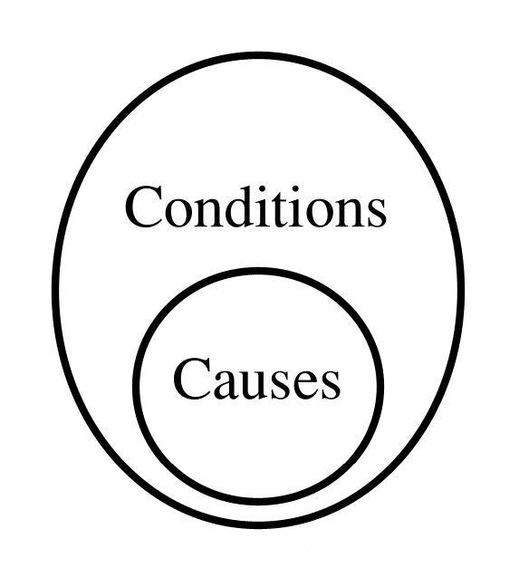
Fig. 9 Causes under conditions
I cannot imagine causes without conditions, the reverse I can. We have to make a step back from causal thinking about probabilities into the broader area of conditional thinking about possibilities. Every cause is a condition for anything to happen, but not every condition is also a cause. The foundation of a house may be a precondition but not a cause of its existence.
Causal thinking is conditional thinking, but conditional thinking is not always causal.Suppose we read in the paper: 'The crash of the cars was caused because one of the drivers lost control of his wheel.' That sounds plausible until an extraterrestrial descends, saying: 'Nonsense, the collision was caused by two objects approaching eachother.'
If our hypothetical extraterrestrial is right, the paper is wrong, because if the cars would not have been approaching eachother and one of the drivers would have lost control there would have been no collision. So it is only a cause under the tacit precondition of cars approaching eachother. Every causal conclusion is based on innumerable tacit conditions called 'ceteris paribus presuppositions'.
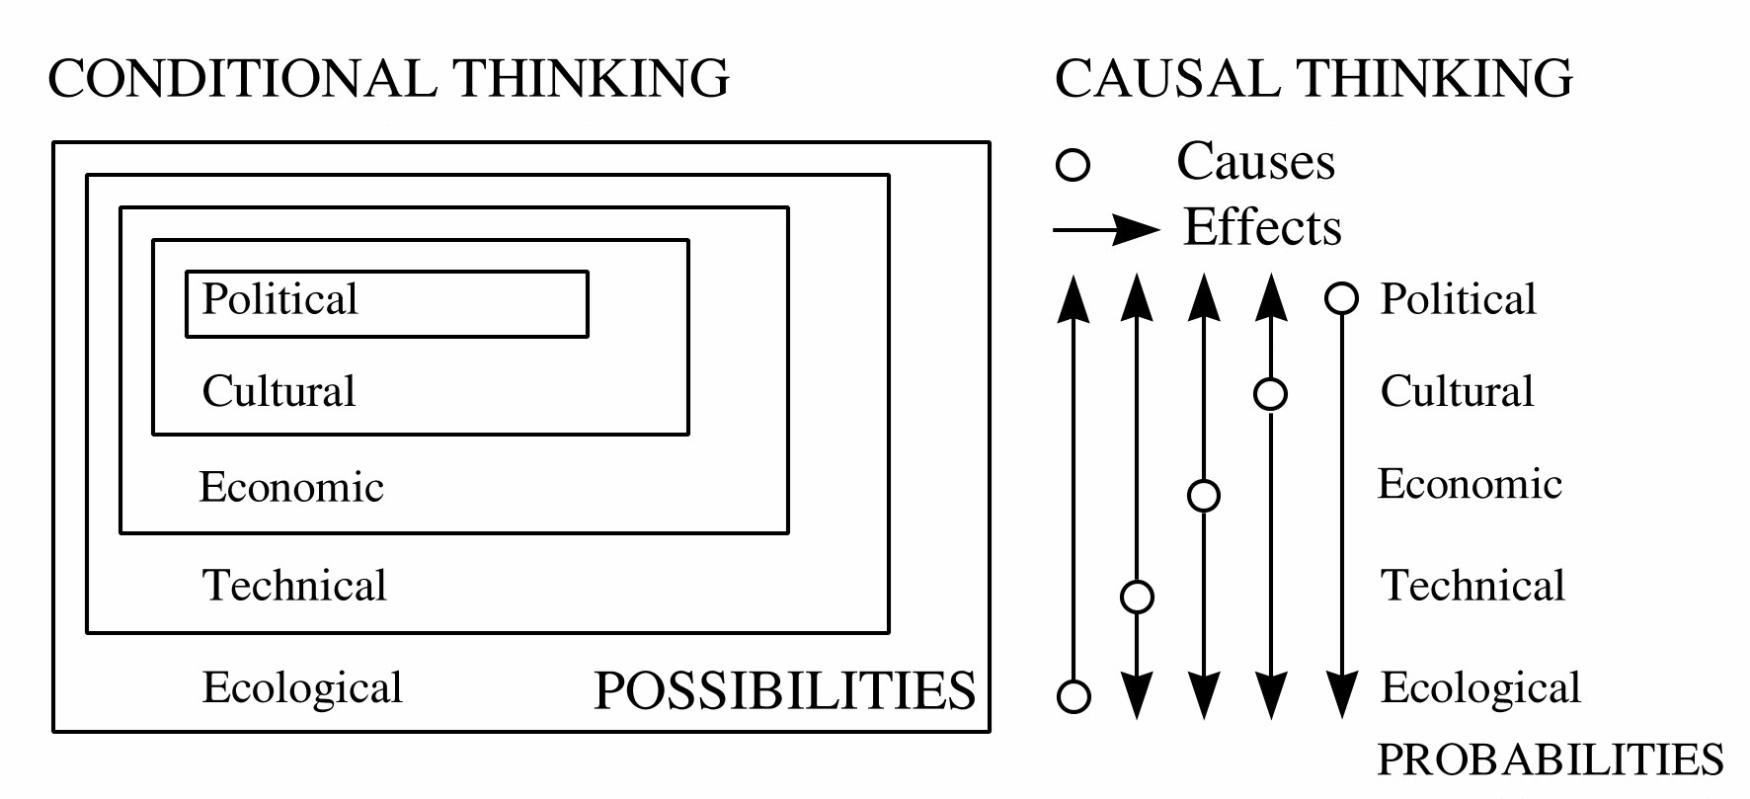
Fig. 10 Conditional thinking as a ceteris paribus environment of causal thinking
I cannot imagine social possibilities without any economical conditions.
The reverse I can.
I cannot imagine economical possibilities without technical conditions.
The reverse I can.
This gives a semantic conditional sequence of possibilities. However, in stable technical conditions economical initiatives can cause technical or social change. But when the dikes burst the technical 'ceteris paribus' conditions for economical determinism are lacking.
The ceteris-paribus presuppositions (conditions, context) of causal explanations also change on different levels in time. That means changing causal prediction. They also can be changed by design forcing shifting explanation about the effects.
Innovative design implies removing some preconditions and making new ones. Design makes 'ceteris non paribus' conditions. In the same time any design copies existing conditions. So, more generally speaking design creates conditions, not causes. After all, designing a house does not mean to cause a houshold, but to make many households possible. Innovative design implicates always removing presupposed conditions and making new ones.

Loose from that the set of conditions (context) change in different wave-lengths:
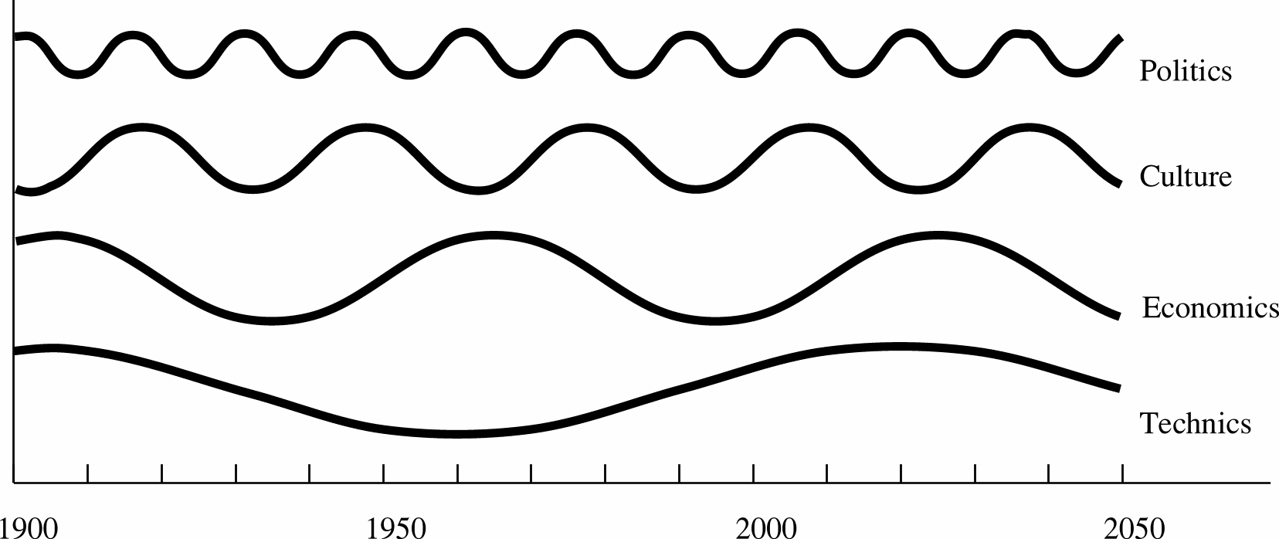
Fig. 11 Changing conditions for causal thinking.
Now we can point out a week component in causal thinking. The ceteris-paribus presuppositions of causal explanations change on different levels and can be changed by design ... by us.

Professor Helmar Krupp (1996), former director of the Fraunhofer Institut in Karlsruhe studied physics, pilosophy and sociology. He came to the conclusion that the individual no longer can influence the evolution of society. Society behaves as a system with its own dynamics. Individuals have to submit to this dynamics. In the conference 'The mind of technology', Delft, 27 november 1996, I tried to comfort him by emphasising design. The limitations of research could be broken by design.
Probable ecological, economical and cultural futures are gloomy from a viewpoint of inevitable Schumpeter dynamics or Fukuyama-expectations. But are the probable futures the only ones that we have to take in consideration? Empirical research is limited to the probable futures, design, innovation or technical research to the possible ones. And that creates hope.

Conclusion
Policy reduces desirable futures, empirical science probable futures, design science possible futures.
The intellectual challenge of this century is to handle diversity instead of generalising it by statistical reduction.
Generalising research has diminishing returns. What could be generalised is mainly generalised in two centuries of empirical research. Problems left are context sensitive problems with too little statistical mass for research; they are the non-probable object of design. However, making your probable future explicit: •protects your project against judgements with other suppositions about the future•raises the debate about the robustness of your design in different future contexts•raises a 'field of problems' instead of an isolated 'problem statement' by subtracting the desirable futures from the probable ones.

References

Ashby, W. R. (1960) Design for a brain the origin of adaptive behaviour (London) Chapman & Hall.

Bense, M. (1954) Aesthetica (Stuttgart) Deutsche Verlags-Anstalt.

Birkhoff, G. D. (1933) Aesthetic measure (Cambridge, Mass.) Harvard University Press.

Boersema, C. Peereboom, et al. (1991) Basisboek Milieukunde HOOFDSTUK 01 (Meppel) Boom ISBN 90-6009-977-x.

Claval (1976) De geschiedenis van de aardrijkskunde (Utrecht) Het Spectrum.

Denters, T., R. Ruesink, et al. (1994) Van Muurbloem tot Straatmadelief. Wilde planten in en rond Amsterdam (Utrecht) KNNV uitgeverij ISBN 90-5011-065-7.

Derrida (1972) Marges de la philosophie (paris) Les Editions de Minuit

Draak, J. den (1993) Van blauwdruk naar draaiboek, scenario's in de ruimtelijke planning en volkshuisvesting.

Fukuyama, F. (1992) The End of History and the Last Man (New York) Free Press.

Hawkins (1937) Causality and implication (London) Sheed & Ward

Hendriks, L. W. J. L. (1993) Begrippen rond bouwen en milieu (Rotterdam) SBR Stichting Bouwresearch.

IJsseling, S (1986) Jaques Derrida, een inleiding in zijn denken.

Jong, T. M. d. (1992) Kleine methodologie voor ontwerpend onderzoek (Meppel) Boom.

Jong, T. M. d. (2002) Verbal models in: T. M. d. Jong and D. J. H. v. d. Voordt Ways to research and study architectural, urban and technical design (Delft) Faculteit Bouwkunde TUD

Jong, T. M. d.; J. Louwe (1972) 100 stellingen van Sharawagi 100 stellingen van Sharawagi (Delft) Faculteit Bouwkunde.

Jong, T. M. de (2004) The future-impact computer programme version 3 (Zoetermeer) MESO www.bk.tudelft.nl/urbanism/team > Publications 2004

Kant, I. (1976) Kritik der reinen Vernunft (Frankfurt am Main) Suhrkamp Verlag.

Koutamanis, A. (2002) Visualization and architecture in: T. M. d. Jong and D. J. M. v. d. Voordt Ways to study and research urban, architectural and technical design (Delft) Delft University Press

Krupp, H. (1996) Zukunftsland Japan, Globale Evolution und Eigendynamik (Darmstadt) Wissenschaftlicht Buchgesellschaft.

Leeuwen, C. G. (1971) Ekologie (Delft) Technische Universiteit Delft, faculteit Bouwkunde.

Luhmann, N. (1973) Zweckbegriff und Systemrationalität (Ulm) Suhrkamp Taschenbuch Wissenschaft.

Margulis, L., K. Schwartz, et al. (1994) The illustrated Five Kingdoms; A guide to the diversity of life on earth (New York) Harper Collins College Publishers ISBN 0-06-500843-X.

Margulis, L., K. Schwartz, et al. (1994) The illustrated Five Kingdoms; A guide to the diversity of life on earth (New York) Harper Collins College Publishers ISBN 0-06-500843-X.

Riemsdijk, M.J. van (1999) Dilemma's in de bedrijfskundige wetenschap.

Russell, B. (1919) Introduction to mathematical philosophy (London and New York) Routledge ISBN 0-415-09604-9.

Stevens, S.S. (1946) On the theory of scales of measurement.

Vos, J. (1993) Natuur in Zoetermeer in: T. M. d. Jong and J. Vos Kwartaalbericht KNNV Zoetermeer 1-10 (Zoetermeer) KNNV Zoetermeer 2, 1993

Wittgenstein (1919, 1959) Tractatus logico-philosophicus (Oxford) Basil Blackwell.

Wittgenstein, L. (1953) Philosophical investigations (Oxford) Blackwell.

World commission environment and development (1990) Our Common Future (Oxford/New York) Oxford University press.

