Language games in policy, empirical research and design
Vilnius, Lithuania 2nd WHO International Housing and Health Symposium 2004-09-28
Delft, 2004-08-04
Prof.dr.ir. Taeke M. de Jong
chair Technical Ecology and Methodology
chair Regional Design
University of Technology Delft, Faculty of Architecture
T.M.deJong@bk.tudelft.nl
www.bk.tudelft.nl/urbanism/team

Different language games during a meeting
Decision-making demands a reduction into discussable topics that can be tested against what is collectively considered desirable. The chairman of a meeting, and its administrative participants in the decision-making process, reduce reality to points on the agenda. And not everything gets a place on the agenda. The first concern of every participant in the decision-making process is ensuring that the points important to him or her be included on it.
During the meeting, an extensive reduction takes place, in which at least location, time and content of appointments and agreements are recorded. The minutes testify to this process of reduction. They do not need to be a completely accurate historical representation of the meeting, with all agenda points and the discussions and considerations that these points invoke, as long as everyone can approve of this account afterwards. It may have even been reduced to the form of agreements, during the next meeting. And here the term ‘agreements’ refers to where and when things are to take place in the future. Thus in the mode of what is desirable, there is a case of two reductions of the polymorph and confusing reality: a reduction to sort, and a reduction to place and time.

One can also discern these two kinds of reduction in other language-games regarding what one knows what one is capable of, and in the modes of the probable and possible. These, however, wind up looking different, and this leads to confusion of terms between the sectors, and to significant methodological differences.

 | Choosing | Knowing | Being able to
Modes: | Desirable | Probable | Possible
Sectors: | Management | Science | Technique
Education: | LLM. | Doctor | Engineer
Activities: | Policy | Empirical Research | Design
Reductions Towards
Type: | Agenda | Variables | Legend
Place And / Or Time: | Arrangements | Relationships | Tolerances
Fig. 1 Language games
The empirical researcher plays an important rôle in the inventory process. (S)he reduces her or his reality not into points on the agenda, but rather into variables. These are nameable characteristics, be they verbal, denumerable, numerable, or measurable, which can take on different or changing values without negating the designation of the given characteristic. This is a reduction to sort: a dissection (analysis) of perceptions about actual objects reduced to ‘characteristics’ that can be represented and put into operation for studying. This reduction of perceptions allows for differences or changes (specifically between ‘values’) in only one direction (‘dimension’) per variable.

The rest of the perception is excluded as a result of the processes of naming and delineation (definition), and is often presumed to be the same (ceteris paribus). This unspoken, undifferentiated quality of ‘the rest’ is only penetrated when a characteristic can be designated a variable in the excluded area. As long as this remains impossible, Wittgenstein (1919) 's rule applies: "Wovon mann nicht sprechen kann, darüber muss mann schweigen". Any sense of doubt regarding the acceptability of this kind of reduction can be witnessed, according to the later Wittgenstein, in the post-modern discussion on the contextuality of ‘general’ statements (which, if only for that reason, are no longer ‘general’) and the differential thinking it has resulted in since Derrida (1972).

The empirical reduction to place and/or time
The reduction to place and/or time is then the (mathematically documented) simulation of the relationship between variables in order to find a similarity with reality. The researcher will not rest with the fact that every variable can take on any arbitrary value: instead (s)he looks for relationships among these variables in order to further limit their ability to move, with the goal of being able to make predictions, constructing a ‘probable future’.
If, after all, possible future characteristics of objects (variables) are supposed to be able to take on values independent from eachother (as is sometimes required or caused by design), then there are no longer any expectations one can rely on.
Relationships between variables pre-suppose a far-reaching reduction to place and/or time, not always acceptible for designers. Indeed, relating two variables demands a sequential (denumerable) and corresponding arrangement of values in both variables. Legend units in a drawing do not.

If in the set of perceived values Y from the variable y, for example, any value is twice as big as that of the same position in x (the first position is 1, the second position is 2, the third position is 3, etc.) in every counted position in this variable (the first position is 2, the second position is 4, the third position is 6, etc.), then this is documented in a mathematical "equation" (y=2x). This relation would become inconceivable if one were to compare the 1 in X with the 6 in Y, and then the 2 and X with the 2 in Y. Sequentiality tacitly pre-supposes a fixed sequence in one space or another (differences) or in time (changes). Without such an internally denumerable spatial or temporal order, every relationship between variables would become impossible.

There is, however, in this seemingly self-evident form of reasoning, something else pre-supposed between the lines, something designers are not always able to deal with: a likeness in distance or duration between the values within one variable (intervals). The values are not only made denumerable (numerically varying only in their position) but also countable (computationally the same in the spacing of their sub-divisions).
Counting pre-supposes equality in the elements being counted. Thus this is fundamentally insufficient, if only on the basis of the elements' different spatial and temporal positions in reality.

If, for example, a programme of requirements for a building is compiled this way, the designer can find opportunities in the formation of the image to combine or analyse numbered and computed functions into new functions (categories) that were not provided for in the variables (and their implicit and largely traditional delimitation) initially chosen. These must first be designated again in new variables in order to relate them then to the customer's list of desires, which list has since been changed by the design. This demands the necessary conceptual abilities from all participants.

One can logically conclude that "if x=1, then y=2". Yet this does not establish any causal relationship: "doubling x causes a doubling of y" (think of the temporal proportion between the number of storks and births that was once demonstrated in Sweden). In empiricism, the step from logical to causal conclusion is often made too easily, and on closer inspection it has something mystical to it (Hawkins, 1937).

Reductions that go too far for the design
These methods of reducing and representing reality have turned out to be unusually fruitful in almost every scientific field, except that of formulating the image in design. The epistemological limits of these ‘scientific methods’ are greater than many realise, and are often too big for ‘integral’ (and differentiating) highly context sensitive designers. Designers are not called in to recreate what already exists, but rather to create new possibilities that do not yet exist in a given context. Furthermore, this method is subject to the law of diminishing marginal returns, now that most of the globally generalisable relationships between nameable and named variables have been elucidated. What now remains are more and more context-dependent local problems.
And with this, more (and more varied) causes, or should we more cautiously call ‘conditions’, are leading to new possibilities within this context. The desired possibilities here form part of a much bigger collection of possibilities which may be useful at some point in the lifespan of an architectural object, yet which cannot be provided for in the programme of present desires. These same causes then lead, even as a result of minute variations in material and social conditions, to various results (chaos theory), or the same consequence is elicited by various causes (many roads lead to Rome). These problems with the empirical method have been studied not only in architectural and urban design, but in organisation theory and ecology as well.

Design language
Creativity means leaving out at least one self evident tacit supposition. We found a systematic way to examine hidden presuppositions in science and technology. We provisionally call it 'conditional analysis' and use it in ecology, design, education and in making computer programs. It has more to do with possibilities than with probabilities or necessities. It gives some insight in the boundaries of imagination and thus design.

It is based on the simple comparison of two concepts A and B, putting the question 'could you imagine A without B?' and the reverse question. Temporarily we take in consideration only the pairs of concepts that make possible a different answer on both questions.
As soon as we can imagine A without B but B not without A we call A a (semantic) condition for B. As soon as we find a concept C that we cannot imagine without B but B without C we can, we have semantically a 'conditional range' of concepts ABC out of which the hypothesis emerges that we cannot imagine C without A, but in the reverse we can. Though introspective, these comparisons turned out to give consensus based on a possibility of falsification. The first consequence of this conditional analysis is, that C can not be defined without using B and B not without C. Conditional analysis can clarify a ‘defenition space’ of concept C.

Let us for instance analyse conditionally the ecological concepts Abiotic, Biotic and Cultural phenomena (A, B and C). I cannot imagine cultural phenomena without biotic (because culture presupposes at any time living people and functioning brains), but biotic phenomena without cultural I can (for instance plants). I cannot imagine biotic ones phenomena without abiotic phenomena, but abiotic phenomena without biotic I can (for instance light, air, water, soil). So the hypotheses to be controlled are: 'I cannot imagine cultural phenomena without abiotic phenomena, but abiotic phenomena without cultural I can.'. If we confirm that hypotheses we can draw a conditional scheme like this:

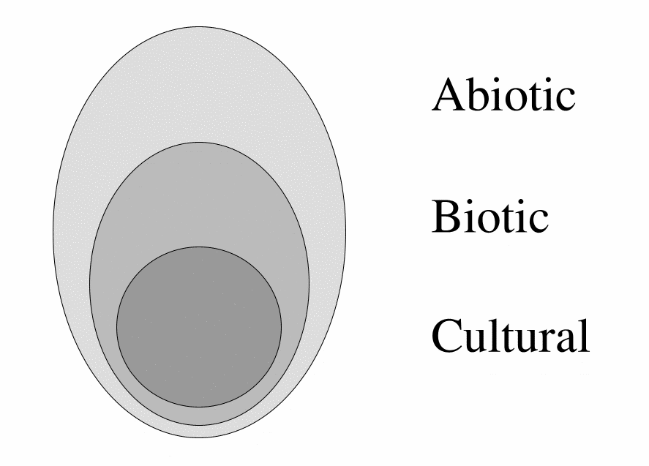 | It seems to be a Venn diagram out of set-theory. But it is not, because set-theory presupposes more than the concept of presupposition itself. It presupposes for example the concept of 'element' and any equality of the elements (according to the criterion of the set). Conditonal analysis as applied on 200 concepts in sciens and technology by Jong (1992) supposes less.  A semantic Venn diagram does not yet need these and perhaps other presuppositions. The drawn borders are no inward formulated borders of sets and elements, but outward boundaries of eventually vague and continuous conception.  The ABC model represents phenomena outside culture, but is itself a concept and thus culture.
Jong (1972)
Fig. 2 The ABC model
This raises the philosophical question whether there is any difference between mental 'preconception' (presupposition, assumption) and material 'precondition' (prerequisite) at all. The environmental crisis taught us however that there appeared preconditions for life we did not preconceive beforehand. We consider 'environment' in an ecological sense as the set of conditions for life, known or yet unknown.

Anthropocentric and ecocentric thinking
Let us now try to draw two very different ecological presuppositions that have a direct influence on the way people design a landscape or townscape: 'Man is part of nature' and 'Nature is only a human concept'; ecocentrism and anthropocentrism.

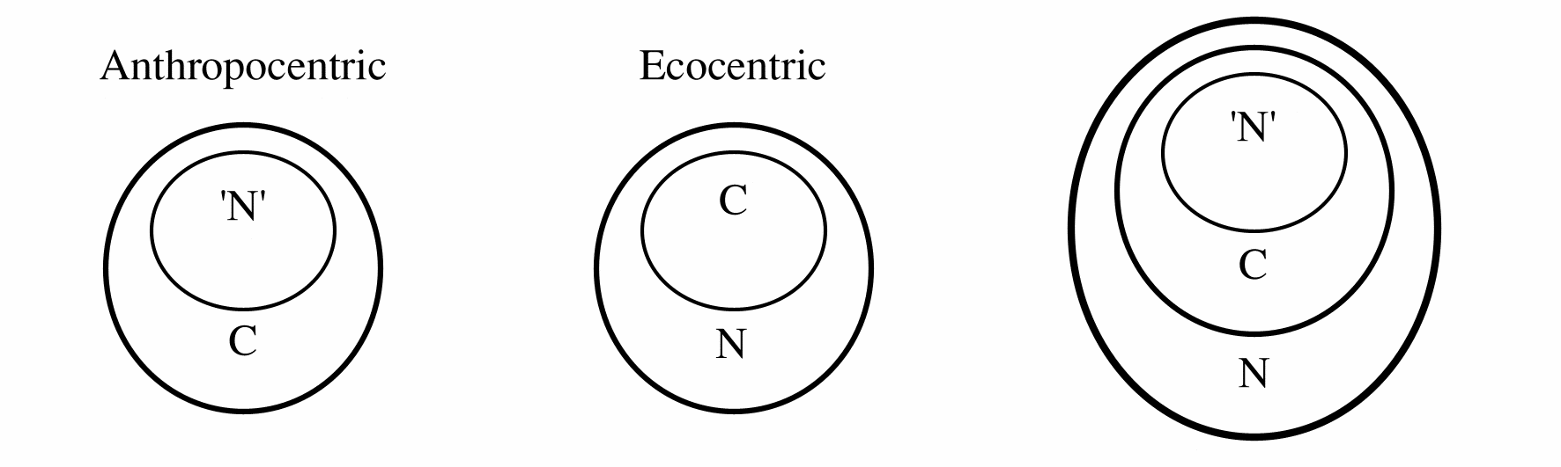
Fig. 3 Presuppositions about the relation between culture and nature
Both suppositions contain a paradox. The anthropocentric way of thinking would imply that physics and biology ('N') cannot find anything new from experiment or observation that is not already included in the existing set of concepts (C) or its combinations (idealistic position). Wittgenstein (1919) said: 'The boundaries of our world are the boundaries of our language.', and: ‘About which you cannot speak you have to be silent.’ It was a reason to suspect him of mysticism.
The ecocentric view however would imply that we cannot communicate such observations. To take these observations serious, we have to regard them as a not yet cultural part of the natural world N (materialistic position).

Let us now consider culture (C) as an intermediate between the picture ('N') and the portrayed in the natural world (N). Wittgenstein supposes that the picture and and the portrayed have their 'logical form' in common. Formal logic however cannot cope with expressions like exclamations, questions, proposals (like designs) and orders: they have no logical form. That is what occupied the later Wittgenstein (1953). In my opinion these linguistic expressions are the very solution to the paradox of ecocentric thinking. Questions are the definition of an emptiness at the boundaries of knowledge, proposals and designs are excursions in an unknown, but nevertheless imaginable and perhaps possible future world.

This brings me to a specification of culture, creativity, science and art. Culture is the set of preconceptions in communication. Suppose we had to explicate all presuppositions of our communication before we could start with it, in that case we would seldom have time to communicate. Fortunately we don't have to explicate every time all these preconceptions, we simply take them for granted and call them culture. That is easy, but it also keeps 'self-evident' concepts out of discussion. Creativity just starts with disclaiming these apparently self-evident preconceptions, science starts with doubting them.
Art is a ripple at the outside boundary of culture denying conventional and adding unconventional presuppositions by poièsis (making). We need art or technique to make new concepts outside conventional language. Science on itself does not provide that.

Probable and possible futures
Probable ecological, economical and cultural futures are gloomy from a viewpoint of inevitable environmental developments. But are the probable futures the only ones that we have to take in consideration? Empirical research is limited to the probable futures. Design, or technical research is limited to the broader set of possible ones.
I cannot imagine the probable without the possible. The reverse I can. What is probable must be by definition possible.

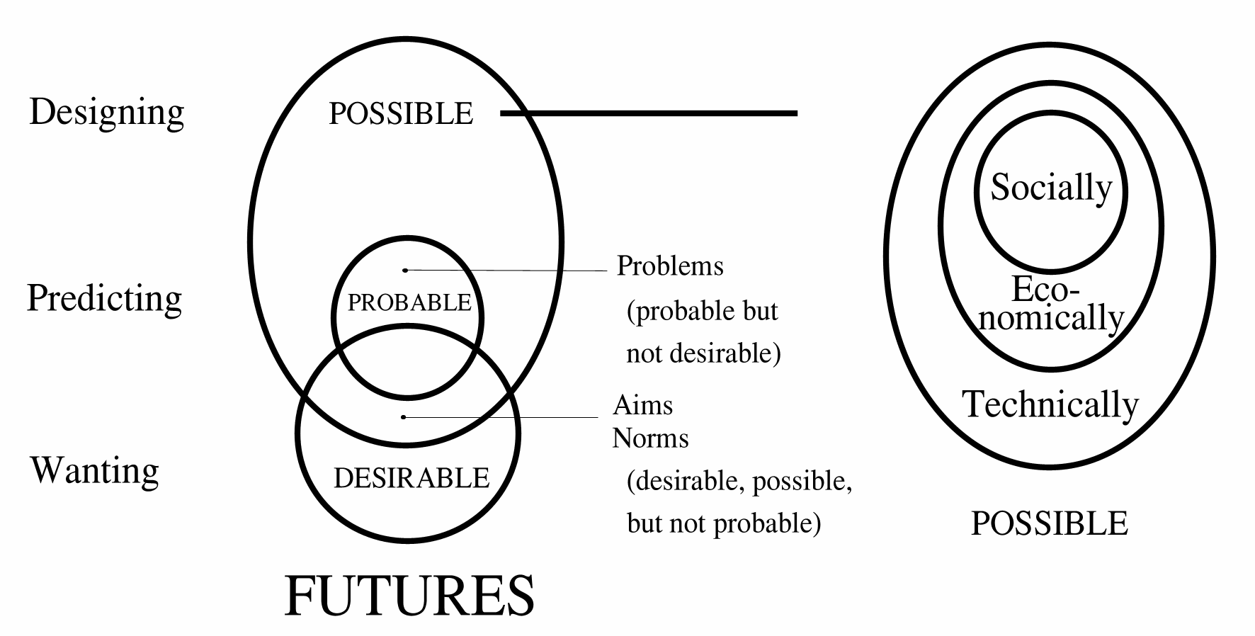
Fig. 4 The modality of the possible
Predicting probable futures requires causal thinking on an empirical basis. We cannot predict possible futures as far as they are not probable: we have to design them. They are invisible for probability-calculations. They are fundamentally ab-normal, outside the 95%-area of probability. Designs cannot be calculated or predicted. If so, they would no longer be designs. Design produces possibilities, conditions, freedom of choice, difference. Designers celebrate exceptions like evolution of life does.

Every line a designer draws is a precondition for further drawing, but not a cause for the rest of the design process. In the same way the performance of the resulting building, the behaviour of its inhabitants, is not caused or even necessarily aimed by the designer, but only made possible in a universum of possibilities opened by the design. Every line a computerprogrammer writes is a condition for the rest of the program, but not the cause of its performance. On the other hand one single missing line can 'ceteris paribus' be called the 'cause' of its break-down. In the same way global life has no single cause, but many conditions of which lacking one on a single place and moment can indeed cause the death of an individual. Special conditions of sunlight, moist and minerals do not cause special life-forms (let alone that they can be aimed by norms of sunlight, moist and minerals per location), they only make different life-forms possible. The relation conditional < > causal has its analogies in the dualities possible < > probable, designing < > predicting, means-directed < > aim-directed, and probably ecocentric < > antropocentric.

Fields of problems and objectives for policy, research and design
The field of expected problems often recorded by research is defined by probable futures we do not want. The field of aims, possible by design is defined by the desirable futures we do not consider to be probable (see Fig. 5). Policy looks for windows of opportunity to select solvable problems from that field of problems to be entered on an agenda that promises success in terms of realisable aims.

Fig. 5 Defining problems and aims
But how to define the fields of probable and desirable futures?
Many companies design extreme scenario’s. Often they take two dimensions in consideration:

- national or continental policy running from executing or controlling private initiatives (?) to own initiative (!) and
- national or continental economy running from decline (-) to growth (+),

mostly resulting in 4 scenario’s (see fig. Fig. 6). They set ceteres paribus parameters for empirial research about context and give a frame for decitions. A project proposal with positive effects in all scenario’s is accepted.
However, national policy could be full of initiative while European policy could restrict itself to executing or controlling these initiatives. Global economy could be growing while national economy is declining. So, scenarios have to be made more explicit in supposed levels of scale. Moreover, economy and policy are not the only sectors to be taken in account to define probable futures. After all, scenarios can differ in supposed culture (for instance running from traditional to experimental on different levels of scale), technology, ecology and distribution of activities in space and time.
To make more explicit scenario’s in the field of possible futures I made a computer programma called FutureImpact (see Fig. 7).

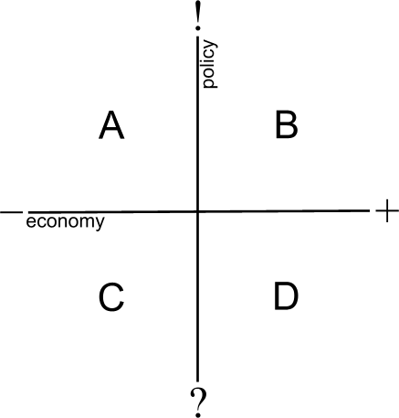 | 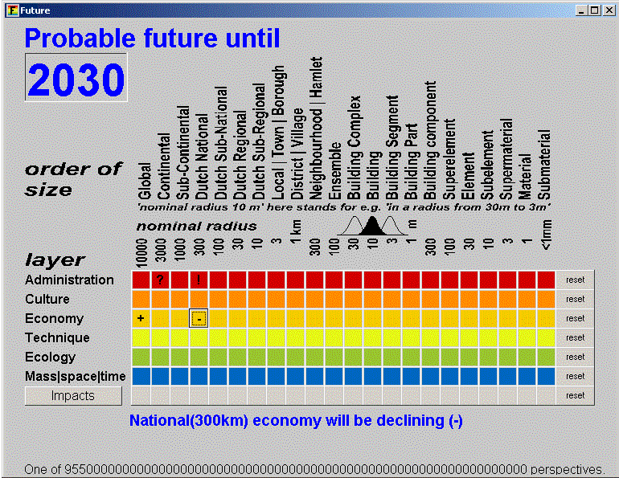
Fig. 6 Example of 4 scenario’s based on extreme alternatives for government and economy | Fig. 7 Scenario A from Fig. 6 made scale-explicit by the FutureImpact programme (Jong, 2004)
A similar second menu of this programme registers the scale of your project and its possible impacts within the supposed future context. You are asked to locate the expected and desired impacts of your project.

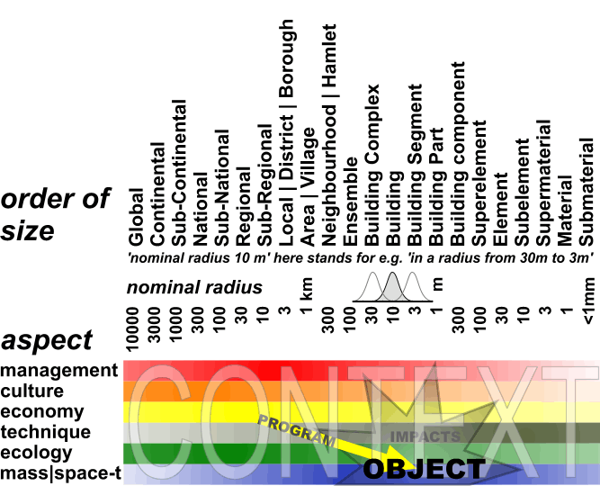

Fig. 8 The object of your project and its (desired) impacts
A wizard button forces the programme to write a priliminary study proposal. To do so, the programme subtracts your futures into fields of problems and aims as shown in Fig. 5. In the produced text you can add considerations you had filling in both menus.

The future context of your project makes possible to evaluate the impact of the project. The impact after all will change when context changes. Empirical research mostly does not take other changes of context in consideration (ceteris paribus supposition) than foreseen in a limited number of scenarios. For a design changing contexts are important, because a building, a neighbourhood, a district always has to function in changing contexts. This ability to function in fifferent contexts is called ‘robustness’. And context is nothing else then a set of conditions.

Causal discourse as part of conditional reasoning
What kind of thinking do we need for design study to reach robustness of design?

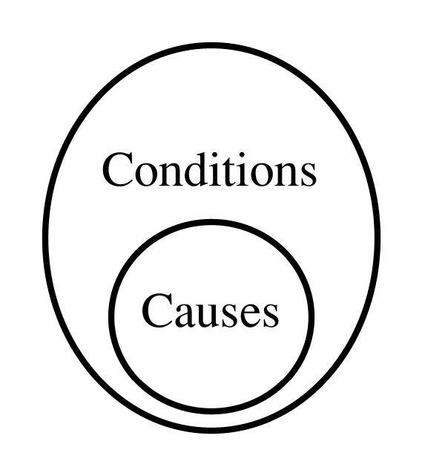 | I cannot imagine causes without conditions, the reverse I can. We have to make a step back from causal thinking about probabilities into the broader area of conditional thinking about possibilities. Every cause is a condition for anything to happen, but not every condition is also a cause. The foundation of a house may be a precondition but not a cause of its existence. Causal thinking is conditional thinking, but conditional thinking is not always causal.  Suppose we read in the paper: 'The crash of the cars was caused because one of the drivers lost control of his wheel.' That sounds plausible until an extraterrestrial descends, saying: 'Nonsense, the collision was caused by two objects approaching eachother.'
Fig. 9 Causes under conditions
If our hypothetical extraterrestrial is right, the paper is wrong, because if the cars would not have been approaching eachother and one of the drivers would have lost control there would have been no collision. So it is only a cause under the tacit precondition of cars approaching eachother. Every causal conclusion is based on innumerable tacit conditions called 'ceteris paribus presuppositions'.

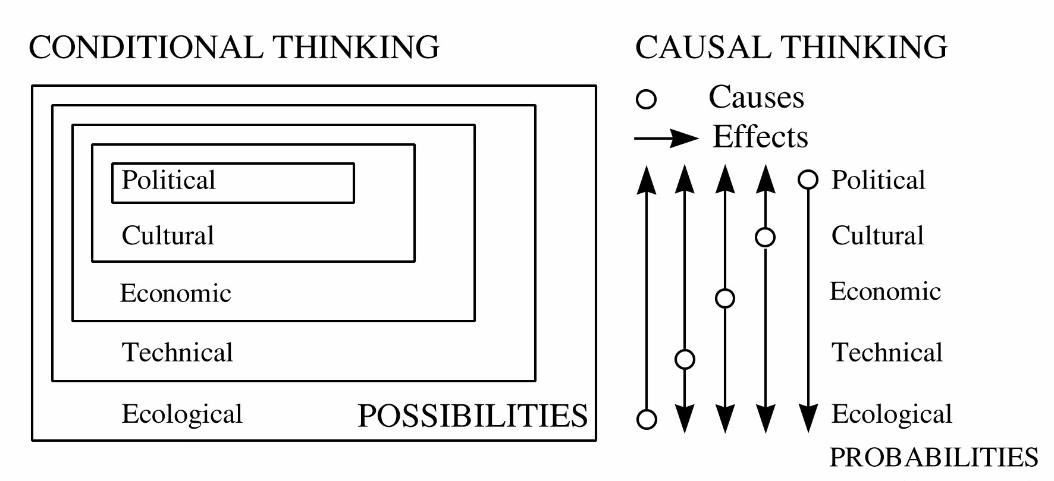
Fig. 10 Conditional thinking as a ceteris paribus environment of causal thinking
I cannot imagine social possibilities without any economical conditions. The reverse I can.
I cannot imagine economical possibilities without technical conditions. The reverse I can.
This gives a semantic conditional sequence of possibilities. However, in stable technical conditions economical initiatives can cause technical or social change. But when the dikes burst the technical 'ceteris paribus' conditions for economical determinism are lacking.
The ceteris-paribus presuppositions (conditions, context) of causal explanations also change on different levels in time. That means changing causal prediction. They also can be changed by design forcing shifting explanation about the effects. Innovative design implies removing some preconditions and making new ones. Design makes ‘ceteris non paribus’ conditions. In the same time any design copies existing conditions. So, more generally speaking design creates conditions, not causes. After all, designing a house does not mean to cause a houshold, but to make many households possible. Innovative design implicates always removing presupposed conditions and making new ones.

Loose from that the set of conditions (context) change in different wave-lengths:

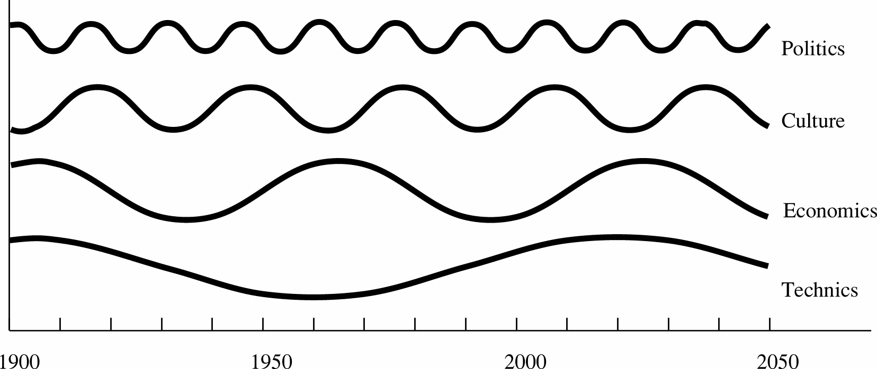
Fig. 11 Changing conditions for causal thinking.
Now we can point out a week component in causal thinking. The ceteris-paribus presuppositions of causal explanations change on different levels and can be changed by design ... by us.

Professor Helmar Krupp (1996), former director of the Fraunhofer Institut in Karlsruhe studied physics, pilosophy and sociology. He came to the conclusion that the individual no longer can influence the evolution of society. Society behaves as a system with its own dynamics. Individuals have to submit to this dynamics. In the conference 'The mind of technology', Delft, 27 november 1996, I tried to comfort him by emphasising design. The limitations of research could be broken by design.
Probable ecological, economical and cultural futures are gloomy from a viewpoint of inevitable Schumpeter dynamics or Fukuyama-expectations. But are the probable futures the only ones that we have to take in consideration? Empirical research is limited to the probable futures, design, innovation or technical research to the possible ones. And that creates hope.

Design making differences
I cannot imagine a representation or drawing without indicated differences, an (eventually tacitly presupposed) vocabulary or legend (key to symbols). The legend is the vocabulary of the drawing. Only by drawing differences one can make forms and only by making different forms one can make structures. Function presupposes a structure within which it has that function.

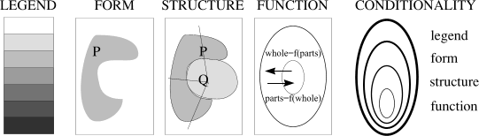
Fig. 12 The legend and its relation to form, structure and function
Nevertheless, within one set of forms (for example a box of blocks) you can imagine different ways of connecting or separating them (structures) and within different structures you can imagine different functions. In the reverse the same function often chooses different structures and the same structure is often built in different forms or materials. So where the design process lays the initiative is free. It can be either a causal, aim-directed (purposive) process starting with the function (funcionalist position) or a conditional, means-directed process (formalist or structuralist position).

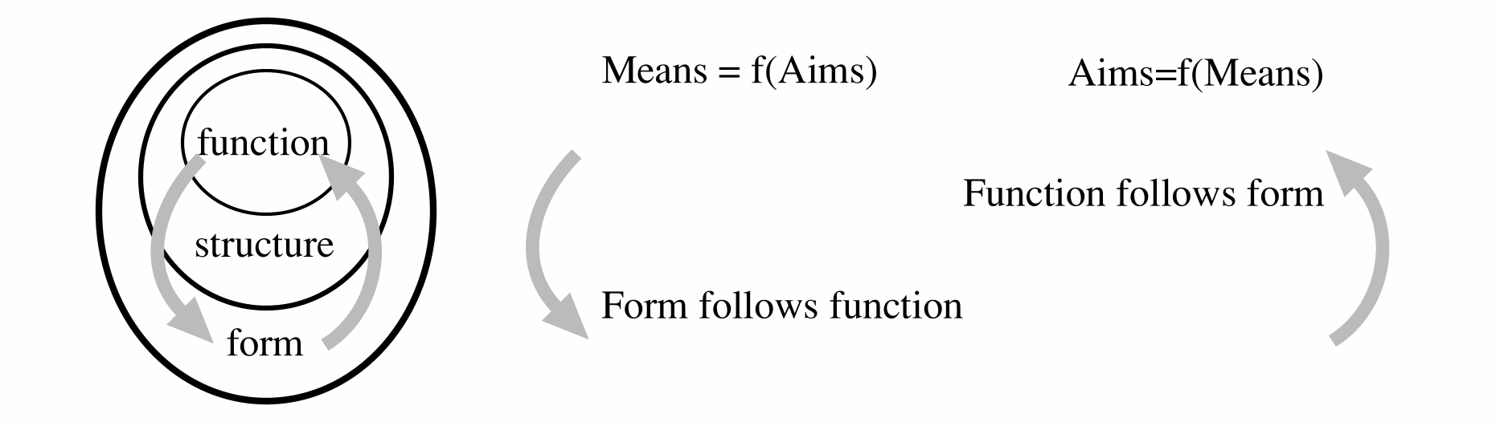
Fig. 13 Function, form, aims and means
When the number of aims is smaller than the number of means you better can use aims as independent variable with the means as dependent variable. In architecture and certainly urban planning the number of means is smaller than the number of aims. In that case you better can variate the means to see what gives the greatest amount of possibilities for future generations (robustness).

Environment, the set of conditions for life
We define environment in the technical and ecological sense as ‘the set of conditions for life’ (Hendriks 1993). In this definition 'conditions' can be interpreted as ecological, technical, economical, cultural or administrative preconditions. These substitutions result in 5 different usual concepts of 'environment': the administrative environment, the cultural environment etc. The concept 'life' can be substituted in the same sense as 'social life, cultural life, life of men, animals, plants etc, multiplicating the meanings of the concept of 'environment'.
In this definition, both ‘conditions’ and ‘living’ can be more closely specified. By means of substitution, more precise concepts of the environment arise, such as ‘the set of physical conditions required for plant life’ or ‘the set of managerial conditions required for animal life’.

conditions | life
managerial | human
cultural | human
economic | animal
technical | animal
ecological | plant
mass/time/spatial | plant
Fig. 14 Substitution possibilities in defining environment
One can presume a sequence of conditionality in both columns (one cannot imagine management without a culture to carry it; one cannot imagine animal life without plant life, etc.). That becomes an issue as soon as one attempts to weigh the importance of different environments against each other. However, also without the above presumption, these substitution possibilities allow 18 more precise environmental definitions to be made. We can summarise managerial, cultural and economic conditions as ‘societal conditions’ and the remaining ones as ‘physical conditions’. In this way, the number of environmental definitions is reduced to 6. Plant and animal life-forms can be summarised as ‘non-human life-forms’ (12 environmental definitions), but they can also be more precisely distinguished in the five ‘kingdoms’ currently recognised in biology, with homo sapiens as the sixth category, bringing the number of environmental definitions up to 42. This figure increases further, if we define a species-specific environment for every species (autecology) or community (synecology).

The current environmental definition of ‘physical conditions for human life’ (more or less according to Udo de Haes in Boersema, Peereboom et al. (1991) )) is just one of the environmental definitions identified above. Udo de Haes’ formulation can be expressed as a technical definition, by reducing it to ‘the collection of physical conditions for societal life’. However, by doing this, the physical surroundings become less optional than those postulated as a condition for societal life.
In other words, an asymmetry is assumed in the ‘relations’ between society and the physical environment.

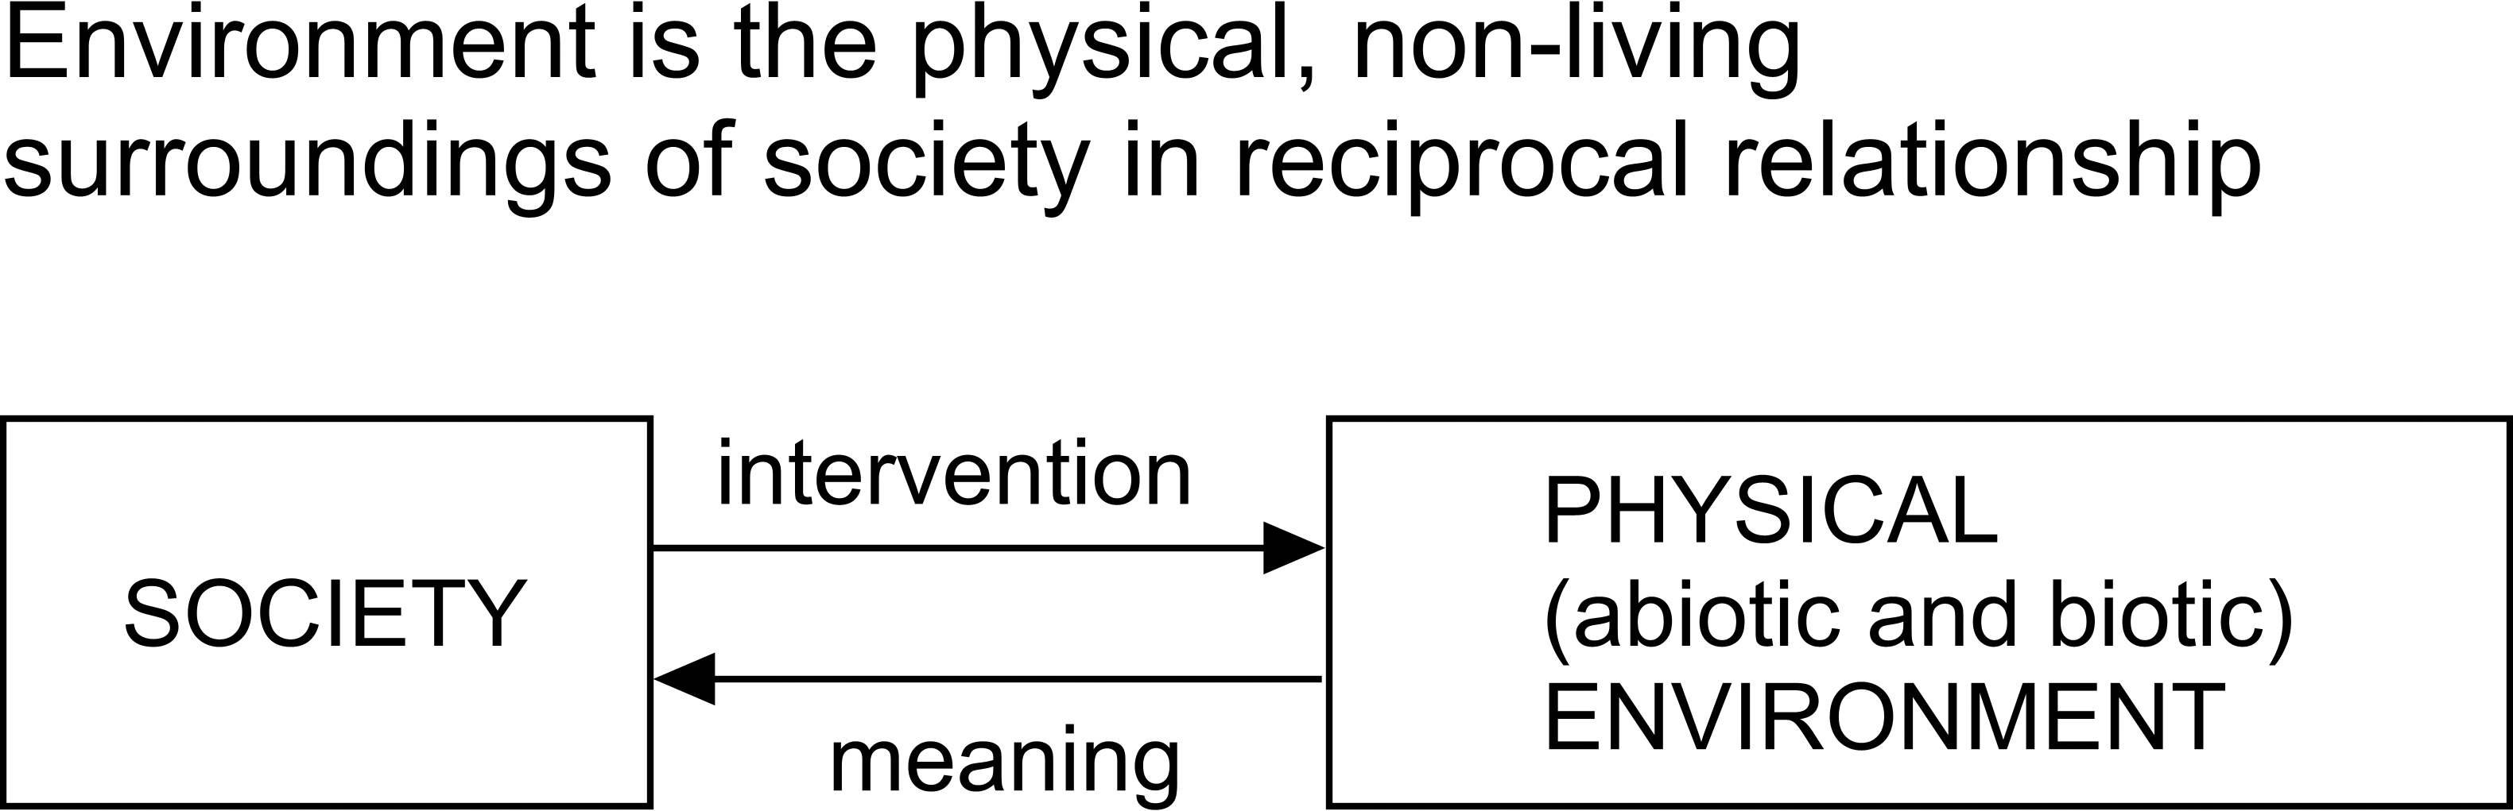 | 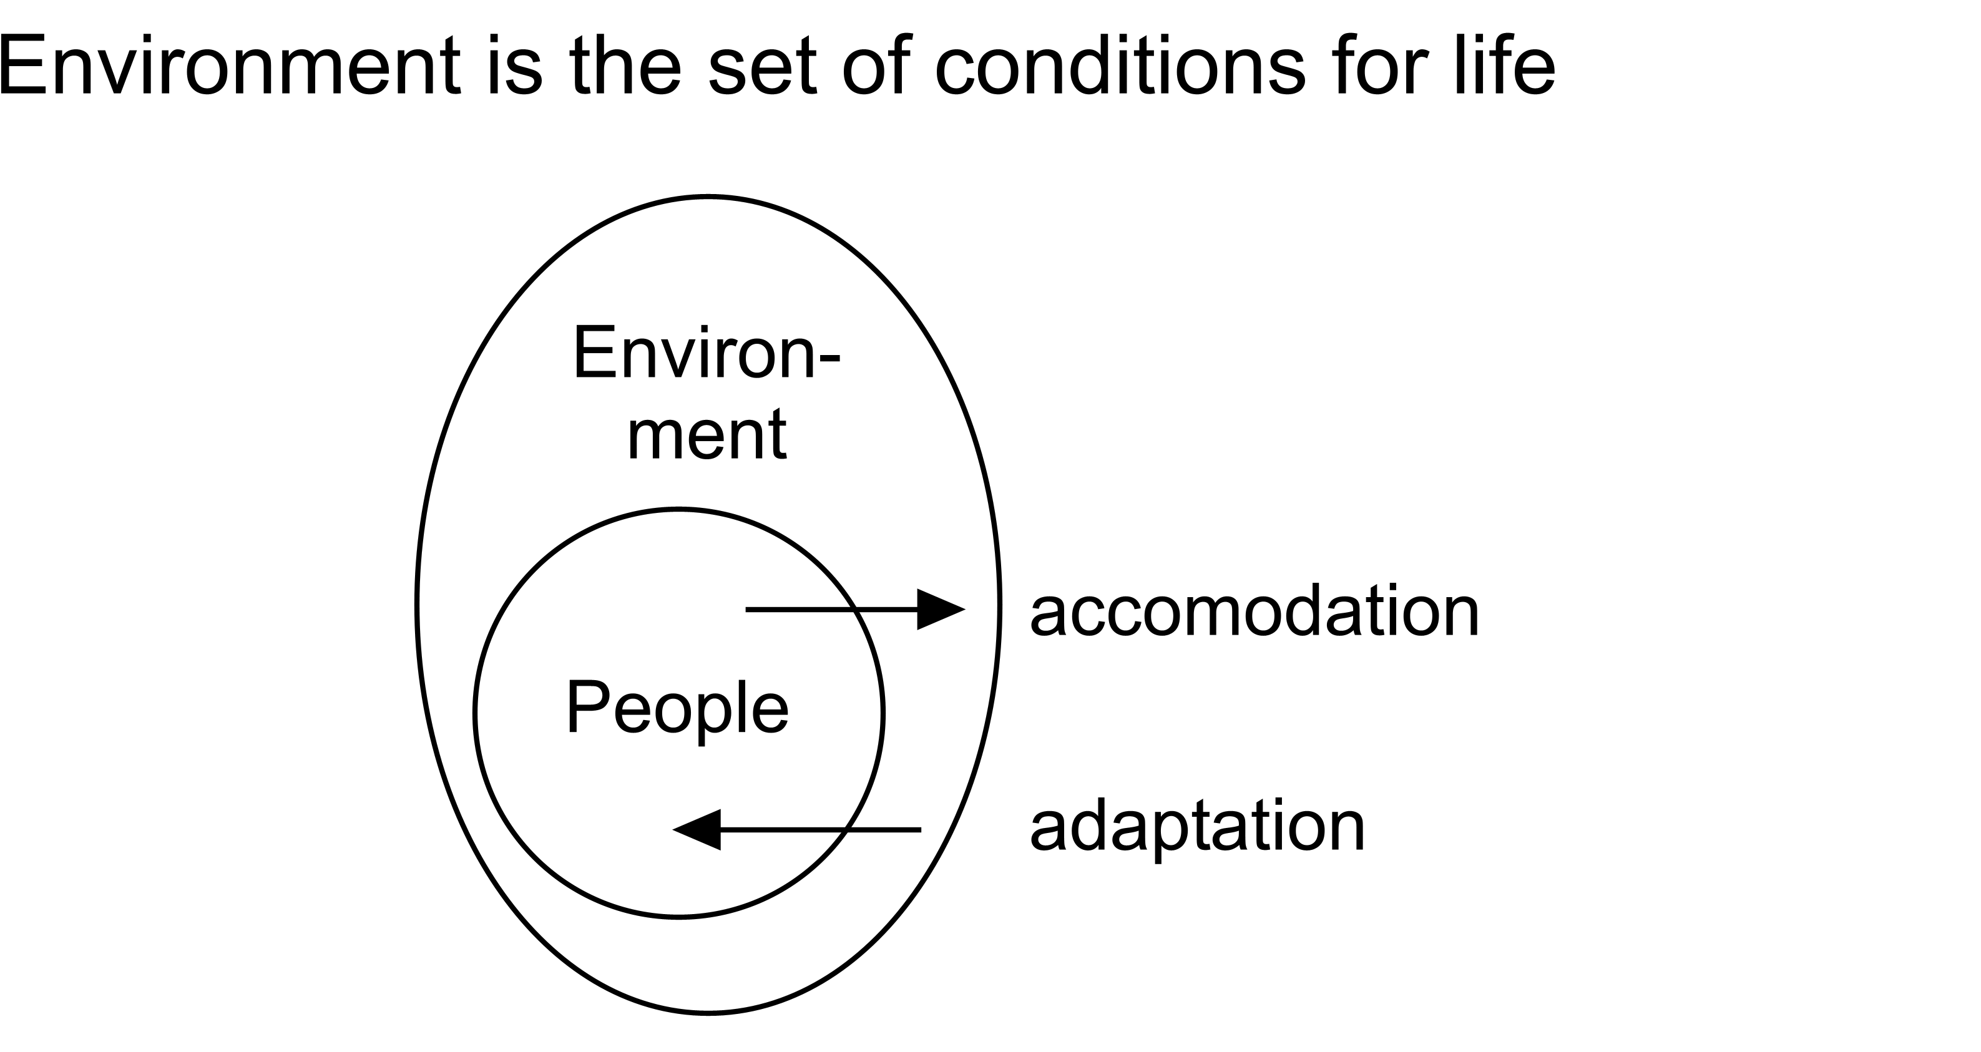
Fig. 15 Environment according to Udo de Haes | Fig. 16 Environment in technical sense
After all, one cannot imagine people, let alone a society, without physical surroundings, but one can imagine physical surroundings without people. A physical environment is thus a technical condition for human and societal life. Because of this, a specific physical environment is not the cause of one or other form of human life, such as physical determinism at the end of the last century would have led one to believe. After all, human beings are able to create new physical conditions for themselves (accommodation) and are thereby the cause of their own conditions. However, they are also able to adapt themselves to existing conditions (adaptation), and only in that case do they partly allow the causality of their lives to be determined by the physical environment.

Conditions
Technical conditions are related to what is possible, while causal relations have a bearing on what is probable within that possibility. After all, what is probable is, by definition, also possible, but not everything that is possible is also probable. There are, therefore, improbable possibilities. One cannot predict these, so one has to design them.

The analogue of this is that every cause is a condition for something happening, but not every condition is also a cause. The foundations of a house can be a condition for building that house, but, that does not mean that they are a reason why that house was built. A house can be a condition for a household; it can create the possibilities for a certain kind of household, but, nevertheless, it is still not the cause of that household.

The above argumentation gives an exact indication of what the responsibility of the designer is, in contrast to that of the researcher. If (s)he designs a home, (s)he must not do it in a way that presumes its occupancy by a specific type of household - that would be an encroachment on the freedom of choice of the future occupants - his design must keep possibilities open for its occupancy by different sorts of households.

The same sort of dilemma exists in ecology. It is not always possible to forecast where a certain ecosystem will come into existence, but we can create the conditions under which certain ecosystems can exist, but others can not.

Building is a prerequisite for human and other life. Building and urbanization has ecologically more positive effects on the environment than negative. In contrast with other productive branches it produces more 'environment' than it costs. It produces an environment for humans without which they would not survive at the same rate. But it also could produce a better environment for a variety of plants and animals than many places outside the built-up area.

The concept of difference
The very beginning of any range of semantic conditions seems to be 'difference'. Any concept presupposes 'difference'. Difference on itself cannot be defined because the concept of 'definition' already presupposes making difference with the rest. But also the concepts of 'making', 'with', 'the', and 'rest' presuppose 'difference'. So in the sentence concerned, 'difference' was already at least five times presupposed! Even the concept of equality (as necessarily presupposed in the concepts of 'gathering' and 'counting' and therefore in set-theory and mathematics) presupposes difference. As soon as you accept that there are 'different differences', for instance more or less difference ('variation'), you have to accept that equality is a special case of difference.

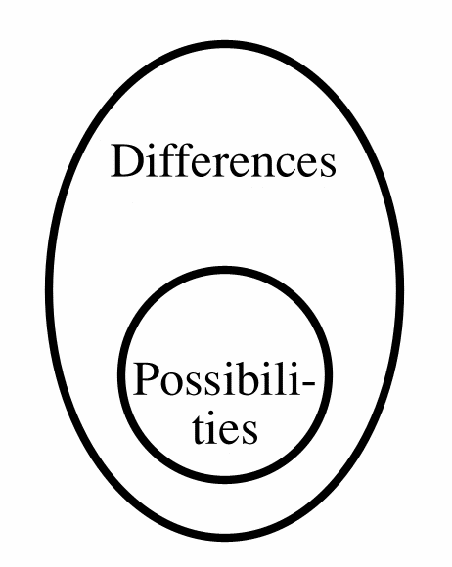 | 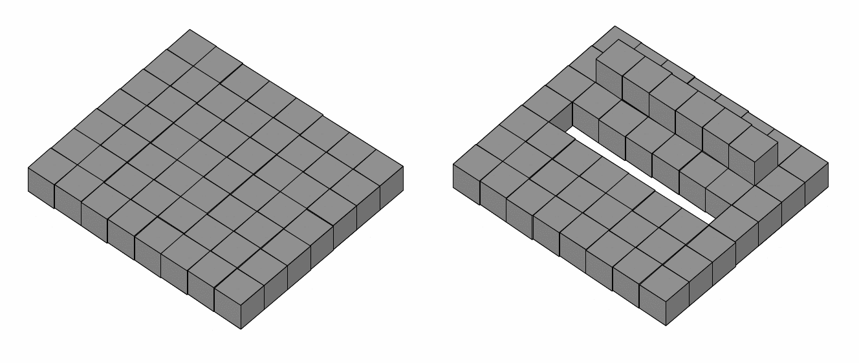
Fig. 17 Anything differs | Fig. 18 Difference makes possible
According to Fig. 18 there should be a more specific relation between difference and possibility than the conditional one in Fig. 17. However, I did not yet find a more convincing consideration than a picture like Fig. 18. Yet this question is essential for designers. If after all their profession as producers of non-probable possibilities has a specific relation with differentiation, than it has a difficulty with the accepted scientific practice of generalization.

Ashby (1960) and Leeuwen (1971) noticed that given a difference you always can imagine more difference, but not always less. The least kind of difference we call equality. Nevertheless, there must be a difference of place or moment left to establish that equality, otherwise the comparison has no sense. So we can draw an important conclusion: equality is a special kind of difference and not the opposite of it.

Many scientists feel uncomfortable with that conclusion because their profession is based on equations that conceive regularities in sets of n>1 'comparable' facts. Designers on the contrary do not, because their profession is based on originality in every single n=1 case. Without that originality their design would not be a design, but a prediction. The very concept 'concept' presupposes any equality in the observations conceived in the concept, but the concept 'conception' presupposes something different from earlier observations. Conceptualization always needs a reduction of diversity.

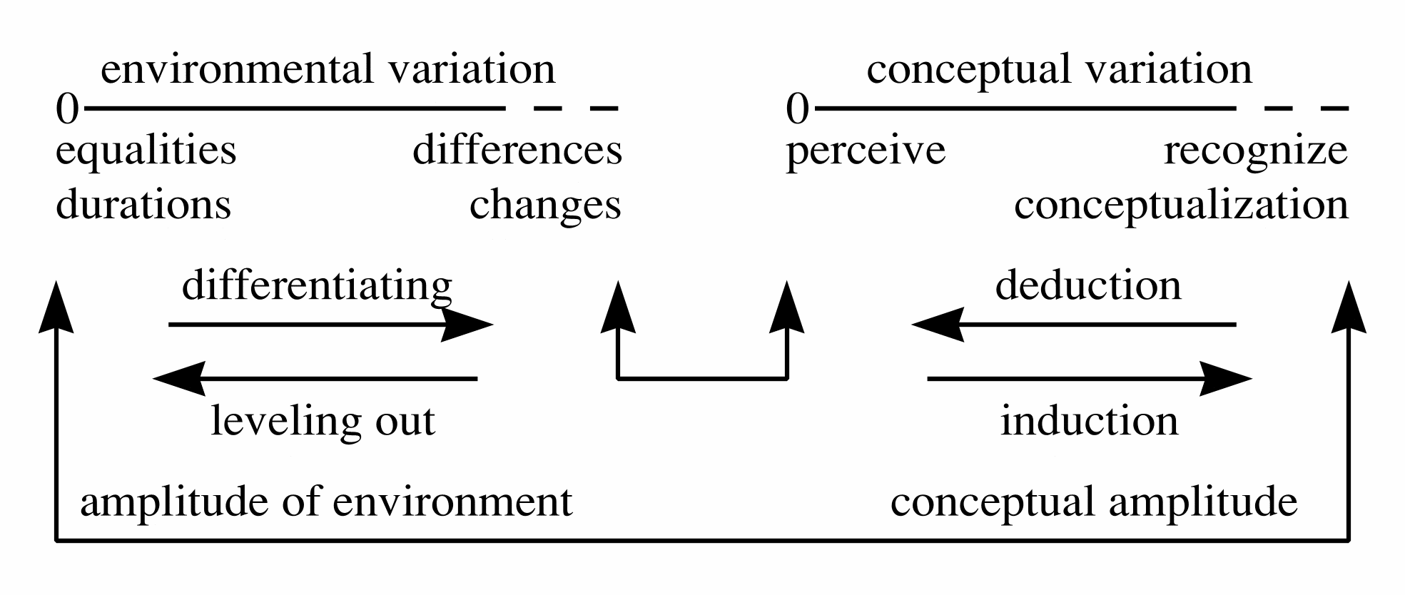
Fig. 19 Perceiving differences, recognising equaities
Vision, hearing, smelling, touching all need differences or changes in the environment. As soon as there is some repetition within these perceptions, we 'recognize' it, which is the basis of cognition and conceptualization. (Re)cognition however is only based on similarity, it reduces the differences that still can be perceived. So conceptualization changes sometimes chaos in surprize, sometimes surprize in recognition, sometimes recognition in boredom.

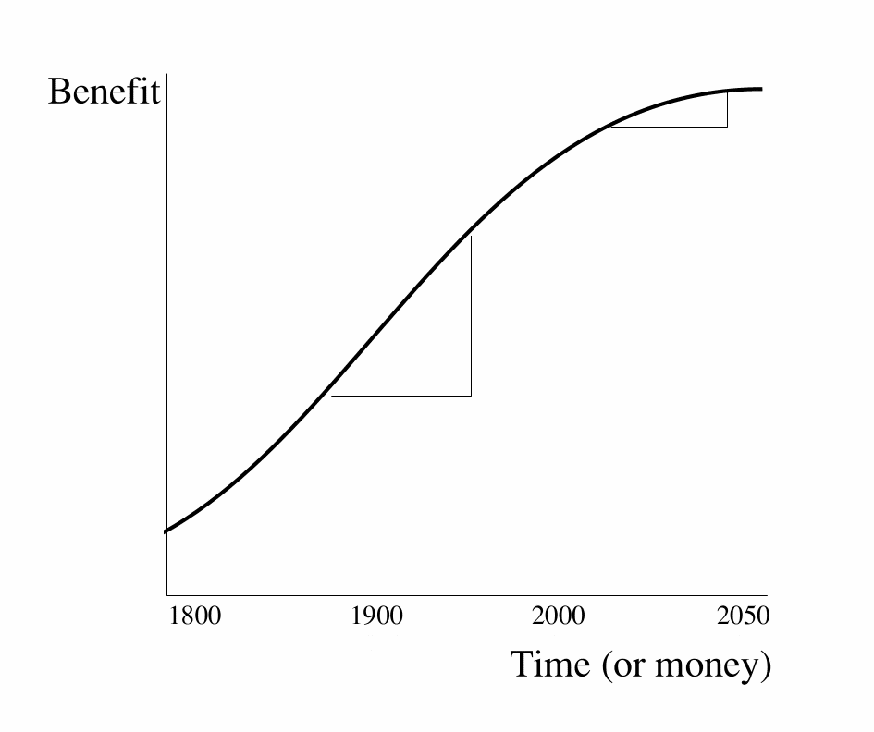 | Causal thinking is a special way of reducing diversity. It reduces similarities in repeating sequences of phenomena to the more general concepts of cause-effect relationships. Causal explanation has the more value the more reduction of different cases is possible by abstraction.  Alas, nowadays there are not so much phenomena left that can be explained mono- (or oligo-)causally. They largely have been explained earlier. What is left are context sensitive effects that can be caused by many different 'causes' or causes that can bring about many different effects, dependent on small differences in the environment where the 'cause' is introduced. Striking a match can cause little damage here, and big damage there. So monocausal (or 'oligocausal') research shows deminishing returns, especially on environmental (context sensitive) issues.
Fig. 20 Deminishing returns of monocausal (or paucicausal) research
Means and aims can only be chosen on the basis of a supposed causal relationship between both. Otherwise thinking about means and aims is senseless. The same means applied here have other effects as applied there. Apart from that they are also scale-dependent and therefore subject of misconceptions.

Conclusion
Policy reduces desirable futures, empirical science probable futures, design science possible futures.
The intellectual challenge of this century is to handle diversity instead of generalising it by statistical reduction.
Generalising research has diminishing returns. What could be generalised is mainly generalised in two centuries of empirical research. Problems left are context sensitive problems with too little statistical mass for research; they are the non-probable object of design.
However, making your probable future explicit:
•protects your project against judgements with other suppositions about the future
•raises the debate about the robustness of your design in different future contexts
•raises a ‘field of problems’ instead of an isolated ‘problem statement’ by subtracting the desirable futures from the probable ones.

References
Ashby, W. R. (1960) Design for a brain the origin of adaptive behaviour (London) Chapman & Hall.
Bense, M. (1954) Aesthetica (Stuttgart) Deutsche Verlags-Anstalt.
Birkhoff, G. D. (1933) Aesthetic measure (Cambridge, Mass.) Harvard University Press.
Boersema, C. Peereboom, et al. (1991) Basisboek Milieukunde HOOFDSTUK 01 (Meppel) Boom ISBN 90-6009-977-x.
Claval (1976) De geschiedenis van de aardrijkskunde (Utrecht) Het Spectrum.
Denters, T., R. Ruesink, et al. (1994) Van Muurbloem tot Straatmadelief. Wilde planten in en rond Amsterdam (Utrecht) KNNV uitgeverij ISBN 90-5011-065-7.
Derrida (1972) Marges de la philosophie (Paris) Les Editions de Minuit.
Draak, J. den (1993) Van blauwdruk naar draaiboek, scenario's in de ruimtelijke planning en volkshuisvesting.
Fukuyama, F. (1992) The End of History and the Last Man (New York) Free Press.
Hawkins (1937) Causality and implication (London) Sheed & Ward.
Hendriks, L. W. J. L. (1993) Begrippen rond bouwen en milieu (Rotterdam) SBR Stichting Bouwresearch.
IJsseling, S (1986) Jaques Derrida, een inleiding in zijn denken.
Jong, T. M. d.; J. Louwe (1972) 100 stellingen van Sharawagi 100 stellingen van Sharawagi (Delft) Faculteit Bouwkunde.
Jong, T. M. d. (1992) Kleine methodologie voor ontwerpend onderzoek (Meppel) Boom.
Jong, T. M. d. (2002) Verbal models in: T. M. d. Jong and D. J. H. v. d. Voordt Ways to research and study architectural, urban and technical design (Delft) Faculteit Bouwkunde TUD
Kant, I. (1976) Kritik der reinen Vernunft (Frankfurt am Main) Suhrkamp Verlag.
Koutamanis, A. (2002) Visualization and architecture in: T. M. d. Jong and D. J. M. v. d. Voordt Ways to study and research urban, architectural and technical design (Delft) Delft University Press
Krupp, H. (1996) Zukunftsland Japan, Globale Evolution und Eigendynamik (Darmstadt) Wissenschaftlicht Buchgesellschaft.
Leeuwen, C. G. (1971) Ekologie (Delft) Technische Universiteit Delft, faculteit Bouwkunde.
Luhmann, N. (1973) Zweckbegriff und Systemrationalität (Ulm) Suhrkamp Taschenbuch Wissenschaft.
Margulis, L., K. Schwartz, et al. (1994) The illustrated Five Kingdoms; A guide to the diversity of life on earth (New York) Harper Collins College Publishers ISBN 0-06-500843-X.
Margulis, L., K. Schwartz, et al. (1994) The illustrated Five Kingdoms; A guide to the diversity of life on earth (New York) Harper Collins College Publishers ISBN 0-06-500843-X.
Riemsdijk, M.J. van (1999) Dilemma's in de bedrijfskundige wetenschap.
Russell, B. (1919) Introduction to mathematical philosophy (London and New York) Routledge ISBN 0-415-09604-9.
Stevens, S.S. (1946) On the theory of scales of measurement.
Vos, J. (1993) Natuur in Zoetermeer in: T. M. d. Jong and J. Vos Kwartaalbericht KNNV Zoetermeer 1-10 (Zoetermeer) KNNV Zoetermeer 2, 1993
Wittgenstein (1919, 1959) Tractatus logico-philosophicus (Oxford) Basil Blackwell.
Wittgenstein, L. (1953) Philosophical investigations (Oxford) Blackwell.
Wittgenstein, L. (1963) Tractatus Logico-philosophicus (Frankfurt am Main) Suhrkamp Verlag.
Wittgenstein, L. and W. F. Hermans (1986) Tractatus logico-philosophicus (Amsterdam) Athenaeum-Polak & Van Gennep ISBN 90.253.1533.X.
World commission environment and development (1990) Our Common Future (Oxford/New York) Oxford University press.
www.bk.tudelft.nl/urbanism/team > Publications 2004 Jong, Taeke M. de (2004) The future-impact computer programme version 3 (Zoetermeer) MESO

Index

ABC model 3
abiotic 3
accommodation 10
Achilles and the turtle 14
adaptation 10
agenda(reduction into discussable topics) 1
agreements(reduction(location, time)) 1
aim-directed 5; 9
analysis 1
anthropocentrism 4
appointments(reduction(location, time)) 1
arrangement of values 2
art 4
Ashby(1960) 11
assumption 4
Bense(1954) 14
biodiversity(mankind) 13
biotic 3
Birkhoff(1933) 14
Boersema(1991) 10
Brundtland 13
building(prerequisite) 11
causal relations 10
causal thinking 5
causal thinking(recucing diversity) 12
causal(logical) 2
cause 2
cause(ceteris paribus) 5
cause(condition) 5
ceteris non paribus 8
ceteris paribus 1
ceteris paribus presupposition 7
change 2
chaos theory 2
characteristic(values(independently varying)) 2
characteristics(nameable(verbal, denumerable, numerable, measurable)) 1
Claval(1976) 10
cognition 12
combine or analyse(functions) 2
communication(diversity) 13
comparable facts 11
comparison 3
concept 11
conception 11
conceptualization 11
conclusion(logical, causal) 2
condition(semantic) 3
condition(wave-lengths) 8
conditional analysis 3
conditional comparisons 3
conditional operators 3
conditional range 3
conditional sequence 8
conditional(causal) 5
conditionality 10
conditionals 3
conditions 2; 9
conditions(time) 8
confuson of scale 14
context sensitive effects 12
context-dependent local problems 2
contextuality of ‘general’ statements 2
contradiction 3
countable 2
creativity 3; 4
cultural 3
cultural life 9
culture 4
decision-making process(agenda) 1
definition 1; 11
denumerable 1; 2
denumerable spatial or temporal order 2
dependent variable 9
design 10; 11
design(possible worlds) 5
desintegration 15
desirable 1
difference 2; 11
different positions in reality 2
differential thinking 2
'differentiation' 15
dimension 1
diminishing marginal returns 2
diversity(communication) 13
drawing(difference) 9
drawing(preconditions) 5
ecocentrism 4
ecological disasters 13
ecological tolerance 13
ecology(urbanization) 11
economical conditions 8
economical possibilities 8
empirical method(problems) 2
empirical research(causal thinking) 5
empirical researcher 1
environment 4; 9
epistemological limits 2
equality 11
equality in the elements 2
equations 11
exclamations 4
expectation(variables(dependency)) 2
form(legend) 9
formalist position 9
Fraunhofer Institut 8
freedom of choice(difference) 5
freedom of choice(possibilities(variety)) 14
Fukuyama(1992) 14
Fukuyama-expectations 8
funcionalist position 9
function(legend) 9
function(structure(form)) 9
futures(probable, possible, desirable) 4
general(context) 2
Hendriks(1993) 9
hope 9
idealistic position 4
imagine(possible) 5
improbable possibilities 10
independent variable 9
integration 15
intervals 2
Jong(1972) 3
Jong(1992) 3
Jong(2002) 3
Kant(1976) 4
key to symbols 9
Koutamanis(2002) 14
Krupp(1996) 8; 14
language game(knowing, capability) 1
Leeuwen(1971) 11
legend(vocabulary) 9
living 9
logic 3
logic(formal) 4
logical form 4
logical reasoning 3
Luhmann(1973) 15
marginal returns(diminishing) 2
Margulis(1994) 10
materialistic position 4
means-directed 5; 9
measurable 1
meeting(minutes) 1
method(empirical) 2
methodological differences(modes(probable, possible, desirable)) 1
mind of technology 8
minutes(meeting) 1
modes(probable, possible, desirable) 1
monocausal explanation 12
nameable characteristics 1
naming and delineation 1
natural world 4
numerable 1
outward boundaries 3
paucicausal 12
perception(reduction) 1
physical conditions 10
poièsis 4
possibility(difference) 11
possible 10
possible(future) 5
possible(imagination) 5
preconception 3
precondition 4
preconditions for life 4
predict 10
predictions(variables, relations) 2
prerequisite 4
presupposition 3
probable 10
probable(future) 4
proposals 4
quality(variation) 14
questions 4
recognition 12
reduction into discussable topics 1
reduction of diversity 11
reduction of perceptions 1
reduction to place and time 1
reduction to place and/or time(variables(relation)) 2
reduction to sort 1
reduction(location, time) 1
relating two variables(arrangement of values) 2
relationship between variables(simulation) 2
researcher(empirical) 1
resistance 13
responsibility of the designer 11
risc-cover for life(variety) 13
Russell 14
Russell(1919) 14
scale paradox 15
Schumpeter dynamics 8
science and art 4
scientific methods(epistemological limits) 2
semantic conditional sequence 8
semantic Venn diagram 3
sequential 2
sequentiality(differences, changes) 2
set-theory 3
simulation(variables(relation)) 2
social life 9
social possibilities 8
societal conditions 10
species-specific environment 10
Spinoza 1
structuralist position 9
structure(legend) 9
supposition(tacit) 3
synthetic judgements a priori 4
Systemrationalität 15
technical conditions 8; 10
trade(diversity) 13
Udo de Haes 10
values(changing(variable)) 1
variable(traditional delimitation) 2
variables(ability to move) 2
variables(possible future characteristics of objects) 2
variables(reduction(characteristic, value)) 1
variation 11
variety(risc-cover for life) 13
Venn diagram 3
verbal 1
Wittgenstein 4
Wittgenstein(1919) 4
Wittgenstein(1953) 4
Wittgenstein(early) 1
Wittgenstein(later) 2
World commission environment and development(1990) 13
Zweckbegriff 15

This is a term of Wittgenstein, L. (1953) Philosophische Untersuchungen. Recent edition: Wittgenstein, L. and G.E.M. Anscombe (1997) Philosophical investigations.
This is a Kantian term that has taken on a new interpretation in modal logic.
Stevens, S.S. (1946) On the theory of scales of measurement.
Spinoza: ‘Every determination contains a negation.’
Wittgenstein, L. (1922) Tractatus logico-philosophicus. Recent edition: Wittgenstein, L., Pears D.F. et al. (2001) Tractatus logico-philosophicus.
Wittgenstein, L. (1953) Philosophische Untersuchungen.
IJsseling, S (1986) Jaques Derrida, een inleiding in zijn denken.
Draak, J. den (1993) Van blauwdruk naar draaiboek, scenario's in de ruimtelijke planning en volkshuisvesting.
Riemsdijk, M.J. van (1999) Dilemma's in de bedrijfskundige wetenschap.
Some presuppositions of normal logic lack that seem to stagnate the development of drawing theory, design theory and ecological theory. Though we, Jong, T. M. d. (2002) Verbal models in: T. M. d. Jong and D. J. H. v. d. Voordt Ways to research and study architectural, urban and technical design (Delft) Faculteit Bouwkunde TUD did not examine it thouroughly, semantic conditions may be tacitly presupposed in normal logic. To formulate the function of a logical operator ‘o’, you first need to test the truth-value of ‘PoQ’ in four conditions (if P is true and Q is true, if P is true and Q is false, if P is false and Q is true, if P is false and Q is false). That conditional if..than.. test cannot be performed by the conditional operators (,  and ) to be defined by the truth-table itself. What kind of conditional comparisons are they than if they are tacitly supposed in formulating these well-known conditionals? Conditional analysis may also shed some light on the hidden propositions in the terminology ‘true’ and ‘false’ and the hidden propositions concerning restrictions on space and time in logical reasoning. For instance, the expression ‘It rains and it rains not’ is true on world-scale, but forbidden in formal logic as a contradiction. So the hidden supposition of formal logic must be that only local events could be logically expressed. A drawing containing different locations cannot be logic in this way.
. The expression ‘comparison’ is used here in an unusually broader sense than in formal logic or mathematics, but until now seemed to be correctly understood without explanation.
. Including the comparisons needed for the hypothesis, we needed 6 comparisons to make a conditional sequence of three concepts. The fourth one will need another 6 comparisons, the fifth another 8. We compared appoximately 200 crucial concepts in science and technology like ‘set’, ‘pattern’, ‘structure’, ‘function’ and the like (note 6). That required 39800 comparisons and resulted in a samantically conditional sequence of these concepts with one single condition at the beginning.
. This already says something about my preconception about culture: ‘a plant has no culture’. Though the concept of culture is not yet defined by this operation, it is in any case ‘placed’ and the boundaries of many possible definitions are set.
. Synthetic judgements a priori of Kant, I. (1976) Kritik der reinen Vernunft (Frankfurt am Main) Suhrkamp Verlag. .
. 'Suppose we are human, suppose we use a language, suppose we understand the same things using the same words, suppose this building does not pour down, suppose you don’t kill me for the things I say etceteras etcetera . . . than we could have a conference, shall we have a conference?'
. Old Greek for manufacture, construction
See www.bk.tudelft.nl/urbanism/team > Publications 2004 Jong, Taeke M. de (2004) The future-impact computer programme version 3 (Zoetermeer) MESO
Margulis, L., K. Schwartz, et al. (1994) The illustrated Five Kingdoms; A guide to the diversity of life on earth (New York) Harper Collins College Publishers ISBN 0-06-500843-X..
Claval (1976) De geschiedenis van de aardrijkskunde (Utrecht) Het Spectrum.

