The ecology of health
in regional design perspective
Vilnius, Lithuania 2nd WHO International Housing and Health symposium 2004-09-28
Delft, 2004-08-04
Prof.dr.ir. Taeke M. de Jong
chair Technical Ecology and Methodology
chair Regional Design
University of Technology Delft, Faculty of Architecture
T.M.deJong@bk.tudelft.nl
www.bk.tudelft.nl/urbanism/team

Contents
1 Human health in the urban environment 2
A designer’s view 2
Human density 2
Adaptation and accomodation 2
Distribution of health 3
Avoiding risks could be risky 4
Living with life: living with the risk to die 4
The unfamiliar diversity of unknown life 4
The hidden choice of statistical reduction 4
A reference environment 5
Human abilities to challenge by design 5
Urban living 5
Civilisation damage 6
Motoric deprivation 6
2 Diversity, scale and dispersion; means of design 7
Biodiversity 7
Rarity 7
Space as condition for life 7
The importance of diversity for life 7
The importance of diversity for human living 8
Possibility of choice 8
Quality of life 9
3 Scale-sensitive concepts 10
Scale paradox 10
Spatial state of dispersion as a condition of diversity 11
Ecology as science of dispersion 12
Urban ecology 13
Urban rareness 13
The number of species in town 14
Design conditions 15
4 Urban perspectives in the Netherlands 16
Claims on space 16
The scale of concentration 17
Open space 17
Possible use of open space 18
Norms for open space 19
Suggestions concerning spatial human rights 20
5 Conclusion 21
6 References 22
7 Key words 24

Human health in the urban environment

A designer’s view
Being no expert on human health as a designer the most extensive overview I know in the joint field of medicine and urbanism is edited by Vogler and Kuhn (1957) some 50 years ago. They discuss many kinds of ‘civilisation damage’ in the urban environment from different medical specialist’s points of view. I never found a reference into this comprehensive work and I can understand it considering its size and age. So, I recoil from reviewing it as well, the more so while I am not read up on more recent medical literature. However, the publication is useful to check more recent research programmes in this field and it makes me aware of my designer’s point of view.

A designer focuses on possible futures. And probable futures are only a part of it. Moreover, an urban designer or architect can not restrict him/herself to a well defined problem statement or a limited solution possibly causing new problems in other fields to be covered by the same design. (S)he is confronted with a field of administrative, managerial, cultural, economical, technical, ecological and spatial-temporal problems stemming from an always context-sensitive assignment. The written programme of requirements of the assignment covers only a part of them and a small part of the design decisions to be made. That raises a historical distrust in empirical ceteris paribus evidence based on specialist’s research (Jong and Voordt, Eds. , 2002).

An urban designer for example always quarrels with the traffic specialist forcing to implement national norms in local contexts. The first traffic casualty due to not implementing them would punish him after all. This is the main characteristic of all diciplines where death is in the game (defence, police, fire brigate, traffic and medical specialists): they are bound to national and international norms and punishment. However, the other side of implementing such norms is less local involvement. In the example of traffic engineering that has unexpected consequences. Trying to draw straight and uniform road profiles meant to avoid casualties, the local inhabitant does not experience them as ‘his’ street. That lack of identification results in lack of responsibility. The save straight traffic lines invite to faster driving when there is no police.

Designers on the contrary get their assignments to give local identity, otherwise the solution could be copied from elsewhere and (s)he would never be invited to make a design for that location. I can understand that the reader judges the author takes too many context factors into account to make a proper research programme possible, but I consider such scepticism as a valuable contribution to the scientific debate on the growing limits of ceteris paribus empirical research and the promising possibilities of design studies.

Human density
Apart from the disadvantages of living in high densities Vogler and Kuhn emphasise, its benefits Jacobs (1961) some years later referred to with the eye of a designer, were partly confirmed in a psychological sense. Freedman (1975) discussed research on crowding and behaviour concluding no other impact of increasing density than intensifying existing negative or positive social-psychological processes. However, thanks to human biodiversity or social diversity - stage in the lifecycle, income or life style - some people like to live in high densities, others do not. People with children mostly like low densities of quiet suburbs. So, forced to live in high densities the impact could be primarily negative. However, learning to live in high densities with children might turn out positive by discovering advantages, adapting, compensating shortages and accommodating new functions. Producing accomodations like that, opening up new possibilities is the task of a designer and his means are sun, wind, water earth, life (Jong, 2004) and the numerous, often unexpected possibilities of living that could be drawn.

Adaptation and accomodation
Adapting to an environment and compensating shortages by new accommodations are essential characteristics of life. Life would never have developed without these capacities. The possibility of adaptation and compensation are often forgotten by researchers only interested in forecasting a probable future. ‘Arsenic is poisonous’, they predict. The prediction is based on 3x standard deviation from the average (99.7% of the cases) and if arsenic poison would be ever a global problem their solution would be removing the cause only. But in Austria a village population of so called ‘arsenic eaters’ (source unknown) since centuries seems to got used to it. That is the way evolution solved problems by adaptation and compensation increasing diversity, not by global rules reducing diversity. Oxygen was once a global poison, now it is a prerequisite for aerobic life. Adapting, compensating and accommodating are also ways designers study. When low temperature is a problem of living in higher latitudes we compensate (accommodate) by building acclimatised houses. It is unnatural because it disturbs the natural distribution and abundance of homo sapiens. But since we make houses more than 3000 years it appears natural to us. What we call ‘natural’ apparently is time scale sensitive.

Distribution of health
Epidemiological research seldom succeeds in convincingly separating causal physical context factors like the urban environment from other coinciding influences affecting health. Death rates in the big towns in the nineties were 11% higher than elsewhere in The Netherlands and there are substantial health differences between and within towns (Fig. 1 ). However, they correlate highly with income differences causing different (un)healthy lifestyles. For example they indicate that in a low-income district the chance to die before the age of 65 is 50% higher than in a high-income district. And rich people can move from low-income wet peat and clay districts into high-income sandy districts leaving a less healthy population behind. A recent survey into medicine use shows that the most well-to-do sandy region ‘Gooi’ has the lowest use of medicines in The Netherlands (Fig. 2 ).

Insurance companies could decrease their rates for these groups in the same time increasing their wealth (and health). But to which extend Gooi-people owe their health to wealth and life style, to the lower housing density, to the green area in their direct neighbourhood, dry sandy soil or climate we do not know. The surveyors did not try to explain either comparing regions of The Netherlands because epidemiological research is one of the most tricky disciplines urging expensive longitudinal research extending decades to be convincing. That is a great pity, because as long as statistical evidence fails an even more tricky branch of statistics wins: risk calculation. Risk calculation seems rational, but often it is also the calculation of fears and myths motivated by little more then sharing them in collective fear.

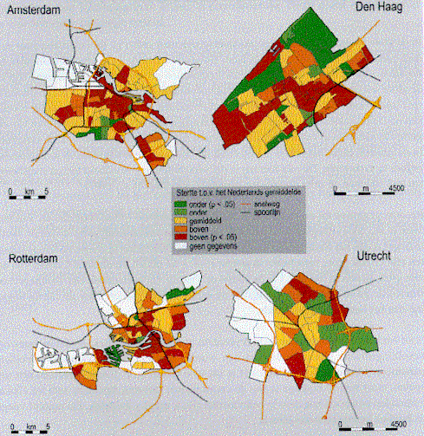 | 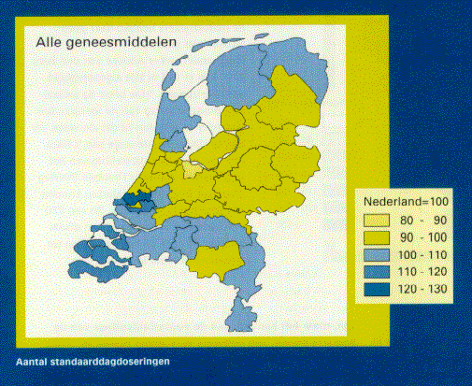
Garretsen and Raat (1989) | Batenburg-Eddes and Berg-Jeths (2002)
Fig. 1 Differences in death rates | Fig. 2 Use of medicines
The more we know, the more possible threads we become aware of to be calculated. That raises fear and fear raises stress. Stress is suspect in raising or stimulating diseases like risk of infection and cancer. Fear for cancer is so well-known a medical symptom that it got its own name in medical vocabularies: ‘carcinophobia’.

Designers in the wake of this uncertainty already try to make solutions for possible problems. That is their task, but they seldom evaluate the effectiveness and possible side-effects of their solutions afterwards (ex post). Urban design is not always the most effective solution in environmental problems remaining after the great positive health effect of housing itself. Barton and Tsourou (2000) advise 12 key health objectives for urban planners in the context of WHO healthy city project in which Eindhoven participates: healthy lifestyles, social cohesion, housing quality, access to work, accessibility, local low-input food production, safety, equity, air quality and aesthetics, water and sanitation quality, quality of land and mineral resources, climate stability. Evaluating their effectiveness again would urge expensive longitudinal research extending decades to be scientifically convincing.

Avoiding risks could be risky
A secret medical survey I heard of by a medical student in the seventies revealed that 50% of our diseases at that time were iatrogeneous (caused by physicians). I do not know whether that was true or not and what the present state of medicine is in this respect. That is why I fear the worst case.
Suppose a new medicine is accepted because it heals a specific disease in 99 from 100 persons, but because everyone reacts different in any of them it causes different kinds of side-effects. Side-effects with enough statistical mass to indicate the new medicine as a cause are described in the instruction leaflet. But what about side-effects not reaching a statistical mass in the diversity of medicated people? The unfortunate client comes back to the doctor with severe symptoms, but the doctor can not conclude the earlier medicine to be the cause and gives another medicine with unpredictable side-effects. And so on. In that case the medical discipline would create its own work. Consulting a doctor would give as much chance to immediate health as to illness later, giving however a little improvement of life expectancy.

McKeown (1976) already doubted the supposed positive impact of medical care on life expectancy but he did not yet take the above argument into account. He argued that the main improvements of life expectancy historically appeared before important medical innovations. So, these improvements could not be explained by medical care. They should be explained by improved life conditions (housing!) and food.

In the same time exceptional occurrences are magnified by television and newspapers. Television and newspapers bomb us by statistical exceptions, distorting our perception of chance and magnifying impact. Risk is popularly defined by chance x impact. The public shame of few physicians involved intimidates the profession as a whole. And we still know little about our body, our own nature yet. Honest physicians remain silent but that is what frightens more. Avoiding any risk physicians prescribe too many medicines, order too many physical examinations increasing the costs of medical care, increasing slowly appearing side effects. There is something wrong in the state of medicine. King Average rules the kingdom of exceptions human species comprises.

Living with life: living with the risk to die
Avoiding one risk raises new risks on other levels of scale is space or time. Always avoiding to catch a cold may result in high susceptibility for flu any time we leave a building or a car. Our hygiene drove life out and nature in exile. Our biological resistance fades, the number of immunity deficiency diseases increases. We do not get injuries enough to become vaccinated by nature itself. We like dangerous holydays to flee from our unnatural and boring safety, but we do not know real danger anymore and fall ill by foreign food.

Insurance companies sell fear. We pay more for safety than for anything else: insurance, police, army, preventing fire, burglary and catching a cold. We fear we can not pay all and we double our work until we die from the impacts of stress. The life time we spend on worry is lost well-being, lost health and life time. Our fear for exceptional possibilities raises new diseases of the mind and we fear them as well. In reality our life is safer then ever, but we do not dare to live with life: the risk to die. Life became strange to us and death as well, we fear the unfamiliar because it could be unhygienic.

The unfamiliar diversity of unknown life
In the mean time numerous other organisms are going their own way, not fearing for anything that is not actual and mostly without any apparent fearing at all. They live from very slow to very fast.
I prefer the slow living plants surrounded by their very fast pairing messengers of life-experience, the insects. Plants are the basis of life’s pyramid. Added animal life only selects and regulates like man does as well by harvesting, preserving, mowing and gardening. Sometimes we visit them and walk in something totally else we belong to historically but do not have to understand, something we should not try to plan.
I think it stimulates human health when we bring life close to everybody’s home and living, but nobody knows, it is a hypothesis. Berg, Berg et al. (2001) give an excellent overview in their essay about the relation between nature and health concerning history, possible impacts on stress, fear, physical resistance and personal growth. Nature puts the stressing concept of our own importance into a relative perspective of one species between 1 700 000 ones or more. They differ more from us than any people we tend to reject in social conflict. Studying nature heals social disappointment by disappointing prejudice. It stimulates an active form of modesty. Nature tempers forced choice as architecture should do as well according to Eyck, Parin et al. (1968).

The hidden choice of statistical reduction
The intellectual challenge of this century is to handle diversity instead of generalising it by statistical reduction. Blinded by immediate measurable positive effects we do not have scientific instruments to count individual side-effects without statistical mass. Generalising research has diminishing returns for context sensitive problems. On the other hand context sensitive design is promising, generating study. Biological evolution and ecological succession is its model. Evolution after all makes use of exceptions surviving in a changing context. You can not understand the process of evolution by stressing the average. Designers are not engaged for the average, but for context sensitive exceptions.

Ecology has to take millions of species into account and we do not know how any of them work. We know very little, otherwise we would be able to design them. To make it worse any specimen of a species is different from most of the other specimens of the same species. To make it finally unaccessible for statistical evidence every specimen is functioning in a different context. The more we know about nature the more we appear to know not, and the more we want to know, to see, to experience. It helps us more to trust surprise than expectation. In any town of the Netherlands specialised study groups of nature associations contribute to atlases of birds by Hagemeijer and Blair , Bekhuis, Bijlsma et al. (1988), Beintema, Moedt et al. (1995), butterflies by Tax (1989) and Bink (1992), bats by Limpens, Mostert et al. (1997), amphibians and reptiles by Bohemen, Buizer et al. (1986) , mammals by Broekhuizen, Hoekstra et al. (1992), fishes by Nie (1996), plants by Mennema, Quene-Boterenbrood et al. (1980), Weeda, Schaminée et al. (2000) and mushrooms by Nauta and Vellinga (1995). But they have to be adapted every year, because context changes. They multiply our shrinking world of holiday destinations by growing local universes we tended to overlook. In any town nature writes a history of war and peace far more thrilling than television and newspapers could do. Nature looks for its journalists because it only exists by the grace of those seeing it.

A reference environment
For millions of years, human characteristics have been tuned to the natural environment in which people had to survive (adaptation). Therefore, it is useful to acquaint oneself with this ‘reference’ environment as such, and, now and then, to allow this nature to be the tutor of architectural (and mechanical engineering) forms. Even in the most advanced studies into the development of autonomous robots, the mechanics of insects are attentively observed. Also in the other development that is thought to be important for the future — biotechnology — nature is often ‘the tutor of art’.
In the history of human origins (anthropogenesis) , human adaptation and environmental determination have played a major role. Approximately 6 million years ago, due to climatic and environmental changes in Africa, Homo habilis exchanged a forest habitat for savanna. Approximately 2 million years ago, Homo erectus developed from this animal. In turn, different human-like animals developed from this creature and later became extinct. Fifty thousand years ago only two of these species remained, the Neandertalers and Homo sapiens sapiens. The Neandertalers became extinct at this time, leaving Homo sapiens sapiens as the sole survivor. For approximately 1 million years, this species’ use of tools has served as a criterium to demarcate humanity: the capacity to oversee a series of acts of which only the first (e.g. the making of tools) can be carried out immediately.

Human abilities to challenge by design
The origins of the human race, preceding Homo habilis, has produced a large number of ergonomically interesting ‘aboreal pre-adaptations’ (adaptations to the former forest environment), such as the ability to grasp with the hands, stereoscopic vision, upright posture, the production of a limited number of offspring at each pregnancy, a lengthy up-bringing of the offspring, etc. The tropical rain forest is then by no means as frightening as is it is made out to be. It is a fantastic experience to cut a path for oneself through this twilit environment: it feels as though one is returning home after 6 million years. All the senses are stimulated in a changing, yet balanced, way. One can seldom see further than 100 metres ahead and is constantly obliged to focus the eyes on objects both nearby and further away. Moreover, it is an environment similar to a Gothic cathedral: full of vertical light-seeking pilasters, in which, occasionally, the sun festively forces its way to the bottom. This demands continuous attentiveness, but, on the other hand, the senses seldom become overloaded.
In this century, we are witnessing the clearance of the last primitive forest peoples and their culture and habitat. Nevertheless, a cultural-ecological study of these communities that are so closely linked with our reference environment could be of importance for future urban design.
The transition from forest dwelling to life on the flat savanna lands must have made the eyes lazy, but the hands and the head more diligent. It is particularly these border environments where people seek cover and where they build their own protective shelters.

Urban living
The biggest mass migration ever was the movement from the country-side to the towns that resulted from the Industrial Revolution. The spatial and social consequences of that process are summarised under the term ‘urbanisation’. A progressive division between production, exchange and consumption (working, transport, living and recreation) has taken place, both in space and time, so that monofunctional spaces and interfunctional activities (activities that are only useful within a series of activities) have come into existence. This division of functions does not only take place between households, but also on the level of the individual households themselves. For everyone, there is a separate time for living, working and enjoying recreation. The household is losing its traditional functions such as providing training, religion, assurance and by that size and coherence.
How people spend their time gives a good indication of their daily lives and their use of space. Less and less time is needed to sustain life. Apes and people who currently live at subsistence level, and many households in the past, need(ed) to spend 40% of their time on that. Nowadays, by dividing tasks, we only spend approximately 8% of our time earning our daily bread, if one includes children, pensioners and others exempt from paid employment.

Civilisation damage
The fact, that communities whose main activities are unrelated to the environment to which they have become attuned in the course of their history, can lead to long-term, unbalanced, over- (or under) stress in the organism. Insufficient adaptation to this stress causes lop-sized development. For example, one can wonder why hardly anyone has perfect teeth or cannot see clearly, without artificial aids, by his fiftieth birthday.
Living in closer proximity to others increases the risks of spreading infectious deseases, anonimity, loss of social control and new forms of criminality, even though according to Freedman (1975) the psychic effects appear not to be too adverse. A new biological tendency has come into existence that causes isolation, strongly polarising life into public and private spaces as Bahrdt (1957) described.
Accommodating to abnormal climates also sets physical demands on this isolation. The resulting ‘inner environments’ not only become a new habitat for humans, but also for birds, rats, mice, fleas, mites, fungi, bacteria, pets and house plants (Reumer, 2000). Asthma, as the third largest cause of death after cancer, heart and vascular disease, is a problem mainly in temperate climates.

Motoric deprivation
In addition to physical illnesses, there are also psychiatric disorders that can be linked with the new living environment, such as more frequent instances of schizophrenia in inner cities, although the cause can also be said to lie in the attraction of inner city areas for sufferers of schizophrenia. Although many tests have been carried out on sensoric deprivation (the lack of sensory stimuli), one should perhaps talk instead of ‘motoric deprivation’in the modern urban environment, in other words, the lack of accompanying motoric sensations from the muscles, and, more generally, the awareness of one’s own body and thereby of non-fictitious ‘reality’. The time spent in the car, in front of a television screen, at a sports competition arouses all sorts of sensoric emotions which have no logical motoric counterpart. Stresses cannot be resolved motorically by physical exertion. This is one of the causes of heart and vascular disease. Where people live in close proximity to each other and where internal spaces are fragile, the ‘motoric sequel’ becomes systematically suppressed, from childhood onwards. This could provide an explanation for the popularity of sport and violence. Specialisation and the division of tasks splinter the unity of life, not only spatially (this happens here, and that there), but also in time (first this, and then that). The number of interfunctional activities is growing and is laying a heavy claim on tolerance to frustration, both for individuals and groups of people.

Diversity, scale and dispersion; means of design

Biodiversity
There are many estimates on biodiversity described much better than I can do by Zoest (1998). We know some 1.7 million well-described species but much more are unknown while some 100 000 species are lost since Linnaeus. The extinction rate is estimated 1000 per year now; the growth in evolution as 1 successful species per year. Though we now know the genome of some, we do not know yet how they work let alone we know their mutual relations. Even how our own species works is nearly completely unknown to us, though we already studied 3000 years on this topic. Having some success in medicine, we seldom understand exactly why. And if so, we know the average, not the diversity of the species and the numerous contexts of every specimen. Compared with the combinatory explosion of unanswered questions we understand almost nothing, otherwise we could invent species. Possible principals punish researchers admitting that honestly and modestly. Mythmakers win the competition. However, myths may be useful for survival.

Rarity
Every state bears its own responsibility in this multitude of species like a modern Noah. Though The Netherlands occupies less than 0.01% of the earth’s surface it entails approximately 35 000 (2%) of the earth’s number of known species. Our responsibility is proportional to their global, continental (blue list), national (red list) or local rareness. The concept of rareness and thus responsibility is scale-sensitive.
Depending on the definition of health I estimate that roughly 80% of the human population is unhealthy. Healthy people are rare. There are positive and negative relations between human health and biodiversity. The impact of biodiversity on human health is unknown. Perhaps a small organism in some square kilometres of the remaining rainforests is on the long term a necessary condition for our human life by producing tiny quantities of chemical compounds conditioning processes in our body and mind as catalysts, but we do not know. How to calculate the risk of loosing them? The reverse impact of human health and growth on biodiversity is better known but not certain.

Space as condition for life
Health is a scale dependent concept in time. Though world population is not healthy on an individual level, in the long term we are a healthy species growing in numbers exponentially ousting other species, living twice as long then some centuries ago.
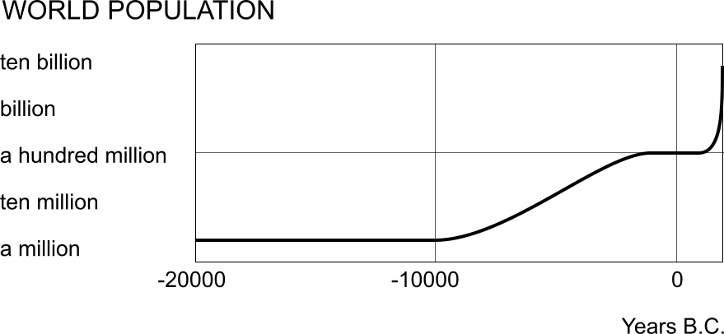
Fig. 3 Estimated growth of world population
And we are not only expanding in number. Per person we need more and more living space in our homes and neighbourhoods. In a wider context we reduced the space we need for agriculture reducing biodiversity in rural areas at the same time.

However, some 20 years ago Jong (1985) found the intensity of urban use in The Netherlands was highest in shops (135 hours/m²year). After shops came offices, social-cultural facilities, schools, home and garden (48 hours/m²year). The other hours of the year (counting 8760 hours) in the urban surface may be available for other species depending on the conditions we leave them by design and use (distinguished by time scale). Some species accept or even welcome our presence like that in step vegetation (for example greater plantain, rats, mosquito’s, sparrows). Could we welcome more rare species in our towns by creating ecotope cities or as Tjallingii (1996) stresses ecological conditions? How does it interfere with our health?

The importance of diversity for life
Londo (1997) considered diversity as a risk-cover for life. In the diversity of life there was always a species to survive or within a species a specimen that survived when context changed. Survival of the fittest presupposes diversity from which can be ‘chosen’ in changed circumstances. Diminishing biodiversity means undermining the resistance against catastrophes. From the 1.7 million species we know, we probably lost some 100 000. So, we not only introduce ecological disasters, but we also undermine the resistance of life against these disasters.
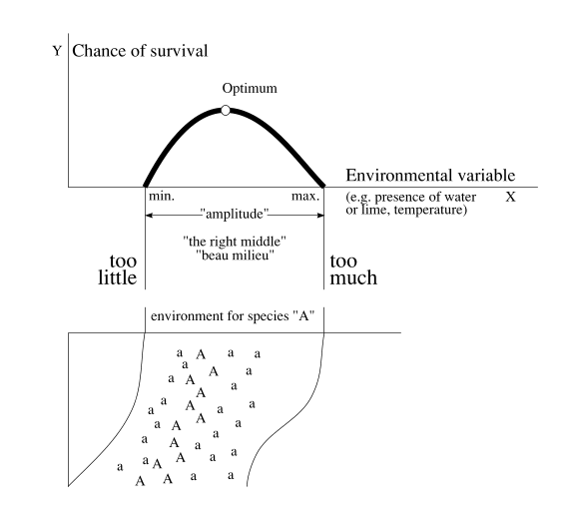 | The curve of ecological tolerance relates the chance of survival of a species or ecosystem to any environmental variable, for instance the presence of water. In that special case survival runs between drying out and drowning (Fig. 4 ).  Imagine the bottom picture as a slope from high and dry to low and wet. Species A will survive best in its optimum. Therefore we see flourishing specimens on the optimum line of moisture (A). Higher or lower there are marginally growing specimens (a). The marginal specimens however are important for survival of the species as a whole.
Fig. 4 Ecological tolerance in theory and reality.
Suppose for instance long-lasting showers: the lower, too wet standing marginal specimens die, the flourishing specimens become marginal, but the high and dry standing specimens start to flourish! Long-lasting dry weather results in the same in a reversed sense. Levelling the surface and water-supply for agricultural purposes in favour of one useful species means loss of other species and increased risk for the remaining.
But there is a less friendly ecological lesson hidden within this scheme. Marginal specimens are important for survival of the species as a whole. A reservoir of unhealthy specimens favours species. Death regulates life. Health is also spatially scale-sensitive.

The importance of diversity for human living
Biodiversity in mankind is a crucial value in our quality of life. As we are here we are all different and the very last comfort you can give a depressed person is 'But you are unique'. Reading Philp (2001) you should conclude that medicine hardly discovered that uniqueness in the evaluation of medicines. It hinders generalizing science using concepts as average and standard deviation. Dieckmann, Law et al. (2000), Riemsdijk and NOBO (1999) and Jong and Voordt (2002) are aware of that difficulty in ecology, organization theory and design study. Evolutionary ecology (see Pianka (1994)) is only comprehensible considering exceptions outside the limits of a normal test population (3*standard deviation) as Philp (2001) described.
Diversity is also a precondition for trade and communication. If production and consumption would be the same everywhere, there would be no economical life. If we would have all the same perceptions and ideas, there would be no communication. It is an important misconception to believe that communication only helps bridging differences. Communication also produces diversity by compensating each other and coordinating behaviour by specialization.

Possibility of choice
The World commission environment and development (1990) of chairwoman Brundtland summarized the environmental challenge by stating sustainability as leaving next generations at least as much possibilities as we found ourselves. But what are possibilities? 'Possibilities' is not the same as economical supply. If our parents would have left us the same supplies as they found in their childhood, we would be far from satisfied forced by their choices. 'Possibilities' has to do with freedom of choice and thus variety. Our converging Schumpeter-economy as Krupp (1995) described and converging culture of Fukuyama (1992) leaves no choice. In our search for the alternative we find everywhere in the world the same hotels, the same dinners, the same language. This century, the last 'primitive' cultures are lost and with them an experience of life that no western language can express. After looking at their dancers in the afternoon on our rain forest holyday we find them back in disco in the evening.
The most extreme consequence of this levelling out would be a world without economy and even communication. That is the ultimate consequence of local autarky. If there were no longer any differences in production factors, exchanging goods and services would no longer be necessary. If total worldwide distribution of knowledge and consensus would be the result of our communication age, there would no longer be anything worthwhile to communicate. These thought experiments show clearly that 'difference' is also a hidden presupposition in communication and economy. The question remains on what level of scale self-sufficiency is desired: global, continental, national, local like Steekelenburg (2001) illustrates beautifully in his scenarios.

Quality of life
Quality can be measured in terms of possibilities of use, experience and expectation for future generations. The way design can sustain a sustainable development in the sense of Brundtland is to produce more ‘choices’ for man, animal and plant. If there were one best solution for all problems of architecture and urban planning, it would be the worst in the sense of choices for future generations! This paradox pleads more for diversity than for uniform solutions. Moreover, if there were a uniform solution, the designer would have no task. Quality is always a function of variation.

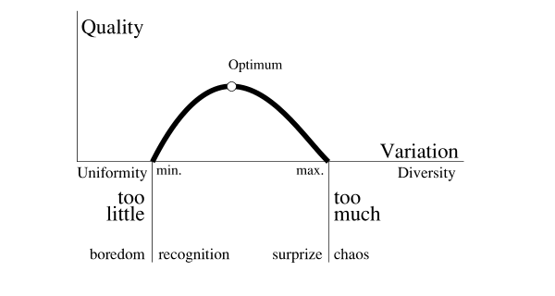 | Quality of possible experience moves between diversity and uniformity, surprise and recognition. One step too far into both sides brings us in the area of boredom or confusion.  This is a simple conception, already recognized by Birkhoff (1933) and Bense (1954), but why did it not succeed, why is quality always posed as an unsolvable question? Because the concept of diversity is scale sensitive and so is our experience. When on one level of scale we experience chaos, in the same time on an other level of scale we could experience boredom.
Fig. 5 Quality = f(Variation)

Scale-sensitive concepts

Scale paradox
As I mentioned on page 7 discussing rarity, rareness, responsibility and even health are scale sensitive concepts. So is quality. But any discussion on variety and thus variables can fall prey to confusion of scale. That means that even logic and science as forms of communication are prey to a scale paradox. The paradox of Achilles and the turtle is a beautiful example of a scale-paradox in time. The turtle says: 'Achilles cannot outrun me when I get a head start, because when he is where I was at the moment he started I'm already further, when he reaches that point I am again further and so on!’ This conclusion is only incorrect by changing the time-scale during the reasoning. Russell finds something similar on set theory. Russell (1919) bans sets containing themselves and reflexive judgements, as 'I lie’. This sentence is not only a object statement, but in the same time a meta-linguistic statement about itself producing a paradox. When I lie I speak the truth and the reverse.

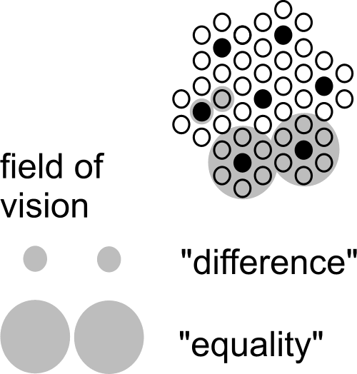 | The scale paradox means an important scientific ban on applying conclusions drawn on one level of scale to another without any concern. The picture shows the possibility of changing conclusions on a change of scale by a factor 3. There are 7 decimals between a grain of sand and the earth. That gives approximately 15 possibilities of turning conclusions. Between a molecule and a grain of sand applies the same. This ban is violated so many times, that this should be an important criterion on the validity of scientific judgements.  The scale-paradox is not limited on concepts of diversity. An important example of turning conceptions into their opposite by scale is the duality of aim and means.
Fig. 6 The scale paradox
For the government subsidizing a municipality the subsidy is a means, for the municipality it is an aim. So the conception of means changes in a conception of aim by crossing levels of scale. The turning of 'Zweckbegriff' into 'Systemrationalität' discussed by Luhmann (1973) may be a turning conception of the same scale-sensitive character. In growing organizations integration on the level of the organization as a whole means often disintegration of the subsystems and perhaps a new form of integration in the sub-sub-systems. This process is called 'differentiation'!

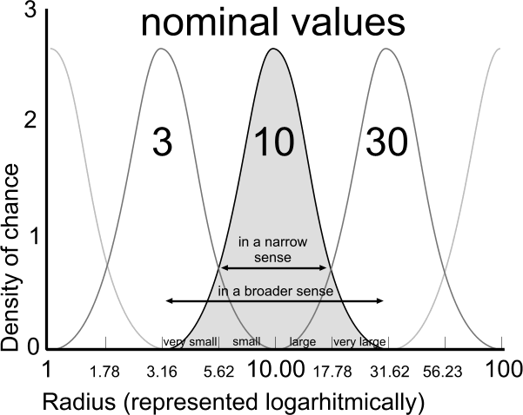 | An element from the nearly logarithmical series {1, 3, 10, 30, 100 …} is the name (nominal value) of an ‘elastic’ urban category ranging until those of the nearest categories (scale range). The name giving ‘nominal’ radius r=10 then is the median of a chance density distribution of the logarithm of radiuses between (rounded off) r=3 and r=30, with a standard deviation of 0.15. We chose a series of radiuses (and not diameters) because an area with a radius of {0.3, 1, 3, 10km} fits well with {neighbourhood, district, quarter, conurbation} or loose {hamlet, village, town, conurbation} in every day parlance.  Then also the system of dry and wet connections, traffic and drainage could be named in this semi logarithmical sequence according to average mesh widths.
Fig. 7 Names and boundaries of urban categories

Spatial state of dispersion as a condition of diversity
Form as a primary object of design presupposes state of dispersion.

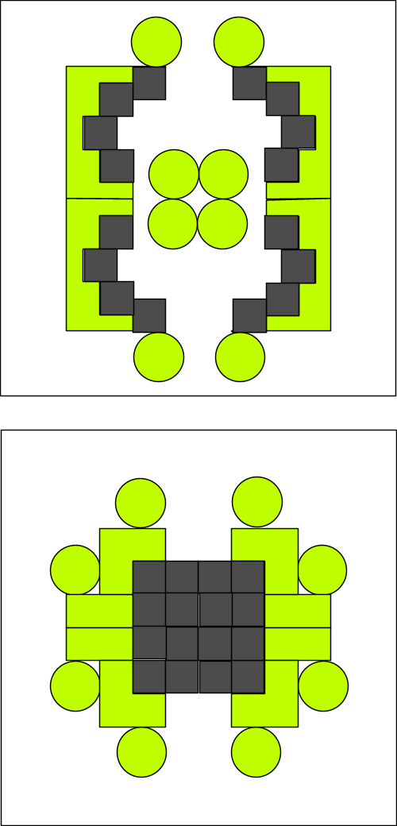 | 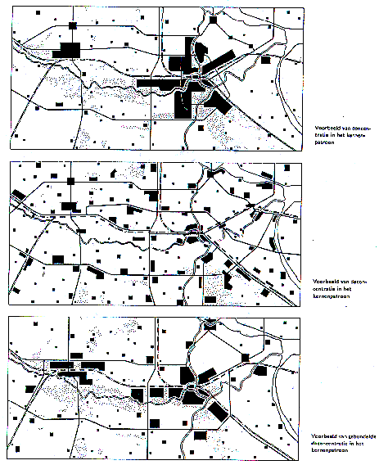
 | RPD (1966)
Fig. 8 States of dispersion r=100m | Fig. 9 Accumulation, Sprawl, Bundled Deconcentration r=30km
Scale articulation is especially important distinguishing states of dispersion. State of dispersion is not the same as density. Considering the same density different states of dispersion are possible (Fig. 10 ) and that is the case on every level of scale again (Fig. 11 ).

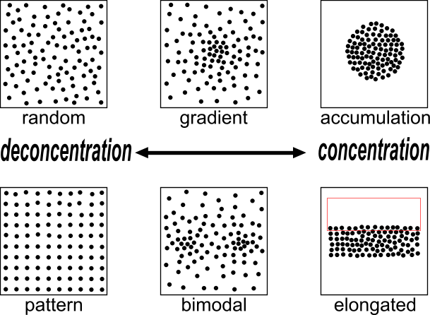 | 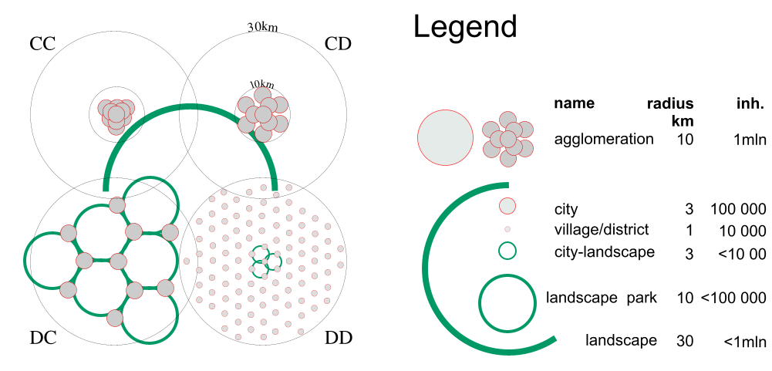
Fig. 10 States of dispersion in the same density on one level of scale | Fig. 11 One million people in two states of distribution on two levels of scale (accords CC, CD, DC and DD).
Fig. 10 shows the use of the words concentration (C) and deconcentration (D) for processes into states of more or less accumulation respectively. Applied on design strategies in different levels of scale we speak about ‘accords’ (Fig. 11 ).
In Fig. 11 the regional density is equal in all cases: approx. 300inh./km². However, in case CC the built-up area is concentrated on both levels (C_{30km}C_{10km}) in a high conurbation density: (approx. 6000inh./km²).
In the case CD people are deconcentrated only within a radius of 10km (C_{30km}D_{10km}) into an average conurbation density of approx. 3000 inh./km².
In the case D_{30km}C_{10km} the inhabitants are concentrated in towns (concentrations of 3km radius within a radius of 10km), but deconcentrated over the region. The urban density remains approx. 3000 inh./km².
In the case D_{30km}D_{10km} they are dispersed on both levels.

Urban sprawl in a radius of 10km hardly influences the surrounding landscape when the inhabitants are concentrated in a radius of 30km (the two variants above in Fig. 11 ).
However, the urban sprawl in a radius of 30km breaks up the surrounding landscape in landscape parks. By that condition the sprawl within a radius of 10km is important again: the landscape parks are broken up further into town landscapes. In The Netherlands until 1983 DC was the national strategy (‘Bundled deconcentration’, ‘Gebundelde Deconcentratie’ from RPD (1966)), after RPD (1983) the policy changed into CC (Compact town’, ‘Compacte Stad’), but turned out in practice as CD and even DD.
The result of both strategies was disappointing.

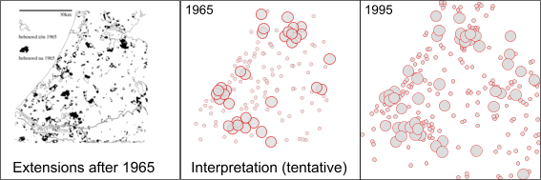
Fig. 12 Urban sprawl in Randstad, The Netherlands

Ecology as science of dispersion
In prominent ecology textbooks there are several definitions of ecology emphasising dispersion or with an increasing awareness of scale (in that case we will speak about spatial distribution):

Andrewartha (1961), cited by Krebs (1994): Ecology is the scientific study of the distribution and abundance of organisms.
•Krebs (1994): Ecology is the scientific study of the interactions that determine the distribution and abundance of organisms.
•Pianka (1994): Ecology is the study of the relationships between organisms and the totality of the physical and biological factors affecting them or influenced by them.
•Begon, Harper et al. (1996): Ecology is the scientific study of the interactions that determine the distribution and abundance of organisms, populations and communities.

Kolasa and Pickett (1991) seem to be the only ecologists fully aware of scale articulation consequences.

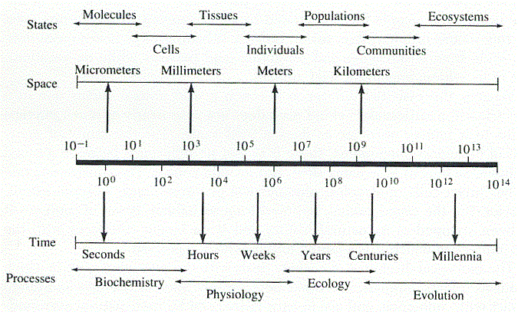 | Pianka stresses relationships in a broader sense than spatial relationships, but he adds a scheme stressing scale in space and time. ‘Community and ecosystem phenomena occur over longer time spans and more vast areas than suborganismal and organismal-level process and entities. (after Anderson (1986) after Osmund et al.)’  Begon, Harper and Townsend distinguish organisms, populations and communities. That distinction looks like a distinction of scale, but is primarily a distinction between different kinds of ecology:
Fig. 13 Diagrammatic representation of the time-space scaling of various biological phenomena.
- autecology concerning populations of one species at a time within their ‘habitat’ and
- synecology concerning the community of different species in the same ‘biotope’.

On the level of organisms one could speak about ‘ecological behaviour’ as for instance Grime, Hodgson et al. (1988) elaborated as plant species bound ‘strategies for survival’ like ‘competitors’, ‘ruderals’ and ‘stress tolerators’ as rôles in a play concerned less predictable than communities reaching a well described ‘climax’.

Urban ecology
Since 19th century’s Dutch hygienic developments in the urban area founded by Cohen (1872) and historically described by Houwaart (1991) are the very source of public housing policy and urban design in the Netherlands. Thanks to that biodiversity in spaced towns, sometimes outruns rural biodiversity.

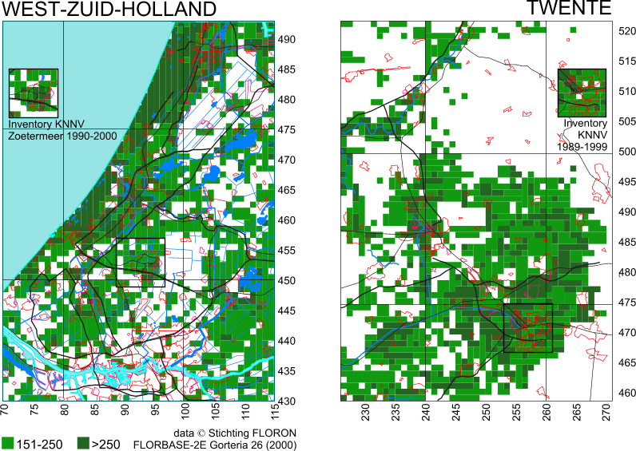
Fig. 14 Number of wild plant species per km2 in the lower and higher part of The Netherlands
Fig. 14 shows that some square kilometres in the urban area of Zoetermeer indicated in the left picture have more that 250 wild plant species per km². Local observers (like KNNV Zoetermeer, reported by Jong and Vos (1995); Jong and Vos (1998); Jong and Vos (2000); Jong and Vos (2003) ) counted even more then national ones (counted by FLORON, reported by Groen, Gorree et al. (1995)). The urban area of Zoetermeer is more in contrast with the rural environment characterised by cattle breeding then Enschede (indicated in the right picture) surrounded by more natural equally rich areas. Fig. 16 shows both in more detail. Here we can see that infrastructure and industrial areas contribute more then we would expect by intuition. Their verges, slopes and rough grounds are less visited and disturbed by man and pet.

Urban rareness
Fig. 15 arranges some 500 urban plant species from the 1500 known in The Netherlands in a sequence of national rareness, naming 50 of them only. Their national presence in % of the 5x5km observation squares is recognisable in the rising line. The spots show the urban presence in % of 1x1km observation squares in Zoetermeer. So, the spots above the line are more common in Zoetermeer than in The Netherlands, the spots below less so.
Fig. 15 Local rareness (100% is very common) of approximately 500 plant species (only partly named) in a sequence of national rareness
A number of nationally rare plant species in the left side of Fig. 15 evidently found their place in urban ecotopes. In the wake of urban plants and ecotopes rare insects and fungi have been observed in Zoetermeer, but seldom nationally rare vertebrates.

The number of species in town
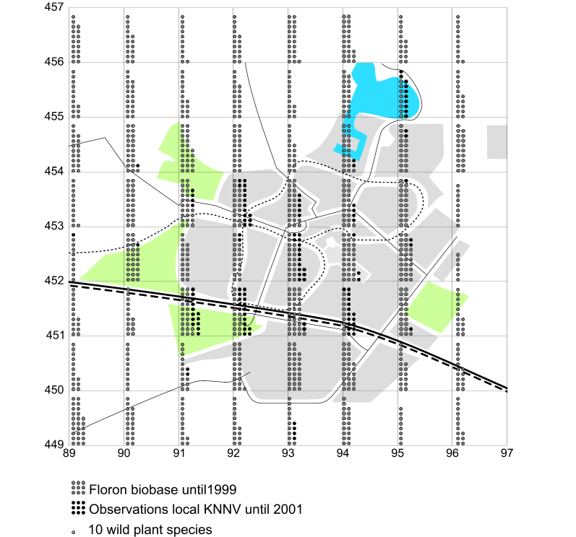 | 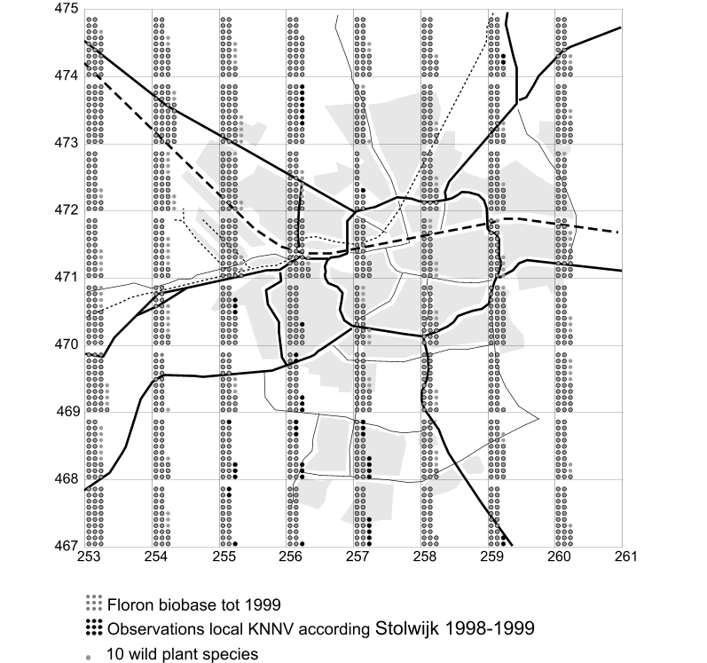
 | Jong (2000)
Fig. 16 Number of plant species per km2 in Zoetermeer and Enschede
The number of species per km2 is added up over several years. So, many species could have been disappeared, they then only show the urban potential. Moreover, some square kilometres could have been observed better then other ones, for example the outskirts.

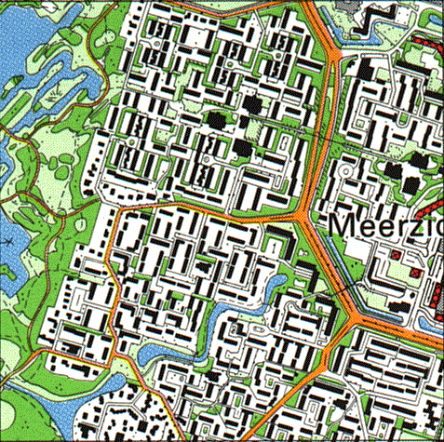 | 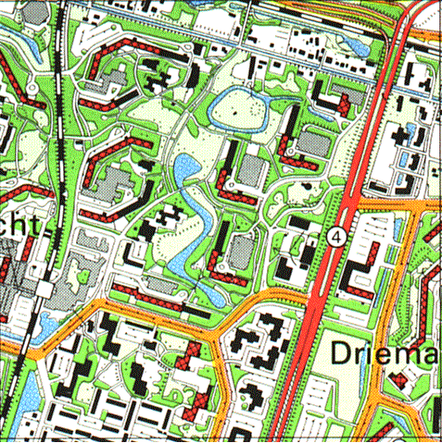 | 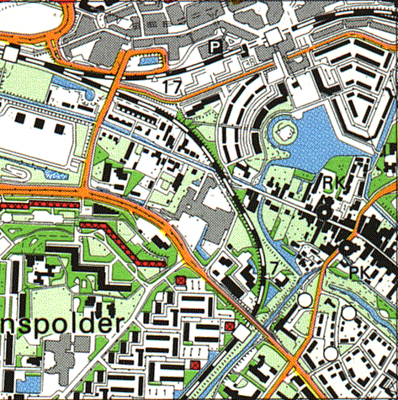
180 | 200 | 330 wild plant species
low-rise outskirts | high-rise | centre
Fig. 17 Number of wild plant species in 3 km² of Zoetermeer
Even when in the centre the plant observations were better then in the outskirts, Fig. 17 warns us for the intuitive view that biodiversity always decreases from the outskirts into the centre. The large number of observed species in the central km² could also be explained by urban age, abiotic variation like seepage, drainage, water level or intersection by infrastructure with verges and slopes, less influence of adjacent agriculture and manure of cattle breeding dispersed by water or wind.

Design conditions
So, some of these possible causes could be varied as means of design aiming urban biodiversity.

Effective variation for botanical biodiversity | in a radius of approx.
altitude, ground | 30km
soil, water management | 10km
seepage, drainage, water level, urban opening up | 3km
The next levels are still hidden for botanical observation usually sampled per square km.
urban lay-out | 1km
parcelling (distribution of greenery) | 300m
pavement, tread, pet manuring, minerals | 100m
altitude differences, mow management, disturbance | 30m
sun lighting | 10m
Fig. 18 Scale-articulated hypotheses of effective abiotic variation producing botanical biodiversity
Fig. 18 shows possible working factors in urban design per level of scale. These hypotheses should be examined and evaluated yet. Accepting that the character of botanical diversity can not be predicted, one could question whether urban biotopes are valuable at all compared with rural nature.

Urban perspectives in the Netherlands

Claims on space
The urban growth since the industrial revolution culminates, especially in the developing countries where the European hygienic history of towns repeats itself. Restricting ourselves to the present Dutch situation claims on Randstad are bigger then ever and the idea of an open Green Heart fades away by urban sprawl.

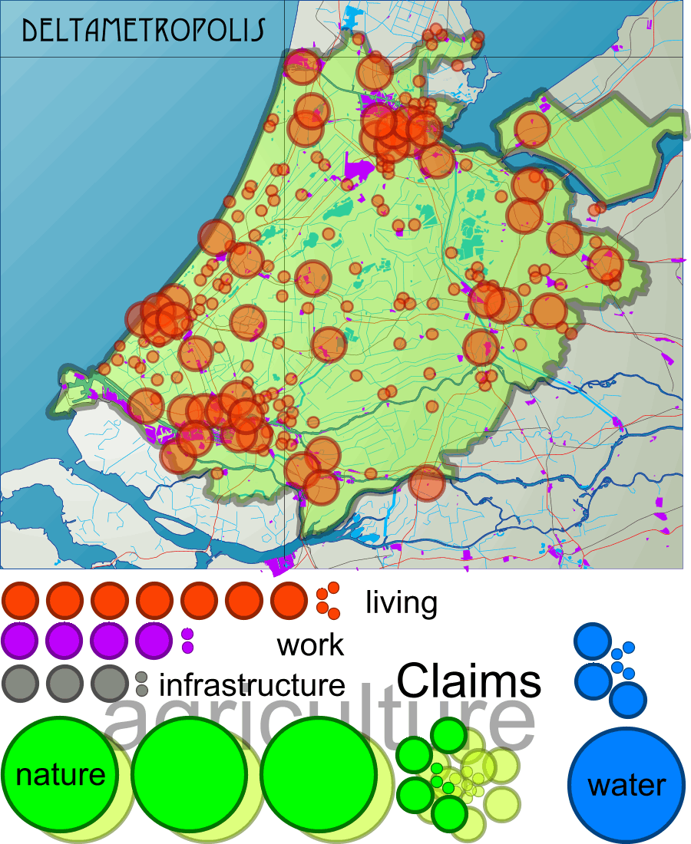 | 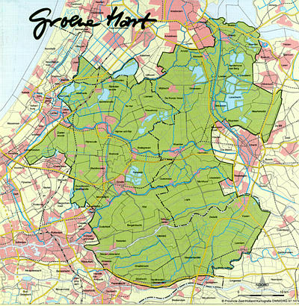
Fig. 19 Claims on Detametropolis area | Fig. 20 The supposed Green Heart
The 30 years old idea of high density conurbations have not been successful in spite of national strategies like bundled concentration or compact cities. And if so, they would have been not effective (see Fig. 11 ) in saving surrounding landscape. It is an example of ideas like high tech transportation solutions that have big metropolises as a reference. However, Randstad does not yet reach the capacity of a real metropolis making fast underground systems possible.

The scale of concentration
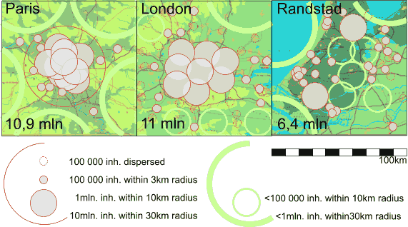
Fig. 21 The capacity of metropoles
From an ecological point of view the condition of measure is less important when we concentrate on vegetation rather than on big animals. From a human point of view we should bring nature closer to home (see page 19). That pleads for openness within the agglomeration and not for accumulation on every level of scale.

Open space
Open space in the Netherlands is reduced by 12.5% urban and rural built area for 16 000 000 inhabitants with ample 300 m2 average built area per person. When these inhabitants were concentrated in 16 conurbations of 1 000 000 inhabitants each within 10km radius (see Fig. 11 ) - regularly dispersed over the country - 10 open landscapes with a free horizon of 30km radius would be available as open space. They would be accessible within 10km from everybody’s house. In empty spaces of that measure bears and eagles could find their habitat and the weekends could be filled by survival journeys we now look for in other countries once a year.
However, agriculture and urban sprawl have filled these potentially open landscapes. If we name an area of 30km radius still a landscape as long as there are less then 1 000 000 inhabitants, The Netherlands still have 10 landscapes (see Fig. 22 ). But not for long, because there are landscapes with nearly 1 000 000 inhabitants and great pressure of urban sprawl. The size of spots in Fig. 22 meets the average urban density in The Netherlands. So, where they overlap the density is higher than average.

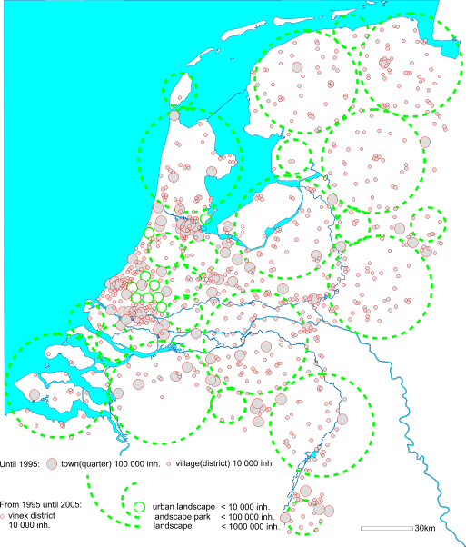
Fig. 22 Built and open space in The Netherlands
From Fig. 22 we can conclude again (see page 11) that concentration within conurbations (r=10km) does not help much in keeping landscapes open. Regional concentration (r=30km) does. Regional deconcentration breaks landscapes up into landscape parks or urban landscapes like happened in the Green Heart of Randstad (recently named Green Metropolis or Deltametropolis). However, deconcentration within conurbations (r=10km) could help making biotope cities. What kind of biotopes are they?

Possible use of open space
Form, size and structure of components are conditions for the function of open areas though urban functions on their turn can be the historical cause of form and structure. The landscape consultancy H+N+S in Utrecht visualised the functional charge for nature as a function of size and altitude in Fig. 23 .
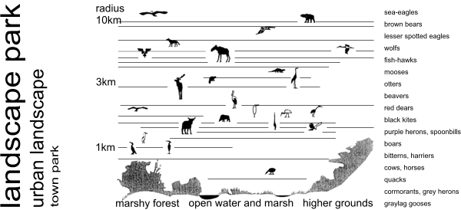
H+N+S
Fig. 23 Possibilities for nature by size and altitude
In Fig. 24 they summarised possibilities of human recreation as well.

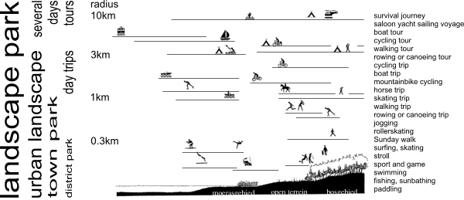
H+N+S
Fig. 24 Possibilities for recreation by size and altitude
The smaller the area the less animals could find a habitat, but that is not the case for botanical biodiversity as far as their distribution is not dependent on animals.

Norms for open space
A crucial space-time dilemma of urban planning is priority for either small open spaces nearby residential areas or remote larger ones with more travel time and a small profit of species.
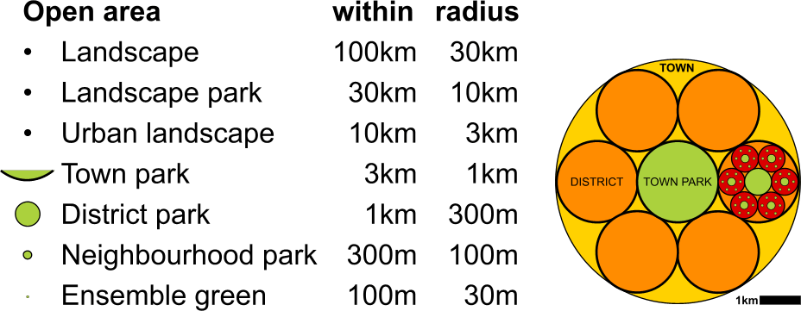
Fig. 25 25% Central green area equally dispersed on 7 levels of scale

If on 7 levels of scale from r=30m until r=30km any built area should be adjacent to at least one central open area of the same size (see Fig. 25 ), approximately 75% of total surface would be occupied by built space and 25% by open space. The largest open space would occupy 10 of that 25%, the 6 next smaller ones together 6 of the 25%, the 36 even smaller ones 3% and so on. The relatively large amount of space token by the largest one is an economic argument for more small ones near by home. However this strategy would stress botanical rather then zoological biodiversity. Moreover, a priority for smaller green spaces nearby home with a smaller emphasis on animals brings nature closer to the inhabitants, especially the young ones.

Suggestions concerning spatial human rights
- Any human has a right on 300m² residential area in a radius of 10km, work and services included.
- Any human has a right on all necessary sources of living within a radius of 30km. These sources have to give access to products of 2000m2 agricultural land per person. This land should be accessible within a radius of 1000km concerning the risk of stagnating logistics.
- Agriculture has to be located in areas with highest supply of water, minerals and sunlight. Towns and untilled natural areas have to be located in areas with less minerals.
- Any human has a right on untilled natural ground uninhabited by man within a radius of x from her or his place of residence measuring at least a radius of x/3; x being {0.3, 1, 3 … 100 000 metre}.
- Dutch cities belong to the most healthy in the world. So, any attention given to health in Dutch cities is distressing in a perspective of the hygienic condition of cities in the second and third world.

Conclusion
The ecology of human health in the urban environment in a designer’s view primarily focuses on growing human density. The history of human species concerns adaptation to and accomodation of its reference environment. Where they are less succesful an unequal distribution of health appears. Civilisation damage by deprivation of evolved human abilities has to be cured by design. A distorted risk perception by mass communication raises risky norms based on a statistical reduction of diversity in man and nature. The importance of diversity for life and human living can not be overestimated. The intellectual challenge is to handle diversity instead of generalising it by statistical reduction. However, human diversity as part of a broader ecological view on biodiversity is a scale-sensitive concept to be coped with by scale-articulation of study.

Spatial state of dispersion is a condition for diversity. Diversity is a condition for the possibilities of choice for future generations. Urban perspectives have to take exploding claims on space into account. The scale of concentration determines the open space remaining for its essential uses. So, suggestions concerning spatial human rights resulting in norms for open space from a viewpoint of health would be a great help for urban design.

Many adjacent questions are left open. Are norms on any level the right mean to cope with the diversity of people and their variety of options for complete physical, mental and social well-being? Is stabilising environmental factors a good answer to challenge evolved human abilities? Is freedom of choice for future generations guaranteed by making our contemporary choices? How to produce diversity without reducing it?

References
Andrewartha, H. G. (1961) Introduction to the Study of Animal Populations (Chicago) University of Chicago Press.
Barton, H. and C. Tsourou (2000) Healthy Urban Planning (London) Spon Press ISBN 0-415-24326-2 hbk; 0-415-24327 pbk.
Begon, M., J. L. Harper, et al. (1996) Ecology (Oxford) Blackwell Science.
Beintema, A., O. Moedt, et al. (1995) Ecologische atlas van de Nederlandse Weidevogels m.m.v. SOVON (Haarlem) Schuyt & Co BV ISBN ISBN 90-6097-391-7.
Bekhuis, J., R. Bijlsma, et al., Eds. (1988) Atlas van de Nederlandse Vogels (Arnhem) Sovon ISBN 90-72121--01-5.
Bense, M. (1954) Aesthetica (Stuttgart) Deutsche Verlags-Anstalt.
Berg, A. E. v. d., M. M. H. E. v. d. Berg, et al. (2001) Van buiten wordt je beter. Een essay over de relatie tussen natuur en gezondheid (Wageningen) Alterra, bijlage bij het jaarboek 2001.
Bink, F. A. (1992) Ecologische atlas van de dagvlinders van Noordwest-Europa (Haarlem) Schuyt & Co Uitgevers en Importeurs ISBN 90-6097-318-6.
Birkhoff, G. D. (1933) Aesthetic measure (Cambridge, Mass.) Harvard University Press.
Bohemen, H. D., D. A. G. Buizer, et al., Eds. (1986) Atlas van de Nederlandse amfibieën en reptielen (Hoogwoud) KNNV Uitgeverij.
Bohn, U. (2001) Karte der natürlichen Vegetation Europas. Map of the Natural Vegetation of Europe. (Bonn) Bundesambt fur Naturschutz.
Bohn, U., G. Gollub, et al., Eds. (2000) Map of the Natural Vegetation of Europe scale 1: 2.5 million BN Bundesambt für Naturschutz (Bonn) Federal Agency for Nature Conservation.
Broekhuizen, S., B. Hoekstra, et al., Eds. (1992) Atlas van de Nederlandse zoogdieren Natuurhistorische Bibliotheek van de KNNV (Utrecht) KNNV Uitgeverij ISBN 90-5011-051-7 geb.
Cohen, L. A., Ed. (1872) Handboek der openbare gezondheidsregeling en der geneeskundige politie met het oog op de behoeften en de wetgeving van Nederland (Groningen) J.B. Wolters.
Dieckmann, U., R. Law, et al. (2000) The Geometry of Ecological Interactions: Simplifying Spatial Complexity (Cambridge) Cambridge university press.
Eyck, A. E. v., P. Parin, et al. (1968) Ecology in Design / Kaleidoscope of the mind / Miracle of Moderation / Image of Ourselves (Philadelphia) Graduate School of fine arts, University of Pensylvania.
Freedman, J. L. (1975) Crowding and behavior (San Francisco) W.H.Freeman and Company.
Fukuyama, F. (1992) The End of History and the Last Man (New York) Free Press.
Garretsen, H. F. L. and H. Raat (1989) Gezondheid in de vier grote steden ('s-Gravenhage) SDU uitgeverij.
Grime, J. P., J. G. Hodgson, et al. (1988) Comparative Plant Ecology (London) Unwin Hyman.
Haccou, H., S. P. Tjallingii, et al. (1994) Econiveaus: een discussie over schaalniveaus en strategieen voor duurzame ontwikkeling van stedelijke systemen. (Wageningen) IBN-DLO Instituut voor Bos- en natuuronderzoek.
Hagemeijer, W. and M. J. Blair, Eds. The Atlas of European Breeding Birds (London) Poyser.
Held, J. J. v. (1991) Beknopt overzicht van de Nederlandse plantengemeenschappen (Utrecht) Stichting Uitgeverij KNNV ISBN 90-5011-055-x.
Houwaart (1991) De hygienisten. Artsen, staat & volksgezondheid in Nederland 1840-1890 (Groningen) Historische Uitgeverij Groningen.
Jacobs, J. (1961) Death and Life of Great American Cities (New York) Random House.
Jong, M. D. T. M. d. (2002) Scheidslijnen in het denken over Natuurbeheer in Nederland. Een genealogie van vier ecologische theorieen. (Deft) DUP Science.
Jong, M. T. T. M. d. and C. Kwa (2000) "Ecological theories and Dutch nature conservation" Biodiversity an conservation 9: 1171-1186
Jong, T.M.d. (1985) Programma NNAO scenario (Den Haag) Stichting Meso and Sociaal-geografisch instituut UvA
Jong, T. M. d. (2000) "De abiotische uitgangssituatie in de stad" De Levende Natuur 101-6 URL www.bk.tudelft.nl/urbanism/TEAM.
Jong, T. M. d. (2001) Ecologische toets van drie visies op Almere Pampus (Zoetermeer) Stichting MESO: 24.
Jong, T. M. d. (2004) Sun wind water earth life and living (Delft) Lecture paper URL www.bk.tudelft.nl/urbanism/TEAM > publications
Jong, T. M. d. and D. J. M. v. d. Voordt, Eds. (2002) Ways to study and research urban, architectural and technical design (Delft) DUP Science.
Jong, T. M. d. and H. Priemus (2002) Forecasting and Problem Spotting in: T. M. d. Jong and D. J. H. v. d. Voordt Ways to research and study urban, architectural and technical design (Delft) DUP
Klijn, J. A. (1995) Hierarchical concepts in landscape ecology and its underlying disciplines (Wageningen) SC-DLO.
Kolasa, J. and S. T. A. Pickett, Eds. (1991) Ecological Heterogeneity. Ecological Studies (New York) Springer-Verlag ISBN 0-387-97418-0; 3-540-87418-0; 90 6789 630 6.
Krebs, C. J. (1994) Ecology The Experimental Analysis of Distribution and Abundance (New York) Harper Collings College Publishers.
Krupp, H. (1995) European Technology Policy and Global Schumpeter Dynamics: A Social Science Perspective Technological Forecasting and Social Change 48, 7-26 (New York) Elsevier Science Inc.
Leeuwen, C. G. (1971) Ekologie (Delft) Technische Universiteit Delft, faculteit Bouwkunde.
Limpens, H., K. Mostert, et al., Eds. (1997) Atlas van de Nederlandse vleermuizen; Onderzoek naar verspreiding en ecologie Natuurhistorische Bibliotheek van de KNNV (Utrecht) KNNV Uitgeverij ISBN 90-5001-091-6.
Londo, G. (1997) Natuurontwikkeling (Leiden) Backhuys Publishers ISBN 90-73348-77-3.
Luhmann, N. (1973) Zweckbegriff und Systemrationalität (Ulm) Suhrkamp Taschenbuch Wissenschaft.
McKeown, T. (1976) The role of medicine: dream, mirage or nemesis (London) Nuffield Provincial Hospitals Trust
Mennema, J., A. J. Quene-Boterenbrood, et al. (1980) Atlas van de Nederlandse flora. Deel 1. Uitgestorven en zeer zeldzame planten (Amsterdam) Uitgeverij Kosmos ISBN 90-215-0847-8.
Nauta, M. and E. Vellinga (1995) Atlas van Nederlandse paddestoelen (Rotterdam) A.A. Balkema ISBN 90 5410 623 9.
Nie, H. W. d., Ed. (1996) Atlas van de Nederlandse zoetwatervissen (Doetinchem) Media Publishing Int BV ISBN 90-801413-5-6.
Odum, E. P. (1971) Fundamentals of ecology (Philadelphia) W.B. Saunders Company.
Philp, R. B. (2001) Ecosystems and Human Health. Toxicology and Environmental Hazerds (Boca Raton / London / New York / Washington, D.C.) Lewis Publishers ISBN 1-56670-568-1.
Pianka, E. R. (1994) Evolutionary ecology (New York) Harper Collins College Publisher.
Riemsdijk, M. J. v. and NOBO, Eds. (1999) Dilemma's in de bedrijfskundige wetenschap (Assen) Van Gorcum ISBN 90 232 3414 6.
RIVM, R. v. V. e. M. (2001) Natuurbalans 2001 (Alphen aan den Rijn) Kluwer.
RPD (1966) Tweede Nota over de ruimtelijke ordening (Den Haag) RijksPlanologische Dienst.
RPD (1983) Structuurschets Stedelijke gebieden (Den Haag) RijksPlanologische Dienst.
Reumer, J.W.F. (2000) Stadsecologie, de stedelijke omgeving als ecosysteem (Rotterdam) Natuurmuseum Rotterdam ISBN 90-73424-15-1
Russell, B. (1919) Introduction to mathematical philosophy (London and New York) Routledge ISBN 0-415-09604-9.
Steekelenburg, M. v. (2001) Self sufficient world (Den Haag) VROM, RPD.
Tax, M. H. (1989) Atlas van de Nederlandse dagvlinders ('s-Gravenland /Wageningen) Vereniging tot behoud van Natuurmonumenten in Nederland, Vlinderstichting.
Tjallingii, S. P. (1996) Ecological conditions: strategies and structures in environmental planning (Wageningen) DLO Institute for Forestry and Nature Research 1996 ISBN 9080111236.
Vogler, P. and E. Kuhn, Eds. (1957) Medizin und Städtebau. Ein Handbuch fur gesundheitlichen Stadtebau (Munchen, Berlin, Wien) Verlag von Urban & Schwarzenberg.
Weeda, E. J., J. H. J. Schaminée, et al. (2000) Atlas van Plantengemeenschappen in Nederland. Deel 1. Wateren, moerassen en natte heiden (Utrecht) KNNV Uitgeverij.
Weeda, E. J., J. H. J. Schaminée, et al. (2000) Atlas van Plantengemeenschappen in Nederland; Wateren, moerassen en natte heiden (Utrecht) KNNV, Alterra, CBS, LNV, KIWA, Directoraat-Generaal Rijkswaterstaat, VEWIN ISBN 90-5011-1327.
Westhoff, V. and A. J. d. Held (1969) Plantengemeenschappen in Nederland (Zutphen) Thieme.
World commission environment and development (1990) Our Common Future (Oxford/New York) Oxford University press.
Zoest, J. v. (1998) Biodiversiteit (Utrecht) KNNV-Uitgeverij.

Key words

aboreal pre-adaptations 5
abundance of organisms 12
accords 11
accumulation(urban) 11
Achilles and the turtle 10
activities(interfunctional) 5
adaptation 2; 4
aim(scale) 10
Andrewartha (1961) 12
animals(size(habitat)) 19
anonimity 5
anthropogenesis 4
arsenic eaters 2
asthma 6
autarky 9
autecology 12
average 2
Bahrdt(1957) 5
Barton(2000) 3
Batenbur(Eddes) 3
Begon, Harper et al. (1996) 12
Beintema(1995) 4
Bekhuis(1988) 4
Bense (1954) 9
Berg(2001) 4
Bink(1992) 4
biodiversity 7
biodiversity(health) 7
biodiversity(infrastructure, industial areas) 13
biodiversity(means of design) 15
biodiversity(urban age, seepage, drainage, water level, infrastructure(verges and slopes)) 15
biodiversity(urban, rural) 13
biotope 12
biotope cities 18
biotopes(urban) 15
Birkhoff (1933) 9
blue list 7
Bohemen(1986) 4
boredom 9
Broekhuizen(1992) 4
Brundtland 8
built area per person 17
built area(open space(distance)) 20
bundled concentration 16
bundled deconcentration 11
cancer 6
cancer(stress) 3
carcinophobia 3
catastrophes 8
central open area 20
children 2
choice(forced) 4
choices(design) 9
civilisation damage 2
claims on Randstad 16
climax 12
Cohen(1872) 13
communication(difference) 9
communication(diversity) 8
community(species) 12
compact cities 16
compact town 12
compacte Stad 12
compensation 2
competitors 12
concentration 11
concentration(conurbation, region) 18
conditions(ecological) 7
confusion 9
connections(scale) 10
conurbation 10
conurbation density 11
conurbations 17
conurbations(high density) 16
costs(safety) 4
criminality 5
crowding 2
cultural-ecological study 5
deconcentration 11
Deltametropolis 18
density(scale) 11
density(urban) 17
deseases(population density) 5
design(diversity) 9
design(generating study) 4
designers(possible problems(uncertainty)) 3
Dieckmann, Law et al. (2000) 8
differentiation' 10
diseases(physicians) 4
disintegration(scale) 10
distribution and abundance of organisms 12
district 10
diversity(communication) 8
diversity(risk) 7
diversity(statistical reduction) 4; 21
division of functions 5
division of labour 5
ecological tolerance 8
Eindhoven 3
Enschede 13
environmental problems(solved by urban design) 3
epidemiological research 3
evolutionary ecology(exceptions) 8
exceptional occurrences(magnified(television)) 3
exceptions(average) 3
extinction rate 7
Eyck(1968) 4
Freedman (1975) 5
Freedman(1975) 2
frustration 6
Fukuyama (1992) 8
functional charge 18
Garretsen(1989) 3
gebundelde deconcentratie 12
genome 7
Gooi(health) 3
gothic cathedral 5
greater plantain 7
Green Heart 16; 18
Grime, Hodgson et al. (1988) 12
Groen(1995) 13
H+N+S 18
habitat 12
habitat(animals) 19
Hagemeijer(?) 4
hamlet 10
hands 5
Harrison(1964) 5
health objectives(urban design) 3
health(biodiversity) 7
health(civilisation damage) 2
health(definition) 7
health(scale) 7
health(towns, income, life style, soil conditions) 3
healthy city project 3
heart disease 6
holydays(dangerous) 4
home(nature(distance)) 17
homo erectus 5
homo habilis 5
homo sapiens sapiens 5
horizon(free) 17
Houwaart(1991) 13
human biodiversity 2
humanity 5
hygienists(19th century) 13
iatrogeneous 4
income 2
industrial revolution 5
inner environments 5
insects 4
insurance companies(fear) 4
insurance(health) 3
integration(scale) 10
intensity(use) 7
interfunctional activities 5; 6
Jacobs(1961) 2
Jong (1985) 7
Jong and Voordt (2002) 8
Jong(1988) 6
Jong(1995) 13
Jong(2000) 14
Kolasa and Pickett (1991) 12
Krebs (1994) 12
Krupp (1995) 8
landscape 11; 17
landscape parks 11
life style 2
life(risk to die) 4
lifecycle 2
Limpens(1997) 4
Londo (1997) 7
longitudinal research 3
Luhmann (1973) 10
marginally growing specimens 8
mass migration 5
means(scale) 10
medicine 7
medicines(use) 3
Mennema(1980) 4
monofunctional spaces 5
mosquito’s 7
motoric deprivation 6
natural(concept(scale)) 3
nature in exile(hygiene) 4
Nauta(1995) 4
neandertalers 5
neighbourhood 10
Nie(1996) 4
Noah 7
nominal value 10
normal test population 8
open areas(function) 18
open space 17
oxygen 2
pairing messengers 4
paradox 10
Philp (2001) 8
Pianka (1994) 8; 12
poison 2
populations 12
possibilities(economical supply, choice(freedom)) 8
psychiatric disorders 6
public and private spaces 5
public housing policy(hygiene) 13
quality 9
quarter 10
Randstad 18
rare plant species(urban, national) 14
rareness 10
rats 7
recognition 9
recreation(open space(size, altitude)) 19
red list 7
reference environment 4
reflexive judgements 10
regional density 11
research(diminishing returns) 4
resistance(biological) 4
responsibility(species) 7
Riemsdijk and NOBO (1999) 8
risk calculation 3
risk(risk avoidance) 4
risk(species(extinction)) 7
risk-cover for life(diversity) 7
RPD (1966) 11; 12
RPD (1983) 12
ruderals 12
Russell (1919) 10
scale articulation 11
scale paradox 10
scale range 10
scale sensitive concepts 10
schizophrenia 6
Schumpeter-economy 8
self-sufficiency 9
sensoric deprivation 6
social control 5
social diversity 2
space-time dilemma(size, distance to residential area) 19
sparrows 7
specialization 8
species 7
species(urban presence) 13
specimens(marginal) 8
sport and violence 6
sprawl(urban) 11
stage in the lifecycle 2
state of dispersion 11
Steekelenburg (2001) 9
stereoscopic vision 5
stress tolerators 12
suburbs 2
surprise 9
survival 12
survival journeys 17
survival(chance) 8
survival(tolerance) 8
sustainability 8
synecology 12
Systemrationalität 10
Tax(1989) 4
The World commission environment and development (1990) 8
Tjallingii (1996) 7
tolerance 8
tolerance to frustration 6
town 10
trade(diversity) 8
transportation(high tech(urban capacity)) 16
tropical rain forest 5
uniqueness' 8
upright posture 5
urban biotopes 15
urban design(health objectives) 3
urban design(hygiene) 13
urban growth 16
urban sprawl 11; 17
urbanisation 5
use(intensity) 7
vascular disease 6
village 10
Vogler(1957) 2
Weeda(2000) 4
WHO 3
World Health Organization 7
Zoest (1998) 7
Zoetermeer 13
Zweckbegriff 10

The views on anthropogenesis are changing. This view is an older one derived from Harrison, G. A., J. S. Weiner, et al. (1964) Human Biology (Oxford) The Clarendon Press in Dutch translation: Harrison, G. A., J. S. Weiner, et al. (1970) Biologie van de mens (Utrecht/Antwerpen) Het Spectrum N.V..
The occurrence of special diseases like schizophrenia in special parts of the city is registered in the years '70 by the GGD of Rotterdam. A two-sided causality appeared. The environment not only caused disease, but selected the immigration of problem cases on other characteristics like income.
Sensory deprivation, the reaction on lack of stimuli is often experimentally examined. See for a short review of the research until 1978: Jong, T. M. d. (1978) Milieudifferentiatie; Een Fundamenteel Onderzoek Faculty of Architecture (Delft) Delft University of Technology or Jong, T. M. d. (1988) Milieudifferentiatie (Delft) DUT Faculteit Bouwkunde.
Health is a state of complete physical, mental and social well-being and not merely the absence of disease or infirmity. Preamble to the Constitution of the World Health Organization as adopted by the International Health Conference, New York, 19-22 June 1946; signed on 22 July 1946 by the representatives of 61 States (Official Records of the World Health Organization, no. 2, p. 100) and entered into force on 7 April 1948. The Definition has not been amended since 1948. See http://www.who.int/about/definition/en/

