THE ECOLOGY OF HEALTH
IN REGIONAL DESIGN PERSPECTIVE
Vilnius, Lithuania 2nd WHO International Housing and Health symposium 2004-09-28

Delft, 2004-08-04
Prof.dr.ir. Taeke M. de Jong
chair Technical Ecology and Methodology
chair Regional Design
University of Technology Delft, Faculty of Architecture
T.M.deJong@bk.tudelft.nl
For full text of this paper and presentation: www.bk.tudelft.nl/urbanism/team > Publications >2004

A designer's view
Being no expert on human health as a designer the most extensive overview I know in the joint field of medicine and urbanism is edited by Vogler and Kuhn (1957) some 50 years ago. They discuss many kinds of 'civilisation damage' in the urban environment from different medical specialist's points of view. I never found a reference into this comprehensive work and I can understand it considering its size and age. So, I recoil from reviewing it as well, the more so while I am not read up on more recent medical literature. However, the publication is useful to check more recent research programmes in this field and it made me aware of my designer's point of view.

A designer focuses on possible futures. And probable futures are only a part of it. Moreover, an urban designer or architect can not restrict him/herself to a well defined problem statement or a limited solution possibly causing new problems in other fields to be covered by the same design. (S)he can not isolate problems as empirical research can do. (S)he is confronted with a field of administrative, managerial, cultural, economical, technical, ecological and spatial-temporal problems stemming from an always context-sensitive assignment. The written programme of requirements of the assignment covers only a part of them and a small part of the design decisions to be made. That raises a historical distrust in empirical ceteris paribus evidence based on specialist's research (Jong and Voordt, Eds. , 2002).

An urban designer for example always quarrels with the traffic specialist forcing to implement national norms in local contexts. The first traffic casualty due to not implementing them would punish him after all. This is the main characteristic of all diciplines where death is in the game (defence, police, fire brigate, traffic and medical
specialists): they are bound to national and international norms and punishment. However, the other side of implementing such norms is less local involvement. In the example of traffic engineering that has unexpected consequences. Trying to draw straight and uniform road profiles meant to avoid casualties, the local inhabitant does not experience them as 'his' street. That lack of identification results in lack of responsibility. The save straight traffic lines invite to faster driving when there is no police.

Designers on the contrary get their assignments to give local identity, otherwise the solution could be copied from elsewhere and (s)he would never be invited to make a design for that location. I can understand that the reader judges the author takes too many context factors into account to make a proper research programme possible, but I consider such scepticism as a valuable contribution to the scientific debate on the growing limits of ceteris paribus empirical research and the promising possibilities of design studies.

Civilisation damage
A human reference environment of some 6 million years has changed dramatically some 10 000 years ago by neolithic revolution, the introduction of agriculture and 200 years ago by industrial revolution. They introduced sedentary and urban ways of living. Human abilities grown by evolution are now unused or stressed in these new environments. They should be challenged by design. Communities whose main activities are unrelated to the environment to which they have become attuned in the course of their evolutionary history, can lead to unbalanced, over- (or under) stress in organisms not yet adapted to such environments. One can wonder why hardly anyone has perfect teeth or cannot see clearly, without artificial aids, by his fiftieth birthday. Urban life alternates sensoric overload and motoric deprivation with boredom and sports in unusual pace.
Living in closer proximity to others increases the risks of spreading infectious deseases, anonimity, loss of social control and new forms of criminality, even though according to Freedman (1975) the psychic effects appear not to be too adverse. A biologically new tendency has come into existence that causes isolation, strongly polarising life into public and private spaces as Bahrdt (1957) already described.
Accommodating to abnormally stable indoor climates also sets physical demands on this isolation. The resulting indoor environments not only become a new habitat for humans, but also for birds, rats, mice, fleas, mites, fungi, bacteria, pets and house plants (Reumer, 2000). Allergies like asthma in temperate climates is there the third largest cause of death after cancer, heart and vascular disease.

Distribution of health
Epidemiological research seldom succeeds in convincingly separating causal physical context factors like the urban environment from other coinciding influences affecting health. Death rates in the big towns in the nineties were 11% higher than elsewhere in The Netherlands and there are substantial health differences between and within towns (Fig. 1 ). However, they correlate highly with income differences causing different (un)healthy lifestyles. For example they indicate that in a low-income district the chance to die before the age of 65 is 50% higher than in a high-income district. And rich people can move from low-income wet peat and clay districts into high-income sandy districts leaving a less healthy population behind. A recent survey into medicine use shows that the most well-to-do sandy region 'Gooi' has the lowest use of medicines in The Netherlands (Fig. 2 ).

Insurance companies could decrease their rates for these groups in the same time increasing their wealth (and health). But to which extend Gooi-people owe their health to wealth and life style, to the lower housing density, to the green area in their direct neighbourhood, dry sandy soil or climate we do not know. The surveyors did not try to explain either comparing regions of The Netherlands because epidemiological research is one of the most tricky disciplines urging expensive longitudinal research extending decades to be convincing. That is a great pity, because as long as statistical evidence fails an even more tricky branch of statistics wins: risk calculation.
Risk calculation seems rational, but often it is also the calculation of fears and myths motivated by little more then sharing them in collective fear.
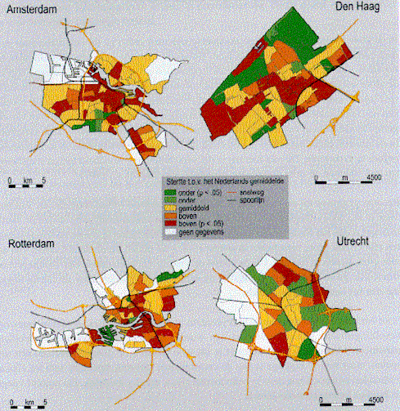 | 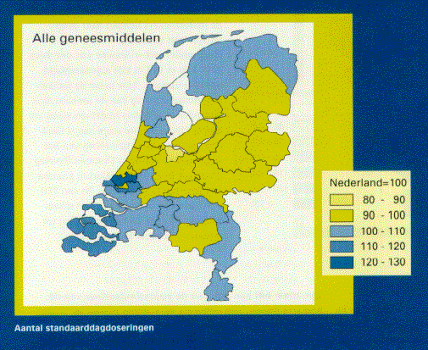
Garretsen and Raat (1989) | Batenburg-Eddes and Berg-Jeths (2002)
Fig. 1 Differences in death rates | Fig. 2 Use of medicines
The more we know, the more possible threads we become aware of to be calculated. That raises fear and fear raises stress. Stress is suspect in raising or stimulating diseases like risk of infection and cancer. Fear for cancer is so well-known a medical symptom that it got its own name in medical vocabularies: 'carcinophobia'.

Designers in the wake of this uncertainty already try to make solutions for possible problems. That is their task, but they seldom evaluate the effectiveness and possible side-effects of their solutions afterwards (ex post). Urban design is not always the most effective solution in environmental problems remaining after the great positive health effect of housing itself. Barton and Tsourou (2000) advise 12 key health objectives for urban planners in the context of WHO healthy city project in which Eindhoven participates: healthy lifestyles, social cohesion, housing quality, access to work, accessibility, local low-input food production, safety, equity, air quality and aesthetics, water and sanitation quality, quality of land and mineral resources, climate stability. Evaluating their effectiveness again would urge expensive longitudinal research extending decades to be scientifically convincing.

Sensory and motoric overload or deprivation
In addition to physical illnesses, there are also psychiatric disorders that can be linked with the new living environment, such as more frequent instances of schizophrenia in inner cities, although the cause can also be said to lie in the attraction of inner city areas for sufferers of schizophrenia . Although many tests have been carried out on sensoric deprivation (the lack of sensory stimuli) , one should perhaps talk instead of 'motoric deprivation'in the modern urban environment, in other words, the lack of accompanying motoric sensations from the muscles, and, more generally, the awareness of one's own body and thereby of non-fictitious 'reality'. The time spent in the car, in front of a television screen, at a sports competition arouses all sorts of sensoric emotions which have no logical motoric counterpart. Stresses cannot be resolved motorically by physical exertion. This is one of the causes of heart and vascular disease. Where people live in close proximity to each other and where internal spaces are fragile, the 'motoric sequel' becomes systematically suppressed, from childhood onwards.
This could provide an explanation for the popularity of sport and violence. Specialisation and the division of tasks splinter the unity of life, not only spatially (this happens here, and that there), but also in time (first this, and then that). The number of interfunctional activities is growing and is laying a heavy claim on tolerance to frustration, both for individuals and groups of people.

Human density
Apart from the disadvantages of living in high densities Vogler and Kuhn emphasise, its benefits Jacobs (1961) some years later referred to with the eye of a designer, were partly confirmed in a psychological sense. Freedman (1975) discussed research on crowding and behaviour concluding no other impact of increasing density than intensifying existing negative or positive social-psychological processes. However, thanks to human biodiversity or social diversity - stage in the lifecycle, income or life style - some people like to live in high densities, others do not. People with children mostly like low densities of quiet suburbs. So, forced to live in high densities the impact could be primarily negative. However, learning to live in high densities with children might turn out positive by discovering advantages, adapting, compensating shortages and accommodating new functions.
Producing accomodations like that, opening up new possibilities is the task of a designer and his means are sun, wind, water earth, life (Jong, 2004) and the numerous, often unexpected possibilities of living that could be drawn.

Adaptation and accomodation
Adapting to an environment and compensating shortages by new accommodations are essential characteristics of life. Life would never have developed without these capacities. The possibility of adaptation and compensation are often forgotten by researchers only interested in forecasting a probable future. 'Arsenic is poisonous', they predict. The prediction is based on 3x standard deviation from the average (99.7% of the cases) and if arsenic poison would be ever a global problem their solution would be removing the cause only. But in Austria a village population of so called 'arsenic eaters' (source unknown) since centuries seems to got used to it. That is the way evolution solved problems by adaptation and compensation increasing diversity, not by global rules reducing diversity for safety. Oxygen was once a global poison, now it is a prerequisite for aerobic life. Adapting, compensating and accommodating are also ways designers study. When low temperature is a problem of living in higher latitudes we compensate (accommodate) by building acclimatised houses. It is unnatural because it disturbs the natural distribution and abundance of homo sapiens. But since we make houses more than 3000 years it appears natural to us. What we call 'natural' apparently is time scale sensitive. Our short-term internal accomodation is called medicine.

Avoiding risks could be risky
A secret medical survey I heard of by a medical student in the seventies revealed that 50% of our diseases at that time were iatrogeneous (caused by physicians). I do not know whether that was true or not and what the present state of medicine is in this respect. That is why I fear the worst case. Suppose a new medicine is accepted because it heals a specific disease in 99 from 100 persons, but because everyone reacts different in any of them it causes different kinds of side-effects. Side-effects with enough statistical mass to indicate the new medicine as a cause are described in the instruction leaflet. But what about side-effects not reaching a statistical mass in the diversity of medicated people? The unfortunate client comes back to the doctor with severe symptoms, but the doctor can not conclude the earlier medicine to be the cause and gives another medicine with unpredictable side-effects. And so on. In that case the medical discipline would create its own work. Consulting a doctor would give as much chance to immediate health as to illness later, giving however a little improvement of life expectancy.

McKeown (1976) already doubted the supposed positive impact of medical care on life expectancy but he did not yet take the above argument into account. He argued that the main improvements of life expectancy historically appeared before important medical innovations. So, these improvements could not be explained by medical care. They should be explained by improved life conditions (housing!) and food.

In the same time exceptional occurrences are magnified by television and newspapers. They bomb us by statistical exceptions, distorting our perception of chance and magnifying impact. Risk is popularly defined by chance x impact. The public shame of few physicians involved intimidates the profession as a whole. And we still know little about our body, our own nature yet. Honest physicians remain silent but that is what frightens more. Avoiding any risk physicians prescribe too many medicines, order too many physical examinations increasing the costs of medical care, increasing slowly appearing side effects. There is something wrong in the state of medicine. King Average rules the kingdom of exceptions human species comprises.

Living with life: living with the risk to die
Avoiding one risk raises new risks on other levels of scale in space or time. Always avoiding to catch a cold may result in high susceptibility for flu any time we leave a building or a car. Our hygiene drove life out and nature in exile. Our biological resistance fades, the number of immunity deficiency diseases increases. We do not get injuries enough to become vaccinated by nature itself. We like dangerous holydays to flee from our unnatural and boring safety, but we do not know real danger anymore and fall ill by foreign food.

Insurance companies sell fear. We pay more for safety than for anything else: insurance, police, army, preventing fire, burglary, terrorism and catching a cold. We fear we can not pay all and we double our work until we die from the impacts of stress. The life time we spend on worry is lost well-being, lost health and … life time. Our fear for exceptional possibilities raises new diseases of the mind and we fear them as well. In reality our life is safer then ever, but we do not dare to live with life: the risk to die. Life became strange to us and death as well, we fear the unfamiliar because it could be unhygienic.

The unfamiliar diversity of unknown life
In the mean time numerous other organisms are going their own way, not fearing for anything that is not actual and mostly without any apparent fearing at all. They live from very slow to very fast. I prefer the slow living plants surrounded by their very fast pairing messengers of life-experience, the insects. Plants are the basis of life's pyramid. Added animal life only selects and regulates like man does as well by harvesting, preserving, mowing and gardening. Sometimes we visit them and walk in something totally else we belong to historically but do not have to understand, something we should not try to plan.

In any town of the Netherlands specialised study groups of nature associations contribute to atlases of birds by Hagemeijer and Blair, Bekhuis, Bijlsma et al. (1988), Beintema, Moedt et al. (1995), butterflies by Tax (1989) and Bink (1992), bats by Limpens, Mostert et al. (1997), amphibians and reptiles by Bohemen, Buizer et al. (1986) , mammals by Broekhuizen, Hoekstra et al. (1992), fishes by Nie (1996), plants by Mennema, Quene-Boterenbrood et al. (1980), Weeda, Schaminée et al. (2000) and mushrooms by Nauta and Vellinga (1995). But they have to be adapted every year, because context changes. They multiply our shrinking world of holiday destinations by growing local universes we tended to overlook. In any town nature writes a history of war and peace far more thrilling than television and newspapers could do. Nature looks for its journalists because it only exists by the grace of those seeing it.

I think it stimulates human health when we bring life close to everybody's home and living, but nobody knows, it is a hypothesis. Berg, Berg et al. (2001) give an excellent overview in their essay about the relation between nature and health concerning history, possible impacts on stress, fear, physical resistance and personal growth. Nature puts the stressing concept of our own importance into a relative perspective of one species between 1 700 000 ones or more. They differ more from us than any people we tend to reject in social conflict. Studying nature heals social disappointment by disappointing prejudice. It stimulates an active form of modesty. Nature tempers forced choice as architecture should do as well according to Eyck, Parin et al. (1968).

The hidden choice of statistical reduction
The intellectual challenge of this century is to handle diversity instead of generalising it by statistical reduction. Blinded by immediate measurable positive effects we do not have scientific instruments to count individual side-effects without statistical mass. Generalising research has diminishing returns for context sensitive problems. On the other hand context sensitive design with all its mistakes is promising, generating study. Biological evolution and ecological succession is its model. Evolution after all makes use of exceptions surviving in a changing context. You can not understand the process of evolution by stressing the average. Designers are not engaged for the average, but for context sensitive exceptions.

Ecology has to take millions of species into account and we do not know how any of them work. We know very little, otherwise we would be able to design them. To make it worse any specimen of a species is different from most of the other specimens of the same species. To make its unaccessibilty for statistical evidence complete every specimen is functioning in a different context.

The importance of diversity for life
Londo (1997) considered diversity as a risk-cover for life instead of a risk. In the diversity of life there was always a species to survive or within a species a specimen that survived when context changed. Survival of the fittest presupposes diversity from which can be 'chosen' in changed circumstances. Diminishing biodiversity means undermining the resistance against catastrophes. From the 1.7 million species we know, we probably lost some 100 000. So, we not only introduce ecological disasters, but we also undermine the resistance of life against these disasters.
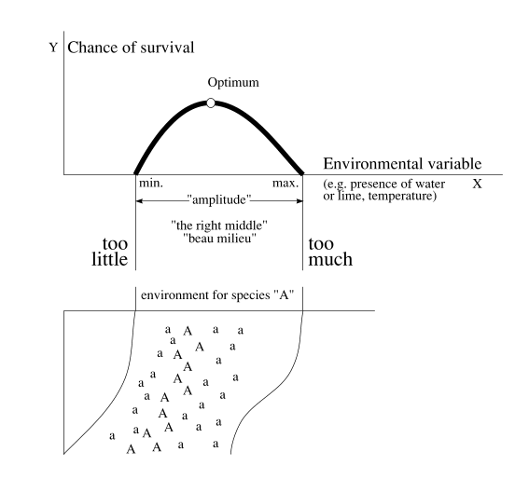
Fig. 3 Ecological tolerance in theory and reality
The curve of ecological tolerance relates the chance of survival of a species or ecosystem to any environmental variable, for instance the presence of water. In that special case survival runs between drying out and drowning (Fig. 3 ).Imagine the bottom picture as a slope from high and dry to low and wet. Species A will survive best in its optimum. Therefore we see flourishing specimens on the optimum line of moisture (A). Higher or lower there are marginally growing specimens (a). The marginal specimens however are important for survival of the species as a whole.

Suppose for instance long-lasting showers: the lower, too wet standing marginal specimens die, the flourishing specimens become marginal, but the high and dry standing specimens start to flourish! Long-lasting dry weather results in the same in a reversed sense. Levelling the surface and water-supply for agricultural purposes in favour of one useful species means loss of other species and increased risk for the remaining.
But there is a less friendly ecological lesson hidden within this scheme. Marginal specimens are important for survival of the species as a whole. A reservoir of unhealthy specimens favours species. Death regulates life. Health is also spatially scale-sensitive.

The importance of diversity for human living
Biodiversity in mankind is a crucial value in our quality of life. As we are here we are all different and the very last comfort you can give a depressed person is 'But you are unique'. Reading Philp (2001) you should conclude that medicine hardly discovered that uniqueness in the evaluation of medicines. It hinders generalizing science using concepts as average and standard deviation. Dieckmann, Law et al. (2000), Riemsdijk and NOBO (1999) and Jong and Voordt (2002) are aware of that difficulty in ecology, organization theory and design study.
Evolutionary ecology (see Pianka (1994)) is only comprehensible considering exceptions outside the limits of a normal test population (3*standard deviation) as Philp (2001) described.
Diversity is also a precondition for trade and communication. If production and consumption would be the same everywhere, there would be no economical life. If we would have all the same perceptions and ideas, there would be no communication. It is an important misconception to believe that communication only helps bridging differences. Communication also produces diversity by compensating each other and coordinating behaviour by specialization.

Quality of life
Quality can be measured in terms of possibilities of use, experience and expectation for future generations. The way design can sustain a sustainable development in the sense of Brundtland is to produce more 'choices' for man, animal and plant. If there were one best solution for all problems of architecture and urban planning, it would be the worst in the sense of choices for future generations! This paradox pleads more for diversity than for uniform solutions. Moreover, if there were a uniform solution, the designer would have no task. Quality is always a function of variation.
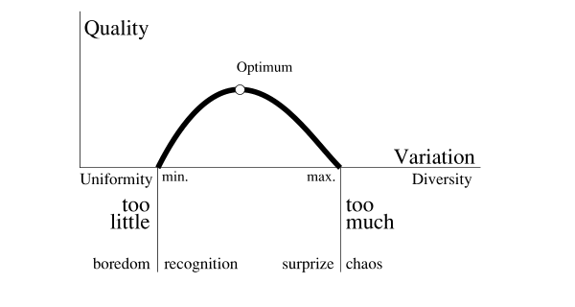
Fig. 4 Quality = f(Variation)
Quality of possible experience or use moves between diversity and uniformity, surprise and recognition. One step too far into both sides brings us in the area of boredom or confusion. This is a simple conception, already recognized by psychologists like Birkhoff (1933) and Bense (1954), but why did it not succeed, why is quality always posed as an unsolvable question? Because the concept of diversity is scale sensitive and so is our experience. When on one level of scale we experience chaos, in the same time on an other level of scale we could experience boredom.

Possibility of choice
The World commission environment and development (1990) of chairwoman Brundtland summarized the environmental challenge by stating sustainability as leaving next generations at least as much possibilities as we found ourselves. But what are possibilities? 'Possibilities' is not the same as economical supply. If our parents would have left us the same supplies as they found in their childhood, we would be far from satisfied forced by their choices. 'Possibilities' has to do with freedom of choice and thus variety. Our converging Schumpeter-economy as Krupp (1995) described and converging culture of Fukuyama (1992) leaves no choice. In our search for the alternative we find everywhere in the world the same hotels, the same dinners, the same language. This century, the last 'primitive' cultures are lost and with them an experience of life that no western language can express. After looking at their dancers in the afternoon on our rain forest holyday we find them back in disco in the evening.
The most extreme consequence of this levelling out would be a world without economy and even communication. That is the ultimate consequence of local autarky. If there were no longer any differences in production factors, exchanging goods and services would no longer be necessary. If total worldwide distribution of knowledge and consensus would be the result of our communication age, there would no longer be anything worthwhile to communicate. These thought experiments show clearly that 'difference' is also a hidden presupposition in communication and economy. The question remains on what level of scale self-sufficiency is desired: global, continental, national, local like Steekelenburg (2001) illustrates beautifully in his scenarios.

Possible use of open space
Form, size and structure of components are conditions for the function of open areas though urban functions on their turn can be the historical cause of form and structure. The landscape consultancy H+N+S in Utrecht visualised the functional charge for nature as a function of size and altitude in Fig. 5 .
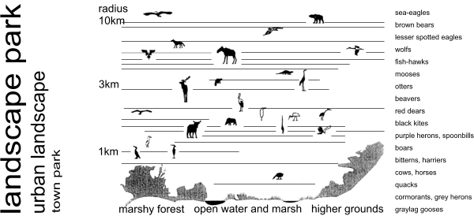
H+N+S
Fig. 5 Possibilities for nature by size and altitude

In Fig. 6 they summarised possibilities of human recreation as well.
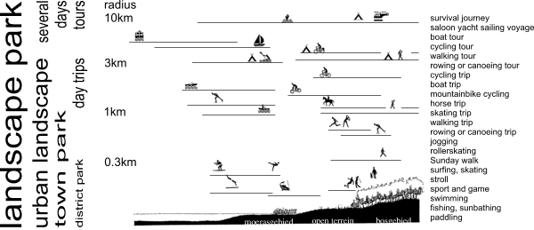
H+N+S
Fig. 6 Possibilities for recreation by size and altitude
The smaller the area the less animals could find a habitat, but that is not the case for botanical biodiversity as far as their distribution is not dependent on animals.

Norms for open space?
A crucial space-time dilemma of urban planning is priority for either small open spaces nearby residential areas or remote larger ones with more travel time and a small profit of species.
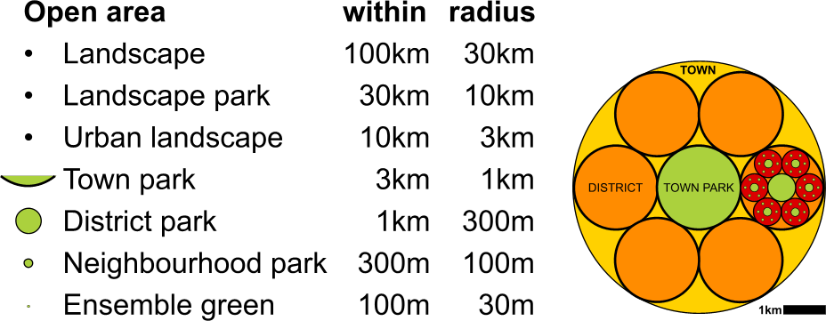
Fig. 7 25% Central green area equally dispersed on 7 levels of scale
If on 7 levels of scale from r=30m until r=30km any built area should be adjacent to at least one central open area of the same size (see Fig. 7 ), approximately 75% of total surface would be occupied by built space and 25% by open space. The largest open space would occupy 10 of that 25%, the 6 next smaller ones together 6 of the 25%, the 36 even smaller ones 3% and so on. The relatively large amount of space token by the largest one is an economic argument for more small ones near by home. However this strategy would stress botanical rather then zoological biodiversity. Moreover, a priority for smaller green spaces nearby home with a smaller emphasis on animals brings nature closer to the inhabitants, especially the young ones.

Spatial human rights?
- Any human has a right on 300m2 residential area in a radius of 10km, work and services included.
- Any human has a right on all necessary sources of living within a radius of 30km. These sources have to give access to products of 2000m2 agricultural land per person. This land should be accessible within a radius of 1000km concerning the risk of stagnating logistics.
- Agriculture has to be located in areas with highest supply of water, minerals and sunlight. Towns and untilled natural areas have to be located in areas with less minerals.
- Any human has a right on untilled natural ground uninhabited by man within a radius of x from her or his place of residence measuring at least a radius of x/3; x being {0.3, 1, 3 … 100 000 metre}.
- Dutch cities belong to the most healthy in the world. So, any attention given to health in Dutch cities is distressing in a perspective of the hygienic condition of cities in the second and third world.

Conclusion
The ecology of human health in the urban environment in a designer's view primarily focuses on growing human density. The history of human species concerns adaptation to and accomodation of its reference environment.
Where they are less succesful an unequal distribution of health appears. Civilisation damage by deprivation of evolved human abilities has to be cured by design. A distorted risk perception by mass communication raises risky norms based on a statistical reduction of diversity in man and nature. The importance of diversity for life and human living can not be overestimated. The intellectual challenge is to handle diversity instead of generalising it by statistical reduction. However, human diversity as part of a broader ecological view on biodiversity is a scale-sensitive concept to be coped with by scale-articulation of study.

Spatial state of dispersion is a condition for diversity. Diversity is a condition for the possibilities of choice for future generations. Urban perspectives have to take exploding claims on space into account. The scale of concentration determines the open space remaining for its essential uses. So, suggestions concerning spatial
human rights resulting in norms for open space from a viewpoint of health would be a great help for urban design.

Many adjacent questions are left open. Are norms on any level the right mean to cope with the diversity of people and their variety of options for complete physical, mental and social well-being? Is stabilising environmental factors a good answer to challenge evolved human abilities? Is freedom of choice for future generations guaranteed by making our contemporary choices? How to produce diversity without reducing it?

References
Barton, H. and C. Tsourou (2000) Healthy Urban Planning (London) Spon Press ISBN 0-415-24326-2 hbk; 0-415-24327 pbk.

Beintema, A., O. Moedt, et al. (1995) Ecologische atlas van de Nederlandse Weidevogels m.m.v. SOVON
(Haarlem) Schuyt & Co BV ISBN ISBN 90-6097-391-7.

Bekhuis, J., R. Bijlsma, et al., Eds. (1988) Atlas van de Nederlandse Vogels (Arnhem) Sovon ISBN 90-72121--01-5.

Bense, M. (1954) Aesthetica (Stuttgart) Deutsche Verlags-Anstalt.

Berg, A. E. v. d., M. M. H. E. v. d. Berg, et al. (2001) Van buiten wordt je beter. Een essay over de relatie tussen natuur en gezondheid (Wageningen) Alterra, bijlage bij het jaarboek 2001.

Bink, F. A. (1992) Ecologische atlas van de dagvlinders van Noordwest-Europa (Haarlem) Schuyt & Co Uitgevers en Importeurs ISBN 90-6097-318-6.

Birkhoff, G. D. (1933) Aesthetic measure (Cambridge, Mass.) Harvard University Press.

Bohemen, H. D., D. A. G. Buizer, et al., Eds. (1986) Atlas van de Nederlandse amfibieën en reptielen (Hoogwoud) KNNV Uitgeverij.

Broekhuizen, S., B. Hoekstra, et al., Eds. (1992) Atlas van de Nederlandse zoogdieren Natuurhistorische Bibliotheek van de KNNV (Utrecht) KNNV Uitgeverij ISBN 90-5011-051-7 geb.

Dieckmann, U., R. Law, et al. (2000) The Geometry of Ecological Interactions: Simplifying Spatial Complexity (Cambridge) Cambridge university press.

Eyck, A. E. v., P. Parin, et al. (1968) Ecology in Design / Kaleidoscope of the mind / Miracle of Moderation / Image of Ourselves (Philadelphia) Graduate School of fine arts, University of Pensylvania.

Freedman, J. L. (1975) Crowding and behavior (San Francisco) W.H.Freeman and Company.

Fukuyama, F. (1992) The End of History and the Last Man (New York) Free Press.

Garretsen, H. F. L. and H. Raat (1989) Gezondheid in de vier grote steden ('s-Gravenhage) SDU uitgeverij.

Hagemeijer, W. and M. J. Blair, Eds. The Atlas of European Breeding Birds (London) Poyser.

Harrison, G. A., J. S. Weiner, et al. (1964) Human Biology (Oxford) The Clarendon Press in Dutch translation

Harrison, G. A., J. S. Weiner, et al. (1970) Biologie van de mens (Utrecht/Antwerpen) Het Spectrum N.V..

Jacobs, J. (1961) Death and Life of Great American Cities (New York) Random House.

Jong, T. M. d. (2004) Sun wind water earth life and living (Delft) Lecture paper URL
www.bk.tudelft.nl/urbanism/TEAM > publications

Jong, T. M. d. and D. J. M. v. d. Voordt, Eds. (2002) Ways to study and research urban, architectural and technical design (Delft) DUP Science.

Kolasa, J. and S. T. A. Pickett, Eds. (1991) Ecological Heterogeneity. Ecological Studies (New York) Springer-Verlag ISBN 0-387-97418-0; 3-540-87418-0; 90 6789 630 6.

Krebs, C. J. (1994) Ecology The Experimental Analysis of Distribution and Abundance (New York) Harper Collings College Publishers.

Krupp, H. (1995) European Technology Policy and Global Schumpeter Dynamics: A Social Science Perspective Technological Forecasting and Social Change 48, 7-26 (New York) Elsevier Science Inc.

Limpens, H., K. Mostert, et al., Eds. (1997) Atlas van de Nederlandse vleermuizen; Onderzoek naar verspreiding en ecologie Natuurhistorische Bibliotheek van de KNNV (Utrecht) KNNV Uitgeverij ISBN 90-5001-091-6.

Londo, G. (1997) Natuurontwikkeling (Leiden) Backhuys Publishers ISBN 90-73348-77-3.

McKeown, T. (1976) The role of medicine: dream, mirage or nemesis (London) Nuffield Provincial Hospitals Trust

Mennema, J., A. J. Quene-Boterenbrood, et al. (1980) Atlas van de Nederlandse flora. Deel 1. Uitgestorven en zeer zeldzame planten (Amsterdam) Uitgeverij Kosmos ISBN 90-215-0847-8.

Nauta, M. and E. Vellinga (1995) Atlas van Nederlandse paddestoelen (Rotterdam) A.A. Balkema ISBN 90 5410 623 9.

Nie, H. W. d., Ed. (1996) Atlas van de Nederlandse zoetwatervissen (Doetinchem) Media Publishing Int BV ISBN 90-801413-5-6.

Philp, R. B. (2001) Ecosystems and Human Health. Toxicology and Environmental Hazerds (Boca Raton / London / New York / Washington, D.C.) Lewis Publishers ISBN 1-56670-568-1.

Pianka, E. R. (1994) Evolutionary ecology (New York) Harper Collins College Publisher.

Riemsdijk, M. J. v. and NOBO, Eds. (1999) Dilemma's in de bedrijfskundige wetenschap (Assen) Van Gorcum ISBN 90 232 3414 6.

Reumer, J.W.F. (2000) Stadsecologie, de stedelijke omgeving als ecosysteem (Rotterdam) Natuurmuseum Rotterdam ISBN 90-73424-15-1

Steekelenburg, M. v. (2001) Self sufficient world (Den Haag) VROM, RPD.

Tax, M. H. (1989) Atlas van de Nederlandse dagvlinders ('s-Gravenland /Wageningen) Vereniging tot behoud van Natuurmonumenten in Nederland, Vlinderstichting.

Vogler, P. and E. Kuhn, Eds. (1957) Medizin und Städtebau. Ein Handbuch fur gesundheitlichen Stadtebau (Munchen, Berlin, Wien) Verlag von Urban & Schwarzenberg.

Weeda, E. J., J. H. J. Schaminée, et al. (2000) Atlas van Plantengemeenschappen in Nederland. Deel 1. Wateren, moerassen en natte heiden (Utrecht) KNNV Uitgeverij.

Weeda, E. J., J. H. J. Schaminée, et al. (2000) Atlas van Plantengemeenschappen in Nederland; Wateren, moerassen en natte heiden (Utrecht) KNNV, Alterra, CBS, LNV, KIWA, Directoraat-Generaal Rijkswaterstaat, VEWIN ISBN 90-5011-1327.

Westhoff, V. and A. J. d. Held (1969) Plantengemeenschappen in Nederland (Zutphen) Thieme.

World commission environment and development (1990) Our Common Future (Oxford/New York) Oxford University press.

Zoest, J. v. (1998) Biodiversiteit (Utrecht) KNNV-Uitgeverij.

