Car physics

Prof.dr.ir. Taeke M. de Jong

1 Thermodynamics in technical car specifications 2
1.1 The force of a car 2
1.2 Acceleration 3
1.3 Keeping velocity 3
1.4 Couple and energy 3
1.5 Efficiency, friction and power 4
1.6 Rotational speed and power 4
1.7 Cylinder volume 5
1.8 Pressure in the cylinder 5
1.9 The amount of gas to be compressed 5
1.10 Increase of pressure by compression (2) and explosion (3) 6
1.11 Maximum force on piston 6
1.12 Average pressure per stroke time 7
1.13 Energy per stroke time 7
1.14 Power per rotation (2 strokes) 7
1.15 Fuel per hour 7

2005-09-26
http://team.bk.tudelft.nl/ > Publications > 2005

Thermodynamics in technical car specifications
If you read a table of technical specifications like Fig. 1 and you do not understand much of its meaning (like I did a week ago) this article may help. Some questions remain open, if I made omissions or mistakes perhaps you can help me the reverse. My way to understanding is writing. That is why I wrote this article: a report of a layman’s understanding, though I am not an extreme car lover myself. However, making the values of Fig. 1 and their relations understandable is not only useful in practice of buying, maintaining and using a car. It is also instructive to repeat concepts of physics in an appealing way for car lovers like many students are. It is done here to introduce the physics of sun, wind, water, earth life and living, mobility space and traffic to urban designers. The car is the engine most influential to urban design, worth to get acquainted with in a technical sense as well. Moreover, it shows the way of thinking other more technically educated engineers are used to.

type | cm3 cylinder content | position of cylinders | cylinders | mm boring | mm stroke | /1 compression | Nm max. couple | on revolutions per minute, r.p.m. | kg weight DIN | sec acceleration 0 – 100 km/h | Hp power | kW power | on revolutions per minute, r.p.m. | km/h top speed | km per litre fuel consumption
280 SL | 2746 | R | 6 | 86.0 | 78.8 | 9.0 | 238 | 4500 | 1500 | 8.9 | 185 | 138 | 6000 | 200 | 7.0
300 SL | 2962 | R | 6 | 88.5 | 80.3 | 9.2 | 260 | 4400 | 1500 | 8.8 | 188 | 140 | 5700 | 203 | 7.1
350 SL | 3499 | V | 8 | 92.0 | 65.8 | 9.5 | 286 | 4000 | 1600 | 9.0 | 200 | 149 | 5800 | 210 | 5.4
380 SL | 3818 | V | 8 | 92.0 | 71.8 | 9.0 | 305 | 4000 | 1540 | 8.5 | 204 | 152 | 5500 | 210 | 6.0
420 SL | 4196 | V | 8 | 92.0 | 78.9 | 9.0 | 330 | 3750 | 1600 | 8.5 | 218 | 163 | 5200 | 213 | 5.9
450 SL | 4520 | V | 8 | 92.0 | 85.0 | 8.8 | 378 | 3000 | 1600 | 9.7 | 225 | 168 | 5000 | 210 | 5.4
500 SL | 4973 | V | 8 | 96.5 | 85.0 | 8.8 | 404 | 3200 | 1600 | 7.9 | 240 | 179 | 5000 | 225 | 6.2
http://www.mb107sl-club.nl/107_techniek.htm
Fig. 1 Technical specifications of old Mercedes-Benz R 107 types
produced from February 1971 t/m Augustus 1989
Without much understanding you already can make some conclusions and raise some questions from Fig. 1. Firstly, the type names seem to represent the cylinder content and as if you remember these types, you know it is related to their cost price. Subsequently, the maximum couple is mentioned on a lower number of revolutions per minute than the power. Why is that? A horse power (Hp) appears to be 0.736 kW. What is boring and stroke? What is couple? How are they related to the cylinder content? What do you need to reach an acceleration of 0 to 100km/h of 1500 kg in 8.9 seconds? Let us start to explore what we can understand by highschool physics.

The force of a car
In physics you define force ‘F’ as mass times acceleration ‘a’ (formula 1 below). It is expressed in terms of newtons. To start moving a stationary car, you need a force F1 to overcome its internal friction of pistons, bearings and gearwheels, a force F2 to overcome its external friction of tyres on the road and perhaps the resistance of air, and last but not least a force F3 to give a stationary car its initial acceleration. That force is what you feel as resistance to overcome with your own muscle power if you have to push a failing car. Setting the car in motion means producing at least some acceleration. After pushing over a certain distance you feel your energy is exhausted. Some people can do it faster, but they may be exhausted earlier after pushing the same distance. The time you spent to reach that distance shows your average power during the time you pushed the car. You have a top speed. Your force, energy and power are different things. They have to be distinguished in physics to make calculations and predictions possible.

Acceleration
In physics you define acceleration ‘a’ in one direction as the increase of velocity ‘Δv’ divided by the time passed by ‘Δt’ (2). If you state the initial time and velocity zero, you can avoid Δ in the formula. By that definition of acceleration you then can write force F as mass times velocity v divided by time t (3). So, if you neglect frictions, with a car of 1500kg you reach a velocity of 100km/h (28m/sec) in 8.9 seconds by a force of 1500 * 28 / 8.9 = 4682 newton. For the real figure you need to add the average frictions F1 and F2 increasing (or decreasing?) from 0-100km/h.

Keeping velocity
Once the car has reached the velocity you want, you can ease off the gas. To keep the car moving by that velocity you only need F1+F2 to overcome the frictions. As soon as you step on the gas again, F3 comes into action, giving the car Δv more velocity added to the existing velocity in the period of Δt you step on the gas. So, the initial velocity (like the initial time) is no longer zero than, and you have to complicate some of the formulas below by a Δ (difference). If you brake, the acceleration is negative. The brake of a normal car has an acceleration of approximately –7 m/sec².

- .

Couple and energy
Two or more wheels give the car a force straight forward by rotation. You define the force of rotation (couple) as force F times radius r (4). The radius of a wheel in a normal car is approximately 30cm. The outline of the tyre meeting the road (rotation length) is 2*π*r (6). So, if r=0.3m, the outline of the wheel is some 1.9m. If you have a larger r (larger wheels), the rotation length and covered distance is also larger, but the force (and acceleration) will be smaller if the energy produced by the engine remains the same.

Turning the driving wheels one time, transmits the force of rotation produced by the engine into a force straight forward covering a distance depending on r. You define energy as force F times distance (8). It is expressed by joules or by litres petrol. So, if you have moved the car 1.9m you needed F*1.9 joules. If that car uses 7 litre petrol per 100km (1 litre per 14.3km), it uses 0.07 litre per km, 0.00007 litre per m and 0.000119 litre per 1.9m.

The couple has the same dimensions as energy multiplying force by distance, be it a radius in case of the couple. If you neglect internal friction, both remain the same from engine into wheel. However, a smaller gearwheel in that transmission compensates its smaller outline by making more rotations per time interval to transmit the same energy. If the wheel has a radius of 1m, the value of the couple of the axis is equal to that of the force the outline transmits. If it is smaller, the force is larger, if it is larger, the force is smaller, but the transmitted energy remains the same. Force and rotation length compensate each other while the couple as a whole remains he same.

That is why the couple of the engine is often given in technical specifications of the car, while varying radiuses and resulting rotation lengths or compensating forces are not. Formulas (5), (6) and (7) are explained here, but will be used later to translate unknown radiuses or rotation lengths into the known couple.

Efficiency, friction and power
Not all energy of the petrol reaches the wheels. The total efficiency of a car transmitting the energy content of petrol into movement and acceleration is approximately 30%. Much is lost by heat production and a little by internal friction. However, that friction changes by increasing velocity. The highest velocity you can reach overcoming all resistance by friction, depends on the rotation energy the engine can produce per second (power). You define power as energy per time interval (9). In formula (10) you use (7) to substitute the unkown rotation length. In (11) the unknown force disappears as well. So you do not have to know the force to calculate the power.

Rotational speed and power
In Fig. 1 you can read the technical specifications of type 280 SL. The values are copied in (12) and (13). The 4500 revolutions per minute should be read as 75 revolutions per second to make proper calculations. Then formula (14) calculates the power: 112 000W or 112kW at 75 per second (r.p.s.). Would 100 r.p.s. produce one third more power (149kW)?

No, in Fig. 1 you can read it is 138kW at 6000 r.p.m. (probably the maximum). If we put all types from Fig. 1 in one graph (Fig. 2), you can see that for any type power starts to increase by rotational speed, but not linear at last. So, in (14) couple should decrease after 4500 r.p.m. Above 6000 r.p.m. even power would decrease, because at that high rotation speed the fuel will have no time enough to burn out completely before its remains are pushed out. But Fig. 1 shows two measuring points only.

Fig. 2 Growing power by increasing number of revolutions per minute | Fig. 3 Growing couple by increasing cylinder volume
How fast power increases in general, apparently depends on the cylinder content unveiled by the type name. The larger your cylinder content, the less rotating speed you need to get the same power (for example 140kW). That keeps your expensive car quiet and distinguished.
Fig. 3 shows how the maximum couple of different types increases quite linear with their cylinder content, while Fig. 2 shows it is reached at lower r.p.m. each time.
Now it is time to study the cylinder volume more in detail.

Cylinder volume
In Fig. 1 you can read values of type 280 SL for boring, stroke and number of cylinders in a row (R), copied in (16, 17 and 18). Boring means the diameter of the piston in each cylinder. So, you have to take half of that value as radius r to calculate the operational surface π*r² of the piston pushing your car forward by exploding gas pressure. Stroke means the distance the piston can move. So, multiplying the surface by that stroke you can calculate the volume per cylinder available to let in a mixture of petrol and air gasified by the carburetter. Multiplying that volume by the number of cylinders produces the total cylinder content of your 280 SL (19), which is 2746 mL (20), a little overdone in the name of he the car type.

Pressure in the cylinder
Boyle and Gay-Lussac discovered that the multiplication of volume and pressure divided by temperature is constant for any amount of gas. If you take as much grammes of gas as its atomic weight counts (grmol), you have a chemical standard amount of gas called ‘mol’, with 6*10²³ molecules (Avogadro’s number). At normal atmospheric pressure and a temperature of 0⁰C or 273K it has a standard volume of 22.3m³. For 1 mol of gas the universal gas constant of Boyle and Gay-Lussac ‘R’ is 8324 joule/K (21). Multiplied by the number of mols in your cylinder R produces a complete formula of their discovery (22). So, you need to know the volume of your cylinder, its temperature and the number of mols it contains to calculate the pressure (23) pushing your car forward.

The amount of gas to be compressed
In Fig. 1 you can read that a piston of the 280 SL type can compress the cylinder content into a ninth (25) of the original volume V1 (24) producing a volume V2 (26). Rewriting (22) as (27) you can calculate the amount of gas let in at 0.9 atm pressure (28, because the engine is drawing the air inside), and on a temperature of a warm summer day Tinlet=300K (29). That amount of gas will remain the same mols compressed or not. The 280 SL cylinder contains some 0.0001 mols (30).

Increase of pressure by compression (2) and explosion (3)
After a little decrease of pressure for inlet (stroke 1) the engine compresses the gas (stroke 2). So, pressure will increase and we estimate the temperature increases into 400⁰C. If temperature would increase more, the fuel mixture could inflame spontaneously as happens in a diesel engine.

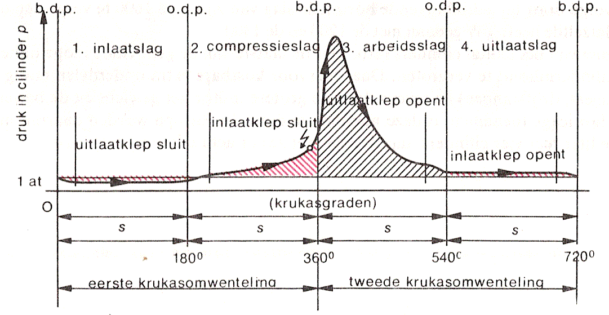
Lobbenoo (ed) 1967
Fig. 4 Pressure in a four-stroke engine
If the sparking plug does its work properly, the compressed gas explodes and temperature, pressure and volume increase. We assume the temperature increases into 1400⁰C or 1673K, the volume again into its maximum V1. Now we can rewrite (22) again to calculate the pressure in both states (33 and 34), because we know the number of mols (31). To let the exhaust fumes out, we need some more pressure than the outside world (35).

- =>
- =>

Maximum force on piston
Subtracting the atmospheric pressure from the highest pressure on piston we can calculate the difference of pressure Δpressure (36). By Δpressure you can calculate the maximum force on piston, because you know its surface π*(0.5*boring)² (38, 39).

Average pressure per stroke time
The force on piston changes dramatically and continually by inlet, compression, explosion and outlet. During compression and explosion, the pressure, diminished by the atmospheric pressure, changes continually between minimum into maximum and the reverse. From Fig. 4 you can estimate the average pressure as part of the maximum (41 and 42) to calculate an average force of every stroke.

Energy per stroke time
The distance the force covers is the stroke, and energy is force times distance (44 - 47).

Power per rotation (2 strokes)
So, you can calculate the energy produced by the engine every rotation (48). Power is the energy delivered per second and we know the number of rotations per second (49). So the power is the energy per rotation times the number of rotations per second for every cylinder (50). In that way you can calculate the power (52).

It fits Fig. 1, because we adapted our estimations of the factors in (41 and 42).

Fuel per hour
Petrol contains a mixture of hydrocarbons (octane, nonane, decane, hendecane, dodecane?) with an energy content of 43 000 000 joule/kg (53) or 30 960 000 joule/liter, which is partly used for motion (57). So, you can calculate how much fuel is used each rotation (57). If you drive 1 hour with rotation speed 4500/min (60 times 4500 rotations), you will use 29 liter fuel (58 - 61). If the 7 km/liter from Fig. 1 (62) would apply at its top speed 200/hour (64), you have to suppose an efficiency of 42% (56), which is probably too high.

T.M.dejong@bk.tudelft.nl
For graphs with more measuring points see http://www.squadra-tuning.com/wat_is_koppel_en_vermogen.htm or http://www.bmwtouring.nl/touring/e30/afbeelding/koppeltoeren.jpg
Look at the animation in http://science.howstuffworks.com/engine1.htm to see how it works. If your computer can read Java http://www.econ.kuleuven.ac.be/tew/labo/nat2/applets/applet4.htm gives more details, be it for a Diesel engine.

