Child perception in cities
Prof.dr.ir. Taeke M. de Jong, 2005-07-09, http://team.bk.tudelft.nl

Introduction
Experiments with babies, reported by Piaget and Inhelder (1947), keep me fascinated from the first time I read about them until now, because of the practical and design implications of the idea. Firstly, they gave the children an object to feel by touching behind a screen making sure they could not see it. Then they showed the same object, making sure they could not touch it. Piaget and Inhelder questioned at what age the children would combine these two totally different sensory impressions into one concept. On the average it appeared to be on the age of one and a half years old. These conclusions were criticized later (it happens earlier) but the idea has remained the same.

Combining different sensory impressions synaesthetically into a concept of any object involved, means more than a conditional Pavlov-reflex. Starting up your digestive system when a bell rings does not yet mean that you can imagine them as a concept, and they are not the same after all. It means that if you feel the object without seeing it, you can make a visual imagination of the object without seeing it. It is the very start of logical operations like ‘not’, ‘or’, ‘if … then’. It explains the fascination of young children for the game of peek-a-boo or hide-and-seek: mother hides herself and calls you. You can hear her voice, but you do not see her. You now are looking for her, because you have the visual imagination you like to check completing your concept.

In later investigations Piaget and Inhelder emphasized the importance of the motoric ability for imagination capabilities and learning. You can change your visual impression by moving physically. This possibility causes continuous experiments by children. I remember my niece celebrating her first birthday. Grandma held her on her lap saying ‘Quiet my darling, quiet!’. But she stayed crying all the time kicking her legs. I had been reading Piaget recently and said: ‘Give her to me’. Grandma handed me the child and I helped her kicking legs to move her body up and down to see my face alternating with the background. She started laughing! Grandma, somewhat embarrassed, thought she loved me more then her, but I explained her the baby was experimenting parallax: changing object and context by moving up and down. She did not see me as a person, she tried to understand the difference between my face and my background first. That is why moving on a seesaw is so fascinating for children.

She should have experienced object constancy earlier: mother is not there; she appears in the door and walks into your direction. Her face enlarges until it fills your total scope of vision: is that large object the same object appearing as a small face peeping around the door? You throw toys out of your box, they bring them back. Repeating experiences like that show constancy of changing objects: different, gradually enlarging impressions link up to one imaginable object. That is why swings and merry-go-rounds are important. Later on you run away from your mother and look back. She became very small and to regain your safety you run back to enlarge her. Your mother is not yet a person, but ‘something large and warm’, like my three years old daughters described their concept of ‘mother’ when I asked them ‘What is a mother?’. The other way round dangerous things are ‘large and cold’. A car is not dangerous when it is far away, because it is small.

There we are. The dangerous things at home are well known when you are three years old, because they are nearby and large, cold, solid and hard. They can hurt when you run too fast. You learn by collision. But once you are in the street you have to run faster to discern objects further away than at home and it takes years to learn that there are objects running faster than you, becoming large, cold, hard and painful very quickly. That is why playing tag is so important. Young animals are short-sighted to learn discerning objects nearby first by little movements causing parallax. The vision, radius of awareness and speed grow with the years of childhood. I think the radius of awareness grows exponentially, but it is a hypothesis.

Which programme of requirements for a Child Street we can conclude per level of scale?

The growing scale of perception
If the radius of awareness grows exponentially it could happen like Fig. 1 shows. The radius R should be interpreted elastically between its neighbors (R=10m means ‘between 3 and 30m’). If psychologists would study that relation and name the values children observe in every stage of their growth, it would be a great help for designers to determine their legend units and composition.

years old | m radius R | area of awareness
0 | 1 | Action space
1 | 3 | Room
3 | 10 | House
5 | 30 | Yard
7 | 100 | Neighbours
9 | 300 | Neighbourhood
11 | 1000 | District
13 | 3000 | Town
Fig. 1 Hypothetical scales of awareness by age
To get an idea of the realities these measures indicate, see Fig. 2. The question is: ‘Which observable variables vary on every level of scale?’.

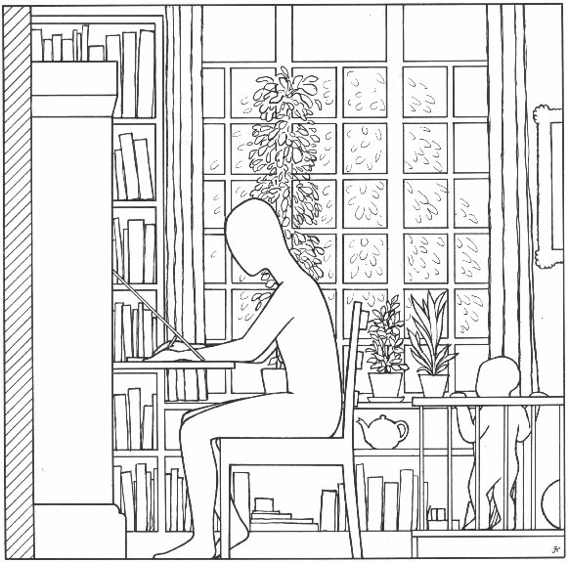 | 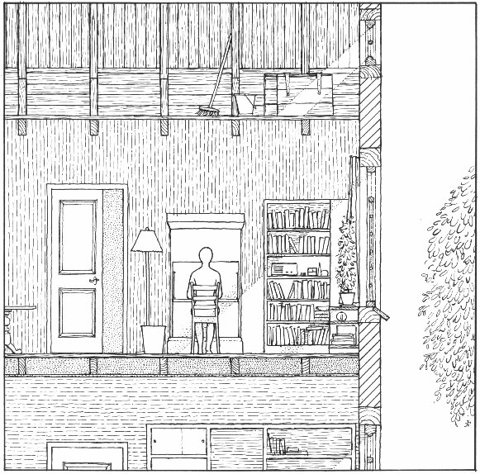 |  | 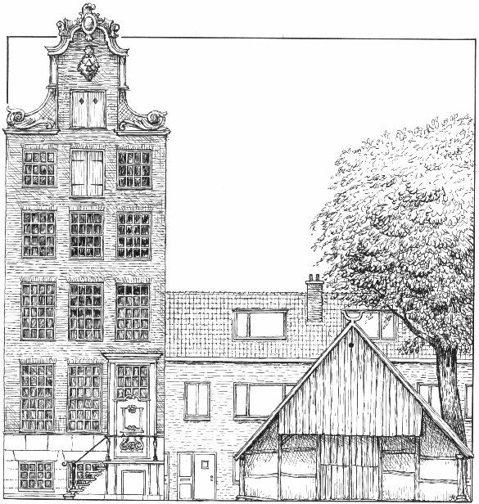 | 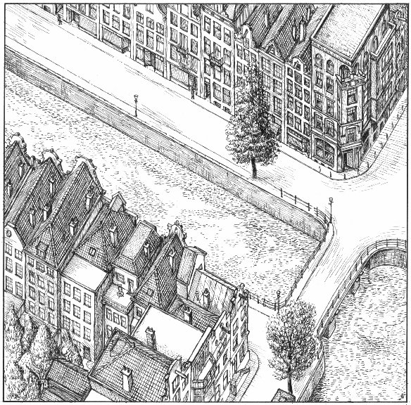
0 year: R = 1m | 1 year: R = 3m |  | 3 years: R = 10m | 5 years: R = 30m
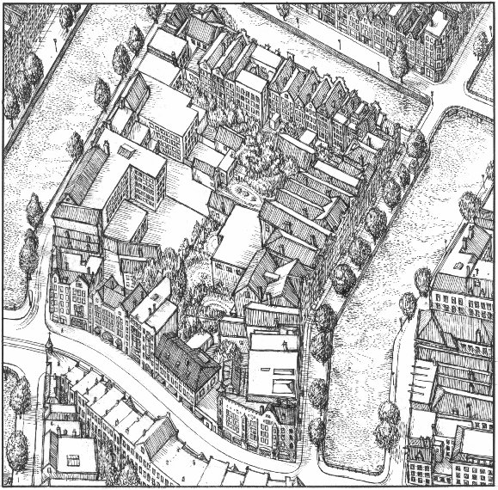 | 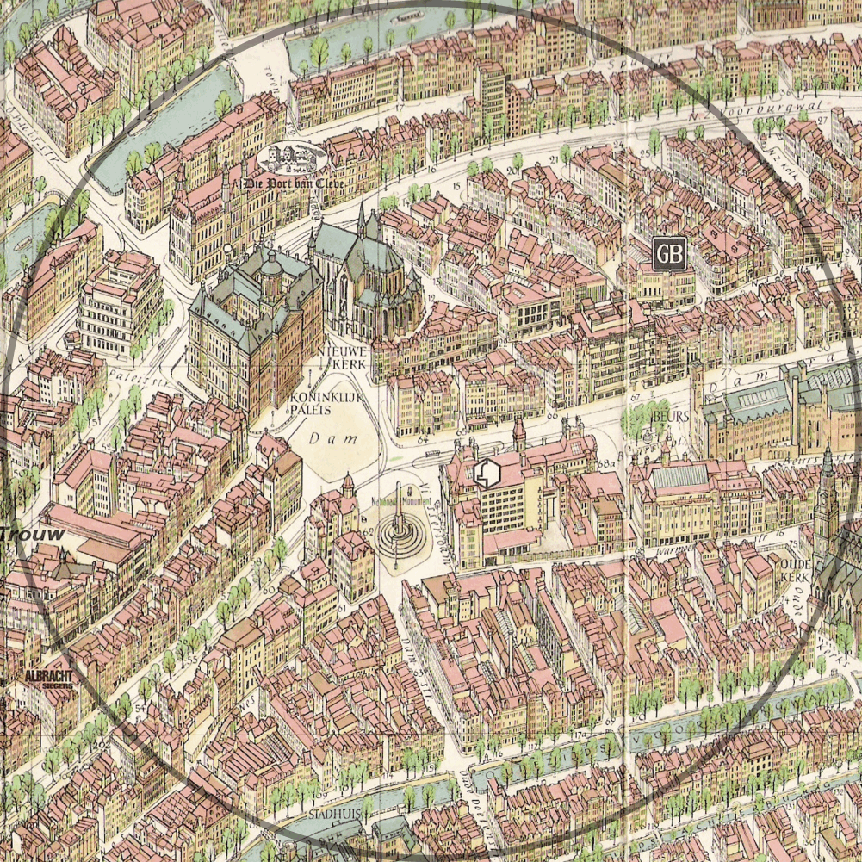 | 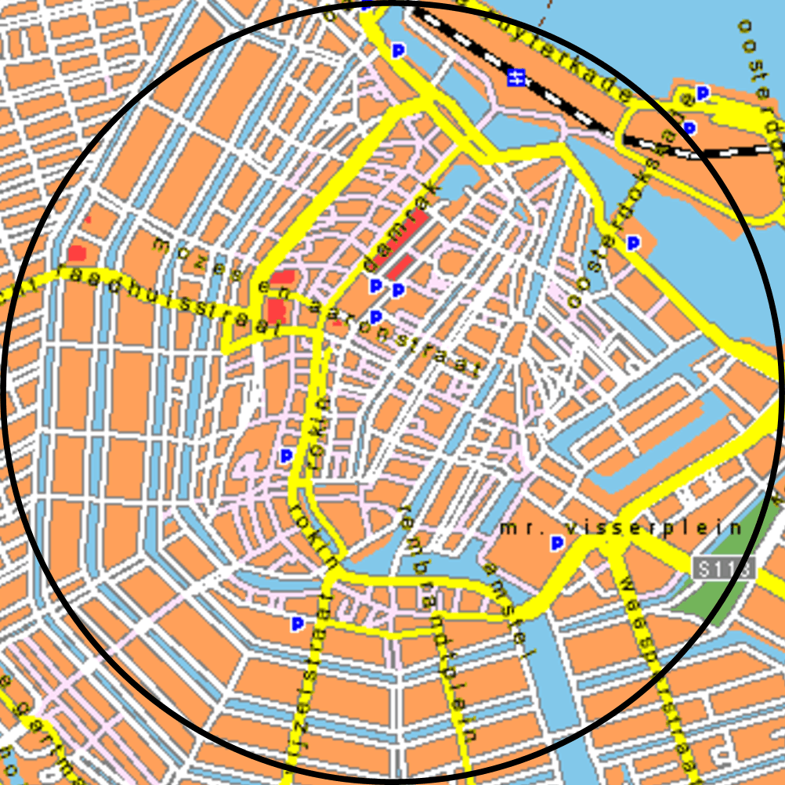 |  |  | 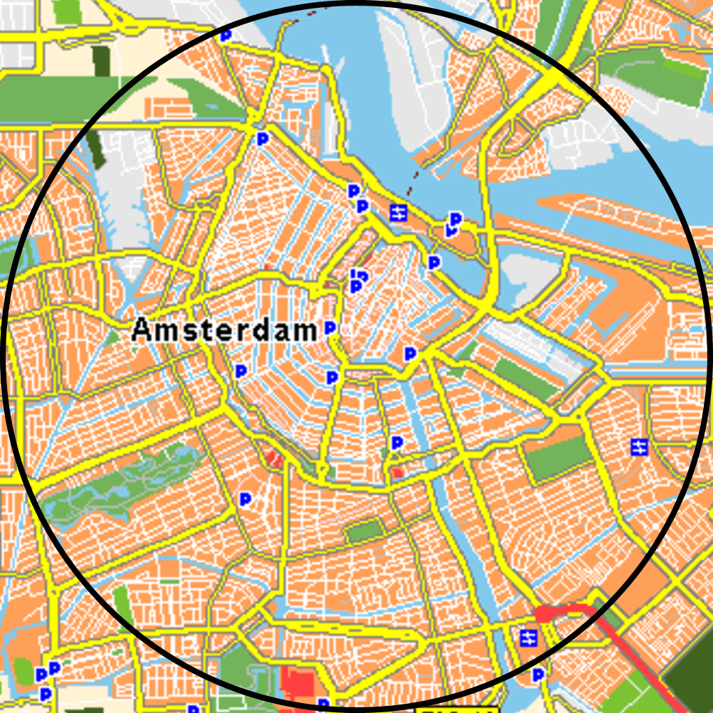
7 years: R = 100m | 9 years: R = 300m | 11 years: R = 1000m |  |  | 13 years: R = 3000m
Jong, T. M. de; 5 drawings by Jan Huffener (1978)
Fig. 2 Growing awareness by scale
Let us first try to look as a child on different ages. I am sorry in this text it’s a boy like I was, rewrite it yourself for a girl if you think it’s relevant.

A baby street like a room (3m)
You are one year old. The front door opens and they put you in a buggy. Suddenly at one side, all kind of unknown objects whiz by. Some objects on the far side stay longer. You don’t have any influence, because they drive your car. You cannot stay to experiment parallax properly. So, you look forward. There, all kinds of objects enlarge, become dangerous, but they pass aside and disappear. Suddenly your driver turns. You shake in your buggy. The scene changes dramatically. They drive you in a dark hole. Slowly in becomes lighter. You hear voices, but you see dresses, trousers, legs, shoes and tiles as different colour surfaces. Looking upward you see bodies towering above you, faces and hands. Suddenly they shake you and drive you in a white hole with cars whizzing by. Another shake makes your scene well-known until they take you out of the buggy. They hold you before a wall that opens after some jingle with a turning hand. You smell something you are used to. You are ‘home’.

A toddler street like a house (10m)
You are three years old. You can walk! That means, you can change the world around you by walking through a black hole. Sometimes the hole is gone, but in the mean time you learned to open the wall, standing on your toes and stepping back, pulling a handle down. There are several worlds, but there is one you can open by pulling a handle aside. In that room there is noise, wind, movement and very much space. You may run. They often call you back. If you fall, it’s hard. Between the tiles there are blades and ants. Sometimes there is a drain cover with holes aside somewhat lower. But if you want to look inside they call you back: “dangerous!”. You find pieces of soft brown clay, but they hold you back: “dirty!”. You may not even step on it. They take you into another room by turning a corner. Suddenly you are standing in the sun. Here plants are huge and not standing on a windowsill, but in the ground. So, they can not fall down if you run through them. But they call you back: “dirty!”. Some have prickles, so you stay walking on the pavement. There are several pavements: stepping down they are darker with smaller stones. But if you step down they call you back: “dangerous! We said that earlier!”. Stupid: that was the drain cover.

A young child street like a yard (30m)
You are five years old. Your father takes you to school in the morning, your mother from school in the afternoon turning 5 corners. They moved into a house with a garden and a gate to a path, going to a playground and to a street with cars and large trees. You may not play in the sand around that trees, it is dirty. You’ve got marbles, but there are not much groves to play marbles. You like to go to the far side, but it is too dangerous. You’ve got a bike, but you may not leave the pavement with the large tiles. If you stay riding on that pavement, going around the corner three times, you come back from the other side! Your friend has no bike, so together you play on the playground. But it is too childish, your little sister plays there with your mother on the wipperchicken and the slide. My friend had a secret hut there, but they cut off plantation. So, it is not very secret anymore. But he has a real Play station on his computer!

A child street like a school (100m)
You are seven years old. You may cross the street in front of your house. Your new friend lives there. His neighbour has a motorbike. He is repairing it in front of his house. Round the corner lives an ugly man. You ring his bell, run away and look around the corner how angry he is. Your mother takes you to her work. You never knew she has a room there as well. Your portrait is on her desk, but you cannot play there. You get a chocolate in a café with strange people. Your father showed you how to go to Grandma by bus and you got a ticket to try yourself. The driver tells you where to go out. You see large buildings where people work, but they don’t live there and there are no children.

A child street like a village or neighbourhood (300m)
You are nine years old. You may cross all the streets until the district way. You can go to school, the sports field, the hairdresser and to Grandma by bike. You’ve got roller skates on your birthday, but you only may skate on the skate ground at five minutes cycling. There are shops where you can buy stickers, but your new friend makes them on his computer. He takes you to the computer shop, but you like the car models you can buy next door. Your pocket money has doubled last year, but it is still not sufficient. If you help Grandma cleaning her house three times you can buy a Ferrari.

A child street to explore (1000m)
You are eleven years old. You climb the old church-tower and see your house from above, your school, your swimming pool and the fields outside the city where you cycled with your friends. You see your own daily life like a bird. Apparently there are many more districts in town. The city ends somewhere. Next year you will go to high school in another district. You will loose friends of your neighbourhood and find new ones from elsewhere.

A teen-ager street to meet (3000m)
There are students from other cities and countries in your class. In the geography class you learn countries and cities by heart. You visit them on holiday. You are not a child anymore. You have seen your city by night. There are right and wrong disco’s. You have got a newspaper round to be able to pay for your girlfriend next time. You look at her lighted room from behind a tree in the street where she lives. Where could you make an appointment next week? She often goes to a volleyball ground hidden behind a large office building in her neighborhood. There you can sit, beyond neon lights, unnoticed by others, pretending to look at the games together.

Field of vision
From the second year on, children grow linear with their age to the adult stature of their nationality (see Fig. 4). After 10 years old they outgrow a car (Fig. 3). So, children have less overview than adults.

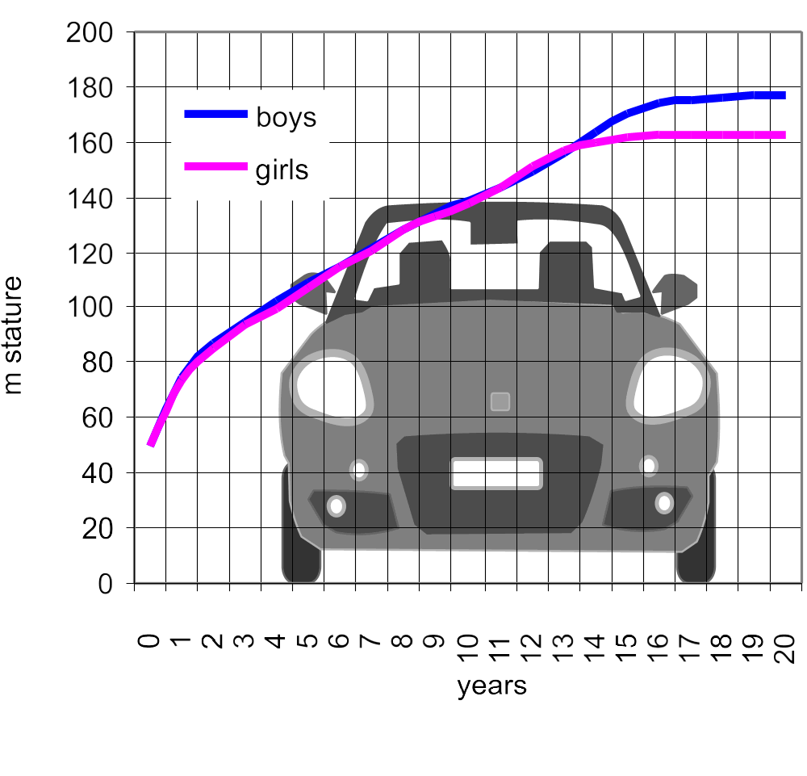 | 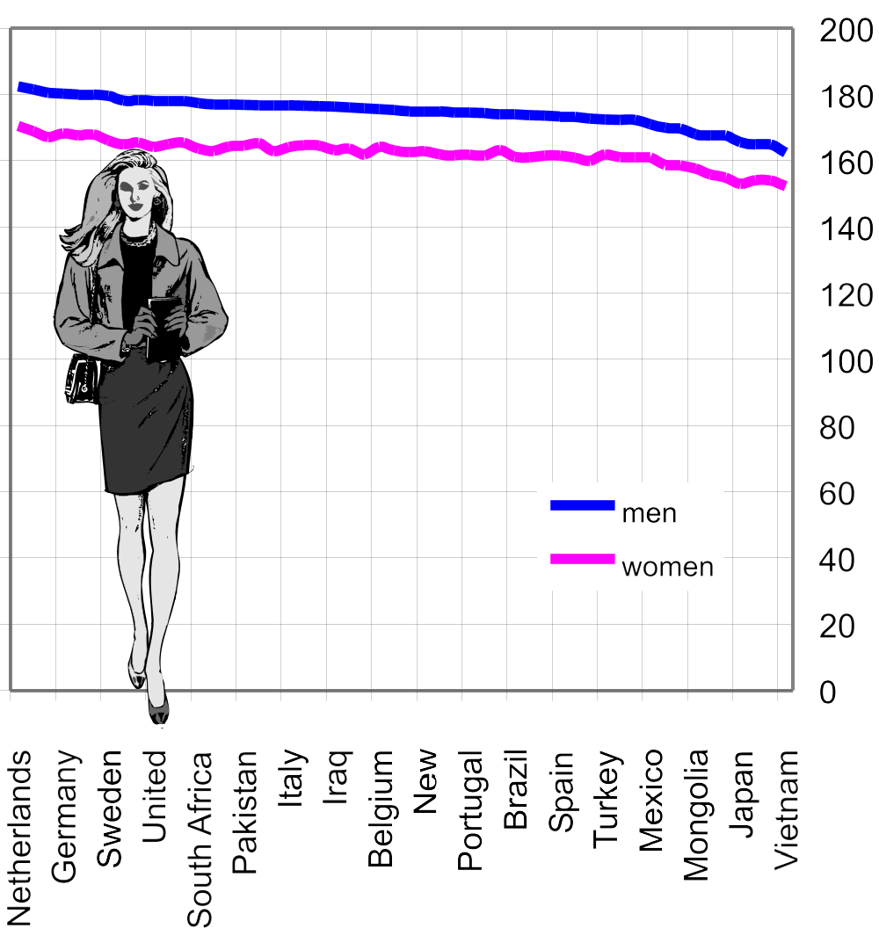
http://kidshealth.org/parent/growth/growth/growth_charts.htm l | http://en.wikipedia.org/wiki/Human_height
Fig. 3 Growth of an average child in the USA | Fig. 4 Adult length variation by nationality
Moreover, their field of vision is smaller. So, their vision is closer to the fixation center with less attention to context. Context sensibility seems to be primarily the task of hearing. But, to determine the direction of noise is more difficult for children than for adults. Deaf people compensate their failing sense by developing a larger field of vision earlier.

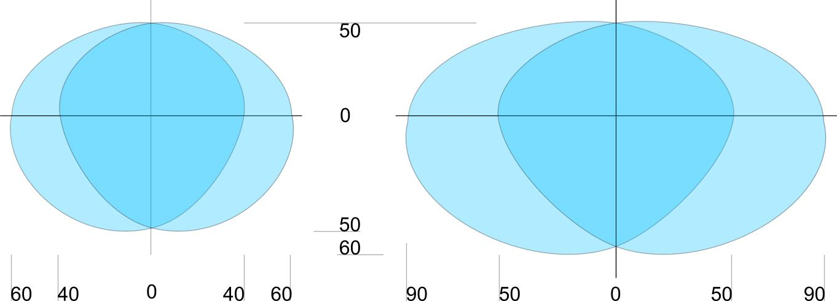
http://www.shef.ac.uk/personal/l/lgf/visiondeaf/ | http://home.zonnet.nl/jcamps/gezichts.htm
Fig. 5 A child’s average field of vision, and an adult’s average field of vision in degrees from center.
Visibility is highest in the central fixation point, declining into the boundaries of the field of vision (see Fig. 6).

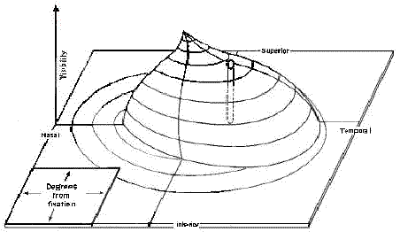 | 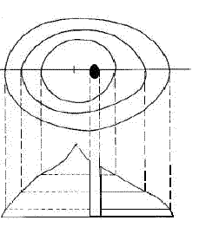
http://www.msac.gov.au/pdfs/reports/msacref13.pdf | http://www.msac.gov.au/pdfs/reports/msacref13.pdf
Fig. 6 Visibility represented by Anderson (1984) as a third dimension in the field of vision.
Because of their limited field of vision children have to move their head more often than adults to build up a concept of context. Adults complain wrongly about lack of concentration then. They have to change focus themselves to understand the composition of a scene as well. Design helps to balance recognition and surprise. Too much recognition causes boredom, too much surprise chaos (see Fig. 8).

The composition of a scene
A scene comprises components and details. To design a quickly understandable scene we have to make larger components externally different from each other, but internally filled with characteristic details recognizably equal to distinguish the particular component from the other components with other characteristic details. That art is called composition.

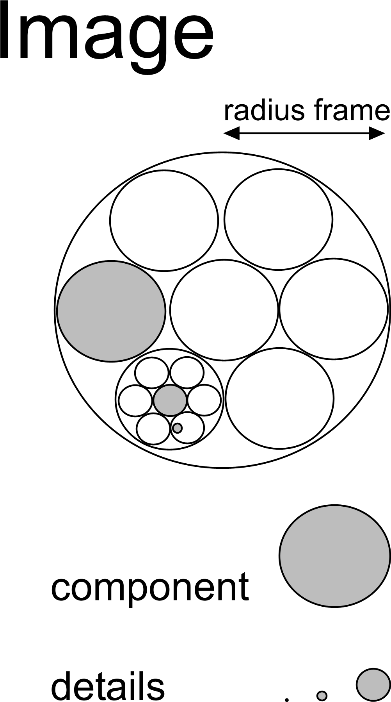 | 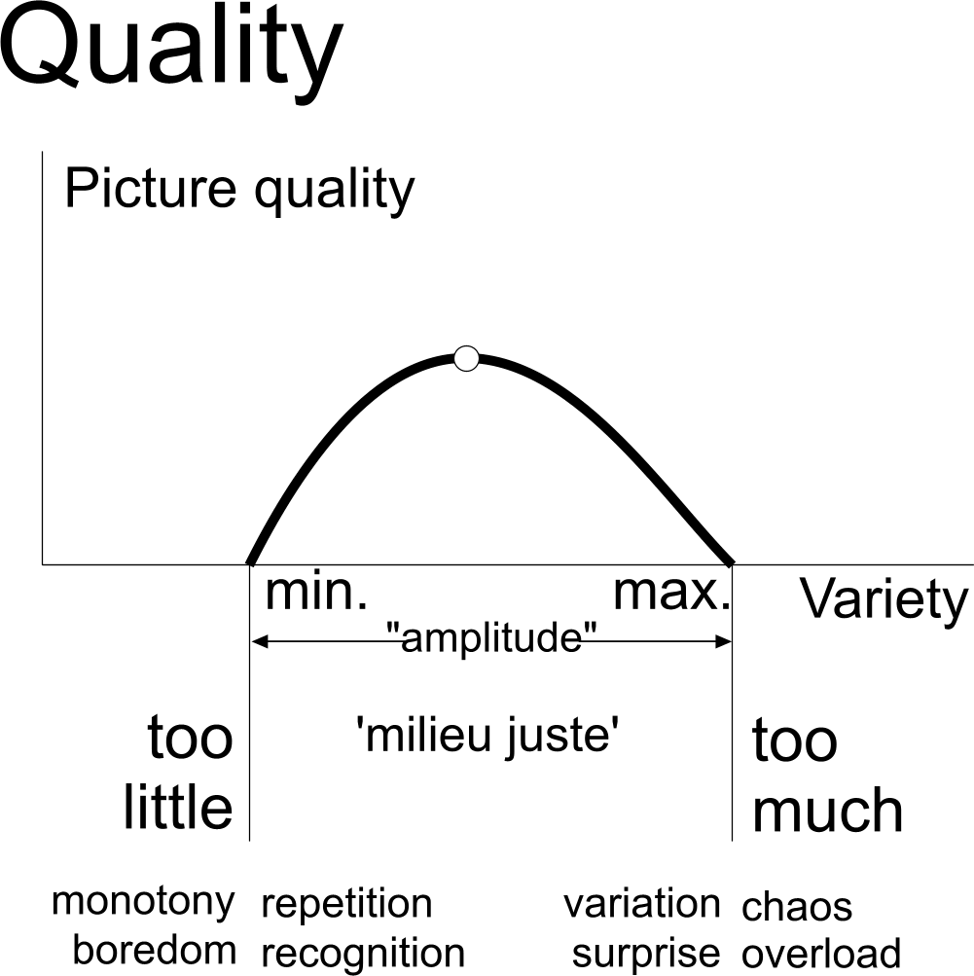 | 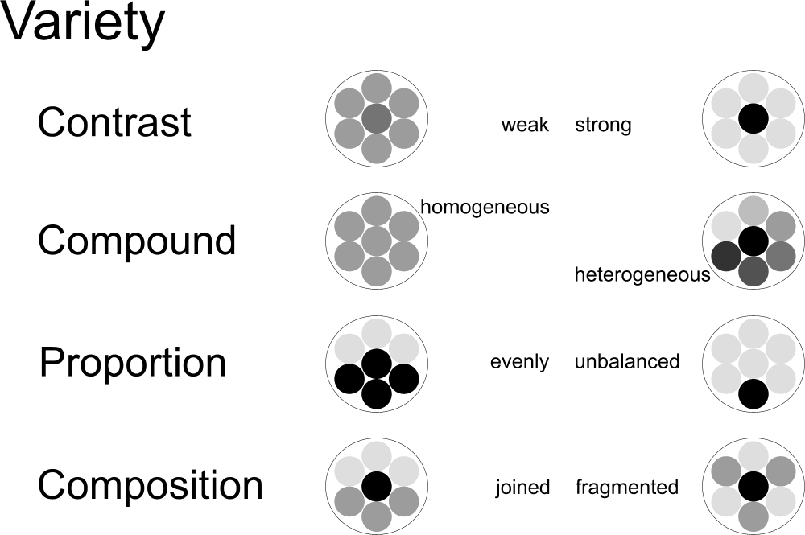
Jong (2004) | Jong (2004) | Jong (2004)
Fig. 7 Components | Fig. 8 Quality as a working of variety | Fig. 9 Design means of variety
Any level of scale mentioned in Fig. 2 needs its own composition. On any level of scale components and details have new characteristics of categorization and orientation. Your action space (R=1m) has hard and soft, movable and non-movable components in different colors. Your room (R=3m) has a door, corners to play, eat and store, different in light, material and visibility. These are the legends for designing a child street like a room.

Your house (R=10m) has differences of accessibility, control, light, noise, temperature, wetness, differently suitable for playing, personal care and rest. What could we use to distinguish the components of a child street like a house? Your yard (R=30m) is differently covered, planted and lighted by the sun. There are components of the house extending in the garden or the street (in-between realm). You behave differently at the back or front side. There are formal and informal places, hard and soft places, places of recognition and surprise. What is the difference between lawn and pavement, terrace and walk? Are there in-betweens to hesitate where to go?

Your school (R=100m) has spaces to sit and to run, compete, watch, play and learn. Your village or neighborhood (R=300m) has spaces to buy, walk and ride a bike. Your district (R=1km) has spaces of living, business, traffic and parks. Your city (R=3km) has spaces to meet and retire, atmospheres and cultures to explore.

Conclusions for urban design
A field of vision comprises a largest measure in reality (frame, expressed as R) and a smallest visible detail (grain, expressed as r). Both change the observed composition if you approach an object or a scene. The distance from the observed composition is approximately equal to its frame.
If the frame of a picture represents a reality of radius R = 10m and the grain a radius r = 10cm, the resolution r / R is 1%. You will call the result a ‘drawing’. If frame and grain differ less (say 3%), it is a rougher sketch, stressing the concept. If they differ more, it could be a more precise blue print (0.1%). Object and details of a blue print lay too far apart to understand the composition or concept immediately, they get their use primarily for realization.

On every level of scale the map you draw may have a different legend. For example, in a drawing with a frame R=10m, you can draw tiles in the pavement (10cm), the kind of plantation, the furniture of the street and the entries of homes. These are adult categories. Make a sketch to group them more roughly into less components, comprising child categories. But what do you choose as components and their legend units in other frames? You have to dissect or group them into components suitable for child perception on different ages. Fig. 10 gives an overview of variety per level of scale named in this article. You could interpret it as guiding principle for design: try to change softness every meter, light every 3m and so on. However, for example light and shadow could be changed very successfully on other levels of scale as well. The table is only a starting point to be extended.

years old | 0 | 1 | 3 | 5 | 7 | 9 | 11 | 13
m Radius of frame | 1 | 3 | 10 | 30 | 100 | 300 | 1000 | 3000 | learning
differences to experience:
hard-soft | x |  |  |  |  |  |  |  | danger
movable|non-movable | x |  |  |  |  |  |  |  | operational abilities
color | x |  |  |  |  |  |  |  | recognition
windows|doors |  | x |  |  |  |  |  |  | orientation
light|dark |  | x |  |  |  |  |  |  | imagination
shelter|corners |  | x |  |  |  |  |  |  | to escape adult movements
function|time |  | x |  |  |  |  |  |  | every time having its own place
visibility |  | x |  |  |  |  |  |  | hide-and-seek
accessibility |  |  | x |  |  |  |  |  | rules
control |  |  | x |  |  |  |  |  | other people
noise |  |  | x |  |  |  |  |  | context
temperature |  |  | x |  |  |  |  |  | kinds of clothes
wetness |  |  |  | x |  |  |  |  | hygiene
ceiling|shelter |  |  |  | x |  |  |  |  | in-betweens to hesitate, to decide
plantation |  |  |  | x |  |  |  |  | nature
sun |  |  |  | x |  |  |  |  | nature
formal-informal |  |  |  | x |  |  |  |  | different behavior
recognition|suprise |  |  |  | x |  |  |  |  | initiative
run|compete |  |  |  |  | x |  |  |  | ambition
watch, learn |  |  |  |  | x |  |  |  | to learn
possibility to buy |  |  |  |  |  | x |  |  | expensiveness
possibility to walk |  |  |  |  |  | x |  |  | interest
possibility to ride a bike |  |  |  |  |  | x |  |  | ride
urban functions |  |  |  |  |  |  | x |  | exploration
meet|retire |  |  |  |  |  |  |  | x | projection|identification
atmosphers|cultures |  |  |  |  |  |  |  | x | identity
Fig. 10 Legends for design
A composition is not only determined by components, but also by details directing your fixation. We only mentioned characteristic details, determining components. But there are also marking details, determining boundaries, connecting details determining in-betweens and striking details labelling the whole scene.

Used literature
Anderson, D.R. (1984) Testing the field of vision (St. Louis) Mosby
Jong, T. M. de; with drawings by Jan Huffener (1978) Milieudifferentiatie; Een Fundamenteel Onderzoek (Delft) Faculty of Architecture. Delft University of Technology.
Jong, T. M. d., Ed. (2004). Sun, wind, water, earth, life and living; legends for design. (Delft) TUD Faculteit Bouwkunde Publicatibureau.
Piaget, J. and Inhelder, B. (1947) La representation de l'espace chez l'enfant (Paris) Presses universitaire de France
Verhulst, F.C. (2003) De ontwikkeling van het kind (Assen) Koninklijke Van Gorcum
Internet: http://team.bk.tudelft.nl, http://kidshealth.org/parent/growth/growth/growth_charts.htm, http://en.wikipedia.org/wiki/Human_height, http://www.shef.ac.uk/personal/l/lgf/visiondeaf/, http://home.zonnet.nl/jcamps/gezichts.htm, http://www.msac.gov.au/pdfs/reports/msacref13.pdf

Key words

accessability 5; 6
action space 5
ambition 6
and 3
Anderson 5
atmospheres 5
atmosphers|cultures 6
background 1
backside 5
bike 3; 5
blue print 6
boredom 5
bus 3
business 5
buy 6
buy 5
car 1
ceiling|shelter 6
chaos 5
characteristic details 5
city 3; 5
color 6
colour surfaces 2
compete 5
components 5
composition 5
computer 3
concentration 5
concept 1
concept of context 5
context 6
context sensibility 4
control 5; 6
corners 3
country 3
cover 5
cultures 5
danger 6
dangerous 3
details 5
different behaviour 6
direction 4
dirty 3
disco 3
district 3; 5
drawing 6
enlarge 1; 2
every time having its own place 6
expensiveness 6
exploration 6
field of vision 4
fixation 4
fixation point 5
focus 5
formal 5
formal-informal 6
frame 6
frontside 5
function|time 6
garden 5
grain 6
growyh 4
hard 5
hard-soft 6
hearing 4
hesitate 5
hide-and-seek 1; 6
highschool 3
house 3; 5
house from above 3
Huffener 2
hut 3
identity 6
imagination 6
in-beteens 5
inbetween realm 5
in-betweens to hesitate, to decide 6
informal 5
Inhelder 1
initiative 6
interest 6
Jong 2
kinds of clothes 6
lawn 5
learn 5
legends 5
light 5
light|dark 6
living 5
logical operations 1
material 5
meet 5
meet|retire 6
merry-go-rounds 1
mother 1
motoric ability 1
movable 5
movable-non-movable 6
nature 6
neigbourhood 3
neighbour 3
neighbourhood 3
neonlights 3
noise 5; 6
object and context 1
object constancy 1
objects 2
operational motoric abilities 6
orientation 6
other people 6
overview 4
parallax 1; 2
parks 5
pavement 5
pavements 3
Pavlov-reflex 1
peekaboo 1
Piaget 1
plantation 5; 6
play 5
playground 3
playing tag 1
Playstation 3
pocket money 3
projection|identification 6
radius of awareness 1; 2
recognition 5; 6
recognition|suprise 6
retire 5
ride 6
ride a bike 6
roller skates 3
room 2; 5
rules 6
run 3; 5
run|compete 6
sand 3
school 3; 5
seesaw 1
shelter|corners 6
shops 3
sit 5
skateground 3
sketch 6
slide 3
soft 5
stature 4
strange people 3
street 3; 5
sun 5; 6
surprise 5
swings 1
synaesthesy 1
temperature 5; 6
terrace 5
ticket 3
tiles 3
to escape adult movements 6
to learn 6
traffic 5
trees 3
urban functions 6
village 3; 5
visibility 5; 6
walk 6
walk 3; 5
walking 3
watch 5
watch, learn 6
wetness 5; 6
windows|doors 6
wipperchicken 3
yard 3; 5

http://www.shef.ac.uk/personal/l/lgf/visiondeaf/

