Ways to study and research Urban, Architectural and Technical design
Prof.dr.ir. Taeke M. de Jong 2005-01-28

- Introduction
Methodology is understanding each other’s methods. However, there are more methods of design, study and research then there are designers and scientists. Which of them we can trust (reliability)? Which of them could communicate or justify our results rationally in the scientific community (validity, criticism)? Which of them could be applied in our own professional motivation? Emotion is our fuel making things move; reason is our oil making things work; criticism is our steering wheel, giving direction. The way to select your own method emotionally and rationally is criticism and debate. Criticism and debate suppose statements, drawings and texts to be criticised and discussed.

My chair ‘Technical ecology’ found in the domain of this context-science a rich source of methodological problems similar to those of design related study. That is why in the year 2000 my chair got the assignment from the Faculty of Architecture TUDelft (3000 students) to compose a book ‘Ways to study and research Urban, Architectural and Technical design’. This book was published in 2002 and is now obliged literature in Bachelors and Masters of this Faculty, supporting courses in the first, third, fourth and fifth year of the curriculum. Approximately 1000 students made a website on their personal ways to study. This contribution gives an impression of its contents. A second volume ‘Ways to precedent analysis’ is in preparation, filling gaps in the section ‘Design research’.
- The book
For the first time 48 authors of the same Faculty explained in one book how they study and research urban, architectural and related technical design and how others do it.
Two committees of methodology (in 1990 and 2000) studied which kinds of methods are the competence of the Faculty of Architecture TUDelft to be teached. They concluded 8 categories. These roughly became the main sections of the book (see Table 1).

A | Naming and describing
B | Design research and typology
C | Evaluating
D | Modelling
E | Programming and optimising
F | Technical study
G | Design study
H | Study by design
Table 1 Categories of design related study
The editors of the book having read all contributions several times decided to standarise only four technical terms throughout the book (see Table 2).

 |  | OBJECT OF STUDY
 |  | determined | variable
CONTEXT | determined | Design research | Design study
CONTEXT | variable | Typological research | Study by design
Table 2 Categories of design oriented study
We speak about study when the object is variable, not yet determined. Electricity was studied in the 18th century, but the phenomenon was not yet determined. That happened in the 19th century. Then it became object of re-search, as the Americans called the empirical scientific activity since the beginning of the 20th century. We followed that use in Europe and degraded the older and more general term ‘study’ as an activity of unexperienced students. But any scientist not having the modesty of the beginner in a world of which we only know and understand a negligible fraction, becomes an administrator of still very poor knowledge. Knowing more means doubting more.

Hertzberger explores the methods assisting in opening up possiblities, instead of determining them. Descartes’ ‘Discours de la Méthode’ focused on doubt. Design study distrusts, like classical sciences, all that is obvious, but does not throw everything overboard all at once. Experience evaporated into routine deserves suspicion of the scientific approach, deeming no pre-supposition sacred. However a culture, certainly a local one, surrounds us with pre-suppositions unbeknown to us; like a fish without knowledge of the water it is taken from, at the same time there is certitude of existing conditions: a table, a bed, a kitchen entails great forms of freedom.

As soon as the object is determined we can re-search it as an empirical fact, with empirical methods. Existing drawings and texts are historical, empirical facts after all, subject to design research and more designerly: typology. But how to study them in a scientific way when we have to make them? Before they exist only the context could be studied empirically as a source of the programme of requirements. But the translation into spaces, masses and materials is an other question with many supplementary decisions. We make design studies like Rembrandt and Chopin made studies, but can we do it in a scientific way? The hypothesis of the book is: ‘Yes!’. If it would be ‘No!’, like Priemus of all the authors most closely seems to state, design courses are not home at a university.
- Context
Table 2 shows another important term for urban, architectural and technical design: context.
The Rector of our TUDelft Jacob Fokkema in his preface agrees with us: there are no disciplines at the TUDelft as context sensible as urban, architectural and related technical design. There are varying political, cultural, economical, technical, ecological and spatial contexts making scientific generalisation difficult. A good solution here could be a bad solution there. How could we compare technical solutions, buildings, neighbourhoods towns or regions when context can not be excluded by a ‘ceteris paribus’ (under the same circumstances) supposition? Which types and concepts survive in different contexts in the course of time? Designs surviving changing functions and programmes (part of their context) during the period buildings can exist as a construction we call ‘robust’.

Designing means varying a not yet determined object in our head. That is difficult enough, even when the constraints are described properly enough for systematic optimisation. But what to do when not only the object is varying, but also the context, for instance the location? In the book that kind of study is called study by design. In fact the graduate student of urbanism, architecture or building technology searching for an object of study and a location is studying by design. The idea of the graduate project develops in mutual relation between possible object and location. The student starting her or his graduate project is swimming in a sea of possibilities, sometimes for months or even years.

Is there a definitive scientific method for study by design? No. We are searching for it, the book is searching for it and there are examples. The simplest way is to keep context for the time being as if determined and vary the object (design study) and then keep the designed object as if determined and vary context (typological research) and the reverse, again and again. Then it is useful to know something about the possibilities of design study and typology until now. Is it the only method? We do not think so. You can invent a new method or use existing methods. If you invent a new scientific method, you get a place in the next edition of the book. However, if you invent a new method you have to prove it to be new and thus read the book first. Otherwise people will say ‘We knew that already’.

We speak rather easily about varying the context, for instance the location. But context is more than location, it is also the ecological, technical, economical, cultural and political context. They all vary! How do we handle that? By experiencing the possibilities. The book helps with a scheme (Fig. 1).
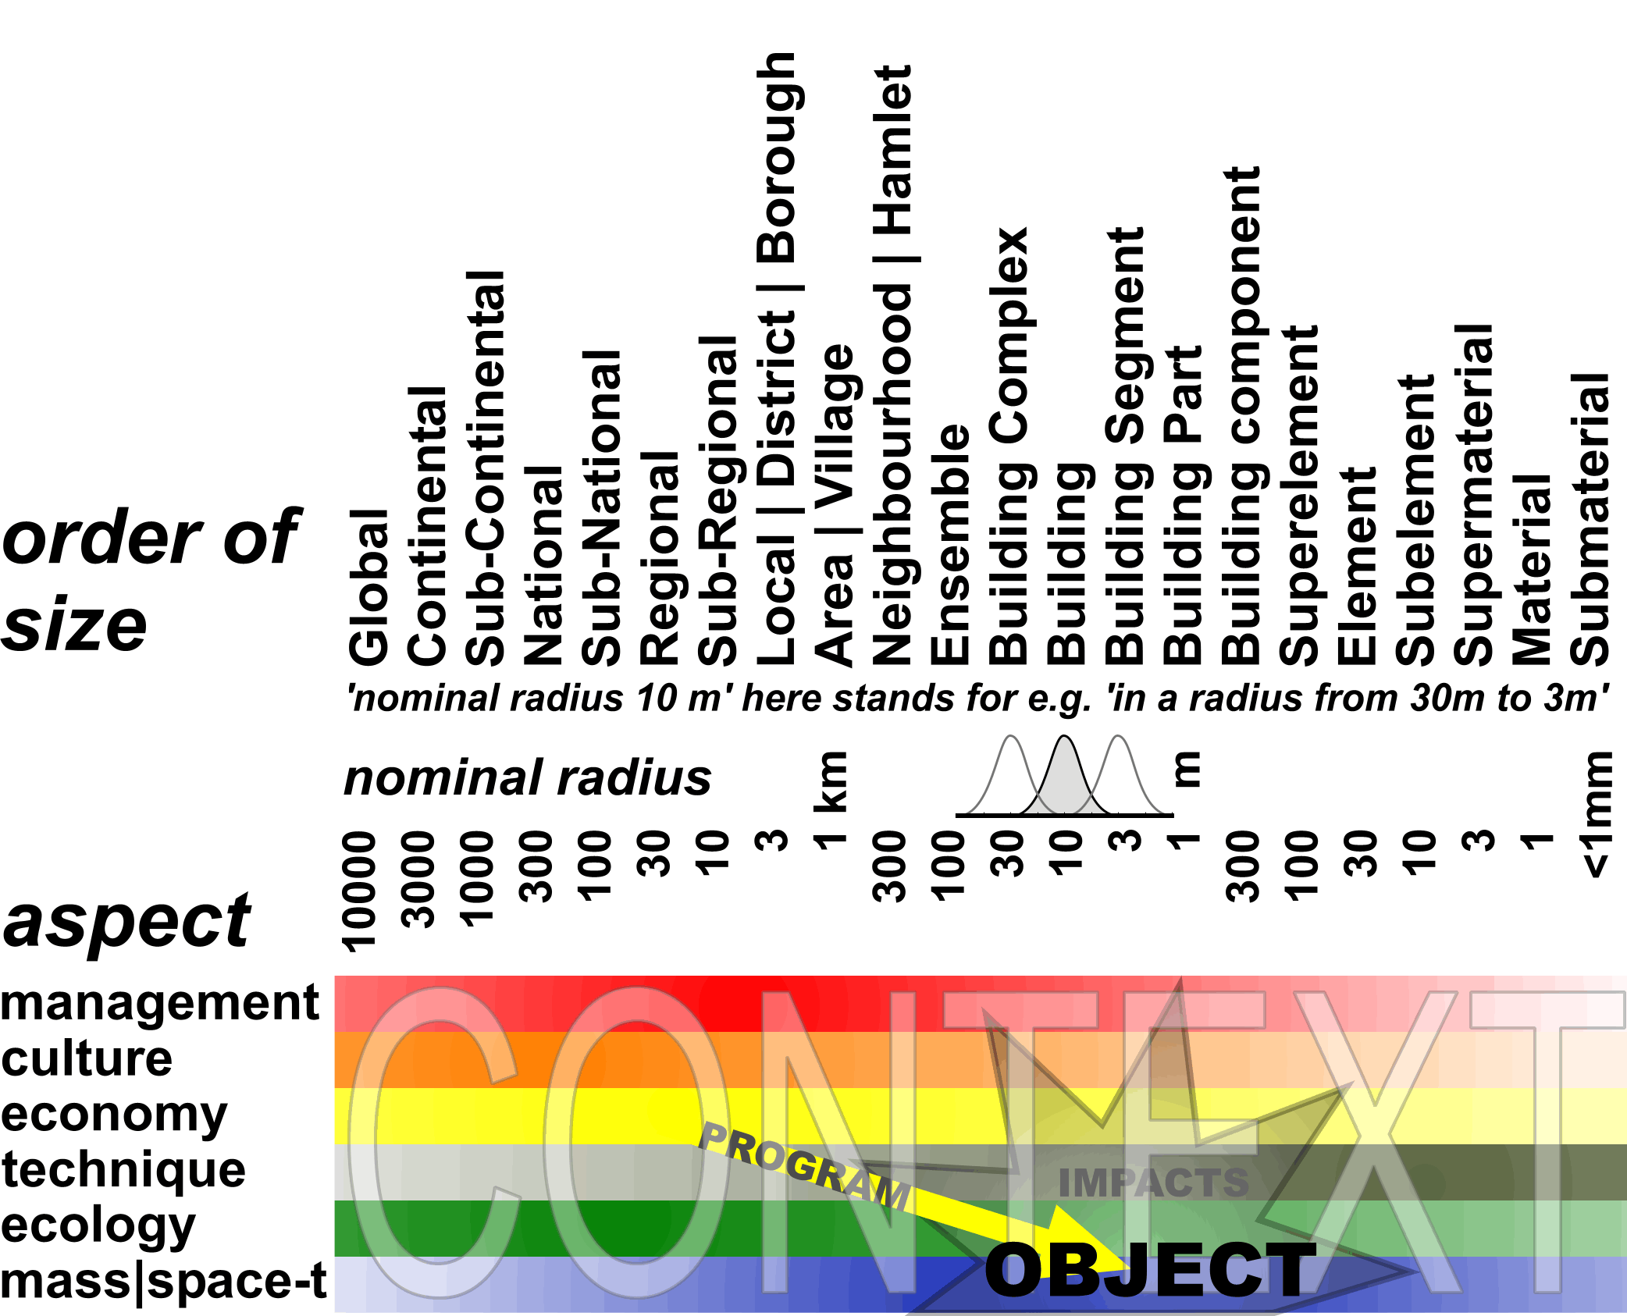
Fig. 1Contexts
Look for the range of scales where your object of study has its place. The rest is context. Any programme of requirements originates in the context of the future object. But what kind of context is it? The management on municipal level can be an initiator, the neighbourhood can obediently follow. Indicate suppositions like this with ‘!’ and “?” in the scheme on some levels of scale in the upper rule. The surrounding culture could be experimental (‘>’) or traditional (‘<’) and that can be different on national, regional, local or any other scale. The local economy could grow (‘+’), the national economy in the same time shrink (‘-‘). The technology could be based on division of tasks (‘/’) on regional level and on combination (‘x’) on local level. In my garden I could develop to more ecological diversity (‘|’) and in the same time more evenness (‘=’) in my neighbourhood if my neighbours do the same. The built up area could be deconcentrated (‘D’) on regional level, but concentrated (‘C’) on local level.

Calculate how many contexts there are possible and you get a feeling of the possible variety of contexts. That is what we learn from ecology as well. To make it worse contexts are changing (perspective). Nevertheless it is important to realise what context you have in mind and hand it over to your judge. When your design or study proposal is judged, your judge could otherwise give a bad judgement because (s)he has an other context in mind for the future. Her or his future is not yours!

Moreover specifying the supposed context of a drawing or text as a scientific document makes it better retrievable.
Retrievability connecterd with the problem of naming and describing concepts and componets of design is a scientific issue of great importance. If you do not communicate your results it will never be part of science. But how do we communicate our (eventually preliminary) drawings for scientific criticism and debate? What kind of accompanying key words do we have to choose to find our drawings back struggling with the same design problems?
What kind of key words do you need yourself to find reference drawings of other designers in a data base according to your problem? Internet is the contemporary answer. But you will not find easily images answering your specific design problem using common key words.
- Key words
Many methodical aspects you can find back in the comprehensive index of the book. It counts some 10 000 key words and key word combinations. The combinations are syntactically coupled to find back contents of drawings or lines of reasoning. In the index an expression like y(x), object(subject) means ‘object y as a working (function, action, output, result, characteristic) of the subject x (independent variable actor, input, condition, cause)’. Syntactic key words give a short and clear representation to criticise validity and reliability of the related concepts used in a study proposal (Fig. 2).
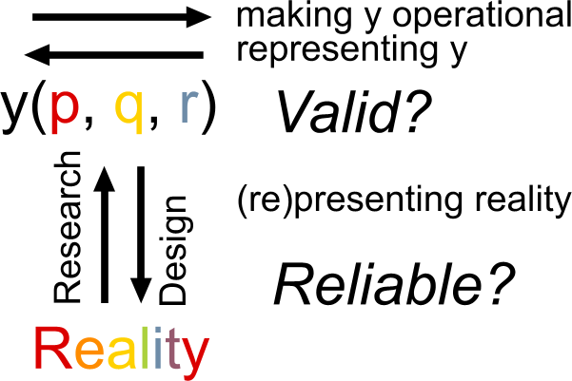
Fig. 2 Judging validity and reliability of concepts used in a study proposal
Suppose you want to make a study proposal. In the index you will find:
study proposal(ability to be criticised) 30  study proposal(ability to be refuted) 30  study proposal(accountability) 29  study proposal(accumulating capacity) 29  study proposal(accumulation(know how, knowledge)) 30  study proposal(aim-orientated) 29  study proposal(assignment initiator) 29  study proposal(bold) 30  study proposal(book) 30  study proposal(cliché) 30  study proposal(concept formation) 29  study proposal(concepts(overlapping)) 29  study proposal(conditional(position)) 29  study proposal(conference) 30  study proposal(converge) 30  study proposal(daring) 30  study proposal(designing(affinity)) 28 | study proposal(drawing code) 29  study proposal(empirically orientated) 29  study proposal(end product) 30  study proposal(expressed(image)) 29  study proposal(expressed(verbally)) 29  study proposal(facilities) 30  study proposal(fascination) 29  study proposal(IAAI) 28  study proposal(identity) 29  study proposal(internet site) 29  study proposal(internet) 30  study proposal(key-words) 29  study proposal(knowledge) 29  study proposal(legend) 29  study proposal(literature lists) 29  study proposal(means-orientated) 29  study proposal(method) 29 | study proposal(presentation) 29  study proposal(publish) 30  study proposal(referee(external)) 29  study proposal(reference(images)) 28  study proposal(representation) 30  study proposal(responsible) 30  study proposal(retrievability) 29  study proposal(risk-free citations) 30  study proposal(scale falsification) 29  study proposal(self-evident aspects) 30  study proposal(study programmes) 30  study proposal(sub-projects) 30  study proposal(synergy) 30  study proposal(theme) 29  study proposal(title(significant)) 29  study proposal(university latitude) 28  study proposal(website) 30
Fig. 3 51 of approximately 10 000 keywords in Ways to Study
It is a checklist! You only have to read 3 pages to know how a study proposal could be judged. On those pages 7 criteria are mentioned which appeared to be useful to judge the research proposals in the Architectural Intervention some years ago and graduate proposals for Bachelors and Masters on our Faculty:

- Affinity with designing;
- University latitude;
- Concept formation and transferability;
- Retrievability and accumulating capacity;
- Methodical accountability and depth;
- Ability to be criticised and to criticise;
- Convergence and limitations.

Graduates and PHD students experimented with these criteria to make study proposals. Concept formation (C) appeared to be a reliable first way to make a preliminary study proposal, using proper key words representing a personal fascination. They help to make your study retrievable by others accumulating urban, architectural and technical knowledge and know-how from the very beginning (D). Primarily vague key words can be made operational for study and research by coupling them syntactically, adding other key words into full sentences and making the supposed working between them more explicit in hypotheses. Then the book helps to find methods to study these supposed workings and prove them by design or research. That helps methodical accounting (E) and makes scientific criticism possible (F). You can show your affinity with designing (A) and your university latitude (B) by comparing existing drawings representing your fascination and making their contexts explicit as described in the preceding paragraph. But the proposal should show limitations as well. You have to show how you will get a result in the limited time given (G).
- Conclusion
The book is not made to read all at once. It is made accessible by very many key words to find your own unique way to study. Students have to choose their own preferences. But design students do not read easily. So, the question arose how to build an interesting course on methodology for designers. A classical exam with questions about the book did not succeed. Instead we asked the students already in the second semester Bachelors to publish their earlier work in a personal website, making it retrievable and convincing for others, to make a proper bibliography and iconography. We added other practical assignments to cover the contents of the book like ‘Compare at least two images fascinating you professionally in a scientific way’, ‘Make a study proposal for your graduation’ or ‘Criticise other websites in the same course’. Raising questions by practice is better than answering them before they arose. In the Masters and PHD phase the emphasis moved to debates about differences in language games between designers, empirical researchers and managers, about differences between research, design study and art science (the object of a newly founded Faculty in the University of Leiden), about the difference between probable, possible and imaginable futures, about the boundaries and suppositions of imagination itself.
The book approaches its second edition, time to think about drastic improvements. You, dear readers are invited to help by criticism and lacking contributions.

Jong, T.M.d. and D.J.M.v.d. Voordt (2002) Criteria for scientific study and design in: Ways to study and research urban, architectural and technical design. T. M. d. Jong and D. J. M. v. d. Voordt. (Delft) Delft University Press . Reliability, validity and criticism are basic values of science.
Jong, T.M.d. and D.J.M.v.d. Voordt (2002) Introduction in: Ways to study and research urban, architectural and technical design. T. M. d. V. Jong, D.J.M. van der. (Delft) DUP Science. It describes essentials of classical debate.
http://team.bk.tudelft.nl/
Jong, Taeke M. de (2003) Het belang van ecologie voor bouwkundig ontwerpen en omgekeerd (Zoetermeer) MESO http://team.bk.tudelft.nl/ > publications 2003
http://team.bk.tudelft.nl/Education/Education.htm
Jong, T.M.d. and D.J.M.v.d. Voordt, Eds. (2002 Ways to study and research urban, architectural and technical design. (Delft) Delft University Press
Dijkhuis, W. (2002) Languages in: Ways to study and research urban, architectural and technical design. T. M. d. Jong and D. J. M. v. d. Voordt. (Delft) Delft University Press.
Hertzberger, H. (2002a) Creating space of thought in: Ways to study and research urban, architectural and technical design. T. M. d. Jong and D. J. M. v. d. Voordt. (Delft) Delft University Press.
Descartes, R. (1637) Discours de la méthode (Leiden) Jean Maire. Descartes, R. (1977) Over de methode (Meppel Amsterdam) Boom . This classical text, the very start of modernism, is short and very readable. Buy it! It also says something very interesting about Holland, where Descartes lived writing the book.
This part is cited from the introduction on the section ‘design study’ in Jong, T.M.d. and D.J.M.v.d. Voordt, Eds. (2002) Ways to study and research urban, architectural and technical design. (Delft) Delft University Press.
Mácel, O. (2002) Historical research in: Ways to study and research urban, architectural and technical design. T. M. d. Jong and D. J. M. v. d. Voordt. (Delft) Delft University Press.
Jong, T.M.d. and L.v. Duin (2002) Design research in: Ways to study and research urban, architectural and technical design. T. M. d. Jong and D. J. M. v. d. Voordt. (Delft) Delft University Press.
Breen, J.L.H. (2002a) Designerly Enquiry in: Ways to study and research urban, architectural and technical design. T. M. d. Jong and D. J. M. v. d. Voordt. (Delft) Delft University Press.
Jong, T.M.d. and H. Engel (2002) Typological Research in: Ways to study and research urban, architectural and technical design. T. M. d. Jong and D. J. M. v. d. Voordt. (Delft) Delft University Press.
Priemus, H. (2002) The empirical cycle in: Ways to study and research urban, architectural and technical design. T. M. d. Jong and D. J. M. v. d. Voordt. (Delft) Delft University Press.
Fokkema, J.T. (2002) Preface in: Ways to study and research urban, architectural and technical design. T. M. d. V. Jong, D.J.M. van der. (Delft) Delft University Press.
Leupen, B.A.J. (2002) Concept and Type in: Ways to study and research urban, architectural and technical design. T. M. d. Jong and D. J. M. v. d. Voordt. (Delft) Delft University Press.
Loon, P.P.v. (2002) Design by optimisation in: Ways to study and research urban, architectural and technical design. T. M. d. Jong and D. J. M. v. d. Voordt. (Delft) Delft University Press.
Verheijen, A.P.J.M., P.J.v. Eldijk, et al. (2002) Designing Naturalis in a changing context in: Ways to study and research urban, architectural and technical design. T. M. d. Jong and D. J. M. v. d. Voordt. (Delft) Delft University Press.
Frieling, D.H. (2002) Design in strategy in: Ways to study and research urban, architectural and technical design. T. M. d. Jong and D. J. M. v. d. Voordt. (Delft) Delft University Press. Vollers, K.J. (2002) Creating non-orthogonal architecture in: Ways to study and research urban, architectural and technical design. T. M. d. Jong and D. J. M. v. d. Voordt. (Delft) Delft University Press.
Jong, T.M.d. and R.P.d. Graaf (2002) Mathematical Models in: Ways to study and research urban, architectural and technical design. T. M. d. Jong and D. J. M. v. d. Voordt. (Delft) Delft University Press.
Jong, T.M.d. and D.J.M.v.d. Voordt (2002) Retrieval and reference in: Ways to study and research urban, architectural and technical design. T. M. d. Jong and D. J. M. v. d. Voordt. (Delft) Delft University Press.
Jong, T.M.d. and J.J. Rosemann (2002a) Naming components and Concepts in: Ways to study and research urban, architectural and technical design. T. M. d. Jong and D. J. M. v. d. Voordt. (Delft) Delft University Press.
Jong, Taeke M. de (2002) Syntactic key words (Delft) TUD Faculty of Architecture http://team.bk.tudelft.nl/ > publications 2002
Jong, T.M.d. (2002) Comparing and evaluating drawings in: Ways to study and research urban, architectural and technical design. T. M. d. Jong and D. J. M. v. d. Voordt. (Delft) Delft University Press.
http://team.bk.tudelft.nl/Education/Education.htm
Jong, Taeke M. de (2005) Policy, research and design as different language games (Zoetermeer) Lezing 20050301 voor het RIVM in Bilthoven http://team.bk.tudelft.nl/ > publications 2005
Jong, Taeke M. de (2005) Extending Science (Zoetermeer) Lezing 20050224 voor het Orpheus-Intituut in Gent http://team.bk.tudelft.nl/ > publications 2005

