Estimating future effects of an urban plan
Prof.dr.ir. Taeke M. de Jong, TUDelft, The Netherlands 2005-04-05

Mr. Major, Mr. Governor, dear audience,

The way we are welcomed in Adapazari, the professional skill and humanity of the Lord Major and his wife, the municipal Secretary and their cooperators have impressed us deeply and filled us with modesty. Could any advice from outside be useful for you? First of all we are here to learn from you. Lord Major Aziz Duran asked the University of Technology of your Dutch twin city, Delft, to make a study proposal to convince European and other sources of finance. It should convince them that your city can become a European model of risk management, urban planning and architectural value. It should convince them, in your city their money will be used most effectively and with greatest returns.

We were convinced by Ali Guney, that the promising region he comes from, is able to such a performance. He studied in the Middle East Technical University, Berkeley and Delft and works at my office as a scientist and as a very popular docent. He brought together departments of geology, urbanism, architecture and building technology of our University to study Adapazari together with its municipality. Our Rector Fokkema, a geologist, thanked him for doing so and joined our prominent team immediately, involving the Universities of Utrecht and Amsterdam. Such a cooperation has a great scientific importance promising cooperation with Turkish experts and scientists as well.

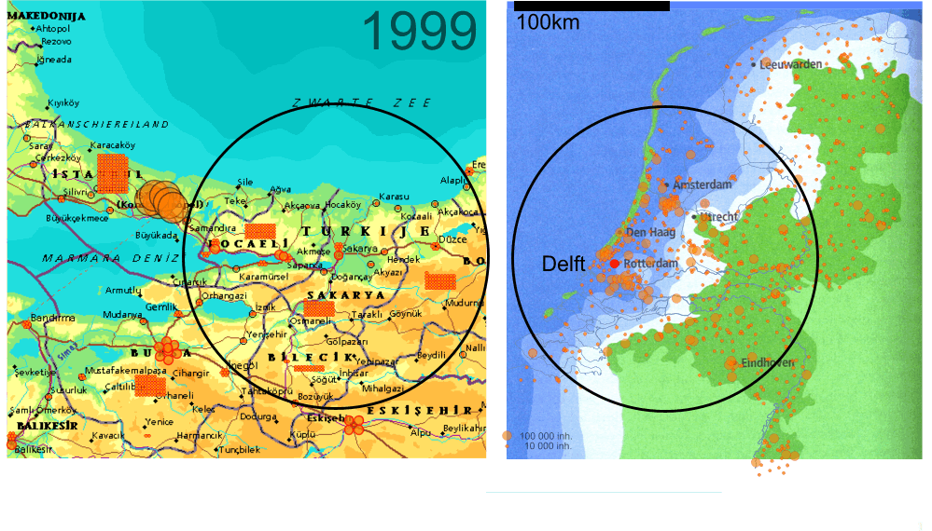
However, both Adapazari and Delft live in risky areas: Adapazari because of earthquakes, Delft because of water. Scientists predict that Delft will be swallowed by the sea within 50 years and that Adapazari would be destroyed again by earthquake if it is built carelessly or in the wrong places. But Delft and Adapazari share optimism and hope to develop unusual technologies and plans controlling their risks. It could be interesting all over the world for other regions in risk as well, and that adds general scientific interest.

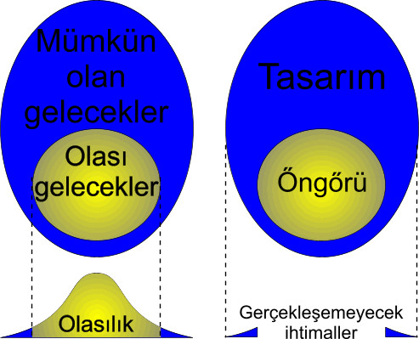 | 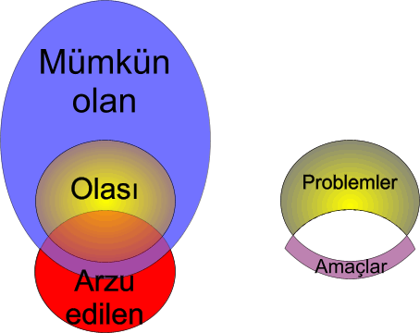 | 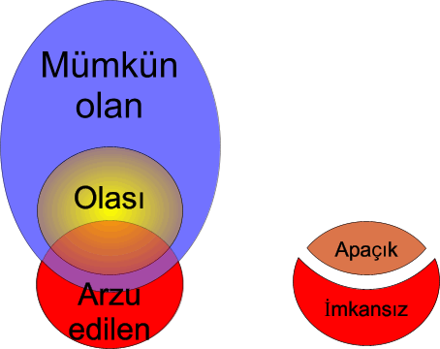

So, if we do not care, it is probable once again to be destroyed by water or earthquake. But probable futures are part of a much larger set of possibilities. Everything probable should be possible after all, otherwise we could not name it probable. But, not every possible future is probable as well! There are improbable possibilities. You cannot predict them, they have to be designed and carefully realised. Probable futures we do not want contain our field of problems. There are also desirable futures that are possible, but not probable. They will not realize themselves. They contain our field of aims. Other desirable futures we can forget. They are impossible or they are probable, obvious. These futures are not to be studied.

In Adapazari there are not only risks, but also opportunities. Dutch people earn some 10 times more than Turkish people. But Turkish income grows some 10 times faster than Dutch income. That means building dikes around Delft is still some 10 times more expensive than building safe homes in Adapazari. Half of Dutch income is spent on personal safety and defense of property by many regulations and inspectors of these regulations.

Investors nowadays flee from Holland because they cannot realize projects easily enough with all these costs and regulations. Why not invite them to invest in an area with regulations for real safety only, to invest in safe homes, carefully designed for people with growing income as long as houses can be built cheaply? But then we need a convincing plan for many years. And we have to hurry. We need a plan avoiding the mistakes Holland made in the period its income grew as fast as yours now: spending too much money for immediate conveniences instead of fundamentals, happiness and esthetic value for our children.

Moreover, after five years of rebuilding a complete city it is time to make plans for the future, plans that avoid mistakes we perhaps made in a hurry. Your income is growing and that means many changes in the way you will use your city. You should look at the changes that have already taken place in other countries to see what probably will happen here as well.

It means for example, that your children will leave your house earlier to rent another house or buy their own one. Then you will need more houses for the same number of people, even if your population would not grow. Your children would like to live with less people in their house to provide their children well-enough conditions and space to study. That means you will live further apart from each other. Then you will have to travel longer to visit each other, to go to school, to work or to shops. You will need a car earlier than you are used to. So, there will be more cars, more roads and less safety in the street. Perhaps you need more space for children to play outdoors safely. But maintenance of public green and the extended pavement by sprawl of built-up area will become more expensive. So, people will eventually prefer their own garden.

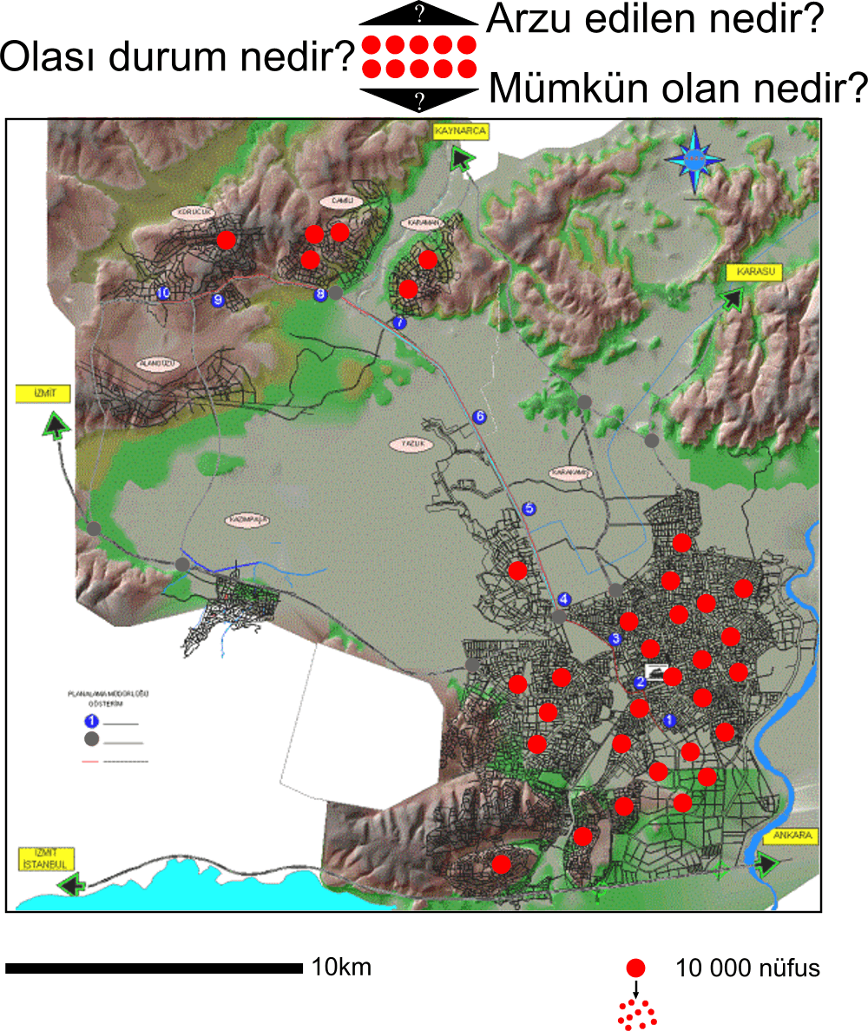
But there will be also more people. Your relatively young population will grow fast and there are people coming from the countryside and from other parts of Turkey, because employment is growing faster in this part of the country then elsewhere. And you will need more employment, because technology makes possible to produce the same with less people all the time. And there are more people to be employed. People would get unemployed if you do not provide more job opportunities like factories and offices in our municipality. And they need space, cars and roads as well. By offering that space and special facilities you can attract more employment, but you have to take care for its impacts. Which of them you can mix up with housing areas, which of them need their own space?

So, within the coming 25 years you possibly will need twice more space for your city than now. Where could you find that space, if you do not like to live in the most risky areas or to destroy the still very beautiful landscape of Sakarya or to loose space your children will need later on for their plans? Within the actual risk-contours you do not have enough space. So, we have to look for more contours where you can build safely with additional building technology and calculate the costs. We have to be more economical with space and calculate carefully what you will need and then draw a plan that combines different uses of space to save space, money and time. Your investments should not devaluate by making mistakes or ugly buildings spoiling your neighborhood, devaluating your property. To improve or rebuild them later will cost more money, because everybody will have a higher income then, including construction workers.

Perhaps you know this already, and I did not have to tell you all of this. But it is good to check whether I understood your situation well in the past four days I was here with you and to conclude that we have a common problem statement.
However, after that a very difficult question remains: what kind of plan do we need precisely here. In Holland every municipality has another method, because of the special governmental, cultural, economical, technical, ecological and spatial situation. And every kind of plan needs its own data to be collected.

You can not make a plan for everything. Many things can be done by the inhabitants themselves after all, but everybody can get benefits of a long lasting municipal plan. With a plan you know what the others are going to do, it can make investments safer. If you can share the costs by intelligently designed combinations that give identity to the place as well, then you will get more profit from your investments. We would like to help making a sustainable plan for places, where people can live, work and recreate better then anywhere. That gives your property more value if you ever would like to sell it.

You can make many kinds of plans. If we regulate much in detail you have less freedom, but you will get more safety about what others in your neighborhood are going to do. If we regulate less, then you will get more freedom, but less safety. What shall we do? We do not like to fill in our own ideas. We like to use your experience as different users of the city. We can gather that experience by asking you two things.

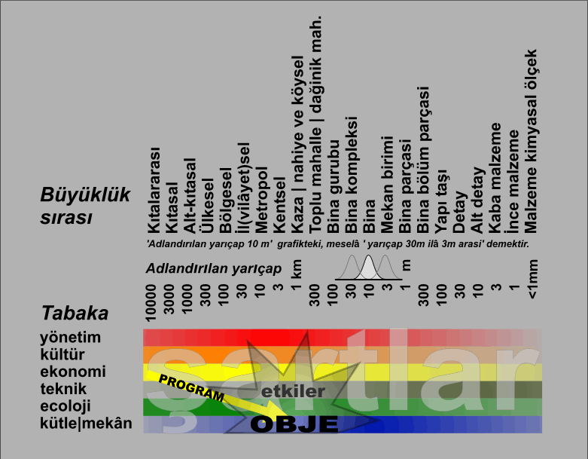

First of all, we would like to know which negative and positive results you expect from a plan like this: where will it cause the most important effects? Do you expect effects on government, culture, economy, building technology, ecology or the quality of space? And on which level do you expect these effects: the region, the municipality, the neighborhood? We do not yet ask you to specify precisely which effects you expect, but where. That is enough to choose the kind of plan and method that can cause or avoid such effects and which kind of data we have to collect. Then we ask which of these effects you would like and which you fear, which effects we have to aim at, to tolerate or even to avoid.

Secondly we would like to use your experience to know what you expect to happen if we would not make any plan. That context determines the effects. Now you do not have to think about what you would like, but what you think to be probable without governmental intervention. For example you could expect that the city without a plan would sprawl over the beautiful landscape of Sakarya, that everything would become the same, that there would be no profitable combinations, that economy would decline by unemployment, that there would be no innovations because everybody remains thinking traditional and that no government will have any initiative. But you also can express the opposite expectations. And again we ask from you to think on different levels of scale. You can expect that national government will have no initiatives any more, but that municipal government, districts, companies or individuals will be full of initiatives, that the municipality will have a culture of innovation, but neighborhoods will remain traditional.

To ask you these questions and get some answers in a limited time we made a computer program we can project on the screen. In the scheme projected I will fill in what I think you expect. You can see what I fill in and we can discuss it. If you do not agree, please raise your finger and tell us what you think. If we are not sure what most of you expect, we can vote. It is only a first try-out to give us a very preliminary impression, a first direction of thinking. So, the results are not fixed, they can be changed later. If you do not like the program, we will skip it and find other ways to hear your voice or vote. If you like it, we can distribute it freely to try it yourself. At least it will help you to distinguish different kinds of future. Scientists like to think about probable futures, politicians about desirable futures and designers about possible futures.
Making a plan you have to take all of them into account.

Thank you sincerely for your attention.

http://team.bk.tudelft.nl/Research/Adapazari/Opdracht.htm

