Ways to plan analysis

(concept) Ir. Ali Guney; Prof. dr. ir. Taeke M. de Jong 2005-10-23

Ways to study

Method, study and research
‘Method’ originates from old Greek ‘meta hodos’ (μετα ٔοδοσ), the ‘way along which’ or the ‘way to’. That’s why we gave our methodology book the title ‘Ways to Study’. Study encloses search, research, inquiry, investigation, examination and so on. We do not always use the popular but more limited word ‘research’, because it has an empirical connotation. Re-search concerns existing cases. It implies the object of study and its context to be determined. So, it does not enclose all design related kinds of study like design itself. Design study concerns objects not yet existing. Composers like Chopin, painters like Rembrandt and architects like Le Corbusier made ‘studies’ as well; they did not re-search, they searched by creation (leaving out at least one assumption commonly supposed to be self-evident until then). They tried to find new examples, prototypes, negating existing cases, avoiding the cliché’s, the very well known types unconsciously applied by their contemporaries.

Analysis, plans and precedents
Plan analysis originates from both Latin and old Greek. Planum is Latin for surface or map. Analysis (ανα λυσισ) means loosening up. In the same way precedent analysis means loosening up preceding (historical) examples, into interesting parts (components, relations, formal reconstructions of the making, supposed transformations). So, it is a kind of empirical re-search, particularly ‘design research’ as Ways to Study names the intended kind of study. As soon as you analyse designs or compositions interpreting flat planes like floor plans, cross-sections and elevations it is plan-analysis. The procedural counterpart of plan-analysis is planning-analysis.

Originally, ‘precedent’ is a juridical term to indicate cases in jurisprudence not yet fixed in laws. Juridical laws are made to avoid bad cases: precedents. By that background it became part of contemporary everyday speech. For example, the Watergate case made President Nixon a case to be avoided: the ‘Precedent of the United States’.

On the other hand, architectural ‘precedents’ are not analysed to avoid such cases, but on the contrary to learn architectural possibilities. These possibilities, proved by existing examples, are not extracted from examples to imitate them, but to combine well-known parts into own new syntheses, wholes, conceptions, types, programmes, models, possibly applicable in always unique other contexts. It supposes such associations can help creating new syntheses (synthetic design). However, within that supposition there are more suppositions hided.

Design as outward synthesis or inward articulation
For example synthetic design (syn-thesis, συν−ϑεσισ means ‘put together’) supposes a way of outward design from predefined parts into a whole. Synthesis is not the opposite of analysis, it necessarily follows analyses being their ultimate aim (engineering). Both operations together are a cognitive, modernist method opposite to an inward approach starting from context.
An inward approach articulates the whole into components and details not determined beforehand or known from examples like a sculptor can do, inspired by a piece of wood or stone, or an urban designer starting with an urban context to define the identity of a smaller location within that whole.

Artus is Latin for joint or limb. Articulus is a diminutive of artus. Articulation starts from context, be it material in space-time, ecological, technical or social: economic, cultural, managerial, administrative context. It does not try to find expected components stemming from previous analyses, it actively draws possible boundaries for unexpected components and details to produce a new composition. In a design process both directions are involved, passing different levels of scale in opposite direction.

Method Clark and Pause
Analysing architectural examples implies you draw parts aiming to synthesize new wholes by combination later. By doing so, Clark and Pause (2005) analysed 104 examples of architecture, typing them by drawing parts (reductions, diagrams) of a supposed architectural reality.
The categories by which they reduce that reality are summarised below in an other sequence (conditional: the next not imaginable without the previous) than Clark and Pause presented:

- site plans;
- floor plans;
  - primary horizontal pedestrian circulations (vertical ones not emphasised);
  - bearing parts (called structures);
- sections;
  - intrusion of natural light;
  - sections recognizable in - or related to - floor plans (called plan to section);
- elevations;
  - missing: material, openings, their dispersion, character (entrance and view)
  - globally visible masses (called massing);
- variation of components (uniqueness as a high value on that variable; ‘equal’ is low);
  - their dominance in a supposed hierarchy;
  - mirrored repetition(called symmetry, balance)
  - additive repetition;
- their composition (called unit to a whole);
  - a formal reconstruction by supposed addition or subtraction of components;
  - geometric proportions between some lengths, widths, heights of components;
- a conclusion, a the common divisor of these analytical operations, a ‘parti’.

Synthetic design is supposed to occur in some reverse way, subdividing these analytical reductions into ‘formative ideas’ to conceive a new design. Then, the parti, now seen as a ‘pre-parametric sketch’ (better to be named a pre-metric or even better a measureless sketch) or even seen as a conception, could be the point of departure of a synthetic design process by adding formative ideas from any example. So, the second part of Clark and Pause (2005) takes the formative ideas as a starting point to collect examples per formative idea. However, are they ideas, ideal types or types?

Typology as a result
In their preface, Clark and Pause claim to unravel designs into ‘archetypes’ by comparison of examples from different contexts. So, actually a typology emerges. In the first part of their book the categories of types are collected per example, in their second part, the examples are collected per type. However, the naming and order of succession in the second part is changed, and they are elaborated into subcategories. It strengthens the suggestion these names represent formative ideas instead of what they are: categories found by generalization of examples from different contexts, types.
The list below shows the sequence of Clark and Pause can be changed into the same conditional order as the previous list of type categories. It shows also, that some of the previous reductions are not used to represent ‘formative ideas’ or examples of a type:

- types of site plans: not represented in a typology by Clark and Pause
- types of floor plans
  - circulation or use (called configuration patterns): linear use; linear circulation; central use; central circulation; double centre; cluster; nested, concentric; binuclear
  - bearing parts (called structures): not represented in a typology
- types of sections
  - intrusion of natural light: not represented in a typology
  - plan to section: equal; half; analogous; proportional; inverse
- types of elevations: not represented in a typology
  - missing: material, openings, their dispersion, character (entrance and view);
  - globally visible masses (called massing): not represented in a typology
- types of component variation in any plane (called progressions):
  - hierarchy;
  - mirrored variation (called symmetry, balance): symmetry; balance by configuration; balance by geometry; balance by positive and negative
  - additive variation;
    - transition; transformation; mediation
    - repetitive to unique: unique surrounded by repetitive; unique by transformation of repetitive; unique in repetitive field; unique added to repetitive; unique defined by repetitive
- types of composition in any plane:
  - a formal reconstruction by supposed addition or subtraction of primary components:
    - subtractive; additive
    - unit equals whole; units contained in whole; whole greater than sum of units; units aggregate to form whole; units overlap; units separate
  - geometric proportions recognizable between some lengths, widths, heights;
    - basic geometry; circle and square; rectangle overlapped by circle; two squares; nine-square; four-square; 1.4 and 1.6 rectangles; geometric derivatives; rotated, shifted, overlapped; pinwheel, radial and spiral; grid
    - reduction: large plus small reduction; part of whole reduction
- types of partis: not represented in a typology

So, we now can speak about different types of buildings: linear use type, linear circulation type, double centre type and so on. Strengthening a specific typological characteristic could be the aim of partial design operations. So, you could try to transform your circular drawing into a more linear type, but that means a lot of partial transformations with many kinds of side-effects. So, if you do not want to loose direction, you need a conception. But the conception of a building is not a type and not a parti, because a conception is unique for a building in a unique context, often including aspects of that context. It should coordinate the imagination of all participants in the building team from context into details. It can bring together different types, but also characteristic details, a style, a programme, a context, an atmosphere directing the whole process of design. Con-ception is Latin for grasping together.

Method Ching
Ching (1996) has drawn many examples of architecture in a beautiful and stimulating book. By his uniform style of pencil drawing he reduces reality throughout the book in the same way with an eye for details. Sometimes he adds diagrams and texts to clarify the process of drawing, but often they seem too self-evident or less convincing than his drawings. In his drawings, Ching shows an architectural way of looking, reconceiving the image from different viewpoints.

He tries to formulate these viewpoints: starting with the course of primary elements like points, lines, planes, volumes, while looking and drawing. He cites Klee because this artist tried the same. They do not aim for a geometrical description, but for a procedural one. Ching tries to do what Clark and Pause do not, but claim to do indeed: offering formative ideas for the making, drawing, design thinking as a dialogue with your sketch. However, Ching fails in systemizing these viewpoints beforehand as ‘Architectural systems and orders’, decreasing the great value of his book by inadequate verbal representation as we will show later (see page 10 of this paper). The page titles say more than his attempt to systemize them in a scheme beforehand. So let us first look what he really does page by page.

Primary elements and shapes
After his Klee-like treatise of handling primary elements like points, lines, planes and volumes in the first section (‘Primary elements’), in the second section (‘Form’) he shows how architects may combine primary forms, shapes and outlines like circles and squares, primary solids, regular and irregular forms and their transformations (derived forms) while drawing by operations like addition and subtraction. What Clark and Pause directly call ‘configuration’ (centralized, linear, radial, clustered, grid on the level on a building group) Ching simply starts to name ‘form’ (page 58 – 71 of the second edition (1996)). He adds important details like corners and the inward articulation of surface (page 80 - 89) from whole into detail, lacking in Clark and Pause (as we mentioned earlier as 4a in the list on page 2 of this paper) however, without elaborating them too much.

The question remains when we should start to use words like configuration, organization, formation and composition as specific kind of ‘forms’. Perhaps on a larger scale, perhaps later in the design process as inward articulation. Form is still a general concept. If we try to define it even more general, form is a contiguous ‘state of dispersion’ of any substance, be it air or stone or whatever legend unit in a drawing. Even empty space or air can have a state of dispersion, a form. The term ‘state of dispersion’ can be used also for loose elements grouped without clear boundaries like groups of settlements, buildings, trees or windows in a façade. Then the term ‘form’ is less appropriate. On the other hand, to indicate even more explicitly bordered components than ‘form’ could suggest, perhaps we could use the term ‘shape’.

Mass, space and form
Like many architects do, Ching seems to state ‘form’ and ‘space’ as opposites: ‘form and space: the unity of opposites’ (page 94 – 97). But an architectural void or space has a form as well, so it can not be its opposite. The physical opposite of empty space is mass, not form. Form has no opposite. A counter form is also a form, be it seen from the opposite side. But Ching partly corrects his mistake on page 95 by stating: ‘Architectural form occurs at the juncture between mass and space. In executing and reading design drawings, we should be concerned with both the form of the mass containing a volume of space as well as the form of the spatial volume itself.’ We can experience both mass and space, but there is a difference between giving form and experiencing form. We can not give space a form without mass, its state of dispersion. But experiencing (looking, touching) form, only occurs by contour as a result of the state of dispersion of mass, its superficial colour or texture. That experience, often called form is not form itself, but a function or working of the form as state of dispersion. Giving form is not possible without giving form to mass, and by doing so we give adjacent space (air) its counter form. So, strictly spoken page 98 is again incorrectly called ‘Form defining space’ (page 98), because empty space is defined (moulded) by mass. Mass and empty space share their mutual boundaries, perceived as contour.

Base and overhead plane
The earth’s mass with its horizontal surface is a necessary part of defining architectural space.
So, that surface as ‘base plane’ is the very start of defining space within its material context. But architectural space is space bordered in more than one direction. So, a minimum of architecture supposes an outline on the earth’s surface. And that is where Ching starts his lessons in bordering space: designing the base plane (page 99 – 113). Even a suggestion of outline by a change in colour, tone or texture could be an act of architectural design (page 100). You can strengthen that outline by a stronger edge definition even without vertical elements. Only after treating these minimal but very effective design operations Ching introduces vertical operations like locally articulating, elevating or depressing the base plane, being the very start of building. The logical next step is a treatise of the second possible horizontal boundary, the overhead plane (page 114 – 119). However a verbal treatise of both planes related to each other, partly recognizable in the drawn examples is missing. Sometimes they react on each other or seem to live their own life. Any variation of horizontal planes forces verticality. That verticality can be strengthened by the vertical bearing structure or ignored. Sometimes they are distinguished or even strictly separated from vertical connections. That relation could have been elaborated more in detail to introduce vertical elements.

Vertical elements
As to be expected, then vertical elements defining space are introduced, mainly separate from the horizontal planes (page 120 – 157). Paradoxically, the state of dispersion of these linear or planar vertical elements can be explained most clearly by drawing the horizontal planes of floor plans perpendicular to their main direction. The tangible struggle to hit the essence of architecture in these pages is partly solved by oblique or perspective drawings. But the secret of connecting horizontal and vertical transitions remains hidden in many details of the drawings. The straight-forward systematic separate treatise of single, parallel, L-shaped, U-shaped and closed spaces summed up as design means in the floor plan are put into a perspective of numerous complex possibilities with well chosen oblique examples of horizontal and vertical variations combined. Now, we realize that floor plans and sections do not unveil 3D architecture properly. That art seems nearly not describable in flat drawings. You have to walk through reality to experience recognition, expectation and surprise by movement through the sequence of architectural spaces partially closed by varying planes. Here, a motorial sense should complete the visual impression. Ching does still not describe the art of sequence verbally, but his drawings raise curiosity to that experience, they stimulate your 3D imagination, introducing the subject of later pages.

Openings or selective connections with the outside world.
Then openings into the outside world break through the reached architectural closeness in many possible ways on page 158 – 165. However, there is yet no difference in orientation or change of daylight highlighting the closed parts of architectural space opposite to the openings in succession during day time. That essential polarization of architectural space causing transitions of light while moving is still missing if your attentiveness in professionally studying the drawings would lack. That need is partially met in next pages about degree of enclosure (page 168 and 169) and light (page 170 - 173). The last part of this section is about outward view (page 174 – 175).

However, the architectural working of outward view can not be understood completely without the previous experience of approach and entrance treated later in the book, the supposed concept of the environment, situation and orientation. Looking through the windows from inside, visual parts of the outside world from where we entered the building are selected and framed. Light is permitted to come in, but moist, noise or unwanted visitors not and warmth is prevented to go out. So, windows are not mere openings, but selective connections with that outside world like doors, pictures and television screens do, having their own selectiveness, moderated by planes, curtains, blinds or frosted glass. In many respects these openings keep the architectural space closed and opened in some other respects.

Organization or configuration, composition, arrangement, formation, lay-out.
But there are openings to other architecturally more or less closed or separated adjacent spaces as well. There can be spaces within spaces, ‘interlocking’ spaces ambiguously belonging to adjacent spaces or independently linking them. Ching names these possibilities ‘spatial relationships’ (page 179) and gives some examples (page 180 – 187).

The state of dispersion of these spatially related spaces in a building group (centralized, linear, radial, clustered or in a grid, page 189 - 226), earlier called ‘form’ is now named ‘organization’ while Clark and Pause speak about ‘configuration’. However, ‘organization’ implies functions like organs fulfil in a body, and that is clearly not Chings intention.

‘Configuration’ could be a better name, it supposes merely figures put together (‘con’). But figures suppose more than recognizable forms (states of dispersion) within that configuration.
A ‘figure’ implies articulations, more or less determined measures (like elongated or high), proportions and details (like corners). So, it is more precise than ‘form’ or even shape. ‘Figures’ in everyday speech refer also to numbers after all.

‘Composition’ could be an even better name, but a composition fills the available space completely with components and details, while configuration does not. Con-posing is literally Latin for ‘putting together’. Composition has literally the same meaning as hidden in Old Greek συσ−τημα, sys-tem. But the contemporary term ‘system’ refers to determined operational workings between its ‘elements’ not intended here. The same workings are supposed between ‘organs’ in an ‘organization’, but there they are supposed to be less determined and often less separated by sharp boundaries. Composition misses that structural content of connections and separations.

Perhaps actually meant both by Ching, Clark and Pause is more general ‘formation’ of recognizable forms at a higher level of scale than these forms, not explicitly being components, details, figures. The design procedural term ‘transformation’ fits in very well as changing the formation without changing the smaller forms. You can change the composition without changing the configuration. ‘Arrangement’ has a more temporary and perhaps functional undertone and ‘lay-out’ supposes composition within a frame given.

Circulation
In developmental psychology the word ‘concept’ is used to explain how young children combine the simultaneous but very different impressions of the senses (for example vision and touch) into the representation of an object. Once they combine these different impressions into one self-sufficient and independent imagination of an object they probably can imagine it without seeing or feeling it.
Piaget was the first to ask attention for this psychological miracle, then emphasizing the importance of the motorial sense. The representation of space is very limited without the ability of moving around, combining the changing impression and motorial experience into a concept. Against this elegant psychological background the clear and broadly accepted meaning of ‘concept’ (Latin for grasping together) should not be confused with the creative act of architectural ‘conception’, though the profession still uses the term ‘concept’.

Approaching, entering and moving around within a building changes the view from inward into outward. The first impression of a building is directly dependent on the sequence of spaces passed. The passage could be chosen in such a way that it clarifies the architectural conception being an essential part of the conception itself. Circulation approaches the use of spaces. Clark and Pause connect circulation verbally to ‘use’, but Ching avoids that connection. The function of a building as described in its programme of requirements, leaves open many architectural possibilities to fulfil that function. This rich variety of structural possibilities insensitive to function is the very object of Chings analysis. Except from purposive, functional circulation for described and programmed limited use, there is a broader set of connections, and separations for movement within a building, making different and unexpected uses possible.

So, probable functional circulation is part of a broader structurally possible circulation giving choice of use. On the other hand, the functional legend of a drawing often contains ‘circulation space’ as a kind of use. But in the floor plan of a building ‘circulation space’ is also a contiguous legend unit connecting all parts with the entrance, next to ‘construction space’ just separating them. So, circulation belongs to a structural legend as well, varying from very accessible into not accessible, very open into closed, irrespective its use, oriented on the entrance al last. A related but different functional legend reaches from public into private or from general use into more specialized use. But the values of that functional variable produce fundamentally different legend units.

In his chapter on apparently structural circulation Ching distinguishes approach, entrance, formation (configuration) of the path, path-space relationships and form of the circulation space (page 229 – 275). Circulation is more than the arrows Clark and Pause draw. It is oriented space, air and mass movement possibly flowing through openings, along separations from the most closed parts of the building into the most open ones. If arrows have to be drawn, they should be drawn opposite to those drqwn by Clark and Pause. Structural circulation polarizes the building from closed to open in all its combinations. If you formulate this property in terms of connections and separations, it is the counter structure of the technical structure of a building, summarized as ‘structure’ in general.

Proportion
Ching starts his chapter about proportion and scale (page 277 - 318) by mentioning material and structural proportions. Different materials (brick, wood, steel or material suitable for membranes) need different proportions compared with the enclosed space. Their application give a building a massive, heavy, closed or an airy, light, open impression. The length and height of a column or beam are structurally related: “If the span or load of a beam were doubled, its loading stress would likewise double, possibly causing to collapse. But if its depth were doubled, its strength would increase fourfold.” (page 280).

The length and height of planes do not have much structural proportion like beams. If not determined arbitrary, their relation is visual (formal) or conceptual (mathematical). There is a conceptual correction of visual perspective by experience. An equal length and height is easily recognized by the eye as a square, even if they are visually distorted by perspective. Designers tend to apply substantially elongated rectangles to avoid small deviations of a 1/1 ratio causing visual uncertainty.

If you repeat rectangles with the same proportions in a composition they could be recognized as kindred. If the rectangular whole in an orthogonal composition has the same proportion as its rectangular parts their diagonals are parallel or perpendicular (Fig. 1). This property is used to show such a mathematical relation in elevations or floor plans (page 288 – 291).
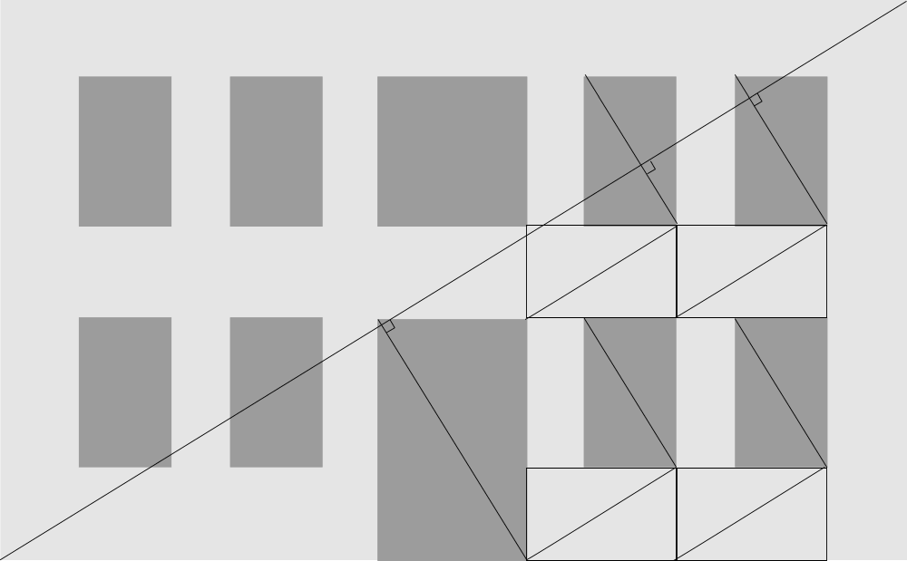 | 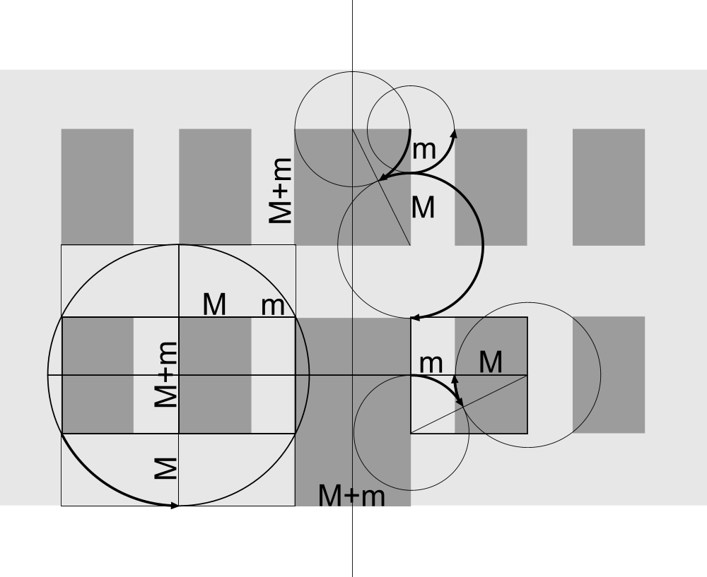
Fig. 1 Diagonals of rectangles show equal proportions as the whole if parallel or perpendicular. | Fig. 2 Golden Section developed from a square by circles around corners of its half.
Some mathematical relations, based on square and circle became popular in architecture, particularly the Golden Section, constructed geometrically as shown in Fig. 2. By sectioning 1 unit in a Golden Section minor (m=0.382) and Major (M=0.618), M/m equals 1.168, and their sum will have the same ratio (1.168) to M.
So, repeating that rule you obtain: and so on =1.618.
Obtaining the same ratio by alternate addition (repetition) of equal measures has great architectural advantages to determine a state of equal dispersion of objects like windows in a façade.
If a window M wide and M+m high (Fig. 2 left below) is extended m in width and M in height you get the same proportion as the original window, a size suitable as a door M+m wide and M+m+M high. Horizontal and vertical intervals between openings m and M fit in that proportional system.

However, Ching does not mention some fundamental difficulties in applying that system of architectural Modules M and margins m. Firstly, more often you will need smaller margins at the ends of a distribution like m+M+m+M+m rather than Modules M+m+M+m+M. But that will not give the whole the same proportion. To get margins at the end you need adaptations of the end margins to give the whole the same proportion (Fig. 3). That is why in Fig. 1 three end margins got an abnormal measure.

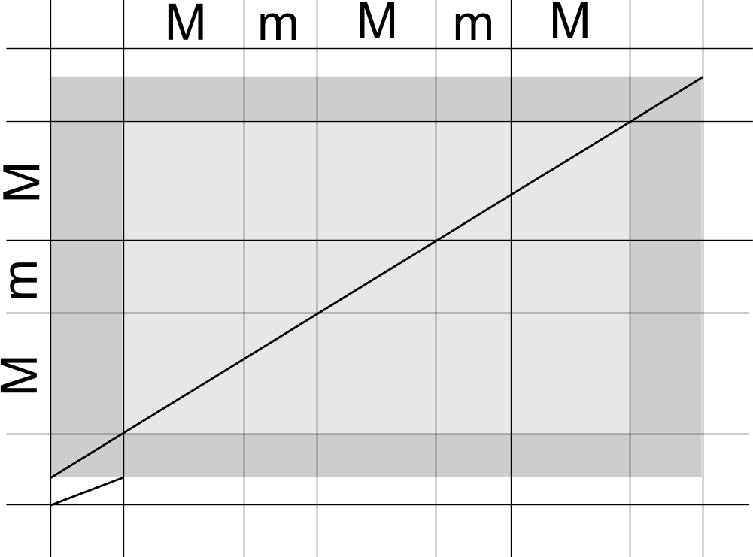 | 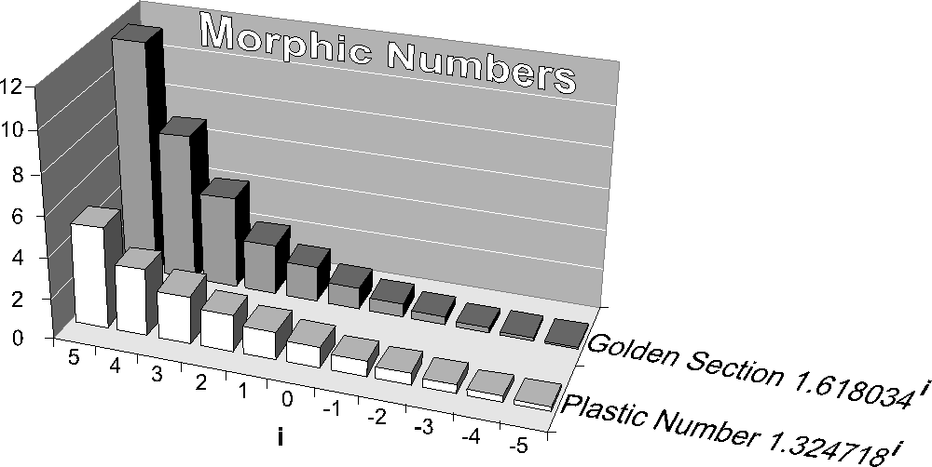
Fig. 3 Golden Section minor margins at the end do not fit in a Golden Section rectangle | Fig. 4 Morphic numbers obtaining the same ratio by adding an other member of the array
Secondly, applying the Golden Section in architecture struggles with too large steps between successive measures for detailed application in architectural design. That is why Le Corbusier took two units based on human measures (183cm in a ‘red array’ and 226cm in a ‘blue array’) as starting point for Golden Section, later combining them by approximation in his measuring system called Modulor (page 302 – 305).
However, that problem was solved even more elegantly by Dom van der Laan. He invented an other ratio with characteristics of addition (plastic number) and Aarts showed the mathematical proof they are the only ratios with such a characteristic, called ‘morphic numbers’ (Fig. 4).

By Ching’s short treatise of many proportional systems and interpretations of classical orders one can't avoid the impression that European renaissance designers looked for a mathematical limitation in a growing chaos of technical, economic, cultural and political possibilities and threats. This restless search for order, justified by a supposed divine mystic of numbers since Pythagoras, paradoxically produced a confusing successive variety ousting one order after the other.

Chings four pages (306 – 309) on Japanese measure systems seem to bring us back to earth: the tatami floor mat with a simple 1:2 proportion. It reduces the possibilities of architectural space into 3, 4, 4.5, 5, 6, 8, or 10 mat rooms with a ceiling 0.3 shaku x the number of mats high. A ken (column distance) is 6 shaku and a mat 3x6 shaku, but both units vary per period and the margins necessary for column thickness. Nevertheless, it is a standard for all buildings, while in Europe measures seem to vary proportional to the dimensions of the individual building as a whole.
Only a casual remark in Chings text learns a shaku is almost equivalent to the English foot.

Ching clearly avoids indications of scale and precise measures in drawings and text. On page 302 he is forced to do so explaining Le Corbusiers Modulor and on page 310 - 313 he explicitly gives measures on anthropometry, but on page 314 in his paragraphs on scale he immediately returns into ‘visual scale’, variable per contextual reference, variable by moving around. It is clear he does not want to become a Neufert filling the brain of design students with standards not to be discussed anymore. The effect is, the object of design remains variable in our head, the essence of design study.
The power of Ching is, he raises numerous questions by drawing, answering only some by text. He teaches architectural thinking, not answers.

However, from urban design we know the legend units (categories) of drawings change by changing absolute scale, changing the frame and grain of the drawing. So, scale can not be avoided.

Ordering principles
Chings book ends by a chapter on ‘Principles’, Latin for ‘first things’. This paradox undermines rightly the idea there is one way into design, one sequence of actions, one method.
On page 320 Ching states: “Order without diversity can result in monotony or boredom: diversity without order can produce chaos.”. To start an educational book on architecture by ordering principles without implementing a sense of architectural variety would kill innocent creativity, the wish to make a difference. You could reproach Clark and Pause for that approach. But the reverse, starting by summing up arbitrary architectural examples hands the reader out into chaos, arbitrariness. So, the book keeps a balance between both in all chapters. The last chapter seems to function as a conclusion. However, it also seems to go back into chapter 4 on ‘organization’ which we prefer to call ‘formation’. It seems to subscribe the idea that designing is primarily ordering space. That hides a supposition: ‘Space on itself is chaos.’.
Ching starts explaining this chapter discusses additional principles to create order, while chapter 4 supposes to employ a geometric (conceptual) basis. That is a difference indeed, but what is the difference? Is it a difference of static analysis into a procedural design approach? The categories on the lowest scale of chapter 4 are ‘within’, ‘interlocking’, ‘adjacent’ and ‘common space’. On the higher scale of formation they are ‘centralized’, ‘linear’, ‘radial’, ‘clustered’ and ‘grid’. What could be added to that?
The last chapter is a treatise of ‘axis’, ‘symmetry’, ‘hierarchy’, ‘rhythm’, ‘datum’ and ‘transformation’. It makes us thinking of category 5 of Clark and Pause’s typology we called ‘types of component variation’, varying from repetition into uniqueness (see page 2 of this paper). And most of Chings categories in his last chapter (‘axis’, ‘symmetry’, ‘rhythm’, ‘datum’) refer to a kind of direct repetition (order): adjacent repetition of direction, mirrored repetition, returning variety and a mat of continuity or geometrical repetition. Hierarchy refers into the denial of repetition, a kind of uniqueness descending from high to low exceptional. Transformation refers into a change of formation (related locations) of smaller forms remaining the same on itself (repetition in time).
If we compare the pages on ‘axis’ (322 – 329) with those on ‘linear’ organization or formation (198 - 207) in chapter 4, we conclude ‘axis’ has a lager, often urban, scale and excludes curved lines while ‘linearity’ does not. They respectively refer to other categories like either ‘view’ or ‘circulation’. However, moving along an axis with focal points at its ends combines the impression of continuity back- and/or forward, but could change on both sides by variation alongside. If left and right are symmetrical it strengthens the axis by symmetry and the impression to be in the heart of an important district. If they are asymmetrical the impression is one of moving along a boundary, giving choice of experience at either sides.
If we compare the pages on ‘symmetry’ (page 330 – 337) with those on ‘centralized’ (190 - 195) and ‘radial’ (page 208 - 213) formations we conclude the latter are more-sided symmetries, while ‘symmetry’ in the last chapter is two-sided only and not necessarily consistent or complete (balance). Here, we prefer the term ‘mirrored repetition’ including ‘balance’ for less equal components on both sides of an axis. That axis is not always visible, but always supposed, with rather precise location in a drawing. So, a ‘clustered’ formation could have ‘balance’ as well.

Variation
If we compare the pages on ‘grid’ (220 - 225) with those on hierarchy (338 – 345), ‘datum’ (346 - 355), ‘rhythm’ (356) and ‘repetition’ (357 – 368), we conclude there is one common denominator: variation.
It reminds us the ecological work of Van Leeuwen, referring to the cybernetics of Ross Ashby. They suppose ‘variation’ as a variable ranging from ‘different’ into ‘equal’ (‘zero difference’ see Fig. 5).

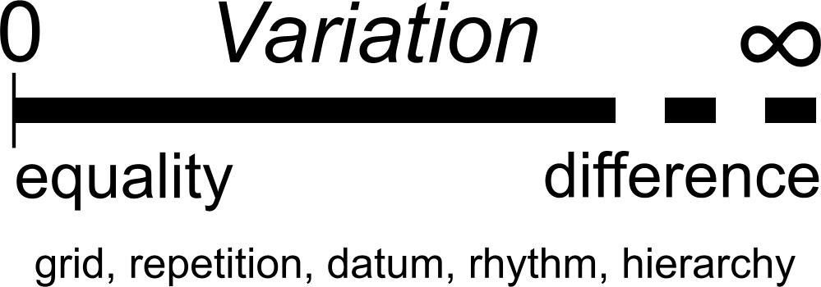 | 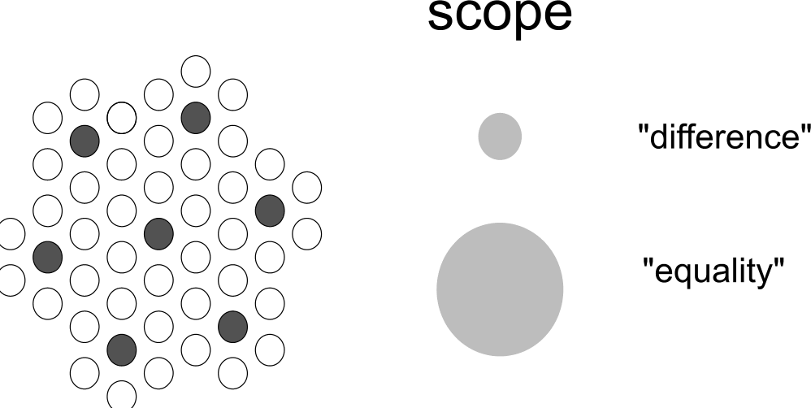
Fig. 5 Some of Chings principles of order as reduced or introduced values of variation | Fig. 6 Scale paradox: the scale dependence of ‘difference’
However, a formation could introduce equality (for example by a grid), while the composing forms, shapes, figures, colors are different. This compositional tension unveils a paradox of scale, already demonstrable by a ratio 3 difference in size (Fig. 6). The introduction on Chings paragraph concerning ‘datum’ (346) clarifies three ideas we will elaborate in a sequence different from Ching.

Firstly, he categorizes ‘axis’ as a kind of datum, a means of orientation in a diversity of components. So, ‘datum’ is a broad category enclosing other ones, as his successive drawings show.
Secondly he states a linear, planar or volumetric datum ‘… must have sufficient size, closure, and regularity to be seen as a figure that can embrace or gather together the elements being organized within this field.’. So, a datum has mainly a larger scale than the components.
Thirdly, he makes a comparison with noting music: ‘For example, the lines of a musical staff serve as a datum in providing the visual basis for reading notes and the relative pitches of their tones.’.
However, a lot of other clarifying associations between spatial ordering principles in architecture and temporal ordering in music can be made. The spatial ordering in architecture is translated in temporal ordering by eye-movements or physically moving, in music temporal ordering is translated in a spatial one by music notation.

For example the term ‘rhythm’ refers to a repeating sequence of different tone lengths in music or in poetry. Rhythm has a larger time scale than the counted time or metrum stressing the first note following the barlines of musical notation (comparable to ‘grid’ in architecture). That emphasis on the first note refers to local hierarchy. Rhythm can follow the metrum as done in classical music. However, in 20th century music, rhythm is often added to the metrum more independently. In that case, rhythm and metrum are competing with each other, giving tension. Both can be translated into space by physical dance movements. The tempo ranges from 40 to 216 crotchets per minute of Maelzels metronome (M.M.), from lento, adagio, grave to allegro, vivace, presto, vivacissimo.

Adding melos to rhythm gives melody. It is remarkable we refer to melos as a sequence of ‘low’ and ‘high’ tones. That spatial association is literally translated into common music notation. So, melos gives music a second dimension added to the first time dimension. However, physics defines pitch of tones as waves per second (Hertz), ranging form 16 (low) to 20 000 (high) waves per second within the audible field. So, that second dimension is a time dimension as well, be it on a much lower time scale.
It is also remarkable, that on the short term our ears get used to a specific sequence of intervals between pitches, the musical setting, often introduced by the first note of the composition. The classical composition as a whole is often called after that setting (for example C-major, D-minor), but many changes in setting in recent music compositions makes such names more suitable for components or details like accords.

Repeating melodies as details in the composition we call ‘themes’, and themes can have ‘variations’. Components of larger scale are called ‘parts’, divided by a short break, often made in a different tempo and called after the name of that tempo. In a concert you are supposed not to applaud during a break like that. It would be nice if architectural periodicals would also learn not to applaud for single buildings, but for the urban composition as a whole.

A third dimension of music is loudness between piano and forte and its increase or decrease (dynamics) between diminuendo and crescendo. It is often used to give emphasis (hierarchy) on a higher time scale than the metrum.

It would be interesting to compare these three dimensions of music or related physics with those of architecture or urban design and to coordinate their terminology. What Ching calls ‘datum’ (Latin for ‘given’) we would prefer to call ‘field’ to avoid confusion with what we call datum in every day speech. For example the magnetic field orientates different components by underlying forces, visible only in the composition as a whole. In that way ‘datum’ or ‘field’ covers many aspects of design, and the science of music elaborates that more in detail than architecture.

Architectural systems and orders
If we follow Ching page by page, particularly by studying his drawings, we find a carefully built-up exercise of the architectural eye. That content is not covered by the schematic introduction on page X of his book. The six columns of that scheme do no justice to his actual sequence from primary elements into order, from surprise about the variety of examples into increasing recognition of principles. It is not even recognizable in the logical and gradual sequence of examples alternated with diagrams throughout the book as we described above. It confuses by its overlapping terminology and forced distinctions. For example, the main distinction between systems and orders is not consistent (overlapping, supposing each other), except if you read ‘systems and their order’. ‘Order’ is subdivided by Ching in ‘physical’, ‘perceptual’ and ‘conceptual’. The order of the systems can be perceptual or conceptual indeed, but not physical without being perceived of conceived.

The two columns headed by ‘Architectural Systems’ contain 5 ‘systems’:

The architecture of (1) ‘space, structure and enclosure’,
experienced through (2) ‘movement in space-time’,
achieved by means of (3) ‘technology’,
accommodating a (4) ‘program’,
compatible with its (5) ‘context’.

These are put together in one sentence, but they can not be distinguished consistently if you read their subdivision in a third column. For example, the subdivision of the first and third ‘system’ both contain ‘structure and enclosure’. But ‘structure’, defined as the set of connections and separations that keep parts together into a whole, should contain technology, not the reverse. In the same way Chings subdivision of ‘program’ contains ‘historical tradition and precedents’, but these are part of our perception presented here as one of the ‘orders’ in the fourth and fifth column.

A circle around the so-called systems ‘space, structure and enclosure’ and ‘movement in space-time’ suggests that the not encircled ‘technology’, ‘program’ and ‘context’ are no subject of the book. However, an arrow from this circle passing the fourth and fifth column (physical, perceptual and conceptual ‘orders’) points vaguely to a sixth column ‘Systems and organizations of …’, grouped according to the preceding columns. That sixth column contains a summary of terms earlier mentioned in the column ‘systems’, again ending with ‘context’, now containing sudden newcomers as ‘machines’.
Context, earlier subdivided in ‘site and environment’, ‘climate, sun, wind, temperature, precipitation’ and so on, there excluded as subject of the book, comes back in this column accompanied by a scheme containing ‘space’, ‘form’, ‘function’ and ‘technics’. The term ‘function’ appears for the first time. The four terms are represented separately in circles connected by lines, but who can imagine form, function or technics without space? So, space should enclose the other three and ‘technics’ could be widened into ‘structure’ to get the classical threesome form, structure and function. Why not? And why is this scheme connected exclusively to context, if space, structure and enclosure were represented earlier as the first ‘Architectural System’?
It is easier to produce a new order than to unravel an existing disorder.

Order in terminology

Form, structure and function
So, let us take the classical threesome of form, structure and function of architectural spaces as a starting point. We define ‘form’ as state of dispersion, ‘structure’ as the set of connections and separations that keep parts together into a whole and ‘function’ as use. These concepts appear both in space and in time. If a state of dispersion changes we call it transformation. A structured process we call operation. Movement is nothing else than a process structured by connections and separations. The set of possible movements we call circulation. So, a building is operational by ‘circulation’.
Function in time we call functioning or performance. The use of form without intention we call perception. So, perception is a function of form. Conceptual reconstruction of reality into a model is part of perception.

Making form we call composing. Designing is proposing an executable composition. A durable composition is a composition kept together by connections and separations. Making connections and separations (structure) we call constructing. The art of construction is called technique, the science of construction technology. Enclosure is all-sided separation and consequently part of structure. An opening is a connection within a separation, so openings are part of structure as well. A description of use or performance before design is called a program of requirements.

Object, context and scale
An object of urban, architectural or technical design has a form, structure, and function within a context. That context can be object of design in a larger context. For example, if the object of architectural design is a building group, the composition of building groups can be object of urban design. So, distinguishing object and context of design supposes levels of scale. The scale of an object is determined by the largest (frame) and smallest (grain) size drawn. The smallest size (grain) is the measure of the smallest detail drawn. The distance between frame and grain determines the resolution of the drawing (for example a global sketch, a drawing or a precise blue print).

Frame and grain in a plane or a volume can be named most easily approximating the real frame or grain by a ‘nominal radius’ from a standard range of scales { …1, 3, 10 …m}. A nominal radius indicates an order of size by one single number. If you read ‘nominally 3m radius’, think ‘a radius between 1 and 10m’ (the neighbour values in the standard range). The interval of roughly a factor 3 is chosen according to Fig. 6, to avoid confusion of terminology on different levels of scale. So, a ‘linear formation R=30m’ could be part of a ‘radial formation R=100m’.

If you draw a building in a frame of approximately 10m radius (R=10m) and the smallest detail (grain) is approximately 0.3m radius (r=0.3m), then your drawing has a resolution of a sketch (Fig. 7).
However, if r=0.1m, then it is a drawing, if r=0.03m it starts to look like a more precise blue print.

As soon as you have determined frame and grain of your object, the rest is administrative, cultural, economic, technical, ecological or spatial context. Within that context your object of study will have administrative, cultural, economic, technical, ecological or spatial impacts on different levels of scale as soon as it will be realized. Some of these impacts may be desired beforehand, others (positive or negative) are not.

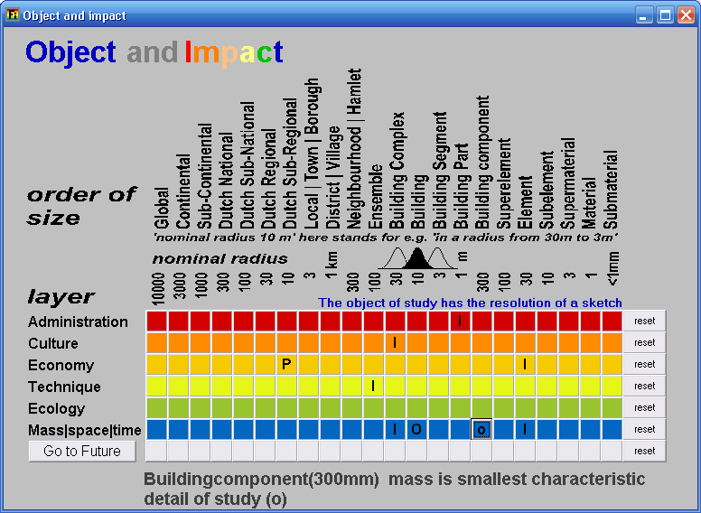 | 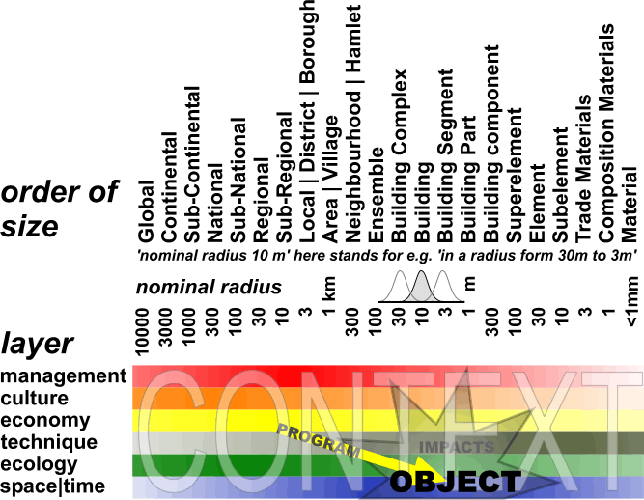
Fig. 7 The sketch of a building as an object of design | Fig. 8 The object and its impacts in its context, the desired ones being a program
If you know desired impacts beforehand, you can formulate them in a program of requirements stemming from different levels of scale, layers and stakeholders or authorities. For example, if your object will have a positive impact on the dwelling market of a conurbation (R=10 economy), you can look for a local investor to pay your design. But you should not forget the other impacts and related persons or institutions concerned.

The object of study within a field of problems and aims
Whether the realized object will have the desired impacts or not, depends on future circumstances. So, you have to make the expected future context more explicit to estimate the impacts and to foresee the field of problems and aims.
 | 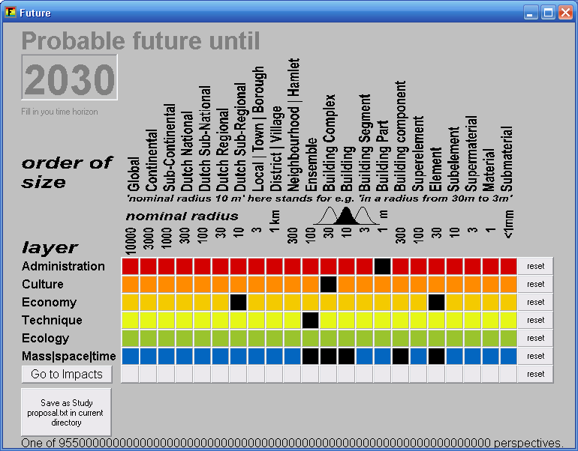
Fig. 9 Finding problems and aims by subtracting probable and desirable futures | Fig. 10 Making the expected future context of your impacts more explicit
The administrative, managerial or organizational circumstances could be different on different levels of scale. For example, on the level of the building complex the investor takes initiative, while the municipality waits and sees. That applies to the cultural circumstances as well: you may have to cooperate with inhabitants organizing their household traditionally as usual, while the government likes to stimulate experimental housing. In the economic layer the region may be in decline, but the producers of building elements are thriving. You expect their technique may be highly specialized, but on the level of the urban ensemble cheaper combinations emerge. Such probable circumstances determine which problems you have to overcome and which aims you have to take into account.

Ching, F. D. K. (1979) Architecture: form, space and order. (New York) Van Nostrand Reinhold Company, Inc.
Clark, R. H. and M. Pause (1985). Precendents in Architecture. (New York) Van Nostrand Reinhold Company, Inc.
Jong, T.M. de; Voordt, D.J.M. van der; eds. (2002) Ways to Study and research Urban, Architectural and Technical Design (Delft) DUP Science.
Steadman, J. P. (1983). Architectural morphology. London, Pion.
Tzonis,A. Huts, ships and bottleracks (1990) in: Cross, N.; K. Dorst and N. Rosenburg Eds.(1991) Research in design thinking (Delft) Delft University Press

Jong, T. M. d. and D. J. M. v. d. Voordt, Eds. (2002). Ways to study research urban, architectural and technical design. (Delft) DUP Science.
However, in a creative sense you can learn more form the analysis of bad cases. Negating or avoiding them stimulates finding other solutions than cliché’s. The French word néant both indicates negation and birth!
Descartes, R. and C. D. M. (1999). Discourse on method, and related writings. (London) Penguin.
Clark, R. H. and M. Pause (1985). Precendents in Architecture. (New York) Van Nostrand Reinhold Company, Inc.
A parameter is a mathematical term for a variable stemming from external influences, not to be affected by the model involved.
Sloterdijk, P. (2003). Sferen. Deel I: Bellen: Microsferologie. Deel II: Globes: Macrosferologie. (Amsterdam) BOOM.
Klee ( ) ___ ( ) …
Contiguous is ‘adjacent in space’. So the term continuous could be reserved for ‘adjacent in time’.
Piaget, J. and B. Inhelder (1947). La representation de l'espace chez l'enfant. (Paris) Presses universitaire de France.
Leeuwen, C. G. v. (1964). The open-and-closed theory as a possible contribution to cybernetics. (Leersum) Rijksinstituut voor Natuurbeheer (R.I.V.O.N.).
Jong, T. M. d. and R. P. d. Graaf (2002). Mathematical models. Ways to study architectural, urban and technical design. T. M. d. Jong and D. J. H. v. d. Voordt. (Delft) DUP.
Neufert, E., Ed. (1980). Architect's Data. (Oxford) Blackwell Science.
Leeuwen, C. G. v. (1971). Ekologie. (Delft) Technische Universiteit Delft, faculteit Bouwkunde.
Ross Ashby, W. (1965). Design for a brain. The origin of adaptive behaviour. (London) Chapman & Hall and Science Paperbacks.
Jong, T. M. d. (1992). Kleine methodologie voor ontwerpend onderzoek. (Meppel) Boom.

