Context analysis
Prof.dr.ir. Taeke M. de Jong 2006-09-29

CONTENTS

Context analysis 1
Introduction 2
Studies related to urban, architectural and technical design or management 2
Study proposals in that field 2
Case studies 2
Context sensitivity 2
1 Levels of scale 3
Scale paradox 3
Domains with different categories, types and legends 3
Many orders of size possibly causing confusion 4
Nominal values of a radius R to name levels of scale 4
Impacts on different levels of scale 4
2 Physical and social layers 5
Layers on different levels of scale 5
Impacts 5
Impacts depending on the probable future context 6
The FutureImpact computer program 6
Making expectations about the future context more explicit to assess impacts 6
Roughly typing social future context 6
Roughly typing physical future context 7
States of dispersion 8
3 Desirable, probable and possible future contexts 9
Subtracting probable and desirable futures 9
Adding possibilities by design 9
The context of invention 10
Limitations of a design related study proposal 10
Conclusion 10
Sources 11

Introduction

Studies related to urban, architectural and technical design or management
Most studies related to urban, architectural and technical design or management like graduation studies on a Faculty of Architecture are design studies with a variable object in a more or less determined context, often on a unique location (see Fig. 1). They produce a description and presentation of a non existent object possible in that local context, its rational and emotional foundations suitable to convince stakeholders and specialists possibly involved in realisation and use.

 |  | determined | variable | OBJECT
 | determined | Design Research | Design Study
 | variable | Typological Research | Study by Design
 | CONTEXT
Source: (Jong and Voordt 2002)
Fig. 1 Four types of design related study

Study proposals in that field
Study proposals for that kind of study are difficult to make, because the object of study is still varying: it has to be determined by the study itself, often resulting in a design. A design can not isolate a single problem statement. There is a field of many problems observed by many people rather than a single problem to be ‘solved’. There is also a field of aims related to many stakeholders and specialists rather than a clear aim statement. Many of these aims are contradictory, together exceeding given possibilities. They have to be recapitulated in a feasible concept, a common road to a result. Since the object is variable, there is not a single hypothesis (the design to be produced is often concerned as hypothesis with the tacit supposition “This will work”). There is also not an easy to describe single method as some suppose in empirical research (Priemus 2002). So, the only way to get grip on the project in a study proposal beforehand, is the determination of the future context by a proper context analysis, including the context of discovery (Klaasen 2003) or context of invention (on page 10 we come back on that subject).

Case studies
In an empirical jargon these studies are ‘case studies’ (Yin 1994; Swanborn 1996; n=1 studies).
Other kinds of study in this field, like design research and typological research (see Fig. 1) often use such case studies. However, these seldom reach a statistical mass (n=many) suitable to draw more general scientific conclusions (‘research’). That is why polls and statistics are seldom useful in this field of study except for understanding the argument of specialists referring to many contexts. Specialists can isolate common problems from those contexts to find more general solutions, supposing they are applicable in the managerial, cultural, economic, technological, ecological and spatial context at hand. However, without context sensitivity, their general solutions raise new problems, new assignments for ongoing study profitable for them.
But a designer raising new problems will not easily get new assignments.

Context sensitivity
An object of architectural or urban design or management is more context-sensitive than any other object of design on a University of Technology (Fokkema 2002). A design in that field has unique features; otherwise it would be an empirically predictable copy out of another context.
So, these objects of study are comparable only if their context is comparable, if the many external parameters have more or less the same values. If, from the many cases studied before, researchers could choose examples that have a comparable context, there is some basis for generalisation. These historical case studies should then be retrievable from a systematically accessible database to find cases comparable with the one at hand.

The main question I try to answer here is: how to standardise a context analysis preceding these case studies. The method I propose will also help making design related study proposals for objects still not determined (see Fig. 1).

Levels of scale
Firstly, I suppose the level of scale of an object of study is important, because any larger size than that of the object supposes a ‘larger context’. But any smaller size than that of the smallest detail taken into account supposes context as well. So, the reach of scale of an object of study has an upper and lower limit, here called frame and granule (see Fig. 6), best indicated by their approximate radius.
The distance between frame and granule determines the resolution of the study (sketch, drawing, blue print), the extent to which the study goes into detail compared to its largest measure drawn. That order of size and consequently resolution of study can be chosen even before the object of study is fixed.
It begins to determine the applicable design and management means. Moreover, it puts the concept of ‘aim’ into perspective. What is the aim of a house, a neighbourhood, a region? Yes, what is the aim of the world? With a growing scale in space and time, the statement of aims becomes more and more dubious.

Scale paradox
The reach of scale is also important, because conclusions on a specific level of scale could be opposite to conclusions drawn on another level of scale (scale-paradox, see Fig. 2).

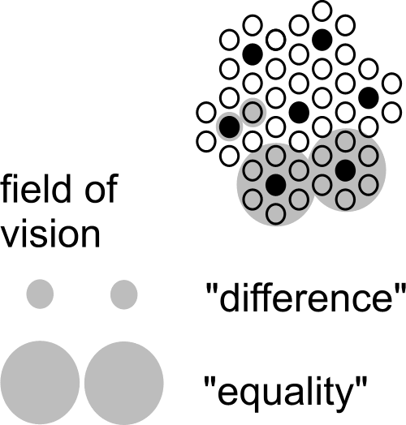 | The scale paradox means an important scientific ban on applying conclusions drawn on one level of scale to another without any concern (read quark discoverer and Nobel prize winner Gell-Mann, 1994).  That does not yet mean conclusions on one level of scale could never be extrapolated into other levels. Fig. 2 only shows the possibility of changing conclusions by a change of scale. And it demonstrates the possibility of a reversal of conclusions already by a factor 3 larger radius. And there are 10 decimals between the earth and a grain of sand.  That gives approximately 22 possibilities of confusing conclusions.
Fig. 2 The scale paradox
If a scale paradox can be demonstrated for concepts of difference and equality as such, it applies to any distinction of spatial categories or classes.

Domains with different categories, types and legends
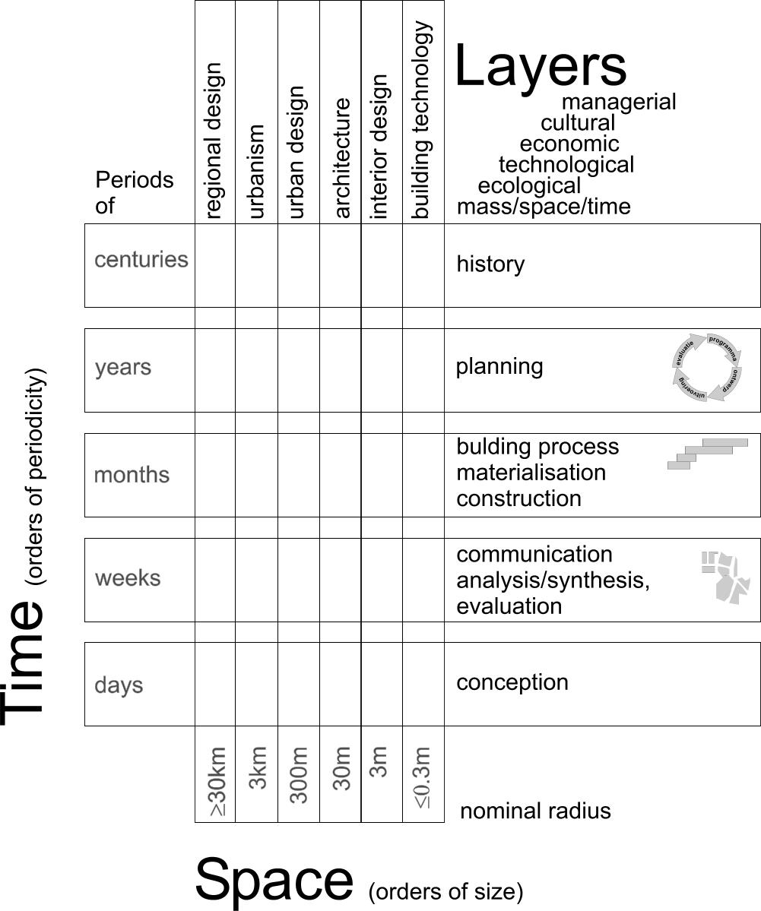 | On any level of scale you need other distinctions of categories and subsequently different typical combinations of their classes: types and legends to be studied or designed.  You can recognise that necessity in the common disciplines of ‘bouwkunde’: urbanism, architecture and building technology (see Fig. 3). The types and legends of architectural disciplines are different from those of urbanism or building technology.  Less recognised are the different time scales you can distinguish on every spatial level of scale. Architectural history is something else than urban or technological history. And history is something else than planning, building process, communicaton process or the process of conception. This is where building management comes in as a separate discipline.  Moreover, these distinctions have different physical and social ‘layers’.
Fig. 3 The domain of Bouwkunde
So, the same kind of argumentation on spatial articulation of scale could be developed for temporal distinctions. What seems true or right in terms of weeks may be false or wrong in terms of months.

Many spatial orders of size possibly causing confusion
In Fig. 2 confusion of spatial scale is already possible by a linear factor 3 difference in level of scale (approximately 10 in surface). That is why for spatial design and management I articulate orders of size by a linear factor of approximately 3. So, to avoid any confusion, I need to distinguish at least 22 levels of scale to define context, beginning with the global context and preliminary ending with that of the physical chemistry of materials (see Fig. 4). Most of these contexts are not relevant for a study at hand, but they are there, most of them buried in hidden (ceteris paribus) suppositions.

Global(10000km) | Continental(3000km) | Subcontinental(1000km) | National(300km) | Sub national(100km) | Regional(30km) | Sub regional(10km) | Town(3km) | District(1km) | Neighbourhood(300m) | Ensemble(100m) | Building complex(30m) | Building(10m) | Building segment(3m) | Building part(1m) | Building component(300mm) | Super element(100mm) | Element(30mm) | Sub element(10mm) | Super material(3mm) | Material(1mm) | Sub material(<1mm)
Fig. 4 Levels of scale to be aware of in any spatially relevant study

Nominal values of a radius R to name levels of scale
Levels of spatial scale are often named by the ratio of a drawing to reality like ‘1:100’. However, it depends on the size of the drawing what kind of object I have in mind. On an A4 paper 1:100 I can draw an object of approximately 10m radius (30m² surface); on an A2 paper it could show an object of 30m radius (300m² surface). That is why I prefer to name the order of size by its approximate radius R in supposed reality chosen from the set {… 1, 3, 10, 30, 100m …}.

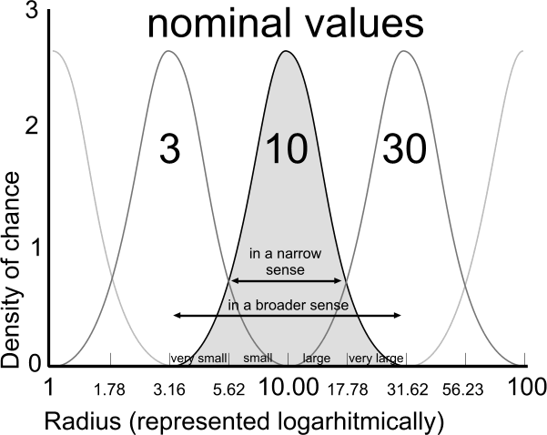 | An ‘elastic’ element from the nearly logarithmic series {… 1, 3, 10, 30, 100 …} is used as the name (nominal value) of the order of size of an urban, architectural or technical category ranging between its neighbours.  To be more precise: the ‘nominal’ radius R=10 is the median of a chance density distribution of the logarithm of radiuses between (rounded off) R=3 and R=30, with a standard deviation of 0.15.  I chose a series of radiuses rather than diameters because an area with a radius of {0.3, 1, 3, 10km} fits well with {neighbourhood, district, quarter, and conurbation} or loose {hamlet, village, town, and sub-region} in everyday parlance. They fit also very well to a hierarchy of dry or wet connections according to their average mesh widths (de Jong, 2006).
Fig. 5 Names and boundaries of urban categories
Moreover, a radius immediately refers to the most indifferent directionless form of circles or globes indicating both surfaces and volumes by one linear value.

Impacts on different levels of scale
Any object of study will have impacts on different levels of scale, hitting interests of stakeholders operating on that level (for example from government administrators into manufacturers of building materials). The first step of context analysis is, to locate these supposed impacts on the level of scale they apply, as far as they could be relevant to the study at hand, not overlooking any level. You can already locate them before you specify them. If you expect positive impacts, perhaps you can find stakeholders on that level wanting to pay for your study. If there are negative impacts, you should not exclude people responsible on that level to minimise or compensate such effects by your study.

Physical and social layers
Secondly, the scale determined context of an architectural or urban design is not limited to its physical environment (mass and space in time, ecology, technology). Social (economic, cultural and managerial) environments do have orders of size as well.
Urban and architectural designers give account of their sketches and drawings to physical and social stakeholders and specialists in different ‘layers’. These participants have their own problems and aims, their expectations and desires, supposing different probable and desirable futures.
These futures have to be combined by design into one common spatial vision or concept of a possible future in order to outline a road for cooperation.
Sometimes it is wise to start defining a common future context before defining an object.

Layers on different levels of scale
So, to analyse or to compose a common future context, you have to distinguish different physical and social layers. In Fig. 7 six layers are chosen, relevant in urban and architectural design. They are chosen in a way they are imaginable on any level of scale, though not always all relevant for every object of study. On any level of scale they have a different meaning. For example, in The Netherlands management(R = 3000km) means European government, management(R = 10km) or (R = 3km) means different forms of municipal administration, R = 10m means household management and on lower levels of scale it means different forms of technical management on the building place, in maintenance or within the industry of building materials.

Impacts
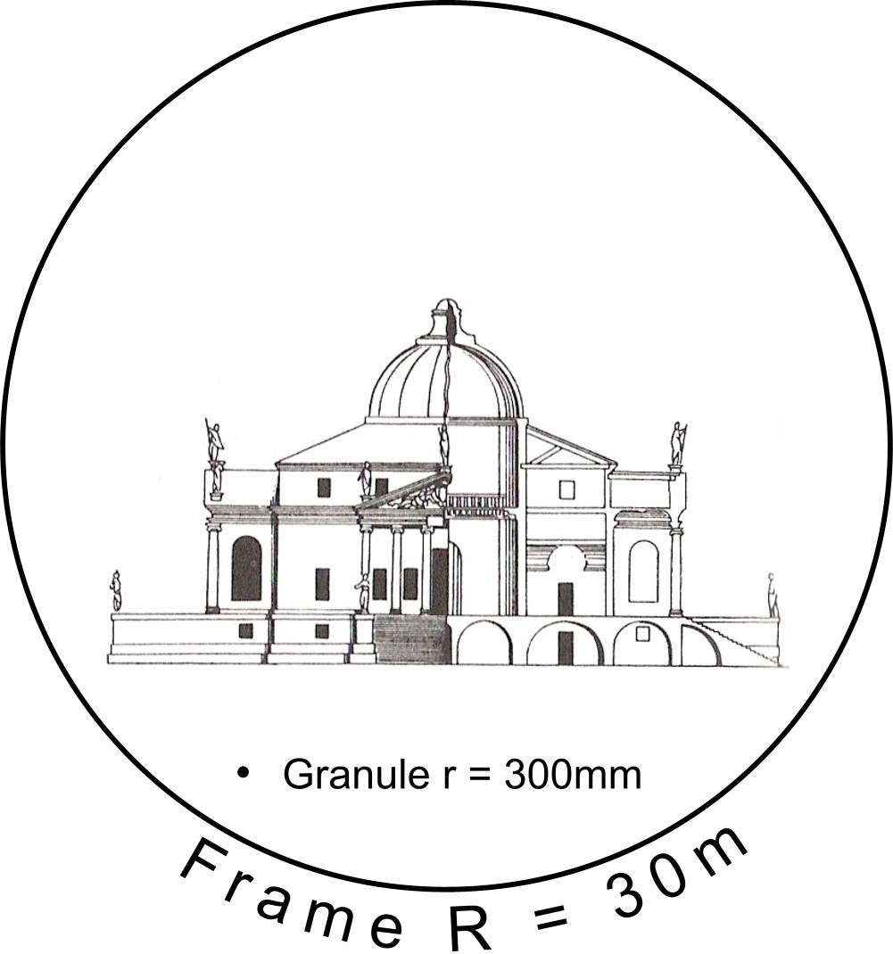 | 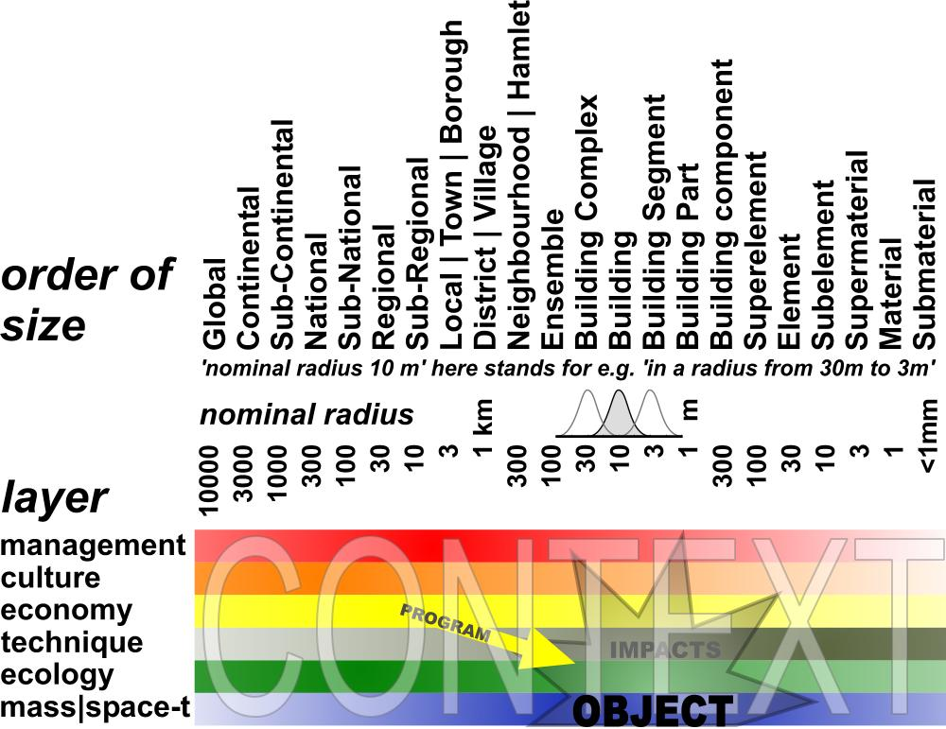
Fig. 6 A frame 100x granule of a drawing representing a building | Fig. 7 Locating a spatial object of study within its context
Once you have determined the frame and granule of the object of study in this scheme, the rest is ‘context’. The still variable object of study will have impacts within that context, on different levels of scale and in different layers. Some of them are desirable. The programme of requirements is nothing else than the set of desirable impacts. The scheme does not specify these impacts; it solely shows their order of size and layer (‘location’).
It is possible to consider these context factors before you choose a specific object on a specific location. So, the scheme can help outlining your object of study from outside.

Impacts depending on the probable future context
These impacts will be different in different future contexts. For example, the local economic impact will be different in a growing regional economy compared with a stagnating local economy. So, you have to specify your expectations about the probable future within which your object will have its impacts.

It is important to be explicit about these expectations, because people with other future contexts in mind will judge your study (design or research) with other suppositions about the probable future. They can reject your study solely on that basis. If you made your suppositions explicit beforehand, you can ask them to judge the qualities of your study or design again but now within that perspective. It could raise an essential debate about the robustness of your study in different future contexts. So, it can be evaluated also against the background of different perspectives.

The FutureImpact computer program
However, it is even better to agree with stakeholders and specialists beforehand about a common vision on a supposed probable future. To that aim I developed a simple computer program called ‘FutureImpact’, usable individually or in meetings (see Fig. 7 and Fig. 8).

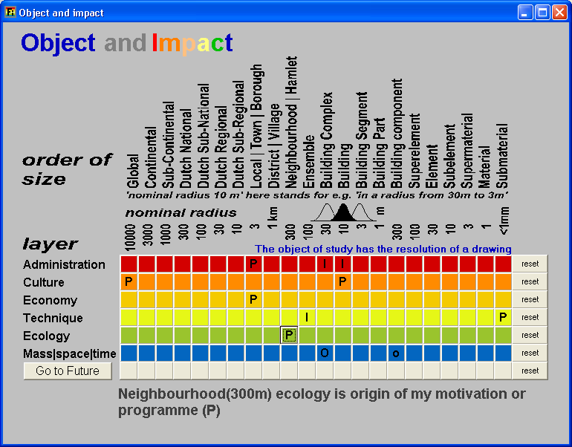 | 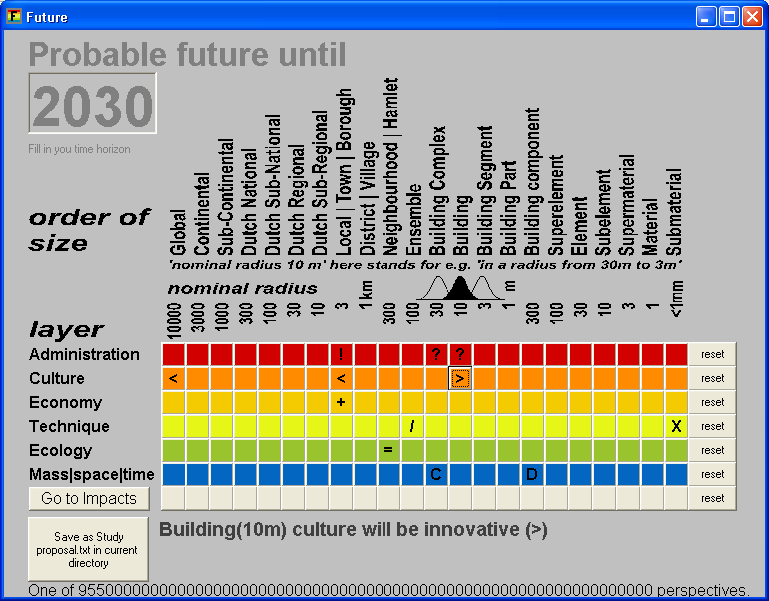
Fig. 8 Locating impacts (I) and the origin of a programme (P) as set of desired impacts | Fig. 9 Making expectations about the context in 2030 more explicit to assess the impacts
This program delivers a more precise division of orders of size and layers than Fig. 7 in separate buttons, to be pressed into two very rough extreme values per button to keep overview. In the second screen (Fig. 9 left below) you find a button producing a text to elaborate the chosen values into more specific interpretations yourself. It is a checklist not to forget any relevant level or layer.

Making expectations about the future context more explicit to assess impacts
Once you have located possible impacts, the future context of these impacts determines their possibility of realisation. For example, if you suppose desirable impacts in municipal administration (R = 3km, see Fig. 8), how could you estimate their value without any supposition about their managerial context in the period these impacts should be realised (for example until 2030 in Fig. 9)? Is it an active management context with many initiatives or is it a passive administrative context of just checking and controlling the rules? In the last case initiative should be part of your own project to get the intended impacts realised. The same applies to the administrator of the building complex (R = 30m) and the users (R = 10m). And these impacts can be opposite on that different levels of scale.

Roughly typing social future context
You can ask that kind of questions on any layer and level of scale again. Any expected or desired impact supposes a context where the impact will be realised or not. How to describe that context shortly in a preliminary sense to keep overview? The problem is to find comprehensive variables per layer that make sense on any level of scale in the scheme to be elaborated and modified later in more detail.

For administration and management I proposed opposites of initiative (‘!’, as symbolised in Fig. 9) and checking and controlling (?), applying on any level of scale. There are many other possibilities to type administration and management style, but this variable hits the core of management itself as far it is relevant for design and applicable on any level of scale.

But what about culture? For example, what does culture mean on the level of building material (R = 1mm)? To include any level of scale, I propose ‘traditional’ (<) opposed to ‘innovative’ or ‘open to experiments’ (>). For example, if your study will have impacts on households (R = 10m), and these households are mainly traditional, it will be difficult to confront them with an experimental design. However, if your client is an innovative housing corporation (R = 1000m?), you will get support from that side. That cultural context will influence your study and your presentation, the way you will arrange the arguments.

The economic context is shortly characterised by growing (+) and declining (-). That can be different on different levels of scale. The economic context could be a declining neighbourhood within a prosperous municipality. A context like that will determine a project or an assignment to a considerable extent.

Roughly typing physical future context
Which extremes could be found to characterise the technological context on any level of scale? It took me some years to choose internal separation (/) and combination (X) of functions as relevant and essential technological context values. It is also an essential design choice on every level of scale: shall I separate or combine pressure and tension (R = 10cm) separating and supporting functions (R = 1m) within my construction, cooking and eating in my kitchen (R = 3m), living and work in my neighbourhood (R = 300m)? If the probable trend is to combine living and work on a level of the district (R = 1km), then you still can separate it on the level of the neighbourhood (R = 300m) or the building complex (R = 30 m). So that expected context is important for any design decision.

In ecology I suppose diversity or heterogeneity (|) as most universal context variable, opposed to equality or homogeneity (=). Which kind of diversity that concerns could be elaborated later: diversity of plants, animals, or people, households with the same or different age, lifestyle or role-emphasis (for example familism versus careerism (Michelson 1970)).

At the purely physical level of mass and space in time, accumulation, concentration (C) of masses versus sprawl, deconcentration (D) is an essential design context factor. What is called mass could be specified later, but concentration and deconcentration (state of dispersion) of legend units in a drawing are characteristics of form and composition on any level of scale. They can differ per level of scale (see Fig. 10 and Fig. 11). An existing or expected scale sequence like DCDC or its reverse CDCD names some global characteristics of form. I will elaborate on the ‘state of dispersion’ more in detail, because it is relevant in other layers as well.

States of dispersion
Form as a primary object of design supposes a state of dispersion of an arbitrary legend unit, for example built-up area.

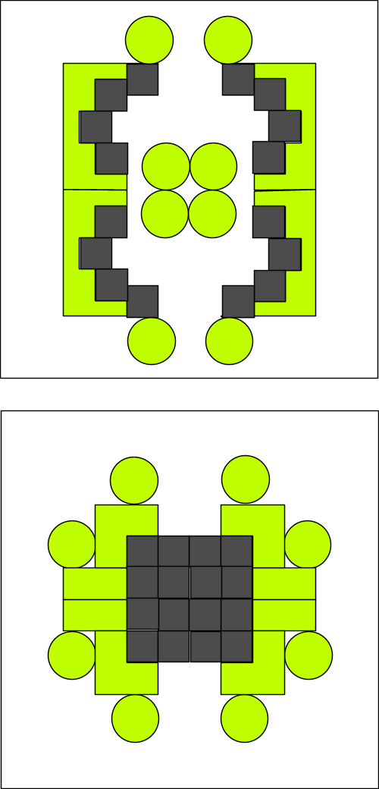 | 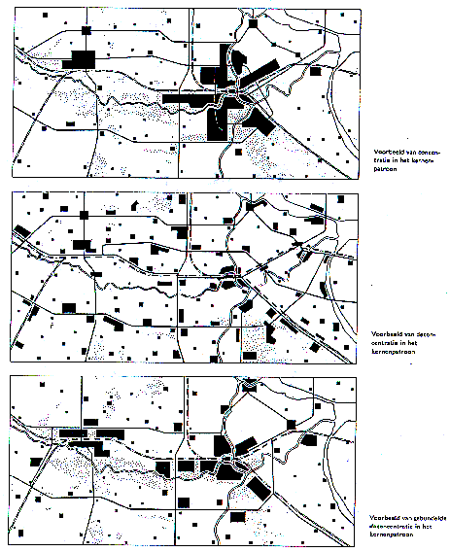
 | RPD (1966)
Fig. 10 States of dispersion r=100m | Fig. 11 Accumulation, Sprawl, Bundled Deconcentration r=30km
Scale articulation is important distinguishing states of dispersion. That is not the same as density. Considering the same density different states of dispersion are possible (Fig. 12 ) and that is the case on every level of scale again (Fig. 13 ).

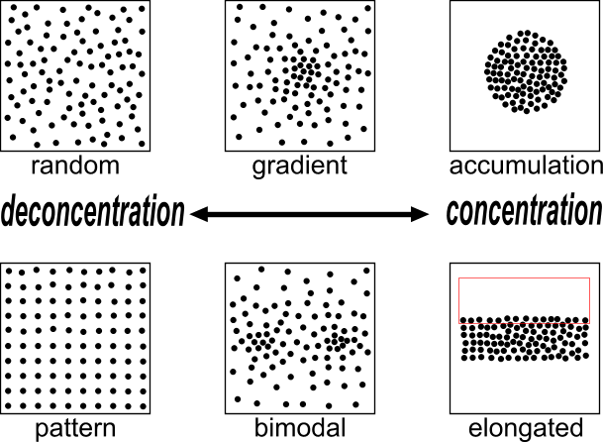 | 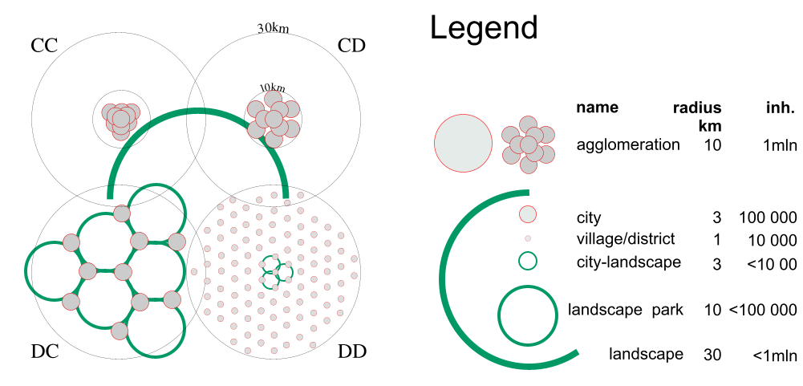
Fig. 12 States of dispersion in the same density on one level of scale | Fig. 13 One million people in two states of distribution on two levels of scale (accords CC, CD, DC and DD).
Fig. 12 shows the use of the words concentration (C) and deconcentration (D) for processes into states of more or less accumulation respectively.
Applied on design strategies in different levels of scale I would speak about ‘accords’ (Fig. 13 ).

In Fig. 13 the regional density is equal in all cases: approx. 300inh./km².
However, in case CC the built-up area is concentrated on both levels (C_{30km}C_{10km}) in a high conurbation density: (approx. 6000inh./km²).
In the case CD people are deconcentrated only within a radius of 10km (C_{30km}D_{10km}) into an average conurbation density of approx. 3000 inh./km².
In the case D_{30km}C_{10km} the inhabitants are concentrated in towns (concentrations of 3km radius within a radius of 10km), but deconcentrated over the region. Since 1966 this was called ‘Bundled deconcentration’ (RPD, 1966). The urban density remains approx. 3000 inh./km².
In the case D_{30km}D_{10km} they are dispersed on both levels.

Desirable, probable and possible future contexts
Thirdly, there are three language games (‘modes’) concerning the future context relevant for urban, architectural or technical design, its stakeholders and specialists (see Fig. 14).

Language games: | being able | knowing | choosing
Modalities: | possible | probable | desirable
Sectors: | technique | science | management
Activities: | design | research | policy
Reductions as to
Character: | legend | variables | agenda
Location or time: | tolerances | relations | appointments
Fig. 14 Three language games
Not distinguishing these modes of future results in a confusion of tongues between stakeholders aiming at desirable futures, specialists predicting probable futures and designers exploring possible futures.
Distinguishing them properly can deliver an outline of fields of problems and aims to take into account.

Subtracting probable and desirable futures
Probable futures we do not want are a field of problems (see Fig. 15). They are predicted or signalled by empirical study of specialists. Desirable futures we do not expect to happen without action (like desirable but not probable futures) are a field of aims. Clients, stakeholders and their representatives (administrators, managers) deliver a field of aims. Sometimes it is a battlefield. Often not all of them are possible in one project. The designer guards and extends the possible by design.

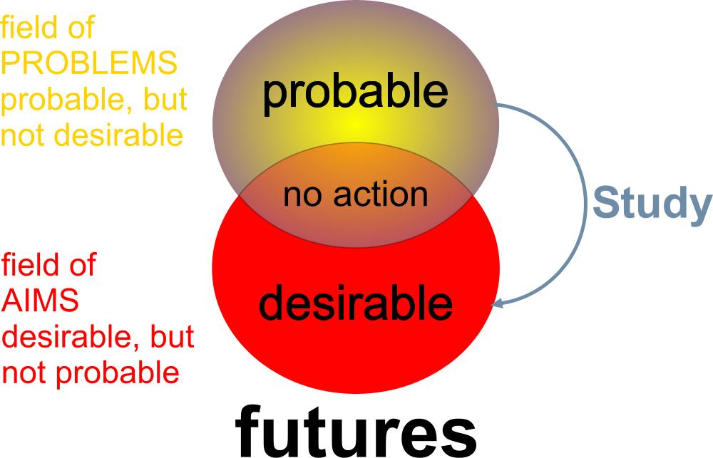 | 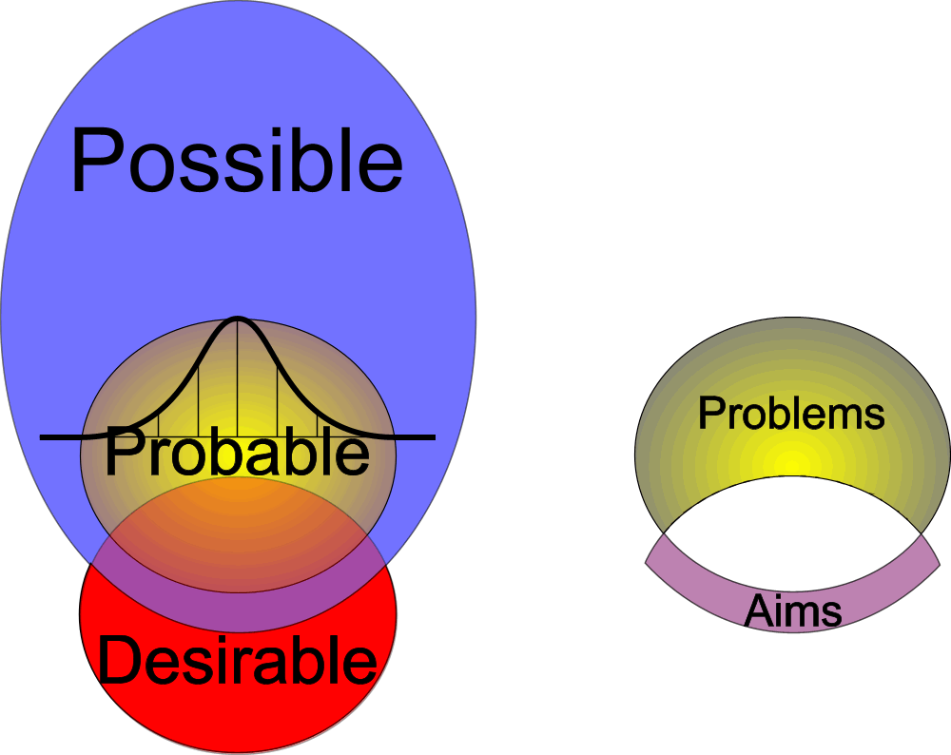
Bron: | Bron:
Fig. 15 Subtracting futures to outline fields of problems and aims | Fig. 16 Adding possible futures, skipping the impossible

Adding possibilities by design
Anything probable is per definition possible, because if something is not possible, it certainly is not probable. But not all possible is also probable (see Fig. 16). There are improbable possibilities. To find these improbable but possible futures (including and using the many probabilities of specialists as possibilities) is the task of the designer. S(he) is supposed to know many possibilities stemming from design~ and typological research (see Fig. 1). Sometimes s(he) adds possible futures no one in the team could imagine, let alone desire beforehand. Their desires and aims embodied in their programme of requirements were limited by their imagination. Desires could change as soon as new possibilities are imagined. That is why design can change a programme of requirements (see Weeber, Eldijk et al. 2002).

The context of invention
The designer has a personal context relevant to be selected for, or to propose a specific design study. It contains her or his field of abilities (portfolio, own work) and field of design means (repertoire, studied references to the work of others). S(he) is supposed to have gathered many preceding examples (precedents) and to have studied them by design research and typology (see Fig. 1) exploring design possibilities by pulling them out of context processing them into a new context (Hertzberger 2002). S(he) is supposed to be able to apply, process and extend them in a given context, which is proven by a portfolio. Of course, s(he) is moulded and limited by education, colleagues and friends. But what can be expressed in a study proposal for possible futures in a more or less determined context is a portfolio and a repertoire.

Limitations of a design related study proposal
To make a study proposal, teachers or clients often ask a clear cut problem definition and clear cut aims, a hypothesis, an overview of methods to reach that aims testing the hypothesis, a planning of time and means (data!) and a list of expected results. I suppose my proposal to weaken the problem~ and aim definition into a broader field of problems and aims will meet objections: “Without a clear problem~ and aim definition any scientific study becomes boundless!” That is an objection typically stemming from the practice of empirical research, focusing on truth or probability, aiming desirability (see Fig. 15).

However, a design related study focuses on possibility (see Fig. 16). In the field of urban, architectural and technical design or management, there are other general limitations to prevent a boundless study. To the weakened ‘fields’ of problems and aims, a scale, repertoire and portfolio can be added. These five limitations can be gathered from a proper context analysis introducing the proposal. More than in empirical research (principally repeatable by others), in design study (principally not repeatable by others) the field of abilities and means of the person executing the study are relevant for the expected result. Once these fields are presented you can choose two different directions of study: elaborating these fields into more perfection or exploring new fields of design means and abilities. Both are legitimate, but their results are different in advance, to be mentioned preceding a study proposal.

Conclusion
The limitations of empirical research result in problem isolation not suitable for studies related to context sensitive urban, architectural and technical design or management cases. That kind of study can utilise other limitations to prevent a boundless study project: a determined scale (frame and granule), the field of design means (repertoire) and the field of abilities (portfolio) of the person executing the study. By adding these limitations the ceteris paribus isolated problem~ and aim statements can be broadened into the description of a field of many coherent problems and conflicting aims to be recapitulated in a concept.

To provide these limitations a design related study proposal should be preceded by a context analysis containing many elements otherwise dispersed in the proposal. So, the proposal itself can be short. Such a context analysis is possible even if the object of study is still variable beforehand, like a design. For example, the contents of a study proposal then could be as follows.

1 CONTEXT ANALYSIS
1.1 Object of study: time span, frame and granule
1.2 Probable future context: field of problems
1.3 Desired impacts of study: field of aims
1.4 My designerly references: field of means
1.5 My portfolio and perspective: field of abilities

2 STUDY PROPOSAL
2.1 Location or other future context factors
2.2 Motivation or programme of requirements
2.3 Intended results, contributions and planning

3 ACCOUNTS
3.1 Meeting criteria for a study proposal
3.2 References
3.3 Key words

The last button of the FutureImpact computer program produces a text with these chapters, asking many questions about the input of the user to elaborate in further detail. The sections 1.1 – 1.3 are already elaborated according to Fig. 15 by automatic subtraction of the probable and desirable futures given by input of the user. That text should be modified by the user thoroughly, it is nothing more than a checklist with many suggestions for elaboration according to the given input and the method proposed here.

Sources
Fokkema, J. T. (2002). Preface in: Ways to study and research urban, architectural and technical design. D. J. M. v. d. T.M. de Voordt Jong (Delft) Delft University Press.
Gell-Mann, M. (1994). The Quark and the Jaguar (London) Abacus.
Hertzberger, H. (2002). Creating space of thought in: Ways to research and study urban, architectural and technological design. T. M. d. Jong and D. J. M. v. d. Voordt (Delft) Delft University Press.
Jong, T. M. d. and D. J. M. v. d. Voordt, Eds. (2002). Ways to study and research urban, architectural and technical design. (Delft) DUP Science.
Jong, Taeke M. de (2004) The future-impact computer program version 04 (Zoetermeer) http://team.bk.tudelft.nl > Publications 2004.
Jong, T. M. d., Ed. (2006). Sun wind water earth life living; legends for design. (Delft) Publicatiebureau Bouwkunde.
Klaasen, I. T. (2003). Knowledge-Based Design: Developing Urban & Regional Design into a Science (Delft) DUP.
Michelson, W. (1970). Man and his urban environment: a sociological approach (Menlo Park, California) Addison-Wesley Publishing Company, Inc. Philippines.
Priemus, H. (2002). The empirical cycle in: Ways to study and research urban, architectural and technical design. T. M. d. Jong and D. J. M. v. d. Voordt (Delft) Delft University Press.
RPD (1966). Tweede Nota inzake de Ruimtelijke Ordening in Nederland ('s-Gravenhage).
Swanborn, P. G. (1996). Case-study's: wat, wanneer en hoe? (Amsterdam) Boom.
Weeber, C. J. M., P. J. Eldijk, et al. (2002). Designing a City Hall in: Ways to study and research urban, architectural and technical design. T. M. d. Jong and D. J. M. v. d. Voordt (Delft) Delft University Press.
Yin, R. K. (1994). Case study research. Design and methods (Thousand Oaks) Sage publication.

If not made explicit, these contexts contain many hidden suppositions around the object of study as remaining equal (‘ceteris paribus’ suppositions). For practical purposes one can define ‘context’ as the ‘set of (hidden) suppositions’.

