Extending science in architecture education
Taeke M. de Jong, Faculty of Architecture, University of Technology Delft, Department of Urbanism, http://team.bk.tudelft.nl/ 2007-05-10

A designer imagines improbable possibilities that do not exist. If designs were probable they would be predictions, not designs. They are not ‘true’ or ‘probable’, but ‘imaginable’ and ‘possible’. Since science aims at truth or at least probability, scientifically a designer is a liar. So, design cannot be science.
However, science itself is a conscious human creation. And a conscious human creation supposes design. So, science supposes design (imaginability and possibility).

Art, design, science and policy
Art supposes imaginability as such. But imaginability is necessary in any conscious practice.
For example policy supposes desirability, as far as the desires are imaginable and possible. Imaginability, desirability, possibility and probability are different modes of practice and reasoning. In design education and practice they appear as different modal futures to be distinguished properly. That distinction makes explicit the problems and aims motivating any practice. Probable futures as far as they are not desirable contain a field of problems for study and design, desirable futures being not probable show a field of aims.

Science supposes imagination
Anything true or probable is per definition possible and imaginable. If the content of a drawing or a text is not imaginable or possible, it cannot be probable let alone true. It cannot be object of science before it is made imaginable. Leonardo da Vinci and Vesalius had to draw our inner organs properly before Harvey could even imagine our blood circulation.

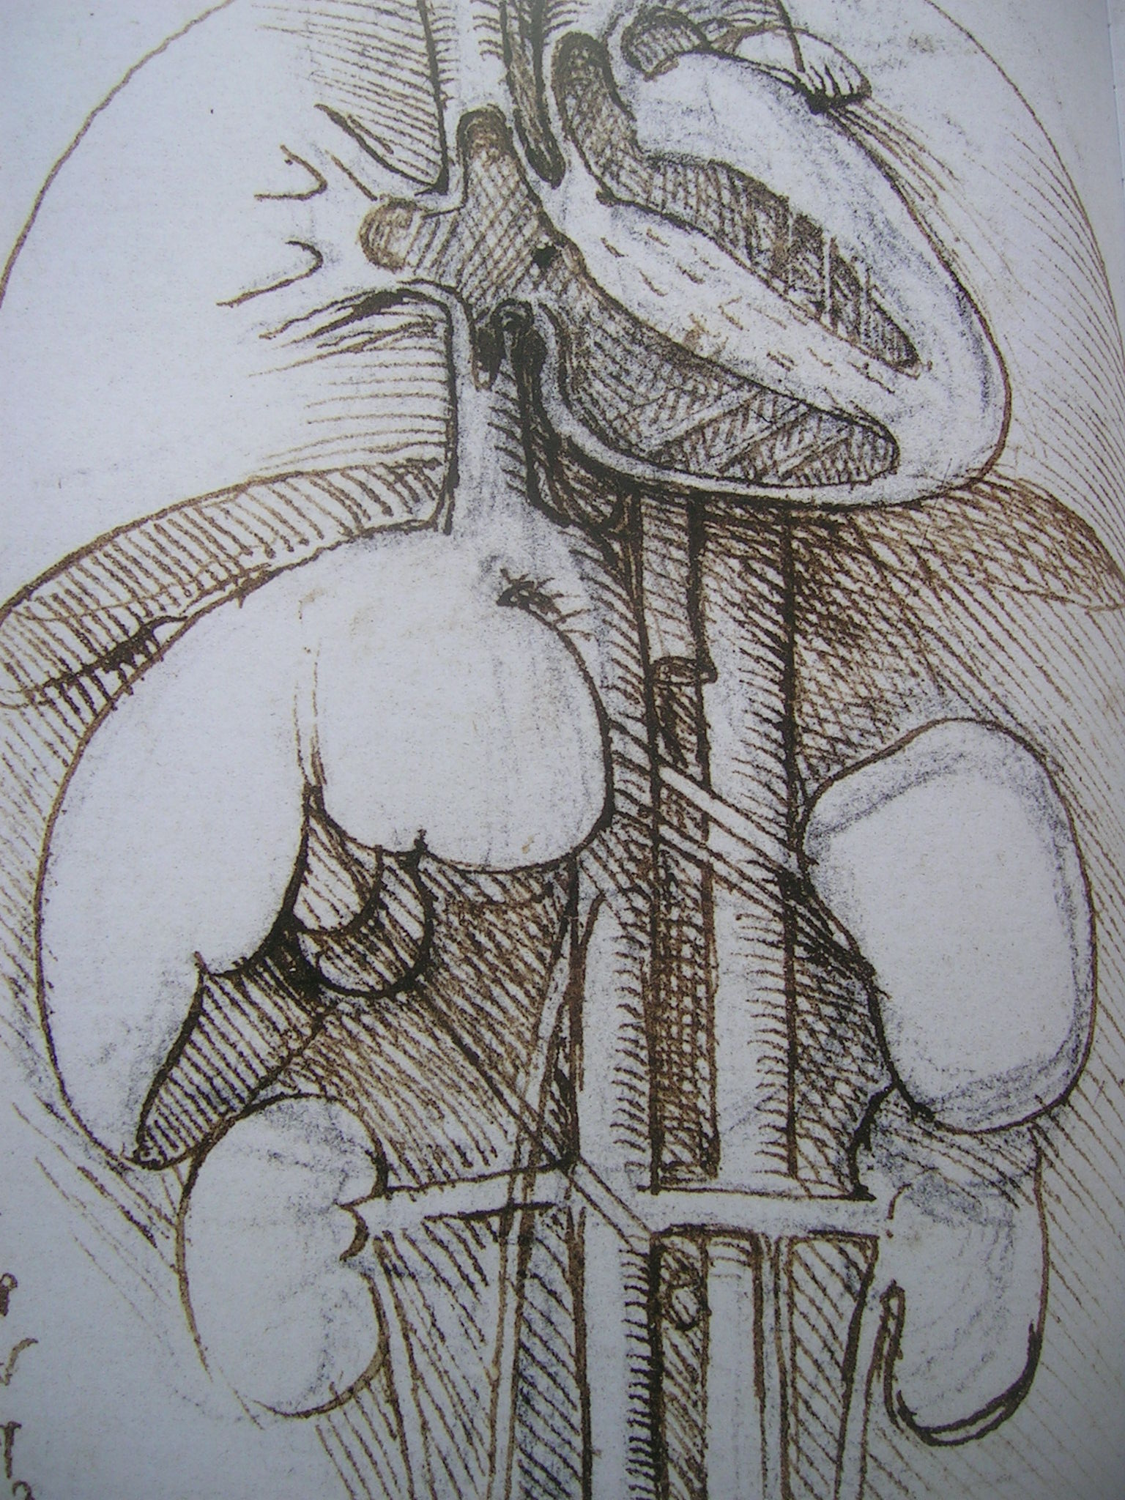 | 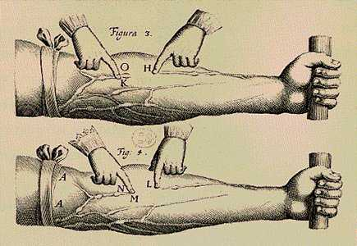
RL19112r | Exercitatio Anatomica de Motu Cordis et Sanguinis in Animalibus.
Fig. 1 The heart by Leonardo da Vinci in 1509 | Fig. 2 The proof of blood circulation by Harvey in 1628
The telescope had to be designed and realised before Galileï could see the moons of Venus and imagine they were continuously falling in a circular movement, confirming Copernicus’ assumptions and Kepler’s measurements. The steam engine had to be designed and realised before Boltzmann could develop thermodynamics 40 years later imagining entropy as the key to its efficiency.

So, imaginability and possibility are preconditions for science. Design is supposed in science, be it often has hidden supposition. So, if design could be part of science (and design education part of scientific education) is the wrong question. The right question is, if science is always part of design.

Science as part of design
If science is the result of human design (we speak about the design of a research programme, the design of research tools like a telescope, a microscope, an inquiry or even algorithms), the answer is: “Yes!”. If we look at the remarkable results of designers without any scientific education we are inclined to say “No!”. However, even designers without any scientific concern do have empirical experience of preceding examples (precedents) proving the possibility of design principles: types, concepts, models and programmes. Moreover, materialising and realising their designs these days, they use scientific results of other people. So, the final answer is: “Yes, science is always part of contemporary possible, realisable designs.”

Science in education
That does not yet mean, design education always needs a scientific input. Scientists defend that input because of the many avoidable design mistakes appearing in realised designs. However, in design practice many specialists judge the growing design in many stages, filtering out such mistakes beforehand. Their task is evaluating research based on models. So, avoiding mistakes at the very beginning of design is the wrong argument. In my opinion, the right argument is, a designer without any scientific experience will be vulnerable in the middle of these specialists. (S)he cannot reject their arguments; ask the right questions about their hidden suppositions.

Specialists
For example, if a specialist shows a graph like Fig. 3 concluding you can reach a higher density by choosing more than 4 storeys (white point), you should be able to ask what her or his hidden suppositions are, the supposed type of allotment, building length, width, depth, the height of storeys, the width of streets and courts, the accepted % built-up area, solar angle into different directions.

Fig. 3 A specialists calculation of density with many hidden suppositions  (http://team.bk.tudelft.nl/ > Publications 2006 > Density .xls) | Fig. 4 Capacity/lane(velocity) with assumptions on brake reduction, reaction time and average length of cars  (http://team.bk.tudelft.nl/ > Publications 2006 > Traffic .xls)
A traffic engineer showing Fig. 4 will claim the capacity of lanes is highest at a design velocity between 30 and 40km/hr. A designer should ask about the assumptions concerning braking efficiency, reaction time, their relation and the average length of cars taken as starting point.

Design limited by specialists’ advice
Education cannot offer all necessary evaluations by specialists on every student’s design.
In practice, a designer confronted with many of such arguments by the many evaluations will become gradually aware of design limits by experience. Avoiding mistakes (s)he will become more and more limited in formulating concepts. Without scientific background (s)he has to trust specialists’ advices without objection. However, a designer with some scientific understanding will put the advice into the perspective of a specific context. (S)he can weigh the advices related to each other and to the architectural quality to be reached.

Specialisms put into perspective by design
Perhaps a designer even recognises the same structure in the advices for example stemming from Fig. 3 and Fig. 4, bringing different disciplines together. That broader interdisciplinary understanding by context sensitive design is urgently needed in science itself. Science increasingly breaks up in specialisations, increasingly inaccessible by their collective suppositions, jargon, instruments (paradigm), not criticized by their growing monopoly, their standards accepted by policy makers, convinced of their own generalizations, less and less aware of context, of each others’ object of study, their limitations. By lack of context awareness, fascinated by mathematical evidence, generalizations based on hidden suppositions, policy makers and designers get contradictory advices. So, they choose their specialists to support their opinions and decisions. Any decision can be supported by some specialist.

Science falling in public esteem
The audience of television programmes, paying their taxes for education and enactments for example on safety, health and environment based on ‘scientific research’, looks at debates between professors with contradictory advices, hired by opinion makers. Expensive earlier enactments are questioned. Where did they pay for? They feel there is something rotten in the State of Science, being increasingly inaccessible for external critics. The university is no longer universal but specialised, struggling for survival in mutual competition. Specialised ‘peers’, authorities, censor scientific publications in expensive specialised periodicals. Three centuries of debate on the topic of authority called ‘Enlightenment’ seem to fade. Mediaeval times are back. Authority is a scientific argument again. The audience looks at debates between authorities without distinction, be it scientists or populists. They do not choose for complex arguments but for the common sense stemming from the everyday scale of personal experience. For whom are they going to pay taxes in the future? Anyway, they are willing to pay for identity, uniqueness, imagination, possibility, and design. Design products sell better than scientific articles. But they contain science.

Extending science
Design education remains attractive for students with imagination. And imagination is a prerequisite for science and policy. Architectural and urban design force to include managerial, cultural, economic, technological, ecological and spatial futures on different levels of scale, including but surpassing everyday scale. That is why they should include science within their education as a real university in itself, open for the depths of many specialisations, but broad, sensitive for context, putting them into perspective. Design extends science from exclusively probable futures into possible, imaginable futures. It offers hope in a world of depressing predictions. In their possible worlds designers make place for desires no one else could imagine before they were designed. Policy makers are freed from limiting suppositions about probable futures by possible futures imagined by design.
The task of design education is to restore the University.

