Hydrodynamics

Static balance

Static forces and the potential energy along a slope
The weight W of a bullet on a slope of α degrees can be resolved in factors perpendicular and parallel to the slope (see Fig. 2). The force parallel to the slope equals W·sin(α).
For example, if α = 30º that force is ½W, because sin(30º) = ½.

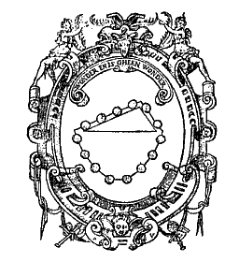 | 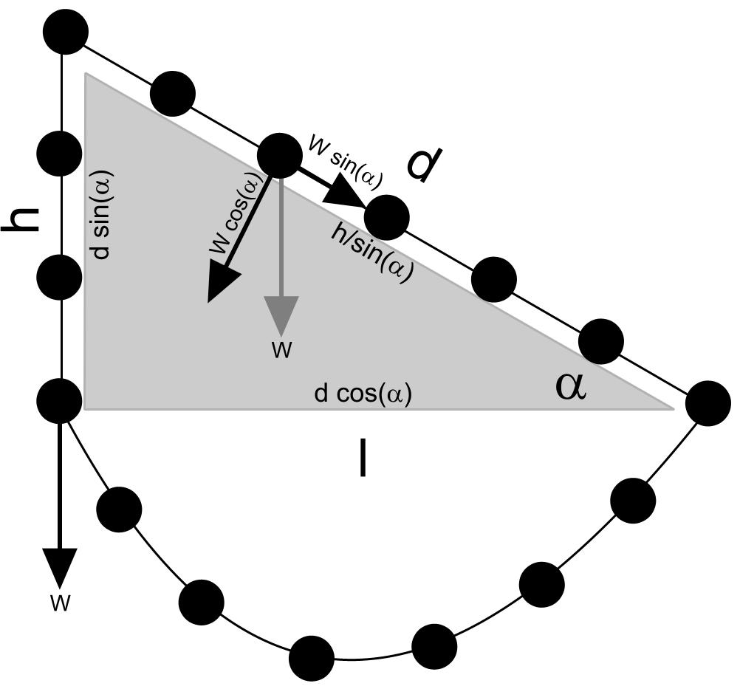
Fig. 1 Stevin: Clootcrans | Fig. 2 Balance on different slopes
However, the distance d any bullet has to cover parallel to the slope into the base equals the vertical height divided by sin(α). So, force times distance (potential energy) remains the same at both sides of the summit. For example, if α = 30º, the force is ½·W, but the distance d to cover is 2·h.
The ‘Clootcrans’ Stevin used as his logo (see Fig. 1) shows the equal potential energy of bullets according to their slope by intuition (count those at the corners in Fig. 2 half).

Potential acceleration
Force is defined as mass times acceleration (F = m·a).
At the vertical wall the potential acceleration equals the gravitational acceleration g = 9.807 m/sec².
If the masses of the bullets are the same, but the force F parallel to the slope is reduced by sin(α) then the acceleration ‘a’ parallel to the slope should be reduced by the same factor.
In case α = 30º, a = ½·g = 4,904 m/sec².

Movement ignoring resistance

Bullets falling or rolling along a slope
Suppose we disconnect all bullets and supply every second a bullet on the summit at both sides.
Acceleration ‘a’ is defined as velocity v divided by time t (a = v / t).
As long as there is no resistance the velocity v of any bullet will increase constantly with the time t according to v = a· t. But, the covered distance will increase disproportionally, because every next second the bullet has covered a larger distance according to its increased velocity.

So, we can conclude a source distributing an equal amount of bullets per second produces a stream thinning downstream gaining mutual distance by increasing velocity (see Fig. 3).

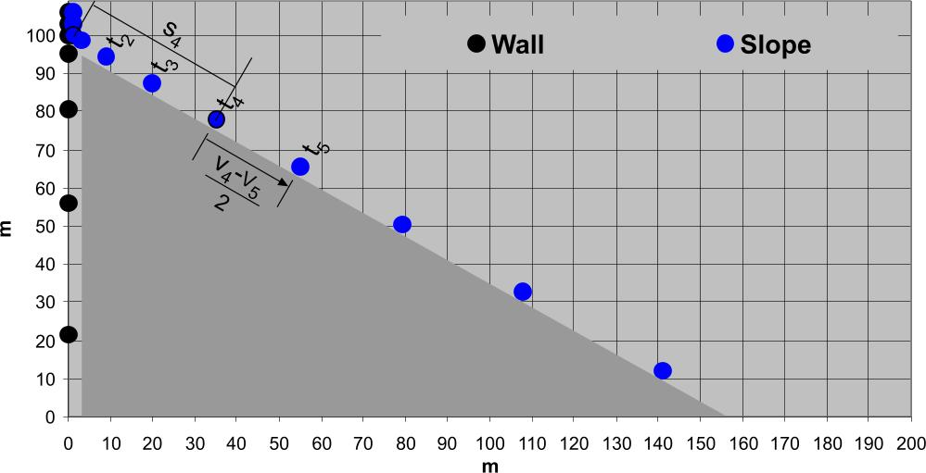
Source: http://team.bk.tudelft.nl/ > publications 2006 Hydrology.xls
Fig. 3 Bullets falling and rolling along a slope every second with a growing distance and velocity

Calculating increasing velocity v and covered distance s along a slope
The growing velocity v and covered distance s shown in Fig. 3 are calculated as follows.
Between any two moments t_{p} and t_{q} (t_{p}<t_{q}) velocity grows from v_{p} into v_{q} with a constant acceleration a: v_{q} –v_{p} = a·(t_{q} –t_{p}). Let the time interval (t_{q} –t_{p}) near zero. Then v_{q} –v_{p} = a·t, or v_{q} = v_{p} + a·t.
At time t half way any t_{p} and t_{q} the mean velocity v_{m} equals (v_{p}+v_{q})/2. Here you can substitute v_{q} .
So, v_{m}=(v_{p}+v_{p}+a·t)/2 or v_{m}=v_{p}+ ½·a·t.

The distance s covered at any moment equals v_{m}t if you take for v_{p} the velocity v₀ at the beginning.
So, s = (v₀ + ½·a·t)t or s = v_{0·}t + ½·a·t², shortly calculated as a time summing integral of s/t = v = a·t:
Supposed the bullets start in rest (v₀=0) and then begin to fall or roll without resistance, then s equals ½·a·t² without initial C.

The velocity at the end of the slope is reached at slope length d = ½·a·t² = ½ ·g·sin(α)·t².
And d = h/sin(α) (see Fig. 2). So t² = (h/sin(α))/(½·g·sin(α)) or 2h/g·sin(α)².
So, t_{end} = sin(α)⁻¹·√(2·h/g).
At that time v_{end} = a·t_{end} = g·sin(α)·sin(α)⁻¹·√(2·h/g) = √(2·g·h).
So, the velocity at the end of the slope is independent from α: it is the same velocity of a falling bullet at the end of the wall. The average velocity along the slope is half of v_{end}: v_{m}:= ½ √(2·g·h).

Kinetic energy
If a bullet of mass m [kg] hits you with a velocity of v [m/sec], and you resist its force stepping back slower bringing its velocity back to zero, the bullet has lost m·v·(v - 0 m/sec)/2 = ½ m·v² energy.
That kinetic energy E_{k} could have been built up falling or rolling h [m] with an acceleration a [m/sec²], according to E_{p} = F·h = m·a·h. Falling or rolling, the bullet lost E_{p}, gaining E_{k}, while E_{p} := E_{k} at last.
So, the process is described as m·a·h := ½ m·v² [joule].

Running water in a pipe
Suppose running water is a stream of more or less cohesive incompressible drops, flowing downstream in a volume per second of Q [m³/sec] everywhere.
Suppose the bullets of Fig. 3 are cubic metres water forced in a pipe of minimal cross section.
The average velocity will be the velocity at the end of the natural slope √(2·g·h) divided by two: v_{m} = ½·√(2·g·h).
So, the cross section of a pipe with capacity Q should be at least A = Q/v_{m} = 2·Q/√(2·g·h) [m²].
Its water content is A·h/sin(α) [m³]. If the mass m [kg] of water relates to its volume [m³] as ρ (normally 1000 kg/m³) its mass equals ρ· A·h/sin(α) [kg].

A water ram
A sudden obstacle at the end of the pipe (like a tap closed at once) shows the large amount of energy built up in flowing water. Such an obstacle has to resist a force F₁ equal to the weight of the water column divided by A [newton/m²] and a force F₂ resulting from kinetic energy E_{k} = ½·m·v² divided by some distance s (braking distance) to get the force (energy is force times distance). If that braking distance is very small F₂ increases into infinity, breaking the water pipe.

A water column of height h on a surface A produces a force F₁ = ρ·h·A·g [newton].
A mass m = ρ·h·A/sin(a) [kg] water with a velocity v = ½·√(2·g·h) [m/sec] reduced to zero over a distance of s metre (braking distance) produces a force F₂ = ½·m·v²/s:

or

The kinetic force F₂ is many times larger than F₁ = ρ·h·A·g caused by the weight of the water column (the difference is ¼·h/s·sin(α)). In the example of Fig. 4 a kinetic force of flowing water is calculated as 500 times the weight of the water column.

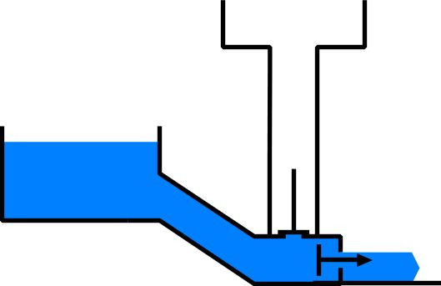 | slope angle | α | 30.0 | deg | (Input)
 | slope | one to | 1.73
 | acceleration | a | 4.9 | m/sec²
 | height summit | h | 1.0 | m | (Input)
 | slope length | d | 2.0 | m
 | time to reach end of slope | t | 0.90 | sec
 | end velocity free flow | v | 4.43 | m/sec | 16 | km/hr
 | average velocity | v_{m} | 2.21 | m/sec | 8 | km/hr
 | discharge | Q | 1 | m³/sec | (Input)
 | min. sectional plane of pipe | A | 0.4516 | m²
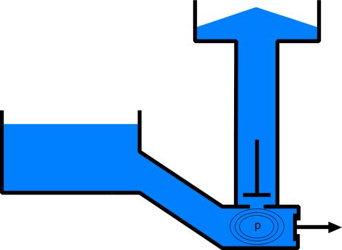 | radius of pipe | r | 37.9 | cm | diameter | 75.8 | cm
 | content of pipe | C | 0.90 | m³
 | density of water | ρ | 1000 | kg/m³
 | braking distance | s | 0.001 | m | (Input)
 | force by weight | F₁ | 4429 | newton | 452 | kgf
 | kinetic force | F₂ | 2213997 | newton | 225757 | kgf | 226 | ton
 | proportion | F₂/F₁ | 500
 | pressure at tap | p | 4912447 | newton/m² | 500912 | kgf/m2 | 501 | ton/m2
 | m height of rise |  | 501 | m
Source: http://team.bk.tudelft.nl/ > publications 2006 Hydrology.xls
Fig. 4 Water ram
That force is utilised in a pumping device called ‘water ram’. The pressure p built up in the water ram by suddenly closing the tap braking the flow to yield its kinetic force is utilised to push up the water through a valve. Theoretically the water column can be built up until 500 m. However, the pressure falls away shortly after the valve opens, so the procedure has to be repeated often to near that theoretical value.

Free flow
The cross section of a free flow A = Q/v will be smaller downstream according to its increasing local velocity v = ½ ·a·t (if there are no other sources feeding the stream).
You can see that decreasing width already on the tap (see Fig. 5).
Since s = ½·a·t² or t = √(2·s/a) and consequently v = s/√(2·s/a) =√(s·a/2), the cross section on any distance from the source will be A = Q/√(s·a/2).

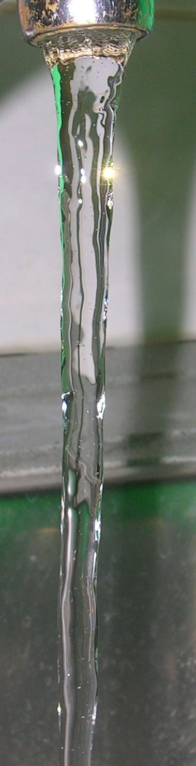 |  | 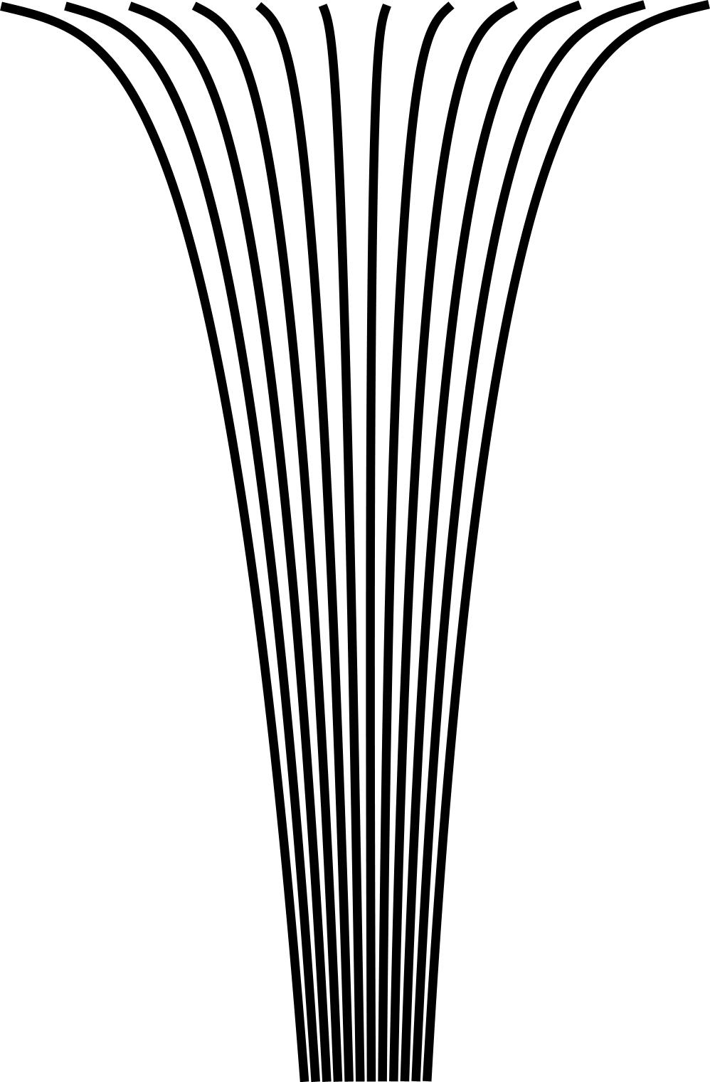
 | Source: http://team.bk.tudelft.nl/ > publications 2006 Hydrology.xls
Fig. 5 Water flowing from the tap | Fig. 6 Simulation of 0.00004 m3/sec falling water | Fig. 7 A river stemming from different separate streams
However, what you see is the diameter, 2·r. And A = π·r². So, 2·r = 2·√(A/π.)
In Fig. 5, the water from the tap has an intial velocity, perhaps comparable with the 0.02m level of the falling water in Fig. 6. As soon as a critical velocity is passed a continuous flow is falling apart in drops like rain. It shows the limits of water cohesion.

A river
A river, stemming from different separate streams with smaller cross sections (see Fig. 7) will end up flowing faster in the end. Moreover, its resistance reduces because of less contact with its bed, becoming more and more smooth (less rocky) downstream. However, its slope reduces also coming closer to the sea. How do these circumstances balance locally?

Resistance
Until now, we supposed flows, running without resistance.
But, any liquid flowing along a surface encounters a shearing force in the opposite direction dependent on its roughness. That force causes deceleraton or even partially flowing back (turbulence).
Force is mass times acceleration. If mass remains the same, the accelerations ‘a’ of previous paragraph 3.2.2 should be reduced. How much is that reduction in a stream flowing through a landscape?

Many parameters play a role, but the result mainly will be that shearing stress reduces the force of water and consequently its acceleration and velocity substantially only if the water level is less than 2m to bottom. However, it always plays an important role in transporting sediments.

So, a river can not adapt its discharge, but rather its form to bring the water most efficiently to the sea. However, that search for the most efficient course may take a very long time, sometimes waiting for a year of extreme rainfall to improve the course, clearing up bottle necks, looking for steeper slopes lessening its tress.

Shearing stress
Manning created the formula of Fig. 8 to calculate the force τ every square metre wetted surface exerts [newton/m²] in opposite direction of the flow (‘shearing stress’).

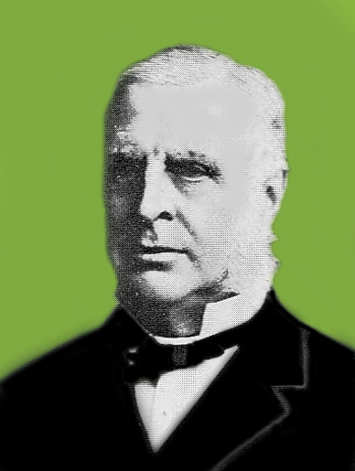
 | http://viwc.lin.vlaanderen.be/water/ts2003_09_grensmaas.pdf
Fig. 8 Robert Manning and one of his formulas | Fig. 9 Shearing stress τ due to different discharge suppositions and local roughnesses and bed forms along 17.5 km of the river Meuse (Grensmaas)
Fig. 9 shows τ for different circumstances a part of the river Meuse (Grensmaas) ranging from 1 to 50 newton/m². Fig. 12 shows the studied part in Fig. 9, folded along the boundary of The Netherlands and Belgium within its winter dikes.

The river Meuse for example
Fig. 10 shows a cross section of a river like the river Meuse approximately half way of its 925 kilometres course. Suppose the surface of its cross section A = 300m² and its discharge Q = 600m³/sec (often in winter). In that case its water level is 5.7m and it transports a mass m = 600 000kg of water per second over 2 metre (so, velocity v = 2m/sec or 7.2km/hr). That represents E_{k} = 1.2 million joule kinetic energy over 2 m, and a force F₂ = 600 000 newton equivalent to a weight of approximately 60 tons.

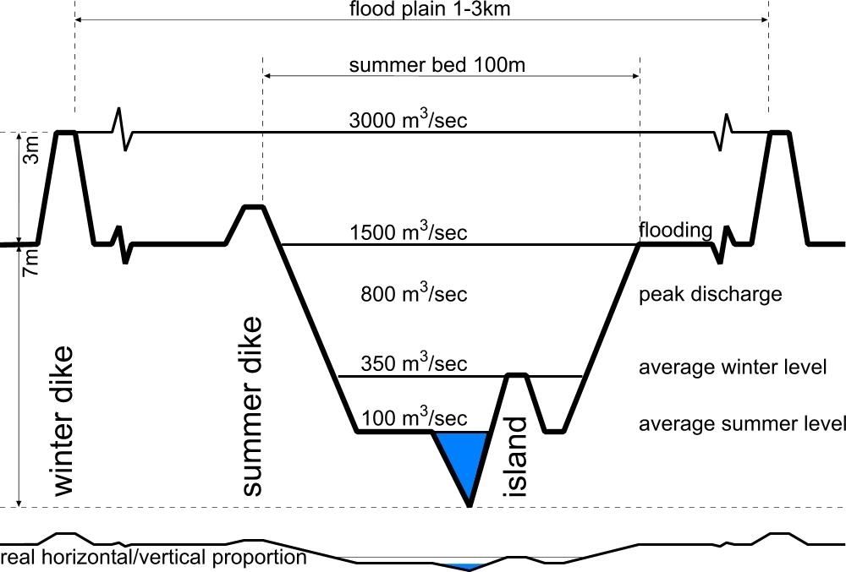
http://viwc.lin.vlaanderen.be/water/ts2003_09_grensmaas.pdf | http://team.bk.tudelft.nl/ > publications 2006 Hydrodynamics.xls
Fig. 10 Typical cross section and wetted surface of a river like the Meuse half way (Grensmaas) | Fig. 11The influence of shearing force by different water levels in Fig. 10
According to Mannings formula in this circumstances the shearing stress τ would be 10 newton/m².
If it shears over the river bed taking 100 m in the cross section (‘wetted contour’), then perpendicular to that cross section in 1sec over a length of 2m the river has to overcome 2 000 newton resistance. That is only 0.3% of the local force of the river. And in this two metres we did not even count the pushing power of many kilometres moving water coming down upstream.

Low shearing stress
So, the influence of the shearing stress τ on velocity and acceleration on a water level of 5.7m is negligible, but in many centuries it has given the actual form to the river by loosening material from the bed. Water with a velocity of 2m/sec could even move stones of 0.5kg, but at the bottom a shearing stress of 10newton/m² will only move some smaller sediment.

High shearing stress
However, at water levels in the same circumstances lower than 2m, τ becomes more than 1%, increasing into 80% on very low water levels (see Fig. 11). You can calculate it yourself for different circumstances downloading http://team.bk.tudelft.nl/ > publications 2006 Hydrodynamics.xls.
So, in small brooks τ will play an important role on the resultant force, acceleration, velocity and kinetic energy.

Kinetic energy per m3 water ½ ρ·v²
In Mannings formula ρ is the mass of 1m³ water (mainly 1000 kg/m³). The kinetic energy reduced by roughness like earlier shown by the water ram (see page 3) is ½ m·v² (see page 3).
So, ρ·v² in the formula represents twice the kinetic energy per m³ water.
You can measure the velocity v [m/sec] on different spots in the cross section to calculate the average velocity (see Error: Reference source not found).
Kinetic energy [newton·m] per m³ is the same as force per m² like τ [newton/m²].
So, the rest of the formula is a dimensionless factor, but how to calculate it?

Roughness n
The roughness of river beds is expressed in a roughness factor n [sec/m^{1/3}] shown Error: Reference source not found, ranging from 0.01 for very smooth concrete until 0.1 sec/m^{1/3} for flooded tight forest.

Hydrolic radius R
R [m] in Mannings formula is the ‘hydrolic radius’, the wet surface ‘A’ of the cross section divided by the length of its wetted contour ‘P’ (R = A/P). The larger ‘A’ is (for example increasing by a larger discharge (see Fig. 10) the less influence the wetted contour has.

The surface/contour proportion is an important factor in many physical phenomena like roads around an urban island (public investment), volume/surface of buildings or growing animals (insolation). If a volume increases by a third power of distance, a minimal surface containing that volume increases quadratically (slower), while the minimum contour (a circle) containing a surface increases in the same time linear (again slower).
A ‘wetted contour’ of a river is not a circle, but it increases slower than the contained cross sectional surface also because the horizontal upper surface is ignored.

Fall and acceleration a
Most difficult to estimate is local ‘a’ in Mannings formula. The total acceleration of a river can be calculated according to page 1 and reduced by varying shearing stress, but that average is locally changed by varying slopes and forced by water masses upstream into increased acceleration in narrow cross sections, partly compensated by higher water levels storing potential energy for accelerations later.

Reduction of acceleration
The part of the river Meuse studied, falls 10m (from 40 to 30 above sea level) over 17.5km length with varying resistance (see Fig. 13). However, the total fall of the river Meuse from source to sea is 409m over 925km. That is the tangent of α = 0.0253 degree. So, you could expect an average acceleration of a = g·sin(α) = 9.807·sin(0.0253) = 0.004 m/sec², partly reduced by a substantial τ in the many feeding brooks at the boundary of the basin (see Fig. 14).

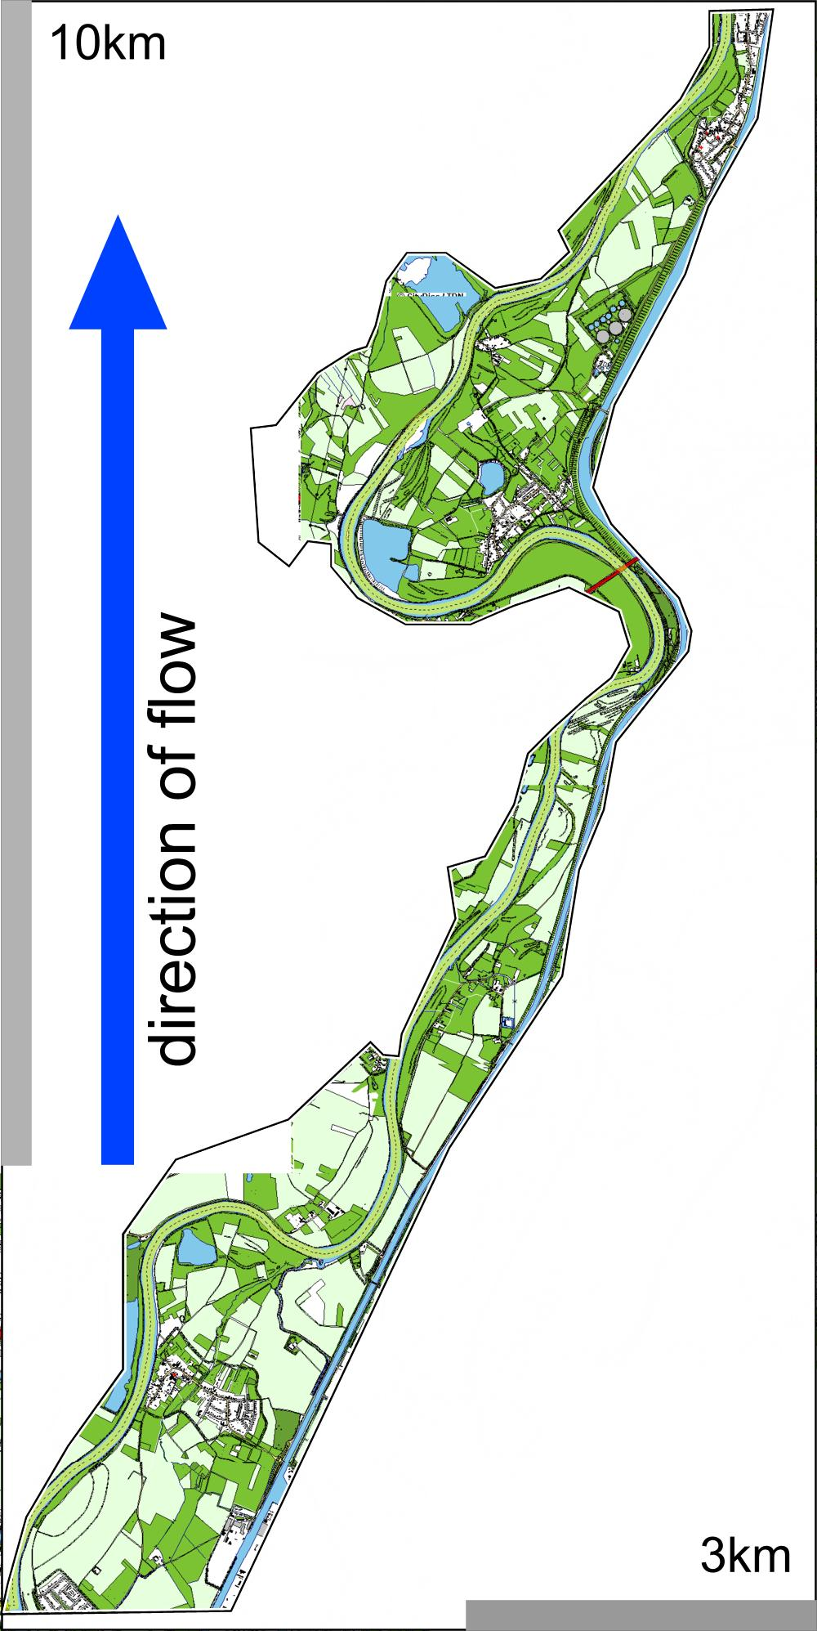
Source: http://viwc.lin.vlaanderen.be/water/ts2003_09_grensmaas.pdf
Fig. 12 17.5km of Meuse (Grensmaas) | Fig. 13 A fall of 10m along 17.5 km of the river Meuse (Grensmaas)
Because v = a·t and consequently t = v/a, the distance covered s = a·t²/2 = a·(v/a)²/2.
So, at distance s = 500km from source the velocity should be v = √(2·a·s) = 66m/sec.
However, we counted v = 2m/sec, to reach Q = 600m³/sec through a cross section (wetted surface) of 300m². So the reduction by τ in all upstream shallow brooks and small rivers of the basin together should be 97%!

Discharge
If you measure the cross section ‘A’ [m²] of a stream and the velocity v [m/sec], the discharge Q = A·v.
However, you also can measure the rainfall of the Meuse river basin in Belgium and France (23 500km²). If in that area at average in a year 1000mm rain has fallen of which 200mm is evaporated or temporarily sunken down into the earth, then Q = 800mm·23500km²/yr. That is 600 m3/sec of water coming into the Netherlands at the boundary of Belgium averaged over a year (see Fig. 14).

However, in a a concurrence of circumstances like in january 1995, there can be more rainfall (up to 350mm per day), less evaporation, no storage in a saturated earth, faster discharge because that earth is frozen, but starting to melt, delivering previously fallen water in the same time.
In such a case you can expect floodings.

Velocity and discharge
Many rivers have a strong relation v = k·Q^{m}, but ‘k’ and ‘m’ differ from river to river. Fig. 15 shows that relation for two extremely different American rivers. In a logarithmic representation the measurements fit very well a straight line. An increasing factor ‘k’ shifts the whole line up, an increasing exponent ‘m’ makes it steeper (v more sensitive for Q). If the Iine is horizontal (m = 0), there is no relation between v and Q whatsoever. Even if the discharge increases, the velocity will not. These are stoic rivers having other possibilities to give space to their discharge, for example in the lowlands. The steep liners are nerveous ones, apparently limited in their cross sections in the highlands.

Source: | Source: Leopold
Fig. 14 Meuse river basin of 36 000 km² through France, Belgium, Germany and The Netherlands | Fig. 15 Different relations between velocity and discharge (the same data in a linear and a logarithmic representation)

Erosion and sedimentation
Material from the river bed (silk, sand and gravel) is transported dependent from the velocity of water.
Source: redrawn according to Pannekoek ( ) Algemene geologie ( ) pag. 225
Fig. 16 Erosion and sedimentation dependent from the velocity of water
From >0.2 cm particle size we call it gravel (see Fig. 16).
Until <0.2 cm it is named sand or silk (see Fig. 17, an enlargement of Fig. 16).
Source: redrawn according to Pannekoek ( ) Algemene geologie ( ) pag. 225
Fig. 17 Erosion and sedimentation at the boundary of silk < 0.0.005 cm and sand >0.005cm dependent from velocity of water, detail from Fig. 16
In Fig. 17 until 0.05m/sec you can conclude that the river bed is stable. Or the reverse: if you see a stable bed, the velocity should be less than 0.05m/sec.

Silt
From a velocity 0.15m/sec all loose silt is moving. So, if you see silt on the bottom, the velocity of the water should be usually less than 0.15/sec. If you do not see silt, it should usually be more. However, heavy clay densified into a cohesive plaster layer needs a higher velocity to erode than you would expect from their particle size.

Sand
From 0.45m/sec (ample 1.5km/hr, slowly walking) onwards all sand is moved. So, if you do not see sand, the velocity will be probably more than 0.45m/sec.

Gravel and stones
At higer velocities you have to look at gravel and stones in to estimate the water velocity (see Fig. 16). From 1m/sec (3.6km/hr) you see stones of 1cm diameter rolling, from 1.45m/sec (5km/hr) stones of 2cm, from 1.7m/sec (6km/hr) stones of 3cm, from 1.95m/sec (7km/hr) stones of 4cm.
On that level the diameter of stones moved grows approximately parabolically with the square of velocity. So, stone diameter ≈ v² like 1 ≈ 1², 2 ≈ 1.45², 3 ≈ 1.7² and 4 ≈ 2². That seems logical, because according to page 3 the kinetic energy of running water (½ m·v²) is proportional to the square of velocity.

Higher velocities widen passages, lower velocities narrow them.
At the long term wider passages of a river with lower velocities will be filled up with sedimentation and narrow passages with high velocities will be widened by erosion or floodings. So, by an equal discharge Q in older natural rivers the velocity v is equalised as well. However we have artificially narrowed our rivers to save land and to make them deeper for ships.

Hydraulic geometry of stream channels

Width (w), depth (d) and stream velocity (v)
The study of the changes of channel width (w) and depth (d), stream velocity (v) and suspended load with a discharge Q = w·d·v is the next step for a better understanding of the behaviour in a landscape.
Channel width, depth and current velocity increase during rising water. This is no surprise to anyone familiar with the regime of rivers, but the regular change of each separately is amazing.

With the help of a wide range of streaming conditions it was found experimentally (Leopold and Maddock, 1953) that width, depth, velocity and load increase as simple power functions of discharge.. This can be translated in the following equations:

w = aQ^{b} d = cQ^{f} v = kQ^{m} (see page 8)

The numerical values of the arithmetic constants a, c and k are not significant for the hydraulic geometry of streams. On the other hand the numerical values p,q and r are very important. All these values are found by measurements. Leopold and Maddock found that the average for some 20 more or less comparable stations in the United States gave the following values:

b = 0.26 f = 0.40 m = 0.34

In these cases during a flood the width of a channel at a specific cross-section will increase slowest (w =aQ^{0.26}), the depth (level) fastest (d = cQ^{0.4} ) and the velocity in between (v = kQ^{0.34}).
Comparing measurements of channel shape and stream velocity in a downstream direction gives surprising results. Normally the discharge of a river downstream increases. The same equations are found to apply at the different downstream cross-sections. Research and measurements proved that:

Width, depth and velocity increase downstream by increasing discharge.
According to Fig. 3 this empirical results also reject the idea that streams in the mountains flow wildly and more rapidly than downstream. These higher streams are characterized by a flow in circulair eddies with almost as much backward as forward motion.
The numerical value of the exponents b and m from the equations above are not the same for changes downstream as for changes with discharge passing an upstream cross-section.
In the downstream direction the average values for the exponents become:

b = 0.5 f = 0.4 m = 0.1

Downstream, the width of the channel will increase most rapidly, the depth a little bit less rapidly, but the mean velocity will increase only slightly. It is believed that the increasing depth downwards permits a more efficient flow in a river and so overcompensates the decreasing slope. As a result a slight net increase in velocity at mean annual discharge will take place.

Further mathematical calculations of the hydraulic geometry equations suggests useful applications of the principles.

The discharge is defined as Q = wdv

and if w = aQ^{b} d = cQ^{f} v = kQ^{m}

then by substitution: Q = (aQ^{b})(cQ^{f})(kQ^{m})

or: Q = ackQ^{b+f+m}

it follows that: a x c x k = 1.0 and b + f + m = 1.0

As is stated above the arithmic constants a, c and k are not important. But it is interesting that for all the made measurements and calculations for the different cross-section b + f + m =1.0 agree.

References to hydrodynamics
Bloom ( ) ( )

http://64.233.183.104/search?q=cache:2qsQymRjhqcJ:manning.sdsu.edu/+Manning+hydrology&hl=nl&gl=nl&ct=clnk&cd=1
http://www.fhwa.dot.gov/bridge/wsp2339.pdf
The Belgian standard TAW in Fig. 13 means ‘above average sea level at ebb-tide on Ostende, 2.426m higher than NAP, the Dutch standard for measuring heights.
http://nl.wikipedia.org/wiki/Stroomgebied_van_de_Maas
http://eps.berkeley.edu/people/lunaleopold/(043)%20Downstream%20Change%20of%20Velocity%20in%20Rivers.pdf#search=%22velocity%20rivers%22

