Dry and wet networks
Taeke de Jong 
22.1 Introduction 448
22.2 Traffic connections 448
22.2.1 Demand 448
22.2.2 Form 449
22.2.3 Hierarchy 451
22.3 Two networks 453
22.3.1 Names and scale 453
22.3.2 Functional charge 454
22.4 Superposition and interference 456
22.4.1 Superposition of levels per network 456
22.4.2 Interference between networks 456
22.4.3 Crossings 458
22.5 Conclusion 459

Introduction
Infrastructure crisscrosses the landscape connecting ever changing human activities along more or less predictable lines of potential. In case of locally increasing economic activity and network density the fragmentation of the landscape will continue along these lines. To anticipate these traces locating quiet areas, this chapter gives an ideal typical categorisation of dry and wet networks as related to their size.

It is ment to give a preliminary overview as long as there is no empirical evidence to generalise a very diverse phenomenon, mainly caused by man (an unpredictable factor, assuming free will and creativity). Like the variety of drainage in a landscape, the opening up of areas occupied by man depends on many local factors, including that of history. Their crossings and bridges as expensive pieces of civic art determine their course for long periods.

However, if you look at the topographical map comparing many fragments of the Netherlands, you can recognise features, a periodicity of roads and drains of different order. Once you establish a range of measures, these are standards to describe deviations making local identity nameable.
Since I proposed an ideal typical range of nominal measures {1, 3, 10, 30 …m} as a rule of thumb for designers, the diversity of spatial reality determined by networks has become more tangible. A ‘nominal measure’ is an elastic name for a range of measures. If in this chapter I write ‘1km’, I mean a measure somewhere between 300m and 3km.

Traffic connections

Demand

Distribution of inhabitants
The distribution of inhabitants (see Fig. 1) is the origin of the city, the support for their facilities, work, shopping and leisure. The connections and the technical equipment derive their use from that distribution and therefore they must be traced back to it. Through the increase of car traffic after the Second World War, connections became dominant in each map.

Calculating demands
You can try to model points like origin and destination (by means of locations of work, distribution and leisure), to calculate the demand for roads on the resulting flows like Newtonian forces between mass accumulations. This is the usual way of traffic modelling.
Fig. 1 The Hague, distribution of inhabitants in R=100m spots of 1000 inhabitants (30m² pp) and a grid of 1km (author on CityDisc, 2001)

Intuitively predicting connections
However, the topographical map simply shows that the Netherlands on average have got a district - or country road every kilometre and a motorway every 30km (see also Error: Reference source not found). In urban areas, the meshes have been filled in further by neighbourhood roads and residential streets, whereas in larger conurbations every 3km a city motorway seems necessary a and every 10km an orbital motorway. Wherever there are gaps between the 3km city motorway and the 30km regional motorway, traffic jams probably appear because the regional highways are used by local traffic.

Form

From radial into grid
Utrecht was a spider in the radial net (see Fig. 2) for centuries. After the Second World War larger ride lengths were demanded, increasingly passing the city by continuing traffic tangents (see Fig. 3). The Dutch landscape was transformed from one full of cities to one featuring a grid system with cities added on.

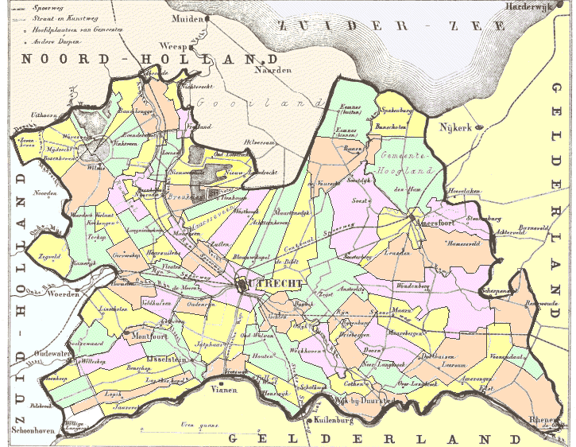 | 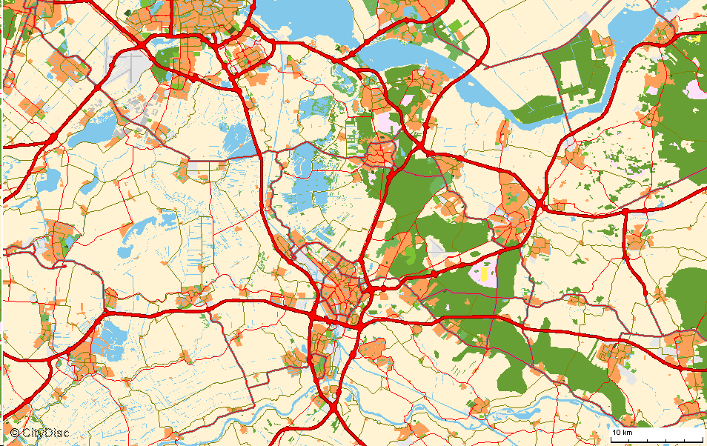
Fig. 2 From radials in 1866 …  (Source Province Utrecht, 1866) | Fig. 3 …via tangents to a bigger grid in 2001 (CityDisc, 2001)
Now, cities themselves (like Utrecht in Fig. 2 as a spider in a thin-lined web) are captured as flies in the peripheral meshes of a larger network. The more distance a city keeps from the central agglomeration (Amsterdam left above in Fig. 3 on the same scale as Fig. 2), the more orthogonal the grid (network city). The question is when that central conurbation in turn will transform from spider to fly in a continental metropolitan net.

The logic of orthogonal grids
The fact that a radial-hexagonal grid is transformed through passing traffic into a tangential-orthogonal grid, can easily be seen through the analogy of a thin sheet of soap bubbles distorted by a long hair (see Fig. 4).

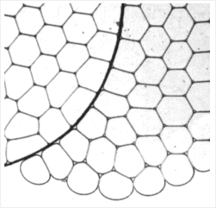 | 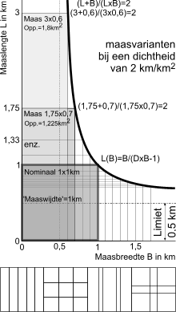
Fig. 4 Right angled by long lines (Hildebrandt and Tromba, 1989) | Fig. 5 Length and width of meshes with the same network density

Although a hexagonal grid has the lowest perimeter/area proportion from the viewpoint of investing in public space, in many respects an orthogonal pattern fits better in urban development (Bach, 2006). An orthogonal grid does not need to contain squares (elongated rectangles are often profitable). You can abstract from the form of a square by expressing the network density (km/km²) in nominal mesh width M of a rectangle with the same network density (see Fig. 5).

Hierarchy
If you leave your home to go on a trip, you start on a ‘residential street’ (some 20m wide), followed by a larger ‘neighbourhood road’ (say 30m wide) reaching an even larger ‘district road’ (say 40m wide) and so on.
The question arises at which mutual absolute distance you have to draw them in urban design. To keep it simple, we take 30m for the smallest residential paths, 100m for residential streets, 300m for neighbourhood roads, and 1000m for district roads (Fig. 6).

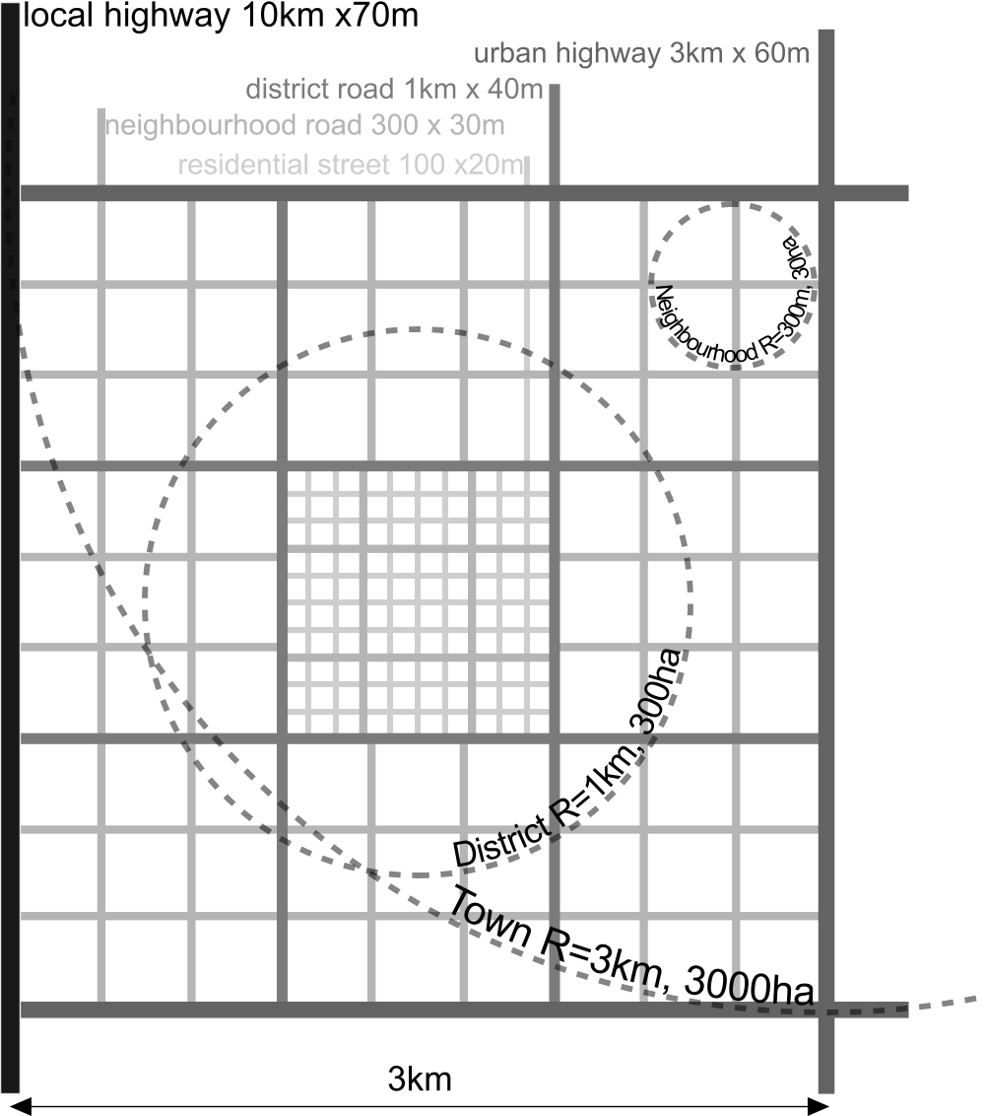
Fig. 6 Four orders in a network hierarchy

This way, every road hierarchy gets a range of different mesh widths. A factor 3 is observed as optimum scale step according to several criteria (Nes and Zijpp, 2000). Do not take that too strictly, it is just a rule of thumb. In the same time that is the average distance between junctions into the higher order. On average every third road of each level you can make a turn to a road of a higher level (see Fig. 6).

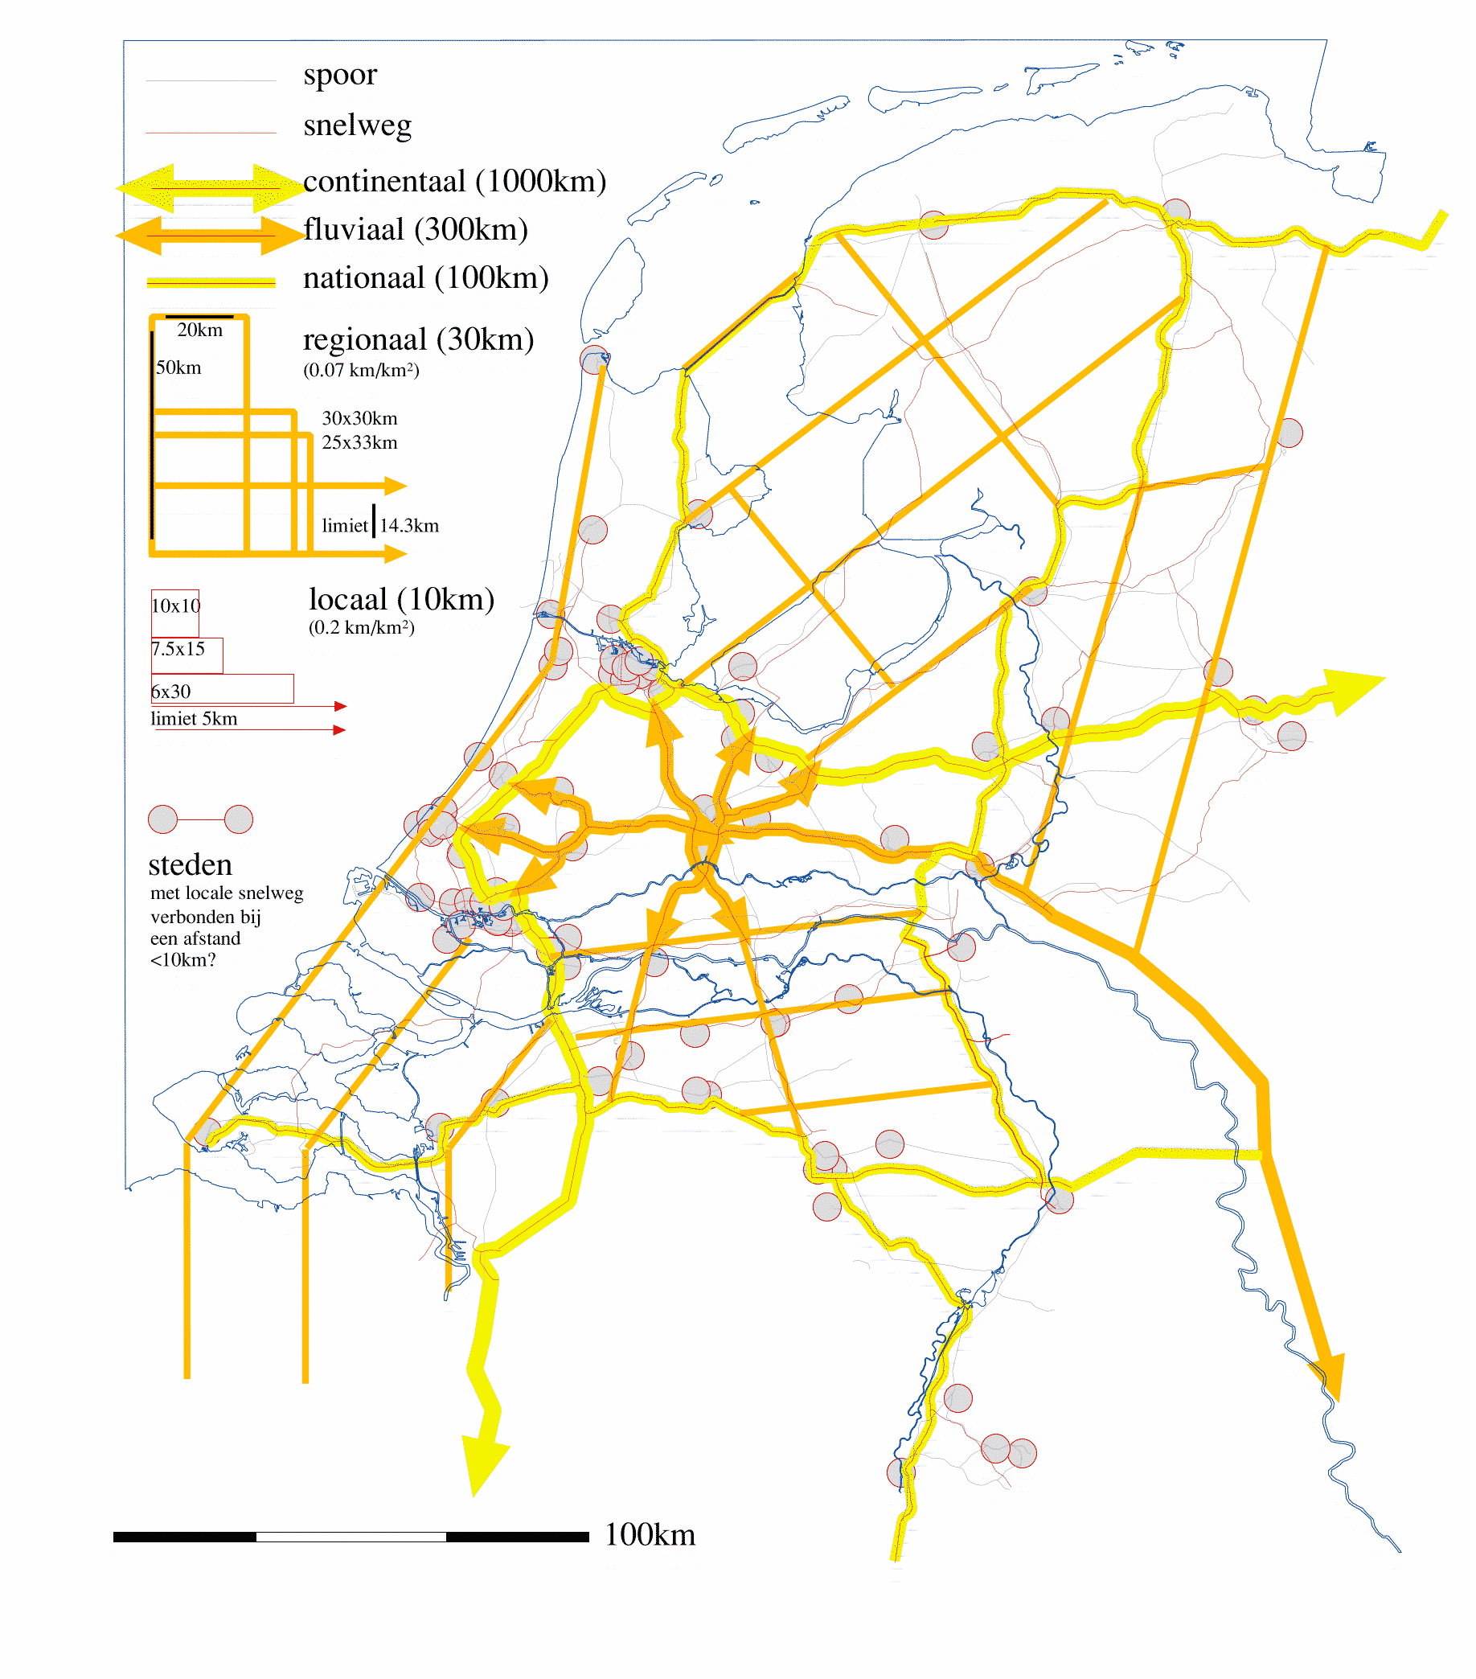
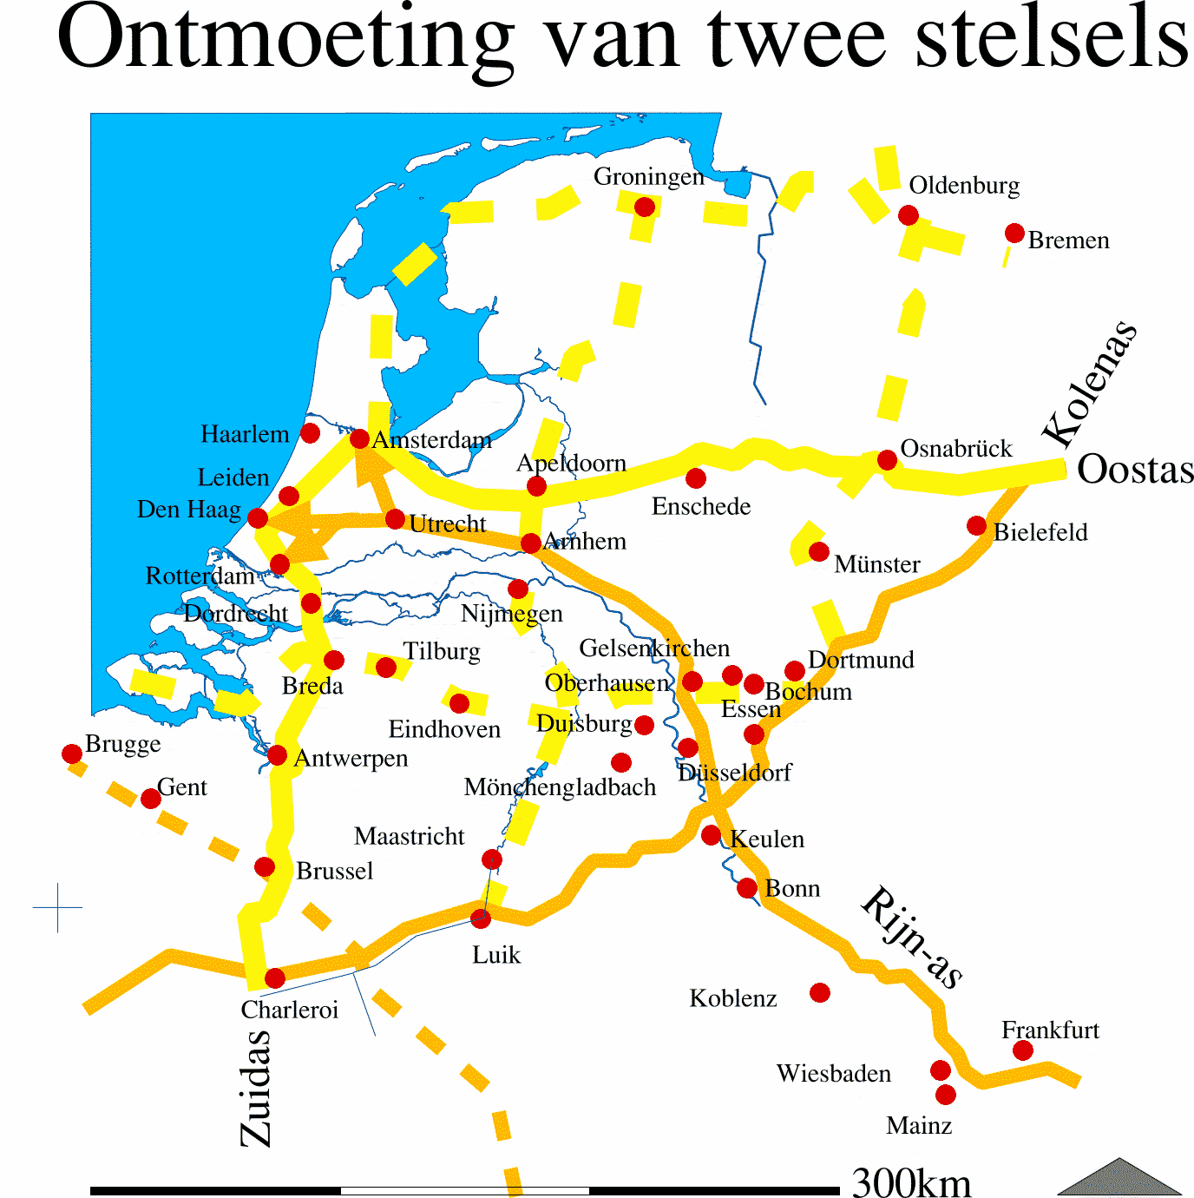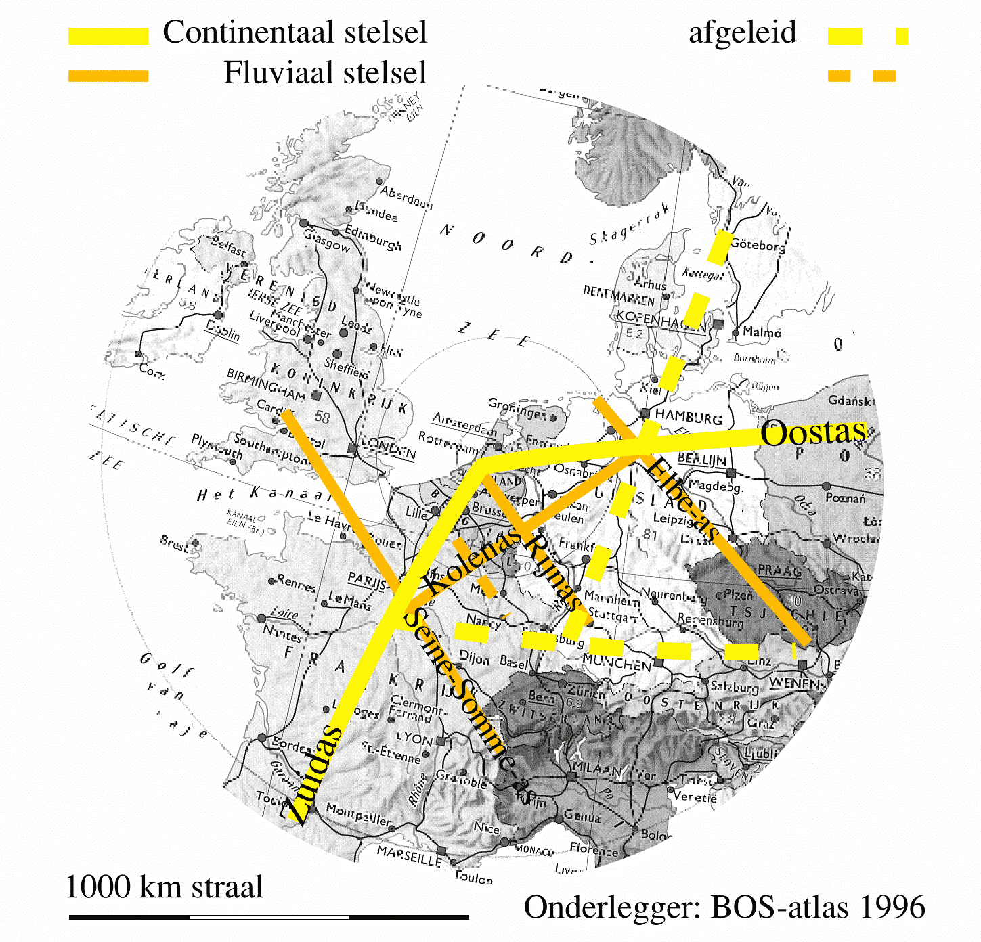
Fig. 7 Potential national, fluvial and continental network systems if nominal densities were applied (Jong and Paasman, 1998)

In the existing networks you might recognise such a hierarchy from the lowest ( Fig. 6) to the highest (Fig. 7 ) levels of scale.

Two networks
This hierarchical range applies also to the artificial wet (water) infrastructure where the natural tree-like drainage by rivers and brooks has mainly disappeared, as in the Netherlands. So, the number of crossings as a result of interference between both kinds of networks is easily outlined in different alternatives of mesh form.

Names and scale
Everybody knows many names of wet and dry connections, regardless of their function (Fig. 8). They seem to fit nearly logarithmically on a constant difference of scale multiplying the mesh width each time approximately by 3.

NETWORK |  | BLUE LEGEND |  | BLACK LEGEND
density | mesh/  exit interval |  | NAME | nominal width | NAME
km/km² | km nominally | width 1% |  | m
0.002 | 1000 | ≥10000 | sea
0.007 | 300 | 3000 | lake | 120 | continental motorway
0.02 | 100 | 1000 | stream/pond | 100 | national motorway
0.07 | 30 | 300 | river/waterway | 80 | regional motorway
0,2 | 10 | 100 | brook/canal | 70 | local motorway
0.7 | 3 | 30 | race | 60 | urban motorway
2 | 1 | 10 | watercourse | 40 | district road
7 | 0.3 | 3 | ditch | 30 | main street
20 | 0.1 | 1 | small ditch | 20 | street
70 | 0.03 | 0.3 | trench | 10 | path
Fig. 8 Names of networks on the higher levels of scale
However, in reality the interval is sometimes more, seldom less than 3 and often the highest and lowest orders are missing. For example clay grounds do not need trenches and sandy grounds start their drainage by brooks. A wet peat area continues its grid hierarchy into the level of canals, a clay area into the level of ditches and a sandy area or city stops at larger water courses. That makes the soil type globally readable from the topographical map. For its dry opening-up, the rural area is detailed until the road, the industrial area until the main street, the residential area until the street. Similarly, rural areas do not need streets every 300m. In the Netherlands they start with roads every 1km as can be seen on topographical maps
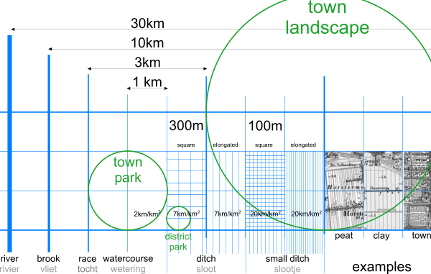
Fig. 9 Styling of wet connections

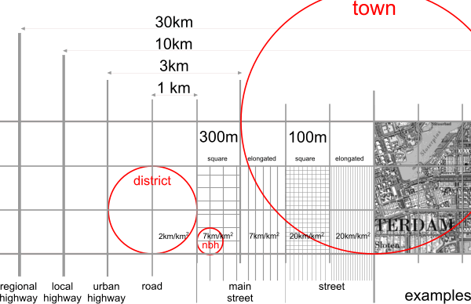
Fig. 10 Styling of dry connections

Functional charge
These functionally neutral names get their time-bound character by changing function. Dry and wet networks get their contemporary meaning by ‘functional charge’ in Fig. 11. Their density implicates the level of investment.

Nominal mesh width | 30m | 100m | 300m | 1km | 3km | 10km | 30km | 100km
Density (km/km²) | 70 | 20 | 7 | 2 | 0.7 | 0.2 | 0.07 | 0.02
wet connections
name | trench | small flooded ditch | a flooded ditch | watercourse | race | brook | river | lake
indicative width 1% |  | 1m | 3m | 10m | 30m | 100m | 300m | 1000m
other names |  |  | stream | stream | stream | stream
 |  | urban canal | urban canal | urban canal | urban canal | industrial canal/waterway | canal | canal
functions | draining |  |  |  |  | drainage pool (from polders)
Nominal mesh width | 30m | 100m | 300m | 1km | 3km | 10km | 30km | 100km
dry connections
name | path | street | main street | road | urban motorway | local motorway | regional motorway | national motorway
an exit every ...km | 10m | 30m | 100m | 300m | 1km | 3km | 10km | 30km
indicative width | 10m | 20m | 30m | 40m | 60m | 70m | 80m | 100m
functions | pavement | opening to a hamlet | neighbourhood street | district road, village road, country road | urban motorway, main road | urban motorway | provincial motorway | national motorway
 | footpath | residential walk | walking route | cycle route | cycle ride
‘Duurzaam Veilig’ (long-term safety) | ‘Woonpad’, free of cars | ‘Woonstraat’, restricted entry for cars | ‘Erftoegangsweg’, sojourn function | ‘GebiedsOnsluitingsWeg’, opening to an area | ‘Stroomweg’, throughway
public |  |  |  |  | bus | express | fast bus | Interliner
Nominal mesh width | 30m | 100m | 300m | 1km | 3km | 10km | 30km | 100km
railway line |  |  |  |  | tram | light rail | regional | national
a supportive base |  |  |  |  | 300m | 1km | 3km | 10km
functions |  |  |  |  |  | the underground/metro | local train | intercity train, Argus
 |  |  |  |  | hybrid systems | hybrid systems | hybrid systems
Fig. 11 The time-bound functional charge of networks

Superposition and interference

Superposition of levels per network
In connection with the dry and wet legend one can imagine their superposition as shown in Fig. 12.

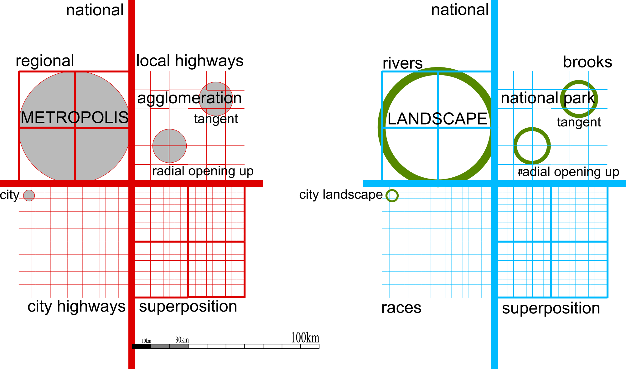
Fig. 12 Superposition of networks
An urban area is radially crossed or tangentially surrounded by infrastructure (see Fig. 12 above left).
By superposition of the higher order over the lower order, the density of the lower order decreases.
By superposing the wet connections over or under the dry connections, both networks interfere (‘interference’).

Interference between networks
When one lays different (for example wet and dry) networks over each other, an interference occurs that defines the number of crossings, and, because of this, the level of investment in civil engineering constructions (Fig. 13).This can be done in different ways. Separating instead of bundling them fragments space more. The diversity of interference has important impacts on ecology and cultural identity.

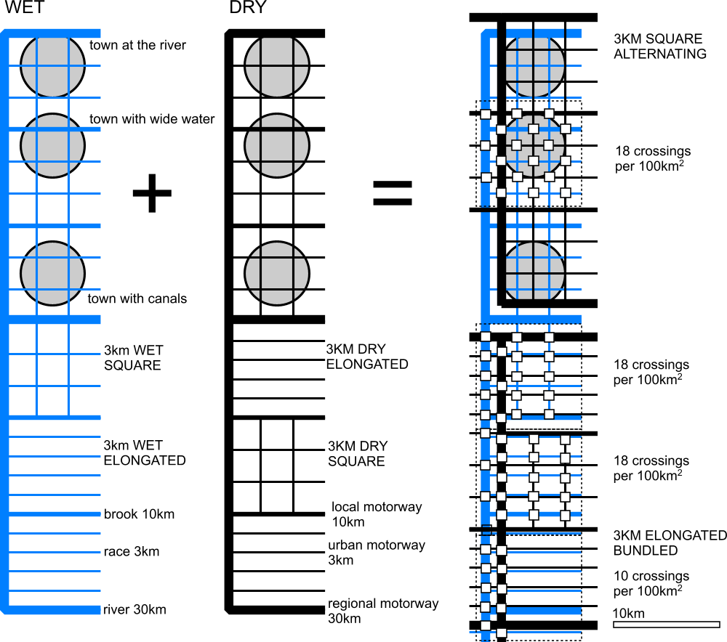
Fig. 13 Interference between wet and dry networks at equal density.
The position of urban areas with respect to orders of magnitude of water and roads dictates their character to a large extent. The elongation (stretching) of networks reduces the need for engineering constructions when their meshes lie in the same direction. If one bundles them together, this also helps to prevent fragmentation. The aim of the ‘Two network strategy’ (see Tjallingii, chapter Error: Reference source not found, page Error: Reference source not found), on the other hand, is to position water, as a ‘green network’, as far away as possible from the roads (in an alternating manner). However, this has the effect of increasing fragmentation by roads and watercourses. Moreover, when does the green-blue line meet a next traffic-potential?

Crossings
Mutually crossings of waterways seldom separate their courses vertically (Fig. 14) as motorways do (Fig. 15).

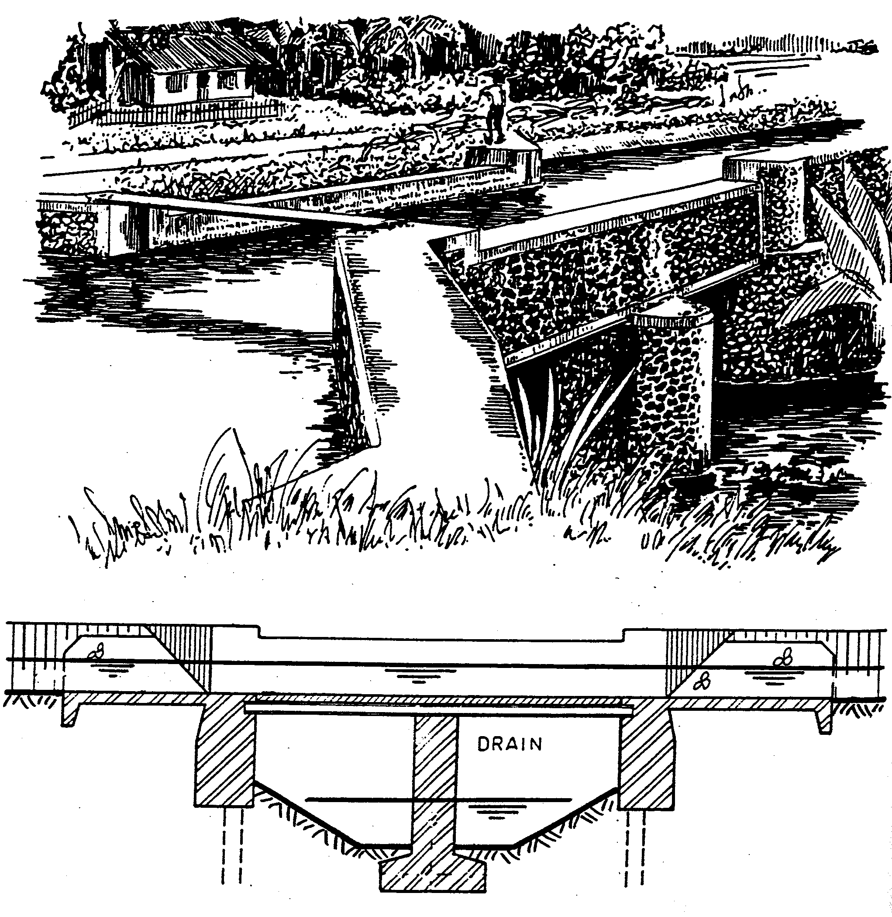 | 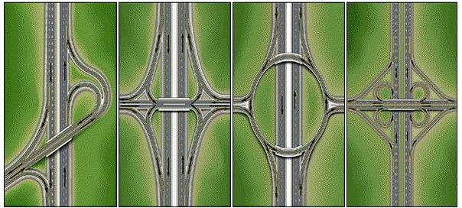
Fig. 14 Crossing of separated waterways (Ankum, 2003; page 160) | Fig. 15 Crossings of highways (Standaard and Elmar)
More often their water levels are separated by locks or become inaccessible for ships by weirs or siphons. However, crossings between roads and waterways in full function have to be separated vertically anyhow. This is fairly common.

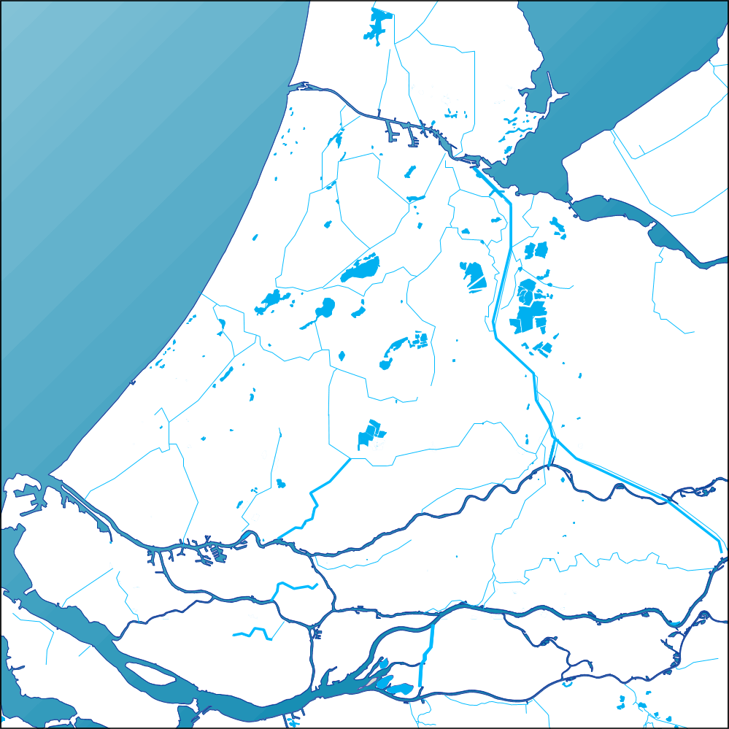 | 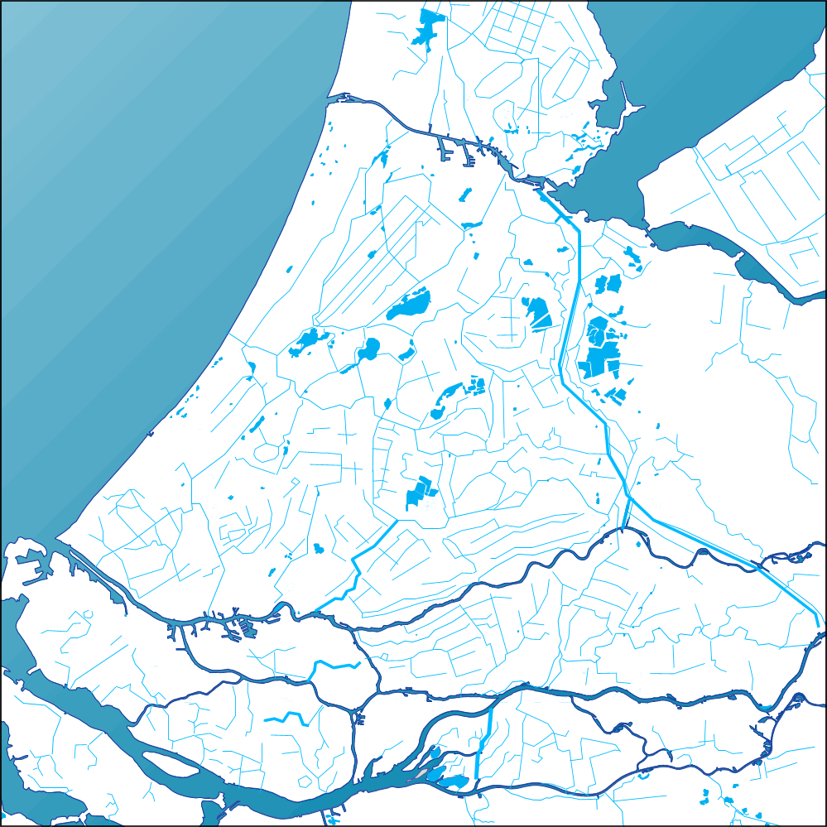
Fig. 16 Rivers, canals and brooks | Fig. 17 Superposition races

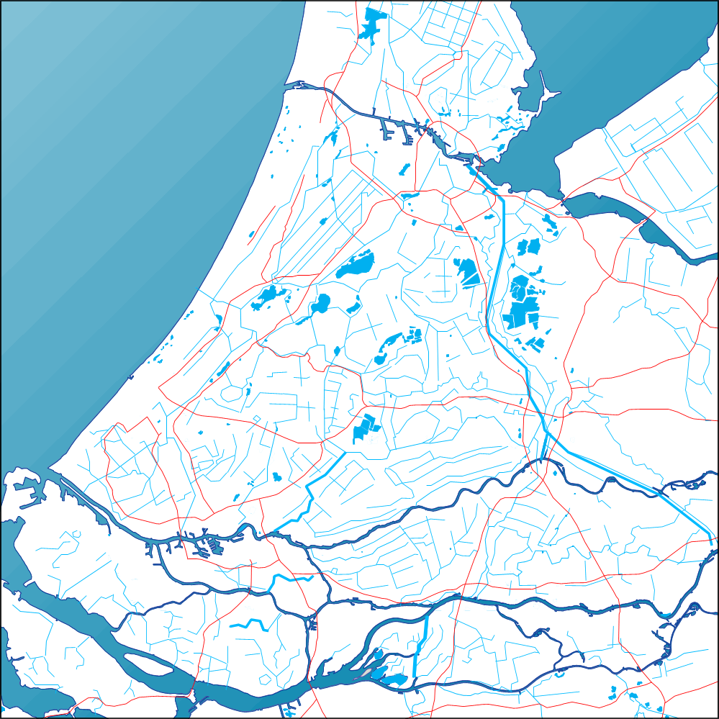 | 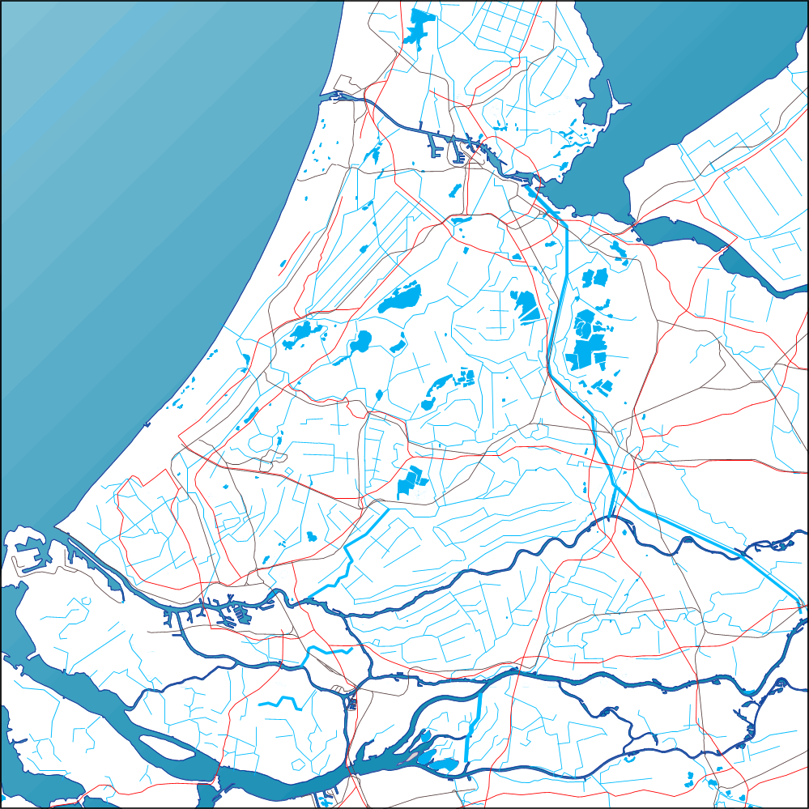
Fig. 18 Interference with highways | Fig. 19 Interference with highways and railways

Conclusion
To protect ‘green’ areas in a sustainable way, the potential of human connections have to be taken into account. The diversity of networks to be expected can be understood by scale articulation. Every level of scale between an established frame (largest observed measure) and granule (smallest observed measure) shows its unique legend of connections. The ‘natural’ hierarchy and interference of different kinds of networks determine the fragmentation to be expected. Understanding the regularity of these connections in densifying areas can avoid mistakes in locating the ‘green’ areas probably once crossed out by an emerging human network. It may help to estimate the realistic possibilities of alternative traces.

