Urban ecology, scale and structure

Taeke de Jong 

20.1 Introduction 374
20.2 Urban ecology 375
20.2.1 State of dispersion and density 375
20.2.2 Urban ecology and urbanism 376
20.2.3 Different kinds of ecology 377
20.3 Scale and size 377
20.3.1 Technically 378
20.3.2 Scientifically 379
20.3.3 Administratively 380
20.4 Structure 381
20.4.1 Coherence in state of dispersion 381
20.4.2 The state of dispersion of green areas related to human presence 382
20.4.3 Large green areas far away or smaller ones close-by 383
20.4.4 Boundaries between legend units 383
20.5 Ecological tolerance 384
20.5.1 Inbetween areas 384
20.5.2 Diversity as a risk-cover for life 385
20.5.3 Health 386
20.5.4 The impact of operational and conditional treatment 386
20.5.5 Generalisation clouded by context factors 387
20.6 Definitions of environment 388
20.6.1 Empirical and technical definitions 388
20.6.2 Distinguishing many types of environment 388
20.6.3 Conditions for diversity beyond empirical expectation 389
20.7 Conditional or operational thinking 389
20.7.1 Possible and probable nature 389
20.7.2 Target species 390
20.7.3 Ecocentric and anthropocentric views 390
20.8 Specialists in a planning team 391
20.8.1 Modalities 391
20.8.2 Context analysis; fields of problems and aims 391
20.8.3 Including context in any specialism 392
20.9 The role of an urban ecologist 393
20.9.1 Specialist or generalist 393
20.9.2 Local identity 394
20.9.3 The task of an urban ecologist 394
20.9.4 Balancing interests 395
20.10 Conclusion 398

Introduction

Beyond understanding
Urban ecology does not stop by understanding alone.
Through its representatives, urban ecologists in service of municipalities or advising urban institutions, it is part of the regional system itself.
It produces images of probable, possible and desirable futures from a biological point of view, influencing the development of towns and infrastructure covering the landscape of and around cities. It takes part in design, planning and decision making.
This chapter tries to discover and develop operational concepts within these contexts.

Urban ecology in an urban context
In practice the urban ecologist meets stakeholders, politicians, designers and specialists experienced in the fields of management, culture, economy, technology, demography and physical planning. They all do have their own jargon and use different language games to convince. Moreover, they got their experience from different levels of scale, inclined to generalise their conclusions into other times, locations and levels of scale. The national administrator thinks national experience is valid on any municipal level, the economist thinks an earlier researched local trend will be regionally reliable as well, the designer thinks about the area as if it were a building and so on. But in practice the discussion is always about one context sensitive case, on a determined level of scale, with many stakeholders, each with their own field of problems and aims to be balanced with facts and imaginations in a project. In this chapter I suppose this behaviour of one particular and dominant species belongs to urban ecology. How to clarify this web of desires, information and imagination determining the final realisation of projects? The urban ecologist needs to know that peculiar way of human behaviour as far as it is useful for her or his practice, because it dominates the system to be advised.

Three aspects of practice
This chapter tries to unravel three coherent aspects of practice: the language game by which one speaks (talking about desirable, probable or possible futures), the ways of thinking about solutions (operational or conditional) and the levels of scale to distinguish to make proper conclusions. It does so from an ecological viewpoint: the distribution and abundance of individuals, communities, systems, subject of physical policy and planning as well. After clarifying that limited viewpoint, it starts with the levels of scale to be distinguished being administratively, scientifically, and technically relevant as a condition to keep a clear view on the other aspects.

Three ecological concepts relevant for any specialist
Then it chooses a technical viewpoint nearest to practice: how could we operationally imagine the actual and future urban distribution of individuals, communities and systems; how could we guarantee their efficient coherence if realised and how to represent that in legends of a drawing, variables of research, items on the political agenda? That will not be elaborated in detail, but just enough to go back to three ecological concepts surprisingly recognisable and convincing for other specialists: ecological tolerance, the technical-ecological definition of environments and the distinction of conditional or operational thinking.

The message of ecology
At that time the time is ripe to come back to the communication of an ecologist with specialists in the project team: how to show them the importance of context, the object of any ecological study by definition. It will re-define the role of an urban ecologist in a planning team and we can conclude that ecology has a message for them.

Urban ecology

Dynamics and diversity
Urban ecology as a scientific domain of study is a subdiscipline of landscape ecology, the science of individuals, communities and systems of plants, animals and humans, their artifacts related to flows of matter and energy on a regional level of scale, be it with more attention to the dominance of humans. The dynamic landscapes within and around towns and conurbations have special characteristics justifying a sub-specialism. The dynamics of human activities and artifacts increase from natural outskirts into rural, built-up and city areas, gradually or with great local contrast (see chapter Error: Reference source not found, page Error: Reference source not found). However, along the same urban gradient spatial fragmentation and diversity of land use increase (see Error: Reference source not found). If biodiversity decreases or increases along that line depends on the level of scale. In natural circumstances diversity is often connected to low dynamics. That may be an important directly observable difference compared to usual ecology.

State of dispersion and density

Density, dispersion and form
According to some internationally authoritative text books (Andrewartha, 1961; Krebs, 1994; Begon, Harper et al., 1996) ecology is at least the science of distribution and abundance of organisms.

Fig. 1 shows that different states of distribution (or supposed to be less conciously intended: ‘dispersion’) in the case of the same density: 100 spots on the same surface. So, abundance (in a standard surface or volume called density) and state of dispersion are different concepts. In the case of the same density different states of dispersion are possible after all. Fig. 1 also shows the designers’ concept of form or shape supposing state of distribution.

Urban ecology adds the distribution of human artifacts (including human institutions) as an important factor. It studies the density, distribution and mobility (distribution in time) of urban components (form and morphogenesis), understood by their separations, connections and operations (structure and organisation), their use and impact (function, eufunction and dysfunction included).

Change of distribution like processes of accumulation (concentration) or dispersion (deconcentration) on different time-scales could be named as morphogenesis even if there is not yet change of abundance (growth or decline). The description of form and morphogenesis (morphology) still could abandon causal explanation by supposing separations and connections (structure) or use by any species (function). That is why form can be primarily the object of design (studying possibilities apart form probabilities).

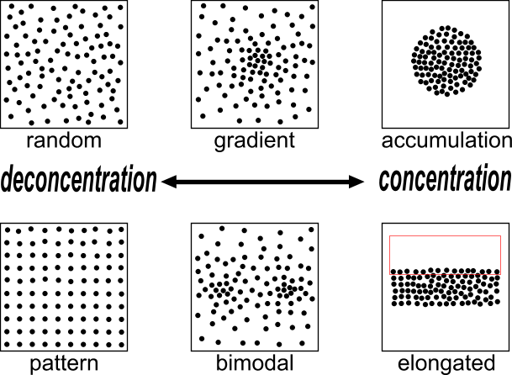 | 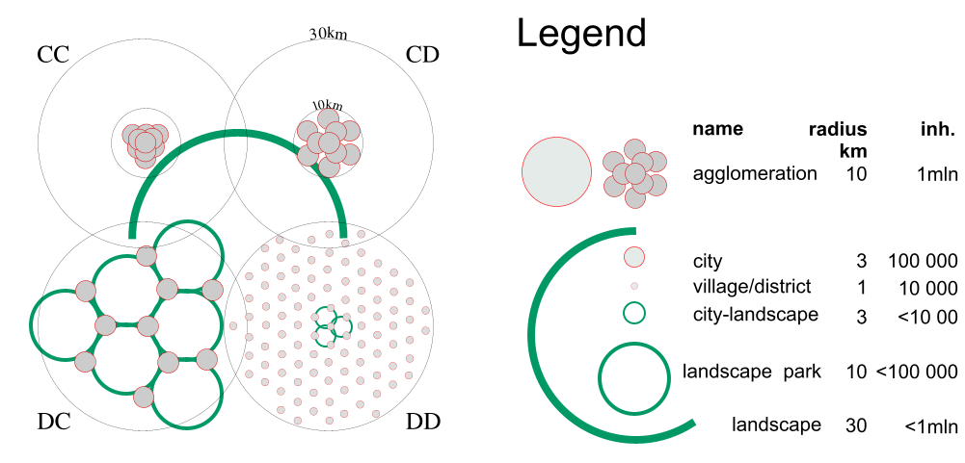
Fig. 1 States of dispersion of 100 specimens in the same density on one level of scale | Fig. 2 One million people in two states of dispersion on two levels of scale  (‘accords’ C_{30km}C_{10km} ; C_{30km}D_{10km} ; D_{30km}C_{10km} and D_{30km}D_{10km})
Fig. 2 shows that morphological categories like concentration and deconcentration could have different meanings on different levels of scale. There are states of dispersion to be described as concentrated in a radius of 30km (C_{30km}), but in the same time deconcentrated in a radius of 10km (D_{10km}) and the reverse (D_{30km}C_{10km}).

Urban ecology and urbanism
Urban ecology is ecology of the ‘urban district’ as a biogeographical unit amongst other biogeographical units (Denters, 1999 and chapter Error: Reference source not found, page Error: Reference source not found). It is the science, design or policy of distribution and abundance of species in case of a relatively high abundance of people (and their artefacts) in different variants of distribution (urban and rural area). Urbanism is a kind of autecology, studying the optimal living conditions of the human species, its states of dispersion and those of its artefacts.

Different kinds of ecology
From the PHD thesis of Mechtild de Jong (2002) I conclude six kinds of ecology in the Netherlands in the previous century competing for governmental assignments (see Fig. 3).

 | abiotic | biotic | Dutch university
environmentology | environment | society
autecology | habitat | population | Wageningen
synecology | biotope | biocoenosis | Nijmegen/Wageningen
cybernetic ecology | abiotic variety | biotic variety | Delft
system dynamic ecology | ecotope | ecological group | Leiden
chaos ecology | opportunities | survival strategies
Fig. 3 Kinds of ecology in decreasing anthropocentrism
In the present-day Dutch target species policy, supported by the European Birds and Habitat Directive, synecology now is most successful. However, climate change changes its description of biotopes, biocoenoses, their distribution and abundance. Cybernetic ecology focuses on steering mechanisms (separations and connections, structure), their distribution and abundance, suitable for creating or restoring living conditions (technical ecology).

Scale and size

Urban dynamics on different levels of scale
The change of urban landscapes on different time scales (see Fig. 4) cannot be understood without a selective study of human dynamics as the primary driving force behind it.

within last | changes in urban areas | within last | changes in urban areas
millenium | Mediaeval, Industrial, Modern towns | week | alternating work and weekend
century | economic development | day | intensity of use, transport
decade | groundworks, building activities | hour | sunlight and precipitation
year | seasons | minute | human activity
month | migrations, flowering periods, trade
Fig. 4 Urban dynamics on different time scales
Apart from these time scales, already mentioned by Van Zoest (chapter Error: Reference source not found, page Error: Reference source not found), this chapter focuses on spatial scales to find a sound structure of the discipline (paragraph 1.3).

States of dispersion on different levels of scale
Urban ecology studies ‘states of dispersion’ of species and artefacts on different levels of scale in the same time. Doing that systematically (see Jong and Paasman, 1998; Fig. 2), you can compare designs mutually, like variants for Randstad (Jong and Achterberg, 1996) or judge local spatial visions ecologically based on rareness expressed in kilometers and replaceability in years (method Joosten, 1992, applied in Jong, 2001; Fig. 5).

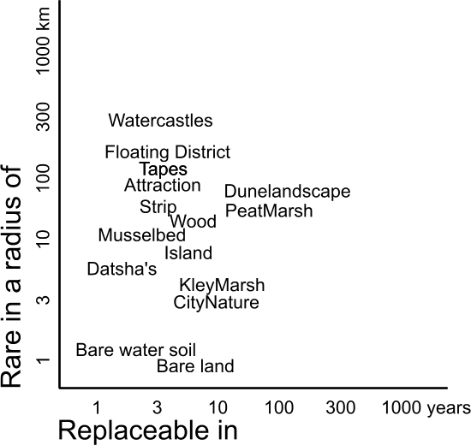
Fig. 5 Ecological evaluation of neighbourhoods named by designers (r=300m) according method Joosten (1992)

The scale of a drawing can be named simply by a nominal radius R from the range {…1, 3, 10, 30 …m} globally encompassing its ‘frame’ in (supposed) reality, and the smallest drawn detail (granule), named by a nominal radius r from the same range.

The distance between frame and granule determines the resolution of the drawing. If that distance is small, designers speak about a sketch design, and if it is large about a blue print. Any scale (combination of frame and granule) presupposes a specific legend, a specific vocabulary of the drawing and consequently technically, scientifically and from a viewpoint of government and management a different approach.

Technically
For example, if you aim for diversity in vegetation on different levels of scale, on every level of scale there are different technical means at your disposal (see Fig. 6).

Operational variety conditions for vegetation | in a radius of approximately | 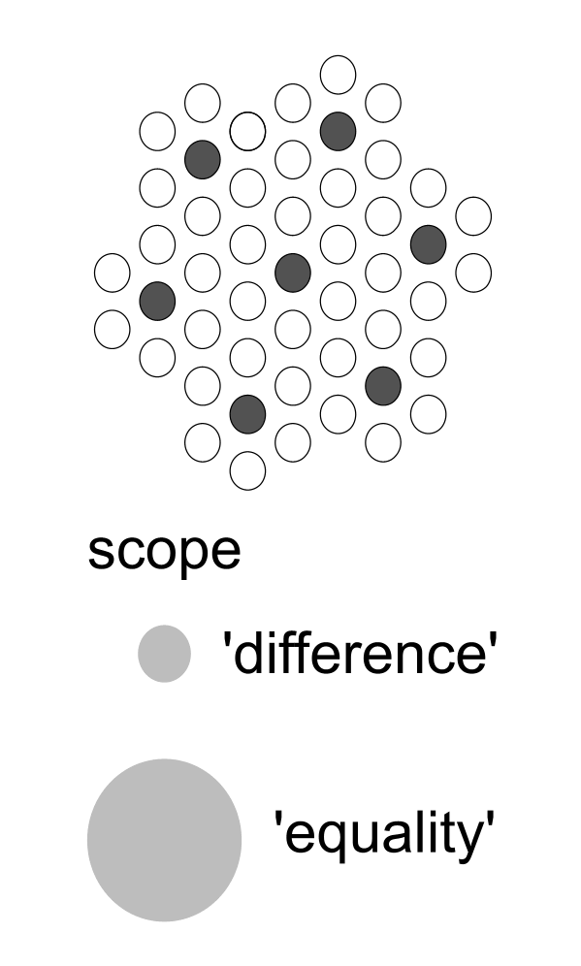
elevation, soil | 30km
soil, water management | 10km
seepage, drainage, water level, urban opening up | 3km
urban lay-out | 1km
allotment (dispersion of greenery) | 300m
pavement, treading, pet manuring, minerals | 100m
difference in height, mowing, disturbance | 30m
solar exposition, elevation | 10m
The radius should be interpreted elastically between adjacent radiuses.
The last four levels of scale hide from the usual view of observations per km².
Fig. 6 Operational variation per level of scale (Jong, 2000) |  | Fig. 7 Scale paradox
However, what causes diversity on one level, could cause homogeneity on another level of scale (scale paradox, see Fig. 7).

Scientifically
All ecologies from Fig. 3 are scientifically meaningful if arranged to the scale of their most appropriate application (see Fig. 8). So, microbiology applies on levels of scale and size measurable in micrometers. Chaos ecology stressing individual opportunities and survival strategies or biology stressing cooperation and competition of specialised functions (organisms or organs) applies on levels measurable in millimetres, and so on.
Fig. 8 shows a preliminary distinction of levels of scale and ecologies supposed to be most appropriate on each level of scale.

nominal | abiotic | biotic | ecology
kilometres radius
10000 | earth | biomen | environmental ecology
1000 | continent | areas of vegetation
100 | geomorfological unit | plant-geographical or flora-districts
10 | landscape | formations | landscape ecology
metres
1000 | hydrological unit, biotope | communities | synecology
100 | soil complex, ecotope | ecological groups | system dynamic
10 | soil unit and transition | symbiosis | cybernetic
millimetres
1000 | soil structure and ~profile | individual survival strategies | chaos ecology
100 | coarse gravel | specialisation | biology
10 | gravel | integration
1 | coarse sand 0,21-2 | differentiation
micrometres (μ)
100 | fine sand 50-210 | multi-celled organisms | micro biology
10 | silt 2-50 | single-celled organisms
1 | clay parts < 2 | bacteria
0,1 | molecule | virus
Fig. 8 Ecologies arranged to their primary supposed range of scale
(Jong, 2002)

Administratively
That does not mean these ecologies have to be limited to their primary level of scale as presented in Fig. 8. Present-day Dutch nature conservation policy has a synecological origin (Bal et al., 2001) but it focuses on different levels of scale by that approach (see Fig. 9).
In Fig. 8 it is supposed synecology has its most appropriate application on areas of 1km radius approximately, but it claims to offer tools of nature conservation at 3km, 300m and 10m as well.

 | Main group 1 | Main group 2 | Main group 3 | Main group 4
Name | almost-naturally | supervised-naturally | half-naturally | multifunctional
Radius | 3km | 1km | 300m | 100m
STRATEGY
spatial scale | Landscape > thousands of ha. | Landscape > 500 ha. | ecotope/mosaic to approx. 100 ha. | ecotope mostly a few ha.
· location | mostly process-determined | process and pattern-determined | process-, pattern- and species-determined | pattern- and species-determined
· processes | not directed | directed integrally | directed in detail | directed in detail
· patterns | not established | not established | established, perhaps a cyclical succession | established
directing variables | none | process-focused on landscape level | process- and pattern-focused up to ecotope level | process- and especially pattern-focused up to ecotope level
)
Fig. 9 The levels of scale in Dutch synecological nature conservation policy (Bal et al., 1995)
From a viewpoint of local government according to Fig. 5 a different approach is imaginable. A municipality could focus its policy on a specific scale of rareness (identity). For example focusing on global (R=10 000km), European (R=3000km, tables of Flora- and fauna legislation), national (R=300km, Dutch ‘Red List’ species), provincial (R=100km), regional (R=30km) or local (R=10km) rareness, are different policies. Large cities could focus on global identity, small ones on a regional identity.

Structure

Coherence in state of dispersion
Technical ecology concerns determining states of dispersion of legend units by design. ‘Form’ presupposes that the state of dispersion is arranged into lines and surfaces. So, a designer or modeller draws the shape of any legend unit relevantly distinguished on the level of scale at hand (see Fig. 10 and Fig. 11). These influence other legend units amidst of which they are supposed to function in reality. By doing so he or she presupposes coherence (structure) of legend units comparable with symbiosis.

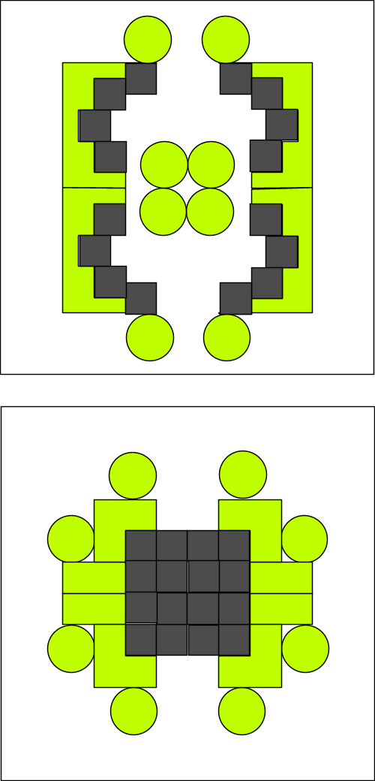 | 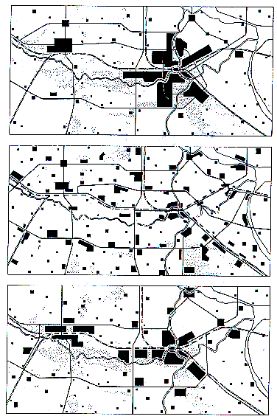
Fig. 10 States of dispersion R=100m | Fig. 11 Accumulation, sprawl and ‘bundeled deconcentration’ R=30km  (RPD, 1966)
So, technical ecology studies legend units (categories or combinations of categories, types) in urban and landscape design, their possible states of dispersion and its impact on their environment.

The state of dispersion of green areas related to human presence
For example, if you give the green surface in a neighbourhood, district or town the same size of radius as the average walking distance to reach it (‘standard green structure’ as I will call it), then in each case approximately 10% of the surface is green (see Fig. 12).

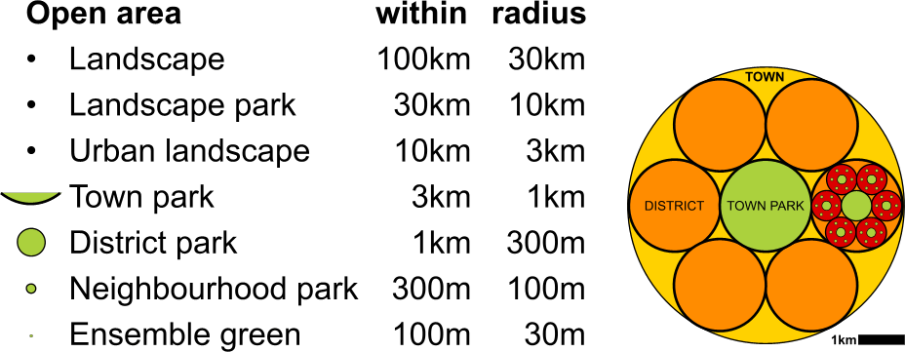 | 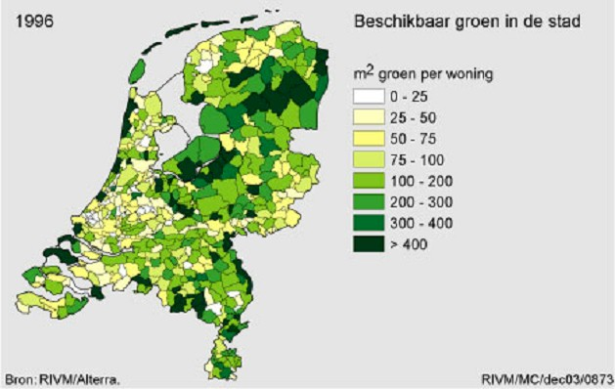
Fig. 12 ‘Standard green structure’ | Fig. 13 m² Green per dwelling (RIVM, 2003)
In a town (R=3km, surface 30km²) of 100 000 people that is 30m² /inh. town park.
In a district (R=1km, surface 3km²) of 10 000 people that is again 30m² /inh.district park.
In a neighbourhood (R=300m, surface 0.3km²) of 1000 people that is again 30m²/inh. neighbourhood park.
If that approach is continued to the fragmented green, any inhabitant would have 120m² green at their disposal or approximately 300m²/dwelling. In Dutch terms that is a maximum (see Fig. 13), but also an easy to handle target standard. The usual standards changing in time (see Error: Reference source not found) could be expressed in percentage of this standard green structure.

This approach could include at least 6% water (Hoogheemraadschap van Rijnland, 2002) in urban areas according to the obligatory ‘Water test’ (Watertoets), to be combined with wet nature (Bureau Stroming, 2006).

Large green areas far away or smaller ones close-by
Now you can work out how much any town deviates from that standard and which level of scale has a relative (dis)advantage. It raises the fundamental question if a town prefers more large green (easy to maintain) at great distance (little public support) or more small green at small distance deviating from the standard. It determines largely the green identity of an otherwise equal amount of green surface per inhabitant.

Boundaries between legend units
On the boundary of legend units mutual effects cause different questions. Formulating these questions depends on the definition of the legend units. If you indicate built-up areas by ‘red’ (R), paved areas by ‘black’ (B), unpaved by ‘green’ (G) and water by ‘blue’ (B), then Fig. 14 gives an example of questions under discussion.

Fig. 14 Questions at the boundary of legend units
These are well-known questions of spatial lay-out and maintenance on different levels of scale: separating or connecting red and green, red and blue and so on. Mixing means separating and connecting on a lower level of scale, segregation on a higher level of scale. So mixing is not the same as connecting, segregation not the same as separating.

Boundaries (separating and connecting zones) could be sharp (limes convergens) and vague (limes divergens), taking up little or a lot of space. If a boundary area takes up a lot of space, it could be indicated by a separate legend unit. In these ‘in between areas’ (mi-lieus) the more homogeneous properties of adjacent areas vary as a transitional stage (gradient) from one legend unit into the other. A transitional stage offers more specific possibilities of settlement for species and artifacts with a specific ecological tolerance of a varying ‘factor of settlement’.

However, any legend unit could be interpreted as ‘milieu’, as a transitional stage between two adjacent legend units. Such a transition can be operationalised for each direction between adjacent legend units as ‘environmental variables’. By such a transition of properties within an originally homogeneous legend unit more specific chances emerge for species and artifacts.

Ecological tolerance

Inbetween areas
The curve of ecological tolerance shows the chance of survival as a result of values of an environmental variable between ‘too little’ and ‘too much’ (see Fig. 15).
Suppose for example that water is present as an environmental variable for plants. In that case the chance of survival of a specimen, population or species varies between drying out and drowning.
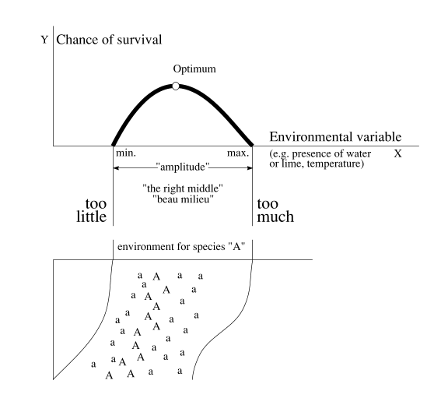 | Such an effect can be observed in the field as shown in Fig. 15 below. Suppose in that figure a slope is imagined from high and dry to low and wet. Species A will survive best near its optimum. On the line of optimal moisture we will find healthy specimens (A). Somewhat higher marginal specimens (a) still grow, but even further from the optimum it is too dry for that species, or in the opposite direction, too wet.
Fig. 15 Ecological tolerance in theory and practice
However, the marginal specimens are important for the survival of the species as a whole. Suppose for example it is raining for a long period. The low-standing marginal specimens will drown, the healthy specimens will become marginal and the originally marginal specimens standing high and dry will begin to flourish. In a long period of drought the opposite will occur.

Levelling out the water level for agricultural purposes to the favour of one chosen food vegetation implies not only loss of other species but also an enlarged risk for the vegetation. Long lasting dryness or precipation destroys the whole yield. So, diversity of environmental properties and species spreads that risk.

Diversity as a risk-cover for life
In general you can suppose diversity to be a risk-cover for life (Londo, 1997).
In the diversity of life forms there have always existed species (or within a species a deviating specimen) surviving a change of circumstances. ‘Survival of the fittest’ supposes a diversity from which in changing circumstances the environment selects. A decrease in (bio)diversity undermines the resistance of life against catastrophes. From the approximately 1.8 million species we know (probably a small part of what exists), we have lost already approximately 100 000. So, not only do we cause ecological disasters, we also undermine the resistance of life against these disasters.

However, within this impression of things a less friendly lesson is hidden raising ethical questions. A reserve of marginal specimens offers a favourable effect on the chance of survival of a population. And one level of scale higher: marginal populations could save the species in a changing environment. But could we accept marginal human populations?

Health
So, health is a scale sensitive concept. It is also a concept bound to the individual: the ecological tolerance differs even per individual. What is good for one may be bad for the other. In that way an environmental variable (for example medication) could show a different effect on different people. Even if a medicine turns out to cure a symptom in 99% of cases it can cause rare other symptoms, different to those caused in all other individuals exposed to this environmental variable. The individual side effects do not have to reach the statistical mass to appear in the instruction leaflet indicating the used medicine as a cause. However for all individuals together they may raise many new misunderstood symptoms, each too rare to prove the cause. Within current medical practice these sympoms are suppressed by medicines (with new individual side effects as a possible consequence). So, it is imaginable that medical treatment ends up in a negative cycle causing its own work (Jong, 2005).

The impact of operational and conditional treatment
McKeown (1976) argued the increased life expectancy in England and Wales in the beginning of the 20th century caused by decreased infection illness could not be caused by medical treatment, but by improved hygiene (sewage, drinking water supply, housing, working conditions) and food. It pleads for a more conditional than an operational approach to health (see pag. 21). However, Mackenbach (2004) made plausible that at least 20% of the improvement in life expectancy could be attributed to medical care.
Public perception of medical treatment is more positive through its immediate impact. The eventually negative side effects afterwards are not demonstrable in many cases and thereby neglected, but together they could have a substantial negative effect (80%?) on the average life expectancy as a whole.

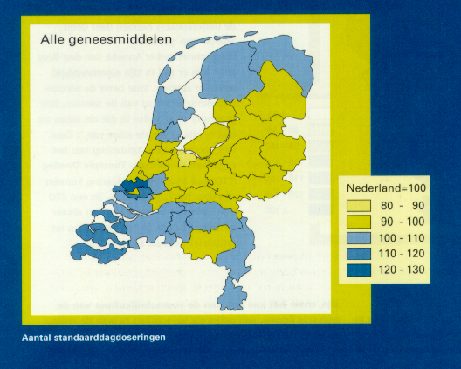 | 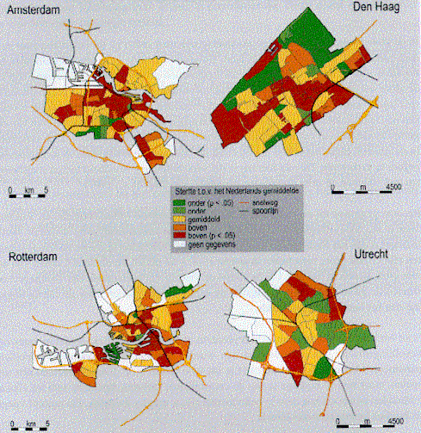
Fig. 16 Different average medicine use in different regions of the Netherlands (Batenburg-Eddes et al., 2002) | Fig. 17 Different life expectancy in cities. (RIVM)
Risk perception rests on incomplete knowledge, uncertainty and fear, aggravated by one sided news coverage about extreme cases, exploited by politicians and insurance companies (“We sell fear”).

Generalisation clouded by context factors
The epidemiological research should give evidence, but struggles with enormeous methodological problems. The excess of environmental variables not to be eliminated clouds every supposed causal relation. And like medicine research and toxicology it struggles with reliability of statistics applied on heterogeneous sets.

For example from Fig. 16 and Fig. 17 you hardly can conclude causal relations (income?, stress?, green in the neighbourhood?). Moreover any organism has by nature many compensating feed-back mechanisms, especially if it can adapt to its environment or move into environments more suitable for its tolerances. In that case reverse causality has to be supposed: favoured or marginal groups gather in specific environments (the ‘Gooi’ in Fig. 16, or deprived neighbourhoods in Fig. 17) with preventive or just illness inducing conditions. The municipal health service (GGD) of Rotterdam in the 1970s found concentrations of schizophrenia in the inner city. What is cause and effect?
Moreover, after some time excessive hygiene or stress could decrease resistance.

With so many uncertainties an urban ecologist or urbanist could only learn from nature to reduce risks through the creation of diversity of environments.
Standardisation into averages (see Error: Reference source not found) is not always the most productive way.

Definitions of environment

Research, design and policy
The probability, possibility and desirability of these aspects (modality) represent scientific, technical and political viewpoints respectively. As soon as we accept decreasing biodiversity and human health as a problem (probable but undesirable), urban ecology becomes ‘environmentology’ aiming at possible ‘sustainable developments’ (keeping possibilities for future human generations). After all, any defined ‘environmental problem’ could be reduced to decreasing biodiversity and human health.

Empirical and technical definitions
‘Environment’ according to the usual Dutch definition of Udo de Haes (Boersema, C. Peereboom, et al., 1991; see Fig. 18) is ‘the physical, non-living surroundings of society in reciprocal relationship’. However, for technical operationalisation people belong to these surroundings. Moreover, I cannot imagine people without environment, but environment we can imagine without people (for example other planets). That is why the technical definition we have chosen reads ‘the set of conditions for life’ (Duijvestein, Jong, et al., 1993; see Fig. 19).

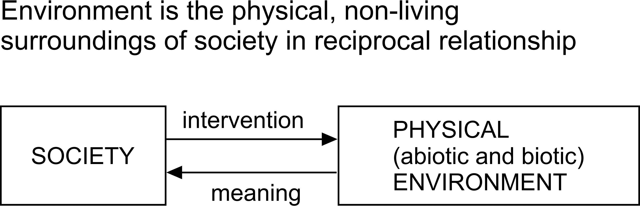 | 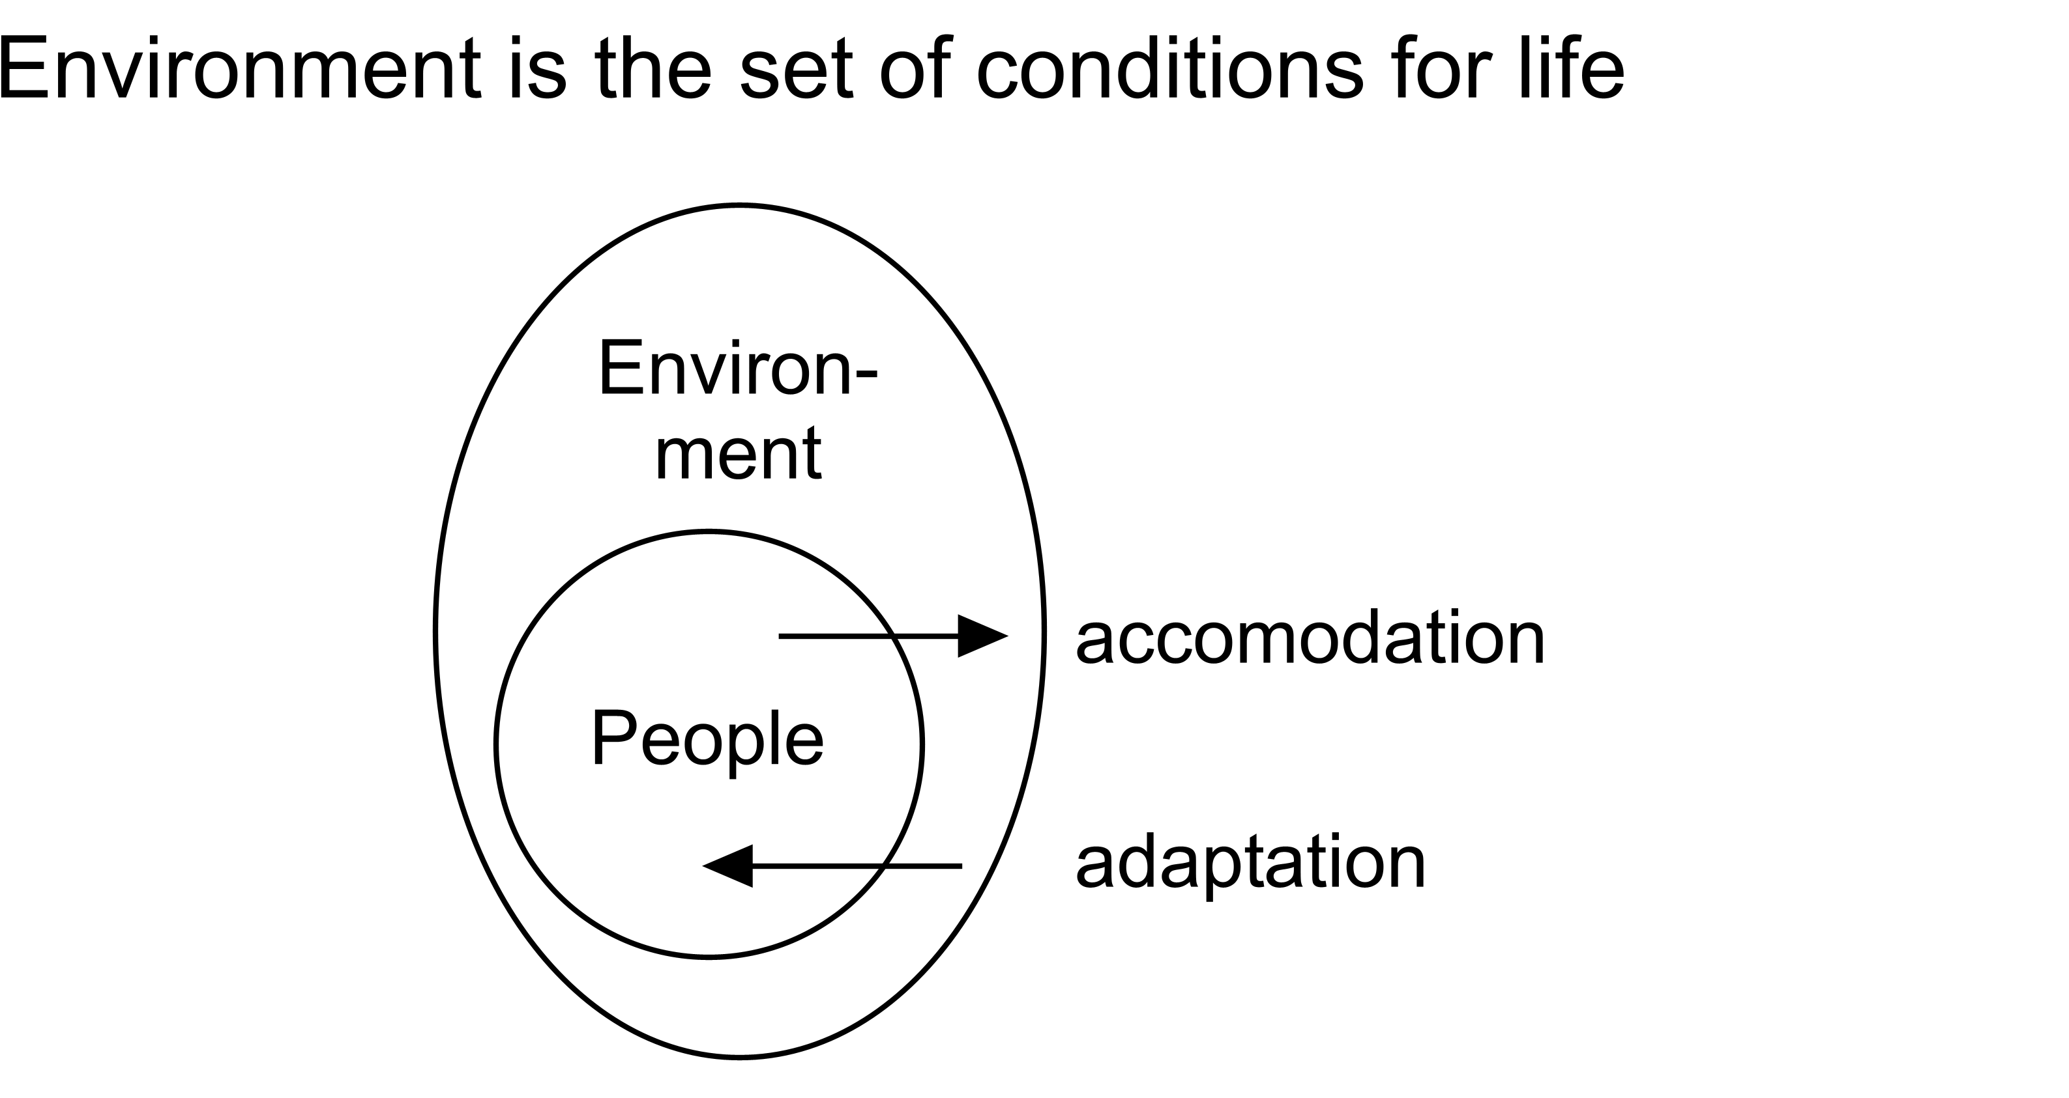
Fig. 18 Environment according to Udo de Haes | Fig. 19 Environment in a technical sense
Social science and geography may stress causal relations (based on probability, the arrows in Fig. 18 and Fig. 19) while technical science cannot abandon conditional relations (based on possibility, such as ‘no people without environment’, ‘no economy without dikes’, ‘no land without pumping stations’). Conditions are often taken for granted by empirical science as ‘ceteris paribus’ suppositions, but in technology they are the essence of ‘environment’.

Distinguishing many types of environment
By that general technical definition you can define different meanings of ‘environment’ by substitution of ‘conditions’ and ‘life’ more specifically (see fig. Fig. 20).

managerial
cultural | A
economic
technical |  |  | B
ecological
mass/time/spatial
conditions for | human | animal | plant | life
Fig. 20 Substitution possibilities in defining environment
For example, cultural conditions for human life (A in Fig. 20) are a kind of environment (‘cultural environment’) different to technical conditions for plant life B (like dikes in the Netherlands). They even can be contrary to each other. Conditions can be operationalised by environmental variables taking different values on different locations. Settlement factors for species, populations or their artifacts consist of these values. ‘Environmental problems’ are simply defined as ‘lacking conditions for life’.

Conditions for diversity beyond empirical expectation
It is not easy to recover all tolerable conditions for any life form. There are many species, especially rare ones with small tolerances of which nowhere near all ecological conditions are known. Specific conditions are often forgotten so that target species do not appear. However, within the urban environment you can vary conditions infinitely (‘environmental differentiation’; Jong, 1978), so that species appear unexpectedly. If you appreciate natural areas as areas where human planning is minimised, you should not create targets but conditions.

Conditional or operational thinking

Possible and probable nature
The conditional (‘means’-directed) approach chooses non-biotic (abiotic) starting points (Jong, 2000) to make vegetations and dependent animal populations possible instead of probable. It relies less on predictions about spontaneous results developing out of the created conditions. A well-designed house (oikos) does not determine the household; it makes different households possible. Moreover, in a technical sense you usually do not start to build the roof of a house first, but its foundations, its primary conditions (see Fig. 21).

Target species
On the other hand, the operational (‘target’-directed) approach chooses target species to realise their specific life conditions, based on the expectation that these conditions are sufficient for other coherent species as well. This usual operational approach appeals to administrators and managers, but it is sensible to the accidental popularity of a target species. It often leads to disappointment if the intended species does not appear like Oriolus oriolus (golden oriole) or to surprise if it appears unexpectedly on other locations like Riparia riparia (sand martin) in Zoetermeer (Jong and Vos, 1993-2006).

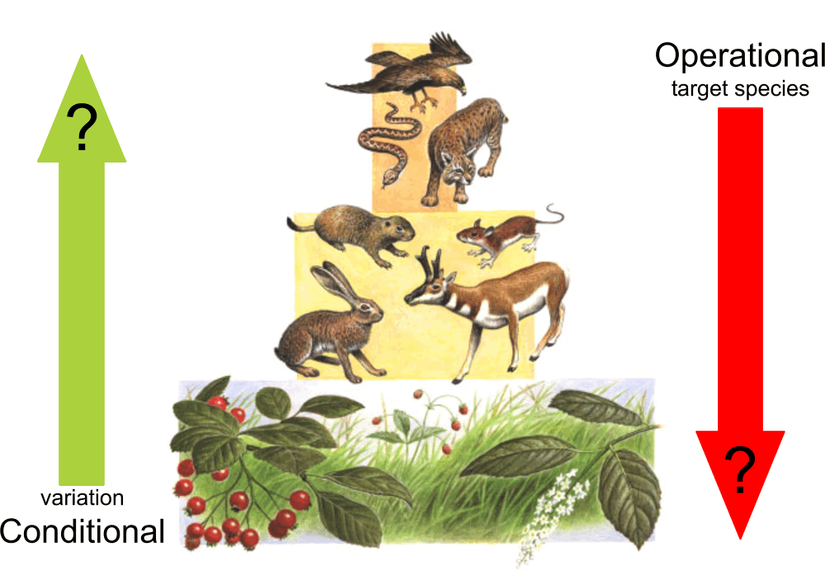 | 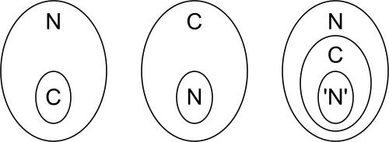
Source:
Fig. 21 Bottom-up or top-down approach (Source unknown, arrows added by the author) | Fig. 22 Culture (C) and nature (N)

Ecocentric and anthropocentric views
Very different opinions underlie the manipulability of nature. The ecocentric view considers culture as part of nature (see the first image of Fig. 22). However, the anthropocentric view considers nature as a concept, part of culture (second image). That is the main opinion of administrators and landscape architects. In that view we can talk about more or less ‘natural’ as added (human) value. Talking about nature forces us to use language. And that is part of our culture. So, the paradox arises in that we cannot exchange imaginations of nature without culture.

On the other hand, from an ecocentric point of view a landscape is more or less ‘cultural’ (made, planned). Then culture is the added variable of which nature is the starting zero value (not influenced by people, unintended, ‘spontaneous’). Within this view nature (N) could contain a culture (C) talking about nature (‘N’) but not covering nature as a whole. Otherwise nothing could be discovered anymore. The Oostvaardersplassen in the Netherlands is a good example of ‘unintended’ nature.

This controversy can cause confusion of tongues in a planning team as soon as ‘nature’ is tacitly taken as something to emerge, something to design or as an object of decision.

Specialists in a planning team

Modalities
Specialists in a planning team not only have different viewpoints on nature, but they also use different (empirical, technical, political) ‘language games’ (Wittgenstein, 1953), meaning different things by the same statements (Jong, 2002 ‘Designing in a determined context’).
So, in any meeting or poll you should know if any statement is meant as probable, possible or desirable (see Fig. 23). Asking people if they agree with a statement has to be distinguished into these modalities. “Do you think it possible, probable or desirable” can produce different answers to the same statement. For example, if the answer is, “It is probable, but not desirable” you have detected a problem. If the answer is, “It is desirable, but not probable”, you have detected a target.

 | being able | knowing | choosing
modalities | possible | probable | desirable
sectors | technique | research | administration
activities | designing | predicting | organising
reductions of supposed reality into
character | legends | variables | agendas
place and time | tolerances | relations | appointments
Fig. 23 Three language games |  |  |  | Fig. 24 Different supposed futures, determining fields of problems and aims

Context analysis; fields of problems and aims
However, though every profession has a primary modality, in any profession every modality plays a role. Probable futures as far as they are not desirable consist of a field of problems perceived by the specialist. Desirable futures as far as they are not probable contain a field of aims for acting according to a plan (see Fig. 24). The implicit images of a future context within these three modalities determine the judgement of the specialist. However, they can diverge in scale and ‘layer’ (see Fig. 14). So, making these three images of the future context more explicit at the beginning could yield a common field of problems and aims and prevent confusion of tongues.

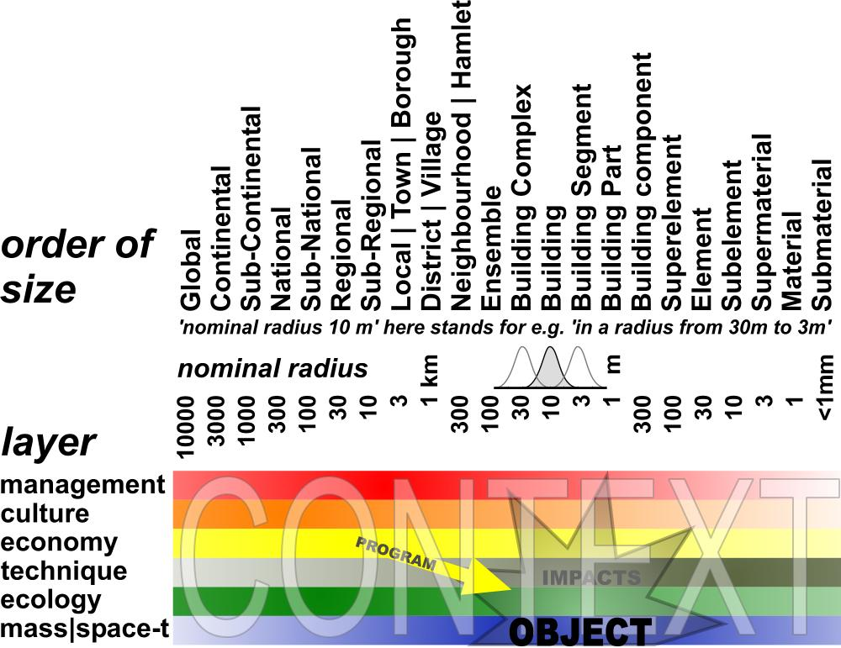
Fig. 25 The future context of the object
What anybody expects or supposes to be possible, probable or desirable, could be different on every different level of scale and layer. The layers of Fig. 25 give a rough indication of the domain of possible specialists in the planning team.

Including context in any specialism
Specialists in a planning team tend to forget the administrative, cultural, economic, technical, ecological or spatial context within which they participate. That is why making the future context explicit is so important. For example in planning the Dutch newtown of Zoetermeer, the urbanists and traffic engineers involved took three-forked roads as a starting point. They argued three-forked roads deliver much less conflict points than crossings with four access roads. Using three-forked roads would reduce casualties substantially.

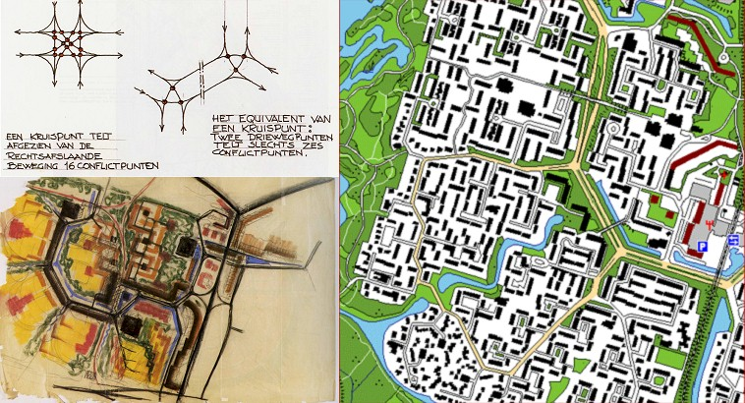
Fig. 26 The traffic concept of three-forked roads design, in Meerzicht, Zoetermeer (Gent, 1999)
However, the number of casualties after realisation did not appear to be less than elsewhere. People drive faster if the situation has clear overall visibility and culture develops into a stage of more indiviual responsibility with less police surveillance. On the other hand, the hexagonal urban lay-out causes more directions of allotment. The inhabitants of Zoetermeer do not complain about that kind of diversity, but services like ambulance, fire brigade, police and delivery services complain they cannot find their way. From an ecological point of view this design principle offers more diversity of expositions to the sun. The observed diversity of plant species in Zoetermeer is relatively high. However that possibility did not play a role in the choice for three-forked roads.

The role of an urban ecologist

Specialist or generalist
Should an urban ecologist take up a specialist’s or a generalist’s position? Because human species is one of many I would prefer a generalist. The ecologist can offer arguments others do not think of, while coalitions with nearly all other specialists are obvious. The urban ecologist firstly should go into subjects of urban civil and environmental engineering (Jong, 2006). Specialisms in urbanism, architecture, cultural heritage, building technology, sustainable building, management of public space and greenery are probably primary allies.

For example, if the administrator or planning agency receives conflicting advice from specialists on ecology and cultural heritage separately, this advice could cancel each other out in the decision procedure. Then, the many opportunities of common interest would be lost.
Urban ecology has its own natural contacts with the urban population via nature associations with many local departments present in any town, like the Dutch IVN, KNNV, Vogelwerkgroep.

Local identity
Within the emerging profession of ‘area development’, (in Dutch: ‘gebiedsontwikkeling’) a project developer’s variant of urban design, ‘identity’ is again a key concept (Geoplan, 2005). Identity is difference from the rest and continuity in itself. The green identity could play a crucial role in urban development. Give any neighbourhood its target species or its unique variant of boundary rich green area. Call street names according to these target species, promote gradual transitions from light to dark, from wet into dry, from accessible to less accessible, from paved into unpaved. Promote the freedom of choice of staying in the public area for different age groups, income groups, life styles. Diversify housing environments that way as a marketing concept. Even urban economy is a potential ally. The price of a dwelling with a view on a park is higher than in a street, in a street with trees higher than in a street without trees. However, that is earlier understood by housing corporations with long-lasting involvement than by project developers.

The task of an urban ecologist
An urban ecologist can be expected to guard (probable), balance (possible) and promote (desirable) the conditions of all life forms in towns in any planning team.
That means attention for monitoring legal and administrative frameworks, but also stimulating imaginative powers, showing possibilities on any level of scale (see Fig. 27).

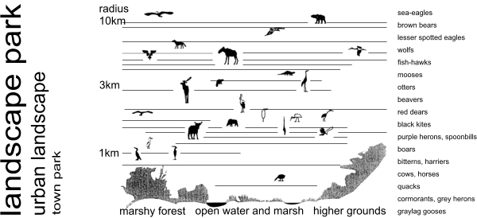
Fig. 27 Possibilities for nature per level of scale and height position
(after H+N+S, Utrecht)
Because human species plays a crucial role in the town, safety, health, leisure and sports are natural components within that power of imagination (see Fig. 28).

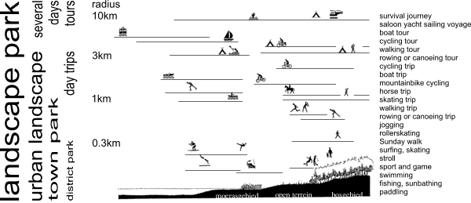
Fig. 28 Possibilities for leisure per level of scale and height position (after H+N+S, Utrecht)

Balancing interests
From these possibilities those increasing freedom of choice for future generations (‘sustainability’) have to be given priority. Freedom of choice supposes diversity (homogeneity delivers no choice); and diversity is tacitly supposed in any opinion about quality. Too much diversity causes chaos, confusion of choice; too little causes boredom, and enforced choice (see Fig. 29). Recognition and surprise, traditional or experimental choice can alternate in between these boundaries. Their balance or alternation determines quality on every level of scale.

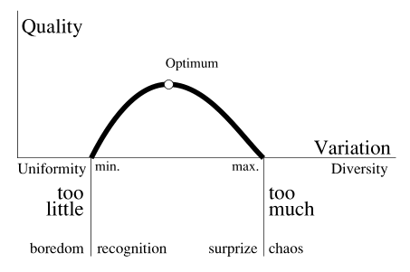 | 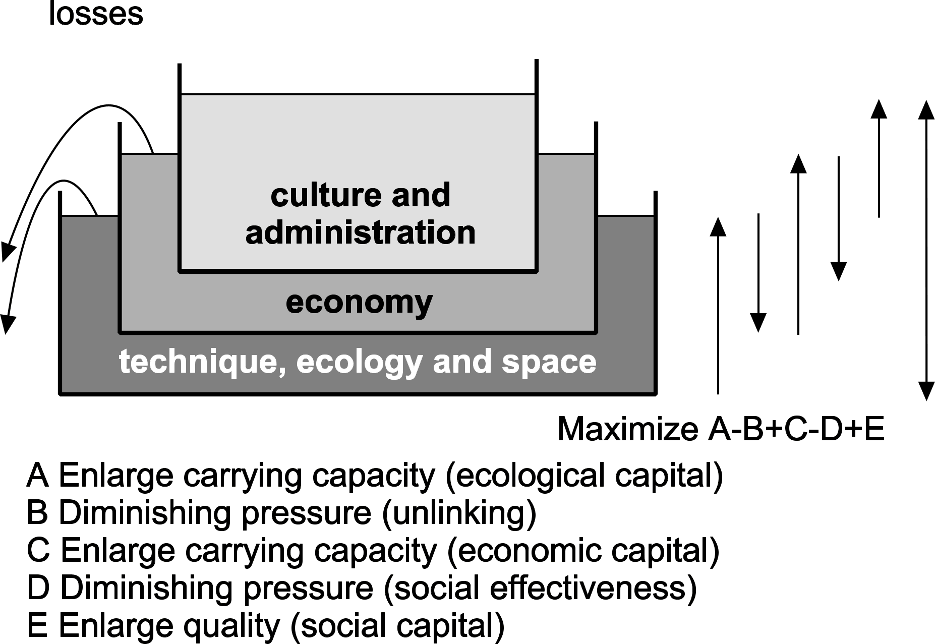
Fig. 29 Quality as a function of variation | Fig. 30 Balancing common interests
The balance of municipal interests can be imagined as vessels filled with liquids of different specific gravity (see Fig. 30). The largest vessel is filled with the heaviest liquid: the available space, ecological capital and technology, what the economy can bear. If the pressure of economy is too high it will cause losses of that basic capital, thereby diminishing possibilities for future generations. Economy is represented as a vessel filled with lighter liquid: economic capital capable of carrying an even lighter vessel of social capital.
A municipal policy should therefore:

- increase the ecological carrying capacity;
- decrease the economic pressure;
- increase the economic carrying capacity;
- decrease the social pressure on the economy;
- increase social capital.

The importance of nature for a town.
The role of an urban ecologist in the balance of Fig. 30 concerns particularly A and B, not forgetting C, D and E. In the mean-time a number of arguments for and against a ‘green’ town is superfluous. I will not go into these arguments here. Many publications refer to them (see chapter Error: Reference source not found, page Error: Reference source not found and Error: Reference source not found, page Error: Reference source not found), supported by interests of economy (the willingness to pay for a representative or for an efficient, useful environment with facilities nearby), well-being and public health (direct and indirect, including social safety and medical care), physical environment (contamination, particulate matter, climate).

The importance of the urban area for nature.
The municipality has to take into account often conflicting nature interests on global, continental, national and regional levels of scale. Especially the actual policy of operational conservation of populations and their habitats seems to oust a broader conditional approach by its strictness and urgence.

It concerns conservation, protection and development of nature:

- the global conservation of diversity (Rio de Janeiro 1992);
- the continental passive conservation of species and their habitats (Birds and Habitats Directive) executing 1;
- the national passive conservation of species and their habitats (Flora- and Fauna legislation with its protected species, obligation for care, prohibitory clauses, protected habitats and codes of behaviour) executing 2;
- the national protection of existing objects (‘Natuurbeschermingswet’ with its ’Aanwijzingen’ and ‘Beheersplannen’);
- the national active policy to protect species (with its approach of habitats, long term programmes like ‘Meerjarenprogramma Uitvoering Soortenbeleid 2000-2004’, ‘Soortenbeschermingsplannen’, red lists);
- the national active policy for nature development (with its ecological network ‘NEN’, wet nature and national parks);
- the regional, provincial tasks resulting from these policies.

Existing situation
In the Netherlands 2006 the national Flora and Fauna legislation integrating the European Birds and Habitats Directive dominates the scene. Since the Dutch 2006 order of council (‘AmvB’) the urban policy focuses on protected species of ‘list 2’ (exemption proviso code of behaviour) and ‘list 3’ (extended check in case of exemption). So, the protected species of ‘list 1’ (light check) and the duty of care generally in force (‘artikel 2’) threaten to lose focus. Codes of behaviour for ‘list 2’ species are developed fixing the duty of care at the same time. In 2005 the municipality of Leyden developed such a code of behaviour submitted for approval to the Ministry of agriculture and nature preservation (‘LNV’). The association of municipalities (‘VNG’) develops such a code of behaviour preventing the effort of separate municipalities. However, these municipalities themselves should have an overview of protected species and values present in their own territory.

Applying an officially accepted code of behaviour has the advantage that not every several plan for building or demolition needs a separate request for exemption. That prevents delay and inefficient use of financial means.
This procedure has the disadvantage of focusing on a relatively small number of species important on a European level but without much local public support in the Netherlands. On the other hand nationally rare species (‘Red list’) are not protected.

More desired situation
National ‘Red list’ species should be protected more actively. They appeal more to public sentiment and create public support. Apart from legally protected species there are many species, though not rare, with an emotional meaning connected to the identity of the area. Based on that support more possibilities develop for a local municipal policy on biodiversity extending into other species.

Apart from the operational approach forced by legal urgencies, a more conditional approach articulated to scale is needed, focusing on all conditions of urban life.

Conclusion
The urban ecologist should be prepared for participation in a planning team. Distinguishing other modalities than scientific ones, their language games, distinguishing operational versus conditional thinking, distinguishing levels of scale, will help to survive in a community of specialists, designers and politicians. But as a professional the urban ecologist has also a message to all of them: be careful with ecological tolerances of individuals, communities, systems, do not always obey singular targets, shape conditions for fields of aims and possibilities for future generations, be context-sensitive and modest in what you think to know.

With acknowledgements to Drs. Johan Vos, urban ecologist of the Municipality of Zoetermeer.
http://www.watertoets.net/
www.fellowsgebiedsontwikkeling.nl
For example the Pipistrellus pipistrellus (‘pipistrelle bat’, ‘dwergvleermuis’, stricly protected, but general in urban areas) and Anisus vorticulus (‘ramshorn snail‘, ‘platte schijfhoorn’, a snail species nobody heard of before).
For example the nymphaea alba (‘white lotus’, ‘witte waterlelie’), the passer domesticus (‘house sparrow‘, ‘huismus’), the fungus symbionts (in symbiosis with trees and shrubs) for example successful in Zoetermeer.

