Modelling sun, wind, water, earth, life, living
Prof.dr.ir. Taeke M. de Jong 2006-11-25

The first model I made (1985) was an allotment generator on a primitive computer in the language ‘Basic’. With all imaginable drawing measures as input it draws the allotment, producing figures of density, FSI, number of parking lots etc. What a draftsman on our design office that time did in a week was now done in seconds. However, making the program took me at least a full time month with years of improvements. Then Windows came, not accepting simple Basic. So I had to start programming from the very beginning again, now in Visual Basic, because the principles of visualization had changed dramatically in the most common platform of Windows. But I managed in 2001 (see Fig. 1).

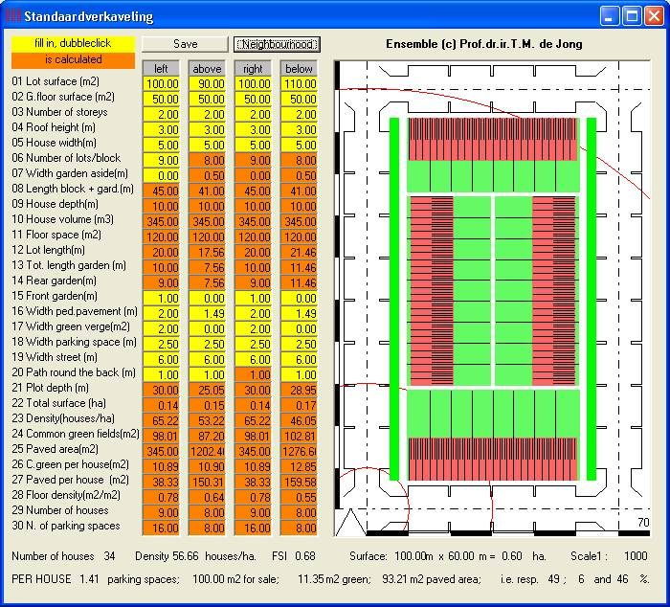 | 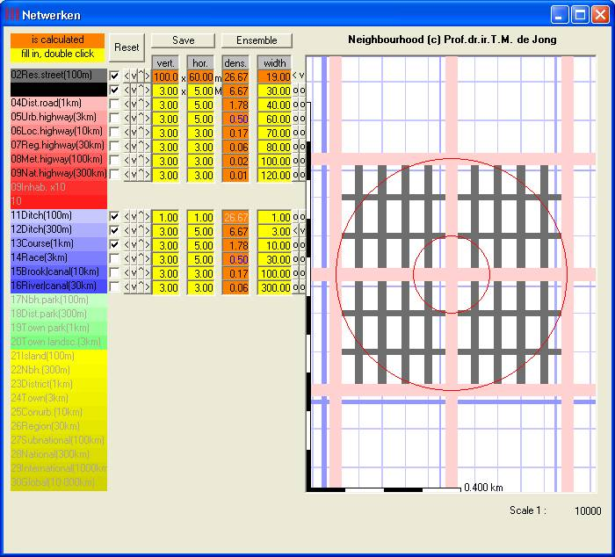
http://team.bk.tudelft.nl/ > Publications 2001 > Standaardverkaveling
Fig. 1 The urban island of an ensemble | Fig. 2 multiplied into a neighbourhood with a hierarchy of dry and wet networks
In Visual Basic I now added a screen multiplying that pattern into a ‘neighbourhood’ with a hierarchy of dry and wet networks to be customized (see Fig. 2). However, to calculate neighbourhood densities I had to add surfaces for green and facilities. That required complicated calculations and algorithms for drawing. So, I left space on the screen, but until now did I not yet make the programming.

Instead I started to study 15 lecture papers of the Faculty of Civil engineering, because our Urbanism education lacked technical insight to make objections on ‘hard’ conclusions of technical specialists in practice. That kind of specialists’ advice breaks off your design if you can not state any critical questions about the presuppositions of their models. So, I started to imitate some of their mathematical models on wind and water in Visual Basic to get insight myself, but the resulting Windows programs still hided the tacit presuppositions (external parameters) and their impact on the behaviour of the formulas used.

Then I discovered the possibilities of Visual Basic in Excel to simulate the specialists’ calculations, showing their presuppositions in yellow cells and sliders changing the hidden parameters. Any TU fellow worker or student has Excel, so I simulated many models on sun, plantation, wind, noise, water, traffic, earth, life an living in Excel. I reported the results in the lectures ‘Territory’ (“Never trust a specialist!”) and an accompanying encyclopaedic book ‘civil engineering for dummies’ describing many specialists’ approaches and models (see Fig. 3). These simulations are downloadable from the Internet. With some work the graphical interface of Excel could show also plans and cross sections. And Excel is useful as a database as well. So, I made for example a database of 420 tree species with many characteristics per species and let Excel draw their plan (with sun shadow at any time) and cross section at any age (see Fig. 4).

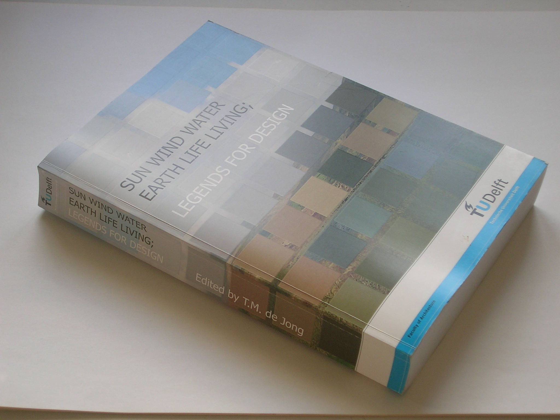 | 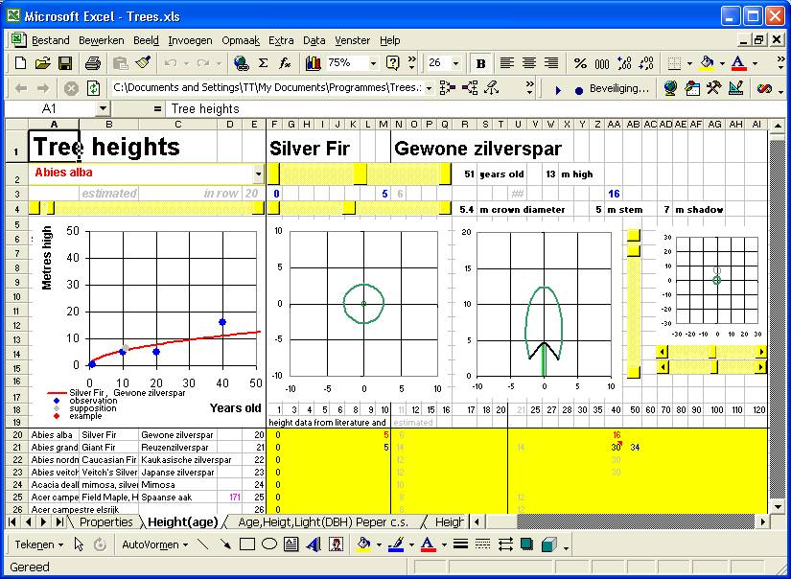
Fig. 3 The lecture book describing many downloadable models | Fig. 4 A visual database of trees
In the chapter ‘Living’ I described different approaches of density used on our Faculty (my own, those of Heimans, Permeta and Uytenhaak) and collected them in a dynamic Excel sheet I will describe here in more detail. Any parameter can be changed by shifting the yellow or blue slides showing the changes real time.

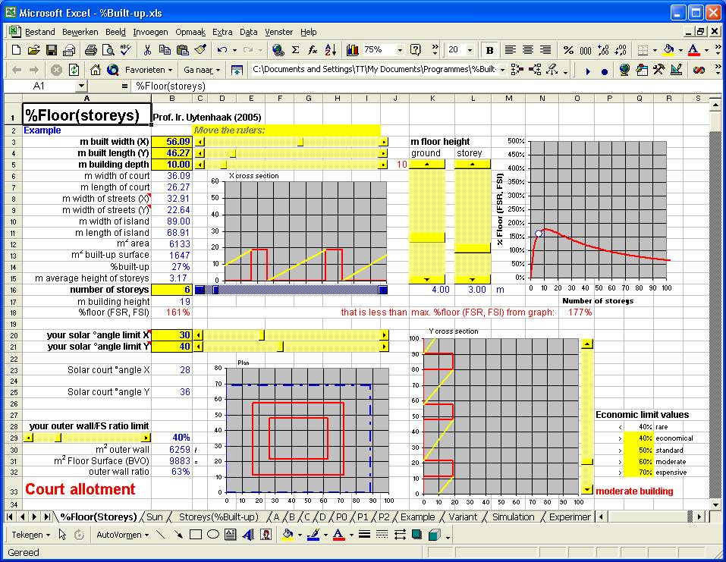 | 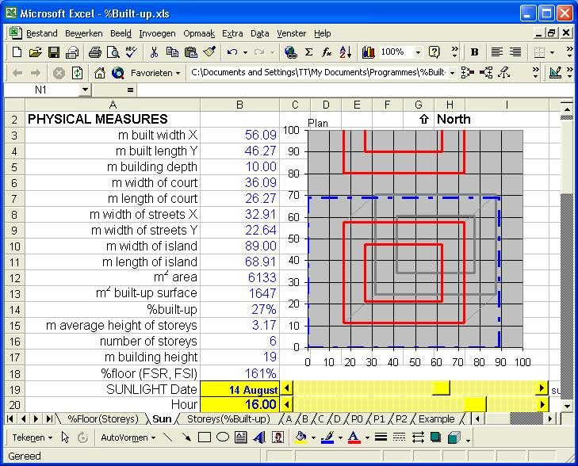
Fig. 5 The variable properties of a court allotment | Fig. 6 The solar shadow behaviour of Fig. 5
The shadows are calculated for any place on earth and time zone at any time (see Fig. 7).
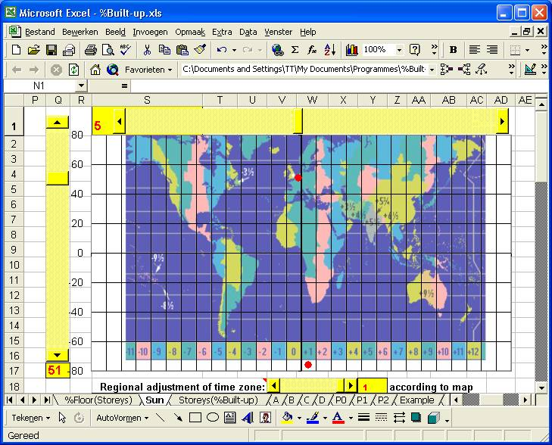 | 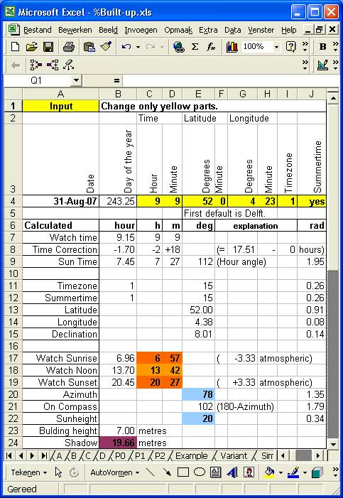
Fig. 7 Setting the place on Earth and time zone | Fig. 8 Solar calculator
The necessary complex set of formulas for solar calculations described by Voorden, M.v.d. (1979) Bezonning (Delft) THD Ct are collected and related in a small work sheet useful to be copied for calculating shadow in other worksheets.

Using the graphic possibilities of Excel in a way they are not really meant for, you can make rough allotment schemes by just giving the number of stories in any cell on a field of 30x30 cells on different levels of scale (see Fig. 9).
In this representation solar calculations are not possible.

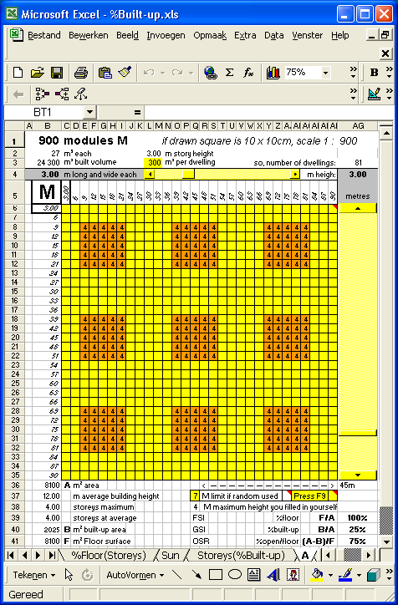 | 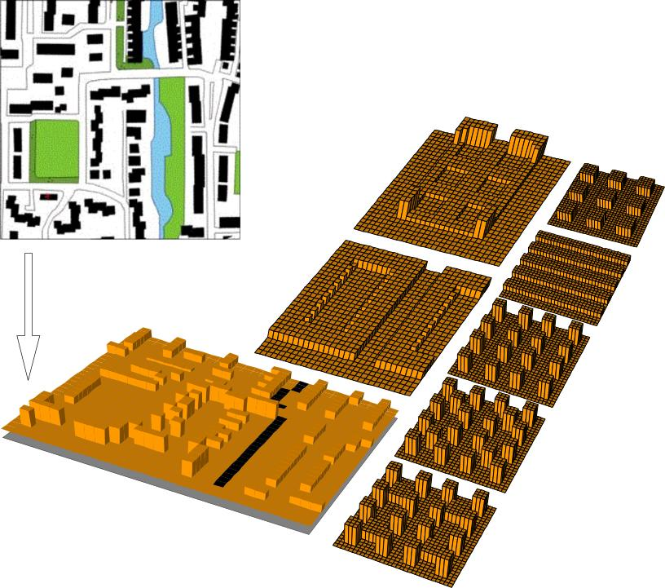
Fig. 9 An Excel field of 30 x 30 cells | Fig. 10 … and its real time simulations
That way you can simulate parts of the topographical map or create theoretical ones like those of Uytenhaak with their density calculations very fast.

http://team.bk.tudelft.nl/ > Publications 2006 > Jong, Taeke M. de (2006) Sun wind water earth life living; legends for design (Delft) .doc (174Mb) in parts (.doc) and additional exercises (.xls)

