A short history of philosophy for designers
Concept Prof.dr.ir. T.M. de Jong 2007-02-27 most recent version http://team.bk.tudelft.nl/ > Publications 2006

1 Introduction 3
1.1 Perception 3
1.2 Thoughts 3
1.3 Science 4
1.4 Critical history 4
1.5 Conceptual faculty 5
1.6 Tools 5
1.7 ‘If’ as a primary tool of thought 6
1.8 Perception and motivation 6
1.9 Scientific importance of fascination 7
1.10 Historical context, conditions of thought 8
2 Antique philosophy 9
2.1 Greek culture 3000 - 400 B.C. 9
2.2 Early fascinations 9
2.3 Turkey 10
2.4 Anaximandros 11
2.5 Pythagoras 11
2.6 Urban geometry 12
2.7 Southern Italy 13
2.8 Travelling teachers (sophists) 13
2.9 Athens 14
2.10 Socrates 14
2.11 Plato 14
2.12 Aristoteles 15
2.13 Hellenistic and Roman philosophy 16
2.14 Scepsis 16
2.15 Supposed hedonism 17
2.16 Stoicism 17
2.17 Rome 17
3 Christianity 18
3.1 Escaping everyday worries 18
3.2 Apologists 18
3.3 Theodicee 18
3.4 Unity 18
4 Medieval philosophy 20
4.1 Augustinus 20
4.2 Scholasticism 20
4.3 Revelation, authority and reason 21
4.4 Universalia 21
4.5 Cordoba 21
4.6 Universities 22
4.7 Thomas of Aquino 22
4.8 Oxford and Paris 23
4.9 Nicolaus Cusanus 23
4.10 Worldly power of church 23
4.11 The fall of Eastern Roman Empire 24
4.12 Money economy 24
5 Renaissance philosophy 25
5.1 Macchiavelli and Erasmus 25
5.2 Reformation 25
5.3 Tolerance 26
5.4 Italy 26
5.5 Technology and science 26
6 Enlightenment 30
6.1 Authority in mediaeval Europe 30
6.2 Reformation and protest 31
6.3 England and the Continent 32
6.4 Spinoza 33
6.5 Leibniz P.M. 34
6.6 Hobbes, Locke and Hume P.M. 35
6.7 Kant P.M. 35
7 German idealists P.M. 36
8 19th Century P.M. 37
9 German materialists P.M. 38
10 20th Century P.M. 39
11 Actual tasks of philosophy P.M. 40
Index 41

Introduction
There are many useful short histories of philosophy about philosophers. Why an other one like this one? Because of design practice. Thales of Milete, Ludwig Wittgenstein and Luciano Crescenzo are engineers like I am. Thales started philosophy in Europe, Ludwig gave it new wings and Luciano described it in an airy style with beautiful examples of everyday philosophical practice. I learned a lot from that style, but I will not imitate it. Many philosophers speak and write themselves in an airy style you would not expect if you read about them.

Perceiving the world as a designer, philosophy is a tool. Philosophy helps to make study proposals comprehensible for people with other perceptions than the maker. It helps to integrate sciences and politics into designs. It helps discussing these designs in different subcultures and language games. And I suppose we still can improve that tool for our purpose as designers. So, let us keep the history short, skipping what seems to be useless for that purpose, keeping in mind what we suppose to ‘know’ nowadays, recognizing the lines of thought we all have had once before. Then we can simply label them by great names the intellectual world knows already, recognizing and showing what we mean without much explanation.

Perception
Daily awake life delivers a continuous inward stream of im-pressions through eight supposed senses, each divided in numerous local sensors near the surface of your body (Fig. 1).

 |  | number of sensors | number of connections | bit/sec speed
vibrations 380-760 nm | eyes | 100 000 000 | 2 000 000 | 50000000
18-18000 Hz | ears | 30 000 | 20 000 | 40000
deformation | pressure | 500 000 | 10 000 | 200000
 | pain | 3 000 000
temperature | cold | 100 000 | 1 000 000? | 2000
 | warm | 10 000
chemical | smell | 10 000 000 | 2 000 | 100
 | taste | 10 000 000 | 2 000 | 10
central neural system
neurons |  |  | 1 000 000 000 000 000
concious |  |  |  | 150
Benesch (1990) pag. 98
Fig. 1 A human stream of impressions supposed by contemporary neurophysiology
A selection of in-formation from these sensors is supposed to flow through a nervous system, combined by a central nervous system, and partly reaching a supposed ‘consciousness’, ready for outward ex-pression as ‘conscious actions’ (operations), linguistic actions included. In between unconscious actions occur like reflexes, routines, habits. Actions are supposed to result in new impressions changing the reception of the neural system by ´experience´ (action-empirical cycle of ‘learning’).

Thoughts
Inside the neural system we suppose ‘thoughts’ to occur and thinking about thoughts I call philosophy. Since a long time, philosophy tries to reconstruct the inward and outward flow as inductive generalization or deducted application. Some philosophers (empiricists like Anaximandros, Aristoteles, Galileï, Hume) stress the inward flow from a diversity of impressions into general thoughts, others the outward flow from general ideas into action (idealists like Plato, Christianity, Descartes, Kant) and some concentrate on the results of human action: justice, language, art and technology, culture in between people (pragmatists like Epicuros, Zeno, James, Wittgenstein, Foucault).
Inward and outward orientations you can find also in psychology (identification, projection), art (impressionism, expressionism) and empirical engineering versus visionary design.

The earliest fascination of philosophy was ‘where it starts’ (archè, origin), a question of causality, not satisfied by traditional answers like ‘God’ or ‘Fate’. However, the question remained ‘what happened before the beginning?’, related to the question ‘what is outside the universe?’. At the boundaries of imagination philosophers had to share some religious suppositions of their contemporaries to keep in touch with them. They pushed back both frontiers to get their own territory in between that ‘outside boundaries’ and the ‘now and here’. By doing so, they enlarged the distance to objects of personal irrational belief (that word is historically connected to ‘love’, meaning affection, fastening, opposite to loosening, analysis, breaking up into pieces).

That caused often condemnation and conviction of philosophers or the emergence of a new religion bridging that gap produced by reason. For example, Christianity introduced a personal God concerned with individuals sending His personal Son. Accepting that external Spirit restored enthusiasm (en-thous is in-god) of earlier animism, especially in times of increasing distance to worldly (governmental) power, nowadays partly restored by mass-media creating personal idols for identification or projection.
Contemporary religion or extended cosmology and everyday questions are the outside and inside boundaries of philosophy, its ‘context’. They clarify much about the usefulness of older thoughts in our contemporary context. We will come back to that topic of context on page 8.

Science
In Europe the first known philosopher is Thales of Milete. He doubted the generally accepted traditional myths and opinions of his age like Descartes would do again, nearly 2000 years later. Both made a new start of thinking by the principle “Take nothing for granted”. That means an appeal to test impressions by other senses, extensions of these senses (designed instruments like telescopes, microscopes, measuring instruments) or change of viewpoint, test what ‘they’ say, test what you think yourself (sup-positions, hypo-theses). It is one of the roots of modern science.

Since then, the path of philosophy is strewn with hypotheses, often apparent mistakes understandable by their historical and geographical context, sometimes with scientific disciplines (sub-cultures, paradigms) trying to avoid these mistakes, more or less avoiding contextual suppositions. Their contemporary method is testing deducted applications. Thinking about these disciplines is an actual task of philosophy, important for designers. Urban, architectural and industrial designers are supposed to overview the results of these disciplines, to add creative thoughts, and to produce proposals for action. In that overview they need a kind of context-bound completeness, science does not deliver as long as it is broken up in context-reducing disciplinary parts. An incomplete design will fail if it has to function for a long time in a complex and often unpredictable context like architectural and urban design. Philosophy can help to overview disciplines, art can help to extend the power of imagination.

Critical history
History is important to be aware of earlier mistakes and to train your thoughts avoiding them. The chronological course of history can be a useful educational course to detect your own successive mistakes supposing a ‘world’ you act in (‘act-uality”). It may give some context-sensibility as well. But we do not have to follow every philosophical mistake at length, especially their outdated cosmologies. They are embedded in historical contexts not always relevant to us, but sometimes necessary to explore to understand their context and to value their remaining advantages against that background. For example the model of Plato’s ideal ‘State’ was written down in a time of many small cooperating city states, often fighting each other, supported by slavery. Plato’s non-democratic reaction looks irrelevant now, but it may have some advantages to pay power less than obedience (like he proposed). A critical history shows some ideas as supposed mistakes and this history even skips those supposed to be useless for contemporary context and design thinking. So, it is a selective history (like every history). But, which selection I choose? I can not be fully aware of my criteria, but I will try to be more explicit.

Especially the long lasting focus on truth or even its 20th century substitution by probability is critically shown from a viewpoint of possibility, or even imaginability, the specific modalities (language games) of design. Alas, the modality of possibility is sparingly presented in the history of philosophy and the modality of imaginability is supposed to be the territory of art. But, how could we imagine thoughts without supposing imagination? Perhaps I should be more precise: separating and connecting different imaginations (conceptual faculty). In line with that, I will add some elements from the history of science and technology. Let me explain that somewhat further before I start my history of philosophy.

Conceptual faculty
In archaeology it is supposed we can conclude historical human presence if we find tools. Tools suppose organisms overlooking a range of actions from which only the first is executable (conceptual faculty). That human faculty seems to be found in other species as well, but either the produced tools apparently emerge from innate routines (for instance the bird’s nest), or they suppose a very limited range of actions (for instance removing side branches to get ants out of ants’ nests like some apes do). So, the tools found to conclude human presence firstly should not be found in every presence spanning all generations or the species as a whole. In that case, we have to conclude manufacturing these tools is an innate routine. If not, it could be a conceptual faculty.

Secondly, the supposed range of actions imagined should be ‘large’. But what is ‘large’? Perhaps the criterion is, you have to suppose intermediate tools to make effective tools (for instance finding appropriate stones to make flint axes). Many questions remain. For example what is ‘effective’. That raises a question about satisfaction, the end of tool making. The question of determining ‘satisfaction’ is difficult to solve, because we know non-human examples of manufacturing tools apparently not meeting any imaginable demand. Animals and children can construct by playing. Let us suppose we can solve that question, and concentrate on intermediate ‘tools’ as accepted proof of a ‘conceptual’ faculty.

Tools
Tools separate or connect, often combining separation and connection, like a sieve, a lid or door, a bowl, barrel or a house (selectors). For example, a house selects ‘dry’, ‘warm’ and ‘safe’. To make selectors, you have to separate or connect materials as well. Searching these materials is separating them from natural resources and collect them (selection, a combination of separation and connection). So, separation and connection are basic operations to overlook the process of manufacturing. Separating human tasks in a range of actions (specialization) shows the faculty of separation and connection as well. And, we have to separate the imagination of actions beforehand from the actions later, to overlook the manufacturing process (planning). Imagination means representation of non-actual objects. We remember objects re-presented (brought back into present) from the experience of different senses in the same time. Negating our senses or experience is the very start of imagination supposed in logical operators like ‘if’.

‘If’ as a primary tool of thought
Imagining separation and connection requires conceptual tools of separation and connection like subtracting and adding. To discuss division of tasks we need a language starting with sentences like “if (you do this now) then (I will do that later)”. ‘If’ and ‘then’ suppose separation of imagined events (ana-lysis) negating actual events and connecting them (syn-thesis). If we cooperate with ourselves, the supposed sentence is: ‘if (I am doing this first) then (I can do that later). ‘If … then …’ is the first tool of imagination (concept) to connect primary imaginations (cases) overlooking a range of future actions. That supposes two faculties.

Firstly, it supposes separate imagination of non-actual cases (presentation), which is an other imagination than the direct imaging of the actual or remembered ones (re-presentation). Representation we suppose also in cameras and in animals as complex stimulus to fulfil their innate routines. These routines are comparable with computer programs waiting for the command ‘run’. I suppose denying actual cases as typically human, in our culture expressed by shaking one's head or the word ‘no’. You can conclude confirmation from two denials (not no); the reverse you can not. But in some language games ‘not no’ is not the same as ‘yes’ (“I do not say ‘no’.”). The Japanese “No” we apparently have to translate by “Perhaps”.
Secondly it supposes overlooking different cases as a whole, imagining the overview as a third imagination (reasoning), for example linguistically expressed as “If … then …”. The truth-value of cases (the case, not the case) is something else than the truth-value of reasoning (true, false). The study of strict reasoning is called logic. Formal logic can be simulated by electronic devices (see Fig. 2).
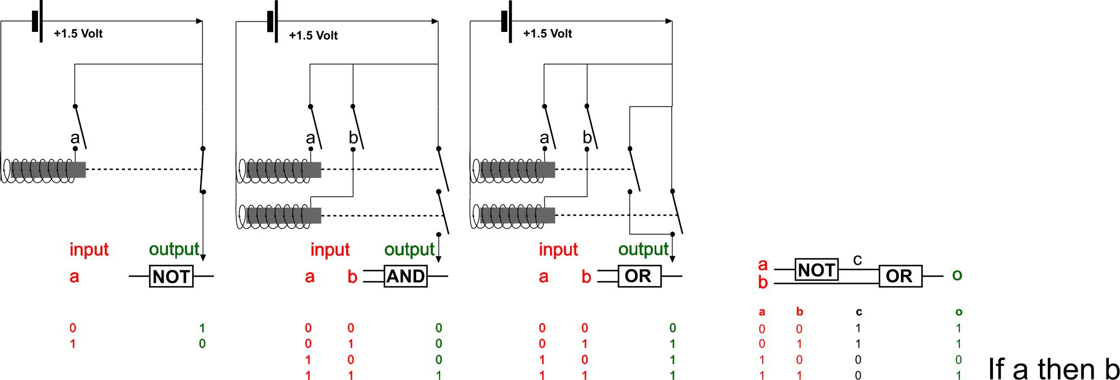
Source:
Fig. 2 Reconstructing ‘if … then’ according to truth tables using relais.
Since 1947 the ‘If … then …’ tool is simulated by transistors, devices used in computers replacing old fasioned ‘relais’. A transistor separates two poles to be connected by a signal on the third one (the ‘base’). If there is a signal, then there is a connection, if there is no signal, then separation occurs. So, a transistor is a switch, a selector.

Perception and motivation
Some of your impressions attract your attention more than others, involving other senses or even driving you into immediate action especially if you are frightened, surprised or delighted. For example, you hear a noise, turn your head, look at its source, decide to fight, to run away, to pay more attention having a closer look or you loose attention.

So, from a multitude (Fig. 1) you select impressions by special attention. What determines that selection? Many selections are physically determined, others determined by habit, communication, education, culture. If you are short-sighted, you will pay less attention for celestial constellations. But, if you are a night person and get a telescope like Galileï, your attention for planets and stars may rise to have a closer look. However, if you are hungry, you focus on food, if you are bored you look for sensations, if you are in danger or tired you look for a safe place, if you are lonely you look for other people, and so on. Which categories of selection (food, sensation, safety, loneliness or special interests you share with your spatial, ecological, technical, economic, cultural, governmental environment) are innate (a priori), inherited, which are learned or habits, probably to be unlearned?

Maslow supposed a conditional sequence of five motivations: first physiological, secondly safety, thirdly solidarity and love, fourthly appreciation and respect, fifthly self-actualisation. The next motivation is supposed to appear as soon as the earlier ones are satisfied. Philosophy, thinking about thoughts, comes to the fore on Maslows fifth phase. Many philosophers were aristocrats, not hungry, safe, beloved, appreciated, having realized many aims. After all these achievements they started to think: “Is this all there is?”. They started to look around, to teach, to write, to publish. Others were not so privileged or lost their achievements, income, appreciation, friends, safety or even their life. Socrates lost his life, Plato his safety, Nietzsche his friends. Fascinated by their questions or answers they did not care much about their primary needs anymore. Which fascination motivated them? Do you share that motivation from a viewpoint of design?

Scientific importance of fascination
Fascination (strongly motivated concentration on an object) is a combination of emotion (motivation) and intelligence. Intelligence itself does not move, it frames, the drive comes from emotion (out-movement). Students and scientists often came to great, sometimes unpredictable results by fascination, but it also can die out without results. Some of us can be busy with a productive fascination in loneliness but most of us need a stimulating environment.

How could we create such a climate of study stimulating scientists and students to productive fascinations? Fascinations do hardly have a retrievable origin. So, it is difficult to arouse them consciously. For example, I am an urbanist. Though I had many other things to do, last week I was completely fascinated by the Middle Ages, this week I can only read about molecules and draw them. My table is full of books about molecules and I have downloaded each time more beautiful computer programmes to draw them 4D. I learn a lot in such periods, make connections I otherwise never would discover or invent, and they bring new, unexpected fascinations. Fascinated like this I neglect my duties, but I feel happy. I do not know where these fascinations come from so suddenly and sometimes I get lost in the multitude of tempting subjects to study.

However, there are many other periods of unhappiness without any fascination. Then, everything is boring. I do not understand why the books I once wanted to read so eagerly lay useless on my table. I put them back in my book case looking for anything able to keep my interest for longer than five minutes. Sometimes it helps to clear up my room and paperwork, to press myself to the tasks of my agenda, but often at the end of the day I ask: “What have I done today?”.

An event that can raise me out of such lethargy is an unexpected guest knocking on my door, coming with her or his issues and fascinations. I start asking questions, try to explain something self evident to me, but not to my guest, and I get all kinds of associations, immediately to be checked by books and articles from my library or the internet. Often, when my guest is gone, sometimes grateful, mostly not, I start to write an article. But in fact it starts like a letter to my guest to explain what she or he did not understand like I supposed to do. In no time my table is full with articles and books I have to check and my article extends into a direction no longer of any interest to my guest. Sometimes I become fascinated.

But when I cannot find the articles or passages I aimed for, or when I lose my track browsing the internet, the fascination dies out again and my unfinished article is buried in my computer file of earlier unfinished attempts. I now realize how important it is, to make your papers and books quickly retrievable to keep the fire burning. Start any article with the date, arrange your book case by author. That is the personal efficiency I learned after many years. I am writing a paper on personal efficiency, the companion of creativity. Use uninspired minutes to clear your room, your archive or your files on the computer, arranging them by date and name respectively. Realizing the sequence of events in your personal history could suddenly revive old fascinations!

A context of study permanently asking directing questions keeps the fire burning. The wind of critical questions fans your fire, but criticasters can bow it out. Scepticism, or even worse indifference can take away all oxygen. A fair debate gives the issue new aspects, splitting it up in contagious, easily burning partial fascinations, leading to feverish searching, discovering or even inventing by design. Feel that happiness looking forward to the next meeting to convince, surprise or even astonish the opponents. Feel the disappointment if it does not work and use that motivation to criticize work of others. But such a climate of study has its conditions. Do not be indifferent yourself, do not be a sceptic or a criticaster, be interested in other issues than your own fascination. University means the place of universal interest in what we do not know. If we could ‘know’ anything more than mere suppositions.

Your study has many political, cultural, economic, technical, ecological and physical contexts influencing the result after all and probably being influenced by the result. This is a short checklist: check these contexts if your reached a dead end. Find new tracks to your subject from outside. For a moment loose your anxiety to be too universal, though teachers always stress limitation. There are more limitations than a stated ‘problem’ or ‘objective’. Your portfolio and references limit your abilities as well. Moreover, it is a rich source of fascination. And fascination is the best limitation. Sometimes a durable fascination is too much limitating. That kind of fascination becomes obsession. Keep the balance.

Historical context, conditions of thought
You live in a governmental, cultural, economic, technical, ecological and spatial context (sphere) very different from any preceding century. To start with this century: you have less space than ever, you are safer than ever, but dangers are overdone or underestimated by mass media and more elusive than ever, you have more technological, economic and cultural possibilities than ever, but you have an enlarging increasingly elusive governmental system loosing power to private forces oscillating between threatening either your personal freedom or your certainty. That context conditions your thoughts about what is, what can be and what you want. It raises other questions in everyday life than before, varying in larger frames and smaller details, grains to locate them in a stable way.

Antique philosophy
If we compare our context with a Greek context some 2500 years ago, people living then had more space, less time to live (closer to death), continuous war, limited technology, an accepted economic division between free men and slaves delivered by war, a multitude of religions without science but with a role of art and imagination seldom seen before and after, representatives of a governmental system you could meet in the street. In that context European philosophy emerged for the first time as an essential part of culture. Nearly everything thought later was once thought there and then.
The history of philosophy appears to show repetition with slight changes, using many times the original Greek words, labelling lines of thought as abbreviations. That is why you have to start your philosophy course in Greece and Turkey.

Greek culture 3000 - 400 B.C.
Greek culture is preceded by the culture of Minoic Crete starting some 3000 B.C., booming from 2000 B.C. It was the time small town-states emerged around the Aegean Sea after the great empires of the Middle-East and Egypt. Crete was a rather peaceful centre of a trade union including the Southern Aegean Sea, like the more often destroyed city of Troy had a federation in the Northern part. From 1500 B.C. Mycene (Peloponnesos) establishes an Aegean Sea federation of fortressed harbour cities, ending about 1250 B.C., a period the ‘Trojan War’ started Homer describes much later. Mycene’s Agamemnon is said to conduct a 10 years siege of Troy. Mycene’s culture is known for example by the treasury of Atreus, Agamemnons father. Then, a first migration of Northern Greek tribes reach the peninsula of Peloponnesos, controlled by Mycene, establishing a unity of Greek culture enclosing common religion, mythology, sporting games, accepting a modified Lebanese (Phoenician) alphabet. However, disciplined Dorian tribes using iron destroy Mycene, conquer Sparta, Crete and parts of the South East coast of Turkey. They leave the environment of Athens and the adjacent Cyclade islands to ‘Ionian’ people, later giving their name to the western (‘Ionian’) coast of Turkey, developing democracy instead of the inherited government of feudalism.

From 1000 B.C. a true Greek culture has established divided in autarchic town-states (‘polis’) firstly governed by noblemen (oligarchy), then by tyrants helped by dissatisfied citizens and farmers, a constitution evolving into democracy with laws, stimulated by tradesmen. However, Greek democracy does not include the many slaves delivered by war. They deliver Greek citizens the free time called ‘scholè’, necessary for story-telling, games, education and philosophy. From 750 B.C. overcrowding causes new colonization of the Mediterranean world. In the East from 600 B.C. the Persian empire develops, attacking the Ionian coast. A federation of Greek town states guided by Athens resists the Persian expansion. In 490 B.C. the army of the Persian emperor Darius was defeated at Marathon. In 481 his son Xerxes came with an army of more than 100 000 people and destroyed Athens, but in 480 B.C. he lost his fleet at Salamis. His army was defeated at last by Spartans at Plataeae.

From 477 Athens (Aristides) founded a trade union of all Greek harbour towns accepting its model of democracy. From 460 it was connected to its harbour Piraeus by defendable walls. Its Acropolis then built shows a harmony of Doric and Ionic styles. Art flourished as never before during Pericles’ democratic government (444-429 B.C.). However, from 431 B.C. the rivalry between Doric Sparta and Ionic Athens resulted in war and Athens suffered a pest epidemic. In 404 Athens capitulated and 30 tyrants, guided by Kriton terrorized Athens during one year to restore the ‘constitution of the ancestors’. A weakened democracy returned condemning Socrates to death because of creating philosophic doubt in the streets of Athens.

Early fascinations
Before Socrates, philosophy was mainly fascinated by nature and its origin (archè). In the Eastern part of the Greek colonies, the Ionic West coast of Turkey, that fascination directly produced an amazingly modern cosmology (Anaximandros) stressing genesis and movement by antithesis, war (Herakleitos). On the other side of the Greek world, Southern Italy, philosophers were fascinated on the contrary by eternal being itself (ontology) stressing paradoxes of movement, denying the possibility of emptiness supposed to be needed for movement (Parmenides and his student Zeno).
In between, travelling teachers (sophists) taught how to convince anybody of anything creating the rules of classical debate, asking payment. Their greatest representative, Protagoras lived in the same town as Democritos, breaking up the cosmos in supposed colliding atoms, accepting the possibility of empty space indeed.

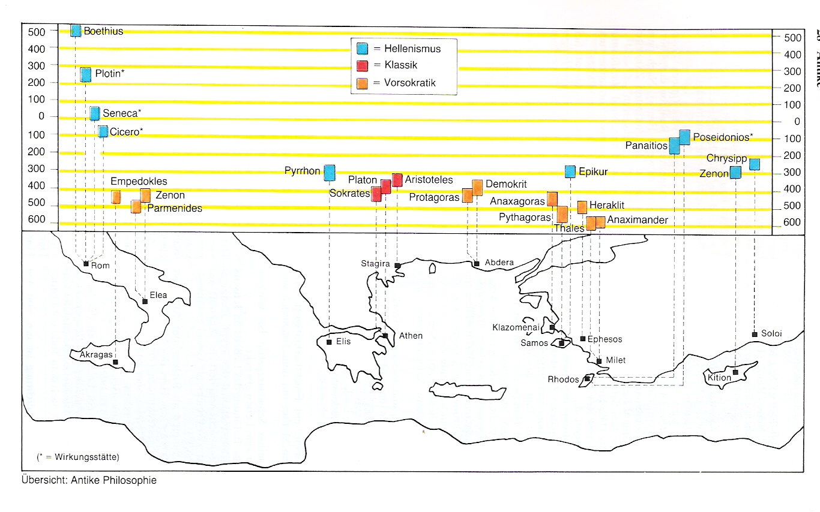
Kunzmann, Burkhard, Wiedmann (1991) pag. 28
Fig. 3 Highlights of antique philosophy
Then, in the centre of the Greek world, Athens, the fascination of philosophy was directed to human life by Socrates and Plato to find an archè in human thought itself. Plato´s encyclopaedic student Aristotle tried to combine these views. He was the teacher of Alexander the Great who, from 334 B.C. conquered the known world of the time until India in ten years, creating Hellenism, causing dissemination of Greek thought. The Roman Empire adopted, repeated, modified all kinds of Greek thought and adapted it to Christianity. The Arabic world did the same to Islam and brought texts of Greek thought back to Europe after 1000 A.D.

Turkey
Europe’s first known philosopher, Thales of Milete walked somewhere in Turkey at the boundary of old civilizations and growing new ones with an old woman looking at the stars, fascinated by their constellations twinkling in the sky, continuously, but systematically changing by hours and seasons. He did not see a pit, stumbled and fell. The woman asked: “How could you expect to know anything from heaven, if you do not even see what is just in front of you?”. But he predicted the local eclipse of the sun in 585 BC. That is why we know he lived that time. He was a politician, did some engineering on waterworks and made travels like many early philosophers. He should have known about the results of Babylonic astronomers and Egyptian geometry.

Milete, near the river Meander was an international trade community. They asked Thales why he was living in poverty at last, fascinated by useless philosophy. He did not answer that question, but in winter he bought all olive presses in town, because from the stars he concluded the olive yield would be abundant that summer. It appeared to be so, and he became rich again to show he was not interested in money. Deduction from a general hypothesis can be useful for particular applications, even if the hypothesis may be doubtful. Thales was the first to derive simple geometrical propositions by proof. By doing so, he started the systematic foundation of mathematics Euclid would finish two centuries later. Euclids book ‘Elements’ was used on high schools until the 20th century.

The attention for unreachable celestial constellations fascinated philosophers from the beginning. They remain more or less the same on travels. The predictable course of stars, their silent heavenly ethereal serenity, suggested a divine mathematical beautiful order (cosmos), an other world of eternal coherent movement contrasting with the chaotic unpredictable incoherent events on earth: political complications, conflicts, wars, injustice to be brought to light, unveiled, dis-covered (alètheia, un-coveredness). Milete was surrounded by endless water and seamen are hermits on their ship with often undisturbed time for reflection. Thales supposed water was the origin of everything. Water has no mountains to overcome as land has. It gave distance from terrestrial chaos, freedom of thought, brought merchants guided by stars and geometry to foreign countries. It carried them back with foreign products and strange ideas to the harbour, counting their profits, learning to count in a mathematical sense as well.

In rest and horizontal balance water mirrors heaven in its surface by perfect geometry, suggesting bottomless depths. It portrays you bowing over its surface as a source of self reflection. Coming from heaven it cleans you and it cleans the earth, collecting itself in rivers feeding the sea continuously. But its rest can be paradoxically dynamic. “You never step in the same river” Herakleitos would say a century later: “Everything flows”. Water can be frozen in winter, evaporated in summer and moved by untangible, elusive air, but movement hides its superb clarity. It extinguishes fire, quenches your daily thirst, but not your thirst for clarity.

Anaximandros
Overseas trade liberates minds from own culture and its myths. Anaximandros, Thales’ successor in Milete is supposed to make the first map of his world. Like Old Testament authors, he supposed land to be a body floating in the sea. He supposed land to be evolved from water and while drying up occupied by organisms from the sea developing into man. He supposed the Earth to be a body freely floating in an other ethereal substance (apeiron) within a celestial system of fires, source of many possible worlds. He supposed that substance bursts continuously into pieces with distinguished opposite marks like warm-cold, moist-dry ” paying each other fines for their injustice according to the order of time”. The Greek word for injustice has a connotation of unbalance. So worlds are signs of unbalance in the apeiron, separation, causing power play, conflict, war between the pieces paying each other fines. Demolition of pieces brings them back to the endless, undetermined apeiron, the origin of everything. So, there is a continuous alternation of separation and unification. The ‘order of time’ shows a feeling for cause and effect to avoid the irrational, non-testible religious suppositions of his culture.

Why did we need Copernicus, Galileï, Darwin and particle physics with negative matter, a concept of the Big Bang to recover 2500 years later a cosmology so similar to that of Anaximandos, completed by Democritos’ atomism? I suppose some lacking conditions. Anaximandros did not yet have instruments (telescopes, microscopes) for empirical observations to test his impressive hypothesis. He did not develop a school, a paradigm shared by researchers before Milete was demolished in 494 B.C. by Persian forces. And how difficult is it for survivors of an assault to believe that demolition is a kind of returning to balance, clarity. Anaximandros’ pupil in Milete, Anaximenos, returned to a perceptible archè: the air we breathe in. He supposed air condenses into water or earth or thins into fire.

Pythagoras
At an island nearby, Samos philosophy started anew by Pythagoras. How to reach that celestial clarity inside while chaos full of conflict and injustice surrounds you outside? The serene art of geometry and counting combined by Pythagoras promised a harmony of celestial and terrestrial spheres. He supposed numbers to be the archè of the cosmos (a Greek word for beautiful order, related to our word cosmetics). The number 1 is a point, 2 a line, 3 a surface and 4 a body. Any body can be represented by numbers. The cosmic harmony of spheres could be heard in successive octaves by doubling the length of strings on musical instruments.
Pythagoras' theorem shows you can make practically pure squares by 5 units as sides and 7 as hypotenuse (Fig. 4). However, the school of Pythagoras discovered it is slightly more than 7. It disturbed the idea of whole numbers governing the cosmos. The school kept that disappointment secret, moved to Kroton in Southern Italy and became a mystic community, Pythagoras became a guru appearing only for students after five years of study.

Urban geometry

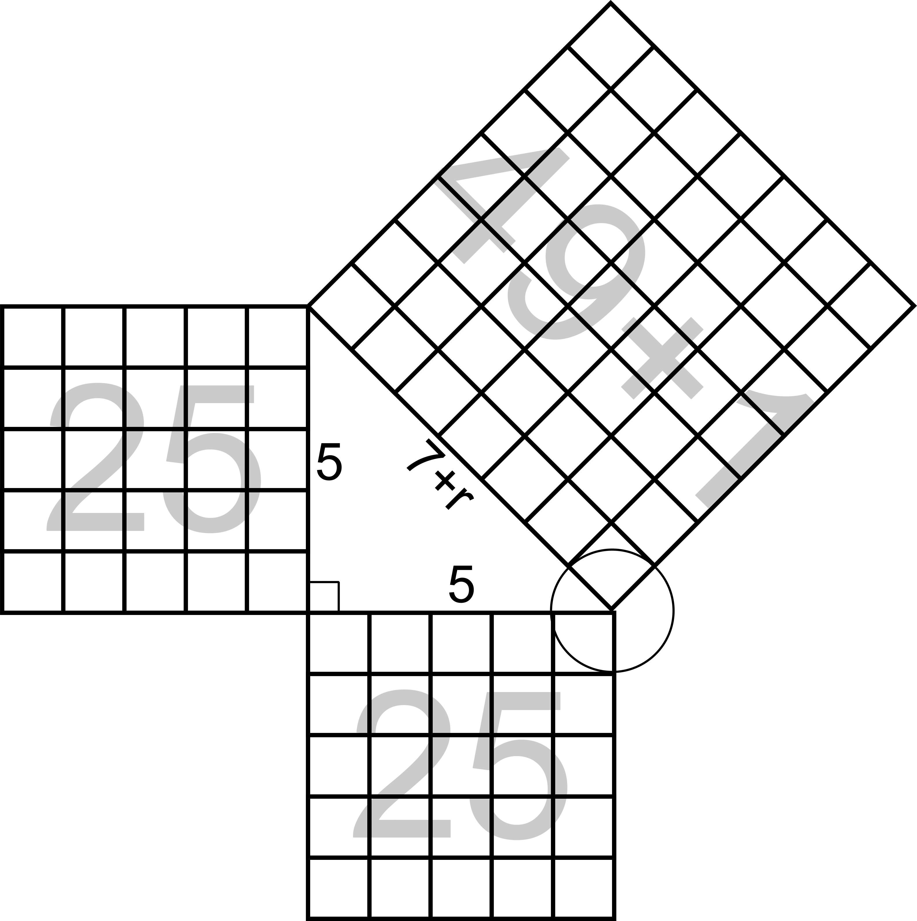 | 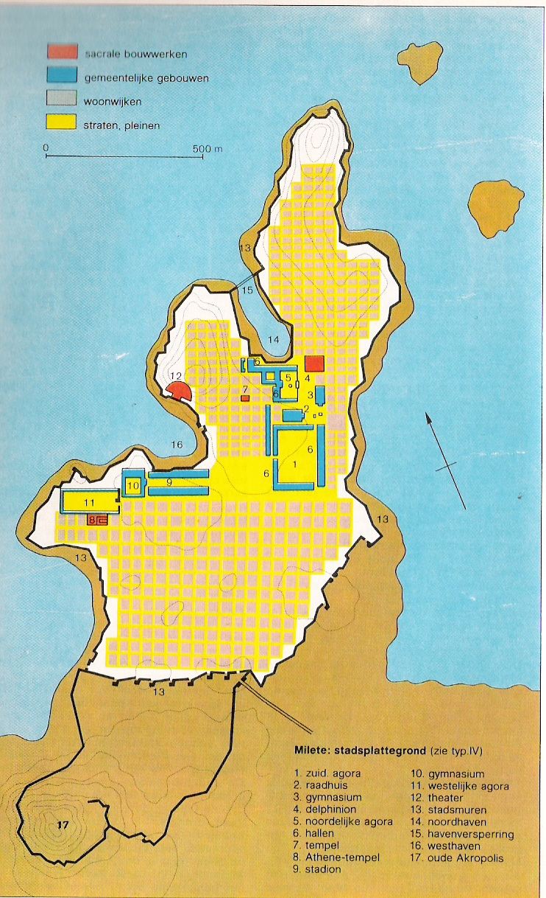
Jong (1992) pag. 204 | Bosch & Keuning (1976) pag. 166
Fig. 4 Constructing a pure square by Pythagoras | Fig. 5 Hippodamos’ Milete
The first known urban planner Hippodamos learned the art of constructing a practically pure square in rough grounds developing the new orthogonal street map of Milete after its demolition (Fig. 5). The old Akropolis (below) giving overview is abandoned, the religious centre is just one of the urban islands of approximately 40x40m in the grid. Approximately 10m wide streets are running East-West, 5m streets North-South to get optimum sunlight in hot summers and cold winters.
Hippodamos was asked to design Piraeus (Fig. 6), the extension of Athens and his rational planning is recognisable in many colonies like Priene (Fig. 7).

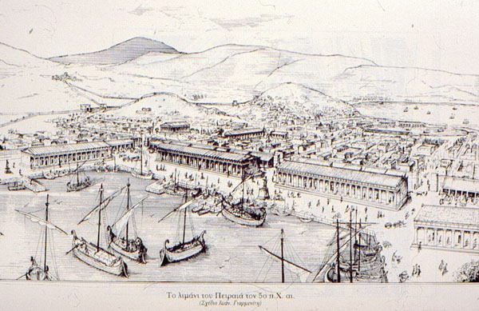 | 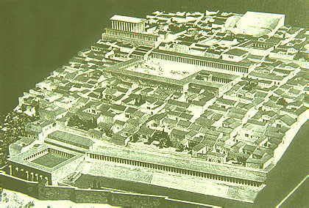
http://www2.rgzm.de/Navis2/Harbours/Athen/Piraeus/PiraeusAbb8.htm | http://www.bodrumpages.com/imagepages/priene_model.html
Fig. 6 Piraeus, the harbour of Athens | Fig. 7 Priene, squares projected on a hilly site
Philosophers in the East slowly accepted dynamic atomic (Demokritos) or even continuous (Anaxoras) fragmentation and endless diversity by combination of particles, ordered by spirit (nous).

Southern Italy
On Sicily Empedocles still supposed four elements: water, earth, fire and air combined by love, separated by hate. But in Southern Italy, about 100km below the Greek town of Naples (neapolis, new town), Eleatic philosophers like Xenophanos rejected anthromorphism of gods, not to be compared with men. Parmenides searched for universal unity of existence, denying emptiness supposed to be necessary for movement. He supposed sensory perception to be deception, the real being as unmoved, eternal logic, shared with human thought, uncovered by philosophy. Pythagoras’ universal, eternal mathematics of numbers probably prepared or matched this context in Kroton. Mysticism means ‘closing eyes’, avoiding deceptive impressions. Many years later Plato stayed three times in Southern Italy. He recognized ‘ideas’ of which reality only shows examples, shadows. Zeno, pupil of Parmenides, elaborated logical paradoxes appearing if you continue to divide distance or time in parts and parts of parts. By doing so, Achilles can never outrun the turtle. Unity of being can not be divided.

Travelling teachers (sophists)
The fascination of these early philosophers produced not only different metaphysical starting points, their schools also gathered and taught mathematics and much empirical knowledge about the world of the time. Tradesmen needed that mathematics, geographical knowledge and knowledge about local habits, culture and history offered by these schools. But they were not next door or immediately available. Moreover, they did not give answer on many other questions from everyday life. For example, trade often causes matters to court to be defended. So they needed lawyers.

Trade got great advantages by trade unions between cities holding the same intentions of honesty and justice. That appeared to be guaranteed better by democracy than by the inherited power of monarchs or noblemen waiting for expensive presents. That is why Athens founded such a trade union of democracies 477 B.C. However, democracy concerns many people and it depends on verbal persuasion of these people, especially by and between politicians. Tradesmen and politicians both needed to learn how to persuade by logic and factual knowledge. And they wanted to pay for it. Their speeches often convinced better by parables comparing actual cases with well known facts and local myths.

So, they paid teachers to write such speeches or to learn the art of rhetoric themselves. Such teachers were called ‘sophists’ and some of them became famous as philosophers like Protagoras, a relativist: “Man is measure of everything”. His training contained to defend contrary standpoints. He taught virtuousness as doing something better than anyone else, a practical kind of ethics without which he supposed society could not exist. But what is ‘better’? He supposed natural selection to improve society. So, criminals are, and have to be, eradicated. His friend Pericles asked him to make laws for the town of Thurii. But what is ‘good’?

Athens
In the times of Socrates, Plato and Aristoteles, the centre of the Greek world, Athens, counted about 100 000 inhabitants. They lived in a man-made world full of imagination, art. It was formed, according to the ideas of famous artists, architects and most recently, an urbanist like Hippodamos. So, it is not so strange these citizens saw the world as a projection of ideas (eidos means figure, shape) squares on a hilly area (see Fig. 7). However, projected on the material world, ideas were spoiled as shadows on a rough surface, resisting their ethereal beauty. Shadows on the wall may unpredictably move by the flames of some divine fire, but the motionless figures (ideas) they portray, remain the same. So, pest and war may destroy, but rebuilding the city and its institutions you recognize the same ideas coming back.
While philosophers in the outskirts were fascinated by nature and eternity, the city of Athens faced direct questions about man and society after many years of rise, conflict and fall, uncertainty, change of viewpoints. Socrates and Plato did not distrust good intentions in people, but how could good intentions produce so much evil? In every man and woman a core of goodness should be buried in a body blurred by physical desire. How to uncover that by reason?

Socrates
Socrates, born in 469 B.C., son of a sculptor and a midwife, probably worked as a sculptor and served as a soldier with distinguished courage in the army of Athens. He experienced the building of the walls into Piraeus and their destruction, the rise and fall of Athens, of democracy, the change of ideas in a turbulent and most decisive short period of European history. Once unemployed, he wandered through the streets of Athens interrogating passers-by about their ideas. What is virtuousness, courage, justice, beauty, ‘good’? He pretended not to be their teacher but a respectful student. He continued to ask, sometimes presenting disturbing examples (induction), sometimes deriving unacceptable conclusions (deduction) until his respected teacher-victim had to admit his original definition was not tenable. By way of embarrassment (aporia) he aimed to bring his victim in a state of beginning self-knowledge. Socrates developed no system, but a conversation method of research (elenchus) using logic (logos).
He aimed at, but seldom reached, precise definitions of blurred notions and developed the art of questioning (defining the contours of the unknown) as a social surgical tool. He tried to expose the hidden good in people buried in their contextual and physical mess, to be reached by self-knowledge, supposed to be the very start of freeing knowledge in general.

Socrates became a well-known person, ridiculized in comic theatre pieces by Aristophanes, irritating interrogated magistrates with laughing young people around. In 399 B.C. he was condemned to death refusing to flee. He did not write (“because writings do not answer”). But his pupil Plato, terrified by injustice, wrote down his interrogations to find out the ideas hidden in man as an ideal sculpture hidden in stone (like Michelangelo stated 2000 years later), to be freed like an innocent child by a midwife. He wanted a political career, but put off from common political hypocrisy and started an Academy in Athens at 387 A.C. That Academy would exist about 1000 years. A 20th century mathematician and philosopher A.N. Whitehead called all philosophy to come next centuries ‘footnotes to Plato’.

Plato
Plato’s writings start by the Apology supposed to be held by Socrates for his court, directly raising questions of contemporary justice. Then, many debates of a supposed Socrates with less and more well-known characters like Parmenides and Protagoras followed. Plato shows a detailed empathy for the opponent in a brilliant literary style. He shows the respect of Socrates for his conversation partner in a common research, not afraid for own embarrassment and doubt. However, Plato’s Socrates seems to become a speaker of his own emerging but not finished system of two worlds: the stable world of ideas, figures, shapes and the variable world of their shadows we can perceive. So, we have to uncover the ideas as scientists and realize them as artists. In his Symposion (guest dinner) he supposes love, desire (eros) as eagerness into eternity and beauty. In his Meno he supposes memory of ideas from before birth (anamnesis). So, he supposes we come back into the world of ideas by death to be reborn in a new life of experience supposed in his Phaedo.

These are components of his ideal state described in Plato’s Politeia. Like Socrates climbed from craftsman, via soldier into philosoph, learning skill, courage, perseverance and reason, the ideal state counts three classes. He proposed the highest governing class of male and female philosophers to live communistic, without marriage. Plato met Dion, the brother-in-law of Dyonisios, the tyrant of Syracuse on Sicily. Dion asked Plato two times to realize his political ideals on Sicily. The first time Plato was openly terrified by the hedonism of Dionisios and his household. He was captured by the tyrant and freed by his friends. The second time the innocent younger Dyonisios was Plato’s student after his father died. However, suspicious courtiers forced him to drive Dion but he prevented Plato to go. Plato escaped again, but now the younger Dyonisius prayed him to come back threatening to confiscate Dions properties. Plato’s friendship to Dion forced him to go for the third time, but Dyonisios forgot his promises and Plato escaped again. After Dions death Plato’s supposed Seventh Letter to the relatives and friends of Dion describes his feelings.

In later writings like Theaetus and Sophistes Plato develops a dialectic method of overview (synopsis) and distinction (dihaeresis). Defining ideas becomes locating them within the most general: being, identity (equality), not-being-this-or-that (difference), rest (stability) and movement (change). In Sophistes Plato gives an new attempt of proposition logic: how to connect subject and predicate (qualification) in a sentence properly. In his last writings like Laws and Timaeus he describes an ideal state taking human inadequacy more into account than he did in his Politeia and a cosmology, supposing a god-craftsman (Demiurg) connecting the world of ideas with material world. That question of the connection of these two worlds remained circulating in philosophy and religion until now.

Aristoteles
Plato’s encyclopaedic student and co-teacher Aristoteles, born in the Macedonian outskirt Stagira, 384 B.C., comes back to earth in his enormeous, but less poetic oeuvre summarizing nearly everything known in his time by empirical observation, speculation and reasoning (Physics, four books). His student Alexander the Great is supposed to send stones, plants and animals gathered on his conquests into his teacher. Aristoteles supposed them to have being, soul and senses by accumulation. Man has reason. Man can connect imaginations into a sentence, sentences into a reasoning, reasonings into a scientific proof (apodeixis). Aristoteles aims to proof what he sees out of definitions and axioms. To avoid the fallacies of sophists he develops the tool of reasoning. So, before Physics he is supposed to write his Organon (‘tool’, six books) on language and logic. After Physics he is supposed to write Metaphysica (‘after physics’, five books), fascinated by ‘being’ (ontology). Then he wrote five books on ethics and two on poetics.

First of all, during about 2000 years, Aristoteles was the authority on logic. The other writings were unknown in medieval Europe until 1000 A.D. Then Arabic translations came to Europe making him the authority on any scientific subject except religion. Only Renaissance learned Europeans to have a closer look themselves. So, let us start by the Organon. Aristoteles writes: “Each uncombined word or expression means one of the following things: what (ousia, substance), how large (quantity), what sort of thing (quality), related to what (relation), where (posture, position), how circumstanced (state of condition), how active, what doing (action), how passive, what suffering (affection).“ These are the categories Kant extended into primary tools you need to interpretate anything you experience by senses. But, as Aristoteles proceeds, uncombined words can not state any positive or negative judgement. To do so, you have to combine them in a sentence: “This (position) man (substance) robbed (action) me.”. This can be true or false. It qualifies (predicates) a subject (this man) reporting an event. The proper construction of sentences is called predicate logic.

Sentences with one word in common (middle term) can be combined in a simple reasoning (syllogism), the area of proposition logic. “This man robbed me. Robbing is forbidden. So, this man is guilty.” But to make absolute proofs like Euclid collected in Alexandria about 50 years later for the complete area of mathematics of that time, you need definitions (“What is robbing?”) and axioms (“Robbing makes a man guilty.”) as first statements. Which are the first general statements (laws) to deduce all particular cases of physics or human affairs? Plato supposed stable ‘ideas’ outside our world. Aristoteles supposes them inside every particular substance we observe.

You can try to find such general statements by generalizing examples (induction), but that will never be complete. However, you can suppose potentials within these substances determining their development as cause (aitia). Aristoteles distinguishes four kinds of cause: material, form, moving-cause and purpose. The material cause is a resistance to form, to moving (inertia, mass, as Newton rediscovered) or purpose. The form cause is the potential as present within plants and animals or their seeds. But it can also be the form of a house the architect had in mind. The moving cause, the only one we now still name ‘cause’, realizes that form and the purpose-cause actualises its use by other particular substances. After serving its final purpose, matter returns to matter, resulting in continuous cycles of successive causes (entelechie).

But what is the first cause? Here even Aristoteles meets religion, again supposing a god as unmoved mover outside our world and a cosmology connecting him with particular substances and events. God only thinks the causes in the four elements: earth (dry and cold), water (moist and cold), air (moist and warm) and fire (dry and warm). They are connected to material world through a fifth, unchanging element: the ethereal.

Hellenistic and Roman philosophy
The empire of Aristoteles’ student Alexander the Great, built in about 10 years, connecting Greece to India and another ocean fell apart after his death, when he was 33 years old. But Greek thought remained spread in the known world as ‘Hellenism’. The world changed from an Old Testament cosmos Thales still supposed, into a New Testament one surrounded by God, as Ptolemaeus, astronomer in Alexandria (the Egyptian City founded by Alexander) would depict around 100 A.D., remaining the common image until Renaissance (Copernicus). Earth with its waters was supposed to be surrounded by air, fire and 7 planets in their courses, the sun being the stable centre of them. Outside that system is God, thinking this material world as an idea.

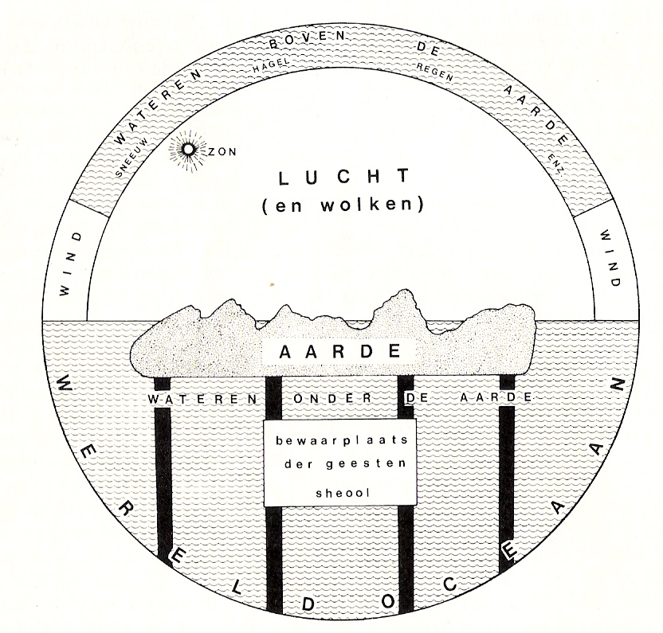 | 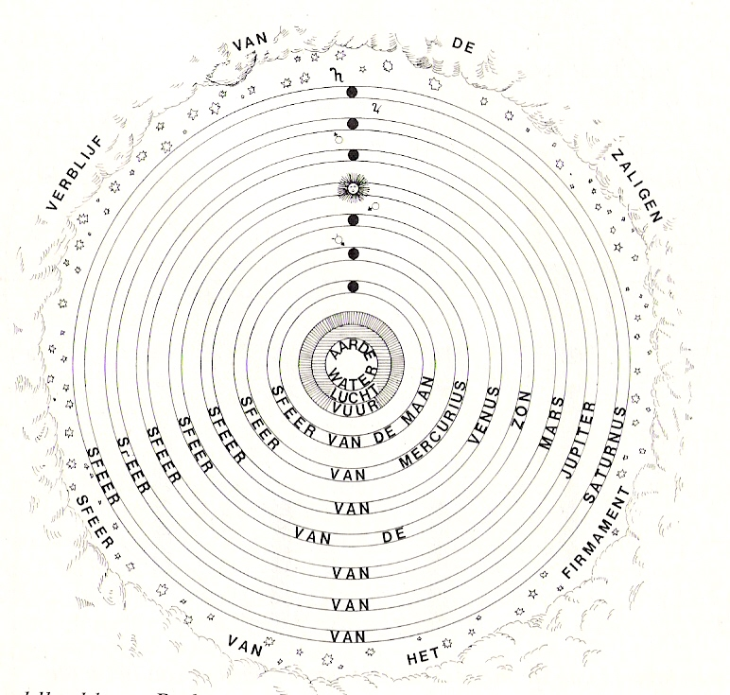
Fig. 8 Old Testament’s Earth floating in water | Fig. 9 New testament’s Earth encapsulated in divine order
The latest Roman neo-platonic philosopher Boëtius around 500 A.D., consul of Gothic king Theodorik, condemned to death, philosophising for his comfort in his cell, will suppose unity as good, and breaking unity up in pieces, producing differences like Aristoteles presupposed, as bad. That thought remained until modernity. However, directly after Alexander and the intellectualism of Aristoteles, people were more interested in direct personal happiness, reached by equality of mind. I will skip their cosmological variations.

Scepsis
Pyrrho from Elis (Peloponnesos), born around 360 B.C., followed Alexander the Great into India. Back in town at some distance from Athens, he remained impressed by Indian fakirs living naked in complete detachment, averse to any intellectual debate. He became sceptical, but not cynical, living like a dog (cunic, kunè means dog) like Diogenes of Sinope some years before him, just showing a way of life. No one can know the truth living in a world of contrasts, differences between living creatures, between men, between senses, locations, distance, environments, between kinds of data, effects, quantity, composition, observations, impressions, educations, habits, traditions, religions, philosophies. But you can enjoy them deferring any judgement (epochè).

Supposed hedonism
Epicurus, born on Samos around 340 B.C. accepted reason only to avoid pain. Sense of pleasure (hedonè) is absence of pain. Disappointed in reaching political influence, his aim was to get happiness (eudaimonia) and spiritual rest (ataraxia), living a hidden life of pleasure with friends in his famous garden. Philosophy helps freeing you from fear for gods and death. About what you can not perceive you can make different theories not contradictory with what you observe, as long as they give you ataraxia. Gods do not meddle with men in their bliss of stable atomic constellations in between many worlds, some like this one, others different. The idea of Democrites’ atoms gives ataraxia. Don’t worry, be happy.

Stoicism
Zeno born on Citium (Cypre), even further from Athens, about 335 B.C. started the very influential school of the Stoic around 300 B.C., teaching logic, physics and ethics in Athens, walking in his stoa (colonnade). He supposed by logic you can accept nature and by doing so, you can live in harmony with nature, producing ethical behaviour. If reason guides you (hègemonikon) you can suppress feeling and passion (apatheia) avoiding their destructive power going along with the inevitable, even if you are a slave. This is the only ‘good’. The only ‘bad’ is evil, and evil is unreasonable. The rest, important to others, like life, health, property, honour, properties, age, illness, death, poverty, slavery, dishonour are not good nor bad, they are indifferent.

Rome
About 200 B.C Athens was defended against Macedonia by the expanding Roman Empire and became part of it. Romans were practical people, admiring the Greek, but choosing from their culture what they liked (eclecticism). In that way you can read the work of Cicero. Some Roman authors like Lucretius and Quintus Horatius Flaccus show epicurist preferences, but most of them chose a stoic life style, like Seneca, Epiktetos and the Emperor Marcus Aurelius. Aurelius wrote a readable short course of stoicism for everybody and one for slaves. Stoic ideas are recognizable also in the works of Descartes, Spinoza, Locke and Kant many centuries later.
However, in the last phase of the Roman Empire Plotinos, born around 200 A.D. caused a revival of platonic thought ending with Boëthuis, serving the Christian king of Goths Theodorik and condemned to death 525 A.D. In this period (around 400 B.C.) schools subdivided philosophy in seven disciplines: grammar, rhetoric, dialectic (trivium) and arithmatic, geometry, astronomy, music (quadrivium), together named free arts (artes liberales).

Christianity
In the mean time Christianity had struck the Roman Empire and philosophy as a flash of lightning. God and government, which’s emperor was supposed to be god, sometimes misbehaving like Nero and Caligula, sometimes not like Hadrianus and Marcus Aurelius, seemed increasingly far away, or driven to the boundaries of time and universe by philosophy. But Christianity promised a personal, well-meaning creator-God concerned with his individual humans by sending a physical Son, Jesus Christ, instead of indifferent, abstract deities far away or scattered in everything (like in Stoic pantheism). It promised more between heaven and earth. This God sends prophets, angels (messengers) and His own Holy Spirit to live in your heart causing en-thusiasm (god inside) like animism and early Greek gods did before. Christ even asked to eat his supposed flesh and drink his blood in a Holy Communion to be one with him. So, Christianity restored the connection of one single almighty ‘first cause’ and ‘last purpose’ with each believer separately and his or her everyday questions of life.

Escaping everyday worries
The Bible, full of Jewish wisdom, rooted in Persian, Babylonic, and Egyptian traditions, offers countless passages openly showing, putting in perspective and relieving unrest, angriness, depression, discouragement, fear, frustration, guilt, impatience, uncertainty, offence, jealousy, loneliness, inferiority, pain, illness, suffering, death, ordeal, tiredness, friends, injustice. Christianity promised salvation from these worries and inherited guilt through Christ, into a life after death with eternal happiness for those accepting faith, doing their duties according to Old testaments Ten Commandments completed by New testament Love, going along with the inevitable on Earth in a Stoic way. But, instead of intellectual examinations on logic and physics, it asked an irrational personal choice for direct faith. So, it also answered anti-intellectual feelings fed by the story of Adam eating from the tree of knowledge, tempted by a snake. That appealed to all classes or Roman society, except the well educated.

Apologists
So, there was a need for Christian philosophy to bridge the gap with antique philosophy and to defend the new faith against heathendom and scepticism. Between 100-250 A.D. the well educated founding fathers of the Roman church died for faith, like Justinus, tried to find a connection with antique philosophy like Clemens from Alexandria or rejected that intellectual connection like Tertullianus (around 200 A.D.) saying: “Just because of absurdity, I believe”. But Origenes accepted the Platonian heritage as a necessary education for reflection on faith creating a acceptable cosmology both ways. He supposed God created all spirits from angels into demons with men in the middle, giving them free will to choose. The punishment for the Fall of Adam locked men up in material life with the possibility of purification coming back in the Unity of God.

Theodicee
However, an important question coming back in any monotheist religion emerged soon: “Why does this personally concerned almighty Creator ever accept evil within its creation?” (theodicee). An early Christian movement, ‘gnosis’ solved that question supposing two gods: an Old Testament jealous God of creation, severe judgement, revenge, and a New Testament one of love, forgiveness and salvation, like the Indian creator and destroyer Shiva and the restoring Vishnu. It did not suppose man to be a sinner, but a scene of battle between good and evil. He has to recognize and understand this continuous battle by knowledge (gnosis).
Connected to this question is, whether man has a free will to choose or not, created and living a life foreseen by God (predestination).

Unity
Movements breaking up the image of God like gnosis or those separating the Trinity God, Christ and the Holy Spirit in three deities threatened the unity of the heavenly kingdom represented by its church on earth. That church had to be Catholic (universal) to defend its promises against scattered deities. So, the council of Nicea (325 A.D.) established the Trinity as a lamp (God) illuminating the surface of dark matter (men) with its light (Christ) and warmth (Holy Spirit) restored the unity around the church of Rome, founded by Petrus (rock), succeeded by its bishop, the Pope. Around 400 A.D Hieronymus translated the Bible into Latin (Vulgata). Since the church became tolerated in the Roman empire 313 A.D., it developed into a non-territorial state within the declining empire, crossing national borders as a representative of a heavenly kingdom feeding hope. It had its own buildings, leadership, laws and administration of justice, able to cope with the turbulent times to come.

Mediaeval philosophy
In mediaeval philosophy faith was the starting point of philosophy, without much worry left about archè. The origin of everything, be it outside the material world or inside man’s soul, was solved, but not how it penetrated the world in between. Philosophy was supposed to complete the Bible embedding it in material life and tradition, answering difficult questions. Plato’s supposed eternal world of ideas shadowing this world matched well with Christian faith, and there was space for reason and logic to fill the gaps. Augustine, frankly describing and renouncing his earlier hedonistic life in Northern Africa, where he was born 354 B.C., gave in his ‘Confessions’ the radiating example how to be converted into Christian faith and a compelling heart-to-heart description of the resulting surprise, relief and joy.

Augustinus
However, Augustinus also had to answer questions of laymen threatening unity, and he was relieved from scepticism himself by reading the neo-platonic writings of Plotinos before his conversion, 387 A.D. He combats scepticism and other heresies in his ‘Against academics’, but Plato’s ideas remain recognizable in all his works like his most influential one: ‘State of God’ (Civitas Dei). Plato’s Politeia and Laws did not connect the poles of God and individual soul like Civitas Dei did describing the heavenly kingdom and its representative on earth, the church. It was written after the plundering of Rome 410 A.D. by Alarik the Goth raising the question if the Empire declined by the softness of Christianity. Augustinus recalls Rome’s immorality and individual selfishness as real cause.

Augustinus’ work is not systematic, but coherent in his personal style, not avoiding the recognizable worry and doubt of the time as the Greeks used to do. He states that doubt is the proof of your existence, because if I make a mistake, I am there (si enim fallor, sum). Descartes would change that statement about 1200 years later in I think, so I am (cogito ergo sum). Augustinus shows his amazement about soul’s immense content of imaginations, its bottomless depth full of forgotten memories suddenly emerging from hidden places (unconsciousness, as Freud would rediscover 1600 years later) without any deciding insight, until God lights His Holy Spirit. Why to be surprised about the troubled outside world, when within you carry a realm whose boundaries you will never reach, unless unclosed into eternity by God?

This utterance is a forerunner of Medieval mysticism, renouncing the world in monasteries and by saint hermits. But Augustinus did not reject the actual world as a shadow. The State of God had to be prepared by the church in this actual world, His Creation. The Holy Trinity is recognizable in every man as being (God), living (Christ) and knowing (Holy Spirit): you are created as the image of God. “But God is eternal and we are not!” rejected the laymen. Augustinus accepts this doubt as his personal doubt and explains stable eternity as something else (without before and after) than changing time on Earth, broken up in seconds, years and pieces of personal life. He supposed God created both earth and time out of nothing (ex nihilo), a real Big Bang, after Hawkins’ explanation satisfying the Pope again about 1700 years later.

However, in your personal life there is nothing else than the actual present, only completed by virtual memories and expectations as supposed ‘befores’ and ‘afters’. ‘Time’, ‘before’ and ‘after’ is nothing more than a way of understanding (by our limited consciousness) of Gods order within our unlimited, eternal soul, reflecting the coming Kingdom to be realized on this earth, the only one God created, until ‘The end of times’. This way Augustinus prepared within the boundaries of faith a task for knowledge and science. It was executed by Medieval monks diligently copying the heritage for the libraries of their relatively safe, remote monastries reclaiming less attractive lands until Charlemagne reunited Europe around 800 A.D.

Scholasticism
In 395 A.D. the Roman Empire split into an Eastern and a Western part. The Eastern part, origin of the monasteries, remained about 1000 years until its capital Constantinople, Byzantium (Istanbul) was conquered by Islamic forces. The Western part fell in 476 A.D. by continuous attacks of Germanic peoples, driven by North East European migrations. Plato’s Academy was closed in 529 A.D.
Until Charlemagne, Europe was a scene of battles and changing boundaries establishing the church as stable international state and hiding place for thought. On the Southern side of the Mediterranean 622 A.D. at June 15th Mohammed settled in Medina, the beginning of the Islamic calendar. The Islamic empire of caliphs developed from Mekka and Medina, establishing centres in East (Baghdad) and West (Cordoba), threatening the growing state of France. Its Majordomus (king’s highest servant) Charles Martel defeated them in Poitiers (732 A.D.). His son Pippin, educated in the monastery of St. Denis, became king of France. His son, Charlemagne conquered parts of Germany, Italy and Spain. In 800 B.C. the Pope crowned him as a Roman emperor. He asked scholars from Ireland, England (Alcuin!), Spain, Italy and Lombardy to come to his court school, the example for monastery schools developing everywhere in the empire, pulling them out of their mysticism and asceticism, the start of scholasticism.

Latin became the lingua franca of all schools and educated people in Europe. That is why they could travel, study, teach, change and settle on any school be it in Paris, Cologne (Köln), Bologna and so on. From 11th century on, some schools developed into universities with four faculties: philosophy, theology, jurisprudence and medicine. Philosophy was subdivided into the artes liberales (see page 17), a kind of bachelors’ study serving the other ones.

Revelation, authority and reason
Johannes Scotus, the Irishman (Eriugena) at the court school of Charlemagne’s son about 850 A.D., argues any doubt of faith has to be refuted by philosophy. The relevation of the bible contains the ultimate truth, but authorities (orthodoxy) can be refuted by reason. For example, he accepted human free will and refuted Augustinus’ acceptance of predestination, like the church itself had eased earlier. The church forgot him, but accepted only centuries later the more carefully-worded defence of reason by Anselmus of Canterbury about 1100 A.D. He gave a reasonable proof of Gods existence. He supposed God as greater and more complete than anything to be imagined. That is why Gods non-existence can not be imagined. So, it must be accepted by reason as ultimate reality. That ‘ontological’ proof was disputed by many, like Kant, when he studied the boundaries of reason again 700 years later. Anselmus concluded from that divine reality, God created real ideas from which our world is derived. So, Johannes and Anselmus remained neo-platonic in their thoughts. In the Arabic world around 1000 A.D. Avicenna (Ibn Sina) studied Plato, Aristoteles and Plotinus distinguishing necessary ‘essence’ and potential ‘existence’, united in God, divided on Earth.

Universalia
In Europe around 500 A.D., the Categories had been translated into Latin by Boëthuis before other works of Aristoteles were translated after 1200 A.D. from Arabic and later from original Greek sources. That text raised the question whether general concepts (universalia) are real or not, and if they are real, whether they are physical or not. If they are not real like the ‘ideas’ of Plato, they are just ‘names’ we use to summarize real things, defended by medieval ‘nominalists’ like Rosselinus, disputed by ‘realists’ like Anselmus. Nominalists threatened the Trinity. Around 1100 A.D. the French philosopher Petrus Abélard tried to solve that dilemma arguing that universalia are not before, not after, but in things. However, in God they are before, in man after. In fact Avicenna stated the same a century earlier within the Arabic world: God realizes His universal ideas in particular matter, man derives them by reason.

Cordoba
The Islamic (Moorish) high schools in thriving Spain showed an admirable tolerance of Islamic, Jewish and Christian scholars teaching together. Arabic translations of Plato and Aristoteles were present in their huge libraries. In the relation of religion and Greek philosophy a remarkably similar shift of neo-platonic ideas into Aristotelian logic and ordering of actual phenomena occurred. An important follower of Aristoteles, Averoës (Ibn Rosjd), born in Cordoba 1126 A.D., became well known in Europe. He supposed matter to be eternal, not created. But matter, having the potential of any form developes into a particular form by God (see page 15). His Jewish colleague follower of Aristoteles, Maimonides (Mosje ben Maimoen), born in Cordoba 1135 A.D., tries to bring the Bible into line with reason by allegoric explanation. Both were abandoned from Cordoba, but their ideas spread over Europe. Around 1200 A.D. Aristoteles was forbidden by the church, around 1300 A.D. nobody could become a clergyman without studying Aristoteles, sometimes even considered as a forerunner of Christ like John the Baptist.

Universities
The crusades from 1000 A.D. until 1300 A.D. brought new ideas about architecture (Gothic replaced Romanesque architecture), shipping, geography and poetry to Europe. So, together with new translations of Aristoteles into Latin a need emerged to summarize all scattered knowledge in universal encyclopaedic works (summae) and institutions (universities).
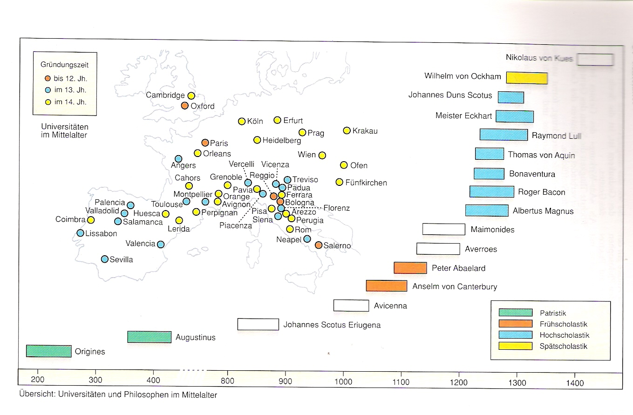
Kunzmann, Burkhard, Wiedmann (1991) pag. 64
Fig. 10 Medieval universities and philosophers
Albertus Magnus, born around 1200 A.D. studied the artes liberales in Padua, theology in Bologna, teached them in Cologne and was send to Paris, the greatest university of the time. He became member of the Dominican order, a mendicant order like the Franciscan and defended them in front of the Pope, became Bishop of Regensburg and retired in Cologne. He gathered the knowledge and criticism of the time in 21 thick volumes enclosing the works of Aristoteles and filled supposed gaps of biology, and chemistry by own research and observations. His pupil in Paris and Cologne, Thomas of Aquino, elaborated his work into a system, now using translations of Aristoteles directly from Greek into Latin.

Thomas of Aquino
Dominican Thomas of Aquino (1225-1274 A.D.) systemized and completed the knowledge of his time, gathered by his teacher Albertus Magnus. He separated original texts from critical remarks. He bordered reason in such a precise way from faith, that it could become the official philosophy of the Catholic church in 1879 and the basis of Catholic education in 1931. He shows what you can accept from earlier philosophers without contradicting faith. Aristoteles’ matter and pure form return as temporary body and eternal spirit, connected in man. He draws the boundaries of reason (passively recognizing the forms, fed by empirical evidence) without innate ideas, but with active ‘imagination’, as an empiricist. Most truths of faith can be understood by reason, like the existence of God (Thomas gives five other proofs, rejecting the one of Anselmus) but some, like the beginning of time, go beyond reason, not to be refuted by reason, left to revelation by faith. He accepts free will of man as ethical basis, made possible by reason. Dante’s poetry shows the world view of Albertus and Thomas in his Divina Commedia.

Oxford and Paris
In the same period Franciscan Roger Bacon studied mathematics, medicine, jurisprudence, theology and philosophy in Oxford and Paris. He stressed studying texts in their original language and natural science based on mathematics and experiments like he learned in Oxford, avoiding blind belief of authorities, common prejudice and mystical deductive knowledge. He supposed nature had to be actively interrogated by experiment. By doing so, he discovered fundamental optical phenomena of refraction of light. Criticizing Thomas and other (badly translated) authorities brought him into conflict with his religious tasks.

Around 1300 A.D. Franciscan Duns Scotus teached in Oxford, Paris and Cologne criticizing Thomas as well. Studying Aristoteles more in detail he concluded philosophy and practical faith have to be separated. So, you can not proof the existence of God by reason; you can choose to experience Him. In contrast with Thomas he supposes experience and reason as subordinate to will, so you are free to choose what you want to see. You want to know, but you can not know to want. So, God wanted a world before He got ideas about a possible world. He supposes ‘this here and now’ (haeciditas, ‘thisness’) as more real than the ‘what ever’ (quiditas, ‘whatness’). ‘What’, derived from many times ‘this’ means a step into nominalism.
He concentrates on the logic of proofs, not denying or confirming beforehand what you want to proof, criticizing the way you proof. From this time on philosophy is no longer the servant of faith.

In the same period William of Ockham (Occam in Latin) studied and teached in Oxford and Paris as well. By supposing logic to be the science of signs (names), he developed nominalism separated from religious consequences, rejecting authority in science. He skips independent general concepts like ‘truth’, ‘quality’ or ‘quantity’, accepting only ‘true’, ‘how’ and ‘how much’ of individual cases. Generalization and relations exist only by thinking. Transsubstantiation of these universalia is uselessly multiplying concepts. You should not suppose more concepts than needed for understanding or proof (‘Ockham’s razor’).

However, Ockham accepted common religion as a chosen experience totally other of observation and reason. So, he rejects religion striving for worldly power like the Pope did in conflict with the German emperor (Investiture Controversy). Religious experience should renounce the observable world, living in poverty like Christ as Franciscans taught. He was captured by the Pope, escaped, and found protection by the German emperor in Munich. In Germany mysticism (closing eyes) revived by Johannes Eckhart (1260-1328 A.D.) recapturing platonic thought.

Nicolaus Cusanus
Nicolaus Cusanus (1401-1464 A.D.) supposes all men are different, reflecting the world as a whole differently as in a hollow mirror with different positions and directions (compare Leibniz’ monades). In his view they possess senses, intellect and reason. Intellect connects the coherent impressions, but reason makes antitheses and contradictions coincide (coincidentia contradictoriorum). That kind of reason allows the tolerance he needed as a diplomat sent to Constantinopel by the Pope for unification of the church. Cunsanus defended to bring all different religions together and studied even the Koran.

Cusanus supposed the world moving through a perfect mathematical universe, anticipating its non-central position in the solar system stated by Copernicus. He supposed God created the world according to mathematical principles. His fascination for mathematics and infinity anticipates the infinitesimal calculating Newton and Leibniz would develop. If you increase the number of corners in a polygon, it is nearing a perfect circle, like the final truth, partly touched by people. If you increase its radius infinitely, you near the infinite straight line where all contradictions coincide, like God. You can never reach it, and you know that. So, you know the unknown (docta ignorantia).

Worldly power of church
Around 1250 A.D. the German empire including Italy, called ‘Holy Roman Empire’, once defender of the Pope, had lost control over German bishops, leaving territorial power and taxes to the Pope. It lost control over Italy and Rome as well. Italy fell apart in town-states, sometimes democratic like Florence. Increasing French influence made the Pope moving from turbulent Rome into Avignon (1309 A.D.), where his wealthy court and high church taxes alienated European believers. He condemned the Franciscan order defending poverty. The Pope went back to Rome in 1377, but in 1378 a second Pope was chosen in Avignon. Many local reform movements emerged, but the council of Konstanz (1414-1418 A.D.) dismissed the former Popes, indicated a new one and restored a fragile unity. Reformers like Johannes Hus were condemned to death (1415). The Eastern Roman Church became subordinated to the Pope in 1439 A.D., but moved its centre to Moscow.

The fall of Eastern Roman Empire
Constantinopel (Istanbul) was conquered by the Turkish Osman Empire in 1453 A.D. Many scholars fled to Italy, bringing original Greek texts and knowledge of Greek language into Western Europe, helped by the contemporary invention of the art of printing. The fall of the Eastern Roman Empire closed the over land trade into the far East by Venice and Western Europe looked for routes overseas, helped by the discovery of an older Chinese invention, the compass. The invention of gunpowder was the coup de grace of feudal knighthood and stimulated overseas conquest, trade and colonization, opening up perspectives dethroning Rome the as centre of the world. To dethrone the Earth as Centre of the Universe was only one step further, prepared by Cusanus, done by Copernicus, mathematized by Kepler after 1500 A.D., both pursued by Church. The final step of verification had to wait until the Dutch invention of the telescope 1608 A.D. was used by Galileï in 1609 A.D. to study Jupiters moons falling in circular orbits
But the idea was from Greek astronomer Aristarchos from Samos around 300 B.C.

Money economy
In the mean time money economy had replaced medieval barter trade since the crusades. The church’ ban on interest was evaded by the church itself collecting its taxes being the largest financial institution in Europe. Tradesmen collecting these taxes were paid by their interest. They learned to calculate their profits mathematically and started banking. Two early capitalist bankers established commercial networks: the Medici, governors of Florence, connected the harbours in the Western part of Europe and the Fuggers from Augsburg connecting Antwerp with Eastern Europe. Botticelli and Michelangelo served the Medici and one of them became Pope financing architecture and art in a way they could no longer afford. The Fuggers developed further with settlements in Chile, Peru, Moscow, controlling Europe’s metal, financing war and peace, influencing the choice of Charles V, duke of Burgundy and The Netherlands, king of Spain and Southern Italy, as emperor of Germany. They financed his war against surrounded France to unite Europe into a safe trade union with modern administration and mercenaries.

Money economy caused regional and local specialization and specialization in agriculture, making farmers dependent on the international market and finance. Landownership changed from locally inherited feudal into commercial economy by land on lease and wage work. Nobility became impoverished, tradesmen took over. Overproduction of silver caused inflation, while increase in prices produced urban proletariats. Urban craftsmen, united in guilds demanded their role in urban administration. Urban and rural revolts undermined the authority of God-given royalty. The economic centre moved to North-Western Europe. The Netherlands with 200 towns became the most flourishing economy of Europe. Their taxes to their Spanish king exceeded seven times his income of silver from America. Increase of taxes, used to oppress Protestantism in their own land, forced these strategic lowlands to reject his royal rights. The United States of The Netherlands became the first modern Republic since the Roman Empire founding 130 cities in the world within 30 years amongst which New York. Antwerp invented collective finance of business applied in Dutch VOC, a public limited company governing a larger area in the world than Europe. The Fuggers went bankrupt by the wars of Spain they financed.

Renaissance philosophy
The Middle Ages had produced an international system of critical scholars and independent universities, united by fair debate and one language: Latin. Albertus Magnus had begun to fill the gaps of natural science in Aristoteles’ works, Roger Bacon had started independent mathematical inventions in optics, interrogating Nature by experiment. Duns Scotus separated church and science, both subordinated to human will and personal responsibility. William of Ockham separated church and worldly power avoiding unnecessary suppositions. Cusanus distinguished intellect (connecting coherent impressions) from higher reason or wisdom (making antitheses and contradictions coincide) aware of the unknown mathematical limits of truth and God forcing tolerance, accepting a worldly diversity of faith, each touching and reflecting a little part of infinity.

Macchiavelli and Erasmus
After 1500 A.D. world wide power concentrated in the court of Charles V in Brussels, advised by two contrasting philosophers: Macchiavelli of Florence and Erasmus of Rotterdam. Macchiavelli defended the benefits of state unity he missed in Italy by separating individual morality from that of statesmen. He supposed the latter were allowed to behave immorally for the sake of safety and prosperity of themselves and their remaining citizens. Flatter the stupid, kill the villains, play the others off against each other. Erasmus on the contrary defends tolerance in a diverse world full of conflict, demanding wisdom connecting contrasts, excluding nobody by education into universal man (uomo universale). He tried to unite the then available Greek texts of humane antique philosophy and New Testament with Christian heritage and approaches uneducated weakness with humour in his ‘The Praise of Folly’. That least serious, but most succesfull text, was illustrated by Holbein. Erasmus wrote it for his British friend Thomas More (Morus), known from his beautiful ‘Utopia’, a peaceful island without private possesion and oppression, but with many religions in contrast with the abuses of his time.
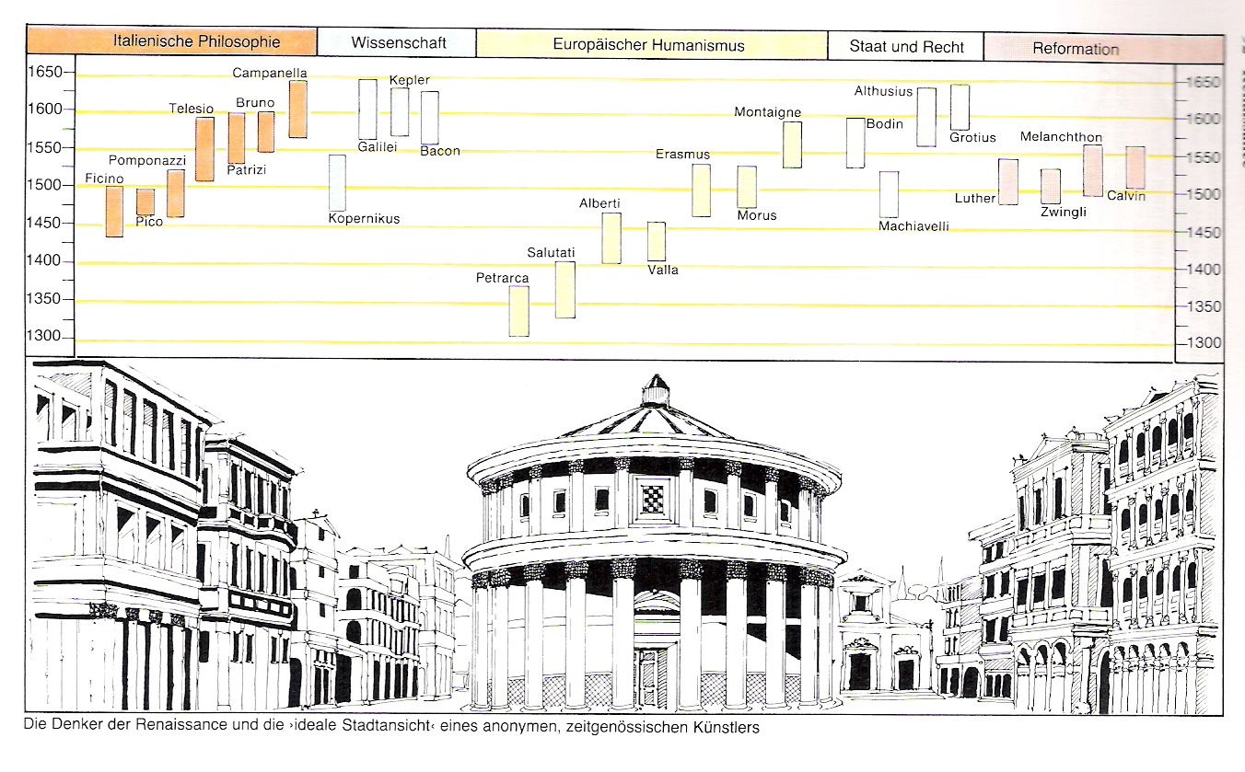
Kunzmann, Burkhard, Wiedmann (1991) pag.92
Fig. 11 Renaissance Philosophy in time

Reformation
Erasmus improved the Vulgata translation of the New Testament and published it 1516 A.D. in Greek and Latin, paving the way for Luthers Reformation ‘back to sources’. 1517 A.D. Luther nailed his provocative statements on the door of the church in Wittenberg, accepting demands of impoverishing farmers, rejecting the use of expensive letters of indulgence for the sake of the wealth of the Catholic church. They impoverished Germany substantially. Banned by the church and by young emperor Charles V in 1621 A.D. he escaped to Eisenach, helped by German electors. There he translated Erasmus’ Bible text into German with protestant annotations, published in 1526 A.D. Though he advised obedience to the state, it is the beginning of centuries of war on religion. Germany becomes divided in Catholic and Protestant provinces and Charles V was forced to tolerate Protestantism in that uncontrollable part of his empire. Luther supported free will, but once choosing for faith man is determined to follow its doctrines strictly to get forgiveness for his inescapably inherited sins. Luther hoped Erasmus would join his movement, but though sympathizing, Erasmus recoiled from his provocative and strict utterances. Protestant faith appeared to develop less freedom for thought and subordinated philosophy to faith again.

Tolerance
However, Erasmus’ message of tolerance was heard by the French king Henry IV, the Dutch prince of Orange leading his new born republic, both tolerating Protestantism, and the French sceptic writer Montaigne. The latter created a new literary genre by his beautiful ‘Essais’, short stories without system put first. What can I know if everybody differs? Other Catholic monarchs seemed to practice the ideas of Macchiavelli. But the Dutch jurist Hugo Grotius established a reasonable justice of sea, war and peace still used as basis of international law, avoiding hate as result of human nature. However, Hobbes removed Grotius’ last religious suppositions. He supposed man to be an animal fighting anybody, only brought to reason by state law.

Italy
The Italian philosophers, not yet or not much disturbed by Reformation, studied and rediscovered Plato (Marcelio Finico, 1433-1499 A.D., Pico della Mirandola, 1463-1494 A.D.), Aristoteles (Pietro Pomponazzi (1462-1525 A.D.), presocratic philosophers of nature (Bernardo Telesios, 1509-1588 A.D.), brought into a more contemporary synthesis by Giordano Bruno (1548-1600 A.D.), condemned to be burnt at the stake.

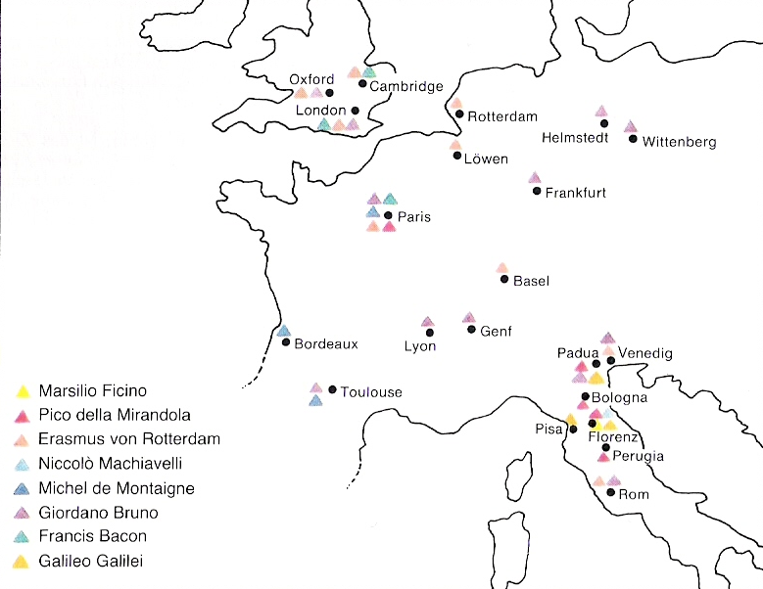
Kunzmann, Burkhard, Wiedmann (1991) pag.96
Fig. 12 Renaissance Philosophy in space

Technology and science

Breaking off the authority of Aristotelian physics
To understand the European centuries of dispute called Enlightenment following Renaissance it is necessary to summarize some scholastic suppositions on physics based on Aristotalian authority still common during Renaissance. Breaking off that authority by thought experiments and observations (especially about gravity by Stevin, Beeckmans and Gallilei) resulted in the breathtaking development of Newtonian physics (for example introducing measurable concepts of mass, acceleration and force) in the 17th century unifying celestial and terrestrial mechanics into one cosmology.

Aristotelian physics
From Empedocles Aristoteles accepted as mentioned on page 15 any terrestrial substance to be composed out of four elements directly recognizable by sensible qualities like temperature and moistness:

 | cold | warm
moisty | water | air
dry | earth | fire
Fig. 13 Aristotelian elements and their sensible qualities
Apart from these substantial qualities Aristotalian substances (for example ‘an apple’) are determined by ‘accidental’ categories like quantity, relation, location and time as distinguished by human language (for example ‘There are 40 apples from the apple tree in the garden this autumn’) adding specifying predicates to a noun (‘substantivum’). That distinction of substantial qualities and adjective categories, forced by the structure of verbal language, formalised in logic is in some respects neglected by quantification of both.

Quantifying substantial qualities
Gallileo Galileï’s (1564-1642) attempt to quantify temperature by his invention of a first thermometer in 1593 shows a different understanding: Aristotelian ‘substantial’ qualities could be quantified. It would last until 1783 de Saussure built the first hygrometer with a moisture scale and until 1714 Gabriel Fahrenheit improved Galileï’s thermometer with a temperature scale, used in the century facing the last remains of Aristotelian physics opening op the road to thermodynamics. Expressing substantial qualities in quantities established the Carthesian idea that essential physical qualities can be fully understood by rational mathematics doubting less reliable sensible qualities beyond spatial ‘extension’.

Quantifying accidental categories
‘Accidental’ categories (like location, time and relation) could be quantified as well. Descartes quantified ‘location’ inventing his (cartesian) coordinates. That made geometry better accessible for algebra (analytical geometry). Reliable time quantification was prepared by Galileï’s ideas about the pendulum, but realised in 1656 by Christian Huygens, making the first reliable clock using a 'natural' period of oscillation. In 1687 Newton published his integrating thoughts probably developed 1665-1667. He quantified the Aristotalian category of ‘relation’ by naming and mathematically relating ‘mass’, ‘acceleration’, ‘force’, ‘inertia reaction’, ‘movement’ avoiding any causal explanation. He solely described their relations in a mathematical form.

Reducing the number of substances and their laws
So, Descartes (still negating empy space) distinguished only three ‘substances’: ‘matter’ and ‘spirit’ coordinated and synchronized by ‘God’, even further reduced into the supposition of one substance by Spinoza. However, Galileï and later Newton clearly stated they did not want to understand things, but solely describe them. That attitude freed physics from searching for the ‘essence’ of substances still leaving space for religion.

Doubt on senses
The doubt on senses was strengthened by other new instruments like telescope, microscope and clock invented in the Dutch Republic. The first telescope was sold in 1608 (the formula kept secret because of its military importance). Galileï imitated one in Italy, discovering moons circulating around Venus like continuously ‘falling’ objects one year later. That not only strengthened Copernicus’ heavily disputed conjecture the Earth being a satellite of the Sun, it also unveiled other weaknesses of Aristotelian physics and Ptolemaean cosmology.

Weight: from internal property into effect of external gravity
Aristoteles supposed heavyness as a quality of a substance striving downwards (earth) or lightness striving upwards (fire) resulting in the proper vertical ordering of earth, water, air and fire observed in nature. So, Aristoteles supposed heavy objects (containing more of the elements earth or water) strive downwards more and will consequently fall faster than light objects containing more air or fire striving upwards. That was difficult to check without precise instruments measuring time. Epicouros, Lucratius and Philoponos (ca. 600 A.D.) already disputed that idea, but Stevin and De Groot falsified it in 1586 by published repeatable experiment with falling bullets of different weight reaching the ground at the same time.

Thought experiments
However, a simple thought experiment dividing a bullet into two halves not changing its falling behaviour would produce the same conclusion, but in two millennia after Aristoteles neither that argument nor Philoponos’ early refutation removed the Aristotelian misunderstanding until Stevins experiment was pubished in Dutch, Latin and French. Thought-experiments stimulated Descartes to suppose physics could be developed by thinking rather than observing just like mathematics. Stevins convincing elaboration of equilibrium of weights according to slope (1586, ‘Clootcrans’, see Fig. 14) is such a thought experiment resulting in the method of vectorial resolution and addition. Stevin also divided surfaces infinitely until they fit a triangle to determine its static centre of gravity. It is the first known publicaton demonstrating infinitesimal reasoning. In 1618 Beeckman reported a thought-experiment with Mr. du Perron (Descartes visiting him with that name) supposing a falling object increases its velocity v by little jerks resulting in the covered distance s=0.5*vt (see Fig. 16 for the inference in modern notation).

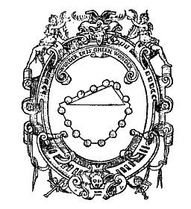 | 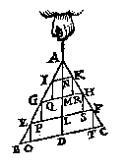 | 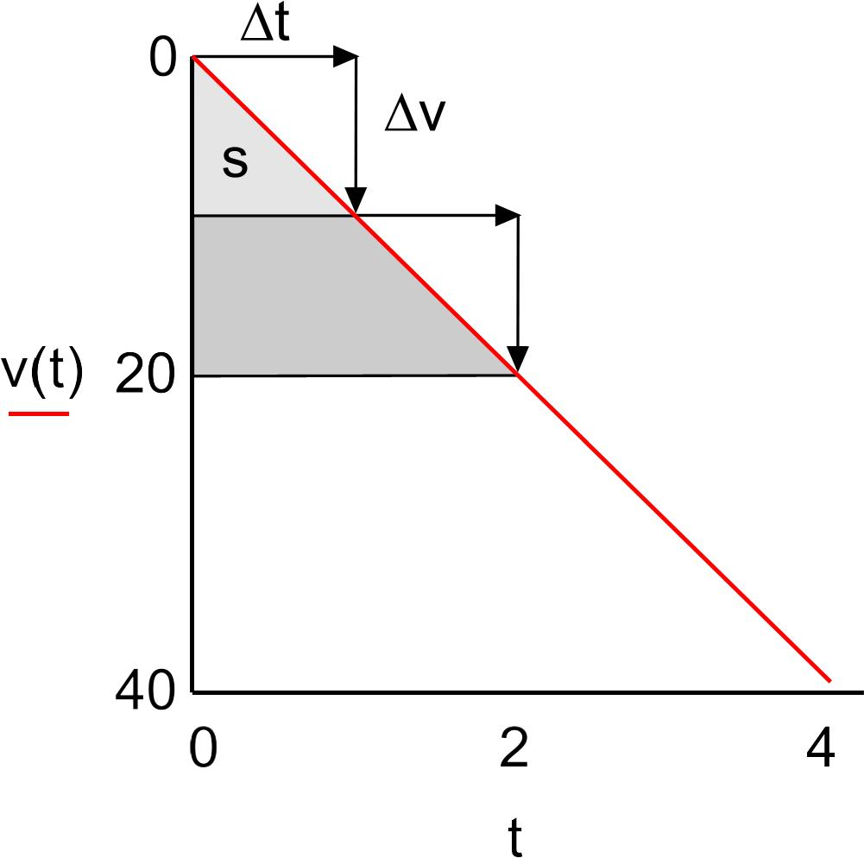
Source: http://www.xs4all.nl/~adcs/stevin/weegconst.html, http://www.humanities.mcmaster.ca/~rarthur/papers/BDFM.pdf |  | Source: http://www.xs4all.nl/~adcs/beeckman/I/1618Lc.html#261
Fig. 14 Stevins Clootcrans | Fig. 15 Stevins infinite division | Fig. 16 Beeckmans and Descartes’ supposed infinitely little jerks on a falling object

Quantifying movement by observation of forced events
Now, Galileï (1638) found a method measuring time t (still with an old fasioned water clock) and distance s of slower, better observable rolling bullets on a slope concluding s=at² for vertical movement (a being a constant, later named as acceleration by Newton). The idea that experiment would give a proportional outcome compared to falling objects was based on Stevins ‘Clootcrans’ (see Fig. 17). These insights improved predicting where cannonballs will fall by parabolic course if the horizontal movement is constant (and by doing so it improved Gallileï’s income, see Fig. 18).

Source: | Source:
Fig. 17 Galileï’s measurements on slopes (equal time intervals between bullets indicated) | Fig. 18 Predicting the parabolic course of cannonballs

Unifying concepts for terrestrial and celestial movement
Galileï’s astronomical observations also falsified the other Aristotelian suppostion that the finite linear movement laws of terrestrial substances are different from infinite circular laws of celestial substances. Physics became less dependent on Belief to reach unity in terrestrial and celestial cosmology. Religion could less ‘divide and rule’ the fragmented Aristotelian physics.

Metaphysical questions about substances
That dismantlement of Aristotelian understanding raised metaphysical questions about the substances to be distinguished and the laws they subsequently obey to understand their behaviour. The long lasting symbiosis of Christian and Islamic Belief with pagan Platonic and later Aristotelian thought may surprize, but it may be also understandable by its lack of unity filled in by Faith, a personal God governing the universe applying His laws for different substances.

Infinite reasoning
Stevin (1586) publised the first mathematical proof based on infinitely dividing surfaces until they fit a triangle to determine its static centre of gravity (see Fig. 15), Beeckmans and Descartes (1618) did it for dynamics of falling (Fig. 16), but Newton and Leibniz developed finite quantifications by infinite dividing and adding now known as differentiation and integration (infinitesimal calculation). That seemed to master Divine Infinity and solved for example the difficulty to determine velocity on an infinitly small moment of time.

Francis Bacon
Francis Bacon (1561-1626) criticized and analysed millennia of stagnation in science since antiquity. He unfolded a scientific programme of inductive purposeful experiments, carefully describing their results to reach more general statements for the sake of society. He clarifies the stagnation of science as traps of passion, education, language and traditional hold to authorities to unlearn before the programme can start. Science is not passive opinion, but active work (non opinionem, sed opus) as Kant will cite him two centuries later on the first page of his ‘Kritik der reinen Vernunft’. His more literary than scientific writings opened up public awareness of the social importance of developing methods for independent science. For example “You can defeat Nature solely by obedience.” (“Natura non nisi parendo vincitur.”) shows a predecessor of Spinoza’s idea you should understand and obey Nature to feel (not being) free.

Enlightenment

Rejection of authority not based on reason
Modernity is supposed to start by Renaissance philosopy (from 1500 A.D.) , followed up by an intellectual (1600-1800 A.D.) and social (economic, cultural, administrative 1700-1900 A.D.) elaboration and penetration in European culture called Enlightenment. Enlightenment is mainly the rejection of any (political, religious, scientific) authority if not based on reason. In the previous sections we met many mediaeval predecessors bounding authority by reason. So, this section starts putting mediaeval acceptance of irrational authority in a historical perspective.

Deductive and inductive reason
Reason can be reached two ways: top down from certainties supposed to be shared in everybody like mathematics, logic and language (deduction, starting by theory, mainly argued on the European Continent), or bottom-up from everybody’s experience through the senses, selected and ordered in the most reliable and efficient way (induction, starting with method, as recommended by Francis Bacon, mainly argued in the Anglo-Saxon world). That debate, comparable with differences between Plato and Aristoteles) lasted two centuries.

Pure and practical reason
The Enlightenment is supposed to finish by Kant at the end of the 18th century. Kant wrote a famous article on Enlightenment before he wrote his most famous critics on pure reason, practical reason and power of judgement. Still many suppose these critics establish the boundaries of two kinds of reason, brought together by a third power of judgement. After Kant, philosophy focused on process, time (Hegel) and irrational roots of reason (Nietsche).

Irrational acceptance of authority
For us, part of modern culture, it is difficult to understand mediaeval irratonal acceptance of authority, though modern communication technology seems to bring back that acceptance by people drowning in a multitude of specialists’ opinions. Moreover, our culture is mixed up with cultures missing a comparable intellectual debate and social process of Enlightenment in their history. So it's worth while to study European Enlightenment more thoroughly reviewing its economic, cultural and administrative roots, to understand the painful process many of us have to go through themselves.

Authority in mediaeval Europe

Times of turmoil
After the collapse of the Western Roman Empire, the early European Middle Ages are historically complicated because of changing boundaries by war all the time. Repeated change of power brought uncertainty about legitimate government and enduring turmoil by changing terrestrial loyalty. But the international superiority of the church gave spiritual stability. People found comfort in the spiritual certainty of life after death, causing the willingness to die for your community (on its turn increasing the probability of war) or abstantion of terrestrial turmoil in monastries.

Division of spiritual and terrestrial hierarchies by Charlemagne
As soon as Charlemagne united Europe, he established a clear division of spiritual (bishops) and terrestrial (counts) hierarchies. That brought temporary civil stability, an advantage for everyday life, administration, trade, economy and culture. However, in 800 the Pope crowned Charlemagne as Imperator Romanorum (emperor of the Romans) in Saint Peter's Basilica. That historical divine blessing of terrestrial power would bring spiritual turmoil as soon as Charlemagnes terrestrial unity fragmented after his death. The controversy between terrestrial and spiritual reasoning raised a number of philosophical questions, reflected by the distinction between practical and pure reason after Renaissance and Enlightenment.

Dual loyalty
Now, the Pope and the Emperors or Kings were both indicated by God to rule the Earth. So, the dual loyalty of subjects brought back an uncertainty of higher order (how to judge), firstly culminating in the Investiture Controversy between an Emperor and the Pope (Canossa). Then the church claiming more terrestrial rights went through its most disastreous period of two Popes, selling spiritual rights on your hereafter for money. Consequently, the church rolled in wealth building its greatest works of art and architecture.

Reformation and protest

Refusing spiritual authority
As soon as the Gospel was translated by Erasmus into proper Latin and by Luther into German, its message of poverty and love appeared to contrast with the church’s worldly power, resulting in extreme wealth and inhumane prosecutions. German economy suffered substantially by paying the indulgences criticised by Luther. That criticism brought civil wars on faith (and taxes) everywhere. Charles V, largely uniting Europe (except amongst others France and Great Britain) doubted between Erasmus’ humanistic advice for tolerance and Machiavelli’s advice to use an ‘ethic of sovereigns’ apart from the usual ‘ethics of subjects’ to the favour of all.

Refusing terrestrial authority
His sun Philips II apparently followed Machiavelli believing strongly in his absolute divine rights as a sovereign indicated by the Pope, by God. His general Alva asked 1/10 tax from his relatively tax-free protestant subjects in the growing economy of The Netherlands to pay the Spanish army suppressing them. However, Charles V’s ‘stepson’, William of Orange, the ‘Father of the Netherlands’, suffering by the same doubts as his stepfather, at last chose for tolerance like Henri IV attempted in France (‘Paris vaut bien une messe.’, Edict of Nantes), Spain’s enemy. From France Montaigne’s popular sceptic essays conquered next century part of Europe putting its suppositions to be Gods focus into the humanistic perspective of Columbus’ and Copernicus’ discoveries like Shakespeare did in England.

Re-inventing the republic
Experiencing the intolerable practices of Philips’ inquisition, violating Christ’s law of love, William of Orange consulted his personal concience and originally protestant faith, deciding his King had lost sovereignty neglecting his duties. He prepared the sensational Dutch decision to dismiss the King to the monarchs of Europe in a personal apology (1580), followed by a historical treatise of the Dutch Parliament: ‘Plakkaat van verlatinghe’ (1581). The Netherlands became a republic of seven united states. The sovereign not only has rights, but also duties and the subject not only has duties, but also rights, both based on reason (Hobbes), learned in the practice of trade.

Consensus by common reason
But what is reason? Is it something to be found within our innate human self (Descartes’ rationalism) or does it come from environmental experience through our senses (Lockes’ empiricism). Descartes stayed in the Dutch Republic from 1628 until 1649 and Locke from 1683 until 1689, returning to England with William of Orange III to establish a nearly republican constitutional monarchy by the ‘Glorious Revolution’. In between Spinoza (1632-1677) pictured God as the only substance appearing in physical Nature to obey, like a paper on which people are free to draw their temporary and local boundaries, conditioned by each other, understood by reason.

England and the Continent

Two sources of reason on both sides of the North Sea
Rationalism deduces a reality from presupposed (or even innate) ‘categories’ like Plato already attempted to find, inspired by the convincing successes of mathematical deductive reasoning, logic, the common structure of language and the human power of invention. However, empiricism constructs a reality by induction from many observations like Aristoteles was inclined to do, inspired by a surprising diversity of discoveries. From mediaeval times until now, rationalist arguments are mainly stemming from the European Continent, and empiristic arguments from the Anglo-Saxon world. Why? In some way, that controversy could be associated to the political question of top-down authority stemming from self-evident principles opposed to bottom-up delegated authority stemming from individual effort, experience, judgement and mutual compromise.

A materialistic conjecture about stable boundaries
Let us try the materialistic argument of relative stability on an island like Great Britain with clear boundaries forced by nature, a splendid isolation opposed to the complex history of a larger continent suffering more territorial conflicts, suddenly changing boundaries and loyalties. An ever returning controversy between changing religion and practice may stimulate the search for universal theory, deductive reasoning. Here fits the picture of Descartes, disturbed by so many opinions in France fleeing to a place where he could retire to elaborate his personal thoughts. On the other hand, relative stability may stimulate the senses, interest in a less disturbing, surveyable environment, inductive empiricism. Here fits the picture of Newton, sitting in a garden, observing an apple falling from a tree.

Fast succession of alternatives
Of course, England had its civil War of the Roses (1455-1485), returning wars against the Scots, the Welsh, the Irish, less dangerous external powers. England had its periods of tolerance and absolutism, turmoils about taxes and religion, Cromwells republican experiment bringing dictatorship. But each time they took shorter periods than on the Continent, with unexpected allies at hand to continue 30 or even 80 years. English turmoils of different kind in the 17th century could be compared in one generation, branding civil war to the worst of all evils. What survived was the experience that any stability whatsoever leads to prosperity.

Hobbes and Locke
That experience is expressed by Hobbes, starting with the simple idea there is a natural war of all against all, to be won by nobody. So, one has to accept power (Leviathan) creating law, order and prosperity. However, Locke accepts power only for the public good. People have the right of rebellion, the right to withdraw their support if the executive power does not fulfill its duty: to preserve property, defending freedom of thought, speech and worship. That is why the executive monarch has to be controlled by an elected legislative parliament, separating these two powers: the constitutional monarchy of the Glorious Revolution. A republic is one step further: the executive power, the president, is chosen as well for a predetermined period. The Dutch Republic still had an executive Prince, be it deprived of power from time to time. The rebellion of the United States of America against England (1776) made the last step into modern democracy by its choice for a periodically chosen president instead of a monarch.

Descartes
René Descartes (Renatus Cartesius, 1596-1650 A.D.), born in France, studying there in a scholastic tradition, served in the army in The Netherlands and in Germany, often retiring for study and writing. He did not dare to publish much during his life, because of Galileï’s persecution 1632 A.D. From 1620 – 1628, he wrote ‘Rules for the direction of the mind’ but did not publish them. To avoid persecution since 1629 A.D. he settled in the young Republic of The Netherlands ‘where everybody is so busy with his own business, not interested in mine, that I could live there as if in wilderness not missing a metropolis nearby’. In The Netherlands he wrote all his books, publishing there only some like ‘On method’, an anonymous work in French, later translated in Latin. It contains four of his Rules:

- accept nothing as true that is not recognized by reason as clear and distinct;
- analyse complex ideas by breaking them down into their simple constitutive elements, which reason can intuitively apprehend;
- reconstruct, beginning with simple ideas and working synthetically to the complex;
- make an accurate and complete enumeration of the data of the problem, using both induction and deduction.

Disturbed by the many opinions of his time, but rejecting scepticism earlier accepted by Montaigne, he looked for subjective certainty inside, according to the first rule. He found certainty regarding intuitively clear and distinct evidence (reason, mathematics, God) and the Augustinian certainty of doubt regarding the senses and their testimony of physical existence. However, why would God deceive our senses (theodicee)?

Analysing ‘man’ according to his second rule, he supposed two constitutive substances: an animal body operating like a machine and immaterial reason. That ‘dualistic’ separation remained object of discussion until now. What connects directives of immaterial reason to operation of the body after all? Descartes supposed God should coordinate and synchronize them every moment in everybody.
Descartes invented the co-ordinate system of analytical geometry according to his second and third rule: breaking op space in three dimensions, reconstructing it in coordinates.

Spinoza

One substance
However, Spinoza (1632-1677 A.D.) seemed to proof in an almost mathematical way that body and thought should be united in one common ‘substance’ with infinite extend and thought (name it ‘God’), not conditioned by anything else. He supposed that substance to be locally modified in ‘modi’ conditioned by each other (natural rights) like figures on an endless paper. These particular figures fill the paper into an ‘everything’ (nature, a pantheistic ‘God’) ruled and ruling by natural law, not changing as a whole.

Self maintainance
Modi have got their rightly drives for self maintenance (emotions, passions) imagining free will, but coming up against their natural boundaries sooner or later, according to the natural rights of their extend or power. So, reason has to foresee these future bounces coordinating and synchronizing opposite momentary emotions into balance. Then, to reach that balance by reason, becomes the drive. That is responsibility without free will, accepting the inevitable. Gods will is nothing else than that Necessity. Accepting and studying that will as our own will is the real freedom we can reach.

Supposed atheism
Thoughts like this, already developed in his early years, made him expelled from the yewish community he belonged to (1656). However, in Amsterdam Spinoza met many kindred freethinker spirits, writing and debating with international scientists, politicians and clergymen. In Europe he became well-known as the first philosophically well educated systematic ‘atheist’, rejected by any representative of traditional faith, concerned as very dangerous by nearly all authors in the century to come. However, he did not concern himself as an atheist. His politeness, courteousness and moderation, disturbed his opponents, because such thoughts should destroy any ethics per definition. So, Spinoza was working on his final work ‘Ethics’ to be published after his death, because he knew he had to be very careful in publishing his thoughts, even in the Repulic he lived in. To find the rest to do so he moved to Rijnsburg (1661) earning his living by making lenses for telescopes and microscopes. His house in Rijnsburg still exists, preserved with a library of books and specimens of the tools he used. In the guest book you can find the signature of Einstein.

Putting the Bible in a historical perspective
In Rijnsburg he started to ripen the spirits with publications supposed to be less controversial like a mathematical restatement of Descartes’ Principia Philosophiae (1644) in 1663, and a thorough study of Bible texts to show them for the first time as Hebrew documents with historical contexts instead of a divine Revelation clouded by traditional interpretations giving right to intolerance (Tractatus theologico-politicus, anonimously published in 1670).

Stability by freedom of speech and thought
In that work he tried to demonstrate how suppression of thoughts by government is more dangerous for peace and faith than freedom of speech. Though this earliest emergence of radical Enlightenment, as Jonathan Israel detects his work, was reprehensible for most of his contemporaries, it became well known all over Europe. He refused a professorate in Heidelberg, but received many international kindred spirits and opponents in his humble house in Rijnsburg and later in Voorburg and at last (around 1670) in The Hague where he died.

Leibniz P.M.

Mastering infinity
Leibniz (1646-1716 A.D.), living in Hannover (Germany), visited Spinoza in The Netherlands and exchanged letters with him. He supposed his substance and its modi to be divided in an infinite number of infinitely small ‘monades’ containing both body and (sometimes sleeping) thought. He could imagine how their sizes nearing zero still could be summed up into a substantial extend by infinite adding, because he invented rules of infinitesimal calculation in the same time as Newton did (resulting in a quarrel about who was the first). But Leibniz developed it further and gave it the symbols still used ( ∫ y dx).

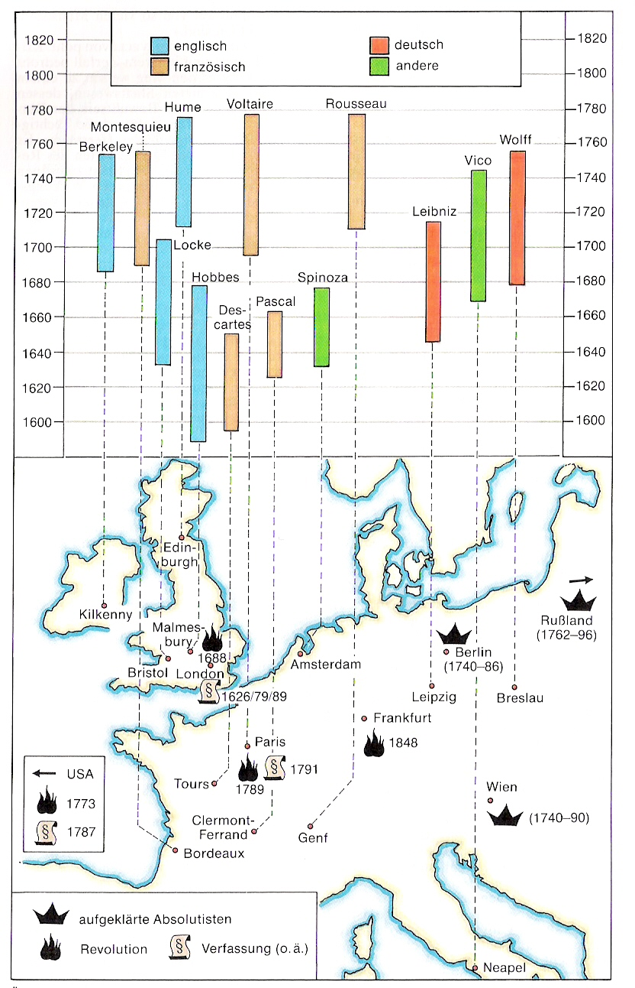
Kunzmann, Burkhard, Wiedmann (1991) pag. 102
Fig. 19

Hobbes, Locke and Hume P.M.

Kant P.M.

German idealists P.M.
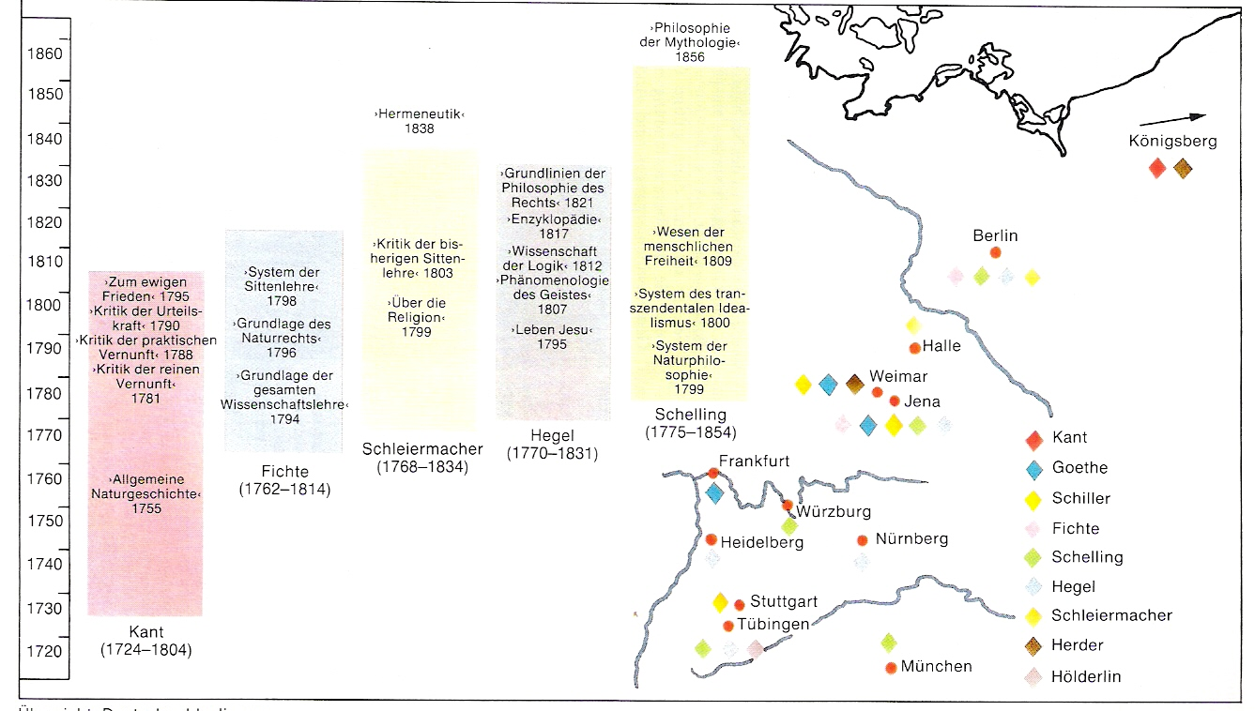
Kunzmann, Burkhard, Wiedmann (1991) pag. 134
Fig. 20

19th Century P.M.
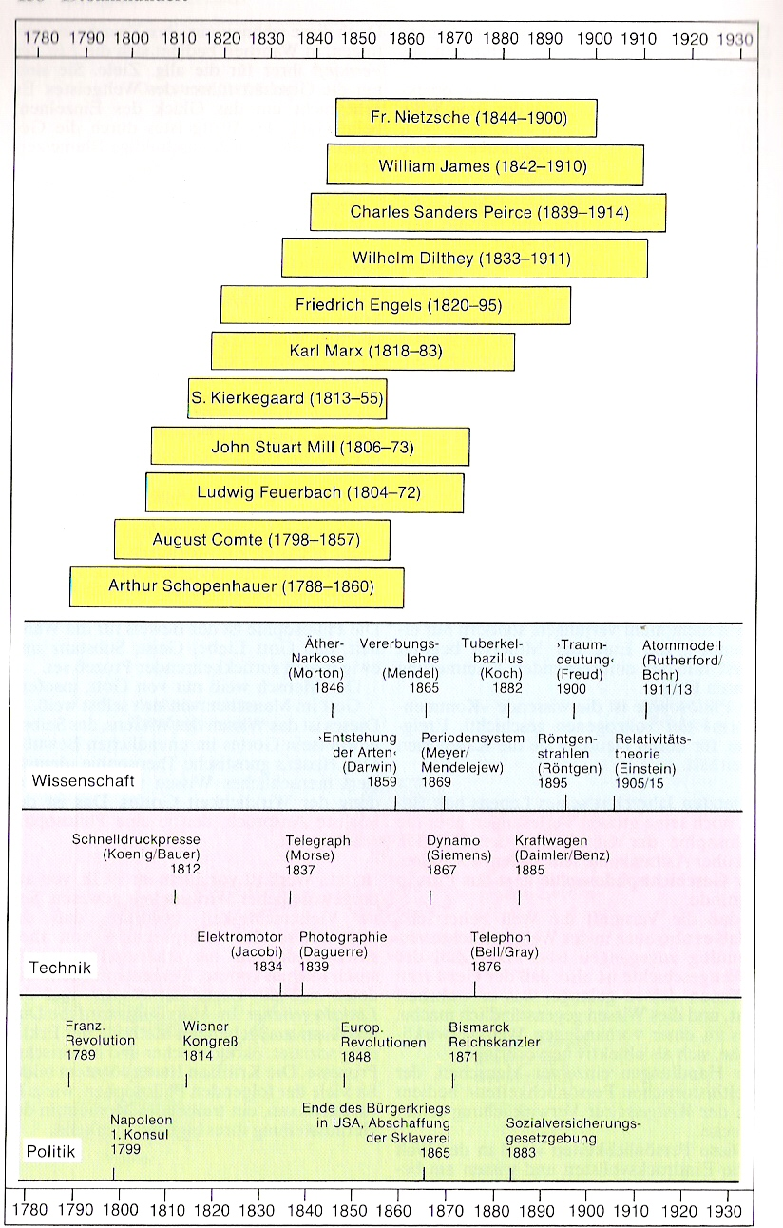
Kunzmann, Burkhard, Wiedmann (1991) pag. 158
Fig. 21

German materialists P.M.
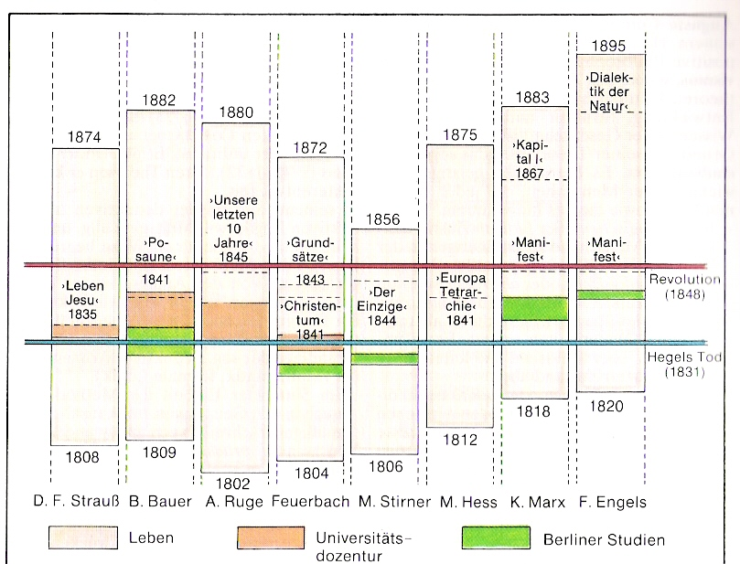
Kunzmann, Burkhard, Wiedmann (1991) pag. 166
Fig. 22

20th Century P.M.
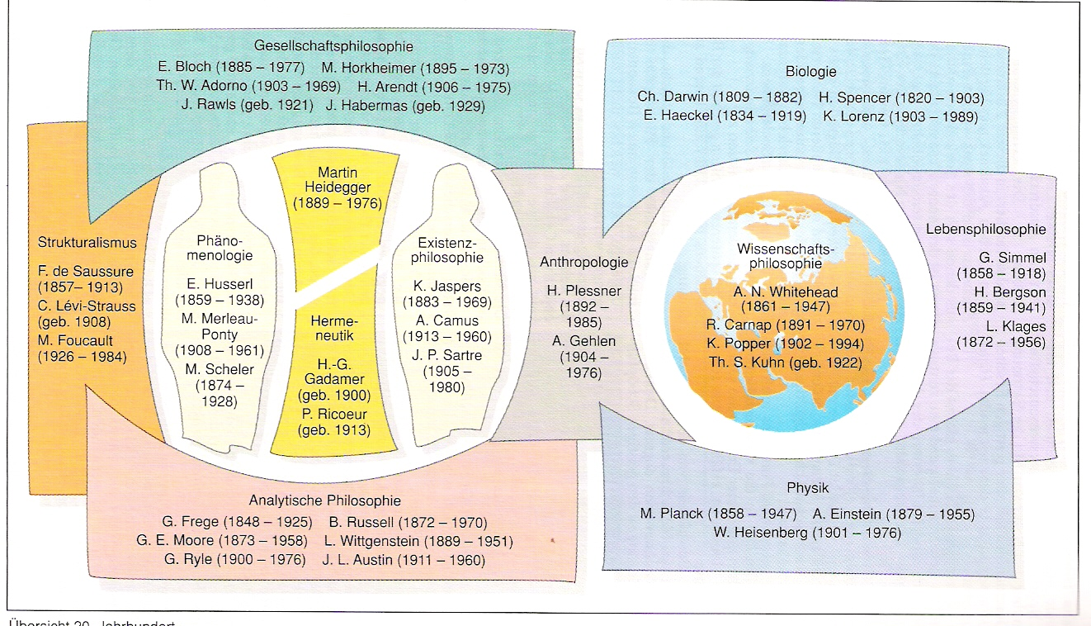
Kunzmann, Burkhard, Wiedmann (1991) pag. 182
Fig. 23

Actual tasks of philosophy P.M.

Index

19th Century 37
20th Century 39
a priori 7
Abélard 21
Academy 14; 21
Achilles 13
Acropolis 9
action 15
action-empirical cycle 3
actions(range) 5
active 15
Actual tasks of philosophy 40
actuality 4
Adam 18
adding 6
Aegean Sea 9
affection 15
afters 20
Against academics 20
Agamemnon 9
agenda 7
air 11; 13
air (moist and warm) 16
aitia 16
Akropolis 12
Alarik the Goth 20
Albertus 22
Albertus Magnus 22; 25
Alcuin 21
alètheia 11
Alexander the Great 10; 15; 16
Alexandria 15
allegoric explanation 21
alphabet 9
analysis 6
anamnesis 14
Anaximandos 11
Anaximandros 3; 9; 11
Anaximenos 11
Anaxoras 13
angels 18
animal 6
animism 18
Anselmus of Canterbury 21
anthromorphism 13
antitheses 25
Antwerp 24
apatheia 17
apeiron 11
apes 5
apodeixis 15
Apologists 18
Apology 14
aporia 14
Aquino 22
Arabic souces 21
Arabic translations 15; 21
Arabic world 10
archaeology 5
archè 4; 9; 10; 11; 20
architectural disigners 4
Aristarchos 24
Aristides 9
Aristophanes 14
Aristoteles 3; 14; 15; 16; 21; 22; 23; 25; 26
Aristotelian logic 21
Aristotle 10
arithmatic 17
art 4; 5; 9
art of printing 24
artes liberales 17; 21; 22
artists 14
asceticism 21
astronomy 17
ataraxia 17
Athens 9; 14; 16
Athens(400 B.C.) 14
atomic fragmentation 13
atomism 11
atoms 10; 17
Atreus 9
attention 6
Augsburg 24
Augustine 20
Augustinus 20; 21
Aurelius 17
authorities 21
authority 21; 23
Averoës 21
Avicenna 21
Avignon 23
axioms 15
Babylonic 18
Babylonic astronomers 10
bachelors 21
Bacon, Francis 29
Bacon, Roger 23; 25
bad 17
Baghdad 21
banking 24
barrel 5
barter trade 24
base(transistor) 6
befores 20
being 13; 15
belief 4
Bernardo Telesios 26
Bible 19
Big Bang 11; 20
biology 22
bird’s nest 5
body 11; 33
body and soul 33
Boëthuis 21
Boëtius 16
Bologna 21; 22
Botticelli 24
boundaries of philosophy 4
bowl 5
Bruno 26
Burgundy 24
Byzantium 20
calculate profits 24
Caligula 18
caliphs 21
camera 6
capitalist bankers 24
Cartesius 32
case 6
cases 23
Categories 21
Catholic 18
Catholic church (official philosophy) 22
Catholic education(1931) 22
Catholic monarchs 26
cause 16
celestial constellations 7; 11
central nervous system 3
central position in the solar system 23
centre of the world 24
certainty 8
change 15
chaos 11
Charlemagne 20; 21
Charles Martel 21
Charles V 24; 26
chemistry 22
Chile 24
Chinese invention 24
Christ 18
Christian 21
Christian faith 20
Christianity 3; 4; 10; 18
church 23
Cicero 17
circle 23
circumstanced 15
Citium 17
Civitas Dei 20
clarity 11
classes 15
classical debate 10
clear 33
Clemens from Alexandria 18
climate of study 7
cogito ergo sum 20
coincidentia contradictoriorum 23
Cologne 21; 22; 23
colonization 9; 24
colonnade 17
colony 9
commercial networks 24
communistic 15
compass 24
complex ideas 33
concept 6
conceptual faculty 5
Conceptual faculty 5
conditional sequence 7
Confessions 20
confirmation 6
connect 5
connecting 5
connection 5; 6
conscious actions 3
consciousness 3; 20
Constantinopel 24
Constantinople 20
constellations 10
context 4; 8
context(political, cultural, economic, technical, ecological, physical) 8
context-bound completeness 4
context-reducing disciplinary parts 4
contradictions 25
contradictions coincide 23; 25
contrasts(connecting) 25
cooperate 6
Copernicus 11; 16; 23; 24
Cordoba 21
cosmologie 4
cosmology 4; 9
cosmos 10; 11
craftsman 15
craftsmen 24
creator-God 18
Crescenzo 3
Crete 9
critical history 5
Critical history 4
critical questions 8
criticasters 8
crusades 22; 24
Cusanus 23; 24; 25
Cyclade 9
cynical 17
Cypre 17
danger 8
Dante 22
Darius 9
Darwin 11
data 33
dead end 8
death 9
debate 10
deception 13
deceptive impressions 13
deducted application 3
deduction 10; 14; 33
definition 14
definitions 15
demand 5
Demiurg 15
democracy 9; 13
Democrites 17
Democritos 10; 11
Demokritos 13
deny 6
Descartes 3; 4; 20; 32
design(philosophy) 3
designers 4
details 8
dialectic 17
difference 15
dihaeresis 15
Diogenes of Sinope 17
Dion 15
discovering 8
distinct 33
Divina Commedia 22
division of tasks 6
docta ignorantia 23
Dominican order 22
door 5
Dorian tribes 9
Doric style 9
doubt 14; 20; 33
doubt of faith 21
dualism 33
Duns Scotus 23; 25
Dyonisios 15
Early fascinations 9
earth 11; 13
earth (dry and cold) 16
Eastern Roman Church 24
Eastern Roman Empire 24
Eckhart 23
eclecticism 17
eclipse of the sun in 585 BC 10
effective 5
efficiency 8
Egypt 9
Egyptian 18
Egyptian geometry 10
eidos 14
Eisenach 26
Eleatic philosophers 13
Elements(Euclid) 11
elenchus 14
Elis 16
emotion 7
empathy for the opponent 14
Empedocles 13
empires 9
empirical cycle 3
empirical knowledge 13
empiricist 22
empiricists 3
emptiness 10; 13
end of times’ 20
engineering 4
England 21
Enlightment 32
entelechie 16
enthusiasm 4; 18
Epicuros 4
Epicurus 17
Epiktetos 17
epochè 17
equality 15
Erasmus 25
Eriugena 21
eros 14
Escaping everyday worries 18
Essais 26
essence 21
eternity 20
ethereal 16
ethics 15
Euclid 11; 15
eudaimonia 17
events(sequence) 8
ex nihilo 20
existence 21
existence of God 22; 23
experience 5
experiment 23; 25
experiments 29
expression 3
expressionism 4
faith 20
faith(diversity) 25
Fall of Adam 18
false 6
farmers 24; 26
fascination 4; 7
fascinations 9
fascinations(partial) 8
feudal knighthood 24
feudalism 9
Finico 26
fire 11; 13
fire (dry and warm) 16
first cause 16; 18
flint axe 5
Florence 23; 24; 25
focus 7
footnotes to Plato 14
form 21
form cause 16
Foucault 4
founding fathers 18
fragmentation(atomic) 13
fragmentation(atomic, continuous) 13
frame 8
France 21; 32
Francis Bacon 29
Franciscan order 22; 23; 24
free arts 17
free will 18; 21; 23; 26
freedom 8; 11
Freud 20
Fuggers 24
future actions 6
Galileï 3; 7; 11; 24; 27; 32
Gallileo Galileï 27
general statements 16
generalization 23
generalizing examples 16
geometrical propositions 10
geometry 11; 17
German bishops 23
German electors 26
German idealists 36
German materialists 38
Germany 21; 24; 26; 32
Giordano Bruno 26
gnosis 18
god-craftsman 15
Gods existence 21
good 17
goodness 14
Gothic architecture 22
governmental system 9
grain 8
grammar 17
Greece 9; 16
Greek 25
Greek context 9
Greek culture 9
Greek culture 3000 - 400 B.C. 9
Greek democracy 9
Greek language 24
Greek sources 21
Greek texts 24
Grotius 26
guilds 24
gunpowder 24
habits 3
Hadrianus 18
haeciditas 23
harbour 11
hate 13
Hawkins 20
heavenly kingdom 18
hedonè 17
hedonism 15; 17
hègemonikon 17
Hellenism 10; 16
Hellenistic and Roman philosophy 16
Henry IV 26
Herakleitos 9; 11
hermits 20
Hieronymus 19
Hippodamos 12; 14
Historical context, conditions of thought 8
historical human presence 5
history 4
history(personal) 8
Hobbes 26
Holbein 25
Holy Communion 18
Holy Roman Empire 23
Holy Spirit 18; 20
Homer 9
Horatius 17
house 5
how 23
how much 23
Hugo Grotius 26
Hume 3
Hus 24
hypocrisy 14
hypotenuse 12
hypothesis 4; 10
Ibn Rosjd 21
ideal state 15
idealists 3
ideas 13; 14; 15; 21
identification 4
identity 15
idols 4
if 6
If as a primary tool of thought 6
image of God 20
imaginability 5
imagination 4; 5; 6; 9; 22
imaginations 15
impressionism 4
impressions 3
India 10; 16
Indian fakirs 16
indifference 8
indifferent 17
induction 14; 16; 33
inductive experiments 29
inductive generalization 3
industrial designers 4
infinitesimal calculating 23
infinity 23
inflation 24
injustice 11; 14
innate ideas 22
innate routines 5
instruments 4
intellect 23; 25
intelligence 7
interest 7; 24
international market 24
internet 7
interpretate 15
interrogations 14
intuitively apprehend 33
inventing 8
invention of gunpowder 24
Investiture Controversy 23
Ionian coast 9
Ionian people 9
Ionic style 9
Ireland 21
Islam 10
Islamic 21
Islamic (Moorish) high schools 21
Istanbul 20; 24
Italy 9; 12; 13; 21; 23; 24; 26
James 4
Jesus Christ 18
Jewish 21
Johannes Eckhart 23
Johannes Hus 24
Johannes Scotus 21
John the Baptist 22
judgement 15
Jupiters moons 24
justice 14
Justinus 18
Kant 3; 15; 21; 29
Kepler 24
know 8
knowledge 14
Köln 21
Konstanz 24
Koran 23
Kritik der reinen Vernunft 29
Kriton 9
Kroton 12; 13
land on lease 24
landownership 24
language 15
language games 3; 5
large 15
last purpose 18
Latin 21; 22; 25; 32
law 26
laws 13; 15
Laws 15; 20
lawyers 13
learning 3
Lebanese 9
Leibniz 23
Leibniz’ monades 23
lethargy 7
libraries 20; 21
lid 5
light 23
limitation 8
lingua franca 21
logic 13; 15
logic of proofs 23
logical operators 6
logical paradoxes 13
logos 14
Lombardy 21
love 4; 13
Lucretius 17
Luther 25
Macchiavelli 25; 26
Macchiavelli and Erasmus 25
Macedonia 15; 17
Maimonides 21
Majordomus 21
Man is measure of everything 13
manufacturing 5
map 11
Marathon 9
Marcelio Finico 26
Marcus Aurelius 17; 18
marriage 15
Martel 21
Maslow 7
mass media 8
material cause 16
mathematics 13
matter(eternal) 21
Meander 10
Medici 24
Medieval philosophy 20
Medieval universities 22
Medina 21
Mekka 21
mendicant order 22
Meno 14
merchants 11
Metaphysica 15
metropolis 32
Michelangelo 14; 24
microscope 4; 11
Middle Ages 7; 25
middle term 15
Middle-East 9
midwife 14
migrations 21
Milete 4; 10; 11
Minoic 9
Mirandola 26
modalities 5
Mohammed 21
molecules 7
monade 23
monasteries 20
monastries 20
Money economy 24
monotheist religion 18
Montaigne 26; 33
morality 25
More 25
Morus 25
Moscow 24
Mosje ben Maimoen 21
motivation 6; 7
motivations 7
movement 9; 13; 15
moving cause 16
Munich 23
music 17
musical instruments 12
Mycene 9
mysticism 13; 20; 23
names 21; 23
Naples 13
natural selection 13
neapolis 13
negating 6
negative matter 11
neo-platonic 20; 21
Nero 18
nervous system 3
Netherlands 24; 32
neurophysiology 3
New Testament 25
New Testament cosmos 16
New Testament God 18
New testament’s Earth 16
new town 13
Newton 23
Nicea 18
Nicolaus Cusanus 23
Nietzsche 7
no 6
nobility 24
nominalism 21; 23
non opinionem, sed opus 29
non-actual objects 5
not-being-this-or-that 15
numbers 11
objective 8
obsession 8
Occam 23
Ockham 23; 25
Ockham’s razor 23
octaves 12
Old Testament 11
Old Testament cosmos 16
Old Testament God 18
Old Testament’s Earth 16
oligarchy 9
On method 32
ontological proof 21
ontology 10; 15
operators 6
optical phenomena 23
Orange 26
order of time 11
Organon 15
Origenes 18
orthodoxy 21
orthogonal street map 12
Osman Empire 24
ousia 15
Oxford 23
Oxford and Paris 23
Padua 22
pantheism 18
paradigm 11
paradigms 4
paradoxes of movement 10
Paris 21; 22; 23
Parmenides 10; 13; 14
particle physics 11
passive 15
Peloponesos 9
Peloponnesos 16
perception 3
Perception and motivation 6
Pericles 9; 13
Persian 18
Persian empire 9
personal efficiency 8
personal responsibility 25
personal style 20
persuasion 13
Peru 24
Petrus 19
Petrus Abélard 21
Phaedo 14
philosoph 15
philosophers 7
philosophic doubt 9
philosophy 3; 9; 18; 21; 40
philosophy(faith) 20
philosophy(tool) 3
Phoenician 9
Physics 15
Pico 26
Pico della Mirandola 26
Pietro Pomponazzi 26
Pippin 21
Piraeus 9; 12; 14
planets 16
planning 5
Plataeae 9
Plato 3; 4; 7; 10; 13; 14; 15; 20; 21; 26
Plato’s Socrates 14
playing 5
Plotinos 20
Plotinus 21
poetics 15
Poitiers 21
polis 9
Politeia 15; 20
polygon 23
Pomponazzi 26
Pope 19
portfolio 8
position 15
possibility 5
possible world 23
posture 15
potential 21
potentials 16
pragmatists 4
Praise of Folly 25
predestination 18; 21
predicate 15
predicate logic 15
presentation 6
Priene 12
prince of Orange 26
printing 24
probability 5
problem 8
profits 11
projection 4
projection of ideas 14
proletariats 24
proof 11; 15
proofs 15; 23
prophets 18
proposals for action 4
proposition logic 15
Protagoras 10; 13; 14
Protestantism 24; 26
psychology 4
Ptolemaeus 16
public limited company 24
purpose cause 16
Pyrrho 16
Pythagoras 11; 13
quadrivium 17
qualification 15
quality 15; 23
quantity 15; 23
questioning 14
questions 8
quiditas 23
Quintus Horatius Flaccus 17
radius 23
reason 21; 25
reasoning 6; 15
reconstruct 33
references 8
reflexes 3
reform movements 24
Reformation 25
refraction of light 23
Regensburg 22
related to what 15
relation 15
relations 23
relevation 21
religion 16
religious suppositions 4; 11
remember 5
Renaissance 15; 16
Renaissance philosophy 25
Renatus Cartesius 32
René Descartes 32
represent 5
representation 6
Republic 24
respect 14
responsibility 25
rest 15
retrievable 8
Revelation, authority and reason 21
revolts 24
rhetoric 17
Roger Bacon 23; 25
Roman Empire 10; 17; 20; 24
Roman philosophy 16
Romanesque architecture 22
Rome 17; 23
Rosselinus 21
Rotterdam 25
routes overseas 24
routines 3; 5; 6
Rules for the direction of the mind 32
safety 8
Salamis 9
Samos 11; 17; 24
satisfaction 5
Scepsis 16
sceptic 26
sceptical 17
scepticism 8; 20
scholasticism 21
Scholasticism 20
scholè 9
school 11
science 4; 5
Science 4; 26
science of signs 23
scientific disciplines 4
Scientific importance of fascination 7
scientific programme 29
scientific proof 15
scientists 14
Scotus 21
sculptor 14
sculpture 14
searching 8
selecting 6
selection(natural) 13
selector 6
selectors 5
self reflection 11
self-knowledge 14
Seneca 17
senses 3; 4
sensors 3
sensory perception 13
sentence 15
separate 5
separating 5
separation 5; 6; 11
Seventh Letter 15
shadows 14
Shiva 18
si enim fallor, sum 20
Sicily 13; 15
sieve 5
silver 24
sinner 18
sins 26
slaves 9
Socrates 7; 9; 10; 14; 15
soldier 14; 15
Sophistes 15
sophists 10; 13; 15
sort of thing 15
soul 33
Southern Italy 13
space 8
Spain 21; 24
Spanish king 24
Sparta 9
specialization 5; 24
sphere 8
spheres 12
square 12
squares 14
St. Denis 21
stability 15
Stagira 15
state law 26
state of condition 15
State of God 20
stimulus 6
stoa 17
Stoic 17
Stoicism 17
straight line 23
streets 12
strings 12
study proposals(philosophy) 3
subcultures 3; 4
subject 15
substance 15
subtracting 6
summae 22
Supposed hedonism 17
supposition 4; 8
suppositions(unnessecary) 25
switch 6
syllogism 15
Symposion 14
synopsis 15
synthesis 6; 33
Syracuse 15
taxes 24
taxes to the Pope 23
technology 5; 9
telescope 4; 7; 11; 24
Telesios 26
Ten Commandments 18
Tertullianus 18
testing 4
Thales 3; 4; 16
Thales of Milete 10
The fall of Eastern Roman Empire 24
The Netherlands 24; 32
The Praise of Folly 25
Theaetus 15
theodicee 18; 33
Theodicee 18
Theodorik 16
thisness 23
Thomas 22; 23
Thomas More 25
Thomas of Aquino 22
thought 13
thoughts 3
Thoughts 3
Thurii 13
Timaeus 15
time 20
Time 20
tolerance 21; 25
Tolerance 26
tool 15
tools 5
Tools 5
tools(effective) 5
tools(intermediate) 5
town-states 9; 23
trade union 9; 24
trade union of democracies 13
trade unions 13
tradesmen 13
transistor 6
Travelling teachers (sophists) 13
Trinity 18; 20
trivium 17
Trojan War 9
Troy 9
true 6; 23
truth 5; 23
truth-value 6
Turkey 9; 10
tyrant 9; 15
unbalance 11
unconscious actions 3
unconsciousness 20
uncoveredness 11
unification 11
United States of The Netherlands 24
unity 13
Unity 18
unity of existence 13
universal interest 8
universal man 25
universalia 21
Universalia 21
universities 22
Universities 22
university 8
unmoved mover 16
uomo universale 25
urban administration 24
urban designers 4
Urban geometry 12
urban islands 12
urbanist 7; 14
Utopia 25
Venice 24
virtuousness 13
Vishnu 18
visionary design 4
VOC 24
Vulgata 19; 25
wage work 24
war 9
water 11; 13
water (moist and cold) 16
what 15
what ever 23
whatness 23
where 15
Whitehead, A.N. 14
will 23; 25
William of Ockham 23; 25
wisdom 25
Wittenberg 25
Wittgenstein 3; 4
words 15
world 4; 23
worldly power 23
Worldly power of church 23
writing 14
Xenophanos 13
Xerxes 9
yes 6
Zeno 4; 10; 13; 17

I often used Störig, Kunzmann et al., Kuypers et al., Russell
Creszenzo, L. d. (1994) Geschiedenis van de filosofie. Van de presocraten tot de neoplatonici. (Amsterdam) Ooievaar Pockethouse.
Dennett, D. (1999) Het bewustzijn verklaard. (Amsterdam) Olympus, Uitgeverij Contact.
Descartes, R. (1966) Regulae ad Directionem Ingenii. Texte Critique Établi par Giovanni Crapulli avec La Version Hollandaise du XVIIème Siècle. (The Hague) Martinus Nijhoff.
Popper, K. R. (1963) Conjectures and Refutations (London) Routledge and Kegan Paul. Kuhn, T. S. (1962) The structure of scientific revolutions. in: O. Neurath, R. Carnap et al The International Encyclopedia of Unified Science (Chicago) The University of Chicago Press. Page. Lakatos, I. (1970) Wetenschapsfilosofie en wetenschapsgeschiedenis. De controverse tussen Pepper en Kuhn (Meppel) Boom. Feyerabend, P. (1975) Against Method (London W1) NLB 7 Carlisle Street.
Russell, B. (1990) Geschiedenis van de Westerse filosofie in verband met politieke en sociale omstandigheden van de oudste tijden tot heden. (Den Haag) Uitg. Servire.
Schrödinger, E. (1945) What is Life? (Cambridge, New York) Cambridge University Press.
Wittgenstein, L. (1953) Philosophical investigations (Oxford) Blackwell.
Mates, B. (1986) The philosophy of Leibniz (New York/Oxford) Oxford University Press. Kripke, Hintikka, J. and M. B. Hintikka (1989) The logic of epistemology and the epistemology of logic. Selected Essays. (Dordrecht/Boston/London) Kluwer Academic Publishers. Divers, J. (2002) Possible worlds (London, New York) Routledge.
Dijksterhuis, E. J. (1989) De Mechanisering van het Werelbeeld. De geschiedenis van het natuurwetenschappelijk denken. (Amsterdam) Meulenhoff. Phorbes,
Harrison, G. A., J. S. Weiner, et al. (1964) Human Biology (Oxford) The Clarendon Press.
Leeuwen, C. G. v. (1966) A Relation Theoretical Approach to Pattern and Process in Vegetation. Wentia. 15: 25-46.
Piaget, J. and B. Inhelder (1947) La representation de l'espace chez l'enfant (Paris) Presses universitaire de France.
Sanford, D. H. (1992, 1989) If P then Q, conditionals and foundations of reasoning. (London) Routledge.
In 1947 William Shockley, John Bardeen and Walter Brattain succeeded in building the first practical point-contact transistor at Bell Labs.
Maslow, A. H. (1943). A theory of human motivation. Psychological Review 50. 50: 370 - 396.
Look the contagiously fascinating website from the graduating student David Rutten http://www.reconstructivism.net . He is fascinated by images, generated by computer codes generating urban design possibilities not imaginable earlier. But no graduating professor is expert in that artistic field, though many feel he is on the right track. He combines a sense of artistry with mathematical precision and drive, characteristic of fascination.
Jong, Taeke M. de (2005) Persoonlijke efficiency (Zoetermeer) Concept diktaat .doc
Sloterdijk, P. (2003) Sferen. Deel I: Bellen: Microsferologie. Deel II: Globes: Macrosferologie. (Amsterdam) BOOM.
Sennett, R. (2001, 2000, 1998) De flexibele mens. Psychogram van de moderne samenleving. (Amsterdam) Maarten Muntinga bv / Uitgeverij Byblos.
Rostovtzeff, M. (1964) De Oude Wereld. Het nabije Oosten en Griekenland. (Utrecht / Antwerpen) Het Spectrum - Aula Boeken.
Diogenes Laërtius
Aristoteles
http://members.lycos.nl/pws5havo/thales.htm
http://aleph0.clarku.edu/~djoyce/java/elements/elements.html
Or his successor in Milete, Anaximandros as Störig indicates.
However, the Greek mythological figure of Narcissus drowned in self obsession looking at his mirror image.
http://www.acturban.org/MasterEAPC/Thinking_city/Ancient%20Cities%20and%20Urban%20Planning/Hippodamos%20and%20the%20Classical%20Greek%20City.htm
http://classics.mit.edu/Browse/browse-Plato.html
Plato, The Seventh Letter, probably not written by Plato
http://classics.mit.edu/Browse/browse-Aristotle.html
Aristotle (350 B.C.?, 1983) Categories (Cambridge, Massachusetts) Harvard University Press, Loeb Classical Library
http://orgonelab.org/miller.htm
Störig,
Newton, I (1987) Philosophiae Naturalis Mathematica.
Matthew 22:21: "Give to Caesar what is Caesar's, and to God what is God's."
1534, the same year Henry VIII declares himself Supreme Head of the English church, the Church of England
Like Franciscus of Assisi (1182-1226) and the Franciscan order stressed earlier.
The Dutch hymn “Wilhemus’ still says: ‘de Koning van Hispanje heb ik altijd geëerd’ (‘I always honoured the King of Spain’).
Toulmin, S. (1990). Kosmopolis. Verborgen agenda van de moderne tijd. (Kampen / Kapelle) Kok Agora / DNB Pelckmans.
http://dutchrevolt.leidenuniv.nl/bronnen/1581%2007%2026%20ned.htm, forerunner of the United States declaration of independence from the English King (1776), two centuries later. http://nl.wikipedia.org/wiki/Declaration_of_Independence
http://radicalacademy.com/phildescartes1.htm
Leibniz, G. W. (1991). Monadologie of De Beginselen van de wijsbegeerte. Kampen, Kok Agora.

