Study and research climate, VCW’s tasks
Prof.dr.ir.Taeke M. de Jong, Chairman VCW 2006-06-14

CONTENTS
1. Introduction 1
VCW’s tasks 1
Research climate 2
2. Study and research in education 2
Education 2
PhD education 2
Methodology courses 2
Historical problems with empirical research methods 3
Context sensitivity of urban and architectural design 3
Design related study 3
The effect of traditional Study proposals 4
Design science 4
Object, context, impact and programme 4
Fig. 6 Object, context, impact and programme as ‘part of the desired impacts in a context’ 5
Ways to study 5
Limitation of study without problem isolation 5
The effect of education on the climate of research and study 5
3. Communication 6
Communication within the Faculty 6
Sectoral conferences 6
Stagnating interaction between departments 6
Getting acquainted with each others production 6
Presence at the Faculty, informal contacts 6
Communication within departments 6
The VCW website 6
Registering PhD studies and dissertations 7
Delft Review of articles and books 7
4. Study and research climate 7
Conferences and work groups 7
Register 8
Enclosure Fisher (Confidential) 9
Enclosure Fisher (Confidential) 9
Criteria for empirical research 9
Research “Into” Design 9
Programming 9
Post-Occupancy Evaluations 10
Total Building Performance Evaluation 11
Historical research 11
Research “through” design 12
Design research 13
Typological research (title added by TdJ) 14

Introduction

VCW’s tasks
In their meeting 2006-02-16 the members of the VCW, Faculty of Architecture, University of Technology Delft, discussed the study and research climate on that Faculty and the criteria they handle judging study proposals of PhD candidates. The members Louwe, Jolles and Read had written papers about the subject, while in december 2005 the Dean of the Faculty rejected four advices of VCW. In his paper, Louwe argued amongst other things VCW is a committee of peers. So, do not be too strict about their criteria, keep them as they are following ZWO criteria to get acquained to that kind of criteria. A PhD candidate has to be able to convince a broad forum of peers that their proposal is worth the money invested. Read added the argument the VCW does not have to theologise about methodology. The VCW followed that advice temporarily.

Research climate
However, the topic of the study and research climate remains actual and the VCW misses insight in the ‘context of discovery and invention’ of PhD candidates. The chairman’s custom to ask promotores to give oppositions instead of defenses after the PhD talks, gives some insight of their critical context, but the advice to ask PhD candidates to clarify that context further on the personal website the Faculty delivers them, was rejected. So, temporarily the VCW will not take much context into account judging the PhD study proposals. What are the other possibilities to improve the study and research climate?

Study and research in education

Education
VCW member Spekkink remarked a proper research and study climate starts with education. “The way you outline your study and research and the way you practice it have to be taught in the first year of study. A course ‘How to write a study proposal’ should be oblidged.” However, the problem is researchers and teachers of the Faculty think very differently about how to write a study proposal and how to bring it into practice. Many do not trust generalizing methodology courses supposing these miss the essence of design, the essence of creativity, the subtile feeling for specific context. Prins even speaks about ‘science war’. He believes in pluralism, producing diversity of always new knowledge and design. Study should develop people, make them discover possibilities and impossibilities to convince others themselves. There is a controversy between judging proposals according to prescribed scientific criteria and encouraging quality, between a desire to research or to create something, be it a book, an essay, a design.

PhD education
Halman reminds us research schools in The Netherlands demand 800 hours of PhD education and most research schools ask more. In PhD education as well as in BA and MSC education there should be sufficient supply of courses concerning methodology and methods of research and study presenting a great variety of methods and techniques and their range of application (what is appropriate and what not). PhD should know the difference between regulative, reflexive and empirical cycles, between a scientifically accounted design process and the development of a theory or method of design related study. Recent years there are many interesting articles published about design related study. Halman recommends Van Strien (’70-’80 RUG), Van Aken (’90-’00, TU/e) and Romme (’00, Tilburg).

Students in general and PhDs in particular have to learn how to distinguish good and bad research. The best way to learn that distinction are workshops showing and explaining examples of both categories. Solid examples of study and research should become showcases, recommended by VCW or even yearly awarded. However, that means the VCW has to take time to invite new born Doctors to present and discuss their final results in relation to their original proposal. Al least VCW members should receive all dissertations to evaluate the impact of their efforts.

Methodology courses
The Faculty manual for PhD candidates obliges a methodology course indeed, suggesting the course ‘research design’ given by the University of Groningen. That suggestion is probably done by reading the word ‘design’, but following the suggested web link you will discover it has nothing to do with spatial design. ‘Research design’ is a common name for outlining a program of empirical research. There are many comparable methodology courses concerning empirical research on any University, Delft University included. Prof. Kroes wrote an excellent book, but his lectures are seldomly followed by the PhDs of our Faculty. On our own Faculty Healy and Astroh give lectures about the philosophy of science. However the Department of Real Estate and Housing is a front runner in teaching master students in a more practical sense to outline a research proposal using two books sold in the Faculty bookshop (see Fig. 1 and Fig. 2). They explain the common program of empirical research (see Fig. 3) pupils already learn in the ‘Study House’ on any high school, and that knowledge is refreshed in the Bachelor’s study of our Faculty by 2 ECTS Science Methodology.

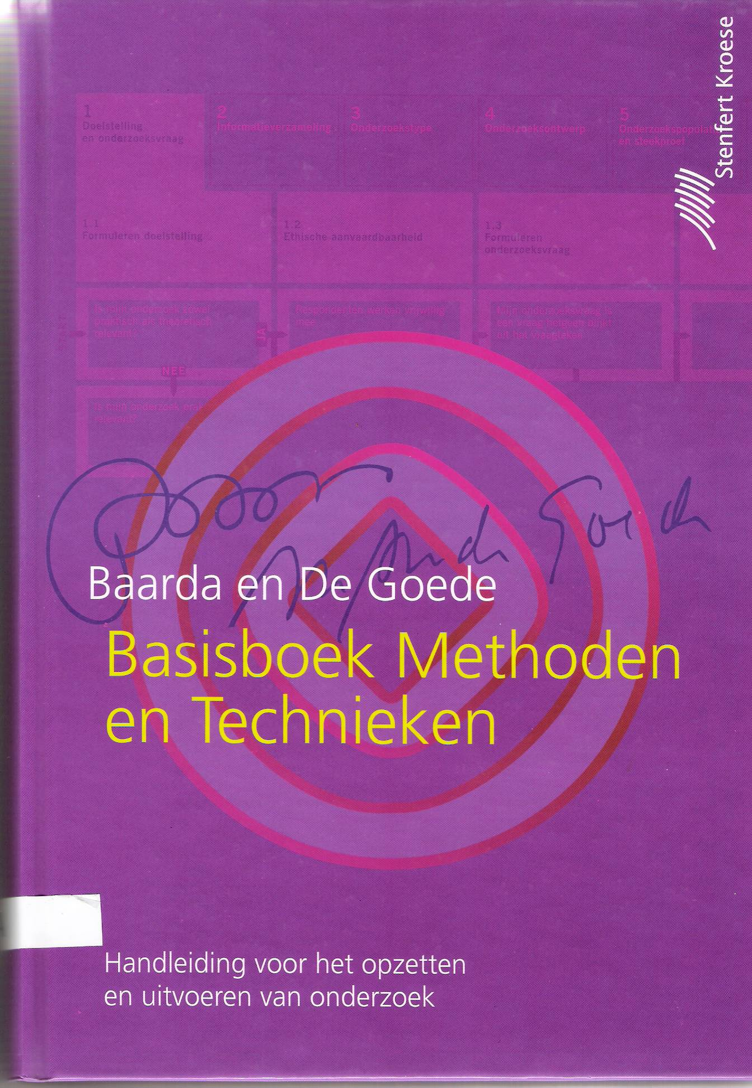 | 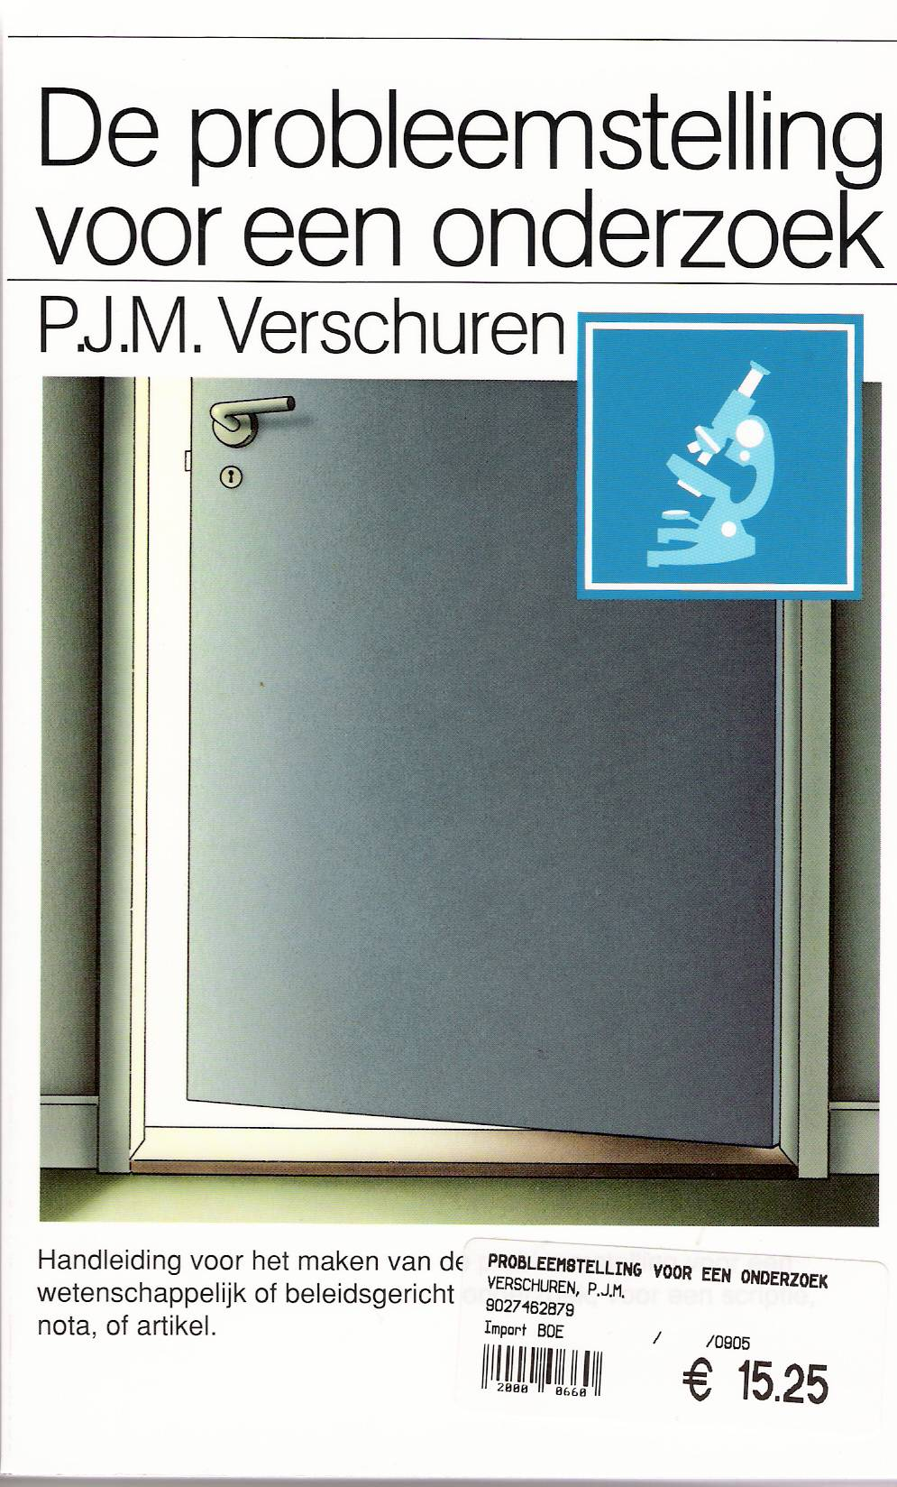 | •problem statement  •clear aim  •references  •starting points  •hypothesis  •variables  •data  •method  •content  •publish | 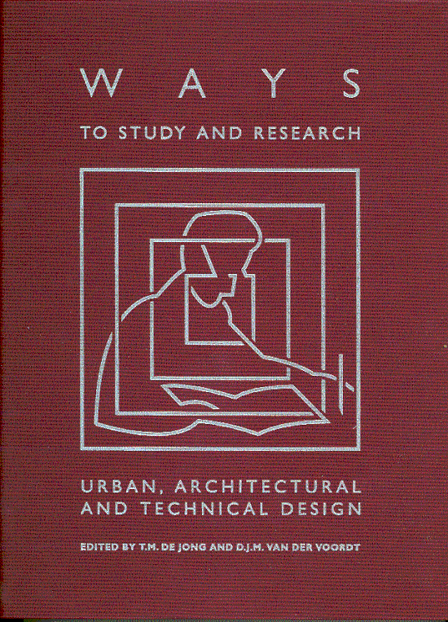
Fig. 1 Baarda and De Goede | Fig. 2 Verschuren | Fig. 3 The common program of empirical research | Fig. 4 The search for design related variants

Historical problems with empirical research methods
However, as long as I know this Faculty, the classical method of empirical research is a topic of debate. Institutes for empirical research like CA, ISO, RIW (later OTB) disappeared from the Faculty because the libraries full of design recommendations and ~tools these institutes produced were not accepted as useful for design itself.
Two methodology committes (1990, 2000) were installed to determine the scientific competence of the Faculty, because the Faculty was mainly judged as ‘artistic’ by the other Faculties of our University, missing a reliable mathematical background. The Faculty organised several international conferences about Design Research. At last the Dean commissioned me to compose a book on design related methodology (see Fig. 4). I asked Theo van der Voordt as partner editor to ensure the empirical input, and within our Faculty we found 46 authors to join us and to explain their design related research. Recently Tom Fisher made an excellent summary and interpretation (see page 10) concerning the empirical research part (not mentioning design study and study by design).

Context sensitivity of urban and architectural design
Rector Fokkema wrote a most important Preface arguing that in a University of Technology there is no design object as context sensitive as that of a Faculty of Architecture. That means, we do have a methodological problem. After all, classical empirical science aims at generalization, while urban and architectural design objects are determined by their unique administrative, cultural, economic, technical, ecological and spatial-temporal contexts on many levels of scale. That means, as once I wrote with Van Duin, studying these objects do not permit the isolation of a problem to be solved. They have to cope with fields of coherent problems and aims (that fits with the field ideas of Read).

Design related study
Compared to Fig. 3, design related study:

- can not isolate problems from a coherent field of problems;
- brings aims together in a field of aims, a ‘concept’;
- has many references, not only written text but especially images: forms, types, models, concepts, programmes;
- has many starting points;
- has designs as hypothesis not stating much more than: “This will work”;
- has many context variables (“parameters”);
- while the object still varies in your head;
- has many ways to study (only some of these in a book with a 10 000 key words index);
- has an unpredictable content growing by drawing, calculating and writing;
- publishes with the medium as a convincing message.

The effect of traditional study proposals
Part of these problems I knew from debates in ecology, management education, and Leyden’s young Faculty of Art Science. In 2003 I studied 30 graduate study proposals of the department of Urbanism, based on the common regulations for graduate study proposals (like Fig. 3), comparing them with the resulting graduate reports. However, I could not discover any influence of the study proposals made in the beginning. So, in my opinion Fig. 3 does not solve the problem of convincing design related study proposals. However, if you do not demand a clear statement of problem and aim, how could you trust on a reliable output? How could you check the result on starting points taken in the beginning?

Design science
Van der Voordt and I took the risk not many authors and editors of methodology books do, to give a definition of science. It was based on terms of reliability, validity and potential of (active or passive) criticism. These terms have different meanings in the search for truth compared with the search for possibility. I claim the word ‘science’ for both. We divided the book in eight sections according to the Faculty competences reported by the first Faculty Methodology Committee (1990) and distinguished four types of study of which only two were named ‘research’ (see Fig. 5).

 |  | determined | variable | OBJECT
 | determined | Design Research | Design Study
 | variable | Typological Research | Study by Design
 | CONTEXT
Fig. 5 Four types of design related study
Our translator Dijkhuis drew our attention to the possibility to translate the Dutch expression ‘onderzoek’ either into ‘study’ or into ‘research’. We reserved ‘study’ for objects not yet determined (like incomplete designs in statu nascendi or ‘electricity’ as studied in the 18th century) throughout the book. This scheme appeared to be useful and was broadly cited within the Faculty.

Object, context, impact and programme
So, the relation between object and context on different levels of scale appears to be of great importance to determine your method of study (see Fig. 6).

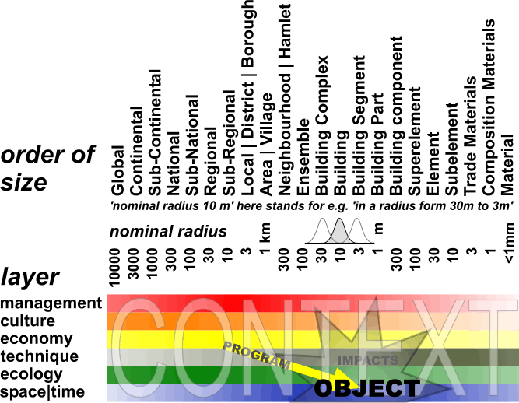

Fig. 6 Object, context, impact and programme as ‘part of the desired impacts in a context’
It determines which impacts you could expect in different probable futures, which of these impacts are desirable, part of the programme, determining the actors possibly willing to finance your study.

Ways to study
In the years after publishing the book Ways to Study, the Faculty commissioned me to explain its content by 1 ECTS (28 hours of study) in the first year of the Bachelors, 3 ECTS for the flow of HTO-students into our Masters’ and 5 ECTS for graduate students Urbanism. Slowly I developed a method to transfer a glimpse of its content by demanding to make a website with 15 take-home assignments. One of these assignments is, to make a study proposal for your graduate study. So, the first year’s Bachelors had to think about their future and about the future context of their design. They had to distinguish a probable and a desirable future. If you subtract the desirable futures from the probable, you discover a field of problems, if you do the reverse you find a field of aims (see Fig. 7). However, the field of aims has to be restricted to possible futures.

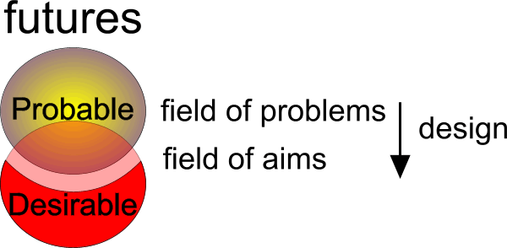
Fig. 7 Determining a field of problems and a field of aims

Limitation of study without problem isolation
The problem remains how to limitate, focus your study if you do not want to choose a clear problem aiming to solve it. After many years I suggested the following, moulded in the other assignments:

- give way to fascination (strongly motivated focus);
- choose a scale (frame and grain) before an object;
- publish your portfolio evaluating it as field of abilities;
- decide to improve or to extend them in your proposal;
- publish images that fascinate you as a field of design means (repertoire);
- look at them as a professional: which concepts, types, models or programmes could you harvest?;
- make your assumptions about the future explicit (the supposed context);
- imagine the impacts your study could have within that context (possible, desirable or not);
- cash your dreams.

So, besides a field of problems and aims designers have four other possibilities to limitate their study: scale, context, field of abilities (portfolio) and field of design means (reference images). It is clear these assignments discouraged many Bachelor students within the time given. So, I facilitated them making a computer game ‘Future Impact’ based on Fig. 6, forcing to make these future contexts explicit, subtracting them by pushing a button, resulting in a written study proposal to elaborate. Not many students elaborated the study proposal properly, but I was glad to force them thinking about object, context, impacts, actors (interested parties, stakeholders) and their hidden assumptions about probable and desirable futures. More than 1500 students made their own website with these assignments. They were motivated by publishing their portfolio on the internet.

The effect of education on the climate of research and study
I do not imagine these exercises contributed much to the climate of study and research in our Faculty, because teachers and researchers were not acquainted with these exercises and their background. They proposed to skip these exercises in favour of design exercises. Still, I believe a proper research and study climate starts with education. The way you outline your study and research and the way you practice it have to be taught in the first year of study. A course ‘How to write a study proposal’ should be obliged. But, to raise a generation of productive PhD candidates you have to start in the Bachelors.

Communication

Communication within the Faculty
Jolles remarked communication has to be improved. He probably focused on communication by the VCW, but there are many communication problems in the Faculty. Teachers do not know each others teachings, they do not hear each others lectures, they do not read each others papers. They prefer to read papers from abroad, stimulated by the reward system of our University. The same applies for PhD candidates.

Sectoral conferences
Many conferences are organised, but they are focused on specialised subjects for interested people already meeting each other all the time. If the subject is more general, you need famous international speakers to attract visitors, but crucial participants from our own Faculty do have no time enough to visit such conferences if they are not paid for participation. Per department, judging PhD symposia are a strong means to get aquainted with each others objects of study and methods, but they should be attended by representatives of other departments of the Faculty.

Stagnating interaction between departments
There is too little mutual interaction between the departments as regards content since graduate committees no longer have an obligatory mix from different departments. These 300 crucial moments of intensive scientific debate and judgement per year have connected people from different backgrounds for decades until it was abolished some years ago. Now, graduate committees are restricted to one or two departments. I think this was the greatest disaster for cohesion as regards content in the Faculty and its scientific climate.

Getting acquainted with each others production
There are some interesting proposals to improve mutual interaction as regards content. Nobody has time to read everything from everybody, but Guney proposes a code of behaviour for scientific collegiality. A small circle of 5 to 10 people from different departments promise each other to read each other’s papers within a week. Lans proposes to take the recent obligation for every TU employee to follow at least one course per year as an opportunity to follow a course of a colleague.

Presence at the Faculty, informal contacts
If the presence of people is a benchmark of study and research climate then we have to be very pessimistic, because very many people are absent. They “work at home”. So, you can not find them the moment you want to have an informal talk. Real Estate And Housing is a favourable exception. It indicates something about the study and research climate. The amount of part timers has effect and the pressure of education is disturbing study and research. Tuesday and Friday are days of high presence.

Communication within departments
Jolles’ second remark to bring the follow-up judgements of PhD candidates into the departments as soon as possible will have a favourable effect on communication within the departments. That is why we have to study the pilot project of Urbanism, make a standard protocol and stimulate the departments to take over that task. The VCW will get more space for its other tasks, for example inviting graduated PhDs to tell us something about their project and experiences.

The VCW website
Jolles’ fifth remark and all Martens’ remarks suggest to improve our own VCW website. Last summer (2005) I made a public website with some parts protected by password accessible for VCW members only. It was not sustained properly last year. At the moment (between two Deans) we have not enough administrative support, but probably in the summer we can update the site with all publications, letters, data about PhDs, personal data of members, agenda of all meetings with all documents, letters, minutes, protected by password if necessary.

Registering PhD studies and dissertations
Martens stresses the distinction between internal and external function of our website, now provisionally distinguished by password. According to Martens the internal function is predominantly an archive of meetings. The external function is partially realized elsewhere by lists of completed dissertations, sometimes published in full text on the web. Our Faculty has its own list. Last summer from that list I made an Excel list of 197 PhD’s (including those who finished their dissertation recently) in rows containing 30 columns not yet completely filled:

department  nr  section  promotor1  promotor2  promotor3  title  initials  PhD candidate's name  working title | starting year  aangemeld pedel  prom 1 form  VCW Check 1  VCW recommended  VCW check 2  VCW recommended  prom 2 form  (expected) end year  years until now | expected number of years  expected number of months  succesfully finished  geldstroom 1  geldstroom 2  geldstroom 3  geldstroom 4  fte  website  Email

Delft Review of articles and books
However, a VCW website offers many more possibilities to be explored. Halman states: ‘Students in general, but PhDs in particular should be able to read, understand, justify and if relevant to criticize scientific articles. That means, they have to be acquainted with methods and techniques (including the tables with statistical corelations and the like) presented in publications. Earlier I proposed to start a ‘Delft Review’ of articles and books reviewed by PhDs. PhDs read many books and articles and many PhDs read the same books. Exchanging their experience would be a great help to find their way in literature.

Study and research climate

Conferences and work groups
Jolles propagates once in two years a VCW conference and Read propagates seminars with DSD on own initiative. For that purpose we have to think about themes interesting for any PhD candidate or for special groups. In fact DSD functions like that, but the difficulty is, the study objects are very different. So, it is difficult to find something interesting for a substantial number of PhDs. Many initiatives came to a dead end. I think classical debates with bold statements to defend would attract people.

Read also proposes work groups as permanent structural link between departments and VCW. In fact this function is fulfilled by the nestores, but Xxxx(?) proposes to abolish them. Perhaps we can propose to bring the nestores consultation into the VCW.

Many questions remain. On page 18 the numbered end notes of this paper are summarised.

Register

Art Science 4
Astroh 2
Baarda and De Goede 3
Barbieri 3
CA 3
Xxxx 8
code of behaviour for scientific collegiality 6
concepts 5
conferences 6; 7
context 4; 5
debates 7
Delft Review 7
Design Research 4
Design Study 4
Dijkhuis 4
Duin 3
ecology 4
fascination 5
field of abilities 5
field of aims 5
field of design means 5
field of problems 5
Fisher 3; 9
Fokkema 3
future 5
Future Impact 5
graduate committees 6
Guney 6
Halman 2; 7
Healy 2
ISO 3
Jolles 1; 6; 7
Jong 3
Kroes 2
Lans 6
Louwe 1
management 4
Martens 6; 7
Methodology Committee 4
models 5
nestores 8
object 4
OTB 3
portfolio 5
Prins 2
programme 5
programmes 5
Read 1; 3; 7; 8
repertoire 5
RIW 3
Rosemann 3
scale 5
science 4
seminars 7
Spekkink 2
Study by Design 4
study proposal 5
types 5
Typological Research 4
Verschuren 3
Voordt 3; 4
Ways to Study 5
work groups 8

Enclosure Fisher (Confidential)
Chapter to be published in Architectural Graphics Standards (2006)
Tom Fisher, College of Architecture and Landscape Architecture, University of Minnesota

De Jong, T.M., D.J.M. van der Voordt, editors. Ways to Study and Research Urban, Architectural, and Technical Design. TK, DUP Science. 2002

Criteria for empirical research
Criteria for empirical research
Reliability: repetition of a measurement under unchanged conditions, rendering identical results. Internal reliability is when the same researcher produces identical results, external reliability when other researchers produce the same results. Demands both objectivity and verifiability
Validity: when the report of a measurement accurately reflects what was measured. It also relates to using the right kind of measurement or looking for the right data to answer the question, so that the method of research is appropriate to the kind of research undertaken
Open to criticism: Is the research refutable, open to criticism, negation, or falsification? Empirical research should also be critical of itself: is a given hypothesis empirically testable or logically consistent?
Relevant: Does the research add to our knowledge? Does it contribute to a new theory, new methods and techniques of study, policies, or products? Does it contribute to improvement of the quality of life?

To understand such empirical research and when to use it, we also need to know its limits for architecture:
- The multi-functional, contextual, and changeable nature of architecture makes it difficult to do reliable research that produces the same results every time.
- Design concentrates on discovering “improbable possibilities” and is “less focused on causality than on conditionality,” making it difficult to produce valid measurements.
- Architecture involves features such as usefulness, beauty, and sturdiness that cannot be compared, refuted, negated, or falsified. The value of design consists of the way in which these incomparable categories have been unified consistently within a specific context.

(de Jong, van der voordt, 23-27)

Research “Into” Design
The methods used in this type of research arise from the social sciences, such as psychology or history. And research “into” design typically involves the two social sciences most closely linked to architecture: environmental psychology, which relates to activities such as the programming or post-occupancy evaluation of buildings, and history/theory, which looks at the past to draw conclusions about or develop general ideas for the present.

Programming
All buildings begin with a statement of need and the development of a program, often in a pre-design stage of a project. One way to think of it is as the first of a three-part process in the creation of a building:

(insert H) (van der Voordt / van Wegen, p 271)

This three-part process also entails a constant checking back with the program to ensure that the identified needs are being met. Those “tests” of the design against the program can occur in at least four points:

(insert I) (van der Voordt / van Wegen, p 272)

In some countries and with some clients, the programming phase has been defined even more specifically. For example, in the Netherlands, building programming includes five areas:

- Usage requirements: This should include the nature, size, organizational structure, and patterns of activities, now and in the future
- Functions and performances: Relevant items – among others – are the spatial need for the building as a whole and per room, physical building conditions envisaged (temperature, light, humidity, sound, view), safety and flexibility.
- Image expectations: What are the client’s expectations in terms of the appearance of a project? What design guidelines or design review process might exist?
- Internal conditions: Conditions related to financial-economic conditions (cost-benefit analysis, for example) and conditions related to time (date of completion, for instance) are among the issues to be addressed here.
- External requirements and conditions: This includes planning and zoning requirements, building code, site requirements, security standards, and environmental policies among others.

Among the methods for programming include:

- Documentation: This includes the use of interviews, questionnaires, analysis of documents, behavior mapping, workshops with users, and scenario building.
- Translation: Here, the organizational characteristics and functional requirements get converted into performance criteria, based on clients’ experiences and the programmer’s professional expertise.
- Site visits: Visits to the project site and to similar projects that might serve as a reference or a precedent often need to occur.
- Analysis: Programming also includes the review of post-occupancy evaluations of similar projects to see what has or has not worked well.
- Literature review: Searches for data, experiences with particular design solutions, stands, and guidelines are among the steps here.

(der Voordt / van Wegen, p 274-275)

Post-Occupancy Evaluations
The post-occupancy evaluation (POE) of buildings constitutes one of the most important ways in which we can learn from our actions and improve the performance of architecture. Key questions to answer in a POE include:

- Is a building used in accordance with the intentions of all involved parties?
- Are daily users satisfied with their accommodation?
- To what extent does the actual energy consumption fit the expected energy consumption?
- To what extent do laymen and experts agree on its architectural quality?
- Is the building designed and constructed according to the standards of the building code?
- How did the planning process come about?
- On which considerations were the design decisions based?
- What kind of expertise was used in the programming phase, the development of the architectural concept, and other stages of the process?
- Was it characterized by an interaction of design and research and an effective participation by clients and users?
- To what extent did legislative prescriptions and economic constraints act on the design?

(van der Voordt, van Wegen p 151)

Total Building Performance Evaluation
Another form of assessing buildings after completion is the Total Building Performance Evaluation (BPO), which falls into four categories:

Functional Aspects
- Availability
- Accessibility
- Effectiveness
- Ergonomic safety
- Social Safety
- Spatial orientation
- Territoriality, privacy and social contact
- Physical well-being (light, sound, temperature, draft, humidity)
- Potential for change/flexibility/adaptability

Aesthetic Aspects
- Quality of image
- Beauty
- Originality
- Order and complexity
- Representation
- Cultural-historical value
- Meaning

Technical Aspects
- Fire security
- Constructive safety
- Material-physical quality
- Environment safety
- Sustainability

Economical and Judicial Aspects
- Budget
- Costs of investment
- Operation costs
- Time investments and time planning
- Laws and legislation
(van der Voordt, van Wegen p 152)

While the focus of each evaluation depends upon the goals or concerns of a building owner or user, the list of characteristics of a building that often get evaluated include:

(insert M) (van der Voordt, van Wegen p 153)

Historical research
Whether or not you are working with an historic building or in an historic district, historical research plays an important role in architecture. The research can include investigation of the history of the site, the community, the client’s organization, the building type, the existing fabric of a structure, or a particular material or system. Historical research depends greatly upon the range and quality of sources, which include:

- Literature: The studies that have already been written about a subject
- Sources: The documentary material, printed or not, from the era of study.

The sources include:

- Primary sources: These include a building itself and the drawings and models of it.
- Secondary sources: What others said or wrote about the building either at the time of its design and construction or afterward.

As in the design process, historical research demands an on-going critique of the sources:

- Correctness: Is a source possibly false or biased toward or against the subject?
- Provenance: Where did the source come from and is that reliable?
- Time: What is the date of the source and how does that relate to the subject?
- Origin: Who was the author of the source?
- Originality: Is the source or the information in it original?

The sources also need to be ordered, of which several ways exist:

- Elementary information: Order the material according to it time, place, subject, author, or any combination.
- Thematic organization: This orders the information according to type, based on function use or form, or based on material and construction, for example.

The literature, too, needs to be ordered in a way that is useful. The ways of doing so include:

- Topographical ordering: This orders material according to published descriptive lists and inventories
- Chronological ordering: Here, the literature gets sorted according to the era or date in which it was produced.
- Bibliographical ordering: The lists of books and other bibliographical material becomes the way to organize the material
- Monographic ordering: Ordering the material according to specific projects or people.

In terms of a building itself, the analysis of it takes two forms:

- Morphological analysis: This involves looking at the specific characteristics (what and how) of the work, in order to compare it to others and to put it in a broader perspective (why). This can include the formal, functional, and structural aspects of the work, or its stylistic or conceptual aspects.
- Technical analysis: This analysis can include looking at the site or material of a building or the construction methods used in it.

(Macel, in de Jong, van der Voordt p 61 - 63)

Research “through” design
Research “through” design takes different forms, depending upon the project and the context:

 |  | Object
 |  | Determined | Variable
Context | Determined | Design  Research | Design  Study
 | Variable | Typological Research | Study by  Design

- Design Research describes and analyzes existing designs with a known context, often in the form of comparative study of the designs’ function, form, structure, and the way they were made.
- Typological Research looks for types, for the same architectural form, structure, technique, function, or context in different contexts.
- Design Study involves making a design in a relatively well-known context of potential users, investors, available techniques, building materials, and political, ecological, and spatial restrictions.
- Study by Design generates knowledge and understanding by looking at the effects of varying both design solutions and their contexts.

These four forms of research “through” design also lie on a spectrum, with some more related to the intuitive and qualitative nature of art and others to the logical and quantitative nature of science:

(insert U) (de Jong, van der Voordt, p 20-21)

Design research
Design often gets pitted against research, as if the intuitive nature of the former does not align with the logical nature of the latter. However, our ideas of what constitutes design and research have so broadened that we now recognize multiple ways in which design constitutes its own form of research.

Although not scientific in nature, design makes use of many sources of knowledge and information, including the study of:

- Precedents: previous design solutions to a similar problem or from which we can draw a useful analogy
- Types: the study of recurring formal themes and characteristic forms, organized systematically as design typologies
- Styles: the study of rules of composition or ornament used in the past and re-interpreted for use in the present

The design process does not work in a logical or linear manner, although neither does the scientific process in most cases. Instead, design tends to be:

- Iteration: the following of a series of successive “loops,” where the current state of a design gets evaluated against previous and possible future steps
- Imaging: design research also consists of a series of what Zeisel calls creative imaging, in which the designer thinks while doing, reacting to ideas as they are visualized, eliminated, refined, or communicated.

Design sits as a hybrid practice between the arts and sciences, employing both expression and knowledge, involving both research and creativity, and drawing from both experience and practice:

(insert V) (Breen in de Jong, van der Voordt , p 97)

Design practice and design research move in different directions, back and forth between (historical and contemporary) culture and (technical and applied) science. Like design itself, practice and research are linked in an iterative process.

At the same time, design and research involve very different methods and goals.

- Design involves conceiving futures, looking forward to “what might be,” seldom looking back to understand what has come to be and why. Design seeks to reach a solution.
- Research, instead, looks at what has been or what is, with the goal of evolving or discovering knowledge.

Education overlaps both, involving the production of knowledge and the creation of design products:

(insert W) (Breen, in de Jong, van der Voordt, p 101)

Design investigation follows certain predictable strategies, not unlike the thinking involved in research:

- Decomposition: Because of the complexity of most design projects, this strategy involves “decomposing” the project, where it is taken apart and subsequently re-assembled, so that items of importance can be isolated and developed further in detail. This allows the designer to look at parts or combination of parts in relation to the whole, recognizing levels of priority and room for variation.
- Variation: By systematically organizing or structuring a project, designers can then begin to see compositional variations, based on dimensions, rhythms, proportions, subdivisions, connections, materials, and colors, to name a few. Often different variations based on some identifiable theme or motif, are worked out, compared, and evaluated.
- Visualization: Possible design solutions need to be made visible for the benefit of the designer or design team and for the other “actors” involved. Drawings and models are the primary “language” of design communication, also forming a “laboratory” involving (de)composition, selection, and variation. This visualization creates impressions of the effects of potential design decisions, which makes choices accessible.
- Reference study: The study of precedents can form a project library, allowing for comparison with similar types of projects and solutions. Findings are not translated literally in the design at hand, but primarily allow for reflection concerning the merits of intermediate design solutions.

(Breen, in de Jong, van der Voordt, p. 100-101)

Typological research (title added by TdJ)
Another way of thinking about design as research is the comparison of designs, both the designed object and the context. De Jong and van Duin offer a way to think about the comparability of different designs.

Independent  variable  Dependable variable | Legend | Form | Structure | Function | Intention
Intention |  |  |  | Intention (function) | Ideology
Function | Semantics | Function(form) | Function(structure) | Human sciences
Structure | Syntax | Structure(form) | Construction | Structure(function) | Structure(aim)
Form | Naming | Formalism | Structuralism | Functionalism | Symbolism
Legend | Logic

- Legend refers to that which takes form, be it a material (concrete, brick) or an element (road, green space).
- Form involves the joining, distribution, or layout of the material or space in or around the material
- Structure is the manner in which composing parts remain as a whole, the complication of separations and connections in a joined whole
- Function refers to any “external action” the activities that occur in or around a design
- Intention relates to the idea or goal of the design and to its meaning

(De Jong and van Duin, p 92)

Questions

Onderzoeksopleiding – hoe onderzoek je – lijkt me een absolute voorwaarde, liefst voor de AIO-opleiding, maar dan toch in ieder geval in het eerste jaar. Verplichte cursus ‘Onderzoeksvoorstel schrijven’. Niet vergeten: wetenschappelijk klimaat is, met alle gebreken, sinds de voorlaatste formele onderzoeksvisitatie aanzienlijk verbeterd.
Kroes, P. A. (1996). Ideaalbeelden van wetenschap, een inleiding tot de wetenschapsfilosofie (Amsterdam) Boom.
Healy, P. (2005). Images of Knowledge. An introduction to contemporary philosophy of science (Amsterdam) SUN Publishers.
Barbieri, U., L. v. Duin, et al. (1992) ACSA. Conference book. Design Studies. ACSA European Schools of Architecture Conference 1992; Conference (Location) Publikatieburo Bouwkunde, Faculteit Bouwkunde TU-Delft. Duin, L. v. and e.a. (1996) Les Doctorats en Doctorates in Design and Architecture EAAE / AEEA - Conference; Conference (Location) Publikatieburo Faculteit Bouwkunde. Rosemann, J. (2000) Research by Design. Proceedings A International Conference Faculty of Architecture Delft University of Technology in co-operation with the EAAE/AEEA; Conference (Location) DUP-Science. Rosemann, J. (2000) Research by Design. Proceedings B International Conference Faculty of Architecture Delft University of Technology in co-operation with the EAAE/AEEA; Conference (Location) DUP-Science.
Jong, T. M. d. and D. J. M. v. d. Voordt, Eds. (2002) Ways to study and research urban, architectural and technical design. (Delft) DUP Science.
Pianka, E. R. (1994) Evolutionary ecology (New York) Harper Collins College Publisher.
Riemsdijk, M. J. v., Ed. (1999) Dilemma's in de bedrijfskundige wetenschap (Assen) Van Gorcum.
Jong, T. M. d. and D. J. M. v. d. Voordt, Eds. (2002). Ways to study and research urban, architectural and technical design. (Delft) DUP Science, page 28-30.
Jong, T. M. d. and D. J. M. v. d. Voordt, Eds. (2002). Ways to study and research urban, architectural and technical design. (Delft) DUP Science, page 22.
Jolles: Communicatie verbeteren. Zo snel mogelijk afdelingen eigen presentaties/kwaliteitsborging laten doen. Uitzoeken hoe “VCW’s” in het buitenland (MIT, ETH) functioneren. VCW symposium 1x per 2 jaar. Website gebruiken, te zijnder tijd verslagen openbaar. Schrijfcursus (i.v.m. overdraagbaarheid onderzoeksvoorstel) Blijven zoeken naar andere kwaliteitsbevorderende maatregelen. T.z.t. brainstormen à la voorstel Pi.
http://team.bk.tudelft.nl/Publications/2005/Gedragscode.doc
http://www.bk.tudelft.nl/live/pagina.jsp?id=73b8e93f-2a17-4242-b69a-aec017e1c637&lang=nl
http://www.library.tudelft.nl/dissertations/dd_list_paged/index.htm
http://www.bk.tudelft.nl/live/pagina.jsp?id=66523f51-8043-4682-b4c2-f3cb2bcd7e20&lang=nl
Read: Instruments for improving research climate - seminars – own initiative (also with DSD) - work groups (permanent structural link between departments and VCW) ‘Expert’ assessment to the departments. Yearly review of departmental portfolio and fillings of research positions.
Xxxx (?): Gemeenschappelijke doelen (onderzoeksklimaat) versus persoonlijke doelen. Sturend inplaats van ‘rechtspraak’. Eenduidigheid en heldere struturen. Verantwoordelijke promotoren. Ook promotor moet op een of andere wijze verantwoording afleggen. Afschaffen functie nestor en nestorenberaad. Teveel ‘meningsvormers’ en te weinig ‘verantwoordelijken’. Geen onderscheid tussen kandidaten met verschillende geldstromen (geen verschuiven van 1 -> 3,4).
Contact Rebecca L Wellik, Dean's Office College of Architecture and Landscape Architecture University of Minnesota Ralph Rapson Hall - 101 89 Church Street Minneapolis, Minnesota, 55455 Tele: 612-626-9068 Fax: 612-625-7525
Should VCW 1) judge without criteria (‘peers’!), then also without arguments in the advice?; 2)going on with ZWO-criteria, then stimulating problem-isolation, research neglecting context?; 3) taking earlier accepted criteria for design related study proposals (Ways to Study page 28-30)?; 4) search for new criteria?
Should VCW advice a more critical role for the promotor in protocols per department (let promotores give oppositions instead of defenses after the PhD talks)?
Should VCW ask the new Dean to review the decision not to ask websites from PhD candidates?
Should VCW not take any context into consideration judging the candidate?
Does VCW have a task in education? If so, only for PhD candidates, also for Masters, also Bachelors?
If a methodology course should be obliged for PhD canditates, should VCW give any direction?
Is 800 hours of study for beginning PhD candidates a standard for our School as well? Should VCW advice about its content?
Should VCW take initiative to start workshops showing and explaining examples of good and bad research?
Should VCW recommend showcases of good research or even yearly award them?
Should VCW to take time to invite new born Doctors to present and discuss their final results in relation to their original proposal?
Should VCW members receive all dissertations to evaluate the impact of their efforts?
Could Ways to Study, extended by some recent methods still be a methodological starting point for our Faculty?
If the design object of our Faculty is the most context sensitive one on our University, any attempt to generalisation should start by an accurate description of context of any separate example.
How do we take the differences of design related study compared with classical empirical study into account judging study proposals?
VCW never checks the influence of the initial study proposal on the Thesis in the end or any case that thesis is not written at last. Should VCW evaluate these sucesses and failures?
Is a judgement based on a clear problem statement and aim enough to stimulate fruitfull study by design?
Is the definition of science in Ways to Study appropriate for all kinds of desirable forms of research and study on our Faculty?
Which kinds of study lack in Ways to Study?
Is the division of ‘onderzoek’ into research and study appropriate?
Is 2 ECTS methodology in the Bachelors enough?
Is implementation of methodology into design projects a better way than a separate methodology course?
If problem isolation and formulating clear aims is not a proper way to stimulate design, are determining frame and grain, formulating fields of problems, aims, design means and ability appropriate means to focus the intended study?
Is FutureImpact a useful tool for context-analysis?
Why should PhD candidates not make a website if all Bachelors’ students do so?
Do you have to start methodological education in the Bachelors to raise a generation of productive PhD candidates?
Per department, judging PhD symposia are a strong means to get aquainted with each others objects of study and methods. Should they be attended by representatives of other departments of the Faculty?
Should VCW advice graduate committees need representatives of more external departments than one?
Should VCW advice a code of behaviour for scientific collegiality?
Should VCW advice to take the recent obligation for every TU employee to follow at least one course per year as an opportunity to follow a course of a colleague?
Should VCW take initiative to decrease absence of employees?
Which judging tasks Should VCW delegate into the departments?
What information should be added to the actual plans for a VCW-website?
Should VCW start a Delft Review of articles and books?
Should VCW stimulate conferences?
Which themes for conferences would be useful to stimulate the research and study climate?
Should VCW stimulate the form of classical debate?
Should VCW stimulate work groups as permanent structural link between departments and VCW?
Which relation of VCW to the nestores is desirable?

