Suppositions of imagination,

boundaries of design
Concept Prof.dr.ir. Taeke M. de Jong 2008-05-29
most recent version: http://team.bk.tudelft.nl/ > Publications 2006

1 Without difference, nothing can be chosen, imagined or realized. 3
1.1 ‘Attention’ supposes difference. 3
1.2 ‘Boundary’ supposes a difference of object and context. 3
1.3 ‘Variation’ supposes different differences. 3
1.4 ‘Comparison’ supposes equality in difference. 3
1.5 ‘Reduction’ supposes less difference than impression. 4
1.6 ‘Identification’ supposes difference of location or occasion. 4
1.7 ‘Image’ supposes difference of identification 4
1.8 ‘Criterion’ supposes a chosen difference. 5
1.9 ‘Variable’ supposes a set 5
1.10 ‘Legend’ supposes difference in location and attribute 5
1.11 ‘Imagination’ supposes different reductions 5
1.12 ‘Paradox’ supposes difference in equality 5
1.13 ‘Modality’ supposes different imaginations. 6
2 ‘Change’ supposes a difference without denial. 7
2.2 ‘Time’ supposes difference of change. 7
2.3 ‘Duration’ supposes a zero-value of change. 7
2.4 ‘Process’ supposes continuity. 7
2.5 ‘Order’ supposes equality in change. 7
2.6 ‘Paradox of change’ supposes movement in rest. 7
2.7 ‘Theories of movement’ suppose different comparisons of movements. 8
2.8 ‘Point of orientation’ supposes equality in movement. 8
2.9 ‘Straight’ supposes a central distance larger than any imagined distance. 8
2.10 ‘Line’ supposes an image of movement. 8
3 ‘Coherence’ supposes duration in change. 10
3.1 ‘World’ supposes a grain of coherence. 10
3.2 ‘Concept’ supposes coherence in observations. 10
3.3 ‘Structure’ supposes difference in coherence. 11
3.4 ‘Function’ supposes change in coherence. 11
3.5 ‘Tool’ supposes function in structure. 12
3.6 ‘Force’ supposes orientation in function. 12
3.7 ‘Probability’ supposes different events. 12
4 ‘Isolation’ supposes freedom in coherence. 13
4.2 ‘Transition’ supposes difference in isolation. 13
4.3 ‘Body’ supposes inside coherence, outside freedom 13
4.4 ‘Dividing’ supposes increase of isolation 14
4.5 ‘Enclosure’ supposes isolation inside. 14
4.6 ‘Distribution’ supposes grain of units and point. 15
4.7 ‘Development’ supposes isolation in process. 15
5 ‘Selection’ supposes consistency in isolation. 16
5.2 ‘Selecting’ supposes different stadia of selection. 16
5.3 ‘Selective material’ supposes different states of selection. 16
5.4 ‘Selective structures’ suppose different functions in different directions. 16
5.5 ‘Selector’ supposes difference in selective functions. 16
5.6 ‘Metabolism’ supposes inlet and outlet of material 17
5.7 ‘Mechanism’ supposes selection of motion. 17
6 Suppositions of life and culture 18
6.1 Ongoing conditional analysis 18
6.2 Suppositions of academic disciplines 18
Index 19
Figures 21

Without difference, nothing can be chosen, imagined or realized.
Accordingly, ‘difference’ has no imaginable suppositions.

‘Attention’ supposes difference.
Anything you have in mind (to choose, to imagine or to realize) differs from any other object and from anything it possibly refers to. Otherwise you could not give attention at all.

‘Object’ supposes attention.

‘Context’ supposes difference from object.

‘Case’ supposes object and context.
Any state of affairs or its imagination (case) differs from any other case.
The plural form supposes different cases.

‘Cases’ supposes difference of case.
Anything differs.

‘Boundary’ supposes a difference of object and context.

‘Denial’ (‘not’) supposes difference from that boundary.

‘Choice’ supposes denial.

‘Inside’ (‘in’) supposes denial of context.

‘Outside’ (‘without’) supposes denial of object.

‘Confirmation’ supposes denying denial (‘repetition’).
So, confirmation supposes denial, not the reverse.
At the boundary you can deny the object as a ‘question’ and confirm it as ‘existent’.

‘Impression’ supposes confirmation.
You can say “I cannot deny the impression”.

‘Distance’ supposes different boundaries.

‘Measure’ supposes different distances.

‘Location’ supposes different measures.
For example measures supposed by coordinates.

‘Extend’ supposes different locations.

‘More’ supposes different extend outside, ‘Less’ inside.

‘Variation’ supposes different differences.
For instance, variation supposes more and less difference than any imagined difference. The difference between 'more' and 'less' different differences is given by the following argumentation (Ross Ashby, 1956, elaborated by Van Leeuwen, 1966, 1971). An imagined difference always may be imagined as more different, but not always as less different. If a difference cannot be imagined as less different than an imagined difference, we call less difference 'equality'.

‘Equality’ supposes less difference than any difference imagined.

‘Grain’ supposes more difference than equality, but less than any other difference.
The least difference we can choose, represent or realize, and which we can not indicate as 'equality', is the 'grain' of the choice, imagination or realization.

‘Comparison’ supposes equality in difference.
We cannot compare red and round (for instance 'more red than round') because a lack of equality in the difference. This impossibility proves the existence of ‘bases for comparison’ (categories as supposed by Aristoteles and Kant, be it not necessarily a priori).

‘Category’ supposes different comparisons.
For example we compare red and green apples more than once to name ‘red’ as a category.

‘Classification’ supposes different categories.
For example the categories red and green.

‘Type’ supposes different classifications.
For example: red and round apples on a tree.

‘Occasion’ supposes difference of type.
For example a red and round apple falling from a tree.
That supposes two types at both sides of a boundary called ‘present’: an apple on a tree and an apple on the ground. You may, but still do not need to suppose change (see 2).

‘Memory’ supposes different occasions.
Memory is actual, so you still do not need to suppose change either.

‘Experience’ supposes different memories.
An experience may also include emotions (for example nice apples) or motives as simultaneous internal impressions.
They are compared with one another giving new experience.

‘Intelligence’ supposes comparison of experiences.

‘Reason’ supposes comparison of intelligence.

‘Reduction’ supposes less difference than impression.
For instance, the incomparably different impressions from your eight senses (red, round, sweet) should have something in common to gather them into an experience (Piaget 1946).

‘Observation’ supposes equality of location or occasion.
How different the impressions from your senses may be, ‘here and now’ is an equality (equality of location and occasion). So, location or occasion reduce experience. Observation supposes that kind of reduced experience. That is why you can not accept observations without labels of location and occasion.

‘Point’ supposes location or occasion.

‘Viewpoint’ supposes difference of point.
For example 100 apples on the tree, 1 apple at the ground, 99 apples on the tree.

‘Association’ supposes difference of viewpoint.

‘Equation’ supposes association of extends.
For example 100-1=99 apples on the tree, 100-99=1 apple at the ground, 99+1=100 apples on the tree.

‘Proportion’ supposes comparison of extends.
For example 1/100 of the apples is fallen from the tree.

‘Identification’ supposes difference of location or occasion.
If objects are equal in location and occasion they are supposed not to be different at all. So, the least difference supposes difference in location and occasion. However, difference of location and occasion points out differences other than those of location and occasion: differences in attribute.

‘Attribute’ supposes more difference than location and occasion.

‘Quality’ (whatness) supposes difference in attributes.

‘Quantity’ supposes quality of extend.

‘Distinction’ supposes more difference than observed.
We can increase difference to each given difference (distinction), for example by adding attributes (labels).

‘Label’ supposes distinction.
Label does not suppose comparison and derived concepts.

’Expression’ supposes label.

‘Exact Expression’ (for instance mathematical expressions) supposes labelled bases to compare.

‘Poetic Expression’ (for instance ‘redder than round’) makes them.
So, science supposes art (poetry, making).

‘Language’ supposes expression.
Images are supposed to be part of language.

‘Image’ supposes difference of identification
In an ‘image’, different identified objects get a different location. Consequently, an image does not exist in the sense that it can be observed before it has been expressed.

‘Contiguous’ supposes equality in boundaries.

‘Diagram’ supposes the expression of an image.
For example in a document or another medium.

‘Design’ supposes a diagram which might be realized.
Therefore, a design may not only suppose an image but also a ‘proposal’. However proposal and realization suppose change (see 2) and somebody proposing and changing the state of affairs (see 3).

‘Criterion’ supposes a chosen difference.
A criterion can indicate a difference of location, occasion, category, classification, type, memory, experience, observation, identification or image.

‘Set’ supposes less difference than a criterion.
If different objects are less different than an arbitrary difference ('criterion'), we call this relative equality and its corresponding objects a 'set'.

‘Sub-Set’ supposes less difference than a set.
If objects in a set differ less in accordance with a different criterion, we call their relative equality and their corresponding objects ‘sub-set’.

‘Variable’ supposes a set
For instance a set of objects showing a colour as first criterion.

‘Value’ supposes a subset.
For instance ‘red’ objects as second criterion.
If they show an equality in their mutual difference there should be a third criterion, for instance spectral order.
A third criterion 'locates' the values in our imagination. This location may be literal (verbal), denumerable (ordinal), countable (equal intervals) or measurable (rational starting from zero value) (Stevens, 1946).

‘Verbal’ supposes quality.

‘Denumerable’ supposes different extends.

‘Countable’ supposes different equal extends.

‘Zero-value’ supposes a boundary of the set.
So, it is a point where the set can be confirmed or denied.
If a ‘zero-value’ can be supposed in the text below, it is supposed a variable starting by zero can be constructed.

‘Measurable’ supposes variation from a zero-value.

‘Legend’ supposes difference in location and attribute
A legend supposes a set of different differences in an image which do not differ in location only.

‘Legend unit’ supposes a sub-set of a legend.
The criterion of that sub-set neglects difference in location.

‘State of dispersion’ supposes difference in location of a legend unit in an image.

‘Pattern’ supposes equality in state of dispersion.

‘Form’ supposes contiguous state of dispersion.

‘Contour’ supposes a boundary of form.

‘Composition’ supposes an equality in the differences of location and attribute of forms.

‘Imagination’ supposes different reductions
Imagination supposes different images to equal an experience. If we want to reduce to image an experience we may reduce objects and context. For example, we step backward to reduce objects or forward to reduce context. In an image we can do both by choosing a resolution.

‘Frame’ supposes reduction of context.

‘Resolution’ supposes frame and grain.

‘Paradox’ supposes difference in equality
For example, different resolutions can reverse suppositions (paradox of scale):

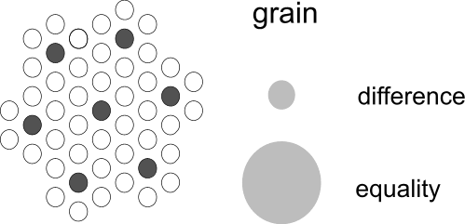
Fig. 1 Scale paradox
This state of affairs justifies a seemingly contradictory expression such as 'difference in equality'. The well known paradox ‘I Lie’ is a paradox of scale equalizing what I suppose to do and what the expression supposes about it (meta-language).

Difference In Equality is a paradox accepted in mathematics as well. For example, the left term of an equation is written differently from that of the right one, and yet we suppose equality expressed as ‘=’. Consequently there must be a difference left in that equality.
We may introduce this difference ourselves to match different practices (for example observing and using): we observe x, want to use y, and we can vary x independently, but y not without x.

‘Modality’ supposes different imaginations.
Assume we distinguish the modalities of possible, probable and desirable (Error: Reference source not found).

When the designer records the legend of his drawing, for instance red for urban areas, yellow for agriculture, and blue for water, he reduces the variation within the urban area, agriculture and water. If he makes a drawing with that legend unities, he first selects their site and form roughly and subsequently more precisely (state of dispersion). During the design process he reduces the tolerances of the design for the benefit of its realization.

The researcher reduces reality in variables, but does not accept that a variable may assume any arbitrary value. He looks for relations between the variables to restrict them in their freedom of movement in order to make more precise predictions.

The manager reduces the problems to a few items on the agenda and tries to reach consensus by appointments.

‘Change’ supposes a difference without denial.

‘Present’ supposes a boundary.
Change supposes difference from that boundary.

‘Past’ supposes a difference you can not deny.

‘Future’ supposes choice.

‘Representation’ supposes past or future in present.

‘Space’ supposes differences without change.

‘Time’ supposes difference of change.
If the horizon would turn with the orbit of the sun (or the face of a clock with its hands), they would not give any representation of time.

‘Period’ supposes different boundaries (time distance), ‘phase’ different periods.

‘Duration’ supposes a zero-value of change.

‘Theory’ supposes equalities or durations.
Theory supposes reduction in a world of differences and changes.

‘Operation’ supposes theory.
Conscious action (operation) supposes equalities and durations to change.

‘Logic’ supposes operations.

‘Realization’ supposes logic.

‘Continuity’ supposes contiguous change.
‘Continuity’ does not suppose duration.

‘Process’ supposes continuity.
There is difference in process.

‘Coincidence’ supposes a zero-value of process.
So, coincidence supposes discontinuity.

‘Stage’ supposes different contiguous phases in a process.

‘Increase’ supposes a stage of more, ‘decrease’ a stage of less.

‘Movement’ supposes duration in change of location.
Movement is a kind of process. There is difference in movement.

‘Rest’ supposes a zero-value of movement.

‘Order’ supposes equality in change.
If x changes, and y changes along with it, x and y are mutually ‘ordered’ as a result.
However, order does not yet suppose coherence or connection (see 3).

‘Coordination’ supposes different variations to be ordered.

‘Synchronization’ supposes coordination in time.

‘Disorder’ supposes a zero value of order (chaos).

‘Flow’ supposes order in movement.

‘Paradox of change’ supposes movement in rest.
The expression ‘rest in movement’ or a seemingly contradictory expression ‘movement in rest’ supposes difference of grain.

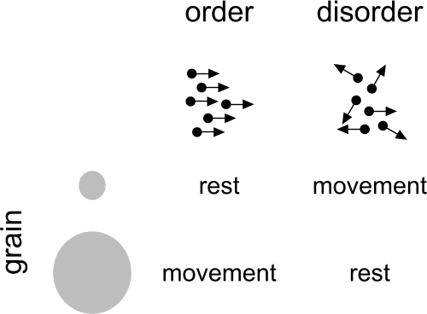
Fig. 2 Order in movement
The paradox of Achilles and the turtle supposes variation of grain in the process of imagination (scale paradox).

‘Theories of movement’ suppose different comparisons of movements.
For example, ‘orientation’ supposes the comparison of locations of movements, ‘speed’ of their distance and period, ‘acceleration’ of their speed and period. They all recognize equalities and durations.
However, the supposition of movement, 'duration in change of location' allows for more than these (physical) theories of movement.

‘Point of orientation’ supposes equality in movement.

‘Orientation’ supposes a point of orientation.

‘Approach’ supposes less, ‘receding’ more, and ‘circulation’ equal distance to the point of orientation.

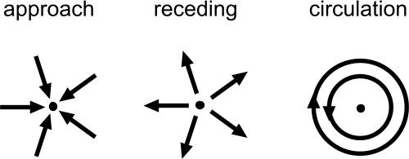
Fig. 3 Points of orientation
Points of orientation suppose points of approach, receding or centre.

‘Into’ supposes approach, ‘from’ receding.

‘Moments’ are points of orientation in time.

‘Sequence’ supposes order in these points.

‘Straight’ supposes a central distance larger than any imagined distance.

‘Concentric’ supposes equality of centre.

‘Parallel’ supposes concentric movement.

‘Direction’ supposes a point of approach or receding (vanishing point).

‘Opposite direction’ supposes equality in direction and difference in vanishing point.

‘Perpendicular’ supposes inward or outward movement directed on the centre of a circulation as vanishing point.

‘Line’ supposes an image of movement.
Consequently, a line can be observed before it is expressed.

‘Drawing’ a line supposes the realization of its image by moving.
Every contour can be drawn as a circulation around a centre since the equality of distance to the centre supposes a (small or large) grain.

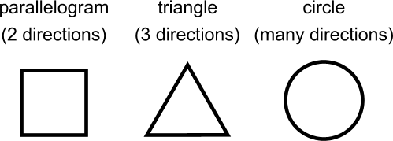
Fig. 4 Primary contours
A contour supposes at least one orientation, two directions or three changes of direction (corners).

‘Coherence’ supposes duration in change.
Coherence can not be observed, it can be supposed if an object changes less than its context.

‘Freedom’ supposes a zero value of coherence.
Freedom is always ‘freedom of change’, sometimes ‘freedom of movement’.

‘Substance’ (matter, energy, signal) supposes coherence.
Substance supposes ‘resistance to change’ (inertia).

‘Subject’ supposes substance.
In communication subjects like ‘I’ are the ‘first coherence’ to be supposed.
Speaking about ‘me’ objectifies the subject.

‘Other’ supposes coherence without subject.
Óther is something different from ‘different’, coherence is tacitly supposed.

‘World’ supposes a grain of coherence.
Speaking about your world you suppose a grain of coherence with your context (‘second coherence’ to be supposed). So, what you suppose outside of your world, you suppose to be beyond your experience. You (first coherence) are connected (second coherence) with facts (third coherence).

‘Fact’ supposes other coherence.

‘The case’ supposes coherence of fact and subject.

‘Not the case’ supposes a zero value of that coherence.

‘Full sentence’ supposes a change of fact.
A ‘full sentence’ supposes to express a change (the verb phrase) between different, coherent objects (noun phrases). One of the noun phrases could be an objectified subject. The full sentence makes sense if the change itself supposes coherence. Coherences can be expressed in a language. Full sentences can be ‘true’ or ‘false’ supposing confirmation and denial.

‘Concept’ supposes coherence in observations.

‘Conception’ supposes coherence in realization.

‘Conceptualisation’ supposes variation of concepts or conceptions.
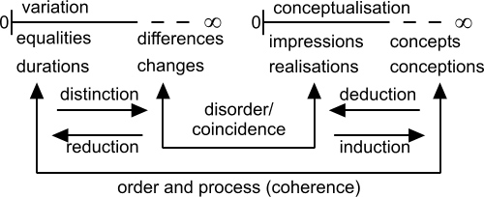
Fig. 5 Conceptual variation
You can speak about concepts or conceptions, so any set of concepts or conceptions can be conceptualised again into a new, more ‘abstract’ concept or conception.
However, you can not always de-conceptualise a concept or conception.
The zero-point of conceptualisation is observation or realization.

‘Induction’ supposes increase of conceptualisation.

‘Deduction’ supposes decrease of conceptualisation.
There are different kinds of induction.

‘Analysis’ or ‘synthesis’ suppose spatial induction.

‘Holism’ supposes a zero value of spatial induction.

‘Cause’ or ‘Initiative’ suppose temporal induction.

‘Synchronic’ or ‘spontaneous’ supposes a zero value of temporal induction.
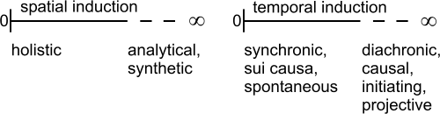
Fig. 6 Spatial and temporal induction

‘Effect’ supposes cause.
However, cause and effect have no fixed sequence.
A cause ----> effect
B cause <===> effect
C cause <---- effect
In the abiotic sphere it is presumed that cause precedes effect. In the biotic sphere there is a chicken - egg relation. In cultural processes it should be presumed that concepts regarding effect may precede the cause of a change (anticipation).

‘Structure’ supposes difference in coherence.
For example, our environment consists of objects that are very coherent (mountains, soil bound building substances in relative rest), and less coherent (air, water, energy, objects for daily use and people in relative movement or change). Together they are the structure of the built environment.
They permeate one another like architectonic mass and space and their intermediate values such as furniture and people).
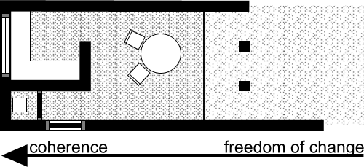
Fig. 7 Structure supposing different coherence

‘Function’ supposes change in coherence.
So, function supposes structure, while change supposes difference.
After a move, a household experiences its function in the new structure as a change in its coherence. Everyday life shows minor changes (change in activity), supposing different activities.

A function can be expressed in a ‘full sentence function’ like y(x), where x supposes a free subject, y an object in coherence with x and the brackets the verbal phrase. So, villa(landscape) means something else than landscape(villa). The verbal expression could be explained in a ‘function expression’ like f(x) =x². Raising x to the square is a change. A verbal expression f(landscape)=’landscape giving a view’, is an change as well. However, it can be interpreted as a ‘behaviour’ (‘characteristic’) or a ‘property’ (actively given attribute). So, property supposes a change, a function.

‘Property’ supposes function.
The word ‘of’ or the adjective form, sometimes derived from a verb as past participle suppose function.
‘Of’ supposes property.

‘Tool’ supposes function in structure.
For example if a structure directs incoherent movements into linear momentum or rotational force.

Fig. 8 Directing movements

‘Rule’ supposes order in function.
The structure of the board (tool) and the rules of play decrease the freedom of movement of a board game player, the freedom of pieces on the board and the coincidence of a dice.

‘Device’ supposes rules in tools.

‘Force’ supposes orientation in function.

‘Attraction’ supposes a substantial point of approach.

‘Repulstion’ supposes a substantial point of receding.

‘Rotation’ supposes a substantial point of centre.

‘Concentration’ supposes difference in substantial approach.

‘Deconcentration’ supposes difference in substantial receding.
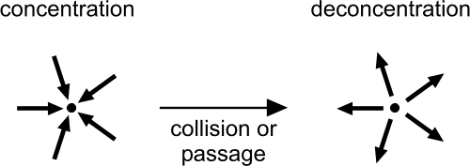
Fig. 9 Event

‘Event’ supposes change in forces.
After each concentration, deconcentration becomes more ‘probable’, for instance by the event of passage or collision.

‘Probability’ supposes different events.
Without a structure each process of different events has a probable direction.

‘Improbability’ supposes structure.
As soon as we suppose a cause for the improbability in a process we suppose a structure.
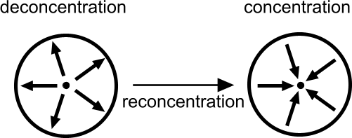
Fig. 10 Event
For instance, the process of reconcentration, though improbable in itself, becomes probable by means of the image of an attracting force increasing with distance or an enclosing structure.

Deterministic structures do not exist, because outside the grain of our image (both with regard to small and large) coincidence and disorder reign by definition.
Moreover, within our imagination (with a wink at Ryle) our will reigns, if we want it to.

‘Isolation’ supposes freedom in coherence.
An isolated part in a coherent whole can be removed from that structure.

‘Consistency’ supposes a zero-value of isolation.
So, you can not imagine consistency without referring to isolation.

‘Material’ supposes isolated substance.

‘Transition’ supposes difference in isolation.
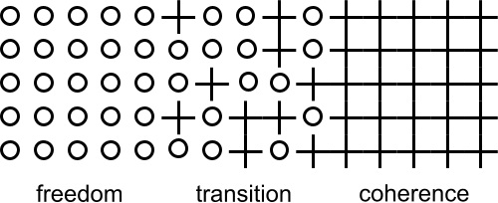
Fig. 11 Transition

‘Border’ supposes a zero-point of transition.
Consistency supposes a difference from that border: consistent freedom or consistent coherence.
So, consistency supposes contiguous freedom or contiguous coherence referring to each other (supposing larger coherence).

‘Body’ supposes inside coherence, outside freedom

‘Cavity’ supposes outside coherence, inside freedom.
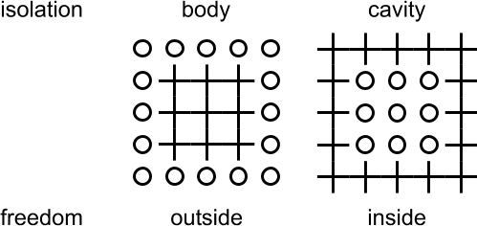
Fig. 12 Body and cavity
A body supposes more coherence than its context (oo++oo), a cavity the reverse (++oo++).
Supposing attracting forces and larger scale, cavity is less probable than body.

‘Dividing’ supposes increase of isolation

‘Uniting’ supposes decrease of isolation.
The effect of these functions or operations is multitude and part.
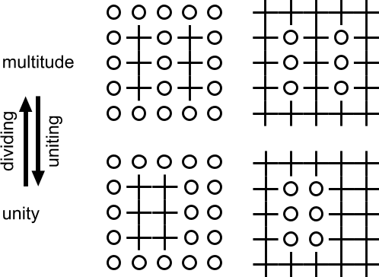
Fig. 13 Dividing and uniting

‘Multitude’ supposes uniting.

‘One’ supposes a zero-point of multitude.
The smallest multitude is two.

‘Part’ supposes dividing.

‘Unit’ supposes equality of parts.

‘Zero’ supposes a zero-point of unit.

‘Numbering’ supposes multitude.

‘Counting’ supposes equality in multitude.

‘Enclosure’ supposes isolation inside.

‘Inclusion’ supposes isolation outside.
So, inclusion supposes concentric contiguity.
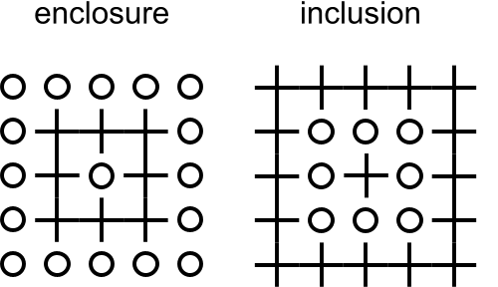
Fig. 14 Dividing and uniting
The technology of living nature and architecture find their focus in enclosure (the shaping of cells and space). The principles of construction find their focus in inclusion (packing, shutting in, bearing).
Enclosure and inclusion make it possible to differentiate between internal and external states.
‘Opennes’ supposes a zero-value of enclosure.
‘Looseness’ supposes a zero value of inclusion.

‘Distribution’ supposes grain of units and point.

‘Accumulation’ supposes equality of point in distribution.

‘Homogeneous’ supposes equality of attribute in accumulation.

‘Spread’ supposes difference of point in distribution.

‘Heterogeneous’ supposes difference of attribute in spread.
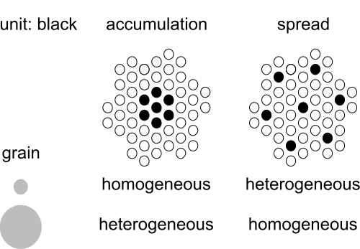
Fig. 15 Accumulation and spread

‘Subdivision’ supposes dividing into different parts.

‘Composition’ supposes uniting from different parts.

‘Development’ supposes isolation in process.

‘Standstill’ supposes a zero-value of development.

‘Occurrence’ supposes a grain of development.
Occurrences may occur alongside (adjacent to) one another or after one another (serial).

‘Adjacent’ supposes contiguously isolated.

‘State’ supposes a set of adjacent occurrences.
A state may border on another state with a spatial transition (insulation).
This transition may result in more (ooo -> +++) and less (+++ ->ooo) coherence.

‘Side’ supposes a transition into more coherence.
For example the North side of a room.

‘Edge’ supposes a transition into less coherence.
For example at the edge of town.
Every unit (body or hole) has at least two transitions in opposite direction.

‘Serial’ supposes continuously isolated.

‘Stadium’ supposes a set of serial occurrences
A stadium may change into another stadium temporal transition.

‘Binding’ supposes a transition to more coherence.

‘Unbinding’ supposes a transition to less coherence.

‘Selection’ supposes consistency in isolation.

‘Mixing’ supposes a zero value of selection.
Selection may be restricted to one, two or three directions as well as to time.

‘Selecting’ supposes different stadia of selection.

‘Separating’ supposes selecting into more isolation.

‘Connecting’ supposes selecting into less isolation.

‘Selective material’ supposes different states of selection.
Selective material supposes different states of selection on two sides of a body or a cavity by separation (<>) or connection (><).

‘Separation’ supposes a separating selective material.
Separation supposes coherence in the separating material (<+++>).

‘Connection' supposes a zero-value of separation.

‘Dynamic separation’ supposes more coherence than the separated states (ooo<+++>ooo).

‘Dynamic connection’ supposes freedom (ooo<ooo>ooo).

‘Static’ supposes coherence (+++<+++>+++).
Statics and dynamics suppose a theory of their respective function.

‘Selective structures’ suppose different functions in different directions.

‘Wall’ supposes a dynamic separation in two opposite directions.

‘Column’ supposes static separation in two opposite directions.

‘Tube’ supposes a dynamic connection in two opposite directions.

‘Tensile stave’ supposes a static connection in two opposite directions.
A separation supposes connection perpendicular to separation and the reverse. (Van Leeuwen, 1971, Basic paradox of spatial order).
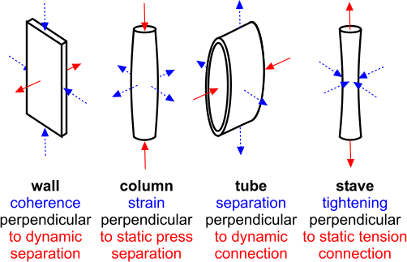
Fig. 16 Perpendicularly opposite additional functions
A static function may be combined with a dynamic one perpendicular to that function and the reverse.

‘Selector’ supposes difference in selective functions.

‘Resistance’ supposes separation from approach.

‘Retention’ supposes separation of deceding.
Examples are sluices ( >> ) around a polder (<< polder >>) or a reservoir (>> reservoir <<).

‘Reservoir’ supposes dynamic connection into one direction and separation into the other directions.
For example a barrel or basin retains water in five directions, whereas the force of gravity retains the water in the sixth (upward) direction. However from above no water is resisted.

‘Valve’ supposes separation in one direction and connection in the opposite direction.
Gravity can serve as a valve.

‘Sieve’ supposes selection of attributes.
For example different measures of extend.

‘Tap’ supposes change in separation.
For example opening and closing.

‘Inlet’ supposes connection of approach (input, import, food, consumption) and separation of deceding (resistance).

‘Outlet’ supposes connection of deceding (output, export, disposal, production) and separation of approach (retention).
(Van Leeuwen, 1971)

‘Metabolism’ supposes inlet and outlet of material
For example food and disposal.

‘Energy exchange’ supposes selective inlet and outlet of energies or signals, resisting and retaining other material.
For example heat exchange.

‘Signal exchange’ supposes inlet and outlet of signals, resisting and retaining other material.
For example measuring.

‘Mechanism’ supposes selection of motion.
For instance, enclosed motion supposes selection of motion within an inclusion.

‘Wheel’ supposes selection of rotation within an inclusion

‘Conduction’ supposes selection of direction within an inclusion.

‘Coupling’ supposes composition of mechanisms.
Selection mechanisms suppose change of composition by means of enclosed motion.
The result of this change, the product, may be more or less difference in the composition between different substances. For example sieving and mixing.
Selection mechanisms suppose structure and function because it is always a matter of more (the mechanism) and of less coherence (the substance subordinate to and moving through the mechanism).

‘Apparatus’ supposes composition of mechanisms.
Apparatus is the last a-biotic concept we need to investigate the suppositions of life.

Suppositions of life and culture

Ongoing conditional analysis
On page Error: Reference source not found I supposed cultural suppositions (C) suppose biotic (B) and biotic a-biotic (A).
An ongoing inquiry into these suppositions could be outlined as follows:

A1 Difference is supposed;
A2 change supposes a difference without denial,
A3 coherence duration in change,
A4 isolation freedom in coherence,
A5 selection consistency in isolation,
B1 use difference in selection,
B2 regulation change in use,
B3 organisation coherence in regulation,
B4 specialization isolation in organisation,
B5 reproduction selection in specialization,
C1 information used reproduction,
C2 certainty regular information,
C3 affection organized certainty,
C4 identity specific affection,
C5 influence reproduced identity.
Fig. 17 Conditional analysis of life and culture
To walk the way back: I can not imagine a human, group or culture having any influential power without identity.
Identity, on its turn, I can not imagine without any affective interaction based on a special position.
Affection, attachment, whether it contains positive feelings or not, supposes organized certainty.
And so on.
P.M.

Suppositions of academic disciplines
Cooperating academic disciplines (subcultures) are confronted by different tacit suppositions in communication. An inquiry into these suppositions is a primary, but often neglected task of philosophy.
P.M.

Index

‘I lie’ 6
= 6
a priori 3
acceleration 8
accumulation 15
Achilles 8
adjacent 15
agenda 6
analysis 11
anticipation 11
apparatus 17
appointments 6
approach 8
association 4
attention 3
attraction 12
attribute 4; 11
bases for comparison 3
behaviour 11
binding 15
body 13
border 13
boundary 3; 7
case 3
cases 3
category 3
cause 11
cavity 13
change 7
change in activity 11
chaos 7
characteristic 11
choice 3
circulation 8
classification 3
coincidence 7
column 16
combination 13
comparison 3
composition 5; 15
concentration 12
concentric 8
concentric contigui 14
concept 10
conception 10
conceptualisation 10
conduction 17
confirmation 3; 10
connecting 16
connection 16
conscious action 7
consistency 13
context 3
contiguous 4
continuity 7
continuous change 7
contour 5; 8; 9
coordination 7
corner 9
countable 5
counting 14
coupling 17
criterion 5
deconcentration 12
decrease 7
deduction 10
denial 3; 10
denumerable 5
design 5
desirable 6
deterministic structures 12
development 15
device 12
diagram 4
difference 3
difference in equality 6
direction 8
disorder 7
distance 3
distinction 4
distribution 15
dividing 14
drawing 8
duration 7
'duration in change of place 8
dynamic connection 16
dynamic separation 16
dynamics 16
edge 15
effect 11
enclosure 14
equal intervals 5
equality 3
equation 4; 6
event 12
exact expression 4
exchange of energy 17
existent 3
experience 4
expression 4
fact 10
false 10
flow 7
force 12
form 5
frame 5
freedom 10
full sentence 10
full sentence function 11
function 11
function expression 11
future 7
grain 3
heterogeneous 15
holism 11
homogeneous 15
identification 4
image 4
imagination 5
impression 3
in 3
inclusion 14
increase 7
induction 10
inertia 10
initiative 11
inlet 17
inside 3
intelligence 4
internal perception 4
isolation 13
label 4
language 4
Leeuwen, van 3
legend 5; 6
legend unit 5
less 3
line 8
literal 5
looseness 14
mark 4
material 13
mathematics 7
measurable 5
measure 3
memory 4
metabolism 17
mixing 16
modality 6
moments 8
more 3
move 11
movement 7
movement in rest 7
multitude 14
not 3
not the case 10
noun phrase 10
numbering 14
object 3
observation 4
occasion 4
occurrence 15
of 11
one 14
opennes 14
operation 7
opposite direction 8
order 7
ordinal 5
orientation 8
other 10
outlet 17
outside 3
paradox 5
paradox of scale 5
parallel 8
part 14
past 7
pattern 5
perception 4
period 7
perpendicular 8
phase 7
Piaget 4
place 3
poetic expression 4
point 4
point of orientation 8
possible 6
present 7
probability 12
probable 6
process 7
property 11
proportion 4
proposal 5
quality 4
quantity 3; 4
question 3
rational 5
realization 7
reason 4
receding 8
reconcentration 12
reduction 4
reduction of scale 5
relations 6
repetition 3
representation 3; 7
repulstion 12
reservoir 16
resistance 16
resistance to change 10
resolution 5
rest 7
rest in movement 7
retention 16
Ross Ashby 3
rotation 12
rule 12
scale paradox 8
selecting 16
selection 16
selective functions 16
selective material 16
selector 16
separating 16
separation 16
sequence 8
serial 15
set 5
side 15
sieve 17
signal exchange 17
space 7
speed 8
spontaneous 11
spread 15
stadium 15
stage 7
standstill 15
state 15
state of dispersion 5; 6
static 16
statics 16
Stevens 5
straight 8
structure 11
subdivision 15
subject 10
sub-set 5
substance 10
synchronic 11
synchronization 7
synthesis 11
tap 17
tensile stave 16
the case 10
theories of movement 8
theory 7
time 7
tolerance 6
tool 12
transition 13
true 10
tube 16
type 3
unbinding 15
unit 14
uniting 14
value 5
valve 16
variable 5; 6
variation 3
verb phrase 10
verbal 5
verbal expression 11
viewpoint 4
wall 16
whatness 4
wheel 17
without 3
world 10
zero 14
zero-value 5

Figures
Fig. 1 Scale paradox 6
Fig. 2 Order in movement 8
Fig. 3 Points of orientation 8
Fig. 4 Primary contours 9
Fig. 5 Conceptual variation 10
Fig. 6 Spatial and temporal induction 11
Fig. 7 Structure supposing different coherence 11
Fig. 8 Directing movements 12
Fig. 9 Event 12
Fig. 10 Event 12
Fig. 11 Transition 13
Fig. 12 Body and cavity 13
Fig. 13 Dividing and uniting 14
Fig. 14 Dividing and uniting 14
Fig. 15 Accumulation and spread 15
Fig. 16 Perpendicularly opposite additional functions 16
Fig. 17 Conditional analysis of life and culture 18

