Introduction
It is improbable you will read the same thoughts as mine while I was writing.
It is possible, but the question is, if it is desirable. Text and images are a tool. If you can use this text and images, use them. They will live their own unexpected life in your imagination.
If cited, I will not reject such interpretations unasked, trying to explain ‘what I really meant’ as long as it does not matter. Interpretations, useless or even harmful to me if I would use them that way myself, in my contexts of ecology, education, computer programming or urban design, may be surprising. Surprise is more than recognition. Not mistake or doubt, but surprise convinces me there is more. Recognition confirms what we supposed earlier, but surprise indicates there is more.
So, do not expect anything, but be surprised. Surprise supposes a choice for attention, fascination.
Surprise is the very source of scientific doubt and curiosity. Surprise makes a difference.

Suppositions of context
Our personal context and history fill our thoughts with suppositions. We suppose we share them with kindred spirits in a culture, but we never know. So, you will probably use other suppositions reading this text than I writing them. Let us see if it survives in an other context. If we were all the same, then just one of us would be enough for any known effort. There would be no need for communication, cooperation, specialization, market or trade. Every second equal human would make our own existence meaningless. But without other people the meaning of ‘meaning’ fades as well. So, we do not really need equal people, we need different people. And the evolution of life seems to provide that difference. Difference makes a difference.

Suppositions of culture
We suppose we share suppositions, otherwise I had to start this text summing up all of its suppositions. That would be boring. It would start by texts like “Suppose we are humans”; “Suppose we have thoughts”; “Suppose these thoughts can be transferred by text”; “Suppose you will not kill me because of what I claim”; “Suppose there will be no flooding in the area I am writing or where you are reading”; “Suppose …” and so on, explaining every several word like ‘human’, ‘thought’, ‘text’, explanation and so on. It could end by texts like “Then I could write a text”; “Shall I write a text?”. Fortunately I do not have to write texts like that, because I suppose we share these suppositions in a ‘set of suppositions by communication (culture).
That culture (including writing and reading) I tacitly suppose writing texts.

Suppositions not taken for granted
However, I am not satisfied taking these tacit suppositions for granted. It is the aim of this text to clarify them, to skip suppositions (even words) I do not need to represent what I mean, to minimize the number of suppositions. That will avoid useless complications in communication.
I supposed to discover any supposition has its own suppositions, except the supposition of ‘difference’. Even ‘equality’ supposes ‘difference’ as I understood Ross Ashby, otherwise we are not able to compare. We can compare different things only. If we conclude equality between them we mean the difference is very small, for example no other perceivable difference than a difference in space or time. Even if we indicate the same thing two times to conclude it remains equal, there should be a ‘difference in time’ to conclude equality. In that case, we suppose we can not count it as two things (double counting), because counting supposes different things being ‘equal’, an important paradoxical supposition of mathematics.

Suppositions of defining
We can not define ‘difference’ without using the concept of difference itself. Defining something means making difference with ‘other’ (different) concepts after all. The paradox of deductive (extensional) defining is, a definition moves the problem of ill-defined concepts into other concepts. They have to be defined as well. Where is the end? Inductive (intensional) defining is peeling off the concept by stating counterexamples until we can suppose something ‘all’ examples have in common (an ‘essence’ like ‘tree-ness’, ‘horse-ness”), but we never will reach ‘all’ examples and we have to define ‘essence’ at last. However, we can analyse what we need at least for any definition. For example, to define variation we need at least the concept of difference. We suppose difference. So, this text does not aim for definitions, but for their suppositions. Then, the word ‘is’ is substituted by ‘supposes’, which is less.

Difference not defined
To define difference as ‘non-equality’ is absurd in two ways. Firstly, ‘equality’ supposes difference, how small it may be, because without that difference comparing to conclude equality is impossible. Secondly, ‘non’ supposes ‘difference’ also. Studying both kinds of difference we have to conclude they are different. So, there are different differences. The first (equality) is ‘difference too small to observe or take into account’, the other (non) is a supposed ‘complete’ difference. From equality we can not derive difference, but from difference we can derive equality like a ‘zero point’ of difference. A given difference always can be increased, but not always decreased, reaching ‘zero difference’. So, I start by difference, where others take equality as a starting point.

Space supposes difference
Difference is supposed by any impression from the supposed outside world and it is supposed in our inside world of imagination as well. If everything would be white, we could see nothing and derive no imagination out of it. If nothing differs I can not imagine anything. The objects of the outside world are not transferred into our imagination, their differences are. I suppose differences within my head as I suppose them outside. Difference does not have ‘extent’ like objects have. Difference is what we suppose between objects, even if they are adjacent. And we need to suppose difference first to conclude there may be an object to be distinguished from its context. That distinction makes a notion of extent possible. I can not imagine extent without difference, but I can imagine difference without extent. So, I can not imagine space without difference. Difference is supposed in the imagination of space, not the reverse. So, you do not need a category of space as an innate (a priori) faculty as Aristoteles and Kant probably supposed.

Time supposes difference
I can re-present (bring back to present) a disappeared difference, object or context. That first ability of imagination without actual external impression I simply would call memory. It is what I have learned as a child by playing peek-a-boo. If an impression differs from memory I can create a notion of change by next impressions. So, change supposes difference. If nothing changes I can not get a notion of time. But time supposes more than change, it supposes difference in change. If the horizon would move with the sun or the dial of a clock with its hands, I could not read off ‘time’, whatever that may be. People can loose their notion of time, keeping their notion of space (difference in location). It is a well-known disease to be repaired by a therapy connecting occasions to locations. If there is little difference between a recent memory and an actual impression I can get a notion called object-constancy, and by changing the context a notion of movement. If that memory is not recent it is called re-cognition.

Repetition
Recognition is the foundation of imagining repetition. Children start learning by moving their eyes, head or body, receiving repeated impressions to be recognized. Counting starts with making a kind of difference in repeated impressions: the first time, the second time, next time. Recognition supposes a successive order between the recognized and the representation. Memory does not, but we can imagine the order of equal impressions itself by adding difference (labels evolving to successive numbers). A label is different from the labelled. Imagining duration of time supposes a second (next) time. A second as a time unit supposes a second time, imagined by ‘distance’. Distance supposes two differences: one at the beginning, one at the end, be it in space or time. One kind of difference between these differences is called distance (there may be other differences). Learning to walk step by step stimulates the imagination of repetition as such, reinforcing a notion of distance, produced by object constancy of moving objects.

Reason supposes repetition
By practising repeated actions (making the same changes) you meet with physical boundaries, but you can imagine repetition without these boundaries. You can imagine repetition of experienced repetitions as a new concept on its own. Your travel of more than one day repeats days of repeated steps. ‘Travel’ gets a meaning. By doing so, you need no sensory impressions anymore excluding disturbing kinds of difference reality shows. Your physical steps by walking and your days of travel are different from each other after all. However, your meta-physical (supposed) steps and days are not. So, you can suppose absolute equality, forgetting the differences. Imagining repetition and equality is the very start of mathematics, expressed in the phrase “And so on”. It makes the number of numbers infinite, even if you did not count (label) them actually. It makes the proof by ‘complete induction’ acceptable, while induction in practice can never proof absolute truth. It is the foundation of the concept of rule, caught in the word ‘so’. The imagination of ‘rule’ neglects differences in change.

Sequence of suppositions
After this analytical remarks I would like to start a systematic constructive study of suppositions asking “Could you imagine A without B? Could you imagine the reverse?”. That method of test on any pair of concepts I call ‘conditional analysis’. Depending on the answer, I conclude a sequence ending by the concept of difference. However, I write down that inquiry in the reverse order, starting by ‘difference’ to get a systematic bottom-up tree of concepts. I study the possibilities of imagination mutually testing a limited set of concepts, possibly relevant for science, design and art. You can test these or other pairs of concepts yourself in the same way. Be prepared, the term ‘conditional’ in the name of the method ‘conditional analysis’ is not the same as set-theoretical inclusions, logical conditionals or causal premises, based on the concept of ‘truth’ or ‘probability’. This treatise is about conditions that do not make things necessary or probable, but only possible and imaginable. Referring to design I call them ‘technical conditions’.

Contexts of use
By doing so, I include other language games than those concerning necessity, truth or probability alone. In empirical science, designers are necessarily supposed to be liars: they draw non-existing things that are not true or ‘the case’. However, the question is, whether they are possible or desirable, part of other language games, where common scientific criteria like reliability and validity, openness to critics have an other use and meaning. These language games are always present in design practice (Fig. 1).

Language games: | being able | knowing | choosing
Modalities: | possible | probable | desirable
Sectors: | technique | science | management
Activities: | design | research | policy
Reductions as to
Character, mark: | legend | variables | agenda
Location or time: | tolerances | relations | appointments
Fig. 1 Three language games
The relation of these language games can be visualized concerning different futures as Venn-diagrams (Fig. 2). Any probable future is per definition possible, otherwise it could not be probable. But not all possible futures are also probable. Improbable futures cannot be predicted, they have to be designed. A desirable future can be probable, possible or impossible. If it is probable, we can wait, we do not have to do something to fulfil our desires. But if a desired future is not probable, we have to do something and set aims. However, if they are not possible we better forget them. If there are probable futures we do not want, we have got a problem.

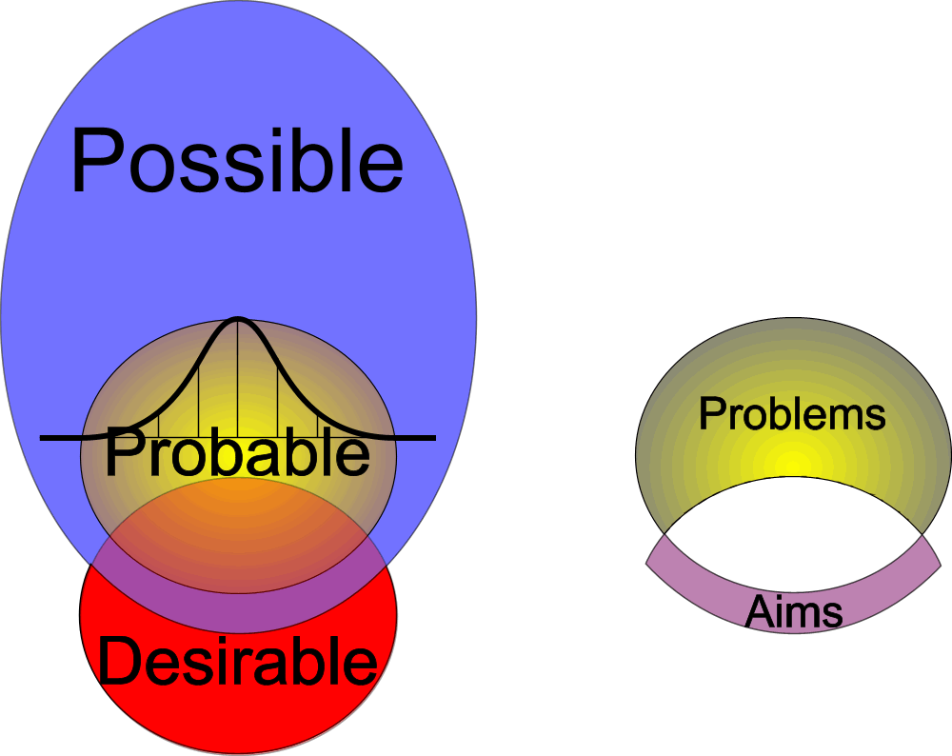
Fig. 2 Three interconnected futures
By talking about futures, the term ‘possible’ is not restricted to the actual possible. It is supposed to be possible at all. Is there anything more? Yes, there are imaginable futures. It is the task of art to make them imaginable. But I do not draw their boundaries, because I can not imagine the other side, the unimaginable. Not all probable or even possible futures may be imaginable. So we need artists to make them imaginable, like Leonardo da Vinci did, drawing the interior of our body, or Constant drawing urban structures for homo ludens. The designer has to explore the boundaries of possibility. So, covering the other language games as well by testing their vocabulary may help communication.

Suppositions as conditions
Aiming this, I started to compare approximately 200 concepts with each other, which implies 200 unknown conditional sequences in approximately 40 000 comparisons. In this treatise they have got a supposed final sequence of technical conditionality. I chose only concepts that have a meaning supposed in the ‘real world’ as well as in our ‘imagination’ and therefore in all conceivable possible worlds. So I can exchange the words ‘technical condition’ and ‘supposition’. This gives me the opportunity to use the expression "B supposes A" when I mean “A is a technical condition for B”.

Suppositions of logic and causation
Thinking this way I supposed to discover that causal relations suppose logical operations and that logical operations suppose technical conditions like rule, operation, change, variables, variation and difference. I can imagine variation and supposed concepts without logic and causal concepts, but the reverse I cannot. So variation and related concepts like variables are a technical condition for logic and causal thinking (and perhaps other ways of thinking). That means, logic or causal thinking are not the very start of human thinking. They already suppose a rational way of thinking that can be done without them, laying their foundations: conditional thinking. So logic and causal thinking are perhaps a special kind of conditional thinking, but not every kind of conditional thinking is necessarily logical or causal. Every cause is a technical condition for something to happen, but not every technical condition is also a cause for that event. If a house needs a foundation, it is a technical condition for the existence of the house, but not its cause.

Supposed making
This is especially important for ecology (context science) and the design of environments. Design is often supposed to be rather an art than a science. Yet the development of science supposed lots of designs, not the reverse. Science itself is a human construction. I can imagine design without science, but I cannot imagine science without design: the design of workspaces, instruments and diagrams (reducing reality into conceivable sets of phenomena, suitable for logic and causal treatment). Designs have made science possible and after that, science on its turn became a factor in design. Some futures can be predicted, others have to be designed.
Probable futures can be predicted on the basis of supposed causal relations, possible futures have to be designed as long as they are not probable. A design is an image that can be realized, formulating all technical conditions by which the aimed possibilities arise. Anything that is probable should be possible, but not anything possible has to be probable.
From the viewpoint of the ecological crisis this is a hopeful thought. Our probable futures are so gloomy, that only possible futures that are not probable could give us any perspective. Exactly these futures have to be designed.

Conditions for life
But there are more relations between conditional thinking and ecology. One could define ecology as the science concerning conditions making life possible. This global definition can be made more precise by substituting a-biotic, biotic, technical, economical, political or cultural conditions and vegetal, animal, human, social or "everyday-" life. An important problem in ecology is, that you can seldom predict what will happen under given conditions, because of the large set of possibly relevant conditions or condition-effect-relationships or the intermingling of what we suppose to be condition and effect (chicken-and-egg). We suppose to know 10% of all species on earth, but from most of them we do not know the relationship with their environment. Within every species any example differs, and lives in a different environment. We suppose a different or changing environment selects the fittest by survival. Their offspring diverges and so on (evolution). Man can live in different environments by adapting his environment. Which ‘brilliant accident’ conditioned man to do so? To suppose the introduction of more than one condition like Kant’s categories or the 16 operators of logic at once looks like intelligent design. So, this project tries to reduce that number of suppositions.

Conditions making possible
A species can appear under different combinations of mostly very delicate, often unexpected conditions. So we only seldom can definitely say what conditions are sufficient to make a species or ecosystem probable to appear. But we know by (often bad) experience what certainly will not happen when special (necessary) conditions are lacking. In that perspective environmental problems simply are "lacking conditions" for "life" (whatever you substitute for it). However, bringing back these conditions by design often seems not to solve the problem, because we did not know all necessary conditions or because the lacking conditions appeared to have lacking unknown preconditions themselves. The latter is the subject of this study: the way conditions we can imagine make each other possible.
In other words: what are the preconditions of every imaginable condition?

A-biotical conditions first
However, this study is limited to a-biotic conditions (A). The study of biotical (B) and cultural (C) conditions are beyond its scope (though I will give a study proposal in the end). But they suppose a-biotical conditions. I cannot imagine C without B and I cannot imagine B without A. So, I have to study a-biotical conditions first. They suppose less.
I want to include context, but I can not divide attention on different objects simultaneously, so I can not but start by supposing difference between context and object of attention. Perhaps there are more tacit suppositions in this treatise. The reader has to decide. But be prepared, I have to use the logic of language to express pre-logic suppositions. Tacit suppositions are difficult to unveil. But, an attempt is better than none. Though I have restricted myself in the number of suppositions per supposition, the reader can add suppositions approaching a definition.

Augustinus
Descartes
Ockham
Ross Ashby
Frege
Popper
Sivadon
Jong,
Wittgenstein
Jong (1992)

