The progress of a 1:25 000 Master plan for Adapazarı
Prof.dr.ir. Taeke M. de Jong 2006-05-30

Data
Within a very short time the Municipality of Adapazarı made great progress in collecting data concerning the development of Marmora region and within that region the development of Sakarya and within Sakarya the development of Adapazarı. On a local scale many data are now available on a sophisticated CAD-GIS system. Surveys on a larger scale than Adapazarı are important to determine the identity of Adapazarı and to make a common vision on its future. From that survey it clearly turns out Adapazarı is a gateway from Ankara and the Northern part of Turkey to Marmora region, struggling with the same problems as other gateways (Edirne, Bursa) in the west and South of the Marmora region. From these gateways Adapazarı has the greatest economic importance and potency, the greatest physical risks, but also the greatest ecological value in terms of air, water, a number of ecological, infrastructural, cultural, recreational, economic and managerial advantages.

Scenarios
It is no surprise then, that the pressure on Adapazarı comes from both sides: from the Marmora region and from the rest of Turkey. Immigration into this area is difficult to predict. So, in my opinion any Master Plan needs the worst case as a starting point: 2 000 000 inhabitants in 2030. If that turns out to be too high, it will be reached later anyhow. Last year I made two extreme scenarios for 2 000 000 inhabitants.

 | 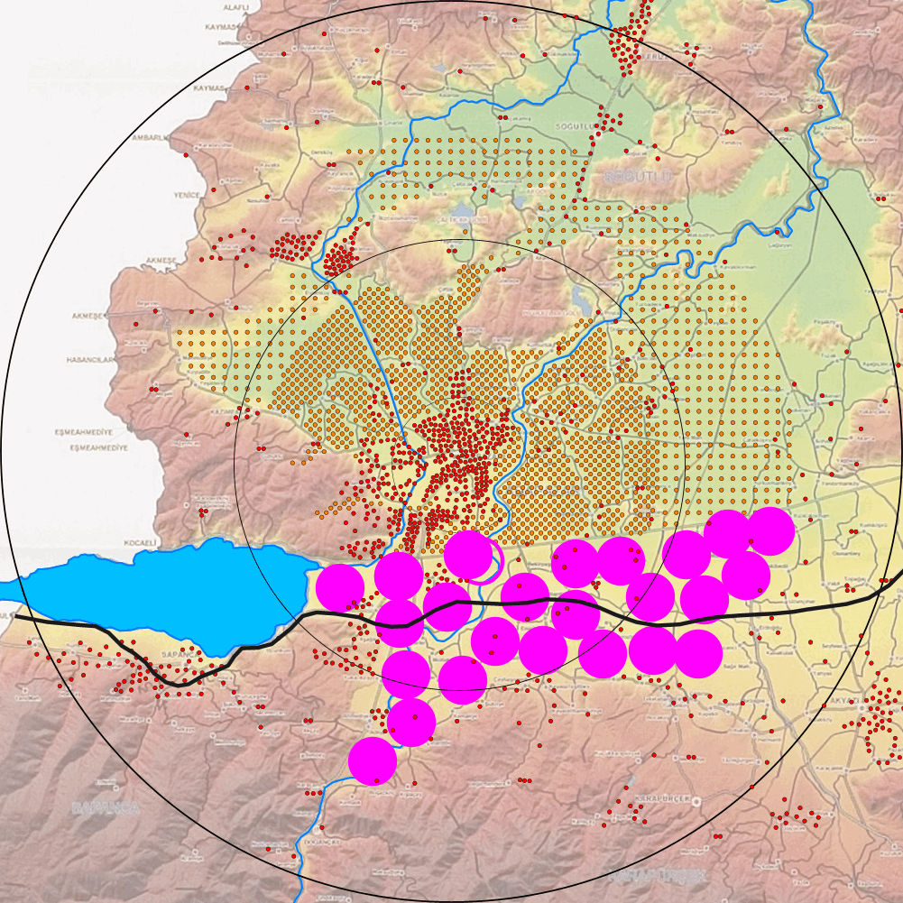 | 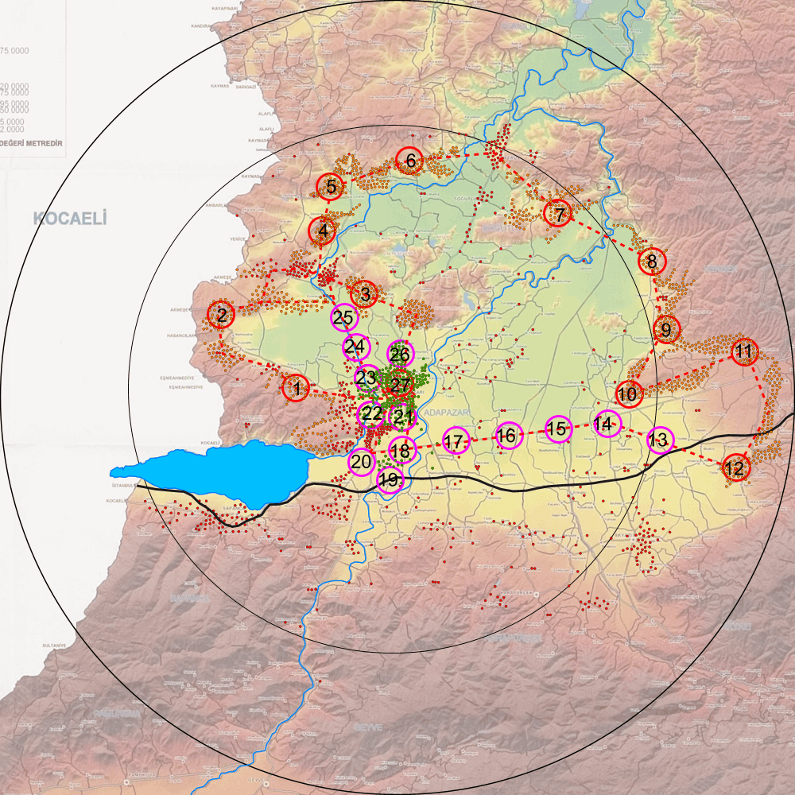
H10
Fig. 1 Actual population of Adapazarı 2005 | Fig. 2 A high-risk scenario 2030 | Fig. 3 A low-risk scenario 2030
Fig. 1 shows an interpretation of the actual Adapazarı population (Turkey) situated in a representation of its physical environment. The population is represented in dots of 1000 inhabitants (400000 inhabitants, 400 dots). The scale of the map is readable by the radius of circles R=10km, R=20km and R=30km.

I sketched two extreme scenarios for 2 000 000 inhabitants in 2030 (see Fig. 2 and Fig. 3).
Fig. 2 shows an imaginable metropolis in 2030 without master plan and supervision concentrically grown from R=3 into R=15km and further in an area with very high earthquake-risks. Larger pink dots R=3km indicate the imaginable wild industrial settlements around the highway Istanbul-Ankara (black line) near the earthquake-fault, caused by an overflow of the Marmora region. The roughly estimated number of casualties by a next earthquake is at least 100 000 inhabitants.

Risk reduction
An accurately realized and maintained master plan can reduce the physical, ecological, technological, economic, cultural and managerial risks of such a development (see Fig. 3), but the consequences of this scenario are big: 200 000 inhabitants have to be evacuated into safer places. Industrial settlements and recreational facilities replace the free coming residential areas (green spots in Fig. 3) and close a ring of infrastructure for commuter traffic and intermediary deliveries. The number of casualties by a next earthquake is difficult to estimate. It depends on many managerial (maintenance), cultural (risk-perception and -acceptation), economic (paying the measures), technological (earthquake-resistant construction), ecological (population growth, vegetation and land slides) and time-spatial (spatial possibilities within a time-frame) factors. Of course everybody hopes there will be no casualties at all (zero-risk scenario).

Risk levels
It is clear that both sketched scenarios are not very probable. The question is, to find a realistic (manageable, acceptable, payable, technically executable, sustainable, spatially and temporally fitting) scenario in between the extremes as close to a zero-risk scenario as possible (see Fig. 4).  And time works against that desirable development. The longer we postpone necessary measures, the closer a high-risk scenario becomes probable. | 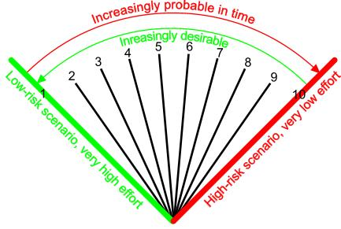
 | Fig. 4 From zero into high risk

Risk acceptance
Now, we can evaluate scenarios and plans between the extremes of risk level 1 and 10.
It is clear anybody is inclined to choose scenario 0 without any casualties.
But suppose it is calculated to realize scenario ‘1’ already will cost the total 100% actual income of the population per year, scenario ‘2’ is calculated to cost 50% and scenario ‘3’ will cost 33% and so on.

In other words, suppose the income tax for everybody will be the total 100% of the actual income per person per year for scenario ‘1’, 50% for scenario ‘2’, 33% for scenario ‘3’ and so on.

Fig. 5 An imaginable relation of costs per scenario
These suppositions are of course imaginary, but they are possible.

The preliminary Adapazarı 1 : 25 000 master plan
Within a very short time the Municipality of Adapazarı made great progress in preparing a master plan concerning managerial, cultural, economic, technological (connections), ecological and physical sectors in a rather balanced way, supposing there will be ample 1 000 000 inhabitants in 2030. If this master plan is realised, the air and water will be safe to breeze and drink. The Sapanca Lake is properly protected. There will be very much space on appropriate places for employment, not polluting the air of residential areas, to be reached by fast connections. There will be great opportunities for recreation in northern urban forests, alongside the river Sakarya and on the Southern slopes of impressive mountains. The old city of Adapazarı gets space to become a culturally attractive historic centre, extending in a modern style into the safer West. Most of the inhabitants will live in relatively safe areas with beautiful views on a Green Heart with diversified agriculture, nature reserves and forests..

The preliminary Sakarya 1 : 100 000 master plan
However, the preliminary 1 : 100 000 plan is still a purely economic plan. It indicates some space for industrial areas, connected by an improved road and some space for undetermined development on risky places. No more, if you believe the map. This plan does not reduce any risk. If the population or its income will grow, the existing unsafe areas will have to be intensified by high rise building, even increasing the existing risks.

Conclusion
The preliminary master plans 1:25000 and 1:100000 are not coherent with each other. The first solves many managerial, cultural, economic, technological, ecological and physical problems at once, 1:100000 only solves some economic problems, raising many others, not cashing the potential of the region. If you ask me what risk level they have, I would judge the last to have the highest risk: 10. For the preliminary 1:25000 I estimate a risk level 4.

Prof dr Ir Taeke de Jong , Delft Unıversity of Technology , Rektör Yardımcısı , Urbanism Öğretim Üyesi , Bilim Kurulu Başkanı (10 dk) Key words: 1:25 000 Ölçekli Nazım İmar Planı Çalışması Görüş ve Önerileri, Adapazarının geleceğindeki riskleri ve öneriler. Koruma kullanma dengesi içerisinde Adapazarının değerleri , Sapanca Gölü , tarım alanları , orman alanları

