OPERATIONAL CONTEXT ANALYSIS

As a part of design related study and research

TAEKE M. DE JONG

taekemdejong@outlook.com

http://taekemdejong.nl/

Faculty of Architecture Delft University

• Abstract:
Context analysis is a necessary part of any study or research project related to architectural, landscape architectural, urban and, within these domains, technical and managerial design. This paper reports the development of a method, used by ample 1000 students for several years to get grip on the vague concept of ‘context’ within these domains: an operational way of context analysis in design practice. It is meant to raise discussion about its value, possibilities to improve it or develop alternatives. Secondly it deals with context analysis as a tool to make research and study proposals in these domains as long as the object of study is not yet determined by design. For the application as a tool like that, a computer program named 'FutureImpact' has been developed, meant for clarification only. Finally the larger scope for both design study and practice, empirical research and management or policy in these domains will be elaborated in a methodological sense: the distinction between possible, probable and desirable futures. The paper concludes problem and target isolation usual in methods of empirical design are insufficient in design related study and research. The disadvantages of broadening demarcated problems and targets into fields of problems and targets could be solved by a proper context analysis beforehand.

• Keywords:
Context; Methodology; Architecture; Urban design; Landscape architecture; design research; typology; design study; study by design.

1. Introduction
'Context' is a broad and general term frequently used in design disciplines like architecture, landscape architecture and urban design. It looks beyond the design intervention both in the social and physical sense and also in terms of design philosophy and theory. In this paper first of all we will put forward the importance of context from a methodological point of view. Secondly we will make clear that context plays a role in all design interventions be it often implicit. Designers, students, researchers should become aware of the different dimensions it can add to the design and to design related study proposals. Finally 'context' can play a role in design critique and theory development.
The focus of the paper is on design study; the role of case-studies and precedents get most attention.

The paper is set up in three parts. In the first part we will pay attention to what 'context' means in design disciplines. In the second part two specific aspects of context are worked out: the role of case-studies and precedents in design research and the concept of scale. In the third part, we will work out the application of 'Future Impact' — a computer application — as a means to come to grips with the context in a variety of research projects. We will conclude with proposals for application of 'context' in research proposals, precedent analysis and theory development.

2. Problem definition and research questions
What is the role of context in research of design disciplines?
How can the concept of context be made operational in design related disciplines?
In what way could this method made applicable for day-to-day design?

3. What is 'context' in design disciplines and how can it be used in research?
The concept of 'context' and the search for a method of 'context analysis' are not new. They are widely present in literary analysis, strategy planning but also in business administration.
Design can be seen as proposing an intervention in an existing physical environment and society.

This environment can be considered as the 'context' of any design intervention, be it physical or social. The question is how it can be made explicit in day-to-day design and in what way it can generate productive conditions for the development of a design.

‘Context’ in architectural design deals with the relation of the future architectural artifact in its social and physical surrounding, a landscape or an urban situation. The Modern Movement is often seen as a design approach that stands for neglecting or at least not paying much attention to context. Whether that is true or not, in the second half of the last century architects started to reconsider the role of context in architectural design. Moreover, ‘context’ is more than historical or spatial context. This paper tries to include managerial, administrative, cultural, economic, technological, ecological, spatial and temporal context on different levels of scale.

In landscape architecture, the context is considered as a 'conditio sine qua non'; in all landscape architectural design context is and always has been part of both the physical and the cultural conditions of space and time. At an ECLAS - conference in Edingburgh, the conference theme dealt with context in landcape architecture in general; not only in ecological and historical sense but also culturally and in terms of meaning and readability (Aspinall & Filor, 1994).
Nesbitt (1996) describes 'contextualism' as an approach in architectural design, an approach that could be considered as a reaction to the modern movement but also as a way of searching for new meanings. She mentions explicitly the different levels of architectural intervention.

Urban design takes an intermediate position in this debate; some see it as typical for an urban design approach to take into consideration the context. Others see it as sometimes needed but sometimes not. Koolhaas (Sigler, 1995) regards context as unnessary in times of global developments; his plea for the 'generic city' is one aspect of that.

4. Case studies as a research method in design disciplines

4.1 Introduction
Design as such deals with the creation of artifacts like elements and structures that do not yet exist. Most studies related to urban, architectural and technical design or management like design projects, research projects, graduation studies on a Faculty of Architecture are design studies dealing with a variable object in a more or less determined context, often on a unique location (‘Design study’, see Fig. 1).

 |  | determined | variable OBJECT
 | determined | Design Research | Design Study
 | variable | Typological Research | Study by Design
 | CONTEXT
Source: (Jong and Voordt 2002)
Fig. 1 Four types of design related study
Design projects produce a description and a presentation of a non existent object possible in that local context, its rational and emotional foundations suitable to convince stakeholders and specialists possibly involved in realisation and use.
Research in design disciplines often takes place by means of case studies. In this research the goal is often the search for generic knowledge by desribing, analysing and comparing case studies. This type of knowledge is different from knowledge in the natural sciences, it is — what Cross (2006) names 'designerly ways of knowledge'.

4.2 The role of case studies in design research
In an empirical sense these studies are 'case studies' (Yin 1994; Swanborn 1996). Other studies in this field like design research and typological research also use case studies. However, these seldom reach a statistical mass suitable to draw more general scientific conclusions ('re-search'). That is why polls and statistics are seldom useful in this field of study except for understanding the argument of specialists stemming from many contexts. Specialists can isolate common problems from that contexts to find more general solutions, supposing they are applicable in the managerial, cultural, economic, technological, ecological and spatial context at hand. However, without context sensitivity, their general solutions raise new problems, new assignments for study profitable for them. But a designer raising new problems will not easily get new assignments.

4.3 Context sensitivity
An object of architectural or urban design or management is more context-sensitive than any other object of design on a University of Technology (Fokkema 2002). A design in that field has unique features, otherwise it would be an empirically predictable copy out of an other context.
So, these objects of study are comparable only if their context is comparable, if the many external parameters have more or less the same values. If, from the many cases studied before, researchers could choose examples that have a comparable context, there is some basis for generalisation. These historical case studies should then be retrievable from a systematically accessible database to find cases comparable with the one at hand.
The main question we try to answer here is: how to standardise a context analysis preceding these case studies. The method we propose will also help making design related study proposals for objects still not determined (see Fig. 1).

5. Scale and levels of intervention in relation to 'context'

5.1 Introduction
'Scale' returns in all design activity. Boudon (1991) distinguishes eleven types of scale. In this research we focus on the role of scale in relation to context. Motloch (2001), defines 'context' as Conditions at global, regional, and local scales. So he relates conditions directly to scale.

5.2 Levels of scale
Firstly, we suppose the level of scale of the object of study is important, because any larger scale than that of the object supposes a 'larger context'. But any smaller level of scale than that of the smallest detail taken into account supposes context as well. So, the reach of scale of an object of study has an upper and lower limit, here called frame and granule (see Fig. 6), both named by their approximate radius. The distance between frame and granule determines the resolution of the study (sketch, drawing, blue print), the extent to which the study goes into detail compared to its largest measure drawn. That order of size and consequently resolution of study can be chosen even before the object of study is fixed.

5.3 The scale paradox
The reach of scale is also important, because conclusions on a specific level of scale could be opposite to conclusions drawn on an other level of scale (scale-paradox, see Fig. 2).

The scale paradox means an important scientific ban on applying conclusions drawn on one level of scale to another without any concern (Gell-Mann 1994).
That does not yet mean conclusions on one level of scale could never be extrapolated into other levels.
Fig. 2 only shows the possibility of changing conclusions by a change of scale. And it demonstrates the possibility of a reversal of conclusions already by a factor 3 larger radius.

There are 10 decimals between the earth and a grain of sand. That gives approximately 22 possibilities of confusing conclusions.

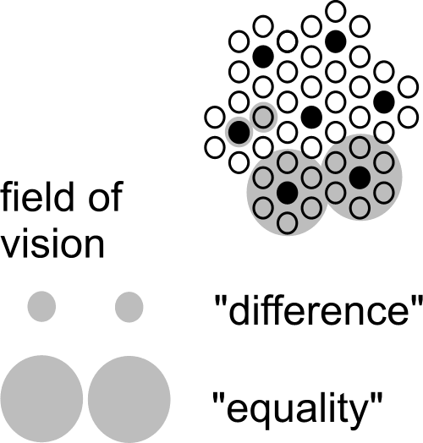
Fig. 2 The scale paradox (Jong, 1992)
The scale paradox means an important scientific ban on applying conclusions drawn on one level of scale to another without any concern (Gell-Mann 1994).

That does not yet mean conclusions on one level of scale could never be extrapolated into other levels. Fig. 2 only shows the possibility of changing conclusions by a change of scale. And it demonstrates the possibility of a reversal of conclusions already by a factor 3 larger radius.

There are 10 decimals between the earth and a grain of sand. That gives approximately 22 possibilities of confusing conclusions.
If a scale paradox can be demonstrated for concepts of difference and equality as such, it applies to any distinction of spatial categories or classes. The same kind of argumentation could be developed for temporal distinctions. What seems true in terms of weeks may be false in terms of months.

5.4 Many levels possibly causing confusion
In Fig. 2 confusion of scale is already possible by a linear factor 3 difference in level of scale (approximately 10 in surface). That is why for spatial design and management we articulate orders of size by a linear factor of approximately 3. So, to avoid any confusion, we need to distinguish at least 22 levels of scale to define context, beginning with the global context, preliminary ending with that of the chemistry of materials (see Fig. 3). Most of these contexts are not relevant for a study at hand, but they are there, buried in hidden (ceteris paribus) suppositions.

Global (10 000km) | Continental (3000km) | Subcontinental (1000km) | National (300km) | Subnational (100km) | Regional (30km) | Subregional (10km) | Town (3km) | District (1km) | Neighbourhood (0.3km)
Ensemble (100m) | Buildingcomplex (30m) | Building (10m) | Buildingsegment (3m) | Buildingpart (1m) | Buildingcomponent (300mm) | Superelement (100mm) | Element (30mm) | Subelement (10mm) | Supermaterial (3mm)
Fig. 3 Levels of scale to be aware of

5.5 Nominal values of a radius R to name levels of scale
Levels of scale are often named by the ratio of a drawing to reality like '1:100'. However, it depends on the size of the drawing what kind of object we have in mind. On an A4 paper 1:100 we can draw an object of approximately 10m radius (30m2 surface), on an A2 paper it could show an object of 30m radius (300m2 surface). That is why we prefer to name the order of size by its approximate radius R in reality chosen from the set {… 1, 3, 10, 30, 100m …}.

An 'elastic' element from the nearly logarithmic series {1, 3, 10, 30, 100 …} is used as the name (nominal value) of the order of size of an urban, architectural or technical category ranging between its neighbours.

To be more precise: the 'nominal' radius R=10 is the median of a chance density distribution of the logarithm of radiuses between (rounded off) R=3 and R=30, with a standard deviation of 0.15.

I chose a series of radiuses rather than diameters because an area with a radius of {0.3, 1, 3, 10km} fits well with {neighbourhood, district, quarter, conurbation} or loose {hamlet, village, town, sub-region} in everyday parlance. They fit also very well to a hierarchy of dry or wet connections according to their average mesh widths (de Jong, 2006).

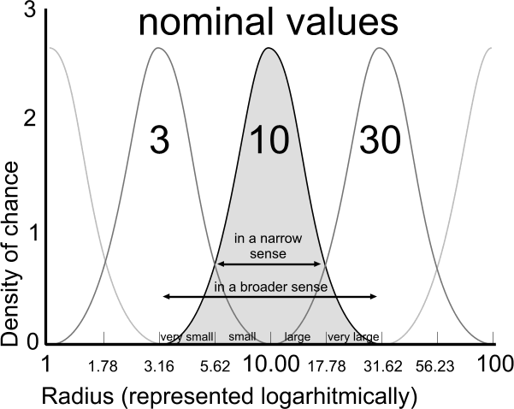
Fig. 4 Names and boundaries of urban categories

An ‘elastic’ element from the nearly logarithmic series {1, 3, 10, 30, 100 …} is used as the name (nominal value) of the order of size of an urban, architectural or technical category ranging between its neighbours.
To be more precise: the ‘nominal’ radius R=10 is the median of a chance density distribution ofthe logarithm of radiuses between (rounded off) R=3 and R=30, with a standard deviation of 0.15.
I chose a series of radiuses rather than diameters because an area with a radius of {0.3, 1, 3, 10km} fits well with {neighbourhood, district, quarter, conurbation} or loose {hamlet, village, town, sub-region} in everyday parlance. They fit also very well to a hierarchy of dry or wet connections according to their average mesh widths (de Jong, 2006)

Morover, a radius immediately refers to the most indifferent directionless form of circles or globes indicating surfaces and volumes as well by one linear value.

5.6 Impacts on different levels of scale
Any object of study will have impacts on different levels of scale, hitting interests of stakeholders on that level (for example from government administrators into manufacturers of building materials). The first step of context analysis is, to make these impacts explicit as far as they could be relevant to the study at hand, not overlooking any level. If you expect positive impacts, perhaps you can find stakeholders wanting to pay for your study. If there are negative impacts, you should hear the people responsible on that level to minimise or compensate such effects by your study.

5.7 Physical and social aspects of design interventions

The context of an architectural intervention either on the level of landscape architecture or urban design is not limited to its physical environment (mass and space in time, ecology, technology). It has to fit in social (economic, cultural and managerial) environments as well.
Urban and architectural designers give account to physical and social stakeholders and specialists in different 'layers' of their sketches and drawings. These participants have their own problems and aims, their expectations and desires, supposing different probable and desirable futures. By design these futures have to be combined into one common spatial vision or concept of a possible future to outline a road for cooperation. Sometimes it is wise to start defining a common future context before defining an object.
Layers on different levels of scale
So, to analyse or compose a common future context, you have to distinguish different physical and social layers. In Fig. 6 six layers are chosen, relevant in urban and architectural design. They are chosen in a way they are imaginable on any level of scale, though not always all relevant for every object of study. On any level of scale they have a different meaning. For example, in The Netherlands management(R = 3000km) means European government, management(R = 10km) or (R = 3km) means different forms of municipal administration, R = 10m means household management and on lower levels of scale it means different forms of technical management on the building place, in maintainance or within the industry of building materials.
Impacts

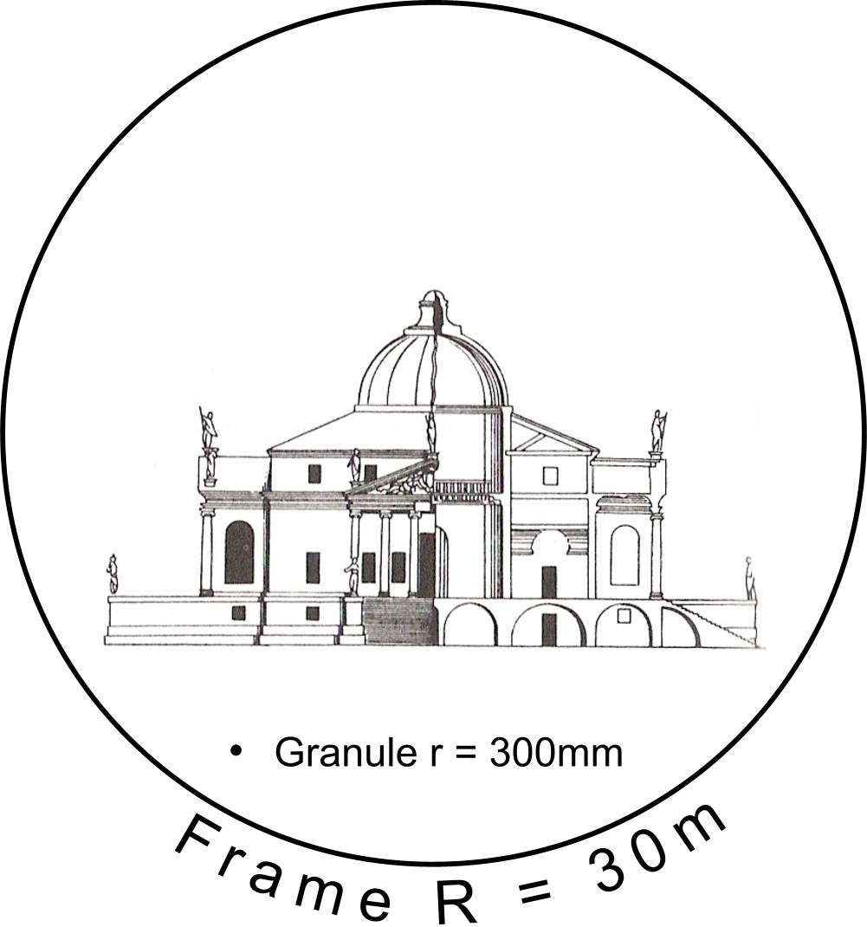
Fig. 5 A frame 100x granule of a drawing representing a building
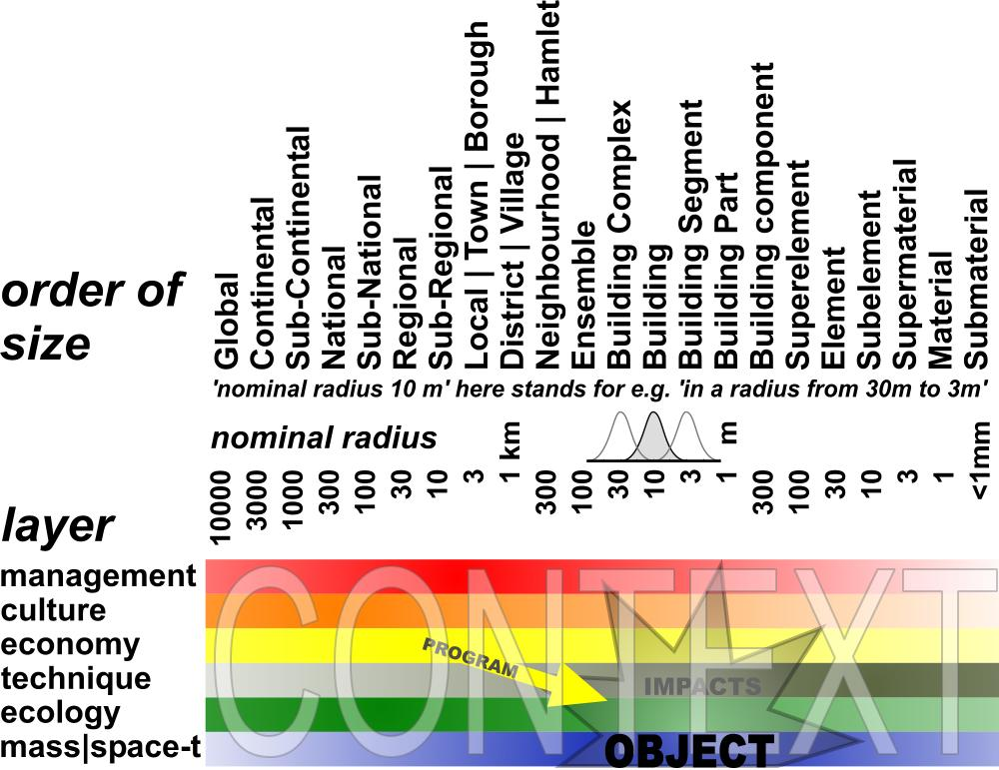
Fig. 6 Locating a spatial object of study within its context
Once you have determined the frame and granule of the object of study in this scheme, the rest is 'context'. The object of study will have impacts within that context, on different levels of scale and in different layers. Some of them are desirable. The programme of requirements is nothing else than the set of desirable impacts. The scheme does not specify these impacts, it solely shows their origin. It is possible to consider these context factors before you choose a specific object on a specific location. So, the scheme can help outlining your object of study from outside.

5.8 'Future Impact'; making explicit the possible futures through design

Including immediately the impact in the design process would be of great value in day-to-day design practice. For research it would enable the explicitation and thus making comparable different plans and approaches.
Impacts will be different in different future contexts. For example, the local economic impact will be different in a growing local economy compared with a stagnating local economy. So, you have to specify your expectations about the probable future within which your object will have its impacts.
It is important to be explicit about these expectations, because people with other future contexts in mind will judge your study with other suppositions about the probable future. They can reject your design solely on that basis. If you made your suppositions explicit beforehand, you can ask them to judge the qualities of your study or design again but now within that perspective. It could raise an essential debate about the robusteness of your study in different future contexts.

The FutureImpact computer program
However, it is even better to agree with stakeholders and specialists beforehand about a common vision on a supposed probable future. To that aim we developed a simple computer program called 'FutureImpact', usable individually or in meetings (see Fig. 6 and Fig. 7).

This program delivers a more precise division of orders of size and layers then Fig. 6 in buttons, to be presses into two very rough extreme values per button to keep overview. In the second screen (Fig. 8) left below you find a button producing a text to elaborate the chosen values into more specific interpretations yourself. It is a checklist not to forget any relevant level or layer.
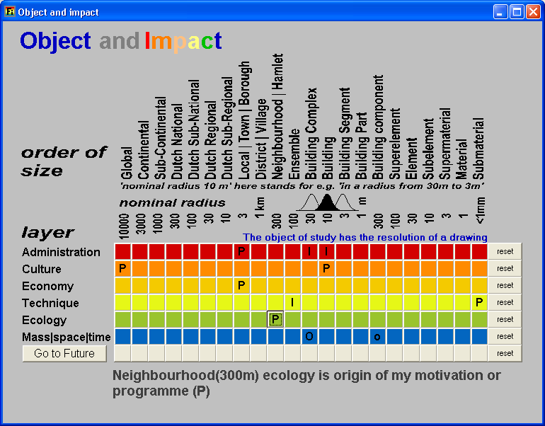
http://team.bk.tudelft.nl/ Publications 2004 Jong, Taeke M. de (2004) The future-impact computer programme version 04
Fig. 7 Locating impacts (I) and the origin of a programme (P) as set of desired impacts
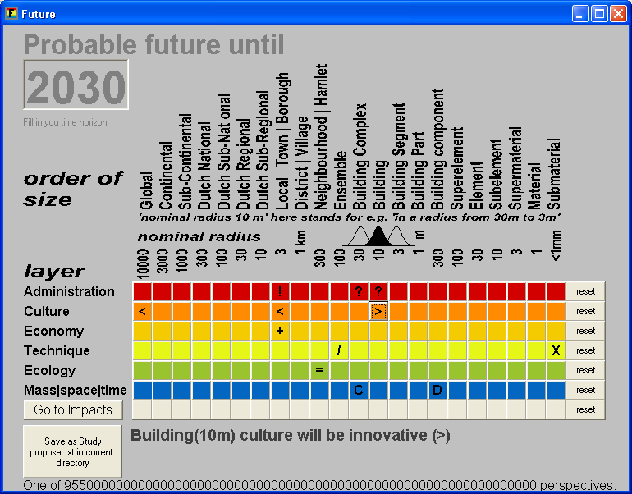
Fig. 8 Making expectations about the context in 2030 more explicit to assess the impacts

Making expectations about the future context more explicit to assess impacts
Once you have located possible impacts, the future context of these impacts determines their possibility of realisation. For example, if you suppose desirable impacts in municipal administration (R = 3km, see Fig. 7), how could you estimate their value without any supposition about their managerial context in the period they should be realised (for example until 2030 in Fig. 8)? Is it an active management context with much initiatives or is it a passive administrative context of just checking and controlling the rules? In the last case initiative should be part of your own project to get the intended impacts realised. The same applies to the administrator of the building complex (R = 30m) and the users (R = 10m). And they can be different on that different levels of scale.

Roughly typing social future context
You can ask that kind of questions on any layer and level of scale again. Any expected or desired impact supposes a context where it will be realised or not. How to describe that context shortly in a preliminary sense to keep overview? The problem is, to find comprehensive variables per layer that make sense on any level of scale in the scheme to be elaborated and modified later in more detail.
For administration and management we proposed opposites of initiative ('!', as symbolised in Fig. 8) and checking and controlling (?), applying on any level of scale. There are many other possibilities to type administration and management style, but this variable hits the core of management itself as far it is relevant for design and applicable on any level of scale.

But what about culture? For example, what does culture mean on the level of building material (R = 1mm)? To include any level of scale, we propose 'traditional' (<) opposed to 'innovative' or 'open to experiments' (>). For example, if your study will have impacts on households (R = 10m), and these households are mainly traditional, it wil be difficult to confront them with an experimental design. However, if your client is an innovative housing corporation, you will get support from that side. That cultural context will influence your study and your presentation, the way you will arrange the arguments.

The economic context is shortly characterised by growing (+) and declining (-). That can be different on different levels of scale. The economic context could be a declining neighbourhood witin a prosperous municipality. A context like that will determine a project or an assignment to a considerable extent.

Roughly typing physical future context
Which extremes could be found to characterise the technological context on any level of scale? It took me some years to choose internal separation (/) and combination (X)of functions as relevant and essential technological context values. It is an essential design choice on every level of scale: shall we separate or combine pressure and tension (R = 10cm) separating and supporting functions (R = 1m) within my construction, cooking and eating in my kitchen (R = 3m), living and work in my neighbourhood (R = 300m)? If the probable trend is to combine living and work on a level of the district (R = 1km), then you still can separate it on the level of the neighbourhood (R = 300m) or the building complex (R = 30 m). So that expected context is important for design decisions.
In ecology we suppose diversity or heterogeneity (|) as most universal context variable, opposed to equality or homogeneity (=). Which kind of diversity that concerns could be elaborated later: diversity of plants, animals, or people, households with the same or different age, lifestyle or role-emphasis (for example familism versus careerism (Michelson 1970)).

At the purely physical level of mass and space in time, accumulation, concentration (C) of masses versus sprawl, deconcentration (D) is an essential design context factor. What is called mass could be specified later, but concentration and deconcentration (state of dispersion) of legend units in a drawing are characteristics of form and composition on any level of scale. They can differ per level of scale (see Fig. 9 and Fig. 10). A existing or expected scale sequence like DCDC or its reverse CDCD names some global characterics of form. We will elaborate on the 'state of dispersion' more in detail, because it is relevant in other layers as well.

States of dispersion
Form as a primary object of design supposes a state of dispersion of an arbirary legend unit, for example built-up area.

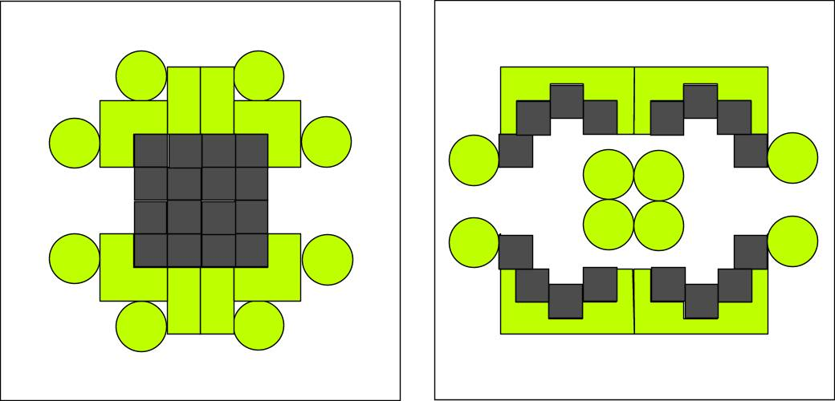
Fig. 9 States of dispersion r=100m

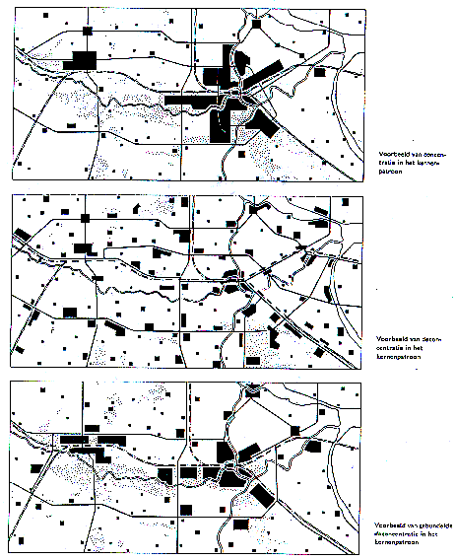
RPD (1966)
Fig. 10 Accumulation, Sprawl, Bundled Deconcentration r=30km

Scale articulation is important distinguishing states of dispersion. That is not the same as density. Considering the same density different states of dispersion are possible (Fig. 11 ) and that is the case on every level of scale again (Fig. 12 ).

Fig. 11 shows the use of the words concentration (C) and deconcentration (D) for processes into states of more or less accumulation respectively. Applied on design strategies in different levels of scale we speak about 'accords' (Fig. 12 ).

In Fig. 12 the regional density is equal in all cases: approx. 300inh./km2. However, in case CC the built-up area is concentrated on both levels (C30kmC10km) in a high conurbation density: (approx. 6000inh./km2).
In the case CD people are deconcentrated only within a radius of 10km (C30kmD10km) into an average conurbation density of approx. 3000 inh./km2.

In the case D30kmC10km the inhabitants are concentrated in towns (concentrations of 3km radius within a radius of 10km), but deconcentrated over the region. This was called 'Bundeled deconcentration' in NRO2. The urban density remains approx. 3000 inh./km2.
In the case D30kmD10km they are dispersed on both levels.

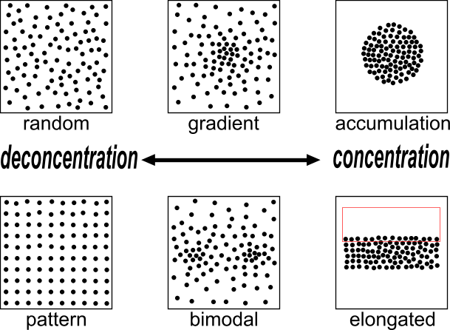
Fig. 11 States of dispersion in the same density on one level of scale

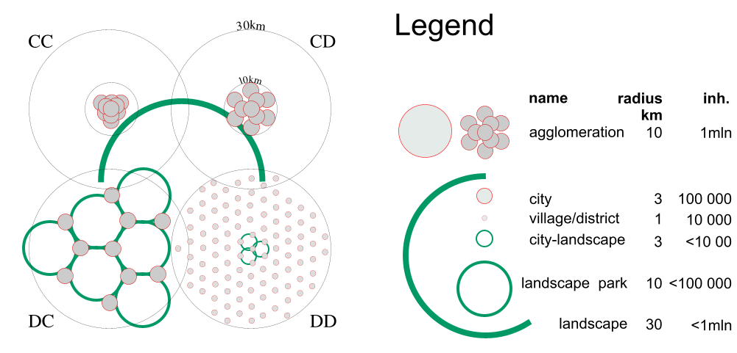
Fig. 12 One million people in two states of distribution on two levels of scale (accords CC, CD, DC and DD).

8. Desirable, probable and possible future contexts

8.1 Language games
There are three language games ('modes') concerning the future context relevant for urban, architectural or technical design, its stakeholders and specialists (see Fig. 13).

Language games: | being able | knowing | choosing
Modalities: | possible | probable | desirable
Sectors: | technique | science | management
Activities: | design | research | policy
Reductions as to
Character, mark: | legend | variables | agenda
Location or time: | tolerances | relations | appointments
Fig. 13 Three language games
Not distinguishing these modes of future results in a confusion of tongues between stakeholders aiming at desirable futures, specialists predicting probable futures and designers exploring possible futures. Distinguishing them properly can deliver an outline of fields of problems and aims to take into account.

8.2 Subtracting probable and desirable futures
Probable futures we do not want are a field of problems (see Fig. 14). They are predicted or signalled by empirical study of specialists. Desirable futures we do not expect without action (like desirable but also probable futures) are a field of aims. Clients, stakeholders and their representitives (administrators, managers) deliver a field of aims. Sometimes it is a battlefield. Often not all of them are possible in one project. The designer guards and extends the possible.

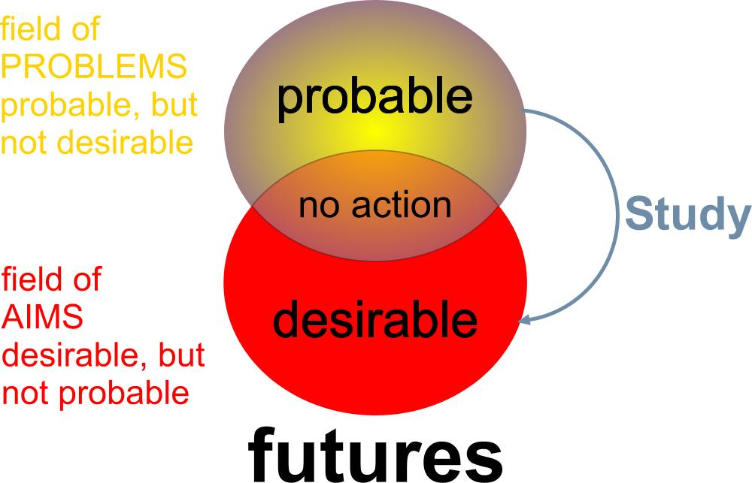
Fig. 14 Subtracting futures to outline fields of problems and aims
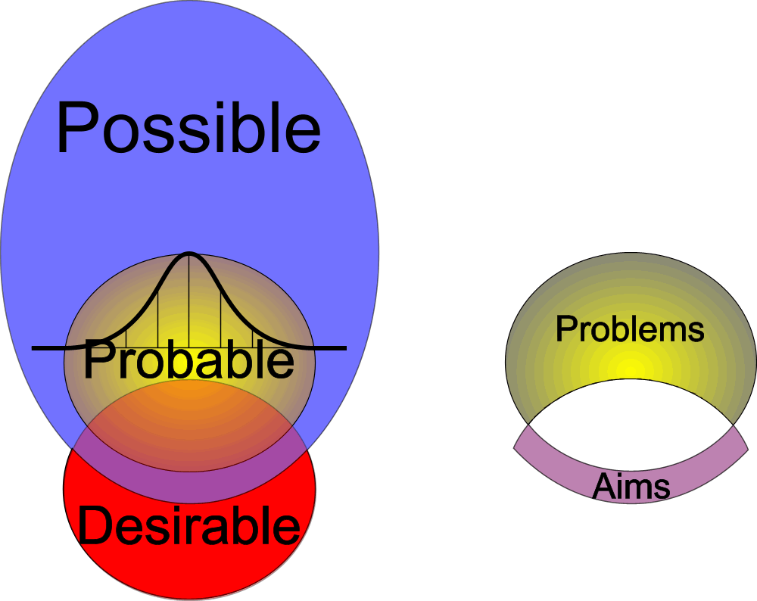
Fig. 15 Adding possible futures, skipping the impossible

8.3 Adding possibilities
Anything possible is per definition probable, because if something is not possible, it certainly is not probable. But not all possible is also probable (see Fig. 15). There are improbable possibilities. To find these improbable but possible futures (including and using the many probabilities of specialists as possibilities) is the task of the designer. S(he) is supposed to know many possibilities stemming from design~ and typological research (see Fig. 1). Sometimes s(he) adds possible futures no one in the team could imagine, let alone desire beforehand. Their desires and aims embodied in their programma of requirements were limited by their imagination. Desires could change as soon as new possibilities are imagined. That is why designers can change a programme of requirements (Weeber, Eldijk et al. 2002).
The context of invention
The designer has a personal context relevant to be selected for, or to propose a design study: her or his field of abilities (portfolio) and field of design means (repertoire, references). S(he) is supposed to have gathered many preceding examples (precedents) and to have studied them by design research and typology exploring design possibilities by putting them out of context (Hertzberger 2002). S(he) is supposed to be able to apply, process and extend them in a specific context, which is proven by a published portfolio. Of course, s(he) is moulded and limited by education, colleagues and friends. But what can be expressed in a study proposal for possible futures in a more or less determined context is a repertoire and a portfolio.

8.4 Limitations of a design related study proposal
To make a study proposal, teachers often ask a clear cut problem definition and clear cut aims, a hypothesis, an overview of methods to reach that aims testing the hypothesis, a planning of time and means (data!) and a list of expected results. We suppose my proposal to weaken the problem~ and aim definition into a broader field of problems and aims will meet objections: “Without a clear problem~ and aim definition any scientific study becomes boundless! That is an objection typically stemming from the practice of empirical research, focusing on truth or probability, aiming desirability (see Fig. 14).
However, a design related study focuses on possibility (see Fig. 15). In the field of urban, architectural and technical design or management, there are other general limitations to prevent a boundless study: scale, field of problems, field of aims, repertoire and portfolio. In short: a proper context analysis introducing the proposal. More than in empirical research (principally repeatable by others), in design study (principally not repeatable by others) the field of abilities and means of the person executing the study are relevant for the expected result. Once these fields are presented you can choose two different directions of study: elaborating these fields into more perfection or exploring new fields of design means and abilities. Both are legitimate, but their results are different in advance, to be mentioned in a study proposal.

9 Conclusion
The limitations of empirical research result in problem isolation not suitable for design related study. That kind of study has other limitations to prevent a boundless study project. A proper context analysis delivers them. A design related study proposal then could have the following contents:

1 CONTEXT ANALYSIS
1.1 Object of study: time span, frame and granule
1.2 Probable future context: field of problems
1.3 Desired impacts of study: field of aims
1.4 My designerly references: field of means
1.5 My portfolio and perspective: field of abilities

2 MY STUDY PROPOSAL
2.1 Location and other future context factors
2.2 Motivation or programme of requirements
2.3 Intended results, contributions and planning

3 ACCOUNTS
3.1 Meeting criteria for a study proposal
3.2 References
3.3 Key words

The last button of the FutureImpact computer programme produces a text with these chapters, asking many questions about the input of the user to elaborate in further detail. The sections 1.1 - 1.3 are already elaborated according to Fig. 14 by automatic subtraction of the probable and desirable futures given by input of the user. That
text should be modified by the user thouroughly, it is nothing more than a checklist with many suggestions for elaboration according to the given input and the method proposed here.

Supposing a proper context analysis is necessary in any design related study it has to be discussed if this is the right one, applicable in any situation.

References
Alberti, L.B. (1986) The ten books of architecture - The 1755 Leoni Edition (New York) Dover, 1485/1986
Aspinall, P.A.; Filor, S. (1994) Proceedings Context as a determinant in landscape architecture (Edinburgh) ECLAS Conference
Bacon, E. (1974) Design of cities (London) Thames and Hudson
Barbieri, S.U. (1985) Tekst en context - Architectuur en situatie in het werk van Luigi Snozzi: elk nieuw gebouw verandert het landschap (j) Forum 30(1)
Boudon, Ph. [ed.] (1991) De l'architecture à l'épistémologie, la question de l'échelle (Paris) PUF
Fokkema, J.T. (2002) Preface In: T.M. de Voordt Jong, D.J.M. van der [ed.] Ways to study and research urban, architectural and technical design. (Delft) Delft University Press
Gell-Mann, Murray (1994) The Quark and the Jaguar (London) Abacus
Hertzberger, H. (2002) Creating space of thought In: Jong, T.M. de; Voordt, D.J.M. van der [eds.] Ways to research and study urban, architectural and technological design (Delft) Delft University Press
Jong, T.M. de [ed.] (2006) Sun wind water earth life living; legends for design. (Delft) TUD Faculteit Bouwkunde Publikatiebureau
Kepes, G. [ed.] (1965) Structure in art and science (London) Studio Vista,
Kepes, G. [ed.] (1965) The nature and art of motion (London) Studio Vista,; Vision + Value series
Klaasen, Ina Trix (2003) Knowledge-Based Design: Developing Urban & Regional Design into a Science (Delft) Delft University Press
Lambert, A.M. (1985) The making of the Dutch Landscape - An historical geography of the Netherlands (London) Academic Press
Mentzel, M. (1990) Trends en tradities in architectuur en stedebouw anno 1990 - 'Context and modernity' in Delft (j) Plan 21(9/10)
Michelson, William (1970) Man and his urban environment: a sociological approach (Menlo Park, California) Addison-Wesley Publishing Company, Inc. Philippines
Motloch, J.L. (2001) Introduction to Landscape Design (New York) John Wiley & Sons Inc.
Nesbitt, K. [ed.] (1996) Theorizing a new agenda for architecture - An anthology of architectural theory - 1965-1995 (New York) Princeton architectural press
Priemus, H. (2002) The empirical cycle In: Jong, T.M. de; Voordt, D.J.M. van der [eds.] Ways to study and research urban, architectural and technical design (Delft) Delft University Press
Staatsbosbeheer (1985) Landschapsarchitektuur (Utrecht) Tentoonstelling van Staatsbosbeheer- Landschapsbouw
Swanborn, P.G. (2003, 2000, 1996) Case-study's: wat, wanneer en hoe? (Amsterdam) Boom
Ven, G.P. van de [ed.] (2004, 1993) Man-made lowlands. History of water management and land reclamation in the Netherlands (Utrecht) Uitgeverij Matrijs
Vroom, M.J. [ed.] (1992) Outdoor space - Environments designed by Dutch Landscape Architects since 1945 (Amsterdam) Thoth
Weeber, C.J.M.; Eldijk, P.J.; Kan, M.L. (2002) Designing a City Hall In: Jong, T.M. de; Voordt, D.J.M. van der [eds.] Ways to study and research urban, architectural and technical design (Delft) Delft University Press
Winkel, C. van (1994) Een gelegenheidskwestie - Over het verlangen naar context aan het einde van de twintigste eeuw (j) Metropolis M 15(4)
Yin, R. K. (1994) Case study research. Design and methods (Thousand Oaks) Sage publication

