Comparing and applying standards for green surfaces in urban areas
Taeke M. de Jong 2007-08-20

Introduction
Both green surfaces in urban areas and their distance to inhabitants can be expressed as a radius. In that case a radius r represents a walking distance or an area a = π r², equal to a circular surface of the same size. That representation of surface is more directly imaginable than huge numbers of hectares fastly increasing by a growing scale. A radius grows slower, and by doing so it indicates orders of size more easily. Fig. 1 shows some standards for green surfaces and their distance to the served inhabitants that way. In that figure we can observe that 'English Nature max.' proposes larger green areas at a distance below 1000m and smaller areas further away than what we will explain here as a ‘Standard Green Structure’. Furthermore, we can conclude that all other mentioned (Dutch) standards are below that standard.

Fig. 1 Some standards for green surfaces in urban areas | Fig. 2 Optimally accessible green surfaces
The figures are calculated in a way explained in this paper. Greenery standards expressed in m² per inhabitant require suppositions about densities for comparison. These densities are taken from the ‘Standard Green Structure’ to be explained below.

Nominal orders of size
If in a range of radiuses, you take after ‘r’ the next radius ‘R’ ample three times larger (R≈3.16*r), then the next area A is ten times larger (A≈10r). It could encompass 7 smaller circles (70%) in closest packing, and a surface proportional to ample 3 circles (30%) as ‘tare’ (see Fig. 2).
If you take an easily nameable range of 'nominal' radiuses = {1, 3, 10, 30, 100, 300, 1 000, 3 000, 10 000, 30 000m}, then the surface increases at average with a factor 10.
In this paper ‘nominal’ means, that if I name a surface ‘10m’, then I will mean something in between 3 and 30m. So, ‘nominal measures’ are not exact, they are 'elastic' between their neighbours, indicating an order of size.

Standard Green Structure
But, greenery standards expressed in m² per inhabitant are still incomparable to those expressed in surfaces and distances. Within R they suppose densities, and densities determine the amount of users and the costs of maintenance. I will use a 'Standard Green Structure' to provide densities on different levels of scale for comparison. Green surfaces are optimally accessible if they are located in the centre of the urban areas they serve. In that optimal case the distance from the boundary of an urban area involved (radius R) to the boundary of a central green surface (radius r) is the maximum walking distance R-r (see Fig. 2). The 'average' distance is approximately half R-r (depending on different densities within the residential area). If the average distance to the green area is the same as its radius, then in this paper we call that distribution of green areas over these levels 'Standard Green Structure' (see Fig. 3). Moreover, in Fig. 3 some common names are added. In this paper they are used to interprate other standards.

nominal | name | nominal | nominal | nominal
green area |  | urban area | ‘average’ distance | max. distance
r |  | R | r | R-r
m |  | m | m | m
10000 | landscape park | 30000 | 10000 | 20000
3000 | urban landscape | 10000 | 3000 | 7000
1000 | town park | 3000 | 1000 | 2000
300 | district park | 1000 | 300 | 700
100 | neighbourhood park | 300 | 100 | 200
30 | small public green | 100 | 30 | 70
10 | common garden | 30 | 10 | 20
3 | private garden | 10 | 3 | 7
Fig. 3 A Standard Green Structure |  |  |  |  | Fig. 4 Shift from average into maximum distance
In Fig. 4 the Standard Green Structure is given in grey. However, most standards are based on the maximum distance. So, for comparison we have to shift the dots half R-r to the right (red dots) as used in Fig. 1.

Inhabitants
In this concept of a Standard Green Structure the spatial distribution of green surfaces is determined, but not yet the number of people served. They determine the density or its reciprocal value, the land use in m² per inhabitant. However, if a village of 10 000 inhabitants grows into a town of 100 000 inhabitants, it will probably need a town park and if it grows into a conurbation of 1 000 000 inhabitants it will probably need a town park for every township and an urban landscape for the conurbation. That amount of desired untilled land was earlier provided as countryside around the village. In a first approximation that will increase the land use of green surface within the urban area.

Urban R(m) | Green r(m) |  |  | Ambition | Inhabitants |  |  | Ambition | Inhabitants
30 000 | 10 000 |  |  | countryside | 0 |  |  | countryside | 0
10 000 | 3 000 |  |  | countryside | 0 |  | 1 | conurbation | 1 000 000
3 000 | 1 000 |  |  | countryside | 0 |  | 6 | townships | 166 667
1 000 | 300 |  | 1 | village | 10 000 |  | 36 | districts | 27 778
300 | 100 |  | 6 | neighbourhoods | 1 667 |  | 216 | neighbourhoods | 4 630
100 | 30 |  | 36 | urban islands | 278 |  | 1 296 | urban islands | 772
30 | 10 |  | 216 | building complexes | 46 |  | 7 776 | building complexes | 129
10 | 3 |  | 1 296 | buildings | 8 |  | 46 656 | buildings | 21
Fig. 5 Different ambition levels
However, in the same time the price of land will increase and the inhabitants will accept higher residential densities. So, for example a neighbourhood park will be surrounded by higher neighbourhood densities in a conurbation than in a village, resulting in a lower land use per inhabitant. Keeping the average distance to the green area the same as its radius, a higher neighbourhood density applies in a conurbation compared to a village. To determine these densities, we need to suppose different ambition levels for growth. To keep it easy we take 10 000, 100 000, 1 000 000 inhabitants and so on as starting points and divide them according to Fig. 2 by 6, 6x6, 6x6x6 and so on to derive the number of inhabitants per level (see Fig. 5). These starting points can easily be changed by taking percentages applying to densities as well.

Densities
Now you can derive different gross and net densities according to any ambition level dividing the appropriate number of inhabitants by the appropriate urban surface. The density of dwellings is calculated by dividing the density of inhabitants by the average number of inhabitants per dwelling (for example 2.25). The floor/surface ratio (FSI) is calculated by dividing the density of inhabitants by the average floor surface per inhabitant (for example 30m²). However, any level of scale has its own gross and net densities. The ‘net’ of the higher level equals the ‘gross’ of the lower level (see Fig. 6).

Higher level |  | gross
 |  | tare = green |  | + rest |  | net (residential)
Lower level |  |  |  |  |  | gross
 |  |  |  |  |  | tare: green |  | +rest |  | net
Fig. 6 Net of higher level equals gross of lower level
The difference between gross and net is ‘tare’. Net density concerns the residential part of the total urban area covered by ‘R’. However, on a lower level that residential part contains again non-residential components to be distinguished by the reciprocal value of ‘land use’.

ambition | density |  |  | land use
 | gross | net |  | gross | - green | - rest = | net
 | inh/ha | inh/ha |  | m²/inh. | m²/inh. | m2/inh.
village | 32 | 59 |  | 314 | 28 | 116 | 170
neighbourhoods | 59 | 88 |  | 170 | 19 | 38 | 113
urban islands | 88 | 164 |  | 113 | 10 | 42 | 61
building complexes | 164 | 246 |  | 61 | 7 | 14 | 41
buildings | 246 | 455 |  | 41 | 4 | 15 | 22
 |  |  |  |  | 68

Fig. 7 Standard Green Structure densities and land use on the ambition level of a village
Taking a closer look on the resulting land use profile of a village for example (see Fig. 7), the tare components can be added, while the gross and net cannot. By adding the green components per inhabitant we find the m²/inhabitant green area (68m²). The same calculation for a conurbation (see Fig. 8) produces a figure not much different from that of a village because of higher densities on the lower levels of scale (72m²). The Standard Green Structure has a rather stable use of approximately 70m² green area per inhabitant, little dependent on the ambition.

ambition | density |  |  | land use
 | gross | net |  | gross | - green | - rest = | net
 | inh/ha | inh/ha |  | m²/inh. | m²/inh. | m2/inh.
conurbation | 32 | 59 |  | 314 | 28 | 116 | 170
townships | 59 | 88 |  | 170 | 19 | 38 | 113
districts | 88 | 164 |  | 113 | 10 | 42 | 61
neighbourhoods | 164 | 246 |  | 61 | 7 | 14 | 41
urban islands | 246 | 455 |  | 41 | 4 | 15 | 22
building complexes | 455 | 682 |  | 22 | 2 | 5 | 15
buildings | 682 | 1263 |  | 15 | 1 | 5 | 8
 |  |  |  |  | 72

Fig. 8 Standard Green Structure densities and land use on the ambition level of a conurbation
In both cases the gross density on the highest level is the same, because the number of inhabitants increases each level of scale with approximately the same factor 10 as the surfaces of the Standard Green Structure. However, the net residential area on the lowest level (buildings) is different. It equals the m² built area per inhabitant. If the average floor surface per inhabitant (for example 30m²) is nearly four times that figure, the average number of stories has to be 4.

Comparing greenery standards expressed in surface, distance or m² per inhabitant
Fig. 9 shows the m² green area per inhabitant of different standards distributed over different levels according to levels and densities supposed in the Standard Green Structure. Figures for common and private gardens are added for comparison.

Fig. 9 Standards of green area expressed in m² per inhabitant on different levels of scale
If figures are given for the 'urban landscape' (yellow) the ambition is apparently a conurbation with higher densities than a town. However, most standards do have the ambition of a town. So, the Standard Green Structure shown here is calculated with the ambition of a town. To change that, use the spreadsheet mentioned earlier. That sheet shows how densities are calculated for different ambitions. Moreover, it enables you to make your own programme for urban green space according to the identity of the location.

Making a specific programme for urban green space
Given the ambition chosen in an other part of the spreadsheet, the worksheet shows the result of your choices asking radiuses of the urban and green area on two levels of scale (for example town and district, see Fig. 10), and the number (1 to 6) of green spaces on the lower level.
Fig. 10 Two levels of scale represented in a 1000m grid
These choices can be made by five sliders and the spreadsheet informs you directly about the consequences (see Fig. 11). On a copy of Fig. 1 two new green spots show how your programme is in the proportion of the other standards.

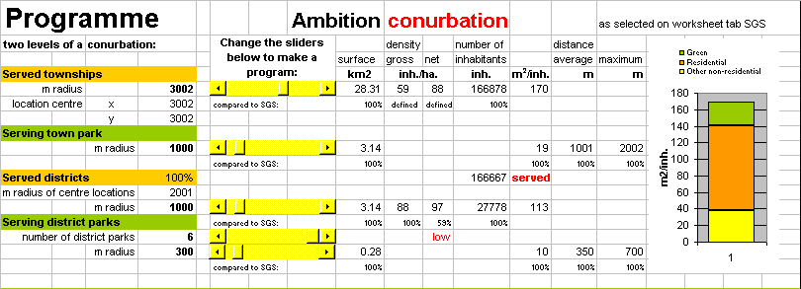
Fig. 11 Choosing a programme

Distributing green areas according to the programme
The next worksheet shows a square with the same surface of the largest circle you chose divided in 90x90 modules, telling you how much modules you need of each category to fulfill your own programme (see Fig. 12).
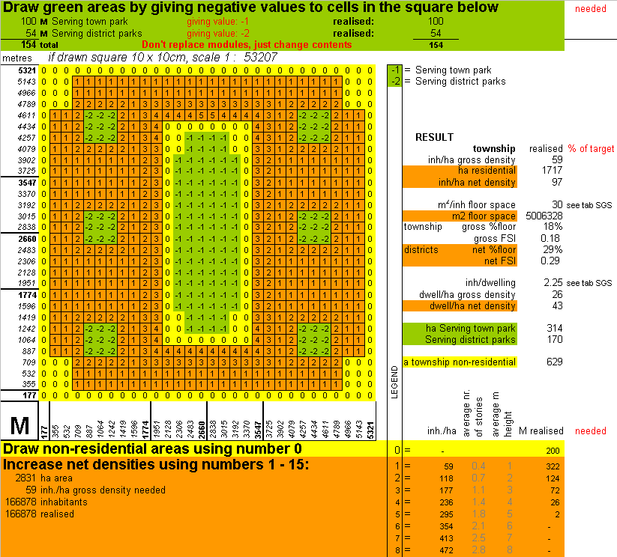
Fig. 12 Distributing categories on a field by numbers
The last problem is to increase the net densities of each module to fulfill your programme.

A first visualisation
This exercise is real time accompanied by a rough visualisation (see Fig. 13).

Fig. 13 A first visualisation
This figure does not represent building heights but densities. To get an impression of building heights the vertical exaggeration is estimated depending on the supposed floor surface per inhabitant, the supposed height of a story and the supposed percentage of built-up area within each module.

Conclusion
To compare urban greenery standards given in surfaces and distances with those given in m² per inhabitant, you need a standard concerning densities. The Standard Green Structure proposed here, delivers different ranges of densities on 8 levels of scale, taking the aspired size of the urban area into account. It is based on the closest packing of equal residential areas around green areas, relating their surface to their average distance from these residential areas. It is not intended to use as a standard on its own withou any concern, but to compare standards and locally chosen distributions deviating from this most mathematical one.

The spreadsheet is downloadable from http://team.bk.tudelft.nl/ > Publications 2007 > Jong, T.M. de (2007) Standard Green Structure (Zoetermeer) .xls

