Spatial human rights

Taeke M. de Jong, 2007-07-12

CONTENTS
1.1 Introduction 1
1.2 Spatial human rights 2
1.3 The human right on natural areas 2
1.4 The other spatial rights 4
1.5 Conclusion 4
1.6 References 4

Introduction

Human species
In my life the world population doubled and in the rest of my life that could happen again. In my life the surface for food production decreased substantially. When I was born I could count on 0.2 ha corn area per person, but now it is 0.1 ha. The productivity per ha. may be doubled, but that increase in efficiency stagnated and caused erosion, pollution and did not stop the exploitation of smoking forests on poor soils, a very temporary solution for desperate farmers. It tempered the reports of hunger in our journals for a while.

Other species
From the 1.6 million species we know we probably lost approximately 100 000. That amount increases every year with at least 1000 species, but that increase will increase if we only think about the consequences of climate change. Evolutionary successful new life forms emerge approximately 1 per year. Still no technical university is able to design life forms with the complexity and fascinating beauty of any species, but most humans do not sleep less by the awareness of loosing these miracles.

Environmental problems
These are the only two environmental problems we face: declining human health (taking hunger into account) and biodiversity. All other problems are derived from these two. And they are negatively related one way: improving health will increase the human population and its demands, decreasing space for nature.

Enough energy
I do not worry so much about the derived problem of energy consumption in the long term quantitatively. The sun delivers more than 5000 the amount of power our world population and biosphere use together. Photovoltaic cells catch that power 10 times more efficient than plants do and they are 10 times cheaper than 30 years ago.
However, the decrease in price stagnates since it nears the economic efficiency of fossil fuels. Why? No one can convincingly explain to me eventual technological boundaries responsible for that stagnation. That dissipation of technology now already lasts longer than the improvement of the steam engine heralding the industrial revolution (a minor revolution compared to what we can expect from solar energy). There may be socio-economic reasons related to the division of capital and protected knowledge. Anyhow, a major change from fossil into bio fuels would be an ecological and human disaster in its competition on space with agriculture and nature.

Space
I do worry about space. Urban design, the division of space is supposed to be my first profession, ecology my second. Recently the urban population passed the rural one in numbers. From a viewpoint of space that is not bad. Sprawl of a still increasing world population is worse than locally high densities leaving substantial surfaces for nature and efficient agriculture. Millions of years our human species lived in numbers to be counted in millions with sufficient space, now they have to be counted in billions. We passed the point we could live without large-scale technology. Concerning these numbers of people we are condemned to technological solutions and regional division of tasks to reach an optimal scale for such solutions.

Spatial division of tasks
On which level of scale can we find an eco-technological optimum of different tasks if long distance transport is no longer an environmental problem from an energetic and environmental point of view? Birds, butterflies whales and eels divide their seasonal tasks over continents. Some regions are more suitable for agriculture, others for urbanization. Why not grow our coffee on another continent more suitable to do so than ours? Should we process our waste locally in autarkic communities or should we centralise that task if that is cleaner, consuming less space? Permacities delegate their task to suitable regions offering a proper scale. Some tasks we could divide world wide, some per continent, some per region and so on. Steekelenburg (2001) graduated on these three alternatives for agriculture.

Completeness of life
On the other hand, from the individual point of view, living in a mono-functional environment with a single task for humankind is boring, while demolishing the completeness of life which evolution shaped us for in millions of years. Our awareness of and competence for all aspects of life fades if we are faced with just one job. The autarkic ideal of Permaculture (Mollison, 1988) tries to restore that completeness, but with the contemporary numbers of people we cannot sustain that ideal for everybody. This study tries to find a sustainable midway by formulating and calibrating spatial human rights on a fair distribution of space. It is just a first attempt for discussion. In the next paragraphs I will give some backgrounds of the first spatial human right (A) I propose below and give some general remarks about the other ones (B-C).

Spatial human rights
Suppose we accept these spatial human rights:

A. Any human has a right on untilled natural ground within a nominal radius of x from her or his place of residence measuring at least a nominal radius of x; x being {100, 300, 1000, 3000, 100 000 metre}.
B. Agriculture has to be located in areas with highest supply of water, minerals and sunlight. Towns and untilled natural areas have to be located in areas with fewer minerals.
C. Any human has a right on all necessary sources of contemporary living within a nominal radius of 30km. These sources, logistic facilities included, have to give access to products of 2000m² agricultural land per person. This land should be accessible within a nominal radius of 1000km concerning the risk of stagnating logistics in cases of disaster like war.
D. Any human has a right on 300m² residential area in a radius of 10km, work and daily used services included.

How could we elaborate that by urban design? In this chapter I will restrict myself to the first requirement of A to explain these preliminary principles: the right on greenery without buildings or agriculture at a distance of 100 metre measuring a surface with a radius of at least 100 metre (π 100² ≈ 30000m²), mostly called public greenery and playgrounds, summarized as ‘ensemble green’. The second requirement of A is the right on greenery without buildings or agriculture at a distance of 300 metre measuring a surface with a radius of at least 300 metre (π 300² ≈ 300000m²), mostly called neighbourhood park. And so on. I will do so in the next section.

To explain requirement B I should say something about ecology (the science of the distribution and abundance of species) on global levels of scale. To explain requirement C I should say something about distribution and density on continental until urban levels of scale and concerning requirement D about distribution and density on urban levels of scale. These subjects are elaborated in a more extended paper: Jong, T.M. de (2007) Density, distribution, competition on space calibrated to spatial rights (Zoetermeer) downloadable from http://team.bk.tudelft.nl > publications 2007. I will give only some general remarks after the next section.

The human right on natural areas
Suppose any human has a right on untilled natural ground within an average nominal radius of x from her or his place of residence measuring at least a nominal radius of x; x being {100, 300, 1000, 3000, 100 000 metre}. A ‘nominal’ radius of 300m means something in between 100m and 1000m. If you give the green surface in a neighbourhood, district or town the same size of radius as the average walking distance to reach it (‘standard green structure’ SGS as I will call it), then in each case approximately 10% of the surface is green area (see Fig. 1).

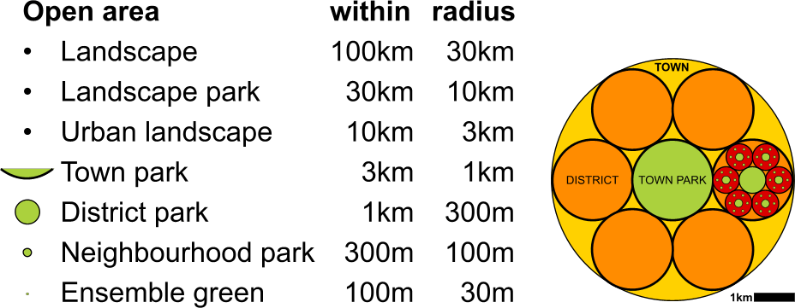 | 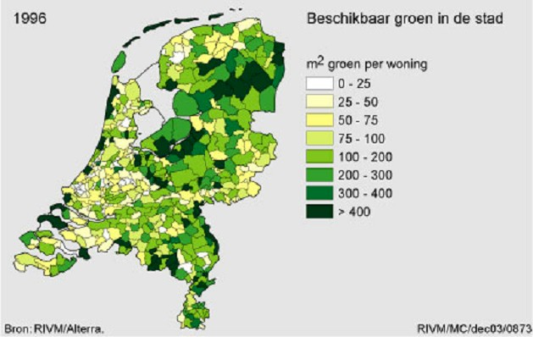
Fig. 1 ‘Standard green structure’ SGS | Fig. 2 m² Green per dwelling ranging from 0 until more than 400 m² (RIVM, 2003)
In a town (R=3km, surface 30km²) of 100 000 people that is approximately 30m² /inh. town park.
In a district (R=1km, surface 3km²) of 10 000 people that is again 30m² /inh.district park.
In a neighbourhood (R=300m, surface 0.3km²) of 1000 people that is again 30m²/inh. neighbourhood park.

If that approach is continued to the ensemble greenery, any inhabitant would have 120m² greenery at their disposal or approximately 300m²/dwelling. In Dutch terms that is near to a maximum (see Fig. 2), but also an easy to handle target standard. The usual standards changing in time (see Fig. 3) could be expressed in percentage of this standard green structure SGS.

Standards of green areas changing in time
The development of norms establishing the area of greenery per inhabitant in towns reflects the changing ideas about urban extensions in the Netherlands: from new towns (‘bundled deconcentration’) with low densities in the sixties, to compact cities to save the open landscape in the seventies and eighties, and a renewed desire for green residential areas in the nineties (see Fig. 3).
Fig. 3 The development of greenery norms in the Netherlands
(using Zoest, 2007)

Large green areas far away or smaller ones close-by?
Now you can work out how much any town deviates from that standard and which level of scale has a relative (dis)advantage. It raises the fundamental question if a town prefers more large green (easy to maintain) at great distance (little public support) or more small green at small distance deviating from the standard into the direction of Mollison. It determines largely the green identity of an otherwise equal amount of green surface per inhabitant.

The other spatial rights
Suppose agriculture has to be located in areas with highest supply of water, minerals and sunlight, towns and untilled natural areas in areas with fewer minerals. Then a global division of tasks regarding food production would have great ecological advantages. Steekelenburg (2001) elaborated possible scenarios to distribute agriculture on regional, continental and global levels of scale with respectively increasing logistic requirements of transport. But as soon as energy is no longer an environmental problem and there would be no other barriers, then global division of tasks would be spatially, ecologically and technically the best. Concentration of food production in the most appropriate areas on the highest level of scale would be the most efficient and sustainable solution. But there are economic, cultural and managerial disadvantages. One of them is security of food supply in cases of global conflict or disaster. Moreover, a mono-functional environment with a single task for humankind is boring, demolishing the completeness of life we are shaped for. However, agriculture is automated rapidly.

Suppose any human has a right on all necessary sources of contemporary living within a nominal radius of 30km and these sources, logistic facilities included, have to give access to products of at least 2000m² agricultural land per person. Suppose this land should be accessible within a nominal radius of 1000km concerning the risk of stagnating logistics in cases of disaster like war. Then a continental division of agricultural tasks is most appropriate. In fact this (de)concentration partly happens in Europe.

Suppose any human has a right on 300m² residential area in a radius of 10km, work and daily or weekly services included. Less frequently used services still could be accessible within a radius of 30km. That would mean relocating much of the daily workspace and services closer to the residential areas, while the removal of households into the direction of the workplace should be easy. Since long the reduction of distance from home to work and services is a crucial task of urban design and planning.

If the future world has to house some 10 billion people in a sustainable way, then the intended autarky of Mollison should be put into a perspective of the most appropriate scales of autarky. Autarky in a radius of 1000km could be realised apart from the question if it is desirable. Which specific autarkies can be realised on lower levels of scale leaving specialised functions to the higher levels of scale? In which sense can a radius of 300km, 100km, 30km, and so on be autarkic? Many activities still happen at home (R=30m) and some even could be brought back home by increasing economic and technical possibilities. But if we would like to bring 2000m² of agriculture per person back home, then urban life is impossible. And cities concentrate people, while voluntarily leaving substantial areas to nature.

In the same way other activities still should be placed out to find their optimal scale and places of concentration. The question is which level of scale is optimal for every specialisation? Economy and technology change all the time and with them the optimal scale of increasingly specialised activities and facilities. Increasing specialisation needs increasing scale resulting in the actual process of globalisation. From the history of retail management we know the scaling-up of shops with a territory of 300m into 1km, 3km and so on. But within the supermarkets and hypermarkets again bakers appear baking their own bread afforded to do so by new technology. So, there are down scaling movements as well.

However, according to Sassen (2001) some specialisations (especially management and financial institutions) increasingly concentrate in a limited number of metropolises, delegating new tasks to lower levels of scale in return. So, globalisation is reaching its ultimate boundary: the planet. From that ultimate level downwards the oscillating up and downward movement of human specialisations could gradually stabilise like a string if you fasten its open end. The unpredictable dynamics made planning difficult and within that uncertainty any government or management (except perhaps the offices of financial institutions) stressed flexibility and neutral design of being suitable to serve many changing aims without identity. Identity is difference from the rest, combined with continuity in itself. Both the difference and the continuity are lost. It may be time now to study the stabilising optima, the string-like nodes and antinodes that can be recognised for a sustainable future and to restore local identity based on stabilising spatial division of tasks.

If these economic and technological dynamics stabilise, then local, regional, continental and global division of tasks could result in a new natural differentiation of sustainable local identities. By the development of unique local identities based on specialisation people can choose their location according to their stage in the life cycle, while changing life style and status. In the long term, energy for travelling and moving will not be an environmental problem anymore. Diversity creates possibilities of choice and that is exactly what we want to give future generations.

Conclusion
Between Mollison’s ideal of local autarky and the needed global autarky with some 10 billion inhabitants to be realised as a self-sustaining planet lie many levels of scale to be elaborated by urban planning and design. Any level could get its own limited internal autarky and external specialisation, leaving sustainable and efficient specialisations to higher levels and other places. We are forced to divide tasks by the large number of people to be sustained now, but there should be some limits perhaps controlled by human spatial rights. The standard green structure SGS developed here may serve as a model.

On the long term energy for travelling and transportation could not be a lasting environmental boundary condition for global, continental or regional specialisation. It could even raise opportunities for new local identities. However, what remains from Mollison’s ideal is his hidden concern about the lost completeness of human life in a world of increasing local specialisation. Perhaps we have to get used to the idea that humans have been wandering hunters and gatherers in 99% of their evolutionary development. They still gather experiences on holidays. Sedentary farmers did not exist before some 10 000 years ago and we are shaped by evolution in millions of years.
The difference could be that humans cannot gather the completeness of their lives in days, weeks or months anymore, they have to do so in a life time.

References
Jong, T.M. de (2007) Density, distribution, competition on space calibrated to spatial rights (Zoetermeer) downloadable from http://team.bk.tudelft.nl/ > publications 2007.
Mollison, B. [ed.] (1988) Permaculture. A Designers' Manual (Tyalgum Australia) Tagari Publications
Sassen, S. (2001) The Global City: New York, London, Tokyo (Oxford) Princeton University Press ISBN 0-691-07063-6 pbk URL www.pup.princeton.edu
Steekelenburg, M. van (2001) Self sufficient world (Den Haag) VROM, RPD
Zoest, J. van (2007) Driving forces in urban ecology In: Jong, T.M. de; Dekker, J.N.M.; Posthoorn, R. [eds.] Landscape ecology in the Dutch context: nature, town and infrastructure (Zeist) KNNV-uitgeverij

