Study and research Urbanism 2008
Department of Urbanism, Faculty of Architecture, University of Technology Delft.
A preliminary attempt by Taeke M. de Jong 2007-11-08

Contents
1 Design related urban studies 2
1.1 Introduction 2
1.1.1 Research 3
1.1.2 Study 5
1.2 Methodical considerations 6
1.2.1 Context sensitivity 6
1.2.2 Design research 6
1.2.3 Typological research 6
1.2.4 Design study 6
1.2.5 Study by design 7
1.3 From research into design and the reverse 7
1.3.1 Context analysis 7
1.3.2 Patterns and processes 8
1.3.3 Space and time 8
1.3.4 Levels of scale 8
1.4 Layers of design 9
1.4.1 The same layers get different names on different levels of scale 9
1.4.2 Legends of design 9
1.4.3 Differentiating study and research 10
1.4.4 Dynamic integration 10
1.5 A divison of starting points 10
1.5.1 The midterm review 2007 10
1.5.2 The first starting point is what is done earlier 10
1.5.3 Coherence of complementary content 11
1.5.4 Coherence of complementary method 11
1.5.5 Flexible teams 11
2 Cultural landscape design 12
3 Urban and Regional Design 13
4 Urban and Regional Strategies 14
5 Designing Urban Environmental Technology (DUET) 15
5.1 Introduction 15
5.2 Common characteristics of the Section 15
5.2.1 The concept of ‘environment’ 15
5.2.2 Technology, the knowledge of technique and techniques 17
5.3 The chair Urban Sustainability 18
5.4 The chair Technical Ecology 18
5.5 Research programme 19
5.5.1 Finished research projects to built on 19
5.5.2 Projects in practice 20
5.5.3 Sustainability Techniques 20
5.5.4 Urban Techniques 20
5.5.5 Theories 26

Design related urban studies

Introduction
This report gives an outline and an outlook of current and intended study in the sections of the Department of Urbanism. This first chapter about ‘design related urban studies’ clarifies a refreshed task division in Urbanism based on some possible divisions in the content and methods of its studies.

The field of study concerning urban areas and surrounding landscapes is wide, in particular if it comes down to integrate disciplines and stakeholders involved in a design or a strategy for area development. In that case any restriction could be a dangerous omission. So, the field of study concerns every layer from physical to social conditions on nearly every level of scale in space and time and all of them in any mode of abstraction: politically, technically, scientifically. Fortunately, many other universities, faculties and disciplines have a task in exploring this field, and the Department of Urbanism has relations to many of them.

So, not everything has to be studied here. On the contrary, most of the field is explored elsewhere in regular disciplines of empirical research: history, geography, planning, economy, civil engineering to name some of them. Integrating them in a design or strategy supposes that content but also an awareness of what misses. That awareness is difficult to obtain otherwise than by designing a realisable pattern or process (strategy). By designing you suddenly realise how much we do not know, how much has to be decided in uncertainty. On the other hand, the time consuming searching what you want to know so often produces disappointment, that you get used to that ignorance, neglecting what we know indeed to apply in spatial designs and strategies.

However, the experience of designing unveils something else. To find a concept connecting a field of scattered interests, incidental facts and missing knowledge, is more than integration alone, more than finding a ‘constellation’ of twinkling stars giving grip in the pattern and process of a local universe.

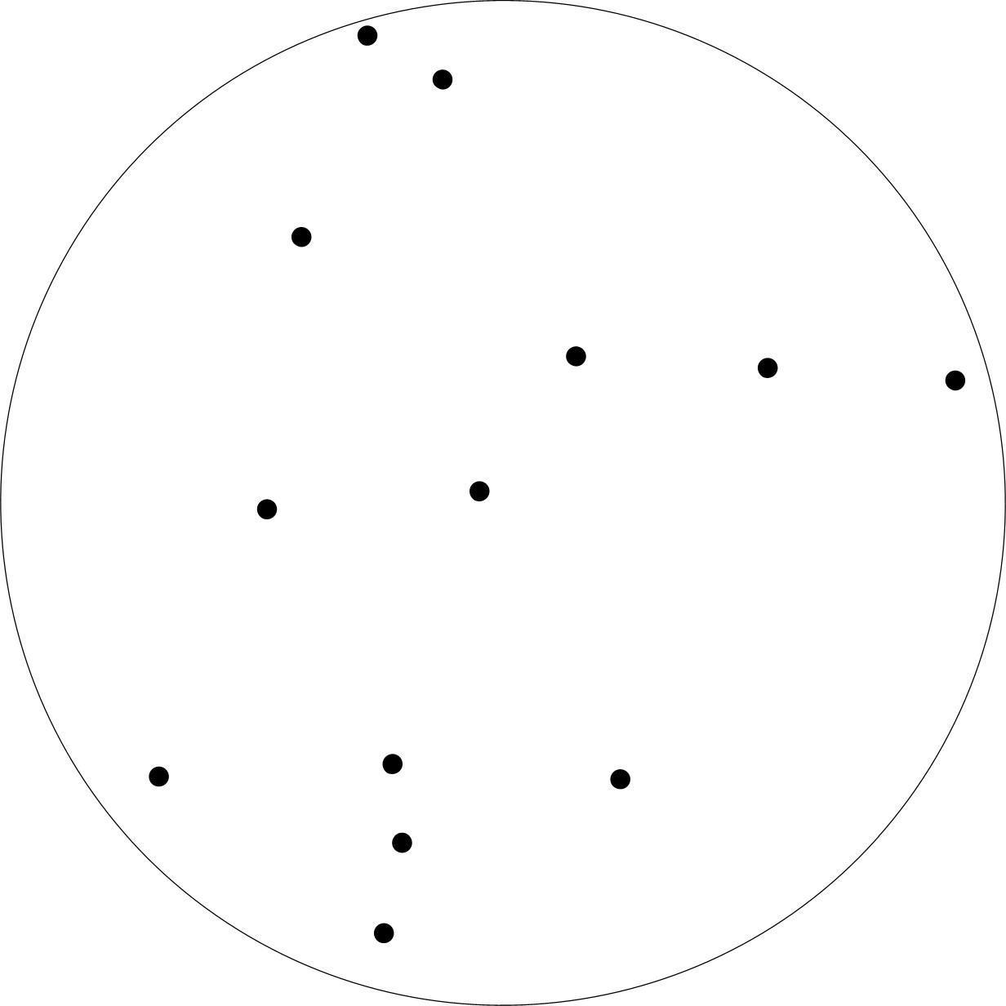 | 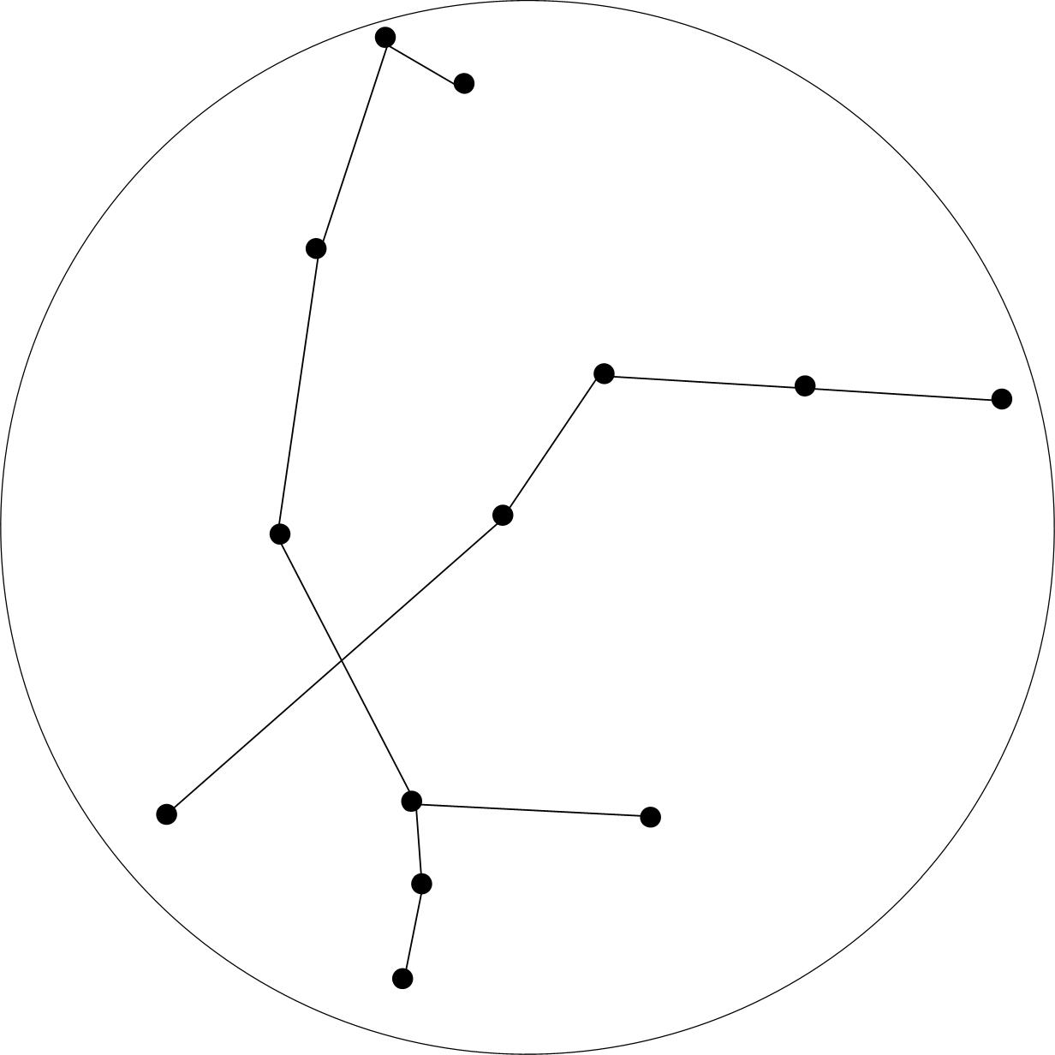 | 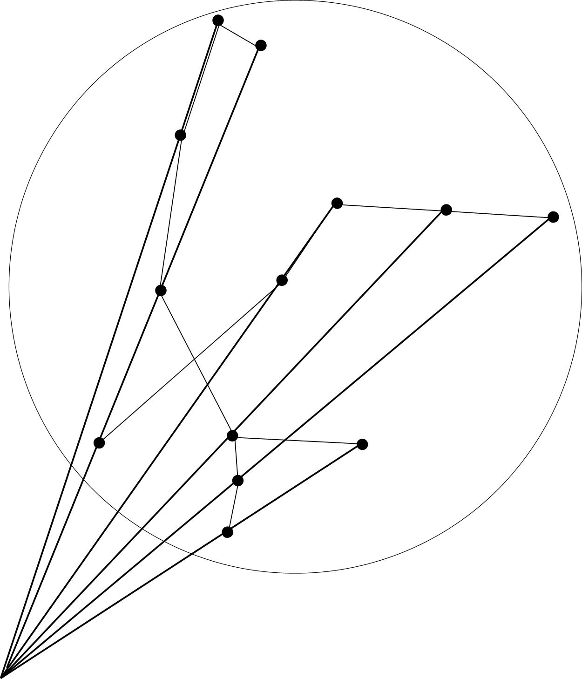
Fig. 1 Facts | Fig. 2 Integration | Fig. 3 Design
It often requires a virtual point outside the field of facts and interests to cover more than what can be captured in verbal or mathematical expressions. Designing requires walking outside that field to find other possibilities and perspectives than what is most probable. It requires imagination.

In a University of Technology, designs are made not only intuitively, but also based on study and research, justified and published in reports. If the object of inquiry is variable (not yet defined) in this report we speak about study; if it is determined about research. In the next sections ‘study’ is encompassing ‘re-search’, a kind of study supposing low to zero variability of the object.
Firstly we will elaborate ‘research’, then ‘study’ as executed in the Department of Urbanism.

Research

Collecting relevant facts and their relations
Design is something else than pure art, it is imagining compositions and procedures realisable in an existing context. The existing context contains more or less strict boundary conditions, restrictions and inspirations for design and strategy. This ever changing spatial, ecological, technical, economic, cultural and managerial context has to be described, analysed, modelled and evaluated. An evaluation at last produces fields of recognisable problems and aims resulting in new motives or programmes of requirements for action. However, the same description can produce different analyses, models and evaluations. So, a research report should separate chapters of initial descriptive research collecting ‘facts’ from suppositions needed for selection of variables and analysis as far as possible. Then should be clarified how they are used to find their relations and to synthesise models representing parts of reality for evaluation in next chapters. But that separation is of course never completely possible.

Making hidden suppositions explicit
Any description already contains suppositions. The words and images used to describe a phenomenon contain generalising categories, exaggerations, probably amplifying general aspects or neglecting local details particularly interesting for design and strategy. These often hidden suppositions should be reduced in number and made explicit as far as possible. Otherwise communication, productive scientific critique and self-cleaning potential of research and study becomes impossible. Alternative interpretations of the same descriptions should be explored to make that critique possible.
However, that separation of stages in empirical research is in debate. The idea that any observation or research is participating, acting study, part of the social and even physical pattern or process to be studied, an intervention on itself, inevitably part of imagination and design, is successfully applied in education. But that idea is also a supposition. Even that kind of suppositions have to be made explicit to be understandable in a common research programme.

Philosophical debate
Making hidden suppositions explicit inevitably introduces a philosophical debate. That should not to be avoided. At the boundary of research, design and practice different language games give rise to confusion of tongues not to be solved in any of these modes separately. However, it is not easy to structure such a debate focusing on the essential problems of design and strategy. The interest in philosophy is apparent everywhere in the Faculty, but incidental excellent professional lectures often miss their target because they require a substantial historical background and related philosophical jargon not present in the audience. Moreover, the common philosophical reflection on history of science introducing Kant, Husserl, Popper, Kuhn, Feyerabend, Lakatos focuses more on truth or probability than on design relevant possibility. Diligent selectivity is required to avoid philosophical overload. For a critical evaluation and to understand the role of design movements like modernism and postmodernism, a proper insight in the history of Enlightenment is required, especially current in a multicultural context. To restore a relation with design perhaps one has to go back to Aristoteles, or even Thales, the engineer at the first observable roots of Western Philosophy and close to the very beginning of urban design (Hippodamos!). From there an effective trace into Leibniz, Whitehead, Wittgenstein, Kripke and so on could be found. But even then you can doubt if these writers could contribute essential insights to integrate specialising science and practice into design and strategy. Besides that, the debates about pragmatism since Peirce, James and Dewey should be shared knowledge to structure an effective philosophical debate and to put into perspective what outsiders like the economist Simon argued about design.

Applicability in design or strategy for existing areas
However, there is one pragmatic supposition the team of Urbanism mainly shares: the object of study has to be applicable in design or strategy for developing real areas. That is not much, but enough to select what we can use from studies executed elsewhere and what we have to demarcate to do ourselves in addition to those studies. The ‘facts’ and their relations produced elsewhere have to be taken into account, evaluated on their completeness for design and strategy. It is interesting to see what kind of planning bureaus the Netherlands has: a Spatial, Nature, Environmental, Economic and Cultural Planning Bureau. What apparently lacks is a technological and a managerial planning bureau, the primary sources for design and strategy. So, we not only have to explore and translate what is applicable from the existing sectors, but also produce what is missing.

Completed designs studied as facts
As soon as objects of design study are finished (no longer ‘variable in the head of a designer’), these objects have become facts. They can be described, documented, modelled, examined and evaluated in a proper empirical cycle before or after they are actually built (design research ex ante and ex post). Elaborated designs can be considered as ‘hypotheses’ for empirical research always implicitly stating “This will work.” (or a negating reverse). But the main part of that hypothesis to be tested by evaluative research (“This…”) is a set of drawings, images, simulations implicitly accompanied by this verbal proposition and often a more explicit verbal explanation.

A drawing as a scientific document
However, a drawing (or animated sequence of images) with its enormous, often suggestive, information content is object of debate. It does not yet have the status of a valid and reliable document in the scientific world such as verbal or mathematical reports with exact definitions and interpretations. Especially the lack of validity of images based on a sound ‘grammar’ or logic raises a problem to scientific judgement. Many attempts are made to reach a status comparable to linguistic grammar, ‘pattern language’. Probably the ‘logic’ of images is an other kind than the controllable logic of verbal or mathematical expressions.

Many ways to evaluate designs
However, that kind of evaluative research is a sound basis of reflection in design education and of making similar programmes for new design assignments in practice and education. So, design research is also the main kind of study in the department of Urbanism, be it done in many ways (methods) to study designs. And there are many ways to study designs, none of them being a convincing winner. We have to accept that variety firstly because a design can be described and documented in many ways dependent on the impact to be studied in many and ever changing contexts. Secondly, the ways designs are made are difficult to recover and to name. It raises the often neglected problem of naming and describing or even defining design acts and design means. They are often indicated by neologisms in language games inaccessible for outsiders characterising different schools of study. That causes naming the same things differently and different things equally. It is worth the effort to continue bridging these islands.

Many ways to describe designs
The way of describing urban designs is not standardized and that causes even more ways to model, examine and evaluate the differently described or interpreted designs. Yet, different evaluations based on the same description should be exercised and compared with analyses based on other descriptions of the same object to determine the influence of descriptive research methods on the result of evaluations. There are promising attempts to give standardized descriptions such as Burg and Stolk (2004) and the ‘plannenmappen’ made in the department of Architecture, but there are many other ways to describe design patterns and processes still in debate.

The choice of mainly Dutch examples
Moreover, there is an overwhelming number of designs to be researched if you look at Google Earth (a revolutionary data source still only partly penetrated in urban research). So, the selection of examples (precedents, prototypes) is a point of debate.

The choice of examples in Delft urban research is mainly derived from the Dutch (Randstad) context, amongst others because the many international students and researchers coming to Delft are especially interested in that context. A delta and lagoon largely below sea level is an interesting case since many deltas and lagoons in the world, endangered by climate change are increasingly populated. Moreover, the Netherlands is very good documented with easily accessible maps and data.

International involvement
You can criticise that emphasis on Dutch examples, but you also can welcome it as an efficient ground for specialisation of different research institutes. To study Spanish examples, you go to Barcelona, to study Italian examples you go to Venice, to study lowland examples you go to Leuven or Delft. Moreover, there are ‘pieds a terre’ in New York, Beijing and Turkey. An international criticism on Dutch examples putting them in the perspective of a globalising context could be stimulated instead of seeking applaud. On the other hand criticism on cases abroad could be stimulated. For example, a studio with many students visited New Orleans. Such cases should be described and published properly to be evaluated by different researchers.

The existing EMU cooperation with other institutions like those of Barcelona, Venice, Leuven, earlier European landscape studies comparing English, French and Italian estates, many PHD candidates from South America, connections with the United States via the Delft School of Design (with many studies stemming from Urbanism) and recent connections in Turkey and China guarantee an international orientation.

‘Good’ and ‘bad’ examples
A consideration could be, if you always have to choose ‘good’ examples, because ‘bad’ examples may be even more instructive. They give a research focus on mistakes to be avoided in future practice and feed the academic climate of mutual collegial criticism and debate, a research climate raising self-cleaning potential. However, that critical climate is frustrated by interests of colleagues in practice. Criticism could hit them in their commercial interests and disturb the many existing relations in practice. The returning public debate in Architecture raised and often stirred by Weeber could be a good example for Urbanism. It requires the ability of interest in criticism on your own work as well. Weeber’s and Koolhaas’s criticism on urbanism is still waiting for convincing answers from urbanists. The changed political Dutch context and the increasing public criticism on ‘verrommeling’ of the Dutch landscape now raise new opportunities for involvement in such a debate.

Study

What is studying a non-determined object?
However, a remaining question is, ‘which methods of inquiry are scientifically convincing if the object is not yet determined (the main object of design study)?’. The making of a design that can serve as a proper hypothesis for design research afterwards requires most of the time spent in designing after all. This question was an issue of two Faculty committees for methodology (1990 and 2000) resulting in a book with 48 authors of one Faculty. Both committees distinguished approximately the same 5 kinds of research (describing, evaluating, typology, modelling and programming) and 3 kinds of study (technical study, design study and study by design) as the competence of the Faculty. That distinction was the main section arrangement of the mentioned publication and still is the basis of this introduction until a more comprehensive publication is available.

Design driven research and research driven design
The Faculty emphasises study by design. The University stresses research driven design, supported for example by Klaasen, whereas the Faculty mainly preferred design driven research because designs as hypotheses raise many unexpected and forgotten research questions specifically important for designers. Research driven design starts with probabilities, design driven research with possibilities to be evaluated. The memorable exhibition ‘The Bridge’ in 1999 showed hundreds of footbridges designed by first year students raising many unexpected possibilities, inspiring civil engineers visiting the exhibition. It convinced many that innovation is best served by design driven research.

Context sensitivity
However, amongst other objects of design in a University of Technology the object of urban and architectural design is according to the Rector of our University Fokkema (2002) the most context-sensitive of all. Its “programme of requirements is not only derived from an economical and technical context, but also from contexts hailing from political, cultural, ecological and spatial considerations; on many levels of scale.“, Fokkema writes. This conclusion has important methodological consequences.

Methodical considerations

Context sensitivity
Context-sensitivity of the object of study makes generalisation difficult, the very aim of any scientific effort so far. Design related study and research are mainly and necessarily based on case studies. Context sensitive cases are difficult to compare. Design research may concern determined objects within determined contexts, but designs differ per definition and the context will always differ and change. So, other kinds of design related study vary either the object (design study) or the context (typological research) or even both (study by design, see Fig. 4):

CONTEXT
determined | Design Research | Design Study
or variable | Typological Research | Study by Design
 | determined | or variable
 |  | OBJECT
Fig. 4 Types of design-related study
Mainly citing Jong and Voordt (2002)ª the terms from this matrix may be explained as follows.

Design research
Any building or built environment is public, a real ‘publication’. Design research is evaluating study of completed designs. It describes and analyses existing designs with a known context, often or implicitly in the form of comparative study. Not only their function or performance is involved, but also their form, structure, operation and the way they were made, the design tools employed in each stage and the way in which these were applied: the making proper. The main problem is the context sensitivity of each separate design, making comparisons with other designs doubtful if their context (in many senses and on many levels of scale) is not comparable. It is an important part of the research portfolio of Urbanism, but it should better include ‘types’ of context, types at different levels of scale. ‘Types‘ distinguished on a lower level of scale appear as legend units in design on a higher level. Typing contexts is especially important for students stemming from (and applications in) other managerial, cultural, economic, technical, ecological and spatio-temporal contexts. It produces also a future opportunity to choose examples of earlier research with comparable contexts to make future comparative research more convincingly reliable and valid.

Typological research
Whenever an identical architectural form, structure, operation, technique, function, performance or concept is recognised in different contexts the notion of a category or ‘type’ (different homogeneous verbal categories combined) is involved. A type only becomes a consistent model if it has been elaborated by design in a determined context for evaluation. So, a type is a design tool, not yet a model suitable for evaluation. The study of such context-independent types, their use in the making of designs (a special kind of models) is called typological research. It is the very basis of plan analysis (precedent analysis). Hertzberger (2002) advises to change the context of types and images as a recipe of creativity, Guney (2007) stresses the use of types in design itself. Others (Duin, Barbieri) stress their function only for communication between designers and researchers of design.

Design study
There are innumerable examples of design study stemming from a well-documented professional practice. Making a design in a relatively well-known context of potential users, investors, specialists, available techniques, building materials, political, cultural, economic, technical, ecological and spatial factors, entails many stages of ‘design study’. It makes use of predictions, is interrupted by stages of empirical research, but it is not primarily predicting probabilities. It cannot use the usual reductive ceteris paribus methodology releasing an object from its context to obtain general conclusions valid in other contexts connected to the practice of predicting. A specific context contains fields of related problems and aims to be solved in combination. It has to produce new possibilities bringing together the many desirabilities and probabilities of stakeholders and specialists into a concept. Designing, decision-making and research are different modes of inquiry and different kinds of language in the building team. Anything probable is possible by definition, but not all possibilities are also probable. That mode of improbable possibilities is the core of design study.

Study by design
Characteristic for study by design is generating know-how and understanding by studying the effects of actively and systematically varying of both design objects and their context.

There are not many scientifically convincing examples of study by design in the Faculty. An inspiring break-through was the dissertation of Vollers (2001). Experimenting with CAD he found new ways of designing and producing curved constructions, looking for contexts of application afterwards. A growing number of new materials raise industrial design experiments with possible applications and unexpected impacts on architecture and urbanism. That changing technological context changes possibilities, but its possible impacts are seldom studied. An interesting issue about designing without a clear context was given by Bergh (2002). Verheijen (2002) describes how during an architectural design study the urban context can change substantially. Frieling (2002) recommends regional design as a means to determine regional strategy in changing contexts.

However, it is interesting to realise, that any terminal project for graduation is a kind of ‘study by design’ if the choice of the object and the context is free. In that case the method chosen by most students is an alternating variation of context and object: alternating typological research and design study. The aim of a graduation study is to show professionalism, and that was precisely the import of Bergh’s argument: study by design throws the inquiry back upon the content of the profession as such. That is why the Department of Urbanism develops an increasing interest in design means and tools based on computing, to be brought together in an intended Urban Lab. Computing forces to be very precise in naming, describing, modelling and developing possibilities of urban design.

From research into design and the reverse

Context analysis
That still doesn't alter the fact that most of the current inquiry in urbanism concerns research of existing designs: design research and typological research of historical examples, even if the context is incomparable. Graduate students produce designs, PHD students seldom do. Moreover, the current research emphasises patterns rather than processes. If processes would get more emphasis, then the value of historical patterns could be put better in a perspective of changing contexts. The awareness of social and physical context gives direction to crucial design decisions concerning what has to remain on the map, what has to be renovated or changed and in which way. If any historical and recent design would be completed with a context analysis, then design research and typology afterwards become equipped with means to decide if besides the object the context of urban patterns is also comparable. That is the very beginning of context sensitive comparison and scientific generalisation, useful in context sensitive design, building and planning processes the reverse again leading to design driven research. That is a proper cycle of design related study and research.

Patterns and processes
Processes should be distinguished in different time scales. Urban history has the pace of centuries, planning of years, building processes of months, design processes of weeks and conceptions of days, hours or even minutes. Their respective evaluating study do have different periodicities, categories, jargons and languages to be distinguished and taken into account to get a proper integration at last. That also applies to spatial scales. Regional design, urbanism, urban design, architecture, interior design and building technology have different components, grammars, words, types and legends as well. The different meanings of words and legends have to be understood before you can integrate them into sentences and maps. No integration without differentiation of components. That is why we need different chairs and well marked out research programmes connected in an urban lab (Ulab), the place of experiments and simulations crossing the borders of disciplinary differentiation.

Space and time
The objects of study of different faculties of the University of Technology Delft are difficult to compare. However, distributing them in the time and space of studied design, experiment and observation, offers an interesting image. They are dispersed around the diagonal of Fig. 5. Their categories, variables, legend units and language are very different. Within that context the object of the Faculty of Architecture has the biggest surface and within the field of ‘Bouwkunde’ Urbanism has.

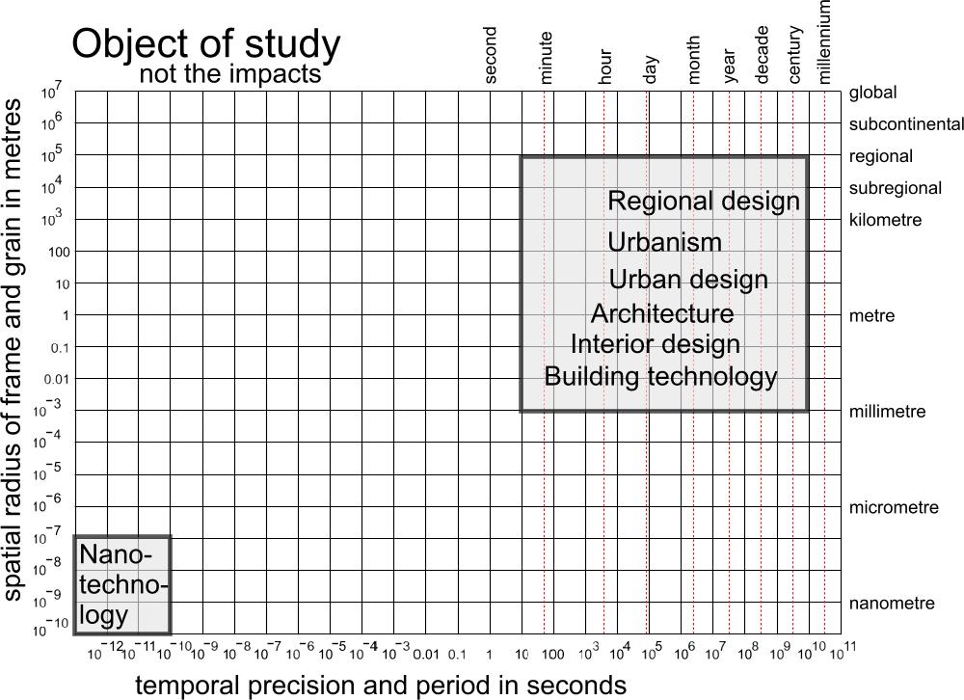 | 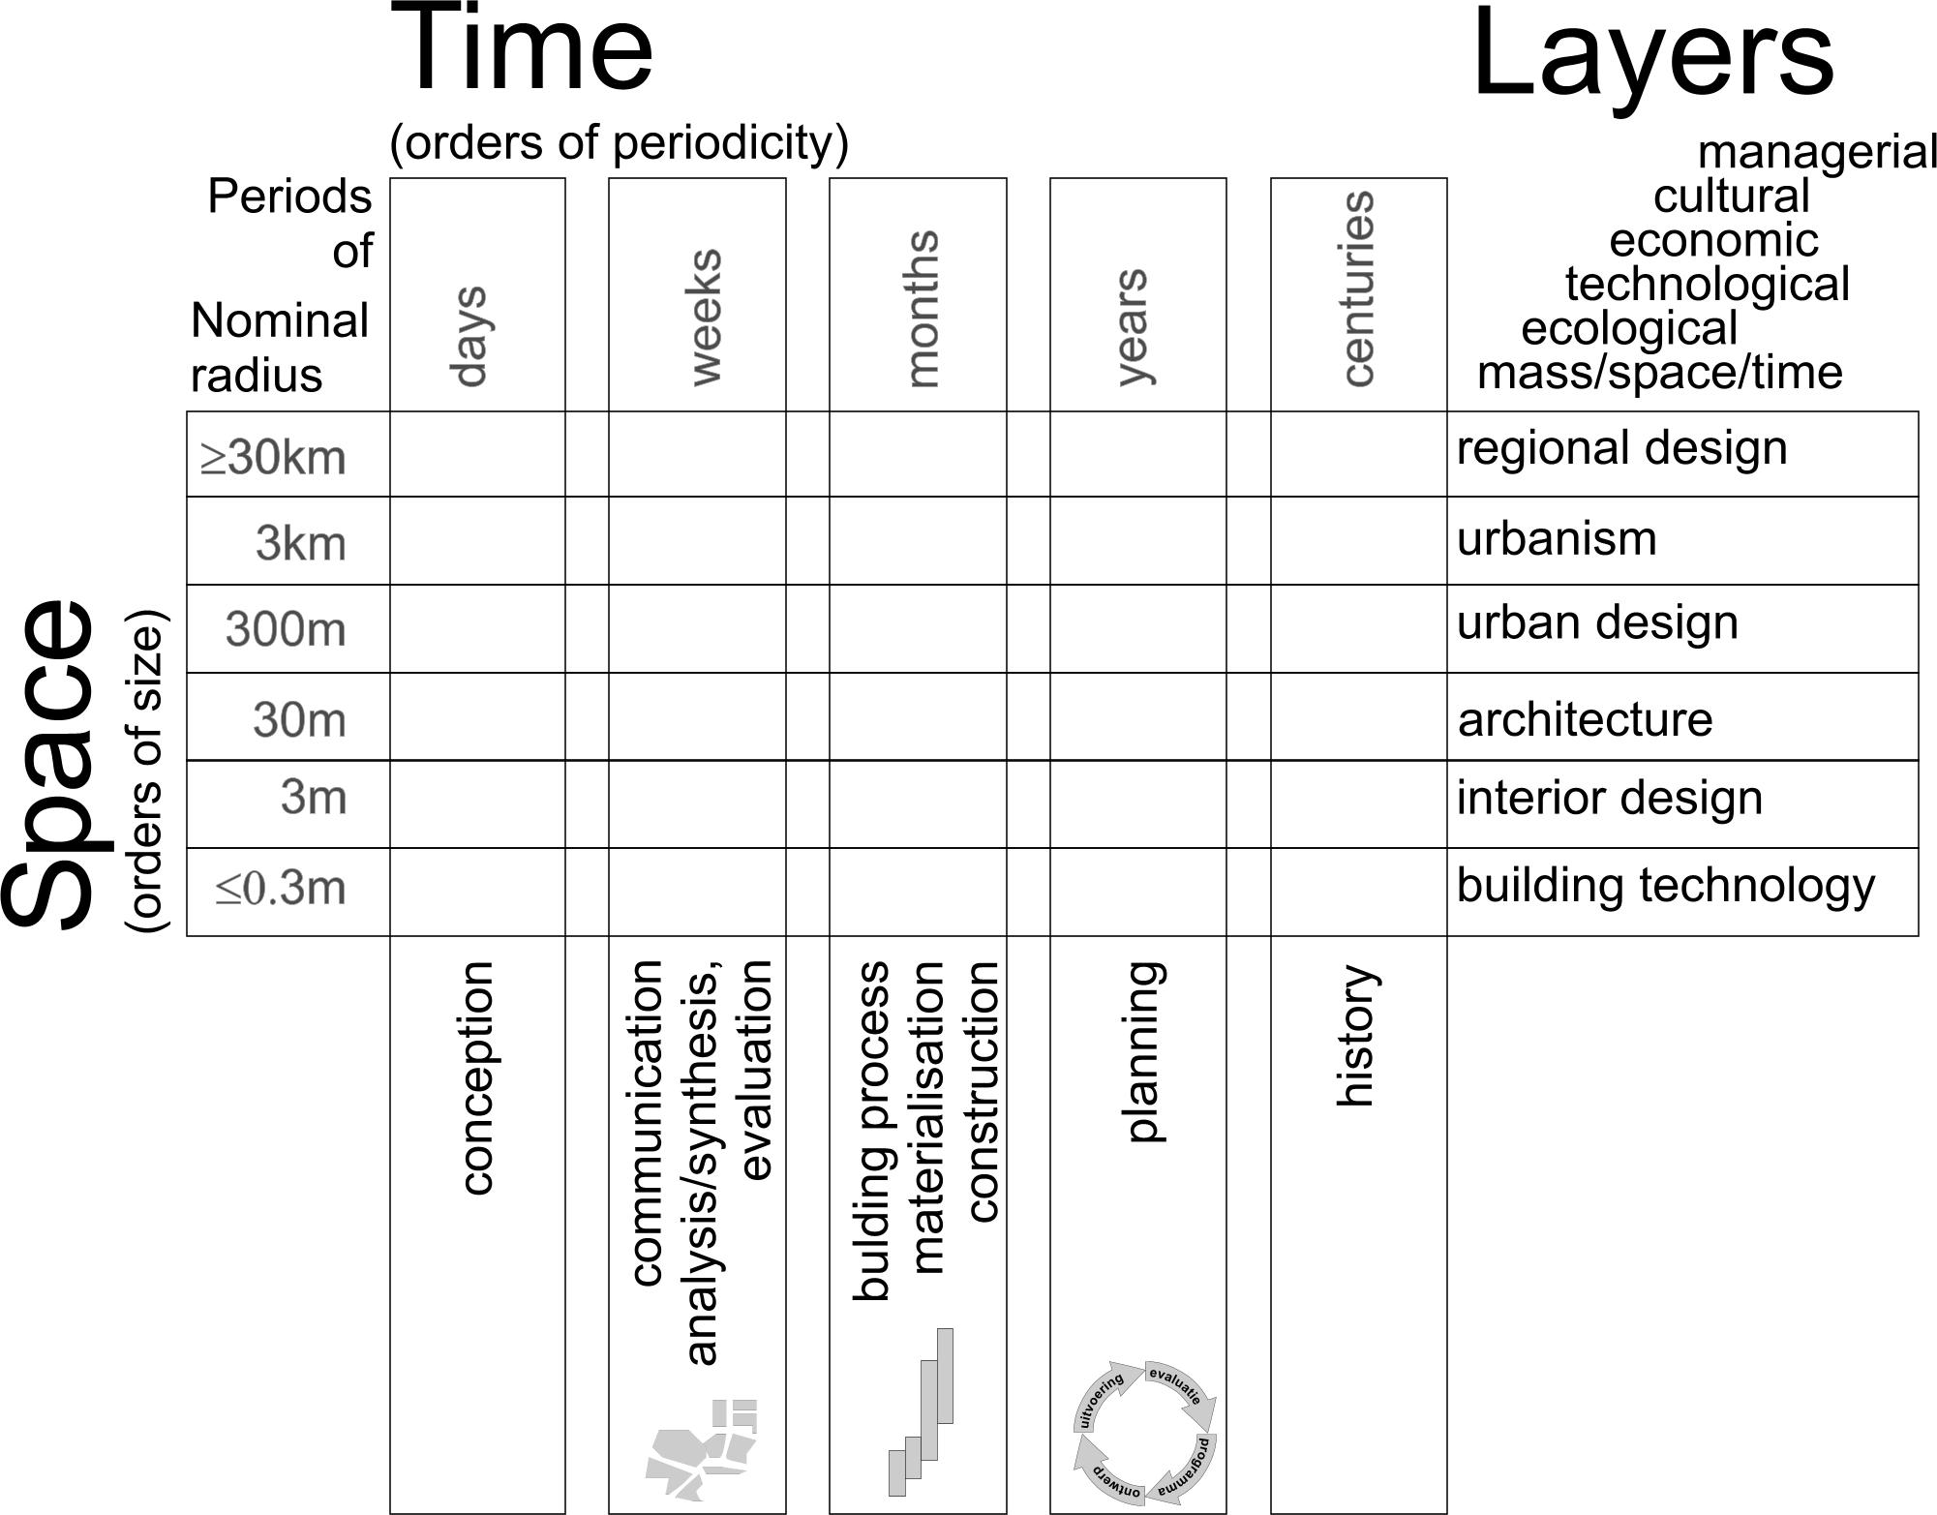
Fig. 5 The domain of the University | Fig. 6 The domain of Bouwkunde
Specialisation in between and within the Faculties could be demarcated along the lines of scale. So, if we want to divide Urbanism’s study and research programme into partial programmes it is interesting to follow that line of thought. Any level of scale has its own history, and in shorter pace its own ways of planning and practice (see Fig. 6). The greatest advantage of this scheme may be, that the cells keep a meaning in different philosophical starting points, be it that they get a different colour. Although you could doubt if Bergson would agree. In social science Gurvitch certainly would.

Levels of scale
You cannot draw conclusions on one level of scale and apply them on another level without concern. Conclusions derived from allotment studies of urban islands demarcated by residential roads applying in a nominal radius of R=100m cannot be applied on areas R=100km marked out by highways without adding new legend units or combining them into new categories, urban types, obeying other laws or grammars of pattern and process without concern. Physical scale-laws show that the mechanical possibilities of ants are other ones than those of people. It cannot be surprising that in an enlarging frame and grain of study (coarse-graining) possibilities of people are different from that of communities, hamlets or towns. Conclusions derived from processes and fluctuations observable in years are other that those observed in millennia.

The current research on complex adaptive systems with apparent self-organisation (recognisable regularities on a higher level of scale), an increasing area of interest within the field of urban design and planning discovers the problem of scale-integration connected with ‘coarse graining’ (information loss by smoothing out fine-scale details). Such scale effects changing conclusions about order and disorder are known in thermodynamics, quantum mechanics, nano technology, biology, ecology and informatics. Self-organisation applies to social patterns and processes as well. The ‘invisible hand’ of Adam Smith was already a kind of self-organisation observed in macro-economy. In computer programs with staggeringly huge amounts of agents regularities without direct causal relation to their individual behaviour emerge. By coarse-graining macro-economy traditionally has become an other discipline than meso- or micro-economy. It uses other categories, variables, paradigms.
However, an urban designer has to integrate all of them and with them the often opposite advices of specialists stemming from different scales, and not all forms of self-organisation are desirable, so the need to understand the underlying mechanisms is apparent.

In the past decades committees responsible for the current task division of chairs have extensively debated many criteria, but time after time the articulation by scale remained as most useful and self-evidently comprehensible.

Layers of design

The same layers get different names on different levels of scale
Layers of scale are often confused with ‘layers of abstraction’ distinguishing object propositions from propositions about propositions (language and meta-language), an important philosophical question not discussed here. Articulating design related urban study and research according to different levels of scale may give a first clarification and task division, but on any level of scale the object of design is embedded in different contexts of decision making, culture, economy, technology, ecology and enduringly limited space and time. These are the ‘layers’ often recognisable in types and legends used in urban and architectural design on any level of scale (see Fig. 6). What is called a ‘type’ on one level of scale may become a legend unit on a coarse-grained level with a larger frame and grain. However, sometimes the legend units do have the same name but a different meaning on the next level of scale involved (for example ‘red’, ‘green’, ‘blue’ mean different things on different levels of scale). That confuses proper communication between disciplines.

Legends of design
Some maps show types of administrative regulation of urban space: more or less rules for building. Other legends are based on cultural content (more or less traditional lay-out, more or less recognition or surprise, more or less inconspicuous system requirements and hotspots of experience) on economic content (more or less income or subsidised by government, more or less initiated by production, consumption or leisure), on technical content (more or lesse sun, shadow, energy, wind, water, traffic, crossings, cables and pipes, soil, site preparation), on ecological content (more or less nature or culture, demographic content of younger or older inhabitants, differences in life style, survival strategies), and on spatial, topographical characteristics.

Differentiating study and research
These ‘layers of design’, translated in legends for design require different types of study on different levels of scale, but they have to be integrated in one design at last offering new possibilities for current and future generations. “Design is everything!” Aldo van Eyck exclaimed getting his honorary doctorate in 1990. But how to teach ‘everything’ and how to study it? Where to start, where is the end? Is it really ‘everything’, or is a given context a useful selector? To start by studying urban and architectural history is the common use, but experienced designers start by an intuitive spatial conception gradually adding layers and their empirical content changing the chosen concept until a feeling of ‘completeness’ is arrived. However, in making a study and research program for a given team such as the Department of Urbanism, tasks can be divided like rooms in the layered building of Fig. 6. It is an illusion to fil all rooms. The portfolio of all participants have to be studied to fill some rooms by the most appropriate persons or teams. To be more precise in the scheme of Fig. 6 would require reading all proposals and results. That huge task is only partly done in regular PHD evaluations.

Dynamic integration
But for design, differentiating study and research, specialisation, means something different than in empirical research. It does not mean making uncrossible boundaries of competence to avoid quarrel. It means any primarily delineated task is only a starting point of study actively keeping the other disciplines in mind. That means the right to criticise these other disciplines proposing other suppositions for them in favour of own suppositions. So, those with socially based viewpoints have to criticise those with physical starting points and the reverse. It means accepting criticism on own suppositions, eagerly inquiring the possibilities of alternative suppositions. However, that universal attitude obeying such an academic ideal of dynamic ideas criss-crossing the debate makes an established University Department vulnerable in the international struggle for life. It prepares unexpected cross-linking, but it does not give a department the immediately recognisable identity of a stern and clearly reduced research programme within that battlefield. And that is what managers and paying institutions want. So, the Department of Urbanism has to seek a balance between freedom and strictness, creativity and diligent research, appreciated by peer reviewed journals. That is a delicate balance between abysses of illusion and suffocation.

A division of starting points

The midterm review 2007
We have been reading the critical remarks of the midterm review 2007 with much interest and recognised what many of us described earlier in critical dissertations and internal debates about the Department of Urbanism. They are glad some of these remarks now have appeared in an external judgement and propose to make existing opposing and critical ideas within the Department explicit in continuous public debates with firm and risky statements. It is time to make use of such critical remarks producing the space of thought created by the uncertainty of debate instead of hush them up.

The first starting point is what is done earlier
But in the same time the advantages of an impressive existing portfolio remain our starting point for further development, we have to built on the foundations of earlier work as the committee advised that PDH’s have to build on earlier work. The reason to join the team of Urbanism is, we believe in its earlier and future results. We firstly have to explain what we have done in a more comprehensible way. Trendy neologisms have to be replaced by titles and headings directly clarifying the contents of study and research of partial programmes in a way scientists from other disciplines can understand. The titles have to be chosen in such a way, that external observation could recognise a coherent division of tasks. So, at the first meeting discussing the midterm review we decided four titles shaping the total programme (with some preliminary adaptations see Fig. 7).

Fig. 7 The four main sections of Design related urban studies
around Ulab, a centre of communication and language development

Coherence of complementary content
Fig. 7 shows a coherent division of tasks. The left column shows a social (cultural, managerial and economic) focus, the right column a physical one (spatial, ecological and technical) according to the layers of Fig. 6. The first row shows a focus on integrated design (pattern) as a starting point to look at its composing parts (from concept into history in Fig. 6), the second a focus on integrating the increasing number of specialisms involved (process) as a starting point looking at designs (from planning into analysis and evaluation in Fig. 6). The levels of scale may be used to differentiate within each section (for example from urban design into regional design) and in the Ulab, a centre of communication. Design means and computer programmes collected there need scale articulation to avoid confusion of tongues between the sections.

The arrangement in the four sections of Fig. 7 does not mean Urban and Regional Strategies will not take physical aspects into account or Environmental Urban Techniques will abandon social and psychological considerations. It just indicates their starting point and direction of view: Urban and Regional Strategies looks at physical design from a social point of view and Urban environmental Technology looks at social specialist’s integration from a point of view of physical conditions.
Urban and Regional Design looks into both directions. However, it is important all sections contain a focus on ‘design’, because we are all part of a spatial design faculty, part of a University of Technology with designing and engineering faculties. This way we hope the bird will have a good flight with a body, two wings, a sensitive head and an effective tail steering it in a beautiful, sustainable and useful landscape.

Coherence of complementary method
Concerning this division of content and competence, the first row of Fig. 7 will have a primary affinity with design research and study (the first row of Fig. 4), the second row of Fig. 7 with typology and study by design (the second row of Fig. 4). Despite of a clear division of tasks, this does not mean that each section will isolate itself from the other ones. To prevent that, the division of tasks is based on starting points from where the other domains are entered and criticised on different levels of scale. The debate is organised in Ulab around scale articulated experiments with computer applications.

Flexible teams
It should become easier to move into an other team if you deviate from starting point. It does not matter if there are smaller and larger teams. Small teams with a clear focus could produce more than large teams with less focus. We do not share the common supposition that teams have to be large to reach important results. In that case Einstein would never have reached his results. From ecology you can also learn that isolated developments may be decisive for evolution. Producing ideas is something else than producing mass products in an industrial enterprise. In management you should distinguish production teams requiring ‘all noses in the same direction’ from innovation teams utilising the difference of its members.

Cultural landscape design

Urban and Regional Design

Urban and Regional Strategies

Designing Urban Environmental Technology (DUET)

Introduction
This section contains the chairs ‘Urban Sustainability’ and ‘Technical Ecology’. They share a common Research Programme named like the section ‘Urban Environmental Technology’. It concerns conditions and developments in the physical environment and its consequences for design and its supporting specialisms. Its aims on physical (space, ecology and technology) and social (economy, culture and management) quality, especially biodiversity and human health in its broadest sense. The scientific disciplines used are urban design, civil engineering, physics, biology, ecology, economy, cognitive sciences, informatics, psychology and philosophy. This chapter focuses on that programme, its domain, specialisation between other programmes, its study and research projects, their coherence and complementarity. It will take some time to shape a more integral view (including education and administration) on the section in the longer term concerning people, their task division, cooperation and research climate. That view will be elaborated further in the course of 2007 and 2008.

Common characteristics of the Section

The concept of ‘environment’

Bottom-up and top down
The definition of ‘environment’, part of the title of the section and its programme, supposes scale-articulation per definition. ‘Environment’ ranges from global to local surroundings. Until now, the approach of the chair ‘Urban Sustainability’ was primarily bottom-up coarse-graining (act local) and ‘Technical Ecology’ primarily top-down fine-graining (think global). From now on it may develop into a division of practice and theory.

Causal and conditional thinking
A usual definition of ‘environment’ reads ‘the physical, non-living surroundings of society in reciprocal relationship’ (see Fig. 8). However, for technical operationalisation people and their artefacts belong physically to these surroundings. Moreover, you cannot imagine people without environment, but environment you can imagine without people. That is why the technical definition both chairs have chosen earlier, reads: ‘the set of conditions for life’ (Duijvestein, Jong, et al., 1993; see Fig. 9).
That includes spatial conditions stemming from different levels of scale.

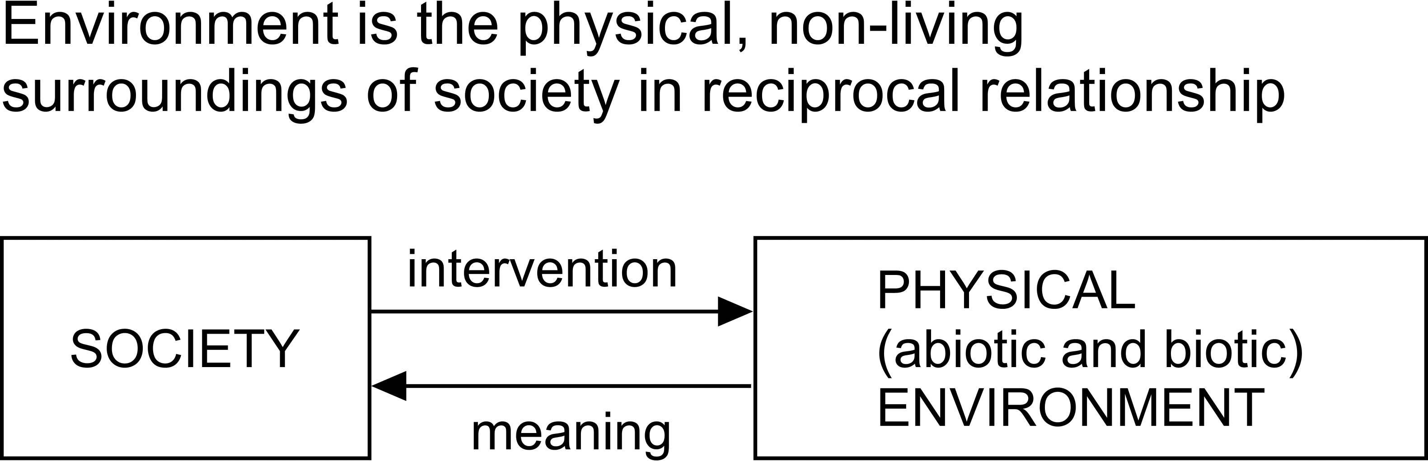 | 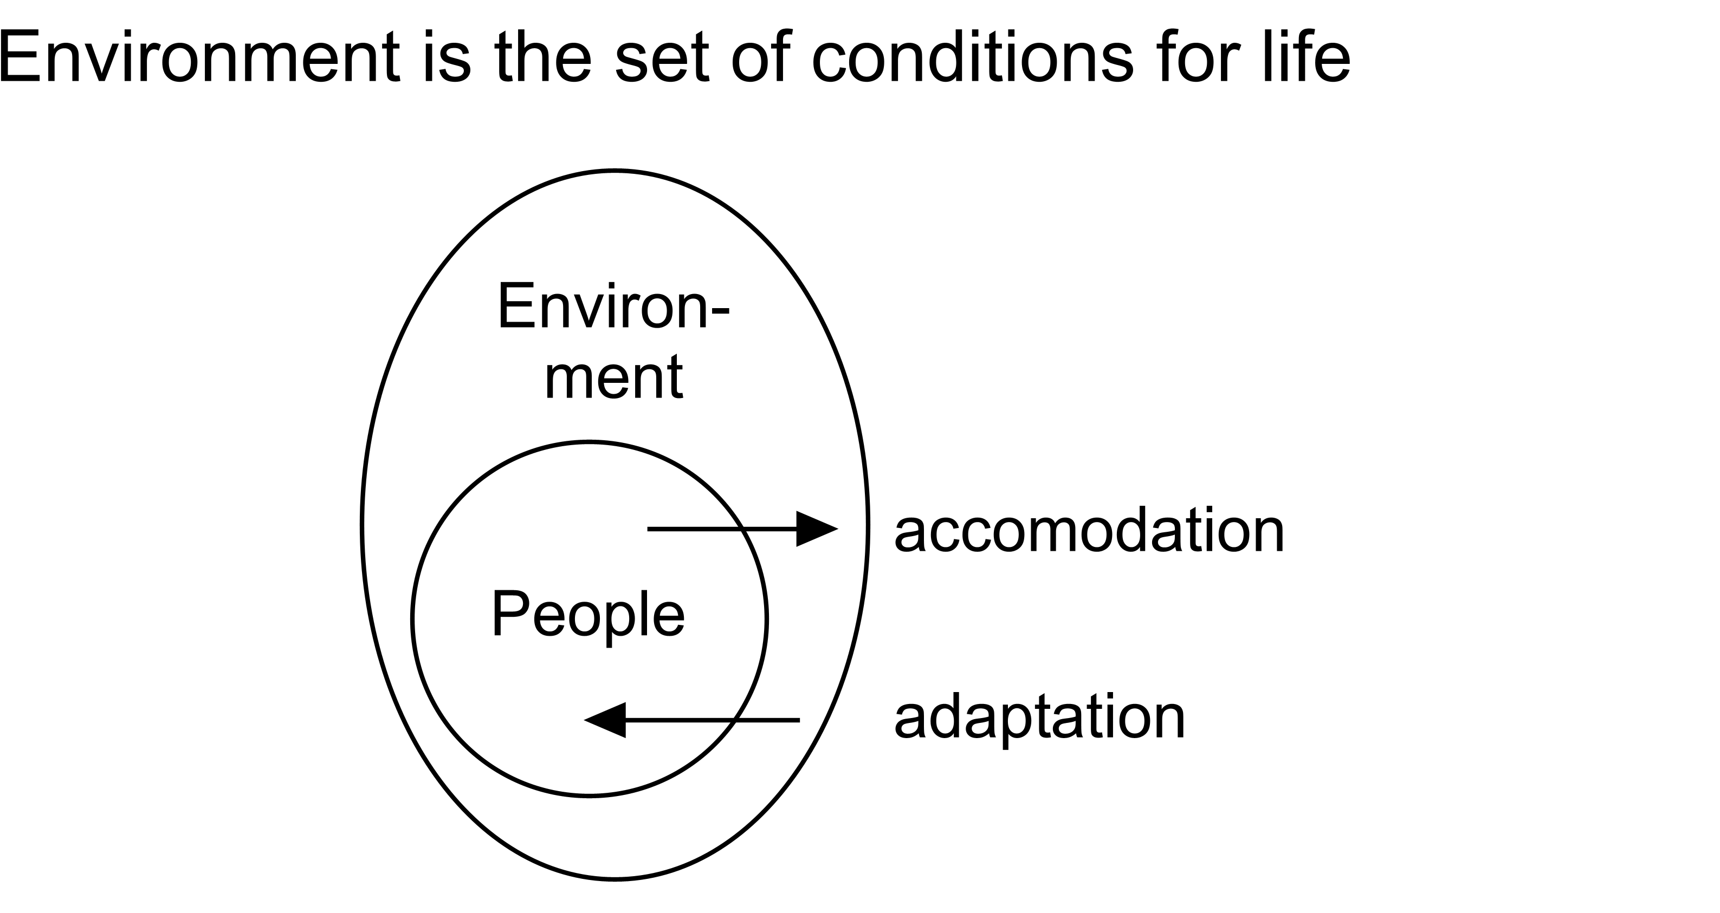
Fig. 8 Environment according to Udo de Haes | Fig. 9 Environment in a technical sense
Social science and geography may stress causal relations (based on probability, the arrows in Fig. 8) while technical science cannot abandon conditional relations (based on possibility, such as ‘no people without environment’, ‘no economy without dikes’, ‘no land without pumping stations’, the arrows in Fig. 9 are asymmetrical). Conditions are often taken for granted by empirical science as ‘ceteris paribus’ suppositions, but in technology they are the essence of ‘environment’, to be included in design.

Distinguishing many types of environment
By that general technical definition you can define different meanings of ‘environment’ by substitution of ‘conditions’ and ‘life’ more specifically (see fig. Fig. 10).

Layer
managerial
cultural | A
economic
technical |  |  | B
ecological
mass/time/spatial
conditions for | human | animal | plant | life
Fig. 10 Substitution possibilities in defining ‘environment’
For example, cultural conditions for human life (A in Fig. 10) are a kind of informational environment (‘cultural environment’) different to technical conditions for plant life B (like dikes in the Netherlands). They even can be contrary to each other. Conditions can be made operational by environmental variables taking different values on different locations. Settlement factors for species, populations or their artefacts consist of ecological tolerance concerning these values.
‘Environmental problems’ are simply defined as ‘lacking conditions for life’ (biodiversity and human health). This scheme is valid on any level of scale, but changing the level of scale changes the meaning of the layers and the size of life forms taken into account.

Connecting environments
Fig. 11 shows the conditional way of looking at the different environments as floating containers with liquids of different specific gravity.

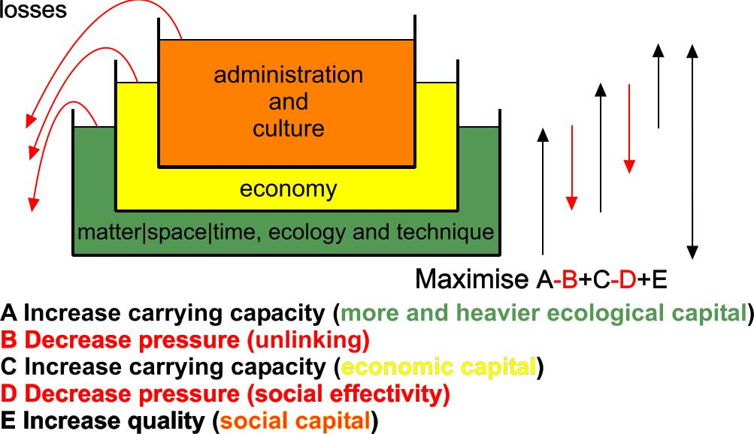
Fig. 11 People, Prosperity and Planet combined in a Project
The relations between Planet, Prosperity and People are asymmetric, alternating causal pressures and historic conditional carrying capacities.

Technology, the knowledge of technique and techniques

Reinforcing the technical capacity of urban designers
Both chairs focus on techniques, operational methods for designing, in particular the ways how engineering tasks can be done in the course of designing without frustrating a design study trying to incorporate all aspects of context. At a University of Technology the voices of technical specialists have to be heard and understood to be able to put them into perspective. So, the section concerns as its first task to clarify, simulate and modify technical contributions of specialists, making the urban designer less vulnerable in their company. Tjallingii’s techniques to modify water management, for example, have, broadly proven in practice, unexpectedly enriched the possibilities of design in new combinations not imagined as possible before, based on proper knowledge of the existing restricting suppositions of usual water management.

Equipped with that ability the urban designer can also take responsibility for vulnerable or future interests not represented by specialists or a programme of requirements. Duijvesteins DCBA-method is a technique to cooperate with many specialists and stakeholders, also broadly proven in practice to produce a more complete and better specified technical programme of sustainability requirements, committing all participants. Bach’s toolbox for context sensitive traffic solutions protecting pedestrians and cyclists convinced traffic engineers enough to publish it themselves.

On the other hand, equipped with that capacity and understanding, an urban designer can better convince specialists and stakeholders of own design standards using their language. Guney’s F(M)OP technique for analysing form, operation and performance of existing designs (precedents) made such analyses applicable for design, POF(M), and it made design concepts readable and understandable for specialists.

Apart from fulfilling the requirements of a programme, a designer has to combine them with the opportunities of a site, the possibilities of a physical and social context not completely represented by any specialist. De Jong’s context analysis is a technique of producing a programme for design study from a viewpoint of designing itself, exploring which specialists and stakeholders have to be involved in a given context.

These components are elaborated below.

Clarifying and simulating specialist’s techniques
The current design practice has to put out partial tasks into an increasing number of specialists participating in a design team. Integrating these diverging contributions in practice, a context sensitive design project meets many professions, restricted viewpoints, suppositions, modes, languages, categories and techniques. In the company of mainly empirically educated specialists the designer is vulnerable if (s)he does not know their hidden suppositions and methods. If a designer is not able to criticise their conclusions, to interpret their adaptability to a specific context, to balance their mutual weight in design, (s)he becomes the prisoner specialisms. Many specialisms are not present at the Faculty of Architecture to exercise that confrontation. But they can be roughly simulated by simple expert systems, open algorithms, sequences of inferences and simulated actions clarifying specialist’s hidden suppositions putting them into perspective.

Clarifying and simulating consequences of vulnerable interests
Moreover, there are always interests not represented in the design team as a specialism and not included in the programme of requirements. But a programme of requirements always still leaves a combinatoric explosion of possibilities and design decisions open. It leaves space for vulnerable and forgotten interests sometimes only emerging if the context changes. Unexpected combinations could increase that space, increasing the support for a design concept. The designer has a responsibility for forgotten and vulnerable interests. (S)he should know the techniques to formulate these interests and make them operational in design. Sustainability still contains many vulnerable and forgotten interests of future generations in the life time of a built environment.

Developing dynamic but convincing context sensitive design standards
On the other hand, the design task itself counts many techniques and suppositions not clear to specialists and stakeholders in a project. While specialists often can fall back on stable standards (environment, safety, traffic), based on scientific generalisations, the designer often fails in explaining design qualities possible in a specific context. Moreover, design standards concerning these qualities can change reacting on emerging opportunities discovered or invented in the design process itself. However, vague or even shifting standards are not very convincing. In that way designs are often rejected unnecessarily loosing the battle with direct technical alternatives only solving the problems of a programme of requirements (also made by specialists) separately, without exploitation of the possibilities of combinations, the site and its context, without many possible added values of design. The section also has a task in translating urban design standards into the same language as those of specialists and bringing them at the same convincing level, developing the techniques to formulate and reach them.

Simulations
From the very beginning in 1987 the chairs already partly in cooperation have made computer programs to clarify hidden suppositions in specialists’ techniques. Using program languages like C in the eighties, databases and Visual Basic in the nineties, now great progress is made in using Excel with Visual Basic components. The advantage of Excel is that it is available, open and adaptable to everybody not hiding any supposition. So, any student or researcher now can change the specialists’ parameters in public domain experiments concerning sun, energy, plantation, wind, noise, water, hydrology, traffic, 3D altitude maps, ecological and demographic principles, population densities, programming surfaces of a site, its content of facilities, economic models, calculations of 3D representations, common mathematical functions, statistics and linear programming, all downloadable from the web. The main objective is, applying mathematics without time consuming handling of formulas and data, just looking what happens if you change parameters with a simple slider. Much programming time is invested on the principle “The computer does the math, you do the learning.”

The chair Urban Sustainability
This chair focuses on the relations between Planet (ecological qualities), People (managerial, cultural qualities), Prosperity (economic qualities) and their integration in Projects (technical solutions in mass, space and time) from a specific viewpoint of sustainability. This chair has many relations in practice developing applications of sustainable building. It developed a well-structured research programme and has many tasks in education. It coordinates special attention for sustainability in different departments.
P.M.

The chair Technical Ecology
See http://team.bk.tudelft.nl/ for extended information (cited publications, developed computer programs and project information are mainly downloadable from this site).
This chair was originally named ‘Environmental planning and ecology’. After the establishment of the second chair on urban sustainability it focused on technical ecology, including urban technical design and engineering and by special assignment of the Dean in 2000, on methodology. The chairholder shares a chair on Regional Design with J.A. Schrijnen until a new chairholder is found. The mainly educational task was dispersed over 16 lecture series per year in all years of the Faculty of Architecture courses and one on the Faculty of Civil engineering until 2007.
That educational task is gradually reduced in favour of study and research.

The research programme on design related methodology resulted in an encyclopedic book with 48 authors from the faculty in 2002, used in education until 2007. That task is now delegated to the Department of Real Estate and Housing. The research programme on ecology resulted in an encyclopedic book with 32 authors from different universities (2007) indicating that the University of Technology Delft has a special task in technical ecology (mainly civil engineering). Both results can be considered as critiques on methodology and ecology from a viewpoint of design.

Concerning the lack of urban technique in the design education of urbanism, the chair now focuses on urban technology including the ‘nature technique’ of its predecessor Van Leeuwen, not avoiding some necessary mathematics. This discipline is currently dispersed over many specialisms like those of urban physics, water management, traffic, site preparation plantation, ecology and so on. Since 2005 these scattered specialist’s contributions are gathered in an encyclopedic work from a viewpoint of urban design. In the coming years it is aimed to result in third encyclopedic critique on specialisms. Besides that, several practical case studies are performed, techniques, computer programs and theories are developed supporting that aim.

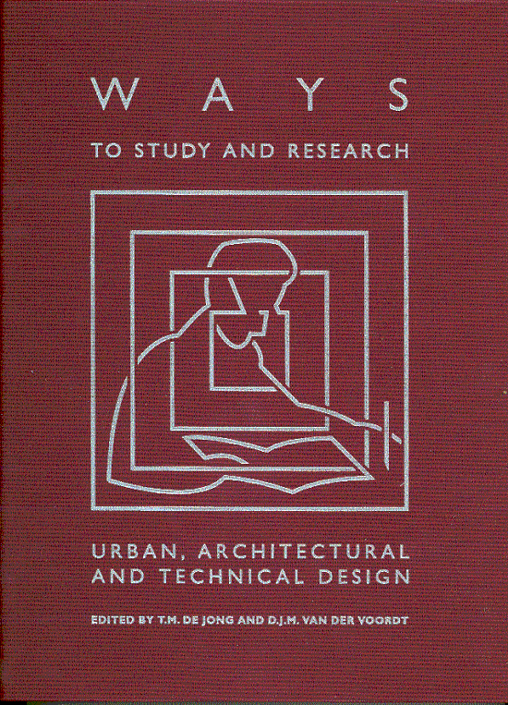 | 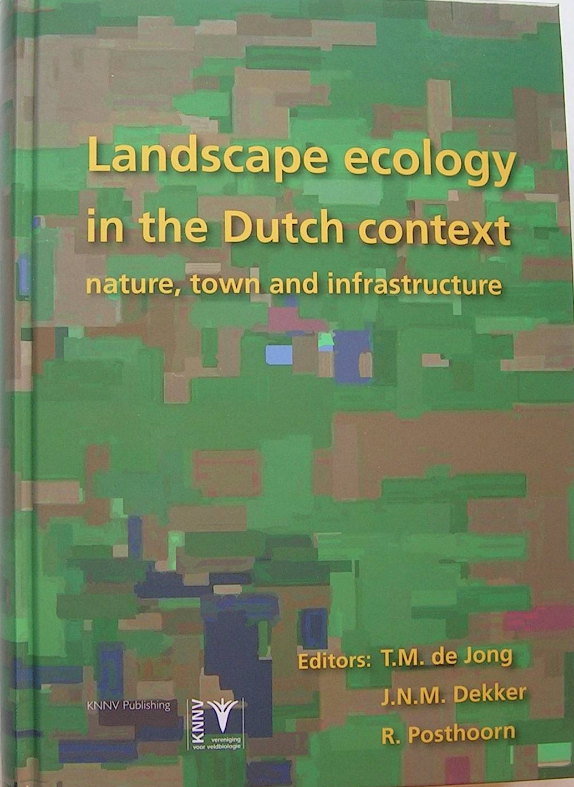 | 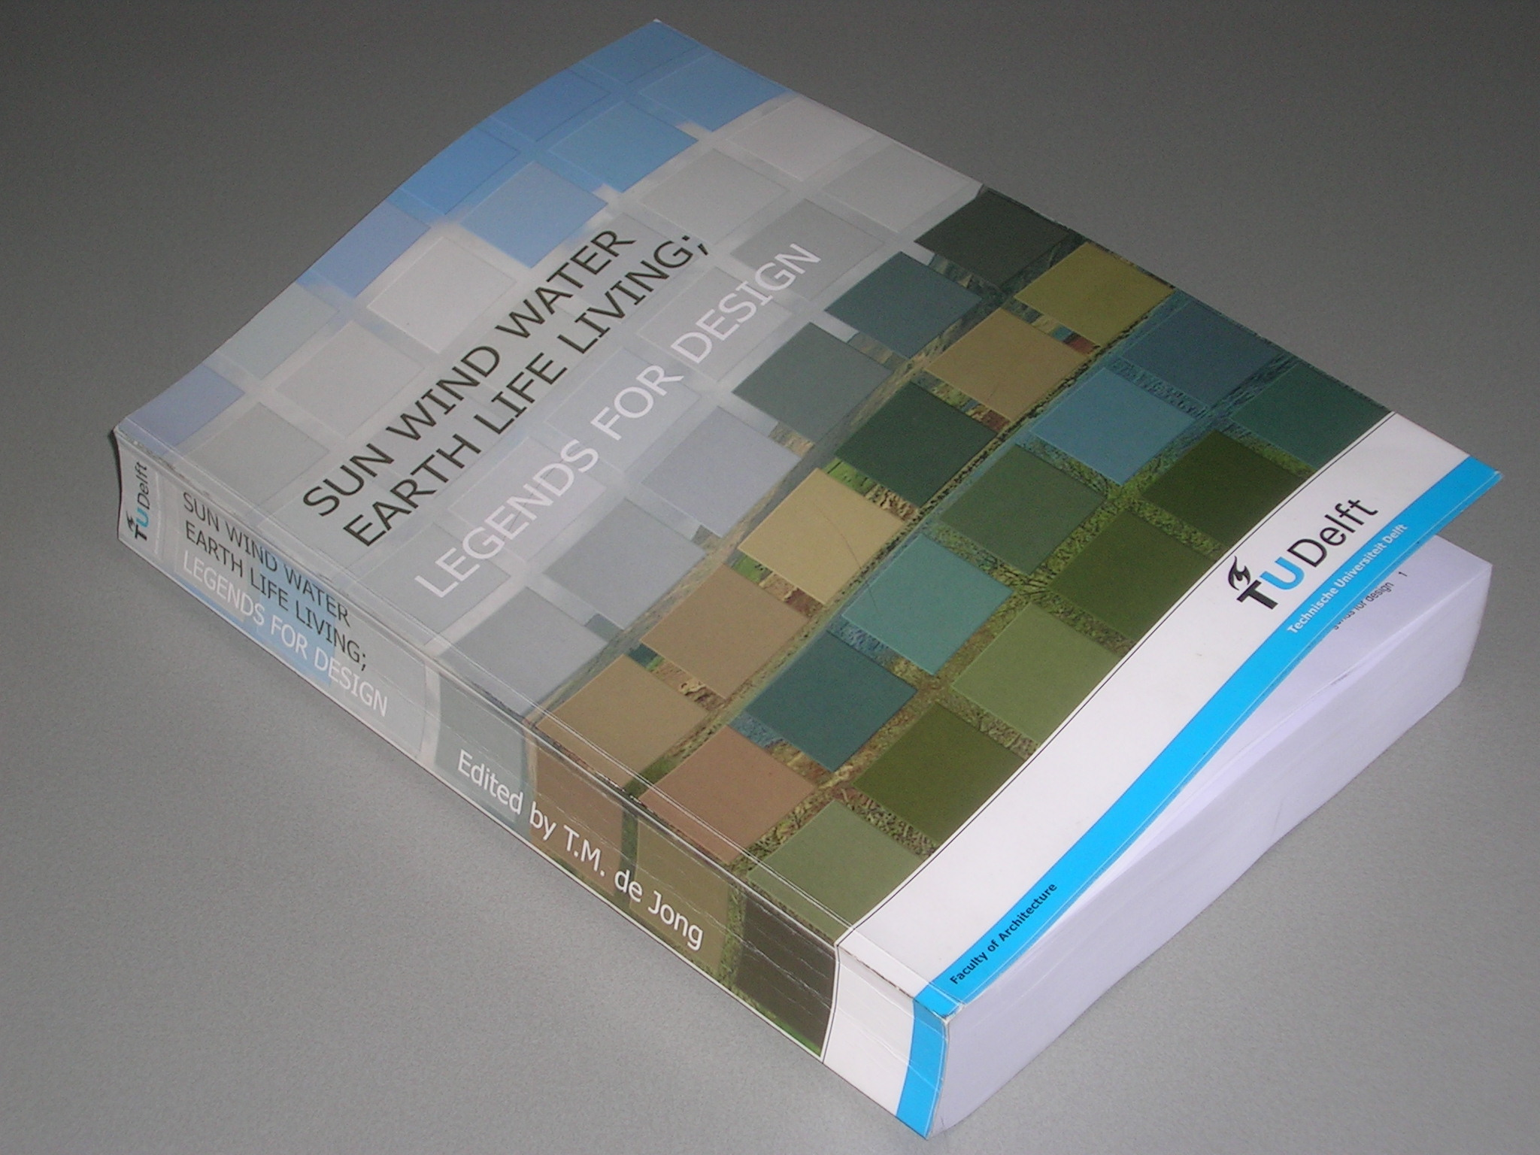
Fig. 12 Methodology | Fig. 13 Ecology | Fig. 14 Urban technology

Research programme
The research programme is based on the existing programme of the chair Urban Sustainability, already well structured in three categories: projects, techniques, theories. One ‘techniques’ programme is added: ‘Urban techniques’ (5.5.4), to be distinguished from the unchanged existing ‘Sustainability techniques’ (5.5.3).

Finished research projects to built on
P.M.

Ways to study urban, architectural and technical design (2002)
This extensive encyclopedic work with 50 authors shows the way 48 researchers of the Faculty explaining how they executed their study until 2002. It still is the starting point to position the current research of the section in the context of study and research in the Faculty. It still is the basis of criticism on empirical and design related methodology.

Landscape ecology in the Dutch context: Nature, Town and Infrastructure (2007)
This extensive encyclopedic work with 32 authors shows the contribution of ecology in the preservation and development of nature in the landscapes, towns and infrastructure of the Netherlands. It is the starting point to position the current research of the section in the context of national research and practice of ecology. From this work the conclusion was arrived that the contribution of TUDelft in this field should focus on urban technology. It still is the sections basis of criticism on scientific ecology.

Projects in practice
P.M.

Adapazarı's Beating Composition
The chair Technical Ecology is involved in the development of the urban area of the Turkish city of Adapazarı, destroyed by earthquake in 1999 (officially estimated 17 000 casualties). Chair participant Guney is confidant of the mayor. An attempt to get funds from the European Investment Bank (EIB) on assignment of the mayor failed in 2005 by local administrative shortcomings. The chair then developed a low risk scenario for the area and made proposals for an Urban and Architectural Master Plan (UMA and AMA). In the mean time Guney achieved a complete change of the structure of urban administration concerning urban development according to European efficiency standards. That great effort resulted in an outlook of ongoing advice at distance increasing local capacity as soon as administrative problems of payment are arranged. Guney is planning a PHD project on Adapazarı. The scientific relevance of the project concerns handling risks in urban planning in a world wide increasing occupation of risky areas, the outlook of a real ‘Randstad’-concept for urban development forced by nature (with 10 new towns of 100 000 inhabitants in a ring of 30km radius) and the introduction of architectural quality in master plans (UMA and AMA).

Almere EcoCity
The chair Technical Ecology is involved in the development of an ecological strategy for Almere. The scientific relevance concerns other priorities than usual based on the superfluous green areas in Almere.

Standards for Urban Green Spaces
PHD candidate Stolk participating in the chair Technical Ecology studying urban quality standards published with Van der Ham a study on qualitative standards for Urban Green Spaces applicable in the Adapazarı and Almere projects. Subsequently De Jong made a computer program for quantitative standards concerning different urban ambitions. Qualitative and quantitative standards should be combined for applications in Adapazarı and Almere. The extensive knowledge of chair participant and landscape architect Van den Toorn in this field should ensure substantial progress on this item, relevant in any urban development.

Strategic Visual Quality Plans
PHD candidate Stolk participating in the chair Technical Ecology was employed in the Provinces of South- and North-Holland involved in developing standards for Strategic Visual Quality Plans. Starting his PHD study in Delft, the province North-Holland supported his study financially and practically involving him in evaluating municipal visual quality plans. The social and scientific relevance is justified by missing standards in the Netherlands, required in Adapazarı and probably Almere as well.

Sustainability Techniques
P.M.

Urban Techniques
Since 1990 yearly improved lecture papers of the chair Technical Ecology concerning urban technology reach the phase of publishing that work in 7 separate volumes of the current 7 chapters reminding Jellema and Neufert with its 6000 key words in the final index. However, that requires the involvement of specialists as co-authors for professional updating and the improvement of more than 1000 illustrations requiring still several years of editing. The intention is to find cooperation of such specialists within the framework of Eekhouts 3TU initiative ‘Speerpunt Bouw’. The chapters contain unusual combinations of disciplines elaborated below as a first step into integration of specialisms in design. It culminates in legends for different layers in design. The main approach of each chapter is top-down fine graining in favour of mathematical models containing parameters mainly stemming from suppositions on higher levels (local climate, hydrology, soil). That approach is complementary to the approach of the chair Urban Sustainability starting with integral local projects.

Volume Sun
This volume starts with the physical concept of energy, its use and supply, but ends with the design of shadow and plantation. The current table of contents is starting point:

1.1 ENERGY
1.1.1 Physical measures
1.1.2 Entropy
1.1.3 Energetic efficiency
1.1.4 Global energy
1.1.5 National energy
1.1.6 Local energy storage
1.2 SUN, LIGHT AND SHADOW
1.2.1 Looking from the universe (a, b and latitude l)
1.2.2 Looking from the Sun (declination d)
1.2.3 Looking back from Earth (azimuth and sunheight)
1.2.4 Appointments about time on Earth
1.2.5 Calculating sunlight periods
1.2.6 Shadow
1.3 TEMPERATURE, GEOGRAPHY AND AND HISTORY
1.3.1 Spatial variation
1.3.2 Long term temporal variation
1.3.3 Seasons and common plants
1.4 PLANTING BY MAN
1.4.1 Introduction
1.4.2 Planting and Habitat
1.4.3 Tree planting and the urban space
1.4.4 Hedges

Volume Wind
This volume starts with global air movements, but ends with traffic noise.
The current table of contents is starting point:

2.1 GLOBAL ATMOSPHERE
2.1.1 Air, its mass and density
2.1.2 Wind, its force and power
2.1.3 The atmosphere
2.1.4 Climate
2.1.5 The urban impacts of wind
2.1.6 Measures, targeted impacts per level of scale
2.2 NATIONAL CHOICE OF LOCATION
2.2.1 National distribution of wind velocity
2.2.2 Closer specification of wind statistics
2.2.3 The energy profit of wind turbines
2.2.4 Energy losses from buildings
2.2.5 Temperature impacts
2.2.6 Comfort of outdoor space
2.2.7 Dispersion of air pollution
2.2.8 Summary national comparison
2.3 REGIONAL CHOICE OF LOCATION
2.3.1 Roughness of surrounding grounds
2.3.2 Impact of new urban area lose from or adjacent to town in case of Westerly wind
2.3.3 Impact of new urban area lose or adjacent in case of Easterly wind
2.3.4 Impacts on energy losses by ventilation behind the edge in the interior of town
2.3.5 Highways, railways, green areas and forests
2.4 LOCAL MEASURES
2.4.1 Local shelter of residential areas
2.4.2 Increase of wind velocity by height
2.4.3 The form of a town
2.4.4 Dispersion of urban area
2.4.5 The form of town edge
2.4.6 Wind directions, temperature and built form
2.5 DISTRICT AND NEIGHBOURHOOD VARIANTS
2.5.1 From calculable ‘rough surface’ into allotments in a wind tunnel
2.5.2 Wind tunnel experiments
2.5.3 Pressure differences between front and back façades
2.5.4 District lay out
2.5.5 Neighbourhoods
2.6 ALLOTMENT OF HECTARES
2.6.1 From wind tunnel experiments into methods of calculation
2.6.2 Impact of trees
2.6.3 Comparing repeated allotments 100x100m
2.6.4 Wind behaviour around high objects
2.7 SOUND AND NOISE
2.7.1 Music
2.7.2 Power or intensity
2.7.3 Sound and noise
2.7.4 Birds
2.7.5 Traffic noise

Volume Water
This volume starts with world wide precipitation, evaporation and run off, but ends with other networks such as traffic and cables and ducts. The current table of contents is starting point:

3.1 WATER BALANCE
3.1.1 Earth
3.1.2 Evaporation and precipitation
3.1.3 Runoff
3.1.4 Static balance
3.1.5 Movement ignoring resistance
3.1.6 Resistance
3.1.7 Erosion and sedimentation
3.1.8 Hydraulic geometry of stream channels
3.1.9 River morphology
3.1.10 Simulating a simple drainage system
3.1.11 Bifurcation or trunking in traffic networks
3.1.12 Catchment area and river length
3.1.13 Local morphologies
3.1.14 Measuring velocities to get Q
3.1.15 Discharge Q on different water heights
3.1.16 Interpolation of experimental data by using Excel
3.1.17 Calculating drainage Q with a rough profile
3.1.18 Level and discharge regulators
3.2 CIVIL ENGINEERING IN THE NETHERLANDS
3.2.1 History
3.2.2 The distribution of water
3.2.3 The threat of floods
3.2.4 Risks of flooding
3.2.5 Measures to avoid floods
3.2.6 Coastal protection
3.2.7 The Delta project
3.2.8 The central coast line
3.2.9 The northern defence system
3.2.10 Polders
3.2.11 Need of drainage and flood control
3.2.12 Artificial drainage
3.2.13 Configuration and drainage patterns of polders
3.2.14 Drainage and use
3.2.15 Weirs, sluices and locks
3.2.16 Water management tasks in the landscape
3.2.17 Local water management maps
3.3 WATER POLICY
3.3.1 Coordination of different administrative sectors
3.3.2 Water boards in Holland
3.3.3 Delfland Waterboard
3.3.4 Spatial plans checked on their impact on water: ‘Watertoets’
3.3.5 Water management in spatial design
3.3.6 Hydrologic cycle and water system
3.3.7 Water quality and management
3.3.8 Sustainability and water management
3.3.9 References to water management in spatial design
3.4 THE SECOND NETWORK: ROADS
3.4.1 Names and scale
3.4.2 Functional charge of networks
3.4.3 Rectangularity forced by connections of a higher level
3.4.4 Superposition of levels
3.4.5 Interference of different networks
3.4.6 Crossings
3.4.7 A traffic network
3.4.8 Measures
3.4.9 A residential street
3.4.10 Space for speed
3.4.11 Roads of a higher level
3.4.12 Urban islands in a network
3.4.13 A neighbourhood
3.4.14 A road hierarchy
3.4.15 From a model back into a real city
3.4.16 Traffic surface
3.4.17 Harbours P.M.
3.5 OTHER NETWORKS: CABLES AND DUCTS
3.5.1 The electricity network
3.5.2 The gas network
3.5.3 Water pipes
3.5.4 Pressure pipelines for sewage water
3.5.5 The telephone network
3.5.6 Radio and television transmitters
3.5.7 Network for the transport of raw materials
3.5.8 Tunnels
3.5.9 Urban scale
3.5.10 The future

Volume Earth
This volume starts with large scale geomorphology, but ends with site preparation.
The current table of contents is starting point:

4.1 INTRODUCTION
4.1.1 Span of view
4.1.2 References Introduction
4.2 KILOMETRES: GEOMORPHOLOGIC LANDSCAPES
4.2.1 Landforms created by water
4.2.2 Landforms created by rivers
4.2.3 Landforms created by ice
4.2.4 Landforms created by the wind
4.2.5 Landforms created by slope processes
4.3 METRES
4.3.1 Pedological landscapes
4.3.2 Clay soils
4.3.3 Sand soils
4.3.4 Peat soils and peat reclamation soils
4.4 MILLIMETRES
4.4.1 Soil structure
4.4.2 Ground water
4.4.3 Soil horizon differentiation
4.5 MICROMETRES
4.5.1 Chemical compounds of the Earth
4.5.2 Weathering
4.5.3 Sediments
4.5.4 Soil
4.5.5 Identifying soil fractions
4.5.6 Naming of ground types
4.6 SOIL POLLUTION
4.6.1 Soil pollution
4.6.2 General soil knowledge
4.6.3 Soil pollution and building activities
4.6.4 Exploratory survey
4.6.5 Follow-up investigation
4.6.6 Causes of soil pollution
4.6.7 Remediation methods
4.6.8 Soil purification techniques
4.6.9 Appendix saneringsregeling wet bodembescherming P.M. (remediation regulations under the Soil Protection Act)
4.7 PREPARING A SITE FOR DEVELOPMENT
4.7.1 Site analyses
4.7.2 Preparing a site for development
4.7.3 Methods for preparing a site for development
4.7.4 Detailed elaboration for urban functions
4.7.5 Check lists

Volume Life
This volume starts with long term biotic changes, but ends with nature management.
The current table of contents is starting point:

5.1 NATURAL HISTORY
5.1.1 Long-term biotic changes
5.1.2 400 000 000 years ago
5.1.3 230 000 000 years ago
5.1.4 65 000 000 years ago
5.1.5 Pleistocene
5.1.6 Identifying plants species
5.2 DIVERSITY, SCALE AND DISPERSION
5.2.1 The importance of diversity for life
5.2.2 The importance of diversity for human living
5.2.3 Scale-sensitive concepts
5.2.4 Spatial state of dispersion as a condition of diversity
5.2.5 300km continental vegetation areas
5.2.6 30km national counties
5.2.7 3km Landscape formations
5.2.8 300m local life communities
5.2.9 30m ecological groups
5.2.10 3m symbiosis and competition
5.2.11 30cm individual strategies for survival
5.3 ECOLOGIES
5.3.1 Generalisation
5.3.2 Six kinds of ecology
5.3.3 Scale classification
5.3.4 Cybernetics
5.3.5 Regulation theory
5.3.6 Separation and discontinuity
5.3.7 Selectors and regulators in the landscape
5.3.8 Ecological networks
5.3.9 Urban ecology
5.3.10 Distribution and abundance of people
5.3.11 Comparing and applying standards for green surfaces in urban areas
5.3.12 Urban perspectives
5.3.13 Human health in the urban environment
5.4 VALUING NATURE
5.4.1 Assessing biotic values
5.4.2 Measuring rarity
5.4.3 The IJsselmeer case
5.4.4 Replaceability
5.4.5 Comparability Problems, which categories?
5.4.6 Valuation bases
5.4.7 Valuing urban nature
5.5 MANAGING NATURE
5.5.1 Main Ecological Structure (EHS) and nature-target types
5.5.2 Nature-target types for the higher sandy soils
5.5.3 Nature-target types in fluvial areas
5.5.4 Nature-target types for the Marine-clay areas
5.5.5 Urban nature
5.5.6 Differences in diversity between and within regions

Volume Living
This volume starts with long term population changes, but ends with economy and environment.
The current table of contents is starting point:

6.1 ADAPTATION AND ACCOMMODATION
6.1.1 Human population
6.1.2 Habitat, density and economy
6.1.3 Population growth
6.1.4 The urban environment
6.1.5 Mobility between urban populations
6.1.6 The urban field is not homogeneous
6.1.7 The force of specialization
6.2 HABITAT
6.2.1 Dutch heritage
6.2.2 Human impact
6.2.3 The last millennium
6.2.4 Reading topographical maps (Visser)
6.3 POPULATION DENSITY
6.3.1 Global densities10 000km
6.3.2 Gross and net density
6.3.3 A binary legend: net and tare surface
6.3.4 (Sub)continental densities3 000 and 1 000km
6.3.5 National densities and distributions300km
6.3.6 Regional distribution100 and 30km
6.3.7 Density or real measure dots distribution
6.3.8 Metropolis density30km
6.3.9 Conurbation density10km
6.3.10 Town density3km
6.3.11 District density1km
6.3.12 Neighbourhood density300m
6.3.13 Ensemble density100m
6.3.14 Urban island density30m
6.3.15 Urban details10m influencing density
6.4 ECONOMY
6.4.1 Dutch statistics
6.4.2 Population
6.4.3 Time and movement
6.4.4 Urbanity
6.4.5 Facilities
6.4.6 Dwellings
6.4.7 Public space
6.4.8 Public utilities
6.4.9 Businesses
6.5 ENVIRONMENT
6.5.1 Conditions
6.5.2 Emissions
6.5.3 Transmission
6.5.4 Immission and exposition
6.5.5 Creating standards
6.5.6 Environmental policy
6.5.6 Environmental impact assessment

Volume Legends for design
This volume starts with mapping, but ends with boundaries of imagination.
The current table of contents is starting point:

7.1 MAPPING
7.1.1 Introduction
7.1.2 Types of maps
7.1.3 Perception and reading of (topographical) maps
7.1.4 Map analysis and interpretation
7.1.5 Making of maps and communication
7.2 CHILD PERCEPTION
7.2.1 Introduction
7.2.2 The growing scale of perception
7.2.3 Field of vision
7.2.4 The composition of a scene
7.2.5 Conclusions for urban design
7.3 COMPOSITION ANALYSIS
7.3.1 Variation
7.3.2 Scale levels
7.3.3 Focus
7.3.4 Morphological reconstruction
7.3.5 Structure in terms of openness and closedness.
7.3.6 Functional differentiation
7.3.7 Intention
7.4 LEGENDS
7.4.1 Resolution and tolerance
7.4.2 Scale-sensitivity
7.4.3 Unconventional true scale legend units
7.5 SCALES OF SEPARATION
7.5.1 Potentials rather than functions
7.5.2 Conditional considerations
7.5.3 The context and perspective of consideration
7.5.4 Relief between built-up and vacant areas
7.5.5 Interaction with exterior spaces
7.5.6 An academic example of urban architectural rules.
7.6 BOUNDARIES OF IMAGINATION
7.6.1 Creativity
7.6.2 Possible futures
7.6.3 Environment, the set of conditions for life
7.6.4 Starting by difference
7.6.5 The importance of diversity in ecology
7.6.6 Conclusion

Specialist’s calculators
Many of the subjects mentioned above require mathematical underpinning and clarification. For every chapter downloadable computer programmes have been written for exercise and research. The aim is simulating specialist’s advice. These 7 programmes are continuously extended, and have to be updated and controlled professionally. Remarkable outcomes of computational experiments should be published in articles, but they have to compete with specialist’s articles in unknown specialist’s journals.

The viewpoint of context sensitive design introduces many questions apparently ignored by specialists taking parameters from other disciplines for granted. So, simulating their activities gives a layman’s insight in their suppositions, raising critique from a viewpoint of design. For example, programming experiments resulted in an unconventional model to determine the modal split in traffic apparently much better fitting the data than currently known models. But we do not know all traffic models, because the source codes are copyright protected and very expensive to purchase. To formulate relevant critique on the existing traffic models in general requires extensive study of these models first, before a substantial formulation of the critique is possible. It is one of our hidden desires to do so, but there are other priorities.

In the time consuming and addictive practice of programming itself the greatest innovations seem to appear if they are not done according to a previously formulated target or programme of requirements. Time after time new horizons of computational possibilities force to explore these unexpected areas of application. Particularly if these experiments are done motivated by a desire to answer questions arising designing in a complex context, they are inclined to combine different disciplines at once giving outcomes easily to be rejected by these disciplines separately.

Unfortunately, developing computer programs is not rewarded in the current assessment system.

Environmental Impact Assessment
The evaluation of designs and projects is core business in the Faculty. The way projects are evaluated by environmental impact assessment (MER) in practice raises questions fed by the above mentioned calculators. In fact these calculators are tools for impact assessment. However, developing and combining them into a competing level of the usually separated tools requires a feeling of covering all aspects of context we still do not have. Nevertheless, we should continue to pay attention to the possibility of being a reliable institute for second opinion.

Precedent analysis/Plan analysis
Plan analysis is the core of Delft architectural education. Since the retirement of Prof. Tzonis his internationally well known approach of precedent analysis based on cognitive science threatens to be lost for the Faculty. Possibilities for application in previously mentioned projects are evident. Guney saves and reformulates that heritage for application in Adapazarı and the PHD projects of Stolk and himself.

Isovist based Visibility analysis
Stolk developed with … an advanced visibility tool fitting and extending the last volume.
P.M.

Theories

Context analysis by future impact determination
The chair Technical Ecology developed a Visual Basic computer programme for context analysis used by approximately 1500 students following the terminated methodology courses in the first, third and fourth year to make design study proposals. A continuous search for comparable tools for context analyses elsewhere is a search for critical remarks on the method and the underlying theory. However, it is still not criticised. Moreover, the method seems too unconventional for application in practice. Even a translation in Turkish did not succeed in applying it in Adapazarı. However, we still believe it is an excellent tool to give any design study a scientific start. The project continues to keep attention of the chair technical ecology.

A critical history of philosophy for designers
Designs covering many specialisms raise many questions of philosophical nature earlier discussed since many centuries. Many returning arguments in that field are made without knowledge about the conclusions they have produced many times before. So, the chair Technical Ecology started to compose a short introduction into the history of philosophy relevant for design. The aim is a manual to make the jargon of lectures on philosophy accessible for designers. It made its progress from ancient philosophy until Enlightenment. An extended study of Enlightenment now has come to an end stressing the influence of Dutch inventions like telescope, microscope and clockwork, Dutch contributions of Stevin, Beeckman, Spinoza and Huygens on philosophy. Some relevant original texts (Descartes in Dutch for example) are made downloadable. However a long road through the 19th and 20th century has to be made to arrive at current philosopy, so often repeating earlier arguments.

Ways to study possibility
The experience of two Faculty committees on methodology and five years of education based on the book ‘Ways to Study’ edited by the chairholder Technical Ecology, continues his awareness that current methods of empirical science cannot be the complete story. Just like the philosophy of science they focus more on truth or probability than on possibility. However, the probability of an ecological disaster urges to get a method exploring possibilities rather than probabilities. The project ‘Ways to study possibility’ aims to collect the earlier experience and add new insights in a book with this working title. A continuous concern has often brought sudden progress in that field and the result is unpredictable, but the target is a publication in 2008.

Specialisms in design
In his function as chairman of approximately 200 TUD PHD sessions replacing the Rector the chairholder Technical Ecology suspects a crisis in science by ongoing scientific specialisation. External scientific criticism from other disciplines is no longer accepted if a discipline develops its own depth in externally inaccessible jargon and isolated paradigmatic argument. Small global villages of professionals meeting each other at closed conferences and PHD sessions loose a feeling of context. The ultimate, probably unattainable, aim of the chair Technical Ecology is to formulate a critique on specialisms completing the trilogy of critiques on methods, ecology and specialism.

Here ‘intuition’ is concerned as experience difficult to transfer by words or drawings, which is more than trial and error.
For example the phenomenon of electricity was object of study in the 18th century, object of research in the 19th century.
Read, Vollebregt?, referring to Dilthey, Whitehead, Bateson and more recent writers on complexity.
Jong, T. M. de (2007) Filosofie in de Bachelors (Zoetermeer) opdracht Decaan
For example the popular lectures of Patrick Healy. His book Healy, Patrick (2005) Images of Knowledge. An introduction to contemporary philosophy of science (Amsterdam) SUN Publishers; Filosofische diagnosen reeks
Jong, Taeke M. de (2006) A short history of philosophy relevant for design (Zoetermeer) concept
Simon (1981) The Sciences of the Artificial. (Cambridge, Massachusetts / London) The MIT press
Alexander, C. (1977) A pattern language (New York) Oxford University Press
Jong, T.M. de (1992) Kleine methodologie voor ontwerpend onderzoek (Amsterdam, Meppel) Boom
Schön, D. (1992) The theory of inquiry, Dewey's legacy to education (j) Curriculum Inquiry 22/2 (summer 1992): 91-117
Burg, L. van den; Stolk, Egbert [eds.] (2004) Urban Analysis Guidebook. Typomorphology (Delft) Technical University Delft, Faculty of Architecture, Department of Urbanism.
Weeber, C. (1998) Het Wilde Wonen (Rotterdam) Uitgeverij 010
Jong, T.M. de; Voordt, D.J.M. van der (2002) Criteria for scientific study and design In: Jong, T.M. de; Voordt, D.J.M. van der [eds.] Ways to study and research urban, architectural and technical design (Delft) Delft University Press Science
Klaasen, Ina Trix (2003) Knowledge-Based Design: Developing Urban & Regional Design into a Science (Delft) DUP
Breen, Jack; Olsthoorn, Bernard (1999) De Brug. The Bridge (Delft) Delft University Press
Fokkema, J.T. (2002) Preface In: T.M. de Voordt Jong, D.J.M. van der [ed.] Ways to study and research urban, architectural and technical design. (Delft) Delft University Press
Performance is the way they are actually used. New possibilities arise to monitor the use of urban spaces real time like GPS monitoring currently examined by vd. Spek.
Leupen, B.A.J. (2002) Concept and Type In: Jong, T.M. de; Voordt, D.J.M. van der [eds.] Ways to study and research urban, architectural and technological design (Delft) Delft University Press
Hertzberger, H. (2002) Creating space of thought In: Jong, T.M. de; Voordt, D.J.M. van der [eds.] Ways to study and research urban, architectural and technological design (Delft) Delft University Press
Guney, A. (2007). Architectural precedent analysis. Meaningful Environments - Architectural Precedents and the Question of Identity in Creative Design. K. Moraes Zarzar and A. Guney. Amsterdam, SUN.
Jong, T.M. de (2002) Designing in a determined context In: Jong, T.M. de; Voordt, D.J.H. van der [eds.] Ways to study and research urban, architectural and technical design (Delft) DUP Science
Vollers, K.J. (2001) Twist & Built creating nonorthogonal architecture (Rotterdam) 010 Publishers
Beukers A., Flemings, M.C. (2000) Encyclopedia of Materials: Science and Technology. Polymer Matrix Composites: Applications (Cambridge, England) Cambridge University Press.
Visscher, Robert (2007) Dansende gebouwen. Supersterk lichtgewicht composiet kan tonnen dragen. (j) Delft Integraal 2007(2)
Jong, Taeke M. de (2002) Technisch toekomstperspectief. (Delft) TUDelft Faculteit Bouwkunde, concept.
Bergh, W.F. van den (2002) Contemplations for Copenhagen In: Jong, T.M. de; Voordt, D.J.M. van der [eds.] Ways to study and research urban, architectural and technical design (Delft) Delft University Press
Verheijen, A.P.J.M.; Eldijk, P.J. van; Kan, M.L. van (2002) Designing Naturalis in a changing context In: Jong, T.M. de; Voordt, D.J.M. van der [eds.] Ways to study and research urban, architectural and technical design (Delft) Delft University Press
Frieling, D.H. (2002) Design in strategy In: Jong, T.M. de; Voordt, D.J.M. van der [eds.] Ways to study and research urban, architectural and technical design (Delft) DUP Science
James H. Brown on http://biology.unm.edu/jhbrown/home.html "The lab is a loose confederation of independent scientists, pursuing their own ideas and interests, offering plenty of interaction and opportunity for collaboration. Students generate, design and conduct their own independent research projects - that may or may not be related to my research programs"-
based on chairing more than 200 PHD ceremonies of different faculties by de Jong.
Bergson, H. (1946) L'évolution créatrice (Paris) Press Universitaires de France
Gurvitch, Georges (1968) Handboek van de Sociologie 1. (Utrecht / Antwerpen) Het Spectrum; Aula-Boeken
McMahon, Thomas A.; Bonner, John Tyler (1987) De Maat van het Leven. Hoe de natuur haar eigen wetten gehoorzaamt. (Maastricht/Brussel) Natuur&Techniek; Wetenschappelijke bibliotheek. Deel 8.
Kroonenberg, Salomon (2006) De Menselijke Maat. De aarde over tienduizend jaar. (Amsterdam / Antwerpen) Uitgeverij Atlas
For example: Portugali, J. (2000). Self-organization and the city (Berlin ; New York) Springer and Batty, M. (2005) Cities and Complexity (Massacusetts) MIT
Gell-Mann, Murray (1994) The Quark and the Jaguar (London) Abacus
For example the recent PHD study Heijden, A.H.(Thijn) van der (2007) Dynamic protein assemblies in homologous recombination with single DNA molecules. (Delft) Doctor Thesis TU-Delft Fac. TNW
Thompson, D'Arcy (2000) On Growth and Form (Cambridge) University Press
Kolasa, Jurek; Pickett, Steward T.A. [eds.] (1991) Ecological Heterogeneity. (New York) Springer-Verlag; Ecological Studies
Prigogine, I.; Stengers, I. (1979) La nouvelle alliance. Métamorphose de science (Parijs) Gallimard Kauffman, S.A. (1993) The origins of order. Self-Organization and selection in Evolution (New York) Oxford University Press
Jong, T.M. de ; Witberg, M. (1993) Stromend Stadsgewest Legenda-analyse (Delft) TU Delft
Udo de Haes in Boersema; Peereboom, Copius; Groot (1991) Basisboek Milieukunde HOOFDSTUK 01 (Meppel) Boom
Tjallingii, Sybrand; Berendsen, Roos (2007) Een Rijke Bron. Een nieuwe rol van water in ontwerpen voor de stad. (Amsterdam) Techne Press
Duijvestein, C.A.J. (2002) Het Nieuwe Ecologisch Bouwen (Delft) TU-Delft, Faculteit Bouwkunde, SOM
Bach, Boudewyn; Jong, T.M. de; Jong, M.I. de; Hal, E. van (2006) Urban design and traffic / Stedenbouw en verkeer (Ede) CROW
Guney, A. (2007). Architectural precedent analysis. Meaningful Environments - Architectural Precedents and the Question of Identity in Creative Design. K. Moraes Zarzar and A. Guney. Amsterdam, SUN.
Jong, T.M. de (2007) Context Analysis. In: Bekkering, Henco; Hauptmann, Deborah; Heijer, Alexandra den; Klatte, Julius; Knaack, Ulrich; Manen, Sanne van [eds.] The Architecture Annual 2005-2006. Delft University of Technology (Rotterdam) 010 Publishers; 92-97 Future Impact.exe computerprogramme
Jong, T.M. de; Moens, R.; Akker, C. van den; Steenbergen, C.M.; Toorn, M.J.M. van den (2007) Sun wind water earth life living; Legends for design (Delft) TUD
Jong, T.M. de; Voordt, D.J.M. van der [eds.] (2002) Ways to study and research urban, architectural and technical design. (Delft) DUP Science
Jong, T.M. de; Dekker, J.N.M.; Posthoorn, R. [eds.] (2007) Landscape ecology in the Dutch context: nature, town and infrastructure (Zeist) KNNV-uitgeverij
Bach, Boudewyn; Jong, T.M. de; Jong, M.I. de; Hal, E. van (2006) Urban design and traffic / Stedenbouw en verkeer (Ede) CROW
Jong, T.M. de; Moens, R.; Akker, C. van den; Steenbergen, C.M.; Toorn, M.J.M. van den (2007) Sun wind water earth life living; Legends for design (Delft) TUD
Jong, T.M. de; Voordt, D.J.M. van der [eds.] (2002) Ways to study and research urban, architectural and technical design. (Delft) DUP Science
Jong, T.M. de; Dekker, J.N.M.; Posthoorn, R. [eds.] (2007) Landscape ecology in the Dutch context: nature, town and infrastructure (Zeist) KNNV-uitgeverij
Ham, R.J.I.M. van der; Stolk, E.H. (2007) Op zoek naar een kwaliteitsnormering voor de inrichting en het beheer van stedelijke groenvoorzieningen: een oriëntering. (Ede, Delft) Stadswerk, TUDelft
Jong, T.M. de; Moens, R.; Akker, C. van den; Steenbergen, C.M.; Toorn, M.J.M. van den (2007) Sun wind water earth life living; Legends for design (Delft) TUD
For example graduate student Urbanism of our chair David Rutten was well known world wide because of his fascinating algorithms published on the web long before he was graduated. He could choose from many invitations all over the world a University cannot compete with. After many years he still is not graduted enjoying an advanced climate of invention abroad a University cannot offer.
See Jong, Taeke M. de (2000) Advies MER AWZI Harnaschpolder aan Belangenvereniging Harnaschpolder (Zoetermeer) MESO or Jong, Taeke M. de (2001) Ecologische toetsing van drie visies op Almere Pampus (Zoetermeer) MESO
Jong, Taeke M. de (2004) The future-impact computer programme version 3 (Zoetermeer) FutureImpact.exe MESO
Jong, Taeke M. de (2006) A short history of philosophy relevant for design (Zoetermeer) concept
Jong, T.M. de (2007) Ways to study possible futures: design extending science (Zoetermeer) concept

