Ways to study possible futures:
extending empirical science by design

Taeke M. de Jong 2007-05-20

Contents
1 Introduction 2
1.1 The difference between empirical research and design study 2
1.2 Limitations of an empirical approach 3
1.3 Design should not merely integrate specialists’ advices 5
2 Reasons for doubt on verbal language 6
2.1 Introduction 6
2.2 Imaging the transfer of ‘thoughts’ by verbal language 8
2.2.1 Schematic Representation 8
2.3 Suppositions of ‘cognitive science’ 10
2.3.1 Complex Schemas 11
2.3.2 Scripts 12
2.3.3 The self-schema 13
2.3.4 Conclusions 14
3 Context analysis 16
3.1 Introduction 16
3.2 Levels of scale 17
3.3 Physical and social layers 19
3.4 Desirable, probable and possible future contexts 22
3.5 Conclusion 23
3.6 Sources 24
4 Extending science by design 26
4.1 Introduction 26
4.2 The need of design in the actual world 26
4.3 Ways to study possibility 27

Introduction

The difference between empirical research and design study
The difference between empirical research and design study is primarily the difference between exploring probable and possible futures. From that proposition as a starting point this study derives consequences for convincing ways to study and justify architectural, urban and related technical design.
This study tries to avoid hidden suppositions only imaginable by other suppositions. I cannot not share such suppositions as long as they are not made explicit. This study tries to avoid usual mystifications (like undefined ‘creativity’) terminating the debate by hidden suppositions.
Besides that I hope do demonstrate that rejecting hidden suppositions (translated into conditions) plays a prominent role in design.

The task of design
Taking a closer look at the difference between probable and possible futures before we have to descend into modal logic, we simply can conclude that anything probable is per definition possible, but not the reverse. So, there are improbable possibilities. The probable ones can be predicted, explored by usual ways of empirical research simply because they are probable. But how to explore improbable possibilities? That is precisely the task of design.

Critical ability
That does not mean designers do not use the results of empirical research. They are part of possibility after all. It solely means it is not their competence to deliver such results. Their core business is developing unpredictable possibilities. The predictable components of design are delivered by empirical research. Designers choose and use them on location balancing them in a context-sensitive composition with improbable combinations, components and details to create the new possibilities needed. Designers are not assigned to make predictions based on causal suppositions (hypotheses) as empirical scientists are. So, concluding causal relations eventually following statistics and probability calculus based on existing data can not be the way of study they are assigned for. However, without knowing how that kind of conclusions are reached, designers are vulnerable in a team of specialists using these generally accepted scientific methods. So, they have to study methods of empirical research to be able to criticise the results of empirical generalisations in the specific context of a location. That critical ability is needed to balance often contradictory empirical advices of many empirically educated specialists in a planning team to be integrated in a composition. I hope to demonstrate that criticism nowadays fails between empirical specialisms.

Reliability in empirical science and design
Drawing unpredictable possibilities, a designer makes pictures of non-existing things, empirically to be taken as ‘lies’. They represent a possibility, no truth. However, they may be ‘realised’. So, in design the first scientific criterion of reliability is extended from truth-reliability into the reliability that a design is possible. That possibility is supposed to be proven by realisation like probability is supposed to be proven by observation (both eventually by preceding experiments on models necessarily excluding many context-factors). A town, a district, a neighbourhood, a building or a building component can be evaluated ‘ex ante’ after modelling or ‘ex post’ after realisation by testing all kinds of sup-positions (hypo-theses) to be ‘true’ or ‘false’ by empirical methods. But that is not the question here. The question is: what kind of inference suits before modelling or realisation in finding possibilities? That effort consumes most of the designers’ time. Is it only applying existing experience? How then to produce new experiences, new possibilities of use designers are assigned for?
It raises a the question of validity in convincing design inferences.

Validity in empirical science and design
The second criterion of validity in empirical science is based on usual logic concerning (eventually fuzzy) truth-values of inference. But what could ‘validity’ mean in design, based on possibility-values of inference? What kind of reasoning could convince the client a design to be desirable and realisable? To judge a plan to be possible means checking conditions (suppositions) to be fulfilled to make something possible. These conditions are often most convincingly demonstrated in a drawing. A design sums up the conditions to make something possible, not the causes to make something probable. We do not design a house to cause a household, we design a house (offer all conditions in coherence) to make many future households possible. A cause is a condition of something to happen, but not every condition needed is also a cause (see Fig. 1).

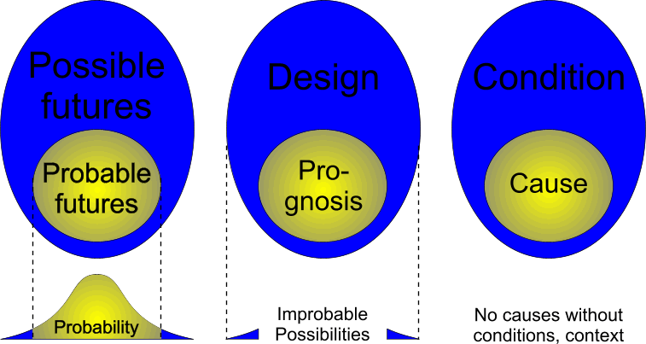
Fig. 1 Exploring probable and possible futures
These conditions are not always the conditional operators of usual logic determining something is ‘true’. If we conclude ‘it is true that this is possible’, like modal logic professes to be able to, a conflict with our first proposition arises: truth primarily must be part of possibility. Possibility is already supposed in the concept of truth. So, one can only say the reverse: ‘it is possible that this is (or becomes) true (or realised)’. The primary convincement of possibility is gradual from definitely ‘not possible’ into ‘possible’. What kind of inference brings us convincingly closer to the latter conclusion? What kind of inference we could call ‘valid’ based on possibility-values? Is it based on experience alone? Is creativity solely based on combinatory operations on well-known components to reach a satisfying composition? Is design solely a kind of combinatorics?

Possibilities beyond experience
That question is particularly urgent if we have to expect a world-wide ecological crisis. Could we overview the possibilities needed to survive that crisis by experience alone? Do we need ‘creativity’ in a broader sense? From the living nature we still discover possibilities never imagined before. Why did we not imagine them before observing them? Are we limited in our possibility-finding, our imagination? I think so. And we have to hurry solving these limitations. We are focused on a truth-finding methodology, but concerning the ecological crisis we now need to find new possibilities to be unveiled by design.

Limitations of an empirical approach

Limitations, hidden in verbal language
These limitations may be hidden in the limitations of our verbal (and subsequently mathematical) language, forcing us to create generalising categories beforehand to name and handle them, testing their ‘truth’ by observations relating them to a supposed existing reality. By naming them we can combine them in full-sentences as proposals for operations. However, our language is a prehistoric tool developed for successful survival by time-bound co-operation. It has limited our exchangeable thoughts into traditional categories. Then, ‘reality’ has been reconstructed in verbal language by operations between these categories. However, many of these categories and their classifications are stemming from former co-operations. Perhaps it is not surprising that many designers are dyslectic and inclined to use neologisms to express the potential categories they create.

The emergence of categories
So, I am interested in the emergence of categories, evolutionary successful in a specific historical context. In designing spatial categories emerge by drawing boundaries. Before there are categories, there are differences offered by our senses or drawn by lines in a design, feeding our imagination and bounding potential future categories (finally to be expressed in the legend of a drawing, bringing them back to verbal categories). Of course, it is easy to make use of existing, well known categories shared by many, but it limits finding unexpected possibilities. It is easy to discuss the mutual location of kitchen en living room or their potential combinations with your client. It is easy to obey the distinction between dry and wet infrastructure of a landscape to discuss solutions with historically distinguished specialists, but in urban design the bridges separating and connecting them are crucial details.

A first ‘equality’ supposition in common language and science
A first supposition of common language and science to be mentioned here is, that in different observations there are equalities (called ‘constancies’ if the supposed equalities appear in time) to be generalised in expectations for other (future) observations (predictions). This supposition itself contains many other suppositions not always shared by designers.

Object constancy
For example, supposed in this first supposition is repeatability of the observation and object constancy. As soon as a baby follows you with its eyes, even if the distance between you and the baby changes (and consequently the supposed image in the baby), we can easily suppose the baby realises that there is a constant object to be distinguished from its eventually more changing environment (identification). In the further development of the child such an object is ready to be named. Consequently, the nameable identity of an object of attention requires suppositions of constancy in itself and difference with ‘the rest’ (identity). The name is used to store solely that difference with the rest supposing a constancy in its existence. We can change its name later, but then we have to choose a name different to other names to keep it carrying the same difference. By this example I would like to stress that names do not necessarily represent objects but differences and constancies, relations with the rest and the past.
In designing the object of attention is not yet determined, it has to be made by changing the picture until we can imagine a possible object.

Categorisation and classification
If we try to count the number of many flying butterflies around a bush we see how difficult it is to avoid double counting without stabilising the scene in a photograph. And that tool of observation again requires a supposition there is an equality between the former scene and the photograph. It even requires the supposition there was a past scene at all, represented properly by the photograph and that we can trust our memory. To be countable we suppose there is an equality in the objects of attention (their difference to the rest) to be named as a category (‘butterfly’). A closer look can teach we counted different kinds of butterflies or even some flying animals not being butterflies as specialists could tell us.
So, the closer look confronts us with new differences to be classified within the category made or even forces us to name a new category. This happened often in the history of science. There was a time we thought carbon was a sound and stable category in chemistry, but by a closer look we had to admit there are different isotopes of carbon. Perhaps once we have to admit that all atoms of carbon are different. We already have to admit that within a living species all specimens are different, reacting different in comparable contexts. To make it worse for those searching for generalisations: any specimen of a living species meets another context, another sequence of contexts, another life-history changing the specimen in turn.
Designers know that any specimen of a built or grown category placed in another context changes by a changed relation to the rest. It is even recognised as an important help to unchain their imagination and to find new categories, new types, new possibilities (Hertzberger, 2002).

A second ‘unity by addition’ supposition in common science
In the astonishing diversity of our impressions many categorisations can be made to suppose many kinds of equality resulting in probabilities, expectations, predictions useful in different contexts. Many tools like telescopes, microscopes, measurement instruments have been developed to make a closer look possible. Every time that closer look shows new and unexpected differences. They have to be standardised in new classes or they force to create new categories. The possible relations between these increasing categorised and classified data sets reduced in ‘variables’ consequently have been increased exponentially in the schematic possibility space of a combinatoric explosion. A growing number of specialised mathematical tools are developed to generalise these relations as operations simulating ever smaller separated parts of reality to solve isolated problems. No single person has an overview. The hidden supposition of still some scientists and many outsiders is the growth of knowledge into a whole, a ‘body of knowledge’. They suppose by adding the conclusions about all these pieces of supposed reality and supposed truth or probability, once a true model of reality as a whole can be reconstructed.

Specialisms isolated from external criticism
But empirical science is broken up in an increasing number of specialisms solving problems carefully isolated from those of other specialists to avoid a struggle of competence. These separated solutions create new problems to be solved by other specialists. Unions of specialised individuals using their own categories, classifications, tools for observation and tools relating these observations, discuss them in small international circles and journals. The judges are peers stemming from their own circle. These unions are global villages no longer to be criticised or judged by outsiders until a manager specialised in distributing money balancing supposed external social interests terminates the budget without much scientific concern.

Design should not merely integrate specialists’ advices

Designers meeting empirical scientists
An architect or urban designer meets many of these specialists and other stakeholders in a project on a location with a determined administrative, cultural, economic, technical, ecological and spatial-temporal context. All occasional participants in the planning team have their own suppositions, language game, definition of the problems to be ‘solved’, categories to be studied, their often contradicting views and aims to be met, seldom to be fulfilled all on that location. Sometimes they are partly gathered in a verbal and numerical programme of requirements, a verbal design based on combinatory unity by addition.

Integrating specialists’ views
The designer is primarily supposed to integrate these views in a concept, balancing the seriousness of all summarised problems and aims based on different specialists’ experiences in other contexts. That is why a designer needs a scientifically critical ability. Creativity means rejecting at least one common supposition. But the task of a designer contains more than integrating views based on experienced probabilities. A realised architectural or urban design will often survive its client. It will be experienced and used in unexpected ways by changing contexts. There should be a rest-value if the client sells its property.

Changing focus by design
Moreover, the intended drawing has to distribute the masses separating and connecting volumes in space. This sounds self-evident, but it is the main time consuming effort of design not delivered by a verbal programme, even if it is properly optimised. A combinatorial explosion of possibilities all meeting the same programme are imaginable. And then, the first proposed arrangement often changes problem and aim definitions written beforehand, because it delivers a new context, a set of related conditions opening up new possibilities of combination and separation (Weeber, 2002). The programme of requirements changes, because the context changes especially if the planning and realisation take a long time. New opportunities emerge, advisors come and go. The process is a continuous debate between verbal and pictural design in a planning team.

Using different language games
The main difference between an empirical and a design cycle is the use of different language games in the design cycle describing desirable, probable and possible futures. Within the design cycle different reductions of reality and future confuse the communication in a planning team (Jong, 2002).

Reasons for doubt on verbal language

Introduction

The first decisive difference
The moment evolution produced the first human has been called a ‘brilliant accident’ marking the first difference between humans and animals. I suppose it should have been a small mutation with great consequences. Otherwise I had to suppose many mutations at once: a creationist’s miracle beyond human understanding. Enlightenment revealed many models simulating miracles up to then in a useful way satisfying a search for freedom by understanding more than by accepting external authority or ‘God’ without any concern. I still try to continue that project. If we start our attempt to understand our difference to animals by a small but decisive mutation we could imagine other mutations successively selected by this ‘brilliant accident’. Then a contemporary human could have a set of distinguishing characteristics. But still the question remains what that small but decisive first mutation and its eventually selective power on other mutations has been. That search for the first decisive difference is also a continuously recurring issue in the history of art, science and technology: who was the first? Any designer tries to make such a difference. Otherwise design would be mere prediction.

The primary question: “What is the difference?”
We accept our difference to animals easily, but we still have difficulties to formulate it. Any time we think we found some decisive difference like creativity, tool-making, picturing, designing, apparent overview of parallel or sequential actions, use of language, logic, counting, accounting, responsibility or ethics we have to admit that some animals already have some of the decisive human faculty. Moreover, comparing genomes we recently had to admit we share a great majority of genes with apes. That small difference is even comparable with other differences between humans themselves if we count the different genes. So, the difference may be smaller than we assumed for a long time, though the practical consequences may be large. The ‘question of humanity’ is important in hidden suppositions of democracy (which individuals could we exclude from voting?), ethics (for example legal and medical questions such as death penalty, abortion and euthanasia) and, as I hope to demonstrate, in the justification of common science.
By doing so, I want to give designing its proper place.

The concept of equality covering a range of differences
As long as we see no difference we are inclined to conclude ‘equality’, the very basis and hidden assumption of categorisation (and within a category: classification). For example, if the category is ‘behaviour’, classes of humans could be distinguished between short-tempered into phlegmatic. If the category is ‘length’, the classes could range from 1mm (an embryo supposed to be human) into 300cm. If the category is ‘skin colour’ it could range form ‘black’ into ‘white’. We represent or name these categories and classes by words tacitly assuming they have something in common, represented as a single ‘average’. For example, the concept ‘human species’ is imagined as an average of many different specimens. We accept deviations until we reach a boundary of exceptions ‘nearly not human’.

Categories and classes, levels of abstraction
Nevertheless we collect these specimens into a set, the species of ‘humans’, generally supposed to be part of a wider category of ‘animals’. So, what is a category (human) to be subdivided into classes of size, behaviour or skin colour on one level of abstraction, becomes a class from a ‘higher’ level of abstraction where ‘animals’ is the category. Then the question arises from which category ‘animals’ is a class. Together with ‘plants’ we can distinguish a category of ‘life forms’ opposed to non-living phenomena. On that level of abstraction we can question the difference between living and non-living phenomena and thus the meaning of ‘death’, commonly seen as a loss of feed-back systems, locally decreasing entropy. Any time we think we found some decisive difference like a reproductive faculty, a local reduction of entropy, the continuation of that steady state by feed-back systems, we have to admit that some dead systems already have some of the decisive life faculty. The boundary ‘nearly not living’ is for example a virus we can compose chemically.
It is often the human artefact, the product of design that brings confusion.

Language as a prehistoric tool for successful cooperation
Categorisation and classification (using words to express supposed categories and classes) reduce reality into generalisations. And we feel forced to do so, because our individual memory can not cope with the incomprehensible multitude of impressions to simulate and discuss alternative realisable actions. However, taking a closer look, we always have to admit there are still differences within any accepted class. As long as we have not discovered them we take them for granted and connect our generalising words in sentences to express possible actions based on expectations and desires. We are looking for rules to connect words into sentences (predicate logic) for successful cooperation (integration of limited specialised actions simultaneously or in a determined time-sequence). It seems to be the very basis of human success in evolution. However, categorical thinking should be compensated additively by ‘predicates’ (paradoxically reducing the general category into a more particular category).
Inclusive design thinking may be primarily subtractive starting from a concept of the whole: the non-existing object to be designed.

Rules of language as a model for action
We often think these language-like rules represent rules hidden in reality to be ‘discovered’, but in judging the effect of the use of language on evolutionary success it is decisive if the intended cooperation succeeded. To judge success we have to suppose ‘aims’. The belief that the rules we find to connect words for successful cooperation (grammar, logic) are representing rules hidden in reality (‘truth’), is a hidden supposition of many scientific (for example logical-positivistic) efforts. However, it is nothing else than a common belief. And I am inclined to doubt the reliability of language and even logic in that respect. I doubt the reliability of reducing an overwhelming diversity into classes expressed in words. I doubt the validity of connecting these words into statements connected into conclusions supposing they will simulate the effect of our potential actions correctly. And doubting is my task … as a scientist in public service. However, many colleagues try to exclude doubt to reach lucrative consensus, which is the task of a manager, the keeper of desirable futures.
The designer is the keeper of possible futures.

The science of equality
The very start of that doubt is the concept of ‘equality’. That concept is not only supposed in common language. It is also the very basis of mathematics, probably best characterised as the ‘science of equality’.
Firstly, we cannot count phenomena that are not ‘equal’ in some classification. If you ask me to count the number of cups on our desk and I count your coffee cup, my coffee cup, my computer and my briefcase answering “Four!” you will not be satisfied. The counted objects have to be ‘the same’. If then consequently I answer “A hundred!” counting the same cup many times you will not be satisfied either. Double counting is forbidden. The counted objects have to be ‘different’. So, classification (and consequently sets) are supposed in any application of mathematics (a weak foundation).
Secondly, mathematical ‘equations’ suppose ‘equality’ because the terms on both sides of the ‘=’ sign have to be ‘equal’ in some respect. But if they are not ‘different’ in another way the expression does not say much.

Equality as a kind of difference
These paradoxes cannot be solved by simply distinguishing ‘quality’ and ‘quantity’, because to define ‘quality’ and ‘quantity’ the concepts of difference and equality are tacitly supposed themselves. However, these paradoxes can be solved by classifying ‘equality’ as a special kind of ‘difference’, not as its opposite. I can imagine ‘different differences’ and call some of them ‘equality’. Equality supposes difference, not the reverse. Starting by the concept of equality you cannot derive a concept of difference. An expression such as ‘equal equalities’ does not bring us closer to a concept of difference. So, before we can understand the nature of language and that special kind of language called mathematics we have to start with the concept of difference as a primary supposition. It is supposed in the working of any of our senses. If everything would be white we could not see anything, if the air would support only one frequency of movement, we could not hear anything, if our tactile sense would report us only one pressure, we could not feel anything and so on. So, differences are reported and stored in some translation before we can conclude objects different from a context.

Focus
P.M.

Imaging the transfer of ‘thoughts’ by verbal language

Imaging a sender and receivers
We do not know yet how the brain operates. But as far as we can imagine how a string of nouns and verbs is accepted by any device, that device should be able to accept and manipulate the received symbols for objects and operations.
A Microsoft Word document (‘data’) needs a computer programme called ‘Word’ and a device (computer) with proper connections and circuits to make ‘Word’ operational. Without knowing exactly which connections and circuits take care for that operation, we can still discuss that operation as a programme of requirements without knowing the design, taking a number of hidden suppositions for granted. In everyday life I also can speak to you without knowing your internal operation. However, I have to rely on your ability to interpret my words: your physical and mental well-being, your language, your culture. Perhaps I have to modify my data protocol (schema) a bit to convince you: the sequence of my arguments, avoiding to repeat what you already know, stressing and underpinning suppositions perhaps self-evident for me, but not for you.

Schematic Representation

Sending data fitting the receiver
Referring to Stillings et al. (1987, Chapter 2.4) the schema of the data (data protocol) has to fit in a schema within the receiver. A story of arbitrary sounds without any system is not accepted by any audience. What schema will work given an audience and its context? That difficult question is studied thoroughly by an election team of a democratic candidate preparing her or his locally modified speeches or by a computer programmer making a document from WordPerfect understood by (compatible to) Word. However, they operate on a very different level of scale or abstraction. The election team has to take the meaning of the words (semantics) within the context of a local electorate into account, while the computer programmer does not, focusing solely on the sequence and syntax of the data. So, there are schemas on different levels. Which schemas are there? Which suppositions can be taken for granted and which should be made explicit speaking to a device, a person or an audience?

First level: symbolizing objects and operations
A first supposed level is translating sets of repeating experiences into common gestures, sounds or words symbolizing parts of that experience, be it objects or operations. Symbols get a ‘meaning’ (semantics). Symbols suppose sender and receiver use them for the same experience, but that can not be proven. Animals alarm each other causing an apparent awareness of the category ‘danger’. But that can be human projection on unconscious biological conditioned response. However, categorisation supposes recognising a repetition in experience, a set of events and reducing them into an expression. Categories can be subdivided into classes (what kind of danger, from which direction, how serious?). In our culture this supposed level of schema is formalised as ‘set theory’, discussing sets, sub-sets, overlapping sets and so on.

Second level: separating and connecting symbols by operations
A second supposed level of schema is separating and connecting nouns (expressing active subject and influenced object) by verbs in an agreed grammar of a language of ‘full sentences’ (syntax). That is the evolutionary foundation for a remarkably extended human cooperation (“Give me that apple.”) compared with animals. If there are no other words than nouns and verbs, utterances in that primitive language are only suitable to express more precise what is the case or wanted separating two objects and an operation. That operation is directed from one entity (subject) into (influencing) another (object). In mathematics, these primitive language operations are formalised as ‘full sentence functions’ (Tarski), simply coded as y(x), where x is the acting subject, y the influenced object, the brackets symbolising the operation, the verb. As soon as we can make that operation explicit it becomes a ‘function’ like f(x) := x².

The ‘not’ operator and other operators necessary for reasoning
The receiver can refuse or deny by gesture, sound or words (“No”, “Not the case”, “I do not agree”, “I do not want to hear you”), preparing the important human awareness of negation (‘not’). That is more than animals do alarming each other. However, full sentences do not yet allow ‘logical’ reasoning discussing ‘the case’ or ‘not the case’ or even possibility. For that kind of reasoning (inference) you need words like ‘if’ or ‘suppose that …’.
That supposes itself a consciously imagining and expressing what is not the case and consequently negating the case at hand or even looking for alternatives. It supposes you can have two experiences in mind in the same time in order to be able to compare (the ‘ = ‘ sign in a mathematical comparison).

Language and calculation
Anyhow, full sentences allow a primitive form of calculation based on the verbs ‘separate’ (divide) and ‘connect’ (add) referring to natural actions like picking and gathering (“You pick them, I store them”; “You get half of the apple”). In the human mind it prepares an awareness of quantity remaining the same in different or changing contexts at both sides of the ‘ = ’ sign (at the tree + in stock before and after picking; between you and me before and after sharing an apple). However, implicitly it supposes an ‘if’ operator also: if 1 = ½ + ½ , then ½ = ½.

Third level: predicate logic
A third supposed level is constructing utterances connecting nouns (categories) to nouns or adjectives to nouns by the often implicit word ‘is’ (“I am a man”, the last three words are the ‘predicate’). The same applies for verbs and adverbs connected to verbs. Adjectives and adverbs are essentially reduced verbs to name a repeating impact (‘noisy man’ reduces ‘The man is noisy’, ‘…makes a sound’ or ‘…cries’). Now you can add verbs (operations) to objects implicitly supposing other operations (“The noisy man is dangerous”, where in its turn ‘dangerous’ means ‘can do harm’). Moreover, an adjective or adverb specifies or reduces the case at hand even further by crossing categories (a crying cat or child are both loudmouths). Paradoxically by specifying combinations, categories can be chosen even more general (abstract, non-specific). ‘A human is a talking animal’ extends the animal category and degrades humans into a class within that category.

Properties
An adjective refers to and generalises more partially repeating experiences than expressed in the original noun or verb category. That implies categories like ‘animals’ are subdivided into classes like ‘friendly’ or ‘dangerous’, referring to an experienced impact, operation, symptom, stabilised into an identifying mark, a characteristic, property. So, properties are operations in essence.
This supposed level of schema is formalised in predicate and class logic.

Fourth level: proposition logic
A fourth supposed level of schema is that of inference, formalised in proposition logic. Now the typical logical conjunctions like ‘not’, ‘and’, ‘or’ are used in language. They can be simulated by electronic or other circuits, combined into conjunctions like ‘if … then’ (Fig. 3 and Fig. 3).

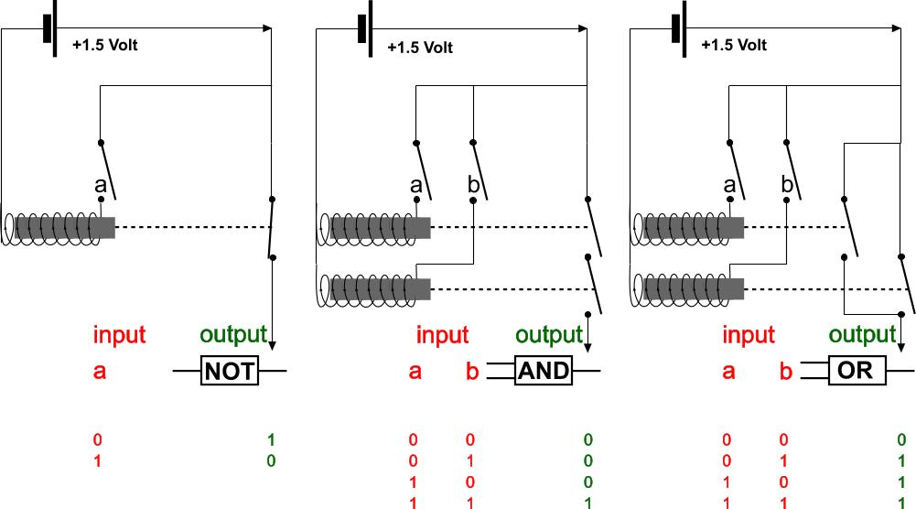 | 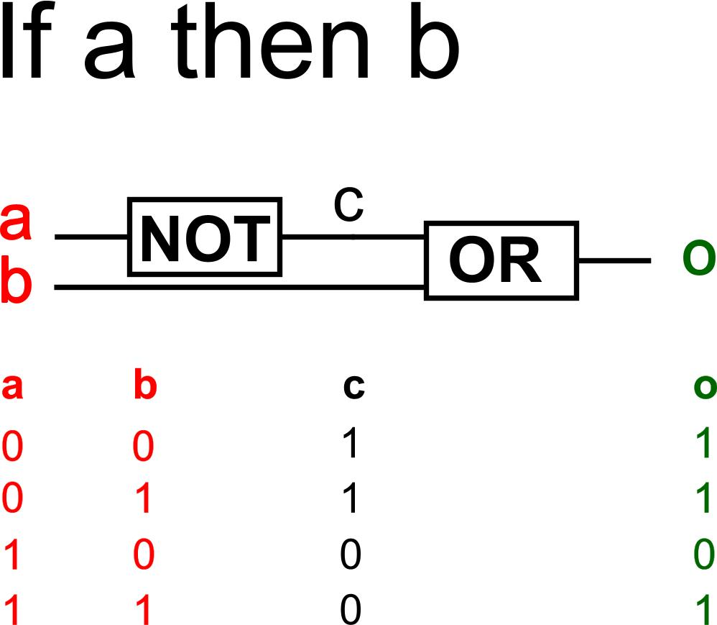
Fig. 2 Not, and, or simulated in electronic circuits .. | Fig. 3 … combined into ‘if ..then’
Looking at these figures it strikes that any circuit representing a logical operation consists basically of two circuits: an initiating steering circuit (source, taking input) and a circuit influenced by the first circuit (delivering output, result). It looks like the initiating subject and influenced object in a full sentence. The tables below the diagrams give binary values 1 (open in the direction of flow) or 0 (closed) for input and output circuits. If a flow comes through it is interpreted as ‘true’, if not as ‘false’. That combination of possible ‘truth values’ delivers a ‘truth table’ determining the character (operation) of logical operators earlier developed in proposition logic. That raises the question if proposition logic is inherent to any steering process most advanced in biological systems. That raises the classical philosophical question how we can synthesise not yet observed experiences by reasoning, fitting so well with reality (called a priori synthetic judgements by Kant). Why do they fit with reality? Is reasoning a physical process? Is proposition logic a physical process, inherent to nature itself, appearing in language at last?

Inference, connecting propositions, syllogisms
A basic form of inference connects sentences like “If a then b. Well, a is the case. So, b is the case.” (syllogism, type ‘modus ponens’). The word “So” connects both earlier sentences (propositions P and Q), but means essentially ‘then’ be it on a higher level. The schema of modus ponens is ‘if P and Q, then C”, C being the conclusion (Consequence). So, ‘if … then’ is an important logical operator in everyday language, but it appears in essentially different meanings, in formal logic necessarily distinguished and coded as ⇒, ⇐ and ⇔. Formal logic distinguishes 16 logical operators like this. Formal logic codes them to avoid confusion appearing in everyday language.

Further development of formal logics
In proposition logic propositions and operations on propositions are evaluated as true or false (they get a binary ‘truth value’). However, ‘fuzzy logic’ allows more values like ‘perhaps’ or different values of probability. Even further nearing everyday speech is modal logic, distinguishing types of inference discussing what can be possible, desirable or probable. “If a is true, then b is true.” is an inference with other rules than “if a is possible, then b is possible.” Here stops the simulation of everyday speech by formal logic and its simulation by electronic devices. Questions, exclamations, orders, motivations on desirability do not, or only partly have a logical form. And questions are the very beginning of science. Higher levels of schema as studied by election teams of democratic candidates take many aspects of meaning and context into account. And, the first mentioned level assigning ‘meaning’ to a symbol can not be done by computer programs in any other way than starting the computer programme telling it they are there (called ‘declaration’ of the variables, the very start of any computer program) and then relating these variables (symbols) to each other, for example b:=a² or a ⇒ b (Boolean expression).

Is logic the primary operation of our brain?
The question remains how far a further development of logic and its simulation in electronic devices (artificial intelligence, AI) could completely cover or even extend human thinking, especially where creativity is involved. It is very attractive to project the experience and success of computer science on the still unknown operation of our brain, but it obscures alternatives.
For example: in biology many kinds of biochemical communication exist (genetic material, hormones, even plants seem to communicate that way, alarming each other for danger). Butterflies seem to recognise each other by smell on a distance counted in kilometres, where according to our physics no molecule is left. They are steering very complex systems (more complex than a national state with its laws and institutions), still not comprehensible by existing ways of analysis based on formal logic so far. In your own communication you will know the experience of not finding the right words, not being able to explain what you mean. Can language express anything you think at all? Are your thoughts perhaps forced into the limited possibilities of language, into logic and a temporal sequence to express yourself? Why do we need poetry, art? Are images compensating the shortages of language? Do images have their own logic? What is the logic of an image then? Could language and images together fully express what we think?

Being aware of these questions, we will nevertheless explore language-like representations and conceptual schemas on a classical logical basis known as ‘cognitive science’ keeping in mind this analysis of language is based on suppositions no more justified than by surprising analogy with human artefacts like artificial intelligence devices.

Suppositions of ‘cognitive science’

Conceptual Schemas
Stillings et al. (1987 page 30) “The schema abstracts away from the details in order to allow categorization and further thought and action based on the categorization. Some form of schematization is absolutely essential to intelligent information processing. Since every concrete object has an infinite number of characteristics, if we try to deal with each object in all of its individuality, we would be permanently paralyzed and bewildered.”

The meaning of a symbol already supposes reduction of experiences. A symbol is even meant to abstain from side issues. However, no experience is the same. Any experience stems from a different or changing context with innumerable aspects. But we recognise the repeating aspects. Categorisation is collecting experiences at least equal in one aspect. We collect them in a set, named by a symbol, suitable for well-defined operations foreseen in a schema. But, could we apply operations on that set supposing these operations will have the same effect back in different and changing contexts?
Is the inductive process just the reversal of deductive application? Is synthesis simply the reversal of analysis?

Heterogeneous sets neglected
For example: suppose we have thousands of experiences with a medicine remedying a specific disease. But we know every human is different, is placed in a different context and reacts different on the same medicines. Some side-effects in ‘allergic’ persons are known, because they appear in a statistical mass justifying to name them in the instruction leaflet. But how do I know the side-effects not reaching that statistical mass? Nobody knows, because they do not have a statistical mass. The hidden supposition is: these effects can not be serious. However, perhaps one person in the set of persons healed from the suppressed disease got a heart-attack half a year later. You can not prove it is caused by the applied medicine, because one person is not a statistical mass to justify that conclusion scientifically. Now suppose any medicine has thousands of effects (which is biologically very probable), all different and appearing in different persons, most of them not reaching the statistical mass to prove the medicine is the cause. So, we can not categorise them as a repeating experience, not symbolise any set of n>1. In that case medicine is a profitable discipline, causing its own work: diseases not demonstrably caused by medicine itself.

Schematic reduction
The schemas in which symbols are arranged to be received properly by the receiver, connect and characterise the symbols by operations like ‘and’, ‘or’ and ‘not’. In such a schema, there is only space for declared symbols agreed between sender and receiver. So, specific information is filtered out. Side-effects remain unknown, even if there are more side-effects than the effects (operations) foreseen. What is knowledge when so much remains unknown purely by the reductive process of verbal communication?

Receiving and sending information
Being aware of these hidden suppositions and limitations of communication we can take care interpreting received information. What is left out? Half truth can be lie. What is supposed in making the schema? If the symbolised sets (categories) are homogeneous like (we suppose to be) chemical elements, we do not have to be so much afraid. If they are heterogeneous, we should be suspicious. On the other hand, sending information we should also send all hidden suppositions we are aware of, all limitations possibly important for application in a specific context. Taking care this way, we can go on exploring the possibilities of schemas in communication as developed in cognitive science.

Complex Schemas
Stillings et al. (1987 page ..?) “ Our general knowledge seems to go considerably beyond concepts for discrete objects and events, such as apple or give, however. Some examples that have been investigated in cognitive psychology and AI are (1) schemas, or frames, for complex visual scenes, such as what a room looks like (Minsky 1977), (2) schemas, or scripts, for complex activities, such as going to a restaurant (Schank and Abelson 1977), and (3) schemas for people’s personalities, including one’s own self (Cantor and Mischel 1979; Markus 1980). We will look are research on scripts, person schemas, and the self-schema.

Frames
New experiences like entering visual scenes, undertaking activities, meeting persons we use expectations stemming from earlier experiences. If you enter a room, you do not expect it’s raining there. However, we suppose other categories than the weather and we suppose more categories to be filled looking around than we are aware of. We use a schema to filter and file the multitude of impressions entering our senses. “O yes, a table, chairs, a bookcase.”
In cognitive psychology and artificial intelligence (AI) such worn schemas activated entering a scene are imitated and called ‘frames’ (Minsky, 1977). You could speak about a ‘frame of reference’ to distinguish it from the frame of a bicycle or a painting. These supposed frames direct our attention efficiently giving rise to recognition or surprise. Younger people have limited frames, being surprised more often, adapting their frame to recognise that experience next time.

Scripts
If you are going to study you are looking for space on the table, a cup of coffee if you are tired, study material, whatever. You open the study manual, look for the assignment, choose chapters to read, read, walk around, write your thoughts down and so on. You are not going to play tennis, so there should be a schema for ‘studying’ in different contexts, vague or precise. That kind of schemas are called ‘scripts’ (Schank and Abelson 1977). Others call it ‘routines’ Could you imagine a script without a frame?
The answer depends on the period you take into account. Entering the room, you had a script of ‘studying’ before activating your frame for a room. So, you could be inclined to say “yes”. However, once in your life time you have developed that script. Could you develop it without a frame?

Schemas for people’s personalities
Suppose a friend enters the room. Which data protocol are you going to activate? Is it a frame, a script, or is it something special? Cantor and Mischel (1979) or Markus (1980) say so. You meet a human like yourself, so your self-image is involved in the contact and it develops by contacts. Let us first explore the concept of script in further detail.

Scripts
Stillings et al. (1987 page ..?) “ Cognitive scientists use the term script or activity schema to refer to a declarative knowledge structure that captures general information about a routine series of events or a recurrent type of social event, such as eating in an restaurant or visiting the doctor. Schank and Abelson (1977) and other script theorists have hypothesized that scripts contain the following sorts of information: an identifying name or theme (such as eating in a restaurant), typical roles (customer, waiter, cook, …), entry conditions (customer is hungry and has money), a sequence of goal-directed scenes (entering and getting a table, ordering, eating, paying bill and leaving), a sequence of actions within each scene (in the ordering scene, customer gets menu, customer reads menu, customer decides on order, customer gives order to waiter, …).

Suppose the set of experiences ‘eating in a restaurant’ have given rise to some routine. You look if you have money enough, enter the restaurant, look in the mirror, re-arrange your hair, look for a place, a waiter and so on. What kind of information did you once give space in a data protocol for such occasions, a script activated by the name or theme ‘eating in a restaurant’?

Components of a script
Schank and Abelson (1977) and other cognitive script theorists distinguish some components of a script.
Firstly, the occasion has to be identified to prevent you are exchanging ‘eating in a restaurant’ with other events like ‘going to sleep’, ‘exam’ or ‘playing football’.
Secondly, there are entry conditions like your budget, being hungry (unless it is a social obligation).
Thirdly there are goal-directed actions, falling apart into actions achieving partial goals.

Goal directed actions
However, goal-directed actions suppose goals. It supposes a human being to be goal-directed. But ‘goal’ is a concept supposing direction of operation and desirability of the result not found in many organisms unless projected by anthropocentrist interpretation. The direction of operation is inherent to our language distinguishing an active subject influencing an object.
So, it is very difficult to imagine and communicate means-driven action, very common part in location or context-driven design instead of goal-driven.

Teleologic approach?
If you accept that concept as a leading principle for research anyhow, then there are still different values of goal-directedness. Some people live from opportunity into opportunity given by the arbitrary context at hand. Perhaps you went to the restaurant to escape the social obligation to have goals, to explicate them any time you meet somebody. “Then that is the main goal, from which many partial goals can be derived!” the cognitive scientist will exclaim triumphantly. Is s(he) right? For example, has nature goals? Does humanity have goals within that frame? Does evolution of life have a goal? What is human destiny? What is the goal of a house, a neighbourhood, a town, a region, yes, what is the goal of the world? The larger the scale, the more dubious becomes the habit to look for a ‘goal’. Is goal-directedness culturally determined? Does it have religious roots? In biology that approach is rejected already in the beginning of the 20th century as ‘teleologic approach’.

Efficient research
Being aware of these questions you can choose for the goal-directed approach in the actually generally accepted scientific paradigm. Scripts ‘define a problem, a goal, a hypothesis, methods to solve the problem a time table for execution, a budget and a way to communicate them’. By doing so, the process of research will be efficient and easily understood by the scientific community. Efficiency supposes a goal, a short way to find what you want. However, that supposes you know what you want. And that perhaps supposes you know who wants that, a self-image. It is interesting our language accepts a sentence like “I want to know”, but saying “I know to want” raises questions. However, the negative expression “S(h)e does not know what s(h)e wants” is usual, but has a negative connotation.

The self-schema
Stillings et al. (1987 page 34) “One’s knowledge of oneself probably occupies a special place in the store of knowledge about people, and psychologists have proposed that the self-concept is a particularly elaborate and influential schema. Markus (1980), for example, has proposed that the self-schema exerts powerful effects on the person’s perception, memory, and thought. Information that is consistent whith the schema is processed more efficiently and better remembered. Incoming information is hypothesized to be evaluated relative to the schema and resisted if it is inconsistent. Plans and predictions of future behaviour are crucially influenced by the schema.”

Compatibility of sender and receiver
Peculiar persons will have difficulties to explain their thoughts to ‘normal’ persons (supposed they exist). So, in the main stream of social opinion and thought, the culture, subculture, the paradigm, the frames of reference and scripts they participate in, will not receive their experience so easily. Perhaps they experience the same occasions different. Their data protocol does not fit in that of the audience (incompatibility). However, many artists and inventors, renewers were peculiar persons. Peculiar persons do not support some main suppositions of the majority. Perhaps it is a quality of creativity to negate some suppositions self-evident to others. Sometimes they had a coach, recognising their achievement but speaking the language of contemporaries. Sometimes the coach forgot the inventor earning most of the money.

Coaching incompatible or inconvenient messages
But sometimes an exceptional person recognises s(h)e is an exception and changes her or his data protocol (schema) for the occasion of ‘communication with other people’. S(h)e should have studied people, their desires, expectations and suppositions as an extra-terrestrial and in the same time, by comparing their frames and scripts, they get an idea about their own schema of experience. From the elaborated list of observed differences they can make an adaptor or interface from their own data protocol into that of others. Such hyper intelligent people live in different worlds, sometimes even splitting their personality (schizophrenia). Sometimes they loose interest in communication (de-realisation). However, it is easier to adapt yourself. Markus (1980) proposed that a self-schema fitting with the incoming data protocols is more efficient. That is a common solution advocated in a country of immigrants.

Normal communication
If you are a normal person, you have learned and not refused many frames of reference, scrips and their names, the conditions where and when to activate which one. You have a repertoire of ‘roles’. You know “how to behave” in any company. So, the communication can skip many suppositions to be explained and that is very efficient. You easily reach what you want, supposed you know what you want or accepted the desires of others (for example your parents or friends). You are a success as long as you do not loose contact with your network. But who is the one wanting something, deciding which protocol has to be activated? Do you ever refuse a role? When do you violate yourself? What is violated then? Who are yourself?

Self-schema
If the evolution of life had produced only ‘normal’, ‘average’ people, recognising each others frame of reference, scripts, a very efficient society would have emerged. However, as soon as the context changes you need other schemas, perhaps schemas available in some peculiar persons already living in exceptional partial contexts similar to those emerged. In evolution such rare specimens are the survivors of the next period. Without diversity there is no evolution, no ‘fittest’ to be selected for survival. And context changes all the time. So, evolution provided a heterogeneous humanity as a risk-cover for life and you are an exception anyhow. The question is, how exceptional. So, if you do not have a reliable coach, you have to study the schema of your audience comparing it with your own, knowing what to say to dose recognition and surprise, staying outside the areas of boredom and chaos in the message to be received in their frame of reference and script. But who is the one studying to know the self-schema? Who decides to change or adapt it to other schemes? If there were two ‘selves’ in the world the same they would be no a ‘self’. So, that question remains unsolved in the classical analytical approach because there is no category of similar experiences experienced by the same self to name and express in any language. Perhaps that question only rises by using verbal language itself.

Conclusions
Stillings et al. (1987 page 35) “… Schemas make the retrieval and deployment of relevant information extremely efficient.”

Next to existential questions and exceptional ones at the edge of art, science and technology to be solved by exceptional people or on exceptional moments, there are many every day tasks for less exceptional people or on less exceptional moments to be solved efficiently. Even if you have the ambition to reach an exceptional task, you have to build in routines for the less exceptional ones and you will need them as part of exceptional tasks. So, it is useful to study schemas already developed and to make them your own to save time and attention for your ‘real’ aspirations.

However, if we take natural evolution as a teacher how to obtain new phenomena, efficiency (supposing a goal) is not what it teaches. Firstly the ‘goal’ of nature is documented nowhere, though many think so on hidden religious grounds. The surprising efficiency of many parts of nature is balanced by the surprising inefficiency of other parts (trial by error). Errors are often points of departure for creativity. They are often scale-bound. What appears as an error on one level of scale (for example the parts) seems to be no error on an other one (for example the whole).

Moreover, the efficient way cognitive science indicates raises many questions stated above unveiling hidden suppositions we do not have to share:

What schema will work given an audience and its context?
There are schemas on different levels. Which schemas are there?
Which suppositions can be taken for granted and which should be made explicit speaking to a device, a person or an audience?
Why do they fit with reality?
Is reasoning a physical process?
Is proposition logic a physical process, inherent to nature itself, appearing in language at last?
Is logic the primary or only operation of our brain?
Can language express anything you think at all?
Are your thoughts perhaps forced into the limited possibilities of language, into logic and a temporal sequence to express yourself?
Why do we need poetry, art? Are images compensating the shortages of language? Do images have their own logic?
What is the logic of an image then?
Could language and images together fully express what we think?
Could we apply verbal operations supposing these operations will have the same effect back in different and changing contexts?
Is the inductive process just the reversal of deductive application?
Is synthesis simply the reversal of analysis?
How do I know the side-effects not reaching a statistical mass?
What is knowledge when so much remains unknown purely by the reductive process of verbal communication?
What is left out? Half truth can be lie. What is supposed in making the schema?
Could you imagine a script without a frame?
Could you develop it without a frame?
Which data protocol are you going to activate?
Is it a frame, a script, or is it something special?
What kind of information did you once give space in a data protocol for such occasions, a script activated by the name or theme ‘eating in a restaurant’?
Is goal directedness a hidden teleologic approach?
For example, has nature goals?
Does humanity have goals within that frame?
Does evolution of life have a goal?
What is human destiny from which partial goals can be derived?
The larger the scale, the more dubious becomes the habit to look for a ‘goal’. What is the goal of a house, a neighbourhood, a town, a region, yes, what is the goal of the world?
Is goal-directedness culturally determined?
Does it have religious roots?
Who is the one wanting something, deciding which protocol has to be activated?
Do you ever refuse a role?
When do you violate yourself?
What is violated then?
Who are yourself?
Does that question only emerge by using verbal language?
Who is the one studying to know the self-schema?
Who decides to change or adapt it to other schemes?
If there were two identical ‘selves’ located in different contexts would they become two different ‘selves’ by acquiring different experiences?

We cannot answer all of these questions, but we have to be aware of the tacit suppositions they raise. Perhaps many of them are raised by using verbal language itself. In the next section I would like to start with the first question:

What schema will work given a particular audience and its context?

Particularly the word ‘context’ fascinates me if (as in design) the object is not yet determined. Demarcating such an object supposes a context. But ‘context’ is everything apart from the object we have to design. How to get grip on that context or its parts relevant for the intended design?

Context analysis

Introduction

Studies related to urban, architectural and technical design or management
Most studies related to urban, architectural and technical design or management like graduation studies on a Faculty of Architecture are design studies with a variable object in a more or less determined context, often on a unique location (see Fig. 4). They produce a description and presentation of a non existent object possible in that local context, its rational and emotional foundations suitable to convince stakeholders and specialists possibly involved in realisation and use.

 |  | determined | variable | OBJECT
 | determined | Design Research | Design Study
 | variable | Typological Research | Study by Design
 | CONTEXT
Fig. 4 Four types of design related study Jong and Voordt 2002

Study proposals in that field
Study proposals for that kind of study are difficult to make, because the object of study is still varying: it has to be determined by the study itself, often resulting in a design. A design can not isolate a single problem statement. There is a field of many problems observed by many people rather than a single problem to be ‘solved’. There is also a field of aims related to many stakeholders and specialists rather than a clear aim statement. Many of these aims are contradictory, together exceeding given possibilities. They have to be recapitulated in a feasible concept, a common road to a result. Since the object is variable, there is not a single hypothesis (the design to be produced is often concerned as hypothesis with the tacit supposition “This will work”). There is also not an easy to describe single method as some suppose in empirical research (Priemus 2002). So, the only way to get grip on the project in a study proposal beforehand, is the determination of the future context by a proper context analysis, including the context of discovery (Klaasen 2003) or context of invention (on page 23 we come back on that subject).

Case studies
In an empirical jargon these studies are ‘case studies’ (Yin 1994; Swanborn 1996; n=1 studies).
Other kinds of study in this field, like design research and typological research (see Fig. 4) often use such case studies. However, these seldom reach a statistical mass (n=many) suitable to draw more general scientific conclusions (‘research’). That is why polls and statistics are seldom useful in this field of study except for understanding the argument of specialists referring to many contexts. Specialists can isolate common problems from those contexts to find more general solutions, supposing they are applicable in the managerial, cultural, economic, technological, ecological and spatial context at hand. However, without context sensitivity, their general solutions raise new problems, new assignments for ongoing study profitable for them.
But a designer raising new problems will not easily get new assignments.

Context sensitivity
An object of architectural or urban design or management is more context-sensitive than any other object of design on a University of Technology (Fokkema 2002). A design in that field has unique features; otherwise it would be an empirically predictable copy out of another context.
So, these objects of study are comparable only if their context is comparable, if the many external parameters have more or less the same values. If, from the many cases studied before, researchers could choose examples that have a comparable context, there is some basis for generalisation. These historical case studies should then be retrievable from a systematically accessible database to find cases comparable with the one at hand.

The main question I try to answer here is: how to standardise a context analysis preceding these case studies. The method I propose will also help making design related study proposals for objects still not determined (see Fig. 4).

Levels of scale
Firstly, I suppose the level of scale of an object of study is important, because any larger size than that of the object supposes a ‘larger context’. But any smaller size than that of the smallest detail taken into account supposes context as well. So, the reach of scale of an object of study has an upper and lower limit, here called frame and granule (see Fig. 9), best indicated by their approximate radius.
The distance between frame and granule determines the resolution of the study (sketch, drawing, blue print), the extent to which the study goes into detail compared to its largest measure drawn. That order of size and consequently resolution of study can be chosen even before the object of study is fixed.
It begins to determine the applicable design and management means. Moreover, it puts the concept of ‘aim’ into perspective. What is the aim of a house, a neighbourhood, a region? Yes, what is the aim of the world? With a growing scale in space and time, the statement of aims becomes more and more dubious.

Scale paradox
The reach of scale is also important, because conclusions on a specific level of scale could be opposite to conclusions drawn on another level of scale (scale-paradox, see Fig. 5).

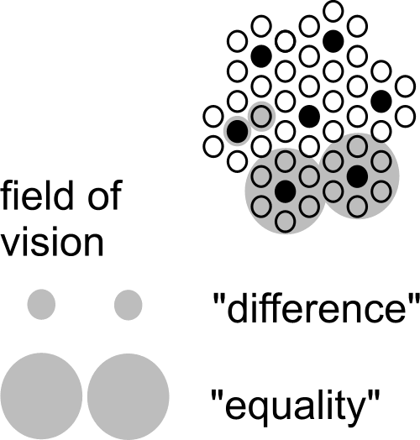 | The scale paradox means an important scientific ban on applying conclusions drawn on one level of scale to another without any concern (read quark discoverer and Nobel prize winner Gell-Mann, 1994).  That does not yet mean conclusions on one level of scale could never be extrapolated into other levels. Fig. 5 only shows the possibility of changing conclusions by a change of scale. And it demonstrates the possibility of a reversal of conclusions already by a factor 3 larger radius. And there are 10 decimals between the earth and a grain of sand.  That gives approximately 22 possibilities of confusing conclusions.
Fig. 5 The scale paradox
If a scale paradox can be demonstrated for concepts of difference and equality as such, it applies to any distinction of spatial categories or classes.

Domains with different categories, types and legends
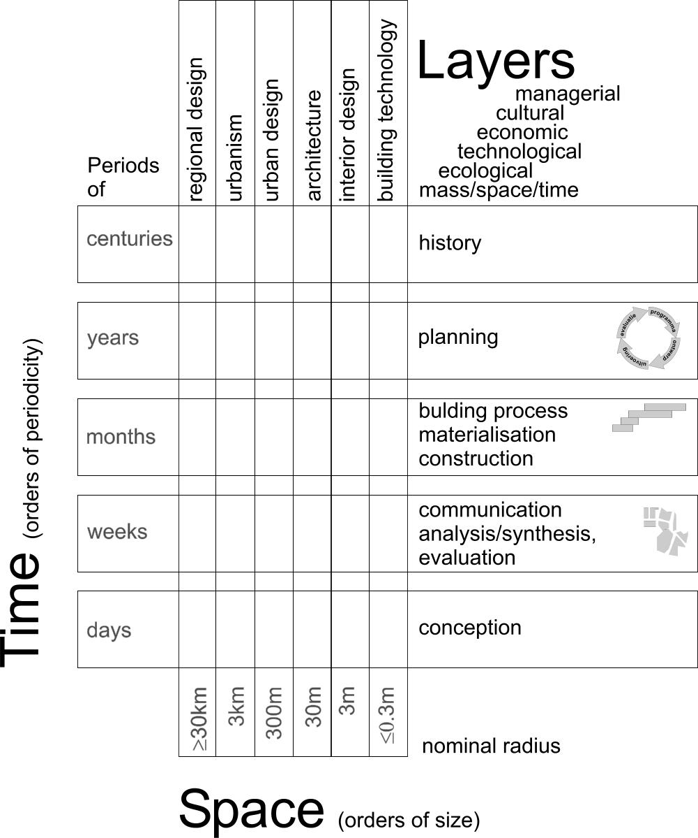 | On any level of scale you need other distinctions of categories and subsequently different typical combinations of their classes: types and legends to be studied or designed.  You can recognise that necessity in the common disciplines of ‘bouwkunde’: urbanism, architecture and building technology (see Fig. 6). The types and legends of architectural disciplines are different from those of urbanism or building technology.  Less recognised are the different time scales you can distinguish on every spatial level of scale. Architectural history is something else than urban or technological history. And history is something else than planning, building process, communicaton process or the process of conception. This is where building management comes in as a separate discipline.  Moreover, these distinctions have different physical and social ‘layers’.
Fig. 6 The domain of Bouwkunde
So, the same kind of argumentation on spatial articulation of scale could be developed for temporal distinctions. What seems true or right in terms of weeks may be false or wrong in terms of months.

Many spatial orders of size possibly causing confusion
In Fig. 5 confusion of spatial scale is already possible by a linear factor 3 difference in level of scale (approximately 10 in surface). That is why for spatial design and management I articulate orders of size by a linear factor of approximately 3. So, to avoid any confusion, I need to distinguish at least 22 levels of scale to define context, beginning with the global context and preliminary ending with that of the physical chemistry of materials (see Fig. 7). Most of these contexts are not relevant for a study at hand, but they are there, most of them buried in hidden (ceteris paribus) suppositions.

Global(10000km) | Continental(3000km) | Subcontinental(1000km) | National(300km) | Sub national(100km) | Regional(30km) | Sub regional(10km) | Town(3km) | District(1km) | Neighbourhood(300m) | Ensemble(100m) | Building complex(30m) | Building(10m) | Building segment(3m) | Building part(1m) | Building component(300mm) | Super element(100mm) | Element(30mm) | Sub element(10mm) | Super material(3mm) | Material(1mm) | Sub material(<1mm)
Fig. 7 Levels of scale to be aware of in any spatially relevant study

Nominal values of a radius R to name levels of scale
Levels of spatial scale are often named by the ratio of a drawing to reality like ‘1:100’. However, it depends on the size of the drawing what kind of object I have in mind. On an A4 paper 1:100 I can draw an object of approximately 10m radius (30m² surface); on an A2 paper it could show an object of 30m radius (300m² surface). That is why I prefer to name the order of size by its approximate radius R in supposed reality chosen from the set {… 1, 3, 10, 30, 100m …}.

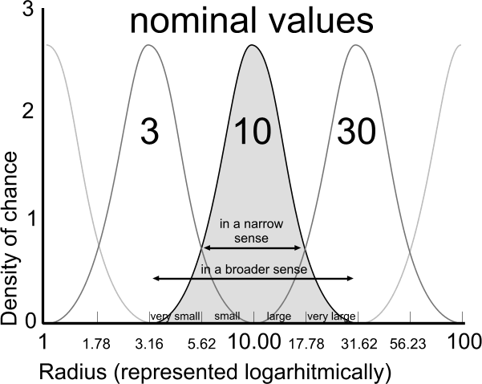 | An ‘elastic’ element from the nearly logarithmic series {… 1, 3, 10, 30, 100 …} is used as the name (nominal value) of the order of size of an urban, architectural or technical category ranging between its neighbours.  To be more precise: the ‘nominal’ radius R=10 is the median of a chance density distribution of the logarithm of radiuses between (rounded off) R=3 and R=30, with a standard deviation of 0.15.  I chose a series of radiuses rather than diameters because an area with a radius of {0.3, 1, 3, 10km} fits well with {neighbourhood, district, quarter, and conurbation} or loose {hamlet, village, town, and sub-region} in everyday parlance. They fit also very well to a hierarchy of dry or wet connections according to their average mesh widths (de Jong, 2006).
Fig. 8 Names and boundaries of urban categories
Moreover, a radius immediately refers to the most indifferent directionless form of circles or globes indicating both surfaces and volumes by one linear value.

Impacts on different levels of scale
Any object of study will have impacts on different levels of scale, hitting interests of stakeholders operating on that level (for example from government administrators into manufacturers of building materials). The first step of context analysis is, to locate these supposed impacts on the level of scale they apply, as far as they could be relevant to the study at hand, not overlooking any level. You can already locate them before you specify them. If you expect positive impacts, perhaps you can find stakeholders on that level wanting to pay for your study. If there are negative impacts, you should not exclude people responsible on that level to minimise or compensate such effects by your study.

Physical and social layers
Secondly, the scale determined context of an architectural or urban design is not limited to its physical environment (mass and space in time, ecology, technology). Social (economic, cultural and managerial) environments do have orders of size as well.
Urban and architectural designers give account of their sketches and drawings to physical and social stakeholders and specialists in different ‘layers’. These participants have their own problems and aims, their expectations and desires, supposing different probable and desirable futures.
These futures have to be combined by design into one common spatial vision or concept of a possible future in order to outline a road for cooperation.
Sometimes it is wise to start defining a common future context before defining an object.

Layers on different levels of scale
So, to analyse or to compose a common future context, you have to distinguish different physical and social layers. In Fig. 10 six layers are chosen, relevant in urban and architectural design. They are chosen in a way they are imaginable on any level of scale, though not always all relevant for every object of study. On any level of scale they have a different meaning. For example, in The Netherlands management(R = 3000km) means European government, management(R = 10km) or (R = 3km) means different forms of municipal administration, R = 10m means household management and on lower levels of scale it means different forms of technical management on the building place, in maintenance or within the industry of building materials.

Impacts
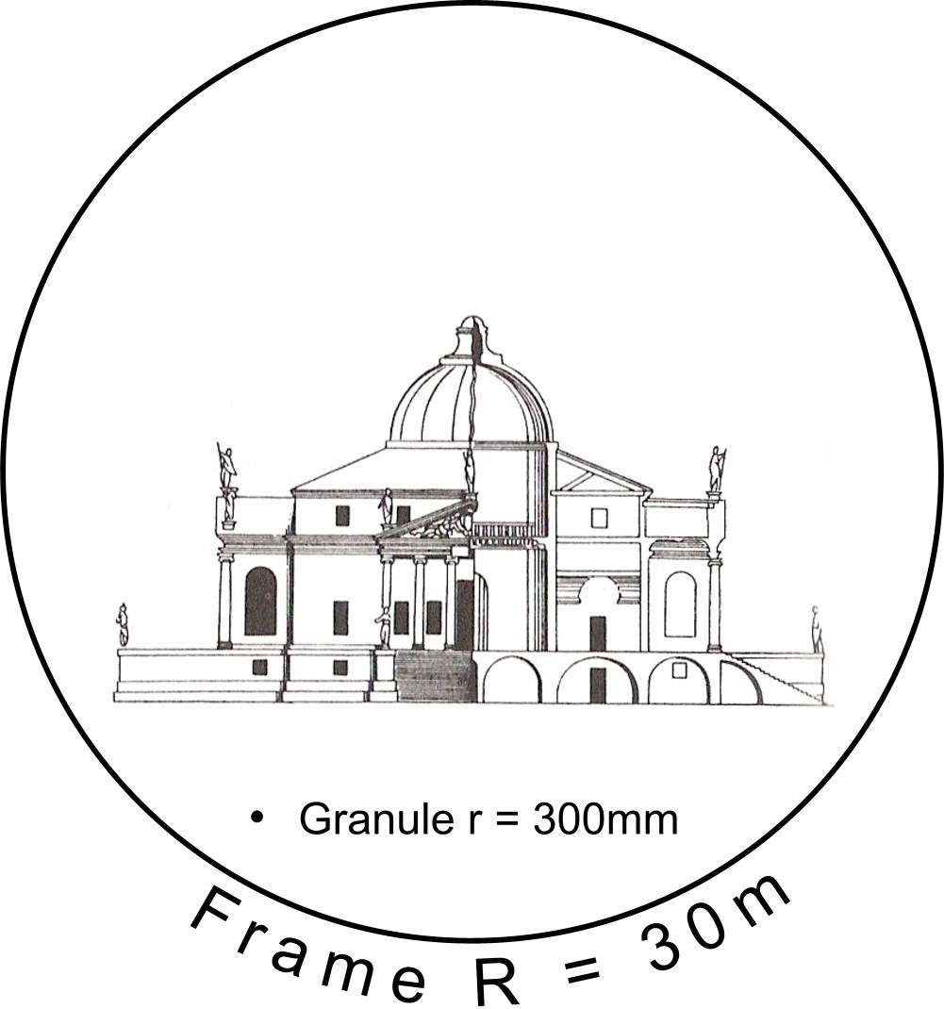 | 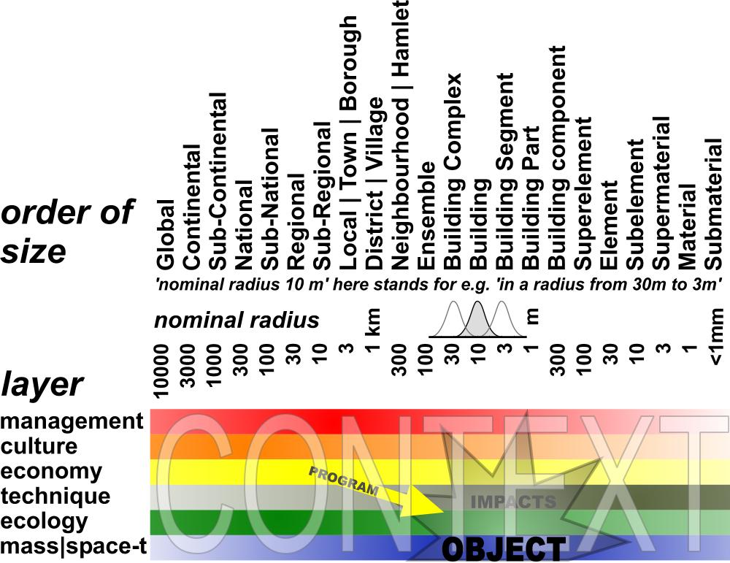
Fig. 9 A frame 100x granule of a drawing representing a building | Fig. 10 Locating a spatial object of study within its context
Once you have determined the frame and granule of the object of study in this scheme, the rest is ‘context’. The still variable object of study will have impacts within that context, on different levels of scale and in different layers. Some of them are desirable. The programme of requirements is nothing else than the set of desirable impacts. The scheme does not specify these impacts; it solely shows their order of size and layer (‘location’).
It is possible to consider these context factors before you choose a specific object on a specific location. So, the scheme can help outlining your object of study from outside.

Impacts depending on the probable future context
These impacts will be different in different future contexts. For example, the local economic impact will be different in a growing regional economy compared with a stagnating local economy. So, you have to specify your expectations about the probable future within which your object will have its impacts.

It is important to be explicit about these expectations, because people with other future contexts in mind will judge your study (design or research) with other suppositions about the probable future. They can reject your study solely on that basis. If you made your suppositions explicit beforehand, you can ask them to judge the qualities of your study or design again but now within that perspective. It could raise an essential debate about the robustness of your study in different future contexts. So, it can be evaluated also against the background of different perspectives.

The FutureImpact computer program
However, it is even better to agree with stakeholders and specialists beforehand about a common vision on a supposed probable future. To that aim I developed a simple computer program called ‘FutureImpact’, usable individually or in meetings (see Fig. 10 and Fig. 11).

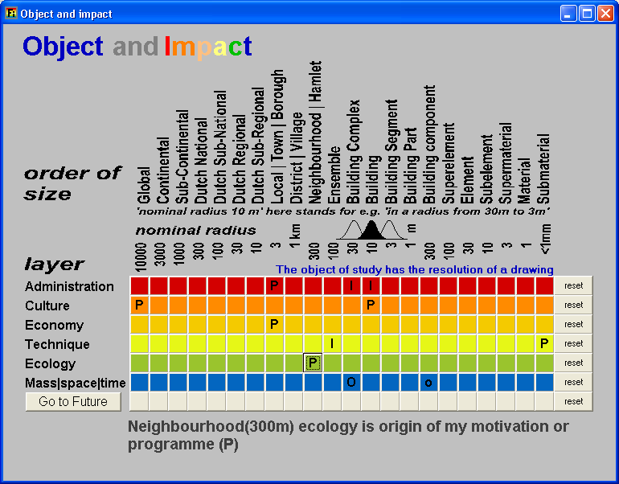 | 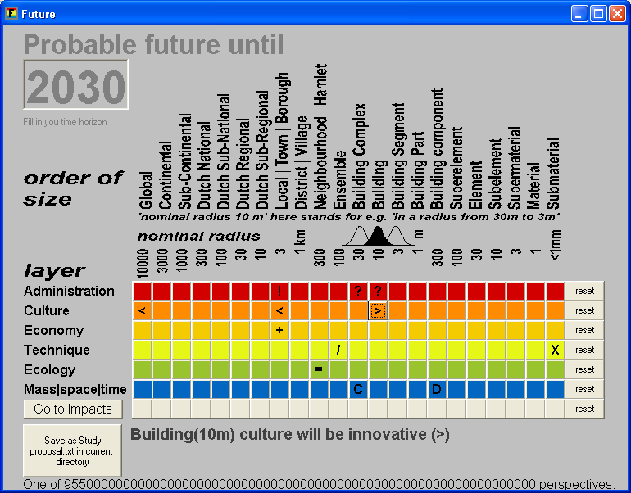
Fig. 11 Locating impacts (I) and the origin of a programme (P) as set of desired impacts | Fig. 12 Making expectations about the context in 2030 more explicit to assess the impacts
This program delivers a more precise division of orders of size and layers than Fig. 10 in separate buttons, to be pressed into two very rough extreme values per button to keep overview. In the second screen (Fig. 12 left below) you find a button producing a text to elaborate the chosen values into more specific interpretations yourself. It is a checklist not to forget any relevant level or layer.

Making expectations about the future context more explicit to assess impacts
Once you have located possible impacts, the future context of these impacts determines their possibility of realisation. For example, if you suppose desirable impacts in municipal administration (R = 3km, see Fig. 11), how could you estimate their value without any supposition about their managerial context in the period these impacts should be realised (for example until 2030 in Fig. 12)? Is it an active management context with many initiatives or is it a passive administrative context of just checking and controlling the rules? In the last case initiative should be part of your own project to get the intended impacts realised. The same applies to the administrator of the building complex (R = 30m) and the users (R = 10m). And these impacts can be opposite on that different levels of scale.

Roughly typing social future context
You can ask that kind of questions on any layer and level of scale again. Any expected or desired impact supposes a context where the impact will be realised or not. How to describe that context shortly in a preliminary sense to keep overview? The problem is to find comprehensive variables per layer that make sense on any level of scale in the scheme to be elaborated and modified later in more detail.

For administration and management I proposed opposites of initiative (‘!’, as symbolised in Fig. 12) and checking and controlling (?), applying on any level of scale. There are many other possibilities to type administration and management style, but this variable hits the core of management itself as far it is relevant for design and applicable on any level of scale.

But what about culture? For example, what does culture mean on the level of building material (R = 1mm)? To include any level of scale, I propose ‘traditional’ (<) opposed to ‘innovative’ or ‘open to experiments’ (>). For example, if your study will have impacts on households (R = 10m), and these households are mainly traditional, it will be difficult to confront them with an experimental design. However, if your client is an innovative housing corporation (R = 1000m?), you will get support from that side. That cultural context will influence your study and your presentation, the way you will arrange the arguments.

The economic context is shortly characterised by growing (+) and declining (-). That can be different on different levels of scale. The economic context could be a declining neighbourhood within a prosperous municipality. A context like that will determine a project or an assignment to a considerable extent.

Roughly typing physical future context
Which extremes could be found to characterise the technological context on any level of scale? It took me some years to choose internal separation (/) and combination (X) of functions as relevant and essential technological context values. It is also an essential design choice on every level of scale: shall I separate or combine pressure and tension (R = 10cm) separating and supporting functions (R = 1m) within my construction, cooking and eating in my kitchen (R = 3m), living and work in my neighbourhood (R = 300m)? If the probable trend is to combine living and work on a level of the district (R = 1km), then you still can separate it on the level of the neighbourhood (R = 300m) or the building complex (R = 30 m). So that expected context is important for any design decision.

In ecology I suppose diversity or heterogeneity (|) as most universal context variable, opposed to equality or homogeneity (=). Which kind of diversity that concerns could be elaborated later: diversity of plants, animals, or people, households with the same or different age, lifestyle or role-emphasis (for example familism versus careerism (Michelson 1970)).

At the purely physical level of mass and space in time, accumulation, concentration (C) of masses versus sprawl, deconcentration (D) is an essential design context factor. What is called mass could be specified later, but concentration and deconcentration (state of dispersion) of legend units in a drawing are characteristics of form and composition on any level of scale. They can differ per level of scale (see Fig. 13 and Fig. 14). An existing or expected scale sequence like DCDC or its reverse CDCD names some global characteristics of form. I will elaborate on the ‘state of dispersion’ more in detail, because it is relevant in other layers as well.

States of dispersion
Form as a primary object of design supposes a state of dispersion of an arbitrary legend unit, for example built-up area.

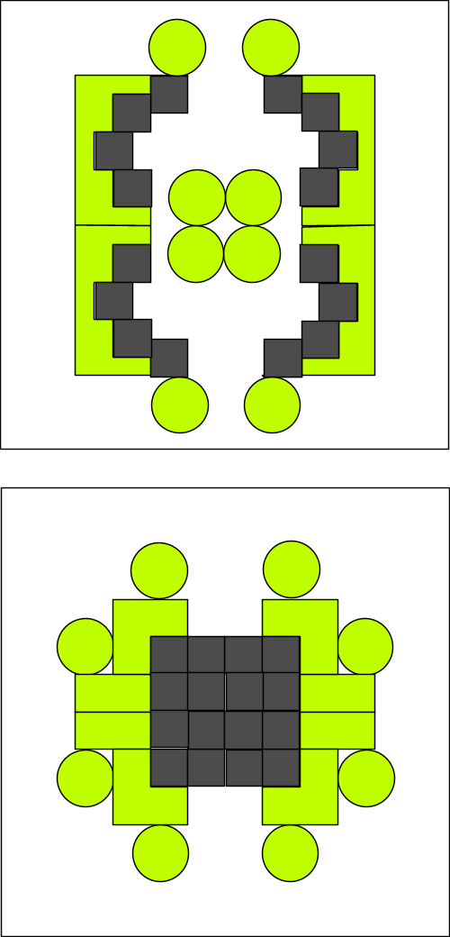 | 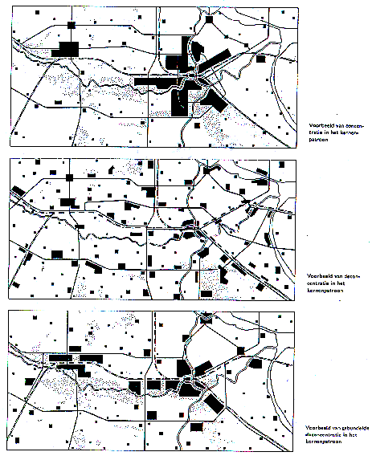
 | RPD (1966)
Fig. 13 States of dispersion r=100m | Fig. 14 Accumulation, Sprawl, Bundled Deconcentration r=30km
Scale articulation is important distinguishing states of dispersion. That is not the same as density. Considering the same density different states of dispersion are possible (Fig. 15 ) and that is the case on every level of scale again (Fig. 16 ).

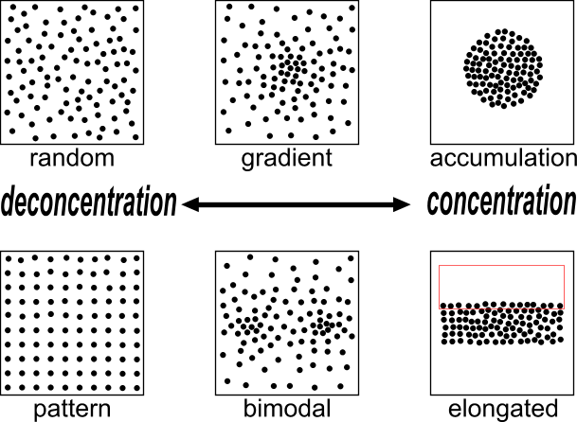 | 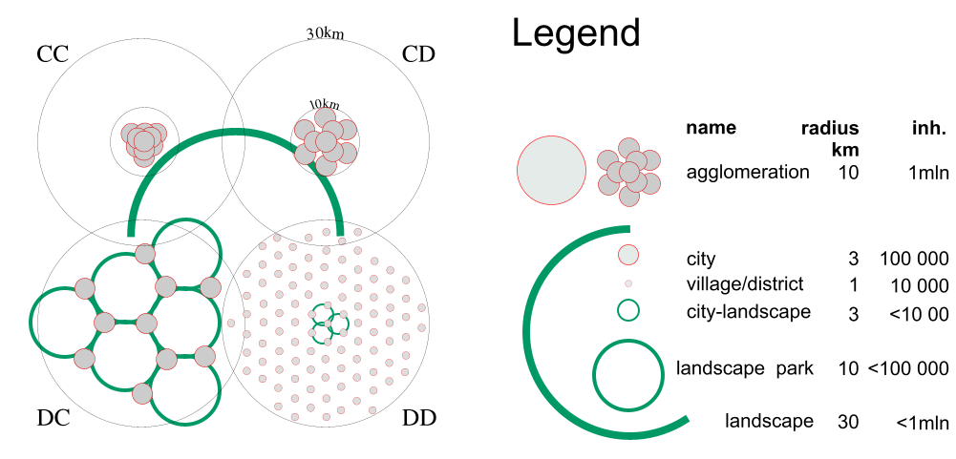
Fig. 15 States of dispersion in the same density on one level of scale | Fig. 16 One million people in two states of distribution on two levels of scale (accords CC, CD, DC and DD).
Fig. 15 shows the use of the words concentration (C) and deconcentration (D) for processes into states of more or less accumulation respectively.
Applied on design strategies in different levels of scale I would speak about ‘accords’ (Fig. 16 ).

In Fig. 16 the regional density is equal in all cases: approx. 300inh./km².
However, in case CC the built-up area is concentrated on both levels (C_{30km}C_{10km}) in a high conurbation density: (approx. 6000inh./km²).
In the case CD people are deconcentrated only within a radius of 10km (C_{30km}D_{10km}) into an average conurbation density of approx. 3000 inh./km².
In the case D_{30km}C_{10km} the inhabitants are concentrated in towns (concentrations of 3km radius within a radius of 10km), but deconcentrated over the region. Since 1966 this was called ‘Bundled deconcentration’ (RPD, 1966). The urban density remains approx. 3000 inh./km².
In the case D_{30km}D_{10km} they are dispersed on both levels.

Desirable, probable and possible future contexts
Thirdly, there are three language games (‘modes’) concerning the future context relevant for urban, architectural or technical design, its stakeholders and specialists (see Fig. 17).

Language games: | being able | knowing | choosing
Modalities: | possible | probable | desirable
Sectors: | technique | science | management
Activities: | design | research | policy
Reductions as to
Character: | legend | variables | agenda
Location or time: | tolerances | relations | appointments
Fig. 17 Three language games
Not distinguishing these modes of future results in a confusion of tongues between stakeholders aiming at desirable futures, specialists predicting probable futures and designers exploring possible futures.
Distinguishing them properly can deliver an outline of fields of problems and aims to take into account.

Subtracting probable and desirable futures
Probable futures we do not want are a field of problems (see Fig. 18). They are predicted or signalled by empirical study of specialists. Desirable futures we do not expect to happen without action (like desirable but not probable futures) are a field of aims. Clients, stakeholders and their representatives (administrators, managers) deliver a field of aims. Sometimes it is a battlefield. Often not all of them are possible in one project. The designer guards and extends the possible by design.

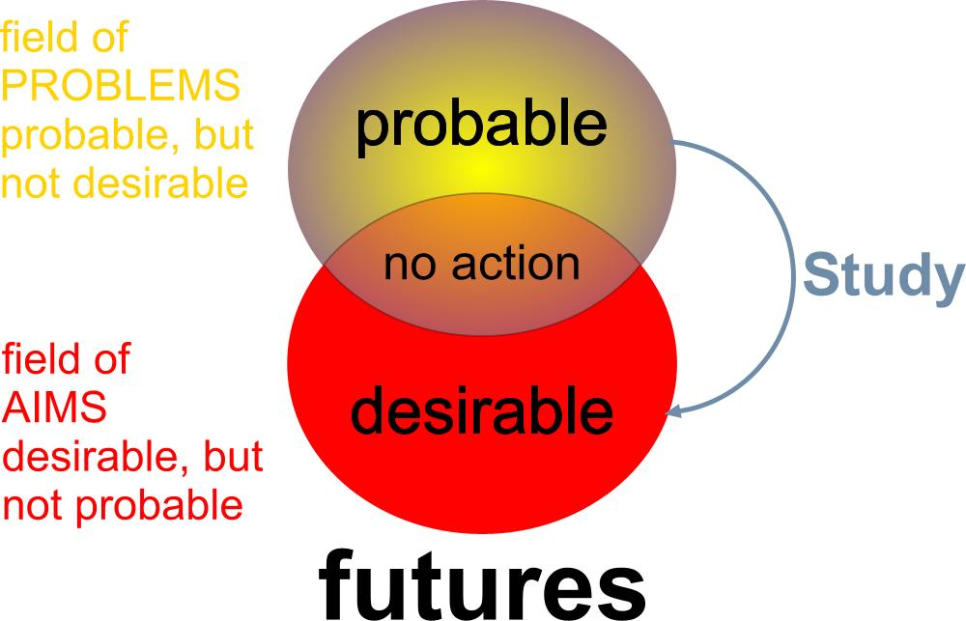 | 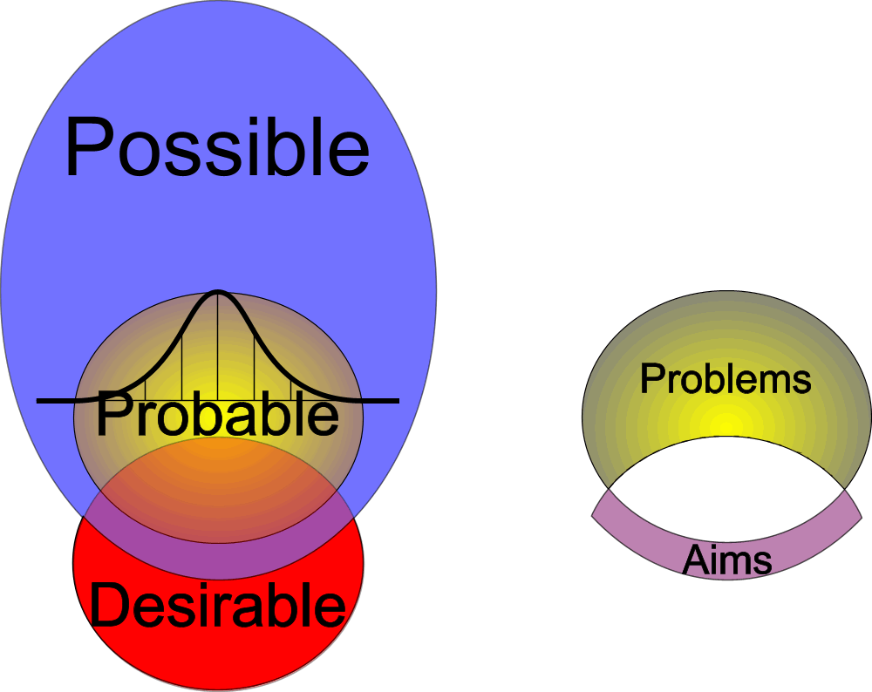
Bron: | Bron:
Fig. 18 Subtracting futures to outline fields of problems and aims | Fig. 19 Adding possible futures, skipping the impossible

Adding possibilities by design
Anything probable is per definition possible, because if something is not possible, it certainly is not probable. But not all possible is also probable (see Fig. 19). There are improbable possibilities. To find these improbable but possible futures (including and using the many probabilities of specialists as possibilities) is the task of the designer. S(he) is supposed to know many possibilities stemming from design~ and typological research (see Fig. 4). Sometimes s(he) adds possible futures no one in the team could imagine, let alone desire beforehand. Their desires and aims embodied in their programme of requirements were limited by their imagination. Desires could change as soon as new possibilities are imagined. That is why design can change a programme of requirements (see Weeber, Eldijk et al. 2002).

The context of invention
The designer has a personal context relevant to be selected for, or to propose a specific design study. It contains her or his field of abilities (portfolio, own work) and field of design means (repertoire, studied references to the work of others). S(he) is supposed to have gathered many preceding examples (precedents) and to have studied them by design research and typology (see Fig. 4) exploring design possibilities by pulling them out of context processing them into a new context (Hertzberger 2002). S(he) is supposed to be able to apply, process and extend them in a given context, which is proven by a portfolio. Of course, s(he) is moulded and limited by education, colleagues and friends. But what can be expressed in a study proposal for possible futures in a more or less determined context is a portfolio and a repertoire.

Limitations of a design related study proposal
To make a study proposal, teachers or clients often ask a clear cut problem definition and clear cut aims, a hypothesis, an overview of methods to reach that aims testing the hypothesis, a planning of time and means (data!) and a list of expected results. I suppose my proposal to weaken the problem~ and aim definition into a broader field of problems and aims will meet objections: “Without a clear problem~ and aim definition any scientific study becomes boundless!” That is an objection typically stemming from the practice of empirical research, focusing on truth or probability, aiming desirability (see Fig. 18).

However, a design related study focuses on possibility (see Fig. 19). In the field of urban, architectural and technical design or management, there are other general limitations to prevent a boundless study. To the weakened ‘fields’ of problems and aims, a scale, repertoire and portfolio can be added. These five limitations can be gathered from a proper context analysis introducing the proposal. More than in empirical research (principally repeatable by others), in design study (principally not repeatable by others) the field of abilities and means of the person executing the study are relevant for the expected result. Once these fields are presented you can choose two different directions of study: elaborating these fields into more perfection or exploring new fields of design means and abilities. Both are legitimate, but their results are different in advance, to be mentioned preceding a study proposal.

Conclusion
The limitations of empirical research result in problem isolation not suitable for studies related to context sensitive urban, architectural and technical design or management cases. That kind of study can utilise other limitations to prevent a boundless study project: a determined scale (frame and granule), the field of design means (repertoire) and the field of abilities (portfolio) of the person executing the study. By adding these limitations the ceteris paribus isolated problem~ and aim statements can be broadened into the description of a field of many coherent problems and conflicting aims to be recapitulated in a concept.

To provide these limitations a design related study proposal should be preceded by a context analysis containing many elements otherwise dispersed in the proposal. So, the proposal itself can be short. Such a context analysis is possible even if the object of study is still variable beforehand, like a design. For example, the contents of a study proposal then could be as follows.

1 CONTEXT ANALYSIS
1.1 Object of study: time span, frame and granule
1.2 Probable future context: field of problems
1.3 Desired impacts of study: field of aims
1.4 My designerly references: field of means
1.5 My portfolio and perspective: field of abilities

2 STUDY PROPOSAL
2.1 Location or other future context factors
2.2 Motivation or programme of requirements
2.3 Intended results, contributions and planning

3 ACCOUNTS
3.1 Meeting criteria for a study proposal
3.2 References
3.3 Key words

The last button of the FutureImpact computer program produces a text with these chapters, asking many questions about the input of the user to elaborate in further detail. The sections 1.1 – 1.3 are already elaborated according to Fig. 18 by automatic subtraction of the probable and desirable futures given by input of the user. That text should be modified by the user thoroughly, it is nothing more than a checklist with many suggestions for elaboration according to the given input and the method proposed here.

Sources
Fokkema, J. T. (2002). Preface in: Ways to study and research urban, architectural and technical design. D. J. M. v. d. T.M. de Voordt Jong (Delft) Delft University Press.
Gell-Mann, M. (1994). The Quark and the Jaguar (London) Abacus.
Hertzberger, H. (2002). Creating space of thought in: Ways to research and study urban, architectural and technological design. T. M. d. Jong and D. J. M. v. d. Voordt (Delft) Delft University Press.
Jong, T. M. d. and D. J. M. v. d. Voordt, Eds. (2002). Ways to study and research urban, architectural and technical design. (Delft) DUP Science.
Jong, Taeke M. de (2004) The future-impact computer program version 04 (Zoetermeer) http://team.bk.tudelft.nl > Publications 2004.
Jong, T. M. d., Ed. (2006). Sun wind water earth life living; legends for design. (Delft) Publicatiebureau Bouwkunde.
Klaasen, I. T. (2003). Knowledge-Based Design: Developing Urban & Regional Design into a Science (Delft) DUP.
Michelson, W. (1970). Man and his urban environment: a sociological approach (Menlo Park, California) Addison-Wesley Publishing Company, Inc. Philippines.
Priemus, H. (2002). The empirical cycle in: Ways to study and research urban, architectural and technical design. T. M. d. Jong and D. J. M. v. d. Voordt (Delft) Delft University Press.
RPD (1966). Tweede Nota inzake de Ruimtelijke Ordening in Nederland ('s-Gravenhage).
Swanborn, P. G. (1996). Case-study's: wat, wanneer en hoe? (Amsterdam) Boom.
Weeber, C. J. M., P. J. Eldijk, et al. (2002). Designing a City Hall in: Ways to study and research urban, architectural and technical design. T. M. d. Jong and D. J. M. v. d. Voordt (Delft) Delft University Press.
Yin, R. K. (1994). Case study research. Design and methods (Thousand Oaks) Sage publication.

Extending science by design

Introduction
The debate about the scientific value of design has been complicated by unnecessary but very common, often tacit suppositions. One of these suppositions is, that design could be part of empirical science. That supposition emerges where design faculties are part of a university, mainly oriented at empirical study (research). Research implies truth-finding or at least probability-finding. In that environment, the design courses are burdened by traditional epistemology and confusing concepts like ‘research-driven design’ to justify ‘design’ as a proper academic discipline.

In this study I skip amongst others that supposition, replacing it by a less complicating one: research supposes design, not the reverse. I am aware that may be hard to accept by empirical scientists, because as researchers they might feel themselves be put in the second place. However, the history of science shows clearly how designs like the telescope, the microscope, the cyclotron made scientific revolutions possible at all. The term ‘research design’ makes clear that also non-material artefacts preceding the research itself are designs. In that perspective a hypothesis or method of research is a design. For example an algorithm is not something to be found somewhere in the field, it is a human construction, a design. Proceeding that way one might say that mathematics, logic or even science itself is a product of human design.

The question is then, what kind of rationality precedes the highly developed truth-finding rationality of research? Here I want to make crucial progress by skipping another hidden assumption. Design is not primarily a problem solving activity. It creates new possibilities by which existing problems also may be clarified and solved, but sometimes they simply disappear by changing desirable futures if new possibilities emerge. A design may put recognised problems into the perspective of alternative possibilities. Problems are part of probable, but not desirable futures. They have a crucial normative component. And new possibilities can change the area of desirability. Solving isolated problems within that field of problems felt by many stakeholders may produce new problems.

Even if designs make use of the results of earlier research, they are not research. The issue is, design is not looking for probability, design is looking for possibility. And anything probable is per definition possible, but not anything possible is also probable. Though a design makes use of many probabilities, it is not its core business. If designs were merely probable, they would be predictions, not designs. So, the core business of design is to find improbable possibilities.

The need of design in the actual world

Sustainability
A sustainable future (keeping substantial possibility of choice for future generations) supposes creation of new possibilities since the proportion resources/population decreases. Do we cover enough possibilities merely by new combinations of well-known examples (precedents), their well-known (‘true’) components and details? In that case design could be scientifically based on combinatorics, the mathematical basis (supposition) of probability as well.

Combinatorial design
Then design is purely composition: arranging well-known components and details into a new whole.
However, are we sure these historical (‘true’) components and details, well-known by analysis of many examples give enough possibilities to handle future fields of problems? Or should they be object of design as well? In that case design is more than composition. It is defining new components and details as well. However, below the scale of details a design usually will use well-known materials. That is where design again encloses many probabilities stemming from examples. So, determining the boundaries of ‘combinatorial design’ from any other possible kind of design is a matter of scale.

Drawing boundaries creating new components and details
But there is an other basis of doubt on the monopoly of ‘combinatorial design’. From biology, particularly ecology, we know undefinable components slightly changing in space: ‘gradients’. Sometimes they appear definable between components as a vague boundary taking up some space themselves, but sometimes they even appear autonomously, indicating there will be still undetermined components on both sides. That awareness changes our usual focus on well-known components defining boundaries into a focus on boundaries the reverse determining components. It is even the way design often starts: sketching vague boundaries still not knowing which components they will bound (separate or connect). They often are filled in by well-known concepts, but some designers put off that early determination.

The limits of language
A verbal description of that design process is not easy. Any verbal description supposes well-known categories and classes of objects, components and details, suitable to be labelled by names. In a full-sentence they are combined into a description or inference (verbal language used as thought experiment). But what to do if these objects do not yet have a name, because they still have to be designed before they are nameable? Then you have to draw them. Drawings unveil more possibilities than verbal expressions can do. That is why drawings are so important for design. Verbal language is an excellent vehicle thinking about ‘truth’, but it is a poor vehicle for thinking about possibility. Categories given a name in a verbal language are averages of well-known examples. But any example has many attributes to be categorised in other sets, making other inferences possible. So, any chosen categorisation starting a language is arbitrary. However, once established in a conventional verbal language it is difficult to use other categorisations if you like to communicate.

The drawing as a scientific document
An important question is, if drawings are useful as scientific documents. What means reliability, validity and critical potential in drawings? For empirical research a drawn design is a lie, because the drawn object does not exist; it is not ‘true’ or at least ‘probable’. However, it may be possible. That way, a drawn design has a critical potential opposed to other proposals or to existing reality. If it is realisable the drawing is reliable, not in the sense of truth, but of potential. But what means ‘validity’ in case of a drawing? Truth-values of classical formal logic are not useful, because ‘truth’ or ‘probability’ is only part of ‘possibility’. Does modal logic with ‘possibility values’ give a solution? It still judges possibility statements as ‘true’ or not (or something fuzzy inbetween): “It is true that this is possible”. But that possibility supposes ‘true’ or ‘false’, while we concluded the reverse: possibility is tacitly supposed in the concept of truth or probability.

Since there are more possible objects, components and details than we can imagine in our life time it is difficult to mark them out before you design them. So, how to make a ‘scientific’ design proposal?

Ways to study possibility
Suppose, we take the usual method of empirical science as a starting point defining the ‘problem’, the target, the method, its limitations, it would look like the following.

The problem
The problem put forward by this study is: “The unprecedented size of the human population and its growing requirements need more possibilities than imagined by contemporary designers.”

The target
The target of this study is, to free the imagination of designers from unnecessary suppositions.

The method
The method is a continuous test of suppositions hidden in traditions like language and signs.
The test is simply ‘if you can imagine A without B and not the reverse, then A is supposed in B’.
So, it is an inquiry into imagination. However, even that sentence describing the method has hidden suppositions: ‘if’, ‘you’, ‘can’ and so on. For example: ‘if’ supposes imagination (of different cases).

Limitations
The test can not clarify all hidden suppositions of choice, imagination and realisation. However, it can raise awareness of these suppositions. That makes rejection of generally accepted suppositions possible (supposed in creativity). It creates more freedom of choice, because choice supposes rejection.
The test will not be repeated for every concept used in this text. However, in attachment 1 I justify my suppositions hidden in some 200 a-biotic concepts (some 40 000 comparisons). For example: ‘change’ supposes ‘difference’, not the reverse.

Empirical research and design study
Let us start with a bold proposition. Empirical research supposes design. After all, empirical science is a human creation, a special kind of design. But there is more looking at their object of study. Empirical research studies ‘truth’ or ‘probability’, while design study explores ‘possibility’ not always being probable. Otherwise ‘design’ would be mere prediction. We can not imagine impossible probabilities. So, probable futures are per definition possible futures (not the reverse).
So, the object of empirical research is part of the object of design (not the reverse).

Science(valid,reliable,opposable)
‘Scientific’ supposes valid and reliable propositions with a critical potential to other statements.
‘Validity’ in an empirical sense is based on logic concerning ‘truth values’.
‘Reliability’ in an empirical sense is demonstrated by valid probability calculations related to many observations.
‘Critical potential’ supposes propositions able to reject or to be rejected by opposite propositions (active and passive critical potential).
It is the basis of judgement, because judgement supposes alternatives.
There are many scientific methods to study probable futures, mainly based on probability calculus.
But how to study possible futures not being probable?

Design science?
Similar criteria for a ‘design science’ should be based on an operational concept of possibility. They can not be based on truth or probability. In an empirical sense a design not yet realised is a lie, because it is not ‘true’. So, the validity of a design can not be based completely on usual logic. There should be a convincing kind of inference tacitly supposed in logic like possibility is tacitly supposed in truth (not the reverse). In the same way, the reliability of a design can not be based completely on probability. Though there could be many probable components and details in a design, the design itself is not predictable. A design rejects actual reality by definition, but on what basis a design should be rejected (passive critical potential)? Any judgement supposes comparison of alternatives.

Kayzer, W.; Sacks, Oliver; Gould, Stephen Jay; e.a. (1993) Een schitterend ongeluk. (Amsterdam) Uitgeverij Contact
Spinoza () Ethica
Harrison, G.A.; Weiner, J.S.; Tanner, J.M.; Barnicot, N.A. (1964) Human Biology (Oxford) The Clarendon Press
or other ‘kingdoms’ of apparently ‘living’ phenomena, see Lynn; Margulis; Karlene; Schwartz; Dolan; Michael (1994) The illustrated five kingdoms A guide to Diversity of Life on Earth (Massachusetts) HarperCollings College Publishers
Ross Ashby
If not made explicit, these contexts contain many hidden suppositions around the object of study as remaining equal (‘ceteris paribus’ suppositions). For practical purposes one can define ‘context’ as the ‘set of (hidden) suppositions’.
Van der Meer
Kuhn
For example Simon
The unsurpassed diversity of nature shows how primitive human designs are.
often named ‘knowledge’
razor of Ockham
including preceding examples
That is less than ‘A contains B’, because that sentence supposes A to be a container of examples like B. However, it could be, that the container can not be imagined without its examples. In that case we classify the examples B as A: ‘B is an A’. However, once we created the concept of A we may also imagine new observations as examples of A.
In my opinion modal logic tries to derive possible world talk form truth talk. But if truth supposes possibility, that attempt is based on a contradiction not to be imagined

