ide+a Workshop Design Processes 2007-02-16
Chair(wo)men:
Prof. dr. ir. Badke-Schaub (Faculty of Industrial Design, chair Design methodology Faculty)
Prof. dr.ir. Taeke M. de Jong (Faculty of Architecture, chairs Ecology, methodology and regional design)

On 2 February 2004 building contractor Van Eekelen adviced in his lecture for the Msc project HighRise Building to start an innovation team by clarifying and utilising the differences of participants instead of immediately looking for similarities. After all, similar contributions only increase quantity, production speed, because the same is done in the plural, required in a production team.
We suppose this workshop to be an innovation team identifying ide+a cooperation projects concerning design processes, according to Van Eekelen primarily based on utilizing the differences between Industrial design and Architecture, probably producing proposals for common projects based on remaining similarities.

So, what are the differences? At first Industrial Design Engineering (ide) aims at mass production in a relatively stable industrial organisation, while ‘a’ - architecture, urbanism, Real Estate and Housing (RE&H) professionals - aim at once-only potentials for a unique location be it using partly mass-producing building technology similar to ‘ide’. The design context of ‘a’ is a temporary organisation directly confronted with clients and many specialists representing a field of different ill-defined, wicked problems and aims, never to be satisfied all in the location given. The location itself has a unique managerial, cultural, economic, technical, ecological, spatial and historic context, different on different levels of scale. Moreover, the product will mostly survive the client.

So, ‘ide’ can make a more clear-cut model of the design context and -process as pure ‘problem solving’ (see Fig. 1) than ‘a’, on its turn faced to vague ‘fields’ of problems taking shape in a designers’ concept with added possibilities of location. It often turns Fig. 1 arrow 13 upside down clarifying the problem by design.

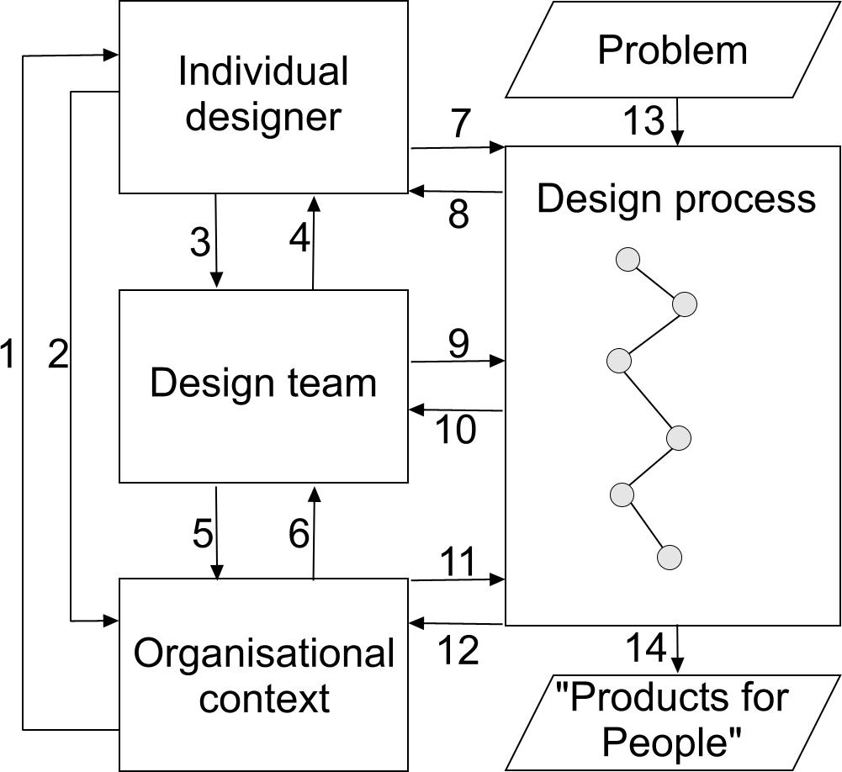 | 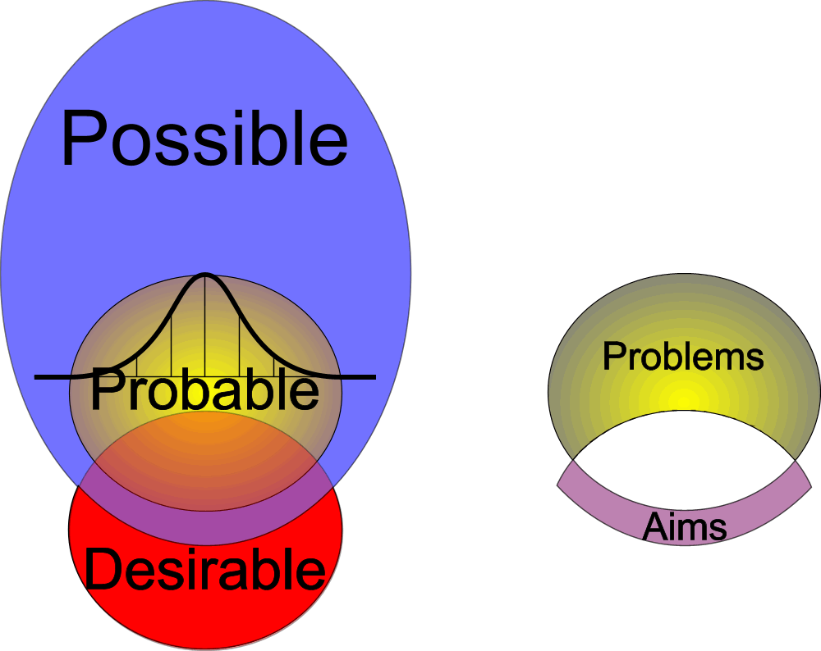  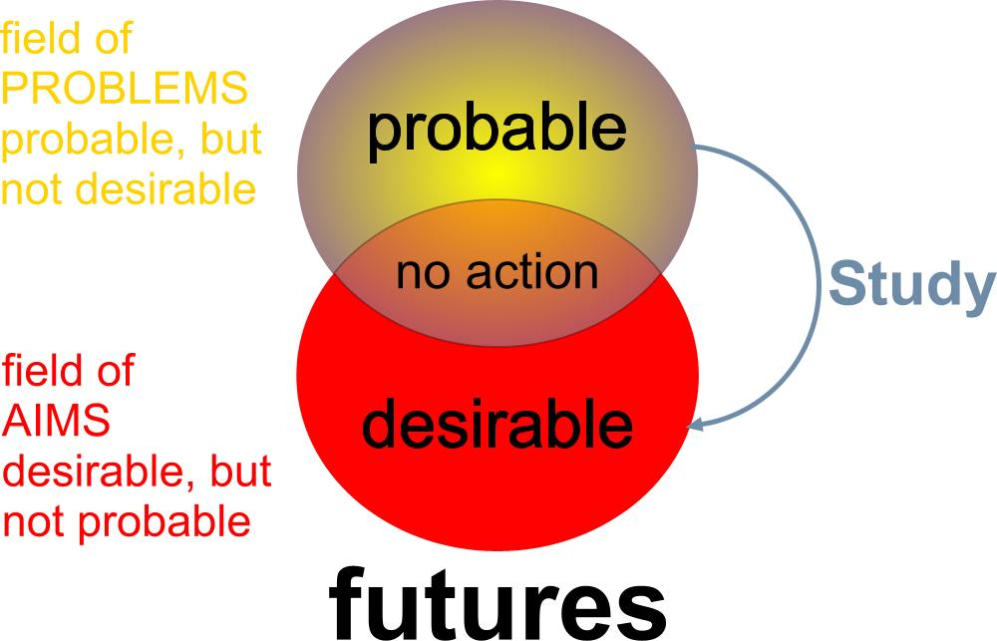
Fig. 1 Badke-Schaub (2006) | Fig. 2 De Jong (2006)
So, ‘a’ lacks the organisational context of ‘ide’, can not always isolate clear-cut ‘problems’ from the physical and social context on location and perhaps needs more abstract models based on ‘possibility’ (see Fig. 2).

What are the similarities? Ide+a share a very current problem in science and technology: integrating diverging specialist’s advices in design (3 and 4 in Fig. 1). In ‘a’ it concentrates on different language games of decisionmakers, empirical researchers and designers, representatives of public and private desirability, scientific probability and technical possibility respectively (see Fig. 2).

Propositions to be disputed:
Problem statements and programmes of requirement do not precede, but are designs.
The primary specialisation is coping with desirable, probable and possible futures.
The first ide+a project on design process should be a regular classical debate like this workshop.
The second ide+a project should be a yearly event designing building components, building interior components or furniture of public space.

