An urban designers’ road hierarchy

TAEKE M. DE JONG
Department of Architecture
Delft University of Technology (TUD)
Berlageweg 1 2628 GA Delft
THE NETHERLANDS
T.M.deJong@tudelft.nl http://team.bk.tudelft.nl

Abstract: - This paper takes a factor 3 between the levels of a road hierarchy as a basis of a rough preliminary ideal typical network model for urban designers making proposals to be checked by traffic engineers. The spatial model starts to cover the area with potential connections, then leaving out levels or parts of the tissue in low density areas. It emphasises the total network rather than separate roads connecting poles of origins and destinations. The existing connections can be compared with the remaining connections in the model to interprete the actual levels. The model can be developed to predict congestion where levels are missing resulting in proposals for improvement or completion. Other interfering networks like waterways can be treated in the same way giving insight in the number of (expensive) crossings by the interference of different networks in different lay-outs.

Key-Words: - road hierarchy, networks ,mesh size, urban design, capacity, intensity, congestion.

Introduction
As a rule of thumb for urban designers I use a factor 3 between the levels of any road hierarchy since 1988 []. It was meant for educational purposes only. However, in 2000 traffic engineers concluded the proportion 3 is better than 2 or 4 for any of the three criteria they used as a starting point for calculation []. So, they questioned if the factor 3 might be a ‘natural phenomenon’. It raised the question if traffic jams in the Netherlands could be solved by adding regional highway levels between the local and national ones.
This paper takes the factor 3 between the levels of a road hierarchy as a basis of a rough preliminary ideal typical network model for urban designers making proposals to be checked by traffic engineers. The spatial model covers the area fully with potential connections, leaving out levels or parts of the tissue in low density areas. It emphasises the total network rather than separate roads connecting poles of origins and destinations. The existing connections can be compared with the remaining connections in the model to interprete the actual levels. The model can be developed to predict congestion where levels are missing resulting in proposals for improvement or completion. Other interfering networks like waterways can be treated in the same way giving insight in the number of (expensive) crossings by the interference of different networks in different lay-outs [].
All input figures in this paper are arbitrary. They illustrate a way of calculating rather than an always context sensitive reality. In the free downloadable original spreadsheet [] they can be changed according to empirically verified context sensitive figures. So, the results can be checked for specific locations. Here the general inference is object of study and open to critique and improvements.

A factor 3 hierarchy
If you leave your home to go for a ride, you start on a ‘residential street’ (for example 20m wide between the façades) via a larger ‘neighbourhood road’ (say 30m wide) reaching an even larger ‘district road’ (say 40m wide), and so on.
At average (according to the starting point) every third road of each level you can make a turn to a road of a higher level (see Fig. 1).
In urban design, the question arises at which mutual absolute distance you have to draw them. To keep it simple, we take a mesh width of 30m for the smallest residential paths, 100m for residential streets, 300m for neighbourhood roads, and 1000m for district roads (Fig. 1).
That semi-logarithmic sequence I used earlier to distinguish orders of scale, based on the approximate radius of settlements of different order of hierarchy in the Netherlands through the ages []. In the Netherlands now it is often used to distinguish orders of scale avoiding scale falsification (the phenomenon that conclusions drawn on a specific level of scale can turn into their opposite at another level of scale, already demonstrable at a linear factor 3) [].

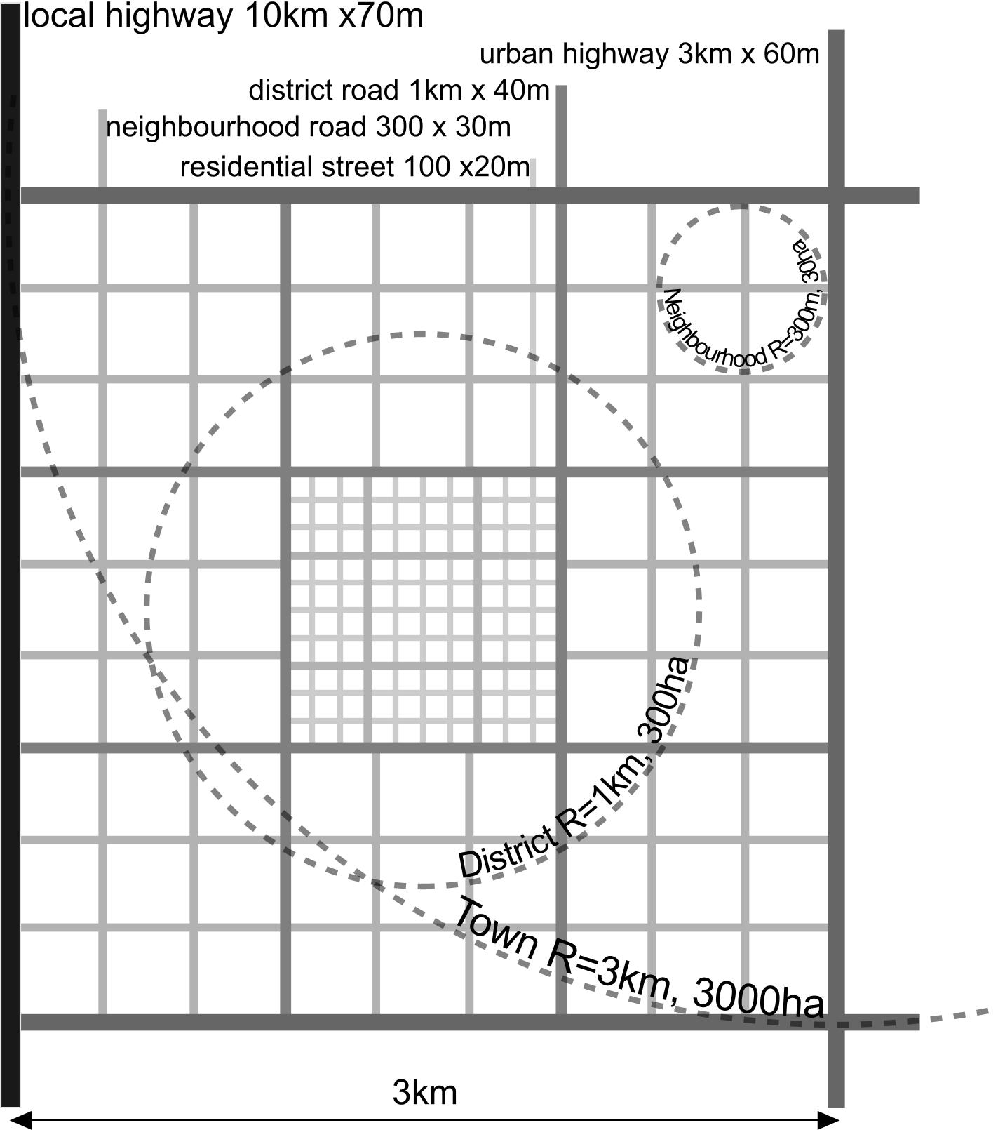
Fig. 1 Five orders in a network hierarchy in nominal measures
These measures are ‘nominal’, in a sense that ‘3’ may be interpreted between 1 and 10, ‘10’ between 3 and 30 and so on. The nominal (naming) character is expressed as (radius) R = {1,3,10 …}. Using a radius R means that the level of scale indicated by R also indicates the order of size of surfaces and volumes. So, R = {1,3,10km …} also indicates the orders of π·R² surface of approximately {3, 30, 300km² …}, at average increasing by a factor 10.
If the capital R represents the largest radius (frame) taken into account, then r can be used as the smallest one (granule). The proportion r/R represents the resolution of a drawing. A proprotion 1/10 characterises a very rough sketch, 1/100 a sketch and 1/1000 a blue print.
That proportion also indicates a tolerance by which a drawing or verbal argument may be interpreted. If the tolerance is supposed to be equal to the grain, Fig. 1 has a tolerance of 10m, because the smallest width of a drawn neigbourhood road (20m) has a radius of 10m.
The model is rectangular and in Fig. 1 it is represented in the special case of squares. Firstly we will motivate rectangularity and then extend the model to elongated orthogonal variants with the same network density as the chosen squares.

Rectangularity forced by a higher level
The most efficient enclosure surrounds the enclosed area with a minimum length of road (indicating investment). As well known, the result is a circle.
In a continuous network it is approximated by a hexagonal pattern. This minimal ratio between periphery and area is demonstrated in many natural phenomena [] (for example cells in a tissue) where preference is given to a minimal ratio between outer area and inner content.
A good example is a cluster of soap bubbles. A cluster of soap bubbles forced into a thin layer (demonstrable by two overhead sheets) produces a two-dimensional variant. The bubbles arrange themselves in polygons with an average of six angles. However, if one pulls a thread through them, the nearest bubbles will re-arrange themselves into an orthogonal pattern (Fig. 2).

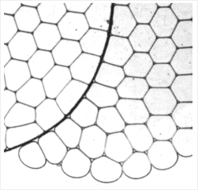

Hildebrandt and Tromba (1989) []
Fig. 2 The formation of right angles
Urban developments from radial to tangential can also be interpreted against this background. The interlocal connections ‘pull the radial system straight’. The additional demand for straight connections over a distance longer than between two side roads (a ‘stretch’) introduces rectangularity. Then every deflection from the orthogonal system is less efficient.
This can be clarified without mathematics by a thought experiment. Imagine a rectangular framework with hinged corners that is completely filled with marbles. If one re-shapes this framework into an ever narrower parallelogram, then there will be space for fewer and fewer marbles. So, in every case, the rectangular shape proves to be optimal in this respect. A triangular grid has a larger perifery/area ratio. If the parallelogram in the thought experiment that became ever more skew, matches an angle of 60° and an extra connecting line is added to cut the parallelogram into two equilateral triangles then it is an equilateral triangular grid with a much larger perifery/area ratio.

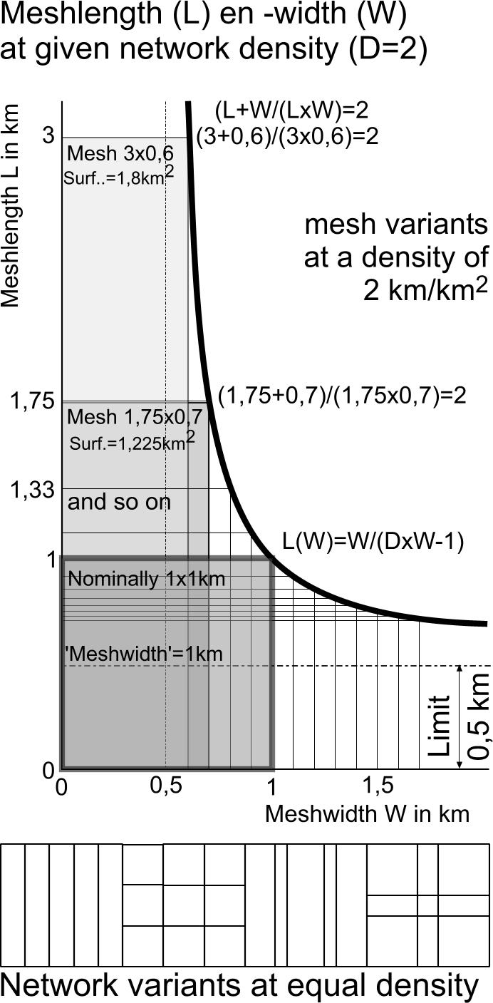
Fig. 3 Length (L) and width (W) of the mesh for a given net density of (D=2)
Fig. 3 shows a sequence of relationships between mesh width and length in rectangular meshes with a net density of 2 km per km² (the same density means the same investment). It is a common network density of country roads and district roads in the Netherlands, recognisable on any topographic map.
Length and width of squares are both 2/density. However, the same density also occurs in a pattern of roads that go infinitely into one direction every 0.5 km. So, if the length and width of the mesh equals 1/d = 0.5 km, the ratio between length and width approaches its limit. In that case, while the net density is 2 km per km², there can exist no ‘crossroads’ any more. That indicates elongating meshes saves the number of (expensive) crossings per km²!

Class | 1 | 2 | 3 | 4 | 5 | 6 | 7 | 8
 | residential path | residential street | neighbourhood road | district road | urban highway | highway | regional highway | metropolitan highway
directly served area | estate | ensemble | neighbourhood | district | town | conur-bation | region | metropolitan region
m radius | mesh |  crossing distance | 30 | 100 | 300 | 1000 | 3 000 | 10 000 | 30 000 | 100 000
directly served number of inhabitants | 10 | 100 | 1000 | 10000 | 100000 | 1000000 | 3000000 | 10 000 000
number of building layers along the road | 1 | 2 | 3 | 4 | 6 | 7 | 8 | 10
m width from façade to façade | 10 | 20 | 30 | 40 | 60 | 70 | 80 | 100
Fig. 4 Approximate spatial characteristics of a factor 3 road hierarchy

A road hierarchy
Going on that way we can make a table (Fig. 4) with approximate measures (in reality they will vary around that logarithmic average) for any type of road in a hierarchy.
In Fig. 4 ‘m radius’ is a nominal measure for the area involved. It applies the mesh width of the theoretical network as well, the distance between crossings of roads of the same level (turn distance). ‘Directly served number of inhabitants’ is as elastic as the nominal surface (read 1000 inhabitants and think ‘something between 100 and 10 000 inhabitants’).
Fig. 11 illustrates how much surface can be occupied by non residential functions. So, the density of in habitants as supposed in Fig. 4 should be adapted to the actual context. For example: a region (R=30km) often has many open spaces, so there we counted 3 000 000 inhabitants instead of 10 000 000 as found in London and Paris.
The spreadsheet mentioned in the introduction of this paper draws the adapted profiles as well according to the supposed number of dwelling layers, the required space for private gardens, pedestrians, parking, bicycle lanes, green verges and vehicle lanes filled in (Fig. 5).

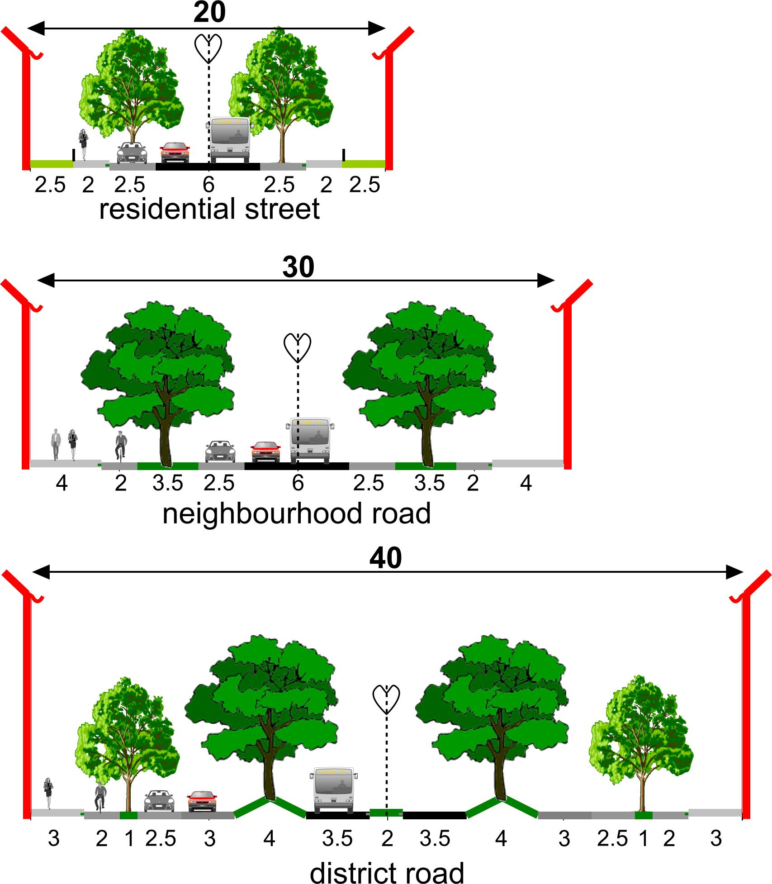
Fig. 5 Variants of 3 supposed profiles

Traffic capacity
The capacity is the maximum possible intensity.
The ‘km/hour design velocity’ in Fig. 6 shows which speed of cars is supposed determining the ‘minimum lane width’ of the lanes as components of the roadway. The ‘number of lanes’ is determined by the expected number of cars per hour calculated in line ‘vehicles/hour intensity’ in Fig. 8.

Class | 1 | 2 | 3 | 4 | 5 | 6 | 7 | 8
km/hour design velocity | 10 | 30 | 50 | 70 | 90 | 110 | 130 | 150
minimum lane width | 1.75 | 2.25 | 2.75 | 3.25 | 3.25 | 3.25 | 3.25 | 3.25
number of lanes | 1 | 2 | 2 | 2 | 4 | 8 | 10 | 16
vehicle/hour capacity per lane | 500 | 1000 | 1500 | 2000 | 2000 | 2000 | 2000 | 2000
vehicle/24 hour capacityof the road | 5 000 | 20 000 | 30 000 | 40 000 | 80 000 | 160 000 | 200 000 | 320 000
Fig. 6 Approximate capacity of a factor 3 road hierarchy

Traffic intensity
The light vehicles/24 hour intensity is calculated in Fig. 7 by multiplying the number of directly served inhabitants, the number of car rides/inhabitant per day (multiplied by 2 for leaving and coming back) and the % infrastructure used surrounding the urban island of origin.
For residential and neighbourhood roads there are visitors as well and the use of higher orders depends on the proportion of larger ride lengths.
In the neighbourhood it does not count so much, but on roads of higher level, cargo transport and service traffic is more important because of their larger ride lenghts.
For cargo we propose a simple, perhaps not yet reliable way. It is open for improvements, but it is used here to avoid complications, hiding the main line of inference. We estimated the kg cargo/ inhabitant/day and divided it by an estimated kg cargo/vehicle to get the number of cargo vehicles/24 hour.

Class | 1 |  | 2 |  | 3 |  | 4 |  | 5 |  | 6 |  | 7 |  | 8
directly served number of inhabitants | 10 |  | 100 |  | 1000 |  | 10000 |  | 100000 |  | 1000000 |  | 3000000 |  | 10000000
inhabitants
car rides/inhabitant/day | 2,00 |  | 2,00 |  | 2,00 |  | 1,00 |  | 0,20 |  | 0,10 |  | 0,05 |  | 0,02
%surrounding infrastructure used | 50% |  | 50% |  | 50% |  | 50% |  | 50% |  | 50% |  | 50% |  | 50%
light vehicles/24 hour intensity | 20 |  | 200 |  | 2000 |  | 10000 |  | 20000 |  | 100000 |  | 150000 |  | 200000
cargo
kg cargo/inhabitant per day |  | 1 |  | 1 |  | 1 |  | 1 |  | 1 |  | 1 |  | 1 |  | 1
kg cargo/vehicle |  | 10 |  | 100 |  | 1000 |  | 1000 |  | 1000 |  | 1000 |  | 1000 |  | 1000
cargo vehicles/24 hour intensity |  | 2 |  | 2 |  | 2 |  | 20 |  | 200 |  | 2000 |  | 6000 |  | 20000
service
service visit/inhabitant/day |  | 0,01 |  | 0,01 |  | 0,01 |  | 0,02 |  | 0,01 |  | 0,00 |  | 0,00 |  | 0,00
service vehicles/24 hour intensity |  | 0,20 |  | 2,00 |  | 20 |  | 400 |  | 2000 |  | 2000 |  | 6000 |  | 20000
Fig. 7 Approximate intensities of a factor 3 road hierarchy
In a comparable way the number of service visits/inhabitant per day produces the service vehicles/24 hour intensity.
Summing these lines, produces the number of vehicles/24 hour intensity (Fig. 8), which divided by 10 approximates the number of vehicles/hour intensity.
If enterprises are taken as residents, the intermediate deliveries are taken into account as well, but in that case the number of rides per resident should be higher. However, the number of visits per ride could be more than 1 as is supposed here.
The capacity is sometimes filled by the intensity in peak hours causing congestion. In Fig. 8 intensity and capacity are compared in the % use by car = intensity/capacity. Above a certain percentage (for example 60%) you can expect congestion.

Class | 1 | 2 | 3 | 4 | 5 | 6 | 7 | 8
vehicles/24 hour intensity | 22 | 204 | 2022 | 10420 | 22200 | 104000 | 162000 | 240000
vehicles/hour intensity | 2 | 20 | 202 | 1042 | 2220 | 10400 | 16200 | 24000
% use by car = intensity/capacity | 0,4% | 1,0% | 7% | 26% | 28% | 65% | 81% | 75%
Fig. 8 Approximate intensity of a factor 3 road hierarchy

Noise and house price
The dB(A) noise on façades depends on many factors like intensity and distance to the façade. It is a rough estimate, but it determines the % devaluation of house prices by noise load []. However, living at a main road may have advantages.

Class | 1 | 2 | 3 | 4 | 5 | 6 | 7 | 8
dB(A) noise on façade [] | 66 | 59 | 62 | 74 | 80 | 84 | 90 | 96
% devaluation of houseprice by noise [Error: Reference source not found] | 10% | 5% | 7% | 22% | 34% | 40% | 48% | 54%
Fig. 9 Approximate noise load and reduction of house price of a factor 3 road hierarchy

From a model into reality
Now, we have to check how reliable this model is, knowing that reality always differs. We restrict ourselves to the spatial characteristics. A complete survey should take more cases into account and measure local intensities to check the theory. Here we take one case only and we do not check all assumptions.
In Fig. 10, a map of the Dutch town Dordrecht, we find 6 levels of roads. The resolution does not permit to see residential paths (1). But in a coloured version we see residential streets (2, white) , neighbourhood roads (3, yellow), district roads (4, same colour, but somewhat thicker), urban highways (5, purple), highways (6, red), regional highways (7, red and orange). We have drawn circles of nominally 3, 1 and 0.3km in the map to indicate the size of parts we nowadays call city, district and neighbourhood.

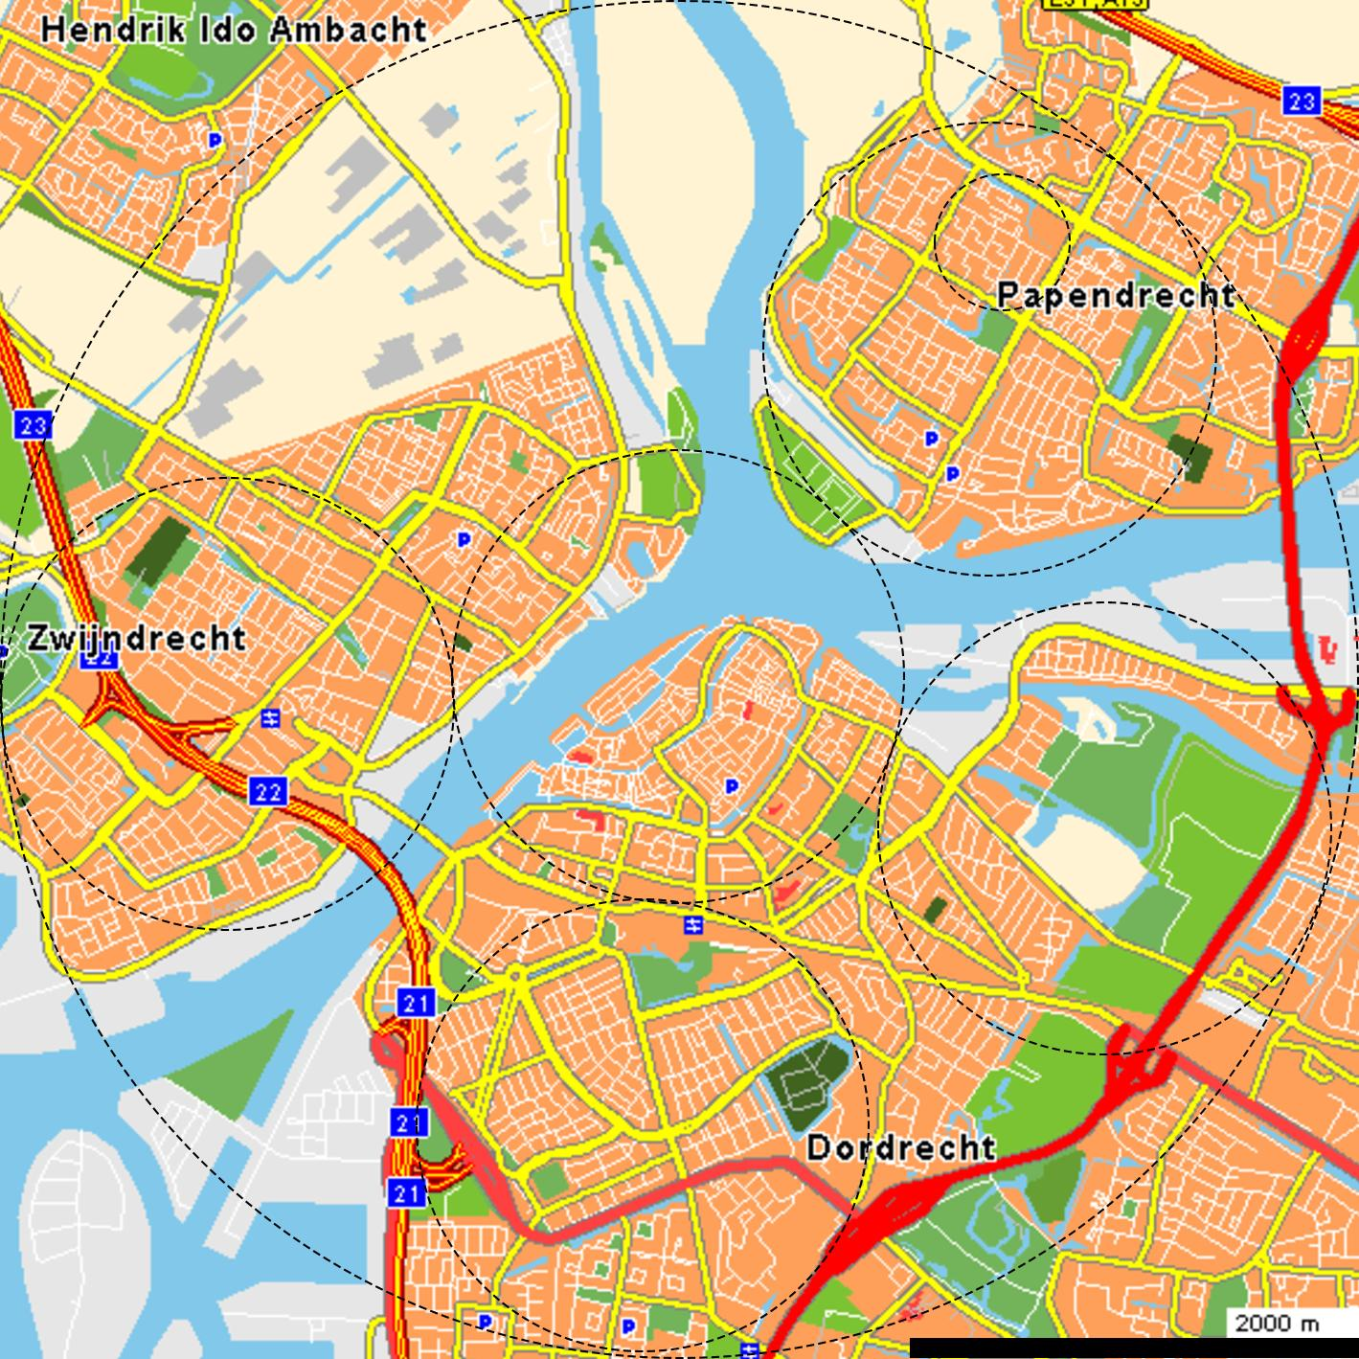
Fig. 10 The urban area around Dordrecht

Deviation of predicted measures
Let us take Papendrecht (above right in Fig. 10). It has some clear squares of approximately 500x500m neighbourhood roads while our model states 300x300m. However, elsewhere (for example in the central part of the city), there are smaller mesh widths (sometimes 100m). So, the model fits better the average. Moreover, we appointed: “read 300m and say ‘something between 100m and 1000m’. So, reality deviates within the appointed tolerance of the model. If our model fits the average, we can say: “Papendrecht has a relatively large mesh width for its neighbourhood roads”.
Within the ‘neighbourhood’ square all streets are approximately 20m wide from façade to façade, according to what we supposed in Fig. 4.
The neighbourhood roads fit the prediction to be some 30m wide as well. However, the district road is not 40m, but 50m wide.

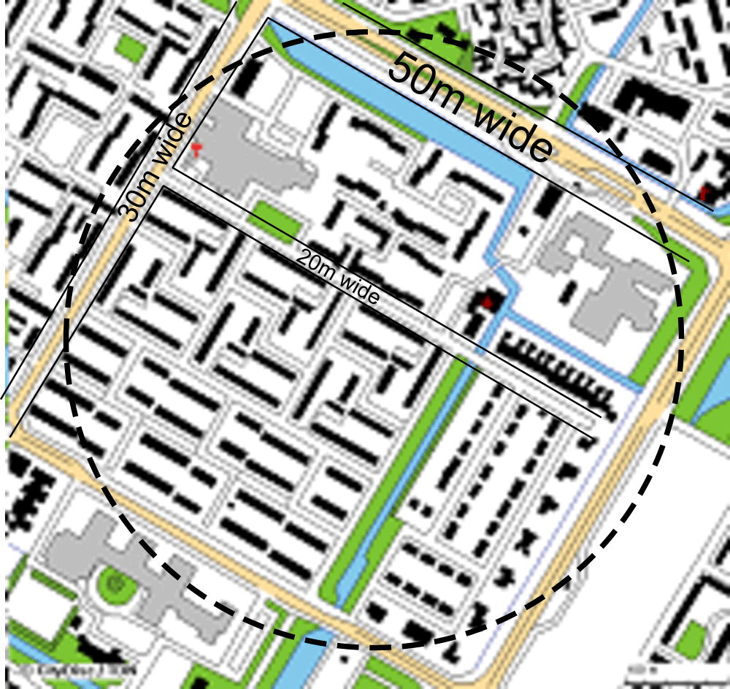
Fig. 11 A Papendrecht detail
There are two possible reasons of deviation: the spatial context and a superimposed function.

Deviations caused by spatial context
We supposed, there should be a district road every 1km, but in Papendrecht in Fig. 10 we see only one within a radius of 1km (diameter 2km). However, there is interference with the network of rivers, clarifying why the second one is not realized. A second one here would not have enough use to legitimate the cost. The river limits its supporting surface. The model supposes a homogeneous topography while reality is heterogeneous. Nevertheless the density of district roads is low comparing to the model, so the remaining one needs more capacity.

Superposition
A district road appearing in a grid of neighbourhood roads can take over a neighbourhood function (superposition). That is another reason to increase its capacity and thereby its width.

Conclusion
A traffic network determines the lay-out of a city for a long time, covering changing requirements. Assuming a apparently timeless rational factor 3 between the levels of a road hierarchy offers the opportunity to make a simple global traffic model stressing the network with all road categories rather than calculating the temporary requirements of separate roads. The model keeps us attentive on regularities in the existing urban tissue to be applied in urban design. It can globally predict traffic intensities and potentials of future connections without extensive research of origins and destinations between traffic poles. It is simple and visually convincing for administrators and designers, open to professional criticism, improvements and adaptations to local contexts.

References:

[?] Jong, T. M. de, Morfologische typologie van netwerken (Delft) Faculteit Bouwkunde TUD 1988
[?] Nes, R. v. and N. J. v. d. Zijpp, Scale-factor 3 for hierarchical road networks: a natural phenomenon? (Delft) Trail Research School Delft University of Technology, 2000
[?] Jong, T.M. de; Akker, C. van den; Bruin, D de; M.J., Moens.; Steenbergen, C.M.; Toorn, M.W.M. van den [eds.], Sun, wind, water, earth, life and living; legends for design. (Delft) TUD, Faculteit Bouwkunde, Publicatiebureau, 2007
[?] Downloadable from http://team.bk.tudelft.nl > Publications 2008 > traffic.xls
[?] Jong, T.M. de, Milieudifferentiatie, een fundamenteel onderzoek (Den Haag, Delft) PhD Thesis Technische Hogeschool; Rijksplanologische Dienst, 1978
[?] Jong, T.M. de, Kleine methodologie voor ontwerpend onderzoek (Meppel) Boom; http://team.bk.tudelft.nl > Publications 1992
[?] d’Arcy Thomson, W., On growth and form (Cambridge UK) Cambridge University Press, 1961
[?]Stefan Hildebrandt and Anthony Tromba, Architectuur in de natuur, de weg naar de optimale vorm (Mathematics and optimal form), Wetenschappelijke Bibliotheek Natuur en Techniek, Maastricht/Brussel, 1989
[?]calculated according to Ruiter, E. P. J., The Great Canyon. Reclaiming land from urban traffic noise impact zones (Zoetermeer) Peutz b.v., 2004
[?]calculated according to the standarised Dutch model SRM1 http://www.stillerverkeer.nl/index.php?section=rmv&subject=RMW02&page=SRM1

