A Turkish Greenheart metropolis
forced by nature

ALI GUNEY; TAEKE M. DE JONG
T.M.deJong@tudelft.nl A.Guney@tudelft.nl http://team.bk.tudelft.nl

Abstract
The municipality of Adapazarı in the Turkish province of Sakarya, destroyed by earthquake in 1999 with great impact (ample 15,000 casualties), took many measures([], [], []). Moreover, it commissioned Delft University of Technology in 2005 to make a scenario for future development summarised here []. That scenario is now gradually elaborated into a master plan by the municipality supervised by Ali Guney. The majority of the fast growing population (approximately 400,000 inhabitants) lives on a dangerous deep ‘lake of clay’ showing liquifaction in case of earthquake. Technically safe building solutions on that kind of soil are expensive. Based on experience in the past one can expect earthquakes of the same severity once in 60 years. Building on the solid grounds surrounding the ‘lake of clay’ would reduce risks substantially. However, these grounds show risks of landslides in case of earthquake.

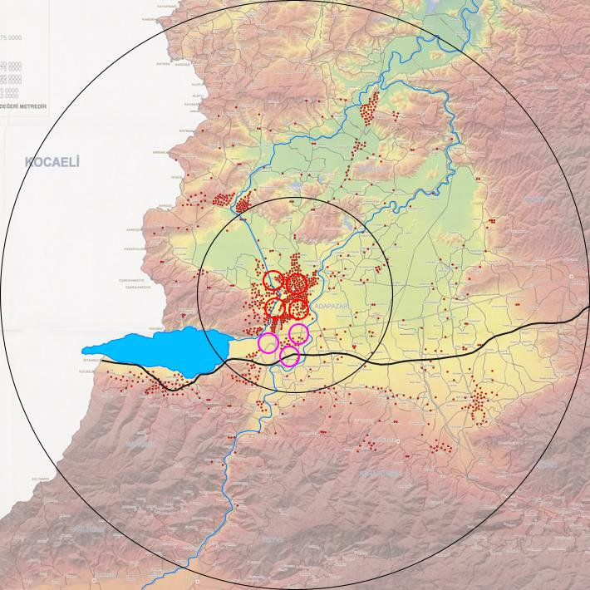 | 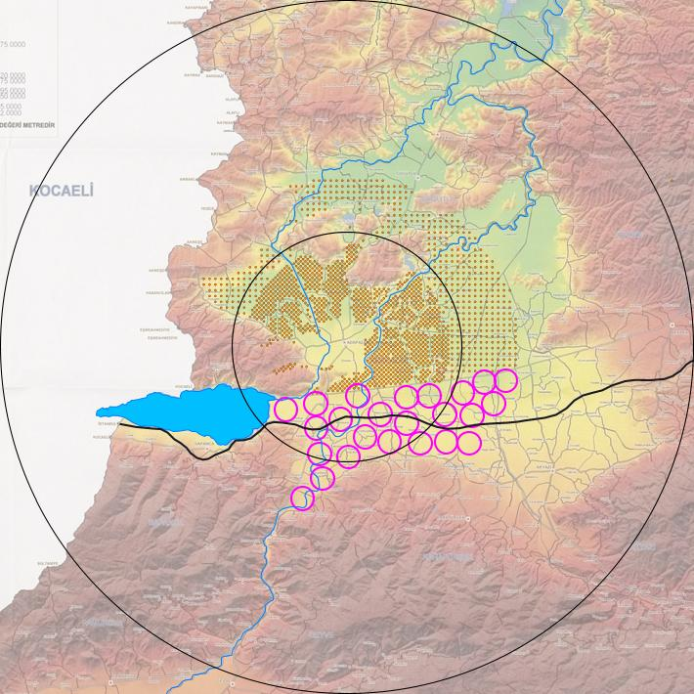 | 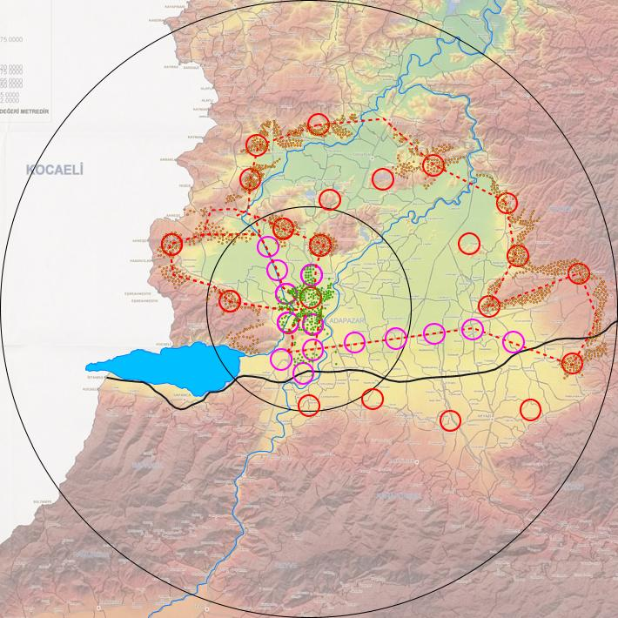
Fig. 1 Representation of actual 400 000 municipal population in net dots (floor space) radius R=100m of 1 000 inhabitants (4 dots R=1km of 1000 000 inhabitants) and 3 dots R=1km of existing business and industrial areas. | Fig. 2 A reference high-risk scenario for 2 000 000 inhabitants 2030 without master plan and supervision, industrial overflow of Istanbul.  Casualties 2030: probably 120 000 inhabitants | Fig. 3 The low-risk scenario: same amount of people divided into 27 different local identities. Circles shown: radius R=10km (normal conurbation) and R=30km (Metropolitan Municipality).

[?] Adapazari, Municipality Deprem sonrasında yıkılan binarın yerindeki boş ve çok hisseli parsellerin , takas suretiyle haklarının transferi, Adapazari municipality; Adapazarı, 2005, http://team.bk.tudelft.nl/Research/Adapazari/publications/200504/ortahasar%20ruilverkavelingen.doc
[?] Adapazari, Municipality Reconstruction works after 1999 east marmara eartquake Adapazari Municipality; Adapazarı, 2005, http://team.bk.tudelft.nl/Research/Adapazari/publications/200504/RECONSTRUCTIONWORKSAFTERTHEEARTQUAKE.doc
[?] Adapazari, municipality, The project proposal for accomodation problem after the earthquake on 17th august 1999 and half damage Adapazari, municipality; Adapazarı, 2005, http://team.bk.tudelft.nl/Research/Adapazari/publications/200504/HALFDAMAGE%20accomodation%20problem.doc
[?] Jong, Taeke M. de (2005) Preliminary low-risk scenario for Adapazarı report to the Municipality (Delft) http://team.bk.tudelft.nl/ > Publications 2005 [ ] VROM, Min.v., Omgaan met Risico's. De risicobenadering in het milieubeleid. Min.v. VROM, Centrale Directie Voorlichting, 's-Gravenhage, 1989 [ ] VROM, Min.v. Een Wereld en een Wil. Werken aan duurzaamheid.Nationaal Milieubeleidsplan 4, Ministerie van Volkshuisvesting, Ruimtelijke Ordening en Milieubeheer, Den Haag, 2001 [ ] MNP Risico’s in bedijkte termen; een thematische evaluatie van het Nederlandse veiligheidsbeleid tegen overstromen Milieu- en Natuurplanbureau - RIVM rapportnummer 500799002, Bilthoven, 2004, milieubalans@rivm.nl; http://www.rivm.nl/bibliotheek/rapporten/500799002.html [ ] Doxiades, Konstantinos Apostolou Ekistics; an introduction to the science of human settlements Oxford University Press, New York, 1968

