Chairman’s impressions
Taeke M. de Jong, 2008-06-17

Introduction
The main issue of the conference was:

1 the contemporary interrelationship of Industrial Design and Architecture
2 a confrontation of contemporary design practice in both domains with academic theory and education

Details about eight cases of design processes in practice (four industrial designs and four from architecture) were collected by students. The students were stimulated to be not too strict in handling their query, because practice can raise new questions that may be lost in a poll structured by academic suppositions. The query of the interviews contained questions about:

1 the project in general
2 social complexities in collaboration
3 design process
4 decision making
5 visualization
6 project management
7 knowledge diffusion

Specialists regarding the topics 2 till 7 were invited to analyze the cases and to write a paper from their point of view. Although the speakers of the conference each reflected on the outcomes of the interviews, it appeared that some of the experts reviewing the cases missed questions. This was more than compensated by the resulting rough material which provided some interesting details beyond the chosen themes.
As an urban designer and ecologist I learned a lot from the interviews and the reflections of the speakers. However, from both also raised many remaining questions. I faced the speakers with some of these questions after their lecture. I will come back on these topics, but let me first cite some statements from the interviews that triggered me most.

The interviews
From the interviews I selected some interesting propositions to introduce the projects at the conference. They are listed below in the first column with small modifications for the sake of readability. In the second column I try to analyze why they triggered me.

propositions | reflection of the chairman
CePeZeds Westraven building interview
Every advisor has solutions. | In an urban design team you often have to disappoint the advisors because they answer partial problems in a whole field of connected, context sensitive problems.
The architect has to take all ideas to a higher level. | To create surplus value at a higher level of scale you need an encompassing concept. A concept like that changes the whole field of problems, the field of aims and the direction of solution.
The architect introduces problems, the advisor provides solutions. | That is an interesting statement contrary to the idea that design is always problem solving. It sometimes creates problems.
Copies are compliments. | Here the returning debate about patents emerges.
Ahrends’ A230 chair
Clients have questions. | That is seldom the sole inspiration for the architect. After all, such questions seldom survive the life time of a building with changing users.
Decision making mostly means: ‘how large is the demand’. | For the architect the next users are unknown. For the urbanist the users are numerous. For both the stakeholders and specialists are different for every project.
The sales agency is our antenna. | Architects and urbanists seldom do have a sales agency.
The purchasing agency is an interesting source. | Architects consult the building materials documentation and references. Urbanists their numerous specialists.
We write our programme of requirements ourselves. | The programme of requirements develops in interaction with the design sketches since a concept changes the whole field of problems, the field of aims and the direction of solution for all participants.
In an office, meeting may be more important than work. | It resulted in a table and chairs suitable for quick meetings at the table of the host.
Styling is 10% of our work. | Does that mean education has to give 90% of the time to other items than styling?
Neutelings-Riedijks Image and sound building
The scale of a project is not relevant for the way of communicating. | But the scale has a relation with the number of possible participants.
Steps are similar to those taught at TUDelft + geographical centered communication. | The plus-sign indicates the many always different contexts architecture and urbanism have to operate in: administrative, cultural, economic, technical, ecological and spatial contexts at different levels of scale and changing in different periods of time.
Different mock ups to simulate different research questions. | Instead of ‘mock ups’ I would like to speak more generally about ‘models’, including mathematical ones. Models are partial representations to analyze and evaluate partial effects.
All knowledge in architecture is common knowledge. | Anyone is 'hands-on' expert, but what about the technical details and changes?
MMIDs Beer tender
Beer tender is produced in very large series. | Except in chains of shops architectural evaluation is avoided by the owner, because it can harm the value of its property. Urban evaluation happens after the retirement of the designer. So, (s)he does not care so much about the performance.
My own style isn’t important in this project. | How different form architectural designers!
Style is work method f-d-p (Functionality & technology, Design (look & feel), Production & assembly) | It would be interesting to study the impact of the work method on style. However, the work method of an architect changes by her or his experience. Unfortunately experienced architects are not aware of their tacit knowledge, they forget to mention hidden suppositions beginners do not share. So, experienced architects often are bad teachers. However, there are exceptions where archiotects are aware of the roots of their experience e.g. Hertzberger. He saved and numbered all his sketches, including the instructive mistakes.
I cannot recall decisions that explicitly. | Even the movements of my hands are decisions. To make them all explicit would hamper designing.
But there have been moments like that during the project. Time, Money and Quality. | That is the selection of decisions to make explicit as asked by the client.
Martinis 1-2-3 house
In the construction world it is only possible to save money by eliminating disciplines. | Urbanist Riek Bakker says: “Sometimes you have to make a problem more complicated to solve it.”
‘Can not’ does not exist. Often it works well to put it aside for a bit. When you look at it the next day, often then you see the solution. | Creativity requires forgetting at least one hidden ‘self evident’ supposition.
A corporation usually have their own list of demands. When you obey this you so to speak have already written the building specifications. The rest in the Netherlands is just norms. …  After this you look at the image quality plan (beeldkwaliteitsplan) and for a big part that decides on what it has to look like. | What is left for the designer?
First we look at the technology and then we look at the design possibilities. | Construction!
…they brainstormed every six to eight weeks for one and a half years…about the possible new ways of building. From these sessions different models were derived. | So, the time you need for one innovation is 1½ year.
At a certain point in time Jaap took a next step. Why would you remove the tunnel, why don’t we take the concrete off? Because that is the part that needs to be moved to the site. | Forget the hidden supposition about what is bound to location and what has to be moved.
When he removed the concrete from the tunnel he asked him self why they would not poor the ground floor on top of the concrete tunnel. In this way you won’t have to poor a cement finish at the end. You are left with perfectly smooth floors and it is much easier to attach all the technical things to the tunnel. These are all decision moment in the progress of the process. | Forget the hidden supposition about what is up and down.
At a certain point a concrete tunnel has to be turned around. Because this will make it possible to install the inner walls. For this wee had to develop a new system, because such a machine did not exist yet. First they had to come up with an idea for this machine and then they had to convey this idea to someone else who was capable of designing it. | If you turn upside down, you create a problem.
In the execution world we use AutoCAD, but many architects do not use this. The drawings have to be redrawn constantly. For many of the 3d images we still use Photoshop to decorate them with trees and people. | That is part of translating one language into another.
As an architect you are closely involved from the moment the urban situation is known. | Architecture is more context sensitive than any other design study. That means work.
We could make more time for this (innovation, ed.) by building a new office building which already has been built somewhere else. When both offices are far apart, no one will make a fuzz about it. …  A housing corporation cannot develop a good product for one location and also use it in another one. | Larger series are profitable for innovation.
What is completely wrong in the world of construction is the fact that everybody starts over.  … we are constantly doing the same thing. …  If we just made a database with all the building plans in it. At this moment every office does their own research and keeps it just for him self. …  When we could trust each other it would be a lot easier. | Plagiarism is forbidden in science and the arts, not in technology. There innovation is protected by patents. But little improvements make possible to evade that ban to copy.
On the country side people live in a house their whole lives and at the end the house is at the end of its lifespan. …  At this moment we are building houses for a lifespan of 50 years, but will this stay the same in the future? In the cities, people move every 7 to 8 years. …  In offices the lifespan is shorter. After 12 years you need to strip an office building completely and upgrade it again. | Architecture is coming closer to product design if the life span of its product decreases. That means a market for Cradle to Cradle.
Robert Barnhoorns Carver
We see that most women chose the managing side of this profession. | Let us avoid the quarrel about gender predisposition.
Investors knew that extra time would be a good investment to there product. | For a real estate developer the life time of the property stops after selling it.
The one who pays makes the last decision. | Go-no go decisions cast their shadow(s).
Architecture knows heroes, industrial design the name of the bureau. | This statement shows a subtle difference between ‘name’ and ‘hero’.
Frank Vermeulens Spark
A car consists over more than 1200 components. | Shortly after my chairmanship I designed a device to keep the pages of differently sized books straight for scanning from above (see Fig. 3). It contains 22 Meccano-components and it took 5 hours to restore all mistakes.
Small steps have to restrict high risks. | Equal steps do not have equal risks, but smaller steps are easier to evaluate on risks. However, steps in designing are often related to each other making next steps (im)possible. To evaluate the possibilities of next steps is not easy, it supposes design.
Architecture is a specified direction in product designing. | In Delft, product design was split off from the Faculty of Architecture into a separate Faculty. This proposition reverses history, but up scaling a profession will meet many problems. The separation was not without reason.
Media like to attach a name of an architect to a building. | Architecture and urbanism are public, local and long term. They are often part of a public debate, asking for publicly responsible names. The value of your property is affected by your neighborhood; you cannot buy the product without influencing your neighbors.
A mass product has a lifecycle of one year, but a building has a lifecycle of 50-100 years. | And if your neighbors sell their property it still affects the value of your property.
Verheijen and Tabbers’ ID building
Small series, big scale difference. | Fons Verheijen gave an excellent summary of differences between Industrial Design and Architecture (see below). I refer to that interview, concluding that the most important factor is scale.
The first big decision was to decide to do such a big renovation project, then deciding upon the final amount of square meters and where to place which function. | ‘To preserve or to change’ is a crucial decision, often taken before design. In urban design and architecture it is more precise: ‘what to preserve and what to change’. These decisions are often the consequence of a programme of requirements. This proposition suggests they precede it.
The whole idea to create one big space in which everybody would be able to enjoy what others are doing was one big risk. | In general, connecting causes more risks than separating.
Indes’ care bed
Not much attention was given to aesthetics. | With such a firm statement not many architects would survive as designers.
Users played an important role, from the start consulted and later when prototypes had to be tested. | In architecture the expensive testing in a prototype is replaced by referring to preceding examples (‘precedents’).
The people involved in the engineering phase are already looking over the shoulder during the concept development stage. | That practice penetrates in Architecture, but its scale forces to choose cheap, less mobile materials in less complicated mechanisms.

These propositions already raise many items discussed in the conference.

Scale (frame and grain)
The difference between Industrial Design and Architecture cannot be described better than Fons Verheijen did in his interview: ‘He is a teacher at the faculty of Architecture but has also has tutored a few Industrial Design students.

- There is a big scale difference. The scales are much bigger in Architecture.
- Industrial Design is much more trained in protocols, this is how you do it (first analyses, then you make a matrix with pro’s and con’s and then you have you answer)
- Architecture put less focus on the analyses but it is still needed to fill the mind with data
- The design process in Architecture is much more intuitive
  - Along the way you slowly come across the rules for this design that you have to obey, everything can be change;
  - It is a trail and error process;
  - Slowly you are combining what you as an architect want in the project, what materials can and what the boundary conditions are (randvoorwaarden). This is what you learn to cope with at the faculty of Architecture.
- Architecture starts much faster with sketching.
- In architecture the making of the building is also very important. There are companies that only do concepts. But according to Fons it gets really exciting when you need the figure out how you can actually make what you have in mind.

Two big differences are:
- Architecture is like an equation with a hundred unknowns, you have to learn to cope with this. (Ongeveerkunde)
How to cope with the doubt
  - Be daredevilry;
  - Be skilful;
  - It is important to know what is the most important at what moment in time
    - For this intuition and experience is needed.
(In architecture this is needed much more than in Industrial Design)
Here fore it is very important to work with intuition instead of protocols.
- Architecture has got secret clients next to the client that hired them. Secret clients are society and the architectural advisory services (welstand). Unasked architects take the whole society in account, and this can influence the design. Luckily Architecture is an old profession and this is accepted. In industrial design you have to fight much more if you want to do something different.’

Most of these remarks are even more valid for the comparison with Urban design. For example, look at the sketch of Zoetermeer Meerzicht from 1966 (Fig. 1) and the contemporary reality (Fig. 2Error: Reference source not found).

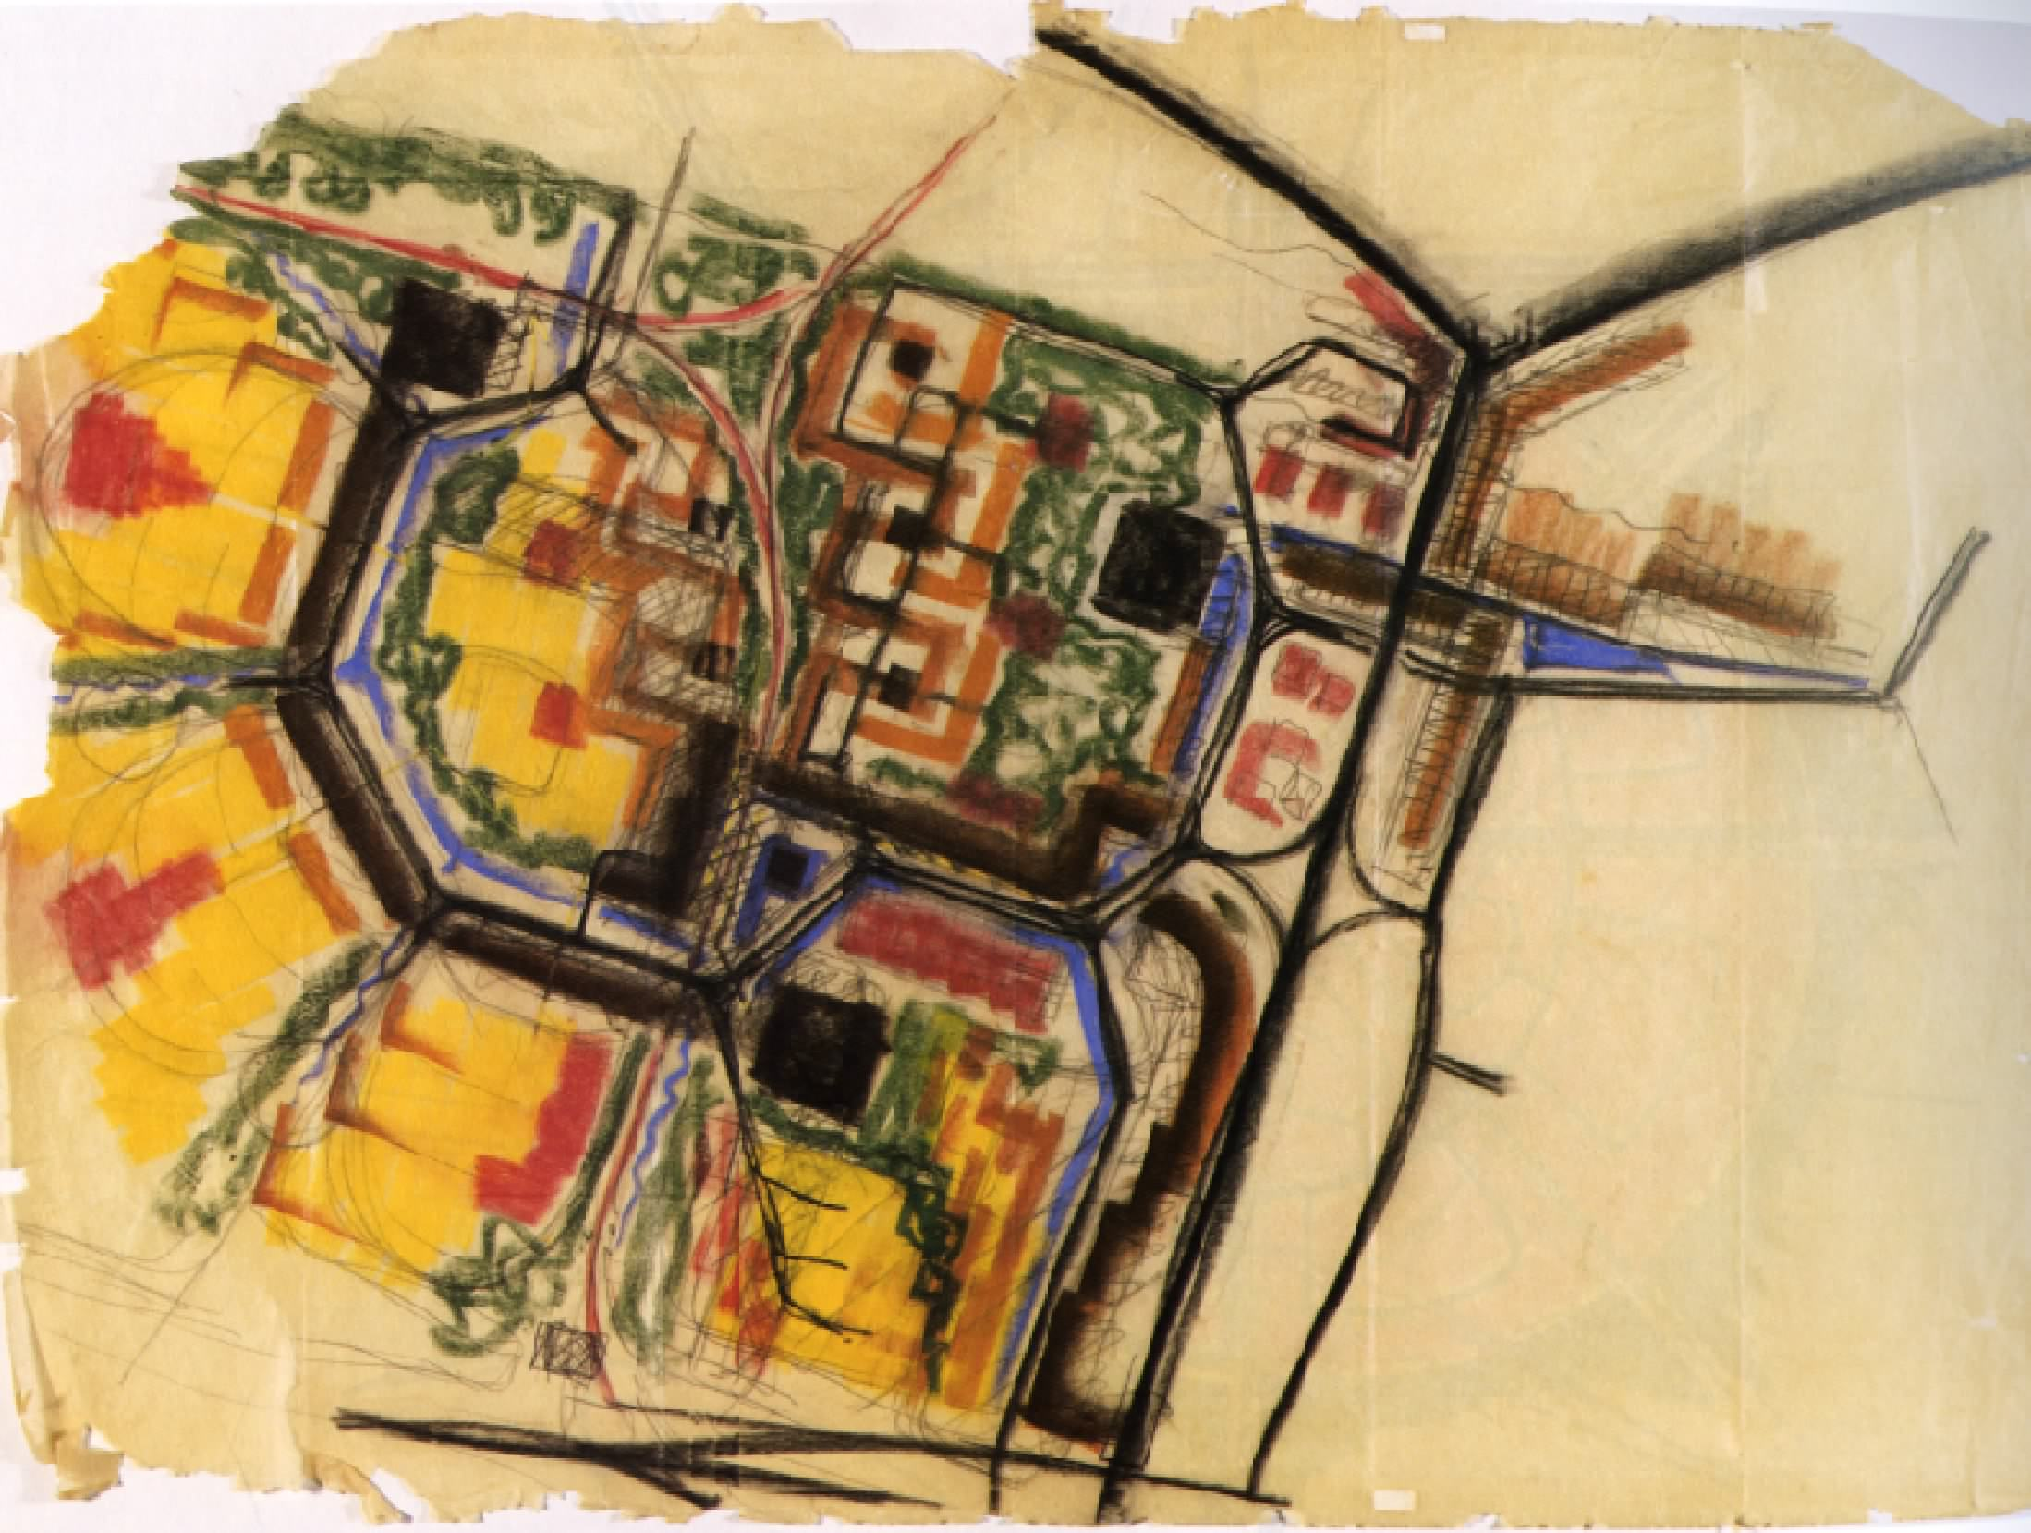 | 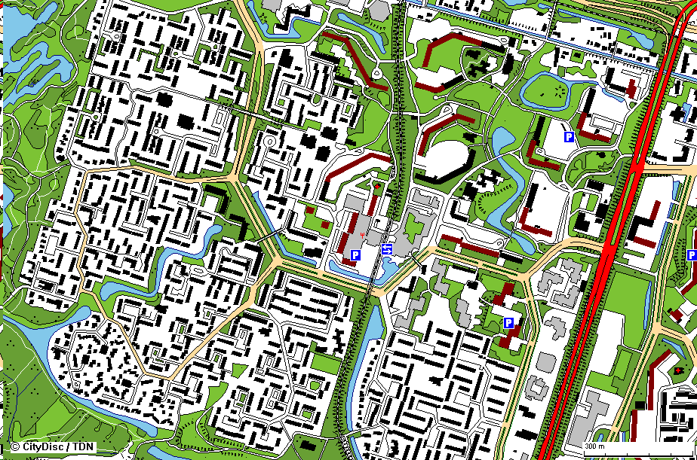
Fig. 1 Sketch of Meerzicht 1966 | Fig. 2 Contemporary reality
In my opinion, most differences are the consequence of scale difference.
The larger scale of architecture and urbanism causes other differences from product design:

- a prominent role of gravity: vertical structures with horizontal floors and connecting spaces;
- many solutions for the same overall problem: to acclimatize, separate or combine activities;
- a ground bound unique, always different and specific context: governmental, cultural, economic, technical, ecological and spatial context;
- many external parties determined by incidental context, less history of cooperation, less shared language;
- up scaling in space and time affects the composition of the team;
- small series, less decision making based on the size of the demand;
- changing scale changes terms and legend units of the drawing;
- boundaries of prefabrication by transport possibilities.

An urbanist designing an office tool
Shortly after my chairmanship I designed a device to keep the pages of differently sized books straight for scanning from above without glass coverage. I lost 5000 titles by the fire of the Faculty, so I wanted to digitize as much as legally possible before the next fire. I bought a fast scanner (1 second per page) with beautiful software, but keeping the reports and books flat by hand was not optimal. As an urbanist with a task to teach technical ecology, I also wanted to understand the difference of designing at the largest scale form product design by doing. It took me 5 hours to make a Meccano prototype of 6 resizable parallelogram’s called ‘Flat keeper’ (see Fig. 3 and Fig. 4). So I learned you can not design such a product without making a model. I always put wrongly-sized screws at the wrong place. I had to understand the rotational behavior of adaptable parallelograms in three dimensions and often changed the size and order of the components. I did not count the times I had to unscrew the model by various reasons: the screw sits in the way of other screws; the parallelograms moved crooked not following each others movements; it did not fit larger books and so on.

What is the difference of industrial design compared to urbanism? In this product gravity plays a role, but not a prominent one much influencing the construction like the flow of water does in Civil Engineering. There are two horizontal planes, but the vertical structures are mobile. It is not bound to different and specific governmental, cultural, economic, technical, ecological and spatial contexts and there were no external parties, but if it had to be produced in large series much effort still would have to be done and more parties would have to be involved. There are no boundaries of prefabrication. The main problem has a limited number of solutions. The character of the legend units are in the range of architecture, but drawing an urban plan requires an other kind of legend, other categories and other ways of thinking. There was no team, but using other materials it would have been necessary. There was no decision making based on the size of the demand and pay-back time, but that would be the case if it would be made for the market.

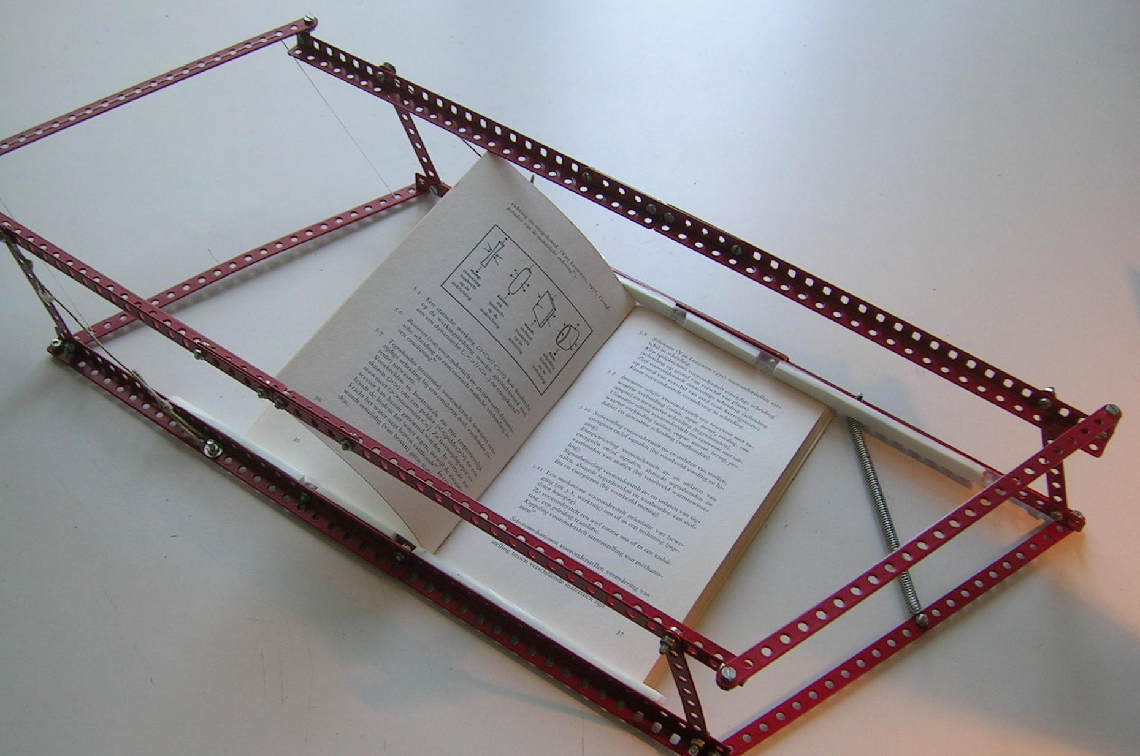 | 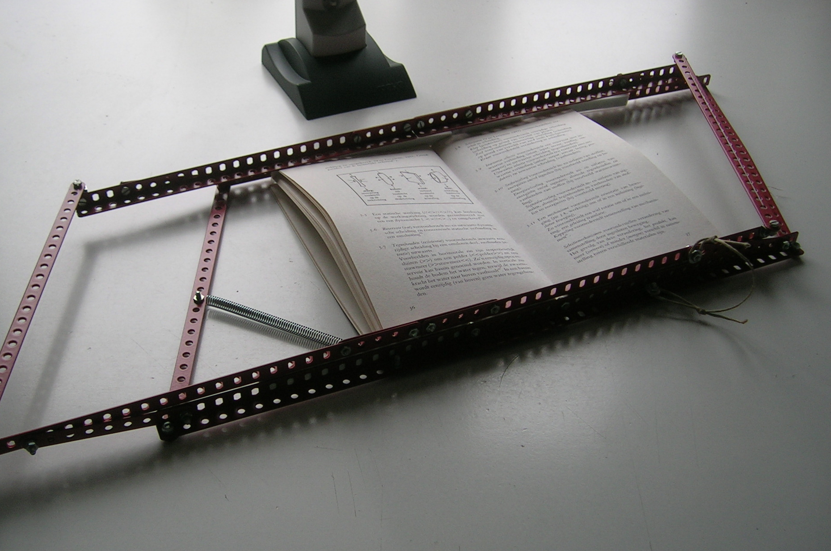
Fig. 3 Flat keeper open | Fig. 4 Flat keeper closed
Starting to use it, it appeared to be a failure. It took too much space. It shifted by using it (producing the wrong part of the picture). It did not keep the paper flat (see Fig. 4, do not care, I am the author of the depicted book). Gravity did not help as I hoped. Shearing forces deformed the book adjusting the device to the size of the book by a spring and so on. The increasing and decreasing thickness of the respective book-halves page by page was also a problem. My hands were faster (how provident is a million years of evolution). So I skipped the idea.

Now the shift of paradigm arrives; the moment I forgot some ‘self evident’ suppositions. I saw the professional book drive of Azis. It is still too expensive for me. However, it does not keep the book flat, but half-open at an angle. The opposite pages are photographed by two cameras. The opposite pages exert less distorting force at each other. I do have one camera only. But its software offers the possibility to insert pages in a range. That combination gave the solution: scan the odd pages first, then the even ones inserting them in the file. Suddenly, during practice I looked at my working hands and I got an idea to make a simple Meccano prototype: the Angle keeper (see Fig. 5 and Fig. 6). Books do not want to be opened. They protest by puffing up their pages. So, make a compromise. Listen to their wishes: do not force them too much, put them in a chair and push their pages gingerly.

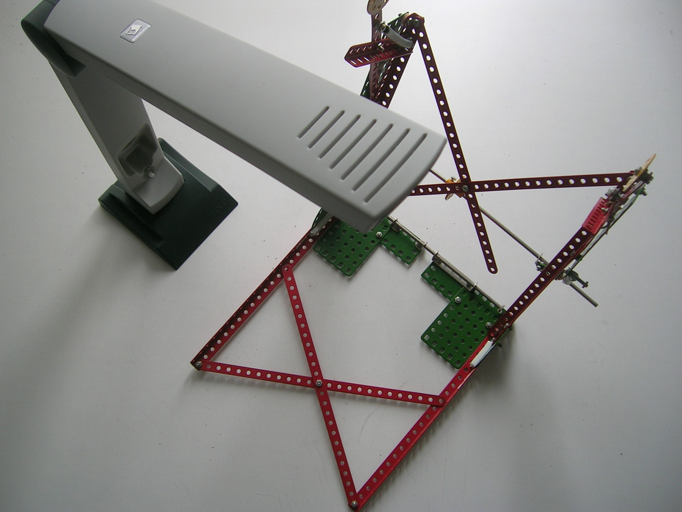 | 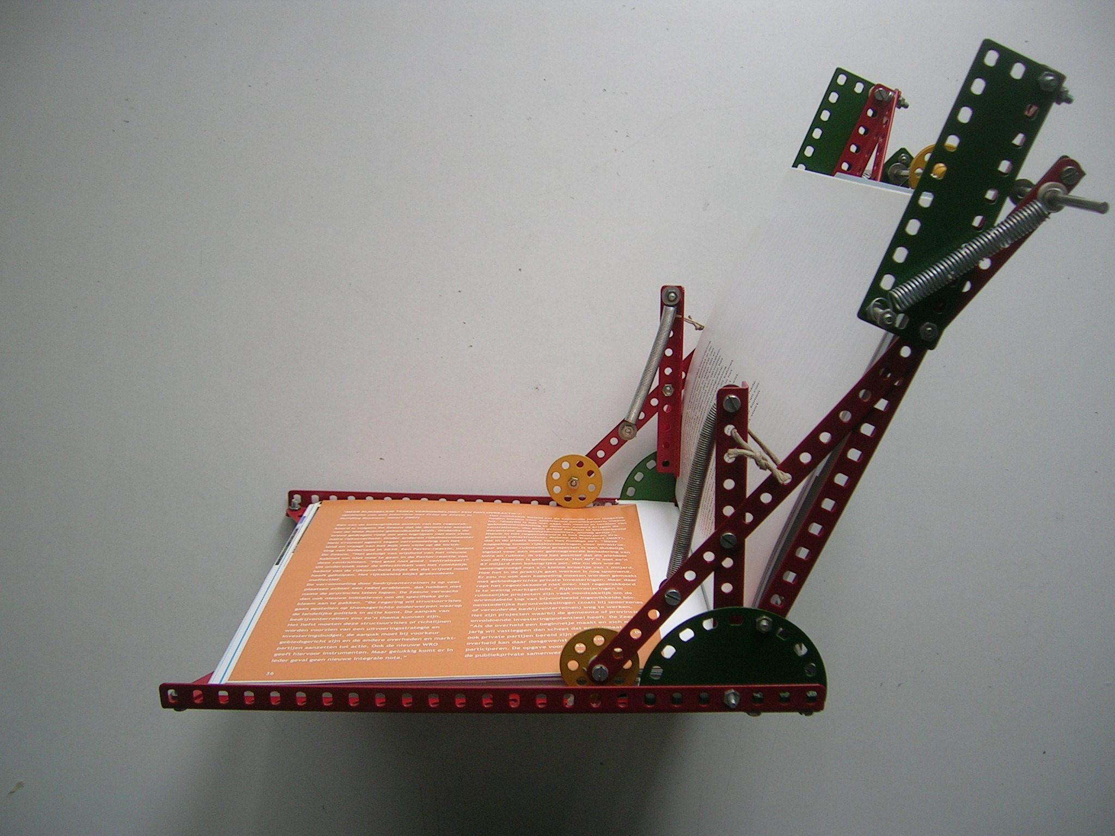
Fig. 5 Angle keeper open | Fig. 6 Angle keeper closed

It worked. I love my Angle keeper. It is small, but it is still adaptable to the size of the book. The thickness is no problem any more. Both pages are pushed back in one act by four springs at four points with no more force than strictly necessary. Two of these springs help opening and closing fast by a tumbler construction I learned from my father, a professor in Fine Mechanics. That is again another scale. So, I can learn from other scales. But I learned more.

Design directions raising problems at another scale
The main problem was very simple: keeping paper flat. But the different directions I chose raised their own problems. These problems were of another scale and character than the main problem. They were the consequence of the chosen concept, but they did not seem to have anything in common with he final goal to be reached. I could not foresee them, so I could not plan the successive design steps. It was a sequence of partial goals and means, keeping the final goal in mind. But that final goal had another scale and character, not helping much to solve the partial problems and to choose from different possible directions. It gradually became a self evident background of less importance, not the real work. Is ‘choosing directions’ not the same as setting goals, be it partial? Is it not part of design itself? Was the main goal not part of my way to design my future office at an even larger scale? The designers of Ahrends chairs said: “We design office-environments.” The architects say: “We design urban environments”. The search for a larger scale is the extension of design into rearranging the goals of that scale. So, what you call ‘goal’ or ‘means’ is scale-sensitive.

Fields of problems and designed goals
A goal has to be designed too; it is a design to be elaborated further. So, design cannot be ‘goal directed’, because ‘design directed design’ is a senseless expression. Engineering is design driven research to solve problems raised by design. Engineering may be a problem solving activity, design is more. Design creates improbable possibilities. So, it changes desirable futures, changing the ‘expected undesirable futures’: the field of problems. The larger the scale, the less these problems can be isolated. In Urban Design there is never one goal or one problem. Solving one isolated problem creates new problems. Moreover, reaching one aim creates new goals. So, there is always a field of problems and goals. There is a changing group of stakeholders and specialists with their own goals and means. They ask for a concept, a complex of means to be evaluated in this field. Wicked problems are not wicked: they are simply fields of related problems. Design does not only solve, it is a sequence of creating goals and means itself. But is means-directed. Paradoxically, stressing problems and goals is looking back. Design looks forward. Now I am in form, ready for debate.

Reflections on the speakers
The speakers nearly all stressed formulating the problem and the goal as a first step of design. So, I will make some remarks to their statement. They advise to plan the steps, to make solutions applicable in more cases, to generalize it and to make criteria for evaluation beforehand. That is the heritage of empirical science: isolate your problem; otherwise the project is shoreless. The hidden supposition is that design can be part of empirical science instead of the reverse. But the aim of design is not to generalize, its aim is to generate. Knowledge, based on generalizations is part of the design process, but its core is something else. Architectural and Urban Design are predominantly context-sensitive. A design is a case study. Most of the design work can not be generalized or foreseen. Design is something else than prediction. Innovation (stressing difference) is something else than production (stressing equality). The probability of production is something else than the possibility of innovation.

Dr.ir. H.H. Achten: Design process
Does describing the design process in an empirical sense add anything to the practice of design? It can help to organise design education. Perhaps it can help to make hidden suppositions explicit to skip them for innovative thoughts. Is a ‘wicked problem’ anything else than a field of related problems, difficult to be catched in verbal representation?

Prof.dr.ir. P.G. Badke-Schaub: Social complexity in collaboration
Is social complexity anything else than the interference of different levels of scale? The integration of a group compared to its integration in a larger context is proportional to the time budget they spend internally and externally. If management asks for many external contacts, the result is sprawl of effort increasing internal entropy. Internal integration causes external disintegration and the reverse at any level of scale.

Dr.ir. P.P.J. van Loon: Decision making
Is everything a decision? Look at my hands. They try to support what I say. Did I decide to move them upward and downward?

Prof.G. Goldschmidt: Visualization
Could sketching be supported by computer interaction? Such an instrument should be rapid, flexible, minimally rule bound, reversible, tolerant of incompleteness or inaccuracy, providing stimuli, supporting feed back. Sketching is another language than verbal or formal language. Literature seldom translates pictures properly and if so very incomplete. It is interesting to see that literature nowadays is translated into comics. Sketching is a way of thinking.

Prof.dr.ir. J.W.F. Wamelink: Project management
Isn’t it all a question of time? Isn’t the fundamental risk the probability not to survive? Formulating the problem takes time, precious time lost for innovation. Lack of time causes specialization. Specialization (separating tasks) save time, integration (combining tasks) saves space.

Dr.Ir. W.A. Poelman: Knowledge diffusion
Is intuition anything else than experience not transferable by words? What is knowledge?

Discussion
I asked the audience for risky questions or statements, because if they are not risky everybody will accept the statement or the predictiable answer beforehand. No new arguments will emerge.

So, Dineke Oudijk started citing three speakers:

“How to predict another persons intentions?”
Prof.dr.ir. P.G. Batke Schaub
“How do designers do what they do?”
Dr.ir. H.H. Achten
“Sketching helps and sustains thinking.”
Prof. G. Goldschmidt

Her statement was: ‘By applying neuro-linguistic programming (NLP), for example in the frame of ‘modelling’ the analysis of the design process of excellent designers will be better possible.’

Marjolein van der Mey questioned:
‘Considering Kant’s theory of humanity (one must not see humans as a set of means or functions that deliver a certain end result, otherwise humans could be fully replaced by for example computers making humans fully replace-able/redundant) is it ethically allowed to see decision making/taking as a ‘calculation’?

…

Anonymus asked:
- How knowledge of the design problem itself is reflected to designer (verbal or sketch or oherwise) and what is the process of understanding better?
- Mechanical design problems are not always structured and also sometimes not well defined!! How can we build a method for such a problem.

Another anonymus delivered a drawing:

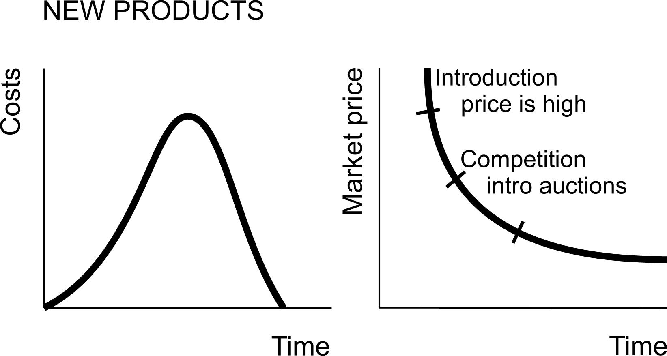
Ir. Annemiek van Boeijen (IO) commented on a question of the chairman:

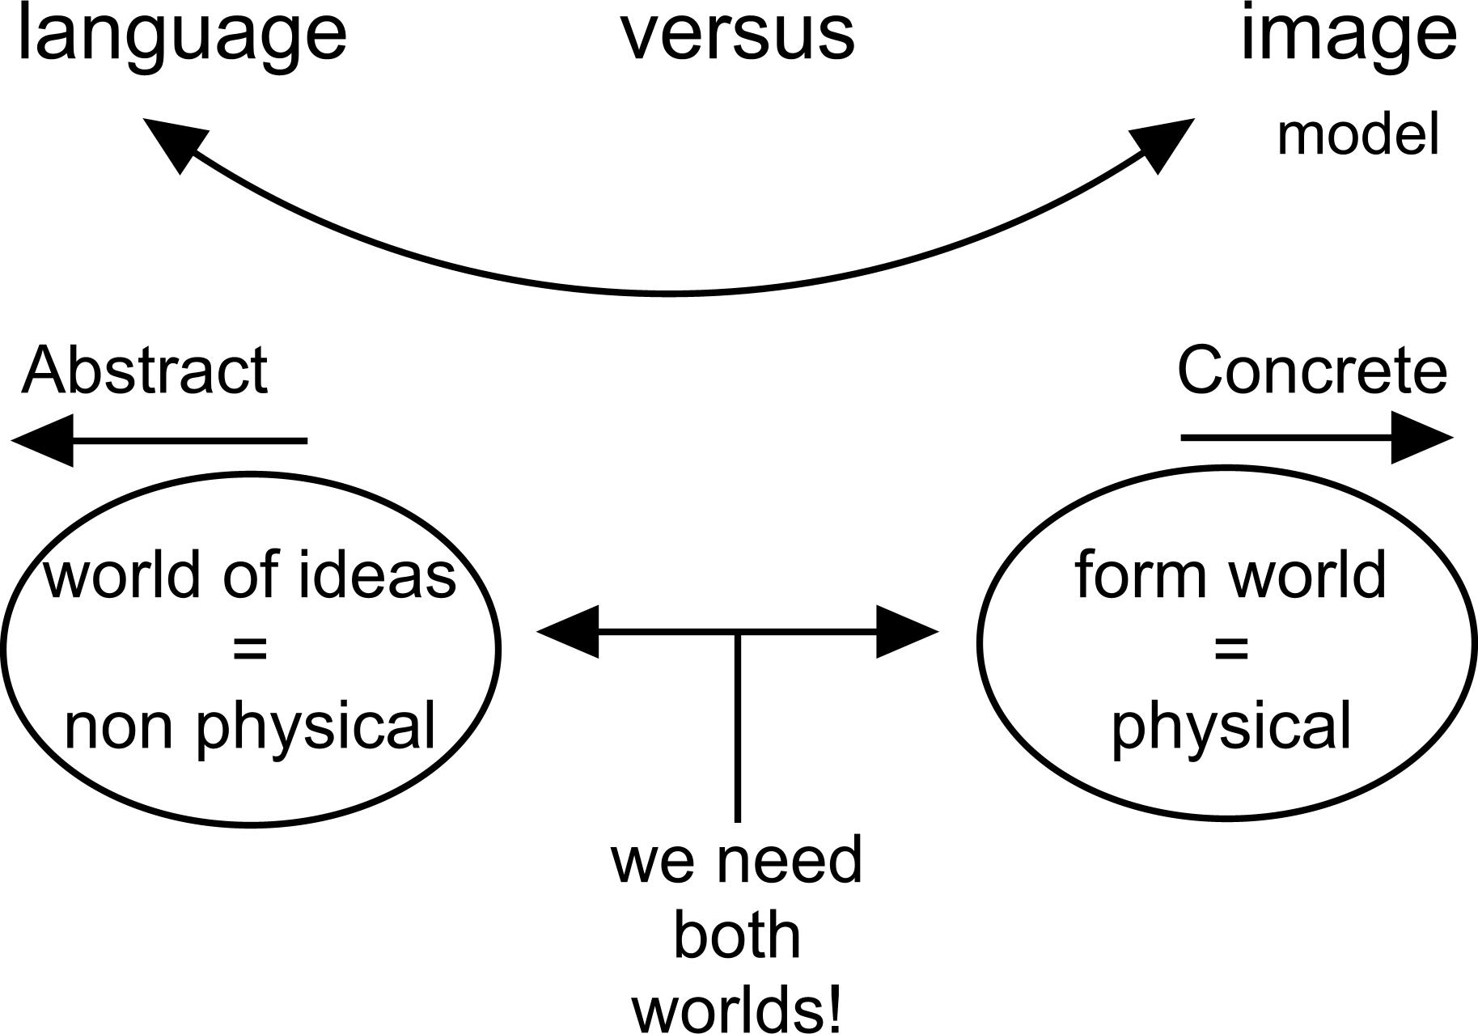

Images, pictures are (tend to be) more concrete, more ‘going to the real world’ and ‘exemplarily’ where as language cannot be that concrete; it is more abstract and useful for general (truths).

Gent, Barth van (1999) Zoetermeer, ontwikkeling van een nieuwe stad (Zoetermeer) Gemeente Zoetermeer
http://www.sceye.biz/index_de.php
http://www.diy.atiz.com/

