Dutch Connection
Taeke M. de Jong, 2008-01-23
Chairs Technical ecology and Metropolitan and Region Design
Faculty of Architecture, department of Urbanism
Fax: +31 (0)15 27 83694
T.M.deJong@tudelft.nl
Marsmanhove 2 2726CM Zoetermeer

Dutch Connection
National perspectives, local projects

Keywords: climate change, identity, national perspectives, concepts, local projects

Recently different land use scenarios until 2040 have been published by the Dutch environment and nature planning bureau MNP (see Fig. 1, Fig. 2, Fig. 3).

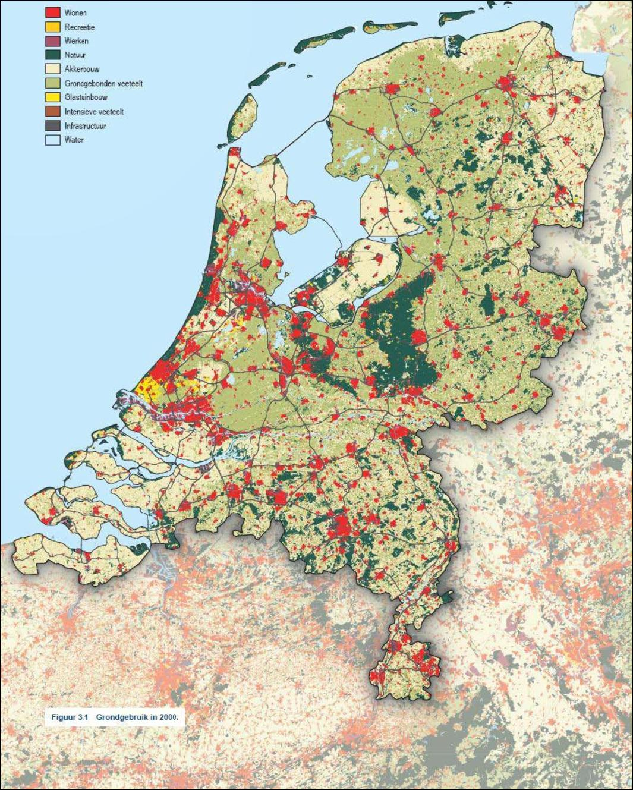 | 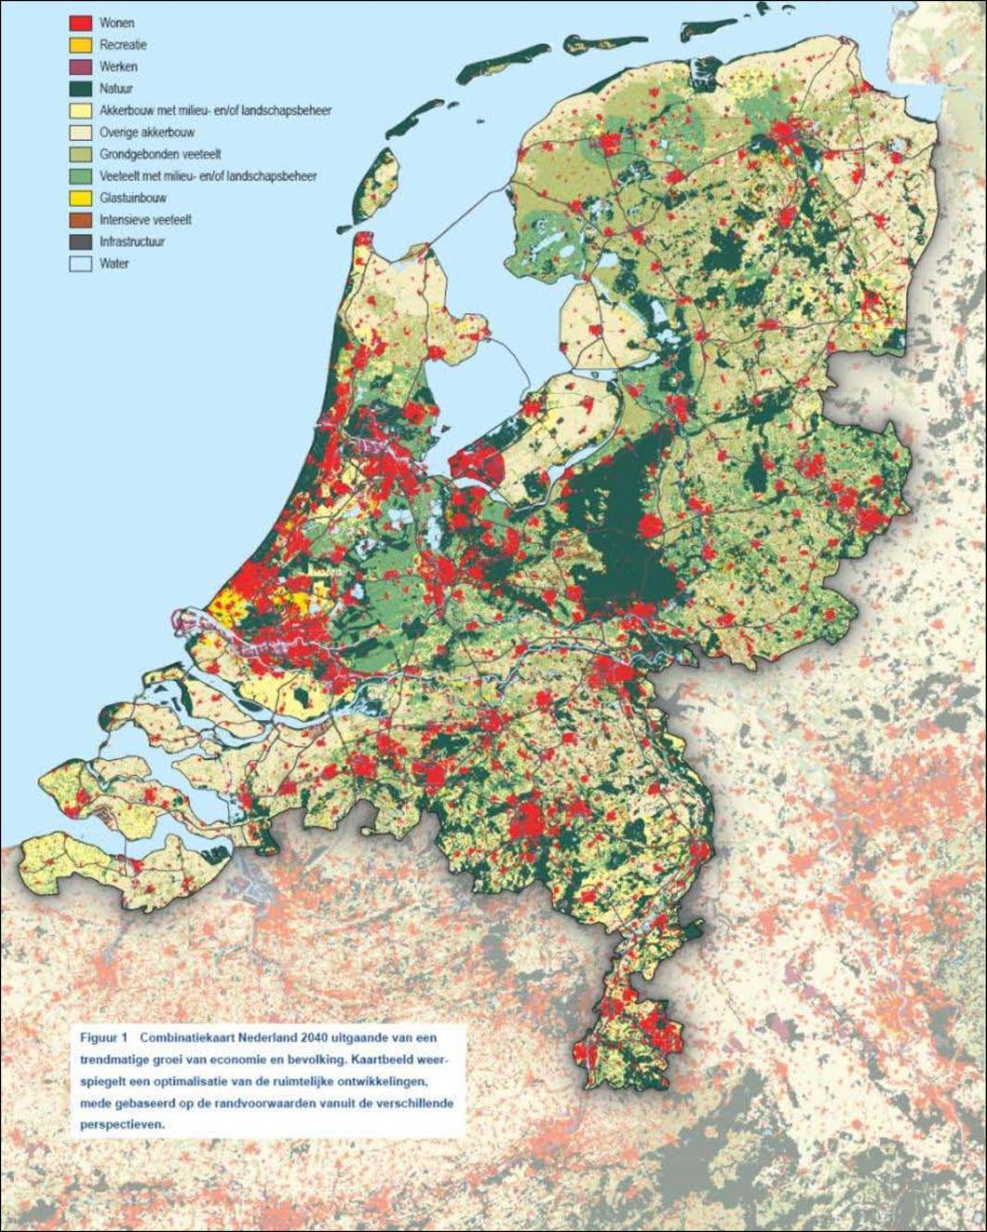 | 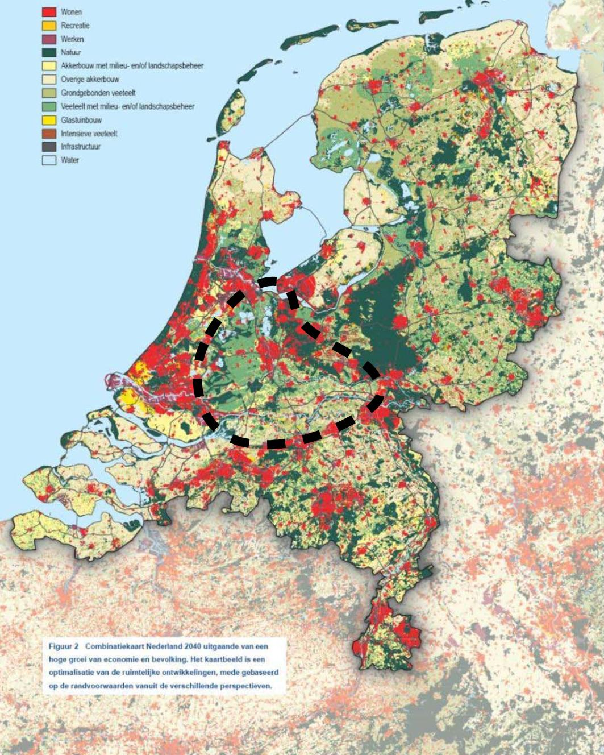
 |  | MNP (2007)
Fig. 1 2000 | Fig. 2 Trend 2040 | Fig. 3 Growth 2040
The MNP has concluded that a ring of cities 10 to 30km around Utrecht will emerge.
So, it suggests an enlarged Green Heart as added in Fig. 3 by the author as a dashed line.
That reminds to one of the CLTM scenarios made in 1994 (see Fig. 5 and Fig. 7) with a green heart including 5 essential Dutch landscapes: wetlands, polders, rivers, Eastern and Southern pleistocene.

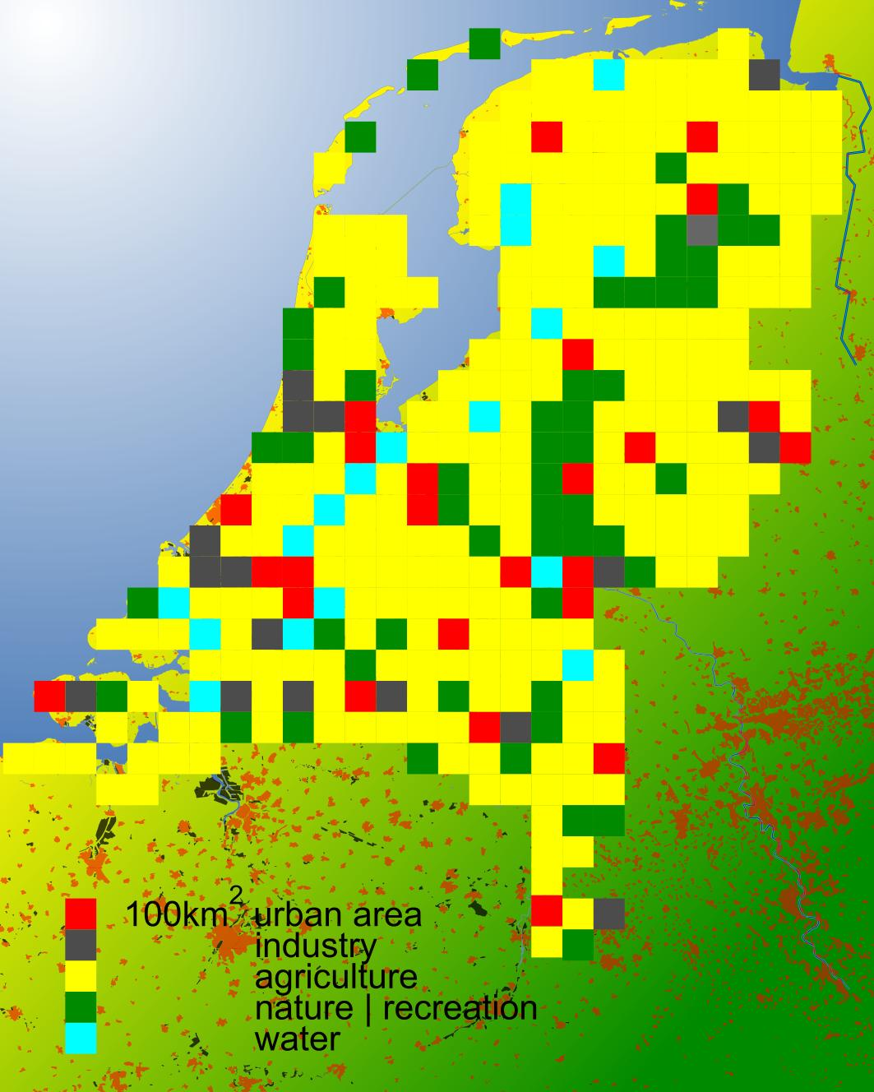 | 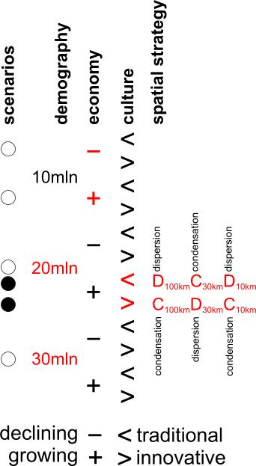 | 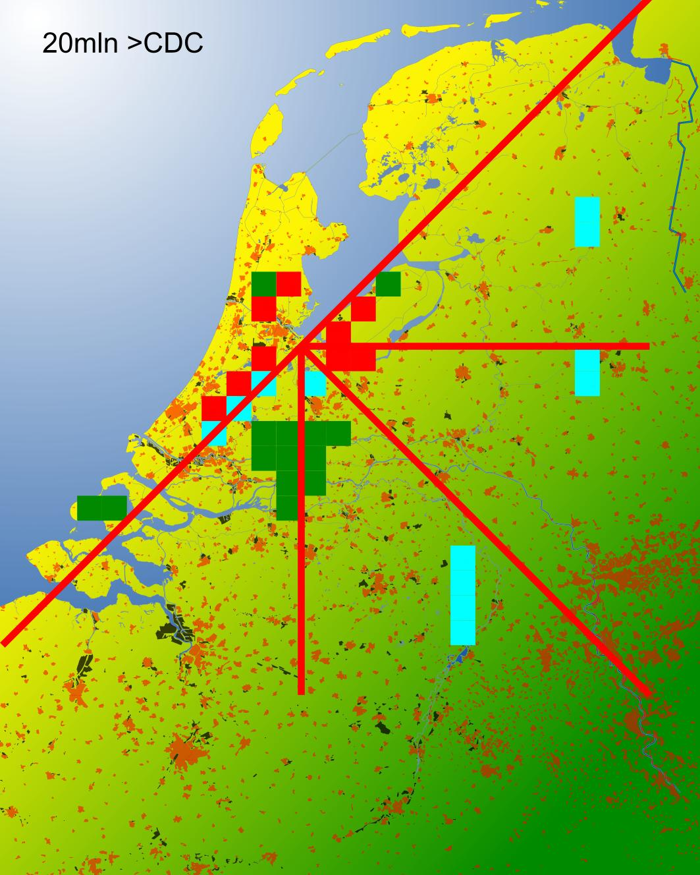 | 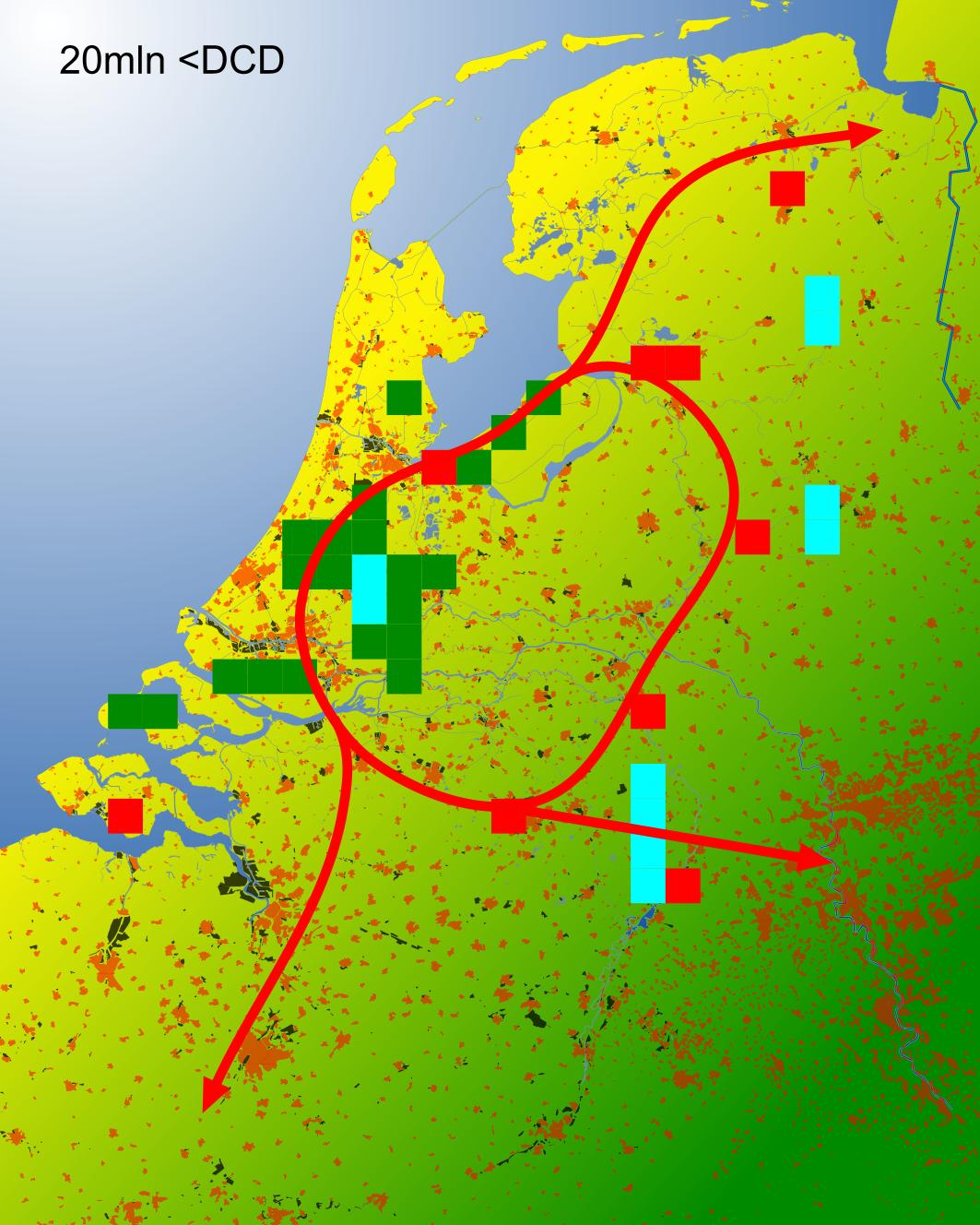
Fig. 4 Reference | Fig. 5 Scenarios | Fig. 6 CDC | Fig. 7 DCD
One extreme scenario (see the black spots in Fig. 5) concentrates nationally, disperses regionally and concentrates locally (CDC, see Fig. 6) and the other does the reverse. (DCD, seeFig. 7).
This article summarises some new insights such as the economic and physical impacts of climate change and the identity of the Dutch landscapes supporting a slightly changed DCD scenario.

This year 50 years ago the first Dutch national document on national planning was published.
It established the idea of a green heart metropolis determining the Dutch national planning for a long time. Commemorating that event Dirk Frieling raised the question if a national concept is still favourable in the current circumstances. Joost Schrijnen answers ‘yes’ as long as it is connected to large projects or common policy on their turn connected with substantial budgets. This article fixes attention on some existing and possible urban projects supporting a DCD scenario.

MNP (2007) Nederland later; Tweede Duurzaamheidsverkenning; deel Fysieke leefomgeving Nederland (Bilthoven) Uitgeverij RIVM
Jong, T.M. de ; Frieling, D.H. (1994) Indicative spatial picture: a Dutch perspective In: Policy, Dutch Committee for Long-Term Environmental [ed.] The Environment: Towards a Sustainable Future (Dordrecht/Boston/London) Kluwer academic publishers
Werkcommissie Westen des Lands (1958) De ontwikkeling van het westen des lands (Den Haag) Rijksdienst voor het Nationale Plan

