Entropy

The ‘quality’ of energy
The production of electricity is expressed in ‘kWh_{e}’ (‘e’ = electrical), the production of heat (Q) in ‘kWh_{th}’ (‘th’ = thermal). A kWh_{e} electricity is more expensive than a kWh_{th} of heat burning gas, petrol or coal, because a power station can convert only approximately 38% from the energy content of fossile fuels into electricity. The rest is necessarily produced as heat, mainly dumped in the environment ‘cooling’ the power station. That heat content could be used for space heating, but the transport and distribution of heat is often too expensive.

However, enterprises demanding both heat (Q) and work (W) at the same spot could gain a profit by generating both locally (cogeneration, in Dutch warmte-kracht-koppeling WKK). The ‘quality’ of both kinds of energy W and Q is apparently different. In the same way high temperature heat has a higher ‘quality’ than the same heat content on low temperature. If you would use the heat from burning fuels firstly for cooking, then for heating rooms demanding a high temperature and at last for heating rooms demaning a low temperature, the same heat content is used three times in a ‘cascade’. Using high quality energy where low quality would be enough leaves opportunities to use the same energy several times (exergy) unused.
The quality of energy can be expressed in a single quantity. That quantity is called ‘entropy’.

Necessary heat loss
The necessary heat loss is described by two main laws of thermodynamics: no energy gets lost by conversion (first law of thermodynamics), but it degrades (second law of thermodynamics). By any conversion only a part of the original energy can be utilised by acculumation at one spot of application. The rest is dispersed as heat content Q, to concentrate the minor useful part W (work) on the spot where the work has to be done. The efficiency of the conversion is W/(W+Q). In the case of electricity production it is 38kWh_{e}/100kWh or 38%.

But, once the work W is done, even that work is also transformed into heat. However, according to the first law of thermodynamics both energy contents are not lost, they are degraded, dispersed, less useful. From fossile fuels into heat, the ‘state’ of energy changes, but how to describe that ‘state’. To introduce that ‘state’ in energy calculations the term ‘entropy’ S is invented. It is often translated as ‘disorder’, but it is a special kind of disorder. What we often perceive as ‘order’, a regular dispersion in space, is ‘disorder’ in thermodynamics. Let us try to understand that kind of disorder.

‘Disorder’ in thermodynamics
In Fig. 1 all possible distributions of n = {1,2,3,4} particles in two rooms are represented.
If one marks every individual particle by A, B, C, D, one can count the combinations producing the same distribution k over the rooms numbered as k = {0,1 …n).
These two numbers n and k determine the probability P(n,k) this combination will occur.
Minimum and maximum values of k represent the extreme concentrations in one room or the other.

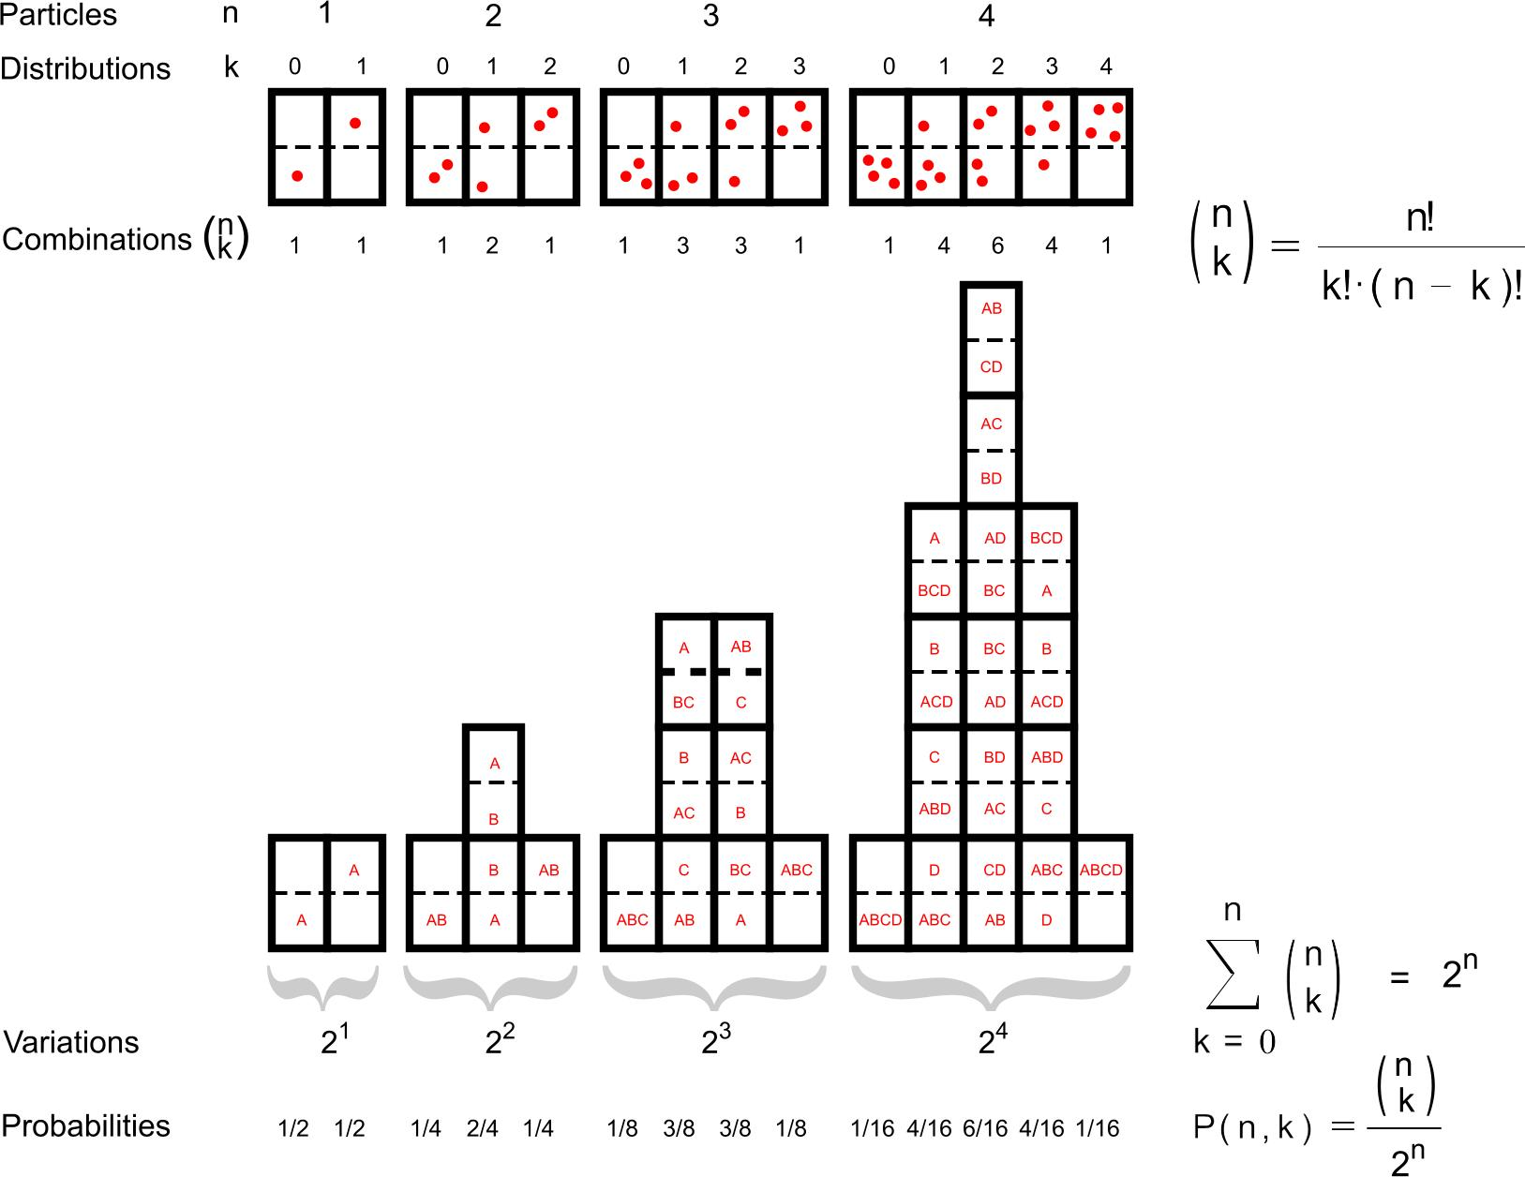
Fig. 1 k Distributions of n particles in two rooms
The more particles there are, the more combinations are possible and the more improbable will be the two extreme cases of accumulation in one room.
For example, if there are 10 particles, the probability of total sprawl is 252 possible combinations from 1024 (25%), but the probability of total accumulation in one room is 1 case from 1024 (0.1% see Fig. 2, left).
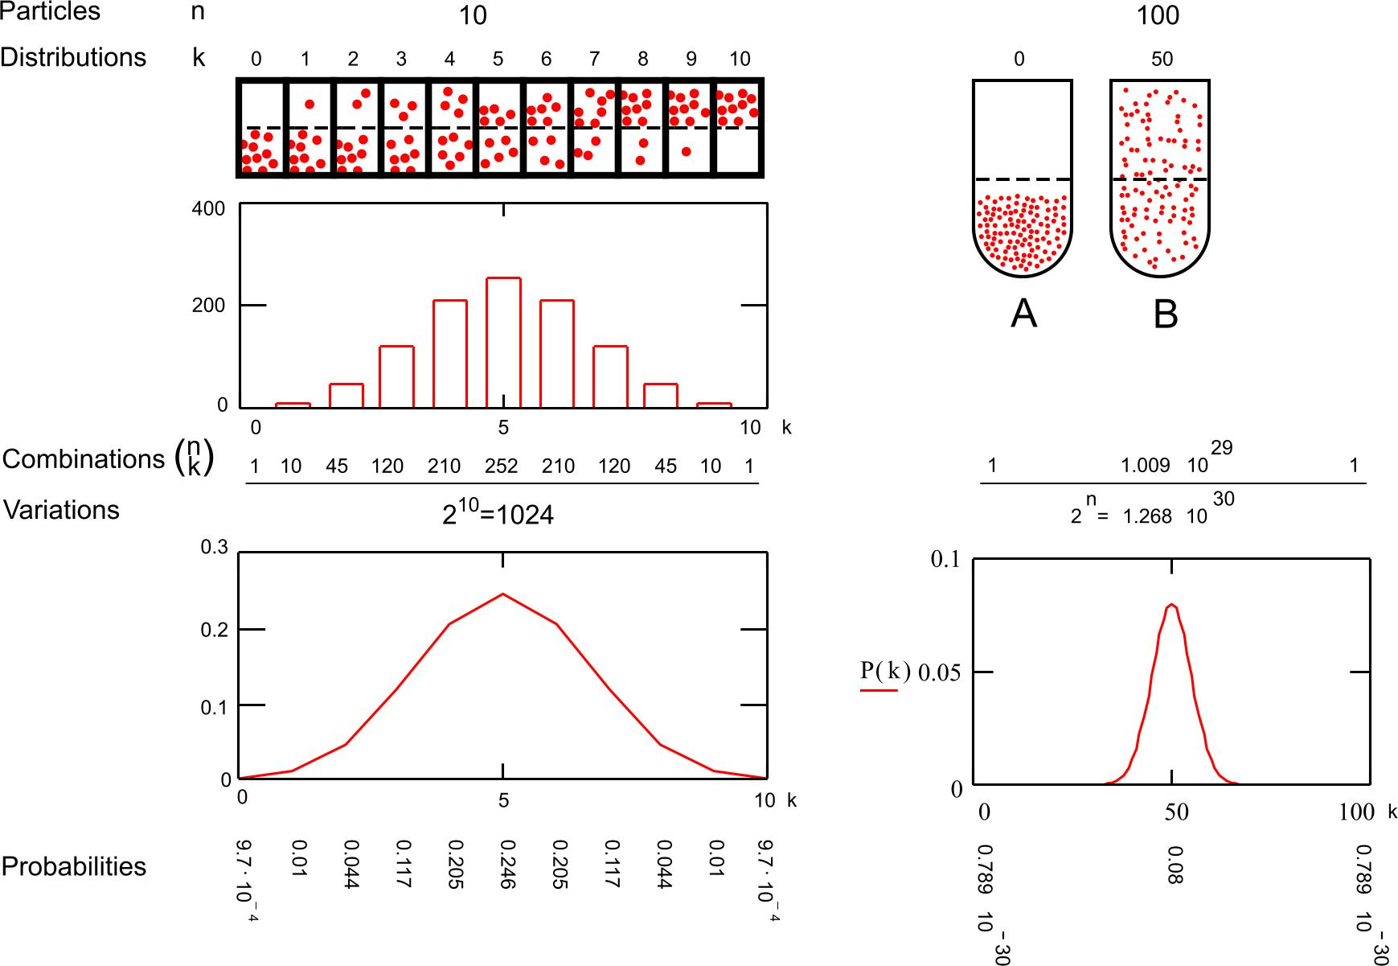
Fig. 2 The decreasing probability of concentration with a growing number of particles
Fig. 2 (A) shows the least probable distribution of 100 particles in a cylinder, but state B is very probable. These probabilities can be calculated as approximately 1/13·10²⁹ (A) and 1/13 (B).
So, if anything changes it will most probably change from A into B instead of from B into A.
That asymmetry of process is the core of thermodynamics.

From Fig. 2 you also can learn that by an increasing number of particles most combinations accumulate around the middle of k=0.5n. If you would calculate the possible combinations of 1000 particles the probability of sprawl (B) between k=495 and 505 (1% of n) would be practically 1 (100%). The graph would show a vertical line rather than a gaussian ‘bell’.

Difference of entropy
Suppose now the content of the cylinder is a mole of gas (that is approximately 6·10²³ particles, Avogadro’s number n). Then the probability of state B approximates 1 (100%). The probability of state A is again 1/2^{n}. That is nearly zero, because the number 2^{n} is extraordinary large: a 1 with more than 10²³ zeros. An ordinary computer can not calculate all combinations of that number as done in Fig. 1. However, to determine the entropy of state A we need the natural logarithm (the exponent to ‘e’ or 2.718) of that probability: ln1/2^{n} or ln(2^{-n}). And ln(2^{-n}) is easily written as -n·ln(2). That will save a lot of calculation, because n will disappear in the definition of entropy by Boltzmann:

Fig. 3 The statistical definition of entropy

In state A and B with n = 6·10²³ particles, the number of moles is 1; n is Avogadro’s number. R is a constant (gas constant) we will explain later. So, entropy is related to probability by a constant. However, Boltzmann chose the logarithm of probability, because if you want to know the entropy of two sub systems (for example two moles), you would have to multiply the combinations of each sub system. If you take the logarithm first, than you can simply add both.

In this case we can write the increase of entropy from stage A into B as S_{B}-S_{A}:

Fig. 4 The increase of entropy from accumulation in one room into sprawl in two rooms

The probability of state B is very near 1, and the logarithm of 1 is zero, so we can write:

Fig. 5 Simplifying the formula of Fig. 4

So, the entropy of stage B is R·ln(2). The natural logarithm of 2 is 0.693, but what is R?
R is the gas constant:

Fig. 6 Defining the gas constant R

In Fig. 6 P is the pressure (force/m²) and V is the volume (m³). So, on balance P·V is ‘force times distance’: energy (expressed in newton·m: joule). T is the temperature in degrees of Kelvin (K).

In a mole of gas the proportion between that energy and temperature in normal conditions appears to be the same: 8.31472 joule/K. That constant is named ‘gas constant’ R. So, that is also valid for both stage A and B. Now we could calculate the increase of entropy as R.ln(2) = 5.8 joule/K·mole.
However, in thermodynamics the ‘probability’ of a state contains more than the distribution over two rooms. For example the reduced freedom of movements of particles in liquids and solids. That is why we limit ourselves here to complete freedom of movement (gas) to describe the states A and B. Moreover gas plays a dominant role in energy conversion any engineer is occupied with.

Change of entropy
If a mole of gas expands from A to B, the heat content Q disperses over a doubled volume. So, the temperature tends to drop and the system immediately starts to adapt to the temperature of the environment. That causes an influx of extra heat energy ΔQ. So, in a slow process T could be considered as constant and the pressure will halve to keep also P·V constant at R·T (see Fig. 7).

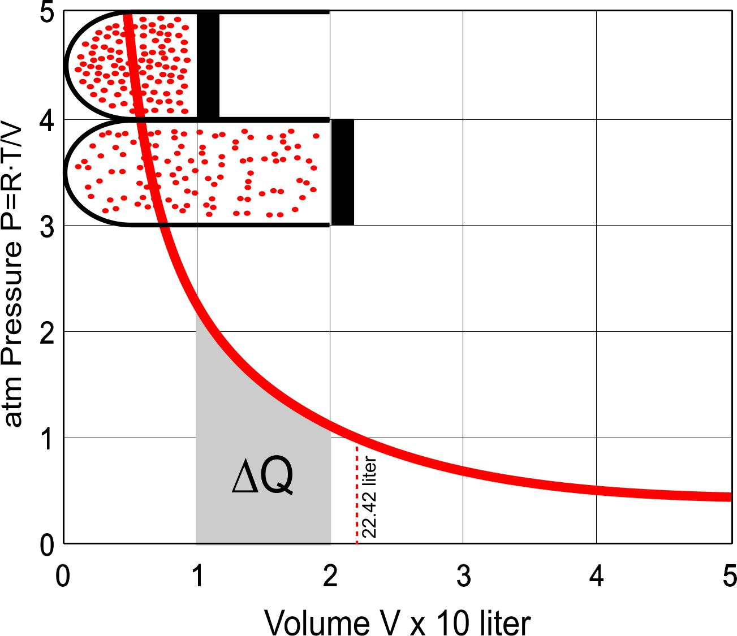 | P·V = R·T (see Fig. 6), so P = R·T/V (see the graph left).  If at any moment Q := P·V, any small change dQ equals P·dV and a larger change ΔQ from stage 1 into 2 is the sum of these small changes:  so, . Remember now Fig. 5:  if , then also . So,
Fig. 7 Extending 1 mole of gas (22.42 liter at 1 atmosphere) from 10 to 20 liter keeping T at 0ºC or 273.26K.
The heat energy Q is equal to P·V, but if it increases P itself is dependent on V.
So, every infinitely little increase of V (dV) has to be multiplied by a smaller P. Summing these products P·dV between V = 1 and V = 2 is symbolised by the first ‘definite integral’ sign in Fig. 7. However, that formula can not be solved if we do not substitute P by R·T/V (see Fig. 6) in the next formula. In that case the mathematicians found out that definite integral is equal to R·T·ln(2).
Now we have a real number for ΔQ, because R·T·ln(2) = 1574 joule.

So, ΔQ/T = R·ln(2), and R·ln(2) reminds us of Fig. 5: it is ΔS, the change of entropy!
A few steps according to Fig. 4 takes us back to the statistical definition of Boltzmann in Fig. 3, but now it is related to heat content Q and temperature T, the variables used in any engineering.
If ΔS = ΔQ/T, then also dS = dQ/T and now we can write the famous integral of Clausius:

Fig. 8 The thermodynamic definition of entropy

This formula shows that an increasing heat content increases entropy, but a higher temperature decreases it. If we now keep the heat content the same (closed system) and increase volume, then accumulation, pressure and temperature decrease (Boyle-Gay Lussac, see Fig. 6), so entropy will increase.
So, accumulation (storage, difference between filled and empty) decreases entropy, increases order.

Design and the conception of order, specialists conceptions
The explanantion of entropy above is extended, because of two reasons.

Firstly, while defending a concept of order, arrangement in design, designers often refer to low entropy and that is not always correct. Perceptual order could refer to a regular dispersion of objects in space and just that means sprawl, entropy. In thermodynamics an irregular dispersion with local accumulations has a lower entropy (disorder) than complete sprawl. However, in fluids and solids rectangular or hexagonal patterns with low entropy appear, due to molecular forces. But in general, if the particles have freedom of movement, sprawl is much more probable than accumulation.
It reminds us of the avoidance of urban sprawl. Thermodynamically accumulation is possible, but very improbable. So, if thermodynamics has any lessons for designers: sprawl is not the task of design, if there is freedom of movement, than it very probably happens without intention.

Secondly, energy and entropy are basic concepts in any engineering. To understand specialists in their reasoning and to be able to criticise them demands some insight by designers. The impact of the industrial revolution, the accumulation of population in cities can not be understood without understanding the manipulation of sprawl on another level of scale as has happened in the development of the internal-combustion engine. The internal-combustion engine is extensively used in industry and traffic. So, I would like to proceed with some explanation of that engine, the main application of sunlight stored in fossile fuels in human society.

Forced concentration
The (change of) force by which a piston is pushed out of a cylinder is equal to the proportion of (change of) energy and entropy Fig. 9.

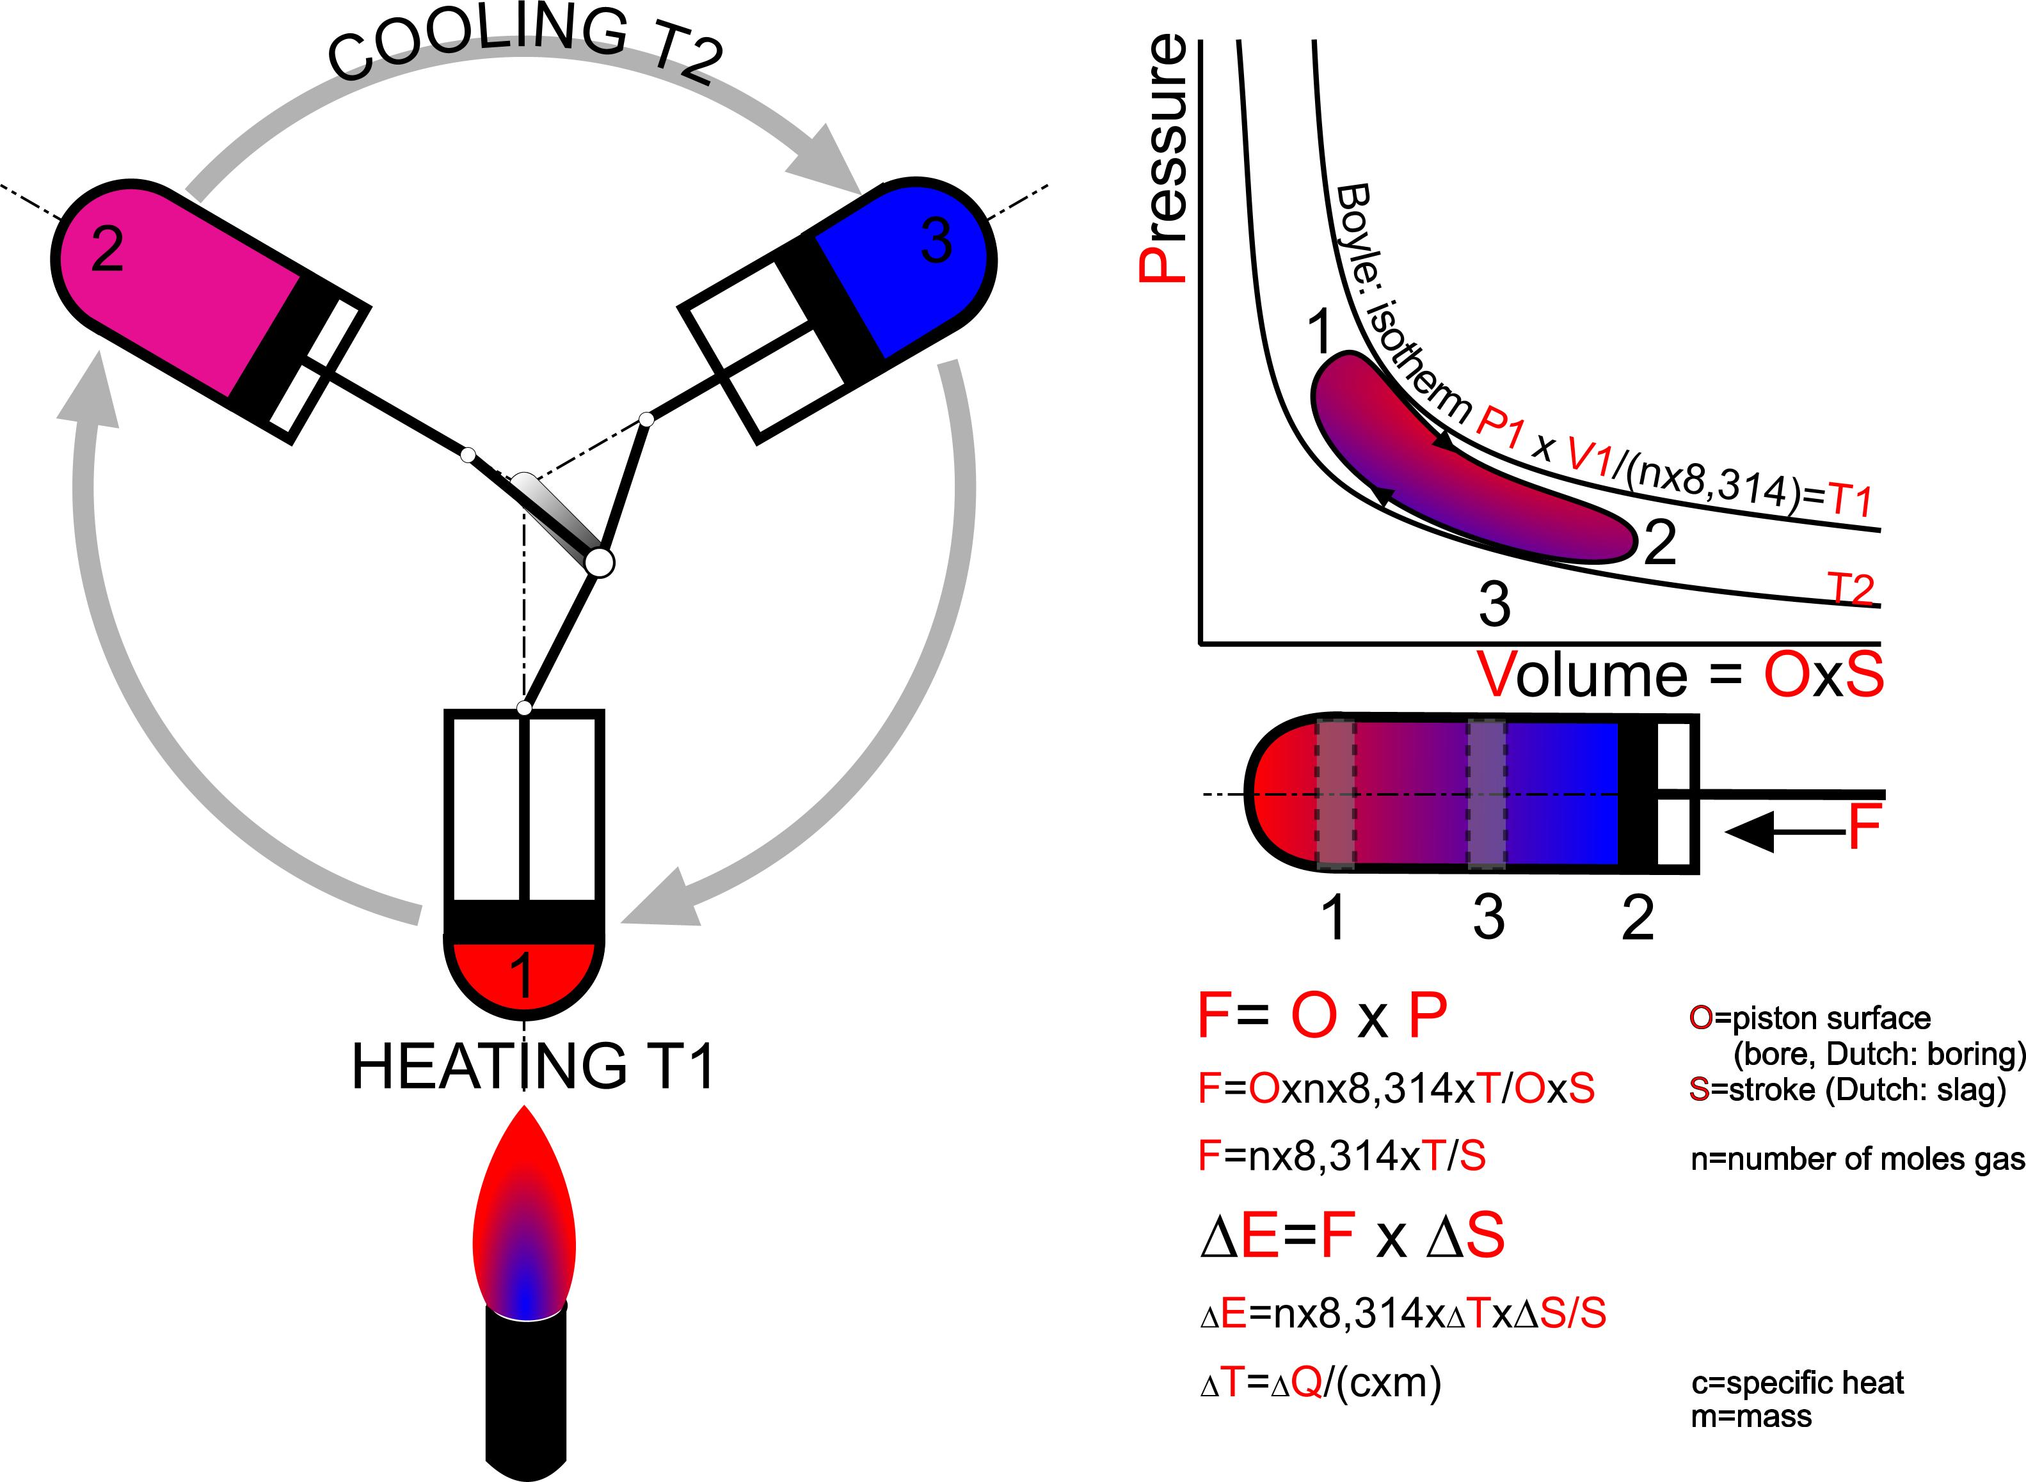
Fig. 9 Carnot-engine
In a cylinder engine, alternating states of dispersion are used to convert imported disordered energy (heat) partly into directed movement. It is only possible by exporting part of the heat in an even more dispersed form (cooling). The necessary event of cooling makes an efficiency of 100% impossible and increases entropy in a larger environmental system. The reverse, adding rotating energy to this engine the principle that can be used for heating (heat pump) and cooling (refrigerator). boring

Here is a tacid supposition, that the particles have an equal probability of entering and leaving a room without an selection at the doors between them like Maxwells Demon (remark of Van Bilsen).
R/n, the gas constant divided by Avogadro’s number is mainly written as Boltzmann’s constant k.
Remark by Van Bilsen.
the Boyle-Gay-Lussac law.
A little math: = ; = ; =

