Scale articulation
Prof.dr.ir. Taeke M. de Jong 2008-11-16

CONTENTS

1 Introduction 2
2 Levels of scale 2
3 Scale sensitive physical and social layers 4
Sources 7

Introduction
Shortly after the publication of an urbanist in Science (Doxiadis,1968) I started my study of architecture and urban design at the University of Technology in Delft, the Netherlands. I chose that study of the largest human artifacts in contrast to the profession of my father, a nuclear physicist. His inaugural speech as a professor in fine mechanics at that University (Jong, 1961) emphasised the importance of scale articulation in choosing categories, variables and parameters to describe the phenomena used to design the smallest human artifacts of the time. He could use diamonds and gold, I had to apply concrete and wood. So, scale articulation became my first fascination in studying architecture and urbanism. I started to collect maps of urban areas at different levels of scale to study the gradual change of the legend (the ‘vocabulary of the drawing’), the ‘material’ describing a building component, a building, a complex of buildings, a neighbourhood, a district, a town, a conurbation or a region and its dispersion in the drawing. So, I appreciated Doxiadis’ distinction in levels of scale, but his intervals varied. His publication feeded hope to transform urbanism into a real science. However, design is more than empirical science as I learned soon. It does not study reality, truth or probability alone (‘empirical research’), it studies possibility of which probability is only a subset. This article attempts to demonstrate how useful it may be to distinguish levels of scale with intervals of a factor 3 distinguishing different disciplines in urbanism or ‘regional physics’.

Levels of scale

Inner and outer boundary of concern
The order of size determines the applicable design and management means. The reach of scale of an object of study has an upper and a lower limit, here called frame and grain or granule (see Fig. 1), best indicated by their approximate radiuses R and r. The proportion r/R determines the resolution of the study, the extent to which the study goes into detail compared to its largest measure drawn (for example r/R = 10% indicates a rough sketch, 1% a drawing, 0.1% a blue print). It also indicates the tolerance, the intended precision of location. For example: a line drawn in a sketch of r = 1m may be interpreted within a range of 1m around the depicted line.

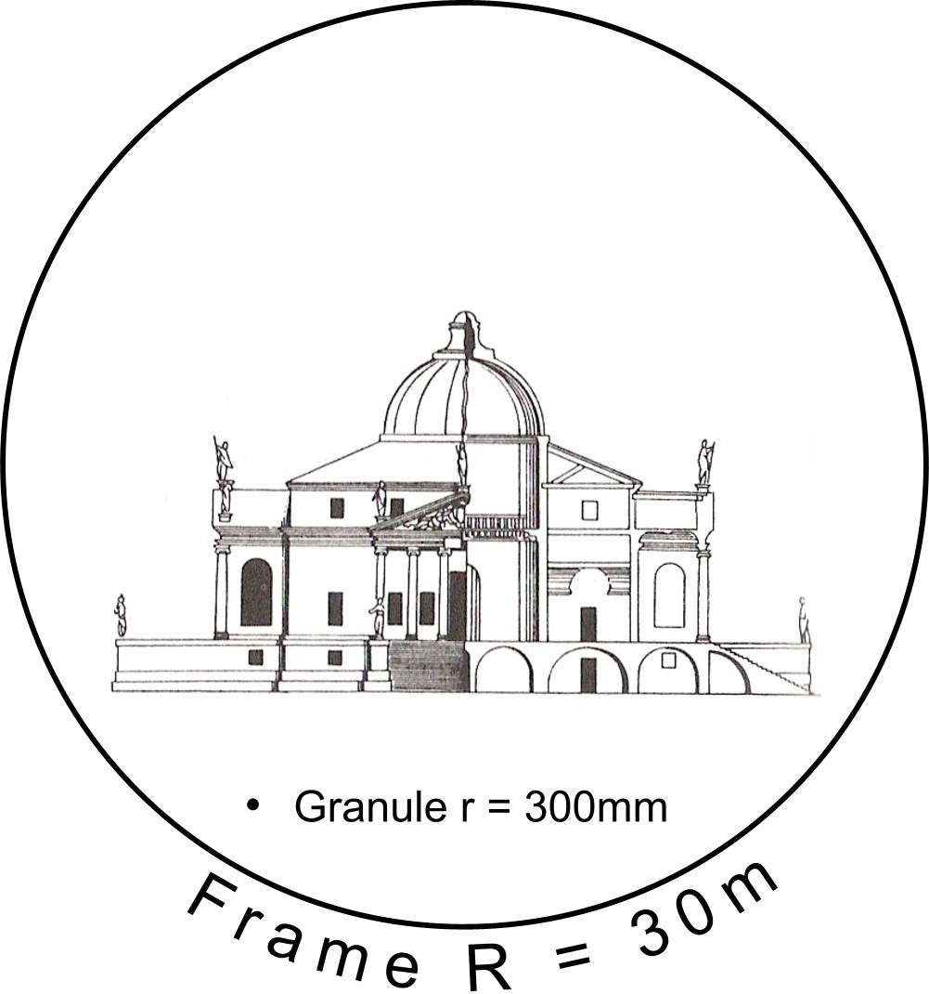 | 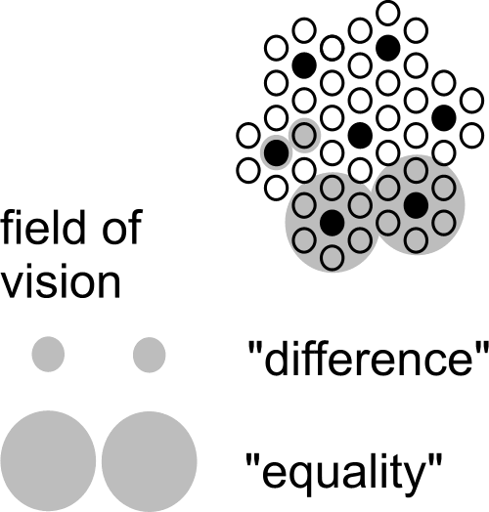
Fig. 1 A frame 100x grain of a drawing representing a building | Fig. 2 Scale paradox

Scale paradox
The reach of scale is so important, because conclusions on a specific level of scale could be opposite to conclusions drawn on another level of scale (scale-paradox, see Fig. 2). The scale paradox means a scientific ban on applying conclusions drawn on one level of scale to another without any concern (scale forgery). However, that does not yet mean conclusions at one level of scale could never be extrapolated into other levels. Fig. 2 only shows the possibility of changing conclusions by a change of scale. It demonstrates the possibility of a reversal of conclusions already by a factor 3 larger radius. And, there are 10 decimals between the Earth and a grain of sand. That gives approximately 22 possibilities of confusing conclusions. If a scale paradox can be demonstrated for concepts of difference and equality as such, it may apply to any distinction of spatial categories or classes.

Domains with different categories, types and legends
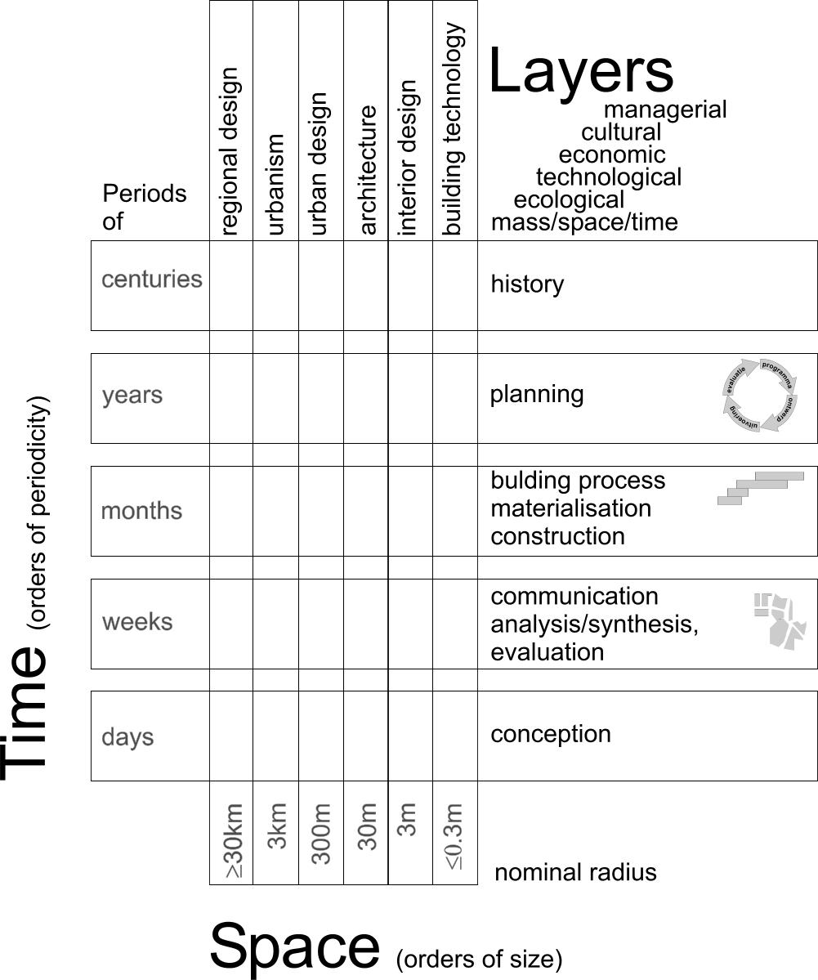 | On every level of scale you need other distinctions of categories and subsequently different typical combinations of their classes: the types and legends to be studied or designed.  You can recognise that necessity in the common disciplines urbanism, architecture and building technology (see Fig. 3). The types and legends of architectural disciplines are different from those of urbanism or building technology.  Less mainly recognised are the different time scales you can distinguish on every spatial level of scale. Architectural history is something else than urban or technological history. And, history is something else than planning, building process, communicaton process or the process of conception. This is where building management comes in as a separate discipline. So, the same kind of argumentation on spatial articulation of scale could be developed for temporal distinctions. What seems true or right in terms of weeks may be false or wrong in terms of months.  Moreover, these distinctions do have different physical and social ‘layers’ to be discused in section 3.
Fig. 3 The domain of Urban and Architectural design

Many spatial orders of size possibly causing confusion
In Fig. 2 confusion of spatial scale is already possible by a linear factor 3 difference in level of scale (approximately 10 in surface). That is why for spatial design and management I articulate orders of size by a linear factor of approximately 3. So, to avoid any confusion, I need to distinguish at least 22 levels of scale to define what is object and context, beginning with the global context and preliminary ending with that of the physical chemistry of materials (see Fig. 4). Most of these levels are not relevant for a study at hand, but they are there, most of them buried in hidden (ceteris paribus) suppositions.

Global(10000km) | Continental(3000km) | Subcontinental(1000km) | National(300km) | Sub national(100km) | Regional(30km) | Sub regional(10km) | Town(3km) | District(1km) | Neighbourhood(300m) | Ensemble(100m) | Building complex(30m) | Building(10m) | Building segment(3m) | Building part(1m) | Building component(300mm) | Super element(100mm) | Element(30mm) | Sub element(10mm) | Super material(3mm) | Material(1mm) | Sub material(<1mm)
Fig. 4 Levels of scale (expressed in R) to be aware of in any spatially relevant study

Nominal values of a radius R to name levels of scale
Levels of spatial scale are often named by the ratio of a drawing to reality such as ‘1:100’. However, it depends on the size of the paper what kind of object you have in mind. On an A4 paper 1:100 you can draw an object of approximately 10m radius (30m² surface); on an A2 paper it could show an object of 30m radius (300m² surface). That is why I prefer to name the order of size by its approximate radius R in supposed reality chosen from the set {… 1, 3, 10, 30, 100m …}. An ‘elastic’ element from that nearly logarithmic series is used as the name (nominal value) of the order of size of an urban, architectural or technical category ranging between its neighbours. To be more precise: the ‘nominal’ radius R=10 is the median of a probability density distribution of the logarithm of radiuses between (rounded off) R=3 and R=30, with a standard deviation of 0.15.
I chose a series of radiuses rather than diameters because an area with a radius of {0.3, 1, 3, 10km} fits well with {neighbourhood, district, quarter, and conurbation} or loose {hamlet, village, town, and sub-region} in everyday parlance. They fit also very well to a hierarchy of dry or wet connections according to their average mesh widths (de Jong, 2006). Moreover, a radius immediately refers to the most indifferent directionless form of circles or globes indicating both surfaces and volumes by one linear value.

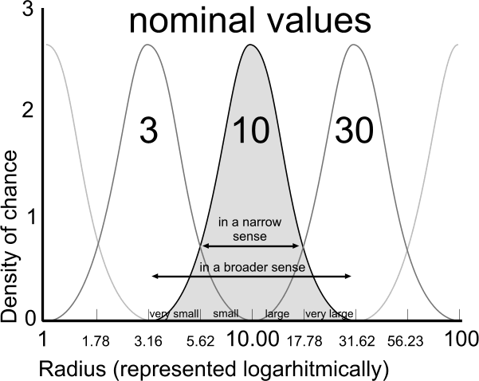 | 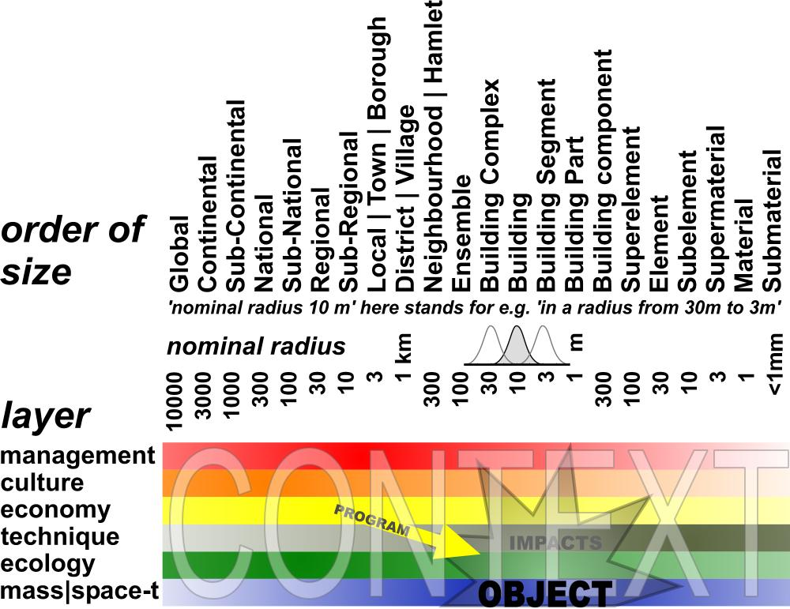
Fig. 5 Boundaries of urban categories | Fig. 6 Locating an undetermined spatial object of design study within its context

Impacts on different levels of scale
Any object of study will have impacts on different levels of scale, hitting interests of stakeholders operating at that level (for example from government administrators to manufacturers of building materials). If the object of study is still variable (such as a possible object of design study compared to a probable object of empirical research), an analysis of context should be the first step. Context analysis could start by locating these supposed impacts on the level of scale they apply, as far as they could be relevant to the study at hand, not overlooking any level (see Fig. 6). You can ‘locate’ them before you specify them. The scheme does not specify these impacts. It solely shows their order of size and layer (‘location’). It is even possible to consider these context factors before you choose a specific object of study at a specific location. So, the scheme can help outlining your object of study from outside. If you expect desirable impacts determining a programme of requirements, perhaps you can find stakeholders at that level and layer wanting to pay for your study. If there are negative impacts, you should not exclude people responsible on that level to minimise or compensate such effects by your study.

Scale sensitive physical and social layers

The basic layer of mass|space-time
At a purely physical level of mass and space in time, accumulation or concentration (C) of masses versus sprawl or deconcentration (D) is an essential design factor. What is called ‘mass’ should be specified (for example built-up area), but concentration and deconcentration (changing state of dispersion) of any legend unit in a drawing are characteristics of form and composition at any level of scale. They can differ per level of scale (see Fig. 7 and Fig. 8). An existing or expected scale sequence like D_{10m}C_{30m}D_{100m}C_{300m} or its reverse C_{10m}D_{30m}C_{100m}D_{300m} names different global characteristics of form. I will firstly elaborate the ‘state of dispersion’ more in detail, because it is relevant for other layers as well.

States of dispersion
Form as a primary object of design supposes a state of dispersion of an arbitrary legend unit, for example ‘built-up area’.

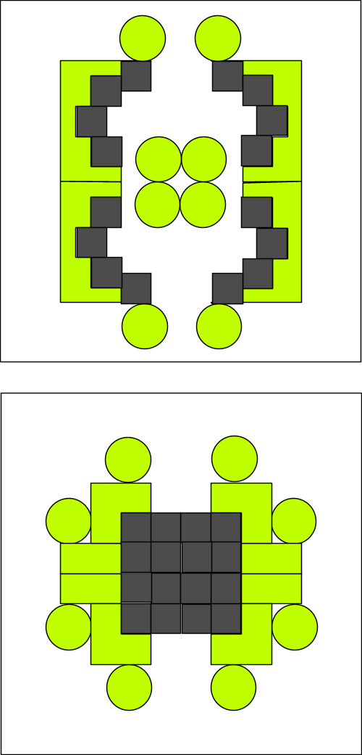 | 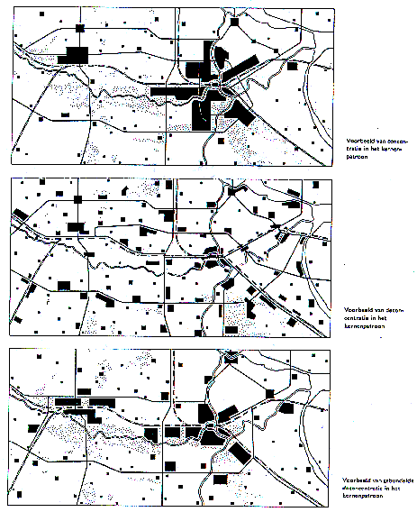
 | RPD (1966)
Fig. 7 Opposite states of dispersion within a frame R = 100m | Fig. 8 Accumulation (C), Sprawl (D), ‘Bundled Deconcentration’ (DC) within a frame R = 30km
Scale articulation is important distinguishing states of dispersion. That is not the same as density. Considering the same density different states of dispersion are possible (Fig. 9 ) and that is the case on every level of scale again (Fig. 10 ).

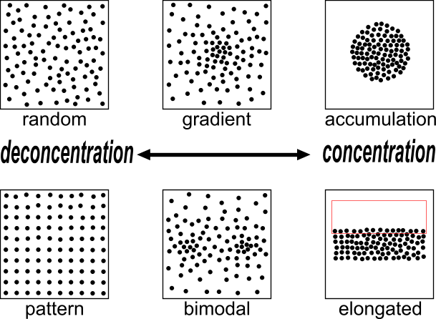 | 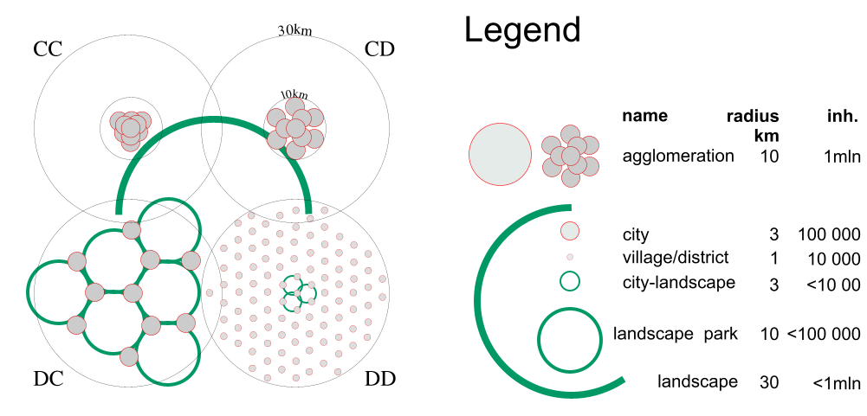
Fig. 9 States of dispersion in the same density on one level of scale | Fig. 10 One million people in two states of distribution on two levels of scale (accords CC, CD, DC and DD).
Fig. 9 shows the use of the words concentration (C) and deconcentration (D) for processes into states of more or less accumulation respectively.
Applied on design strategies in different levels of scale I would speak about ‘accords’ (Fig. 10 ).

In Fig. 10 the regional density is equal in all cases: approx. 300inh./km².
However, in case CC the built-up area is concentrated on both levels (C_{30km}C_{10km}) in a high conurbation density: (approx. 6000inh./km²).
In the case CD people are deconcentrated only within a radius of 10km (C_{30km}D_{10km}) into an average conurbation density of approx. 3000 inh./km².
In the case D_{30km}C_{10km} the inhabitants are concentrated in towns (concentrations of 3km radius within a radius of 10km), but deconcentrated over the region. In the Netherlands since 1966 this was called ‘Bundled deconcentration’ (RPD, 1966). The urban density remains approx. 3000 inh./km².
In the case D_{30km}D_{10km} they are dispersed on both levels.

Ecology at different levels of scale
According to some internationally authoritative text books (Andrewartha, 1961; Krebs, 1994; Begon, Harper et al., 1996) ecology is at least the science of distribution and abundance of organisms.
From the PHD thesis of Mechtild de Jong (2002) I conclude there are six kinds of ecology in the Netherlands in the previous century competing for governmental assignments (see Fig. 11).

 | abiotic | biotic | Dutch university
environmental study | environment | society
autecology | habitat | population | Wageningen
synecology | biotope | biocoenosis | Nijmegen/Wageningen
cybernetic ecology | abiotic variety | biotic variety | Delft
system dynamics ecology | ecotope | ecological group | Leiden
chaos ecology | opportunities | survival strategies
Fig. 11 Kinds of ecology in decreasing anthropocentrism
In the present-day Dutch target species policy, supported by the European Birds and Habitat Directive, synecology now is most successful. However, climate change changes its description of biotopes, biocoenoses, their distribution and abundance. Cybernetic ecology focuses on steering mechanisms (separations and connections, structure), their distribution and abundance, suitable for creating or restoring living conditions (technical ecology). However, all ecologies from Fig. 11 are scientifically meaningful if arranged to the scale of their most appropriate application (see Fig. 12).

nominal | abiotic | biotic | discipline
kilometres radius
10000 | earth | biomen | environmental ecology
1000 | continent | areas of vegetation
100 | geomorfological unit | plant-geographical or flora-districts | landscape ecology
10 | landscape | formations
metres
1000 | hydrological unit, biotope | communities | synecology
100 | soil complex, ecotope | ecological groups | systems ecology
10 | soil unit and transition | symbiosis | cybernetic ecology
millimetres
1000 | soil structure and ~profile | individual survival strategies | chaos ecology
100 | coarse gravel | specialisation | biology
10 | gravel | integration
1 | coarse sand 0,21-2 | differentiation
micrometres (μ)
100 | fine sand 50-210 | multi-celled organisms | micro biology
10 | silt 2-50 | single-celled organisms
1 | clay parts < 2 | bacteria
0,1 | molecule | virus
Fig. 12 Ecologies arranged to their primarily supposed range of scale (Jong, 2002)
So, microbiology applies on levels of scale and size measurable in micrometers. Chaos ecology stressing individual opportunities and survival strategies or biology stressing cooperation and competition of specialised functions (organisms or organs) applies on levels measurable in millimetres, and so on. Fig. 12 shows a preliminary distinction of levels of scale and ecologies supposed to be most appropriate at each level of scale.

Scale articulation of other layers
To avoid scale forgery, scale articulation is important in distinguishing different technical (from fine mechanics until regional design) and economic (from micro- until macro economy) layers als well. It is self-evident that nano technology is something else than urbanism, micro-economy is something else than macro-economy. And, the culture of a household is something else than a national culture, municipal administration is something else than national administration. But, how far should scale-articulation of disciplines go, and what about distinctions in time span? It is a pressing question for urban, architectural, industrial and related technical design.

Sources
Doxiades, K.A. (1968) Ekistics; an introduction to the science of human settlements (New York) Oxford University Press
Doxiadis, C.A. (1968) Man's Movement and his City (j) Science 162: 326-334
Gell-Mann, M. (1994) The Quark and the Jaguar (London) Abacus.
Jong, D.d. (1961) Grenzen van Fijnmechanische Techniek (Delft) TH Delft Inaugural speech
Jong, T. M. d. and D. J. M. v. d. Voordt, Eds. (2002). Ways to study and research urban, architectural and technical design (Delft) Delft University Press Science.
Jong, Taeke M. de (2004) The future-impact computer program version 04 (Zoetermeer) downloadable from http://team.bk.tudelft.nl > Publications 2004
Jong, T.M.d.; Dekker, J.N.M.; Posthoorn, R. [eds.] (2007) Landscape ecology in the Dutch context: nature, town and infrastructure (Zeist) KNNV-uitgeverij
Morrison, P.; Morrison, P. (1982) The powers of ten (New York) Scientific American Books, Inc.
RPD (1966) Tweede Nota inzake de Ruimtelijke Ordening in Nederland ('s-Gravenhage) Rijksplanologische Dienst

