Standing architecture limited by urban flows
Taeke M. de Jong 2008-01-12

Ecologically, architecture is a foamy structure on the Earth’s surface caused by the species homo sapiens surrounded and restricted in shape and structure by different kinds of flows and forces.
This article summarises these restrictions compared to other life forms and chooses some to elaborate as limitations to architecture stressing scale. For example, different from the foam of the species meadow spittlebug (Philaenus spumarius), the human foamcells have a nominal radius R=3m instead of R=0.003m and they are bound to the Earth’s surface instead of to the surface plant leaves. There are many other differences, but this example emphasises the difference of scale and the traffic flows.

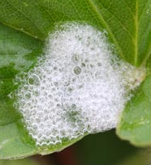 | 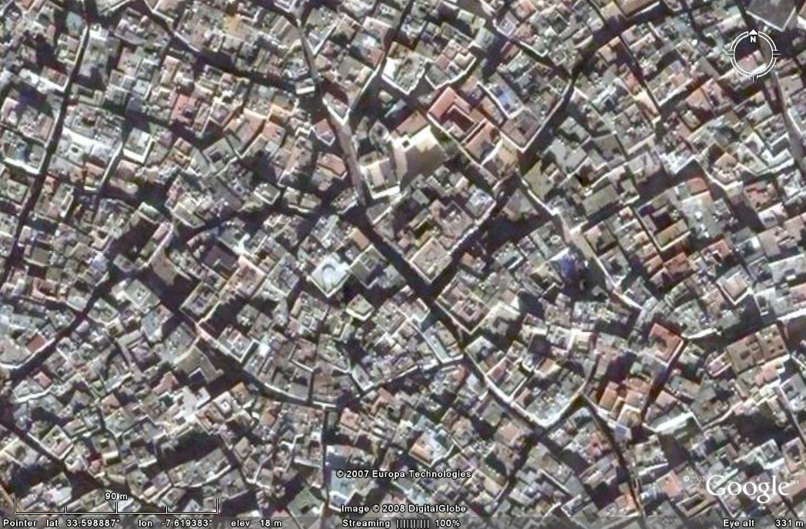
Fig. 1 Spittlebug nymph in spittle | Fig. 2 ed-Dar el-Beida (Casablanca)
According to that size, the human foam is reinforced, mainly by silicon skeletons for example known also from radularia species. The difference in size and environment stresses vertical forces in Fig. 4.

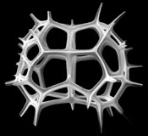 | 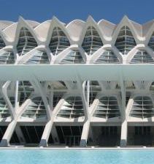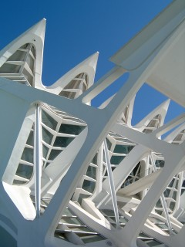
Fig. 3 Skeleton of lophospyris pentagona | Fig. 4 Calatrava in Valencia
Restrictions to vertical forces is known from wood, using carbon as a chemical basis.

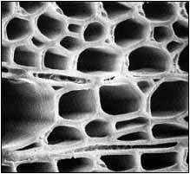
Fig. 5 Wood | Fig. 6 carton
Apart from difference in scale wood has vertical connections and horizontal separations.

The outer foamlayer is selective to flows of light, information, energy and matter. It

A ‘nominal radius’ R is an order or size ranging to its neighbours in the semi-logaritmic range { … 1, 3, 10m …}. So, R=3m is a radius in between 1m and 10m.
http://www.hort.wisc.edu/mastergardener/Features/insects/spittlebug/spittlebugs.htm
Google-Earth 33.60° , -7.62°
http://www.radiolaria.org/
http://www.farfromrainydays.com/2007/05/28/guestblog-valencia-spains-new-juwel/ http://users.telenet.be/simoni/diary/diary-m.htm
http://www.timber.org.au/NTEP/menu.asp?id=80

