Urban design transformations reducing public paved surface

TAEKE M. DE JONG
Department of Architecture
University of Technology Delft
Berlageweg 1 2628 GA Delft
THE NETHERLANDS
T.M.deJong@tudelft.nl http://team.bk.tudelft.nl

Abstract: - Public pavement for traffic and parking is expensive. It has to be paid by lots a land developer can sell, surrounded by public space making them accessible. This paper shows a systematic series of urban design transformations keeping as many variables constant as possible. With little difference in accessibility their urban effects are reported, in particular the impact on the surface needed for public paved surface.

Key-Words: Urban design experiments, public paved surface, urban island, neighbourhood, district.

Introduction
Public pavement for traffic and parking is expensive. It has to be paid by lots a land developer can sell, surrounded by public space making them accessible. This paper shows a systematic series of urban design transformations keeping as many variables constant as possible. With little difference in accessibility their urban effects are reported, in particular the impact on the surface needed for public paved surface.

The urban island
The urban islands (the smallest urban ensembles completely surrounded by roads) drawn in this section are made by a free downloadble computer programme. The design transformations are mirroring, turning, repeating and elongating. Starting points for these experiments (to keep as many variables constant as possible) are:

- centre lines of surrounding roads are chosen on a multiple of 30m (preliminary main grid);
- roadways are everywhere 6m wide; that is not needed everywhere, but it includes a reservation for wider roads of higher level in the traffic network elsewhere;
- the parking standard is everywhere more than 1 parking place per dwelling along the road, starting at least 5m from road corners, only drawn along roads North and South (indicated as ‘N’ and ‘S’) in the drawing of the urban island; the North an South sides of an urban island are chosen because they are best suitable for parking for two reasons: their surface enlarges the North-South distance between outer walls of dwellings, giving more acces to sunlight, and the shadow of North walls is welcome to parked cars;
- sidewalks are seldom smaller than 2m wide;
- there are no front gardens;
- dwellings are 5x10m, 2 floors high with roof timbers of 3m on lots of 100m², housing 2.25 inhabitants in rows not exceeding 40m to avoid extra dilatation;
- paths around the back are 1m wide;
- supposing a location in the Northern hemisphere green areas are drawn East and South filling up the main 30m grid. They show the space saved by design operations (see Fig. 2), but they could be used to enlarge the lots for sale as well, diminishing public space (pavement + green) per lot.

These starting points can be changed easily in the computer programme. However, for the time being they are kept constant below to study the change in allotment performance by the chosen design transformations.

Mirroring the smallest urban island
Fig. 1 shows an urban island with three houses with gardens surrounded by sidewalks and streets. North and South of the island there are parking lots for 2 cars each. The allotment is mirrored at the other side of the street. The smallest urban island taken in consideration here has a grid measure of 30x30m. The consequence of small urban islands is an excessive surface of public pavement (here 76%!), leaving relatively little for sale (here maximally 22%) paying for that public space.

 | 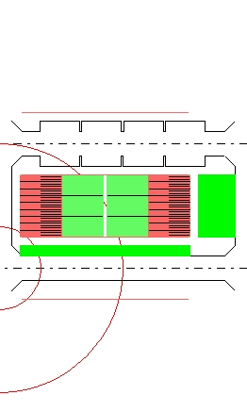
Fig. 1 30x30m | Fig. 2 60x30m W-E mirroring
The first design transformation, W-E mirroring in Fig. 2, elongates the urban island reducing public pavement (here into 67%). Now, W and E roads are used for entrance to houses at both sides and back gardens get more privacy. The lots for sale differentiate in morning~ and evening sun lovers. The gained surface is visualised by a green margin of 9m wide drawn East and 2.50m drawn South to get an idea of road profiles and crossings without greenery in the corner left below in the drawing, where circles are drawn with a radius of 10 and 30m.. Greenery is drawn East, but for children in the afternoon and in the summer evening green area can better be designed in the West to have sunny playgrounds. That does not change the land use.
At a length of 60m, one side with parking places is enough to reach more than 1 parking place per dwelling. The shadow of the N side is best suitable for parking.

Taking sun into account
N-S turning and repeating (Fig. 3) gives both blocks South gardens. Now, the short sides of the urban island are used for parking, forcing cross-parking to reach >1 parking places per dwelling. The path round the back is enlarged at the expense of sidewalks to give proper front access to the Southern block.

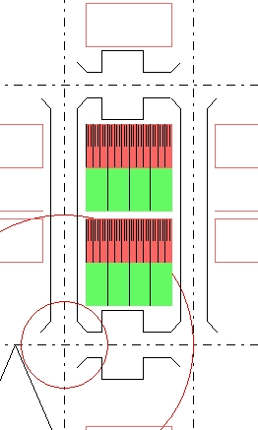 | 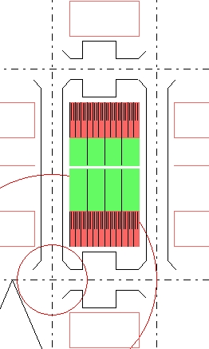
Fig. 3 30x60m N-S Turning and repeating | Fig. 4 30x60m N-S mirroring
N-S mirroring (Fig. 4) introduces North gardens, drawn longer here to get a partly sunny view on the N garden still. It differentiates the lots for sale in size and suggests a different dwelling type for sun lovers with south gardens and artistic life style with Northern light rooms like studios.

Elongating
To reach the same capacity of Fig. 4 by one sided elongating avoids the path round the back utilizing the side walk, giving back a proper size to the sidewalks N and S (Fig. 5). East gardens are suitable for people who like morning sun in the garden and in the sleeping room. Pavement is still 66%.

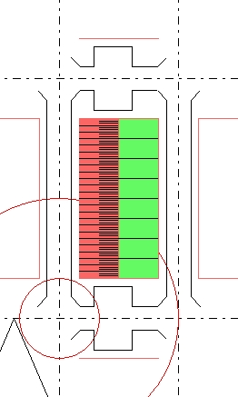 | 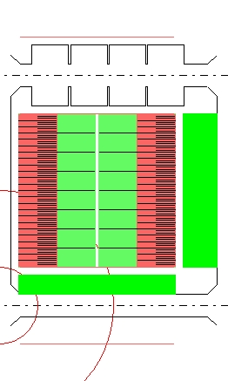
Fig. 5 30x60m elongating | Fig. 6 60x60m mirroring
Mirroring (Fig. 6) gives evening people a chance as well and both gardens more privacy. It differentiates use and plantation.
The enlargement of the urban island again reduces the amount of pavement into 52% in favour of the margins possibly used as green area: 9m East and 5m South.

L-shape and U-shape
Introducing perpendicular blocks (Fig. 7) provides streetcorners with front entrances in 2 directions. That gives the beginning of an urban look and safety by private control of public space on both roads involved. To improve that effect design solutions for corners, not implemented here, would be nice. Such solutions will struggle with smaller or no gardens in the corner.

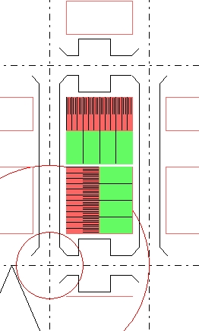 | 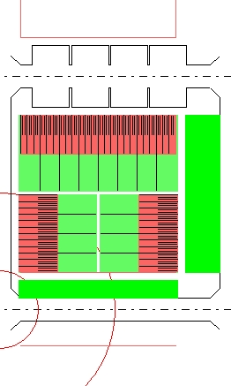
Fig. 7 30x60m L-shape | Fig. 8 60x60m U-shape
Mirroring the L-shape (Fig. 8) produces U-shaped allotments with one open side, here avoiding North gardens. It has the same advantages as previous mirroring transformations, in this case reducing pavement from 66% in Fig. 7 into 52% in (Fig. 8) and introduces green margins of 9m East and 5m South. S gardens go 0.5m around the back now, giving space for ivy-covered side façades avoiding grafitti.

Closed urban islands
Closing the urban island with front entrances on every surrounding street produces a usual allotment type of 90m length, leaving a 9m green margin East to fill the urban grid of multiples by 30m. Limiting parking places to N and S urges cross parking at both sides to have more than 1 parking place per dwelling leaving little space for sidewalks.

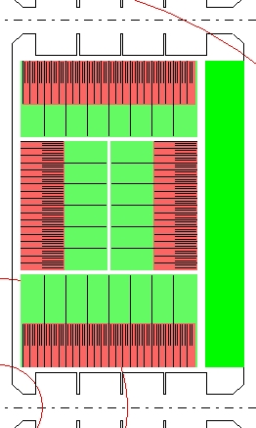 | 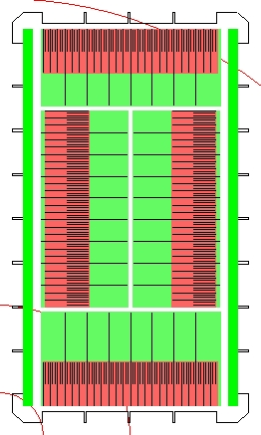
Fig. 9 90x60m Closing | Fig. 10 Elongating and adapting 100x60m
Violating the starting points, N-S elongating to 100m is easy by adding 2 houses West and East. However, the elongated blocks of Fig. 10 exceed 40m and need an extra dilatation, which is expensive. The shortage of parking places forces parking at all sides. By giving up cross parking N and S, there is space for 6 extra houses in total. The reduction of pavement is 2% only, but the number of parking places is 1.4 per dwelling. This time the green margin is distributed W and E to make trees possible.
Fig. 11 Land use per lot of the experiments

Comparing land use
Fig. 11 shows a sorted summary of the land use per lot for sale of the 10 reported experiments. In Fig. 10 we have left the starting points behind and start to look at a higher level. On that level larger spaces for mobility are needed (Fig. 12).

Traffic production
If we repeat the module of Fig. 10 (100 x 60m) 5 times E-W and 3 times N-S (Fig. 12) we reach a mesh width (300m x 300m) suitable for neighbourhood roads.

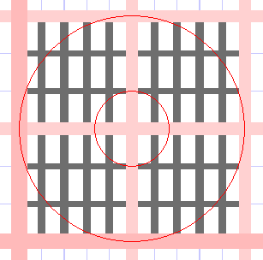
Fig. 12 A neighbourhood, repeating Fig. 10, reaching a radius of 300m (circles drawn with a radius of 100m and 300m)
We now have 15 modules together surrounded by larger neighbourhood roads requiring extra space (for example 30m width between the facades). We call them ‘neighbourhood quarters’, because 4 of them make a neighbourhood (with a radius R=300m, for example supporting a primary school).

Residential roads
Suppose every urban island contains some 75 people going out 4 times a day of which 3 by car. Suppose 1/3 of the car trips the driver is accompanied by a passenger, 1 trip is done by walking or cycling. So, the urban island produces 75·2·2≅300 car movements per day, because they are not only going out, they are coming back as well. That normally means 30 car movements per hour per island. Let them use only two of the four streets around the smallest island. So, a residential street has some 15 car movements per hour, but much more in peak hours. And there are visitors as well.

Neighbourhood quarters
A neighbourhood quarter of Fig. 12 does not only need extra space for pavement of neighbourhood roads, but also for neighbourhood facilities like green, water, perhaps a school, shops and offices. They produce car movements as well, but in the same time they are part of the modules involved unsuitable as residential area. Moreover, the area has to accommodate space for district roads (for example 40m wide, drawn left and below in Fig. 12). So, not all modules will reach 56 dwellings per ha or a floor space ratio (FSI) of 68% reached in Fig. 10. Suppose there are 500 inhabitants per neighbourhood quarter, it produces 500·2·2≅2000 car movements per day using half of the neighbourhood roads available. So, a neighbourhood road has some 1000 car movements per day or 100 per hour and much more in peak hours.

Other transformations
Fig. 13 and Fig. 14 show two allotments of 100 dwellings ( 225 inhabitants) in rows of 10 on 1.8 ha. So, there are 56 dwellings/ha and FSI= 56% while the floor space per two storey dwelling is 100m². From total area 63% surface is for sale and 37% is public space including 1 parking place per dwelling and roadway pavement of 4.2m wide.

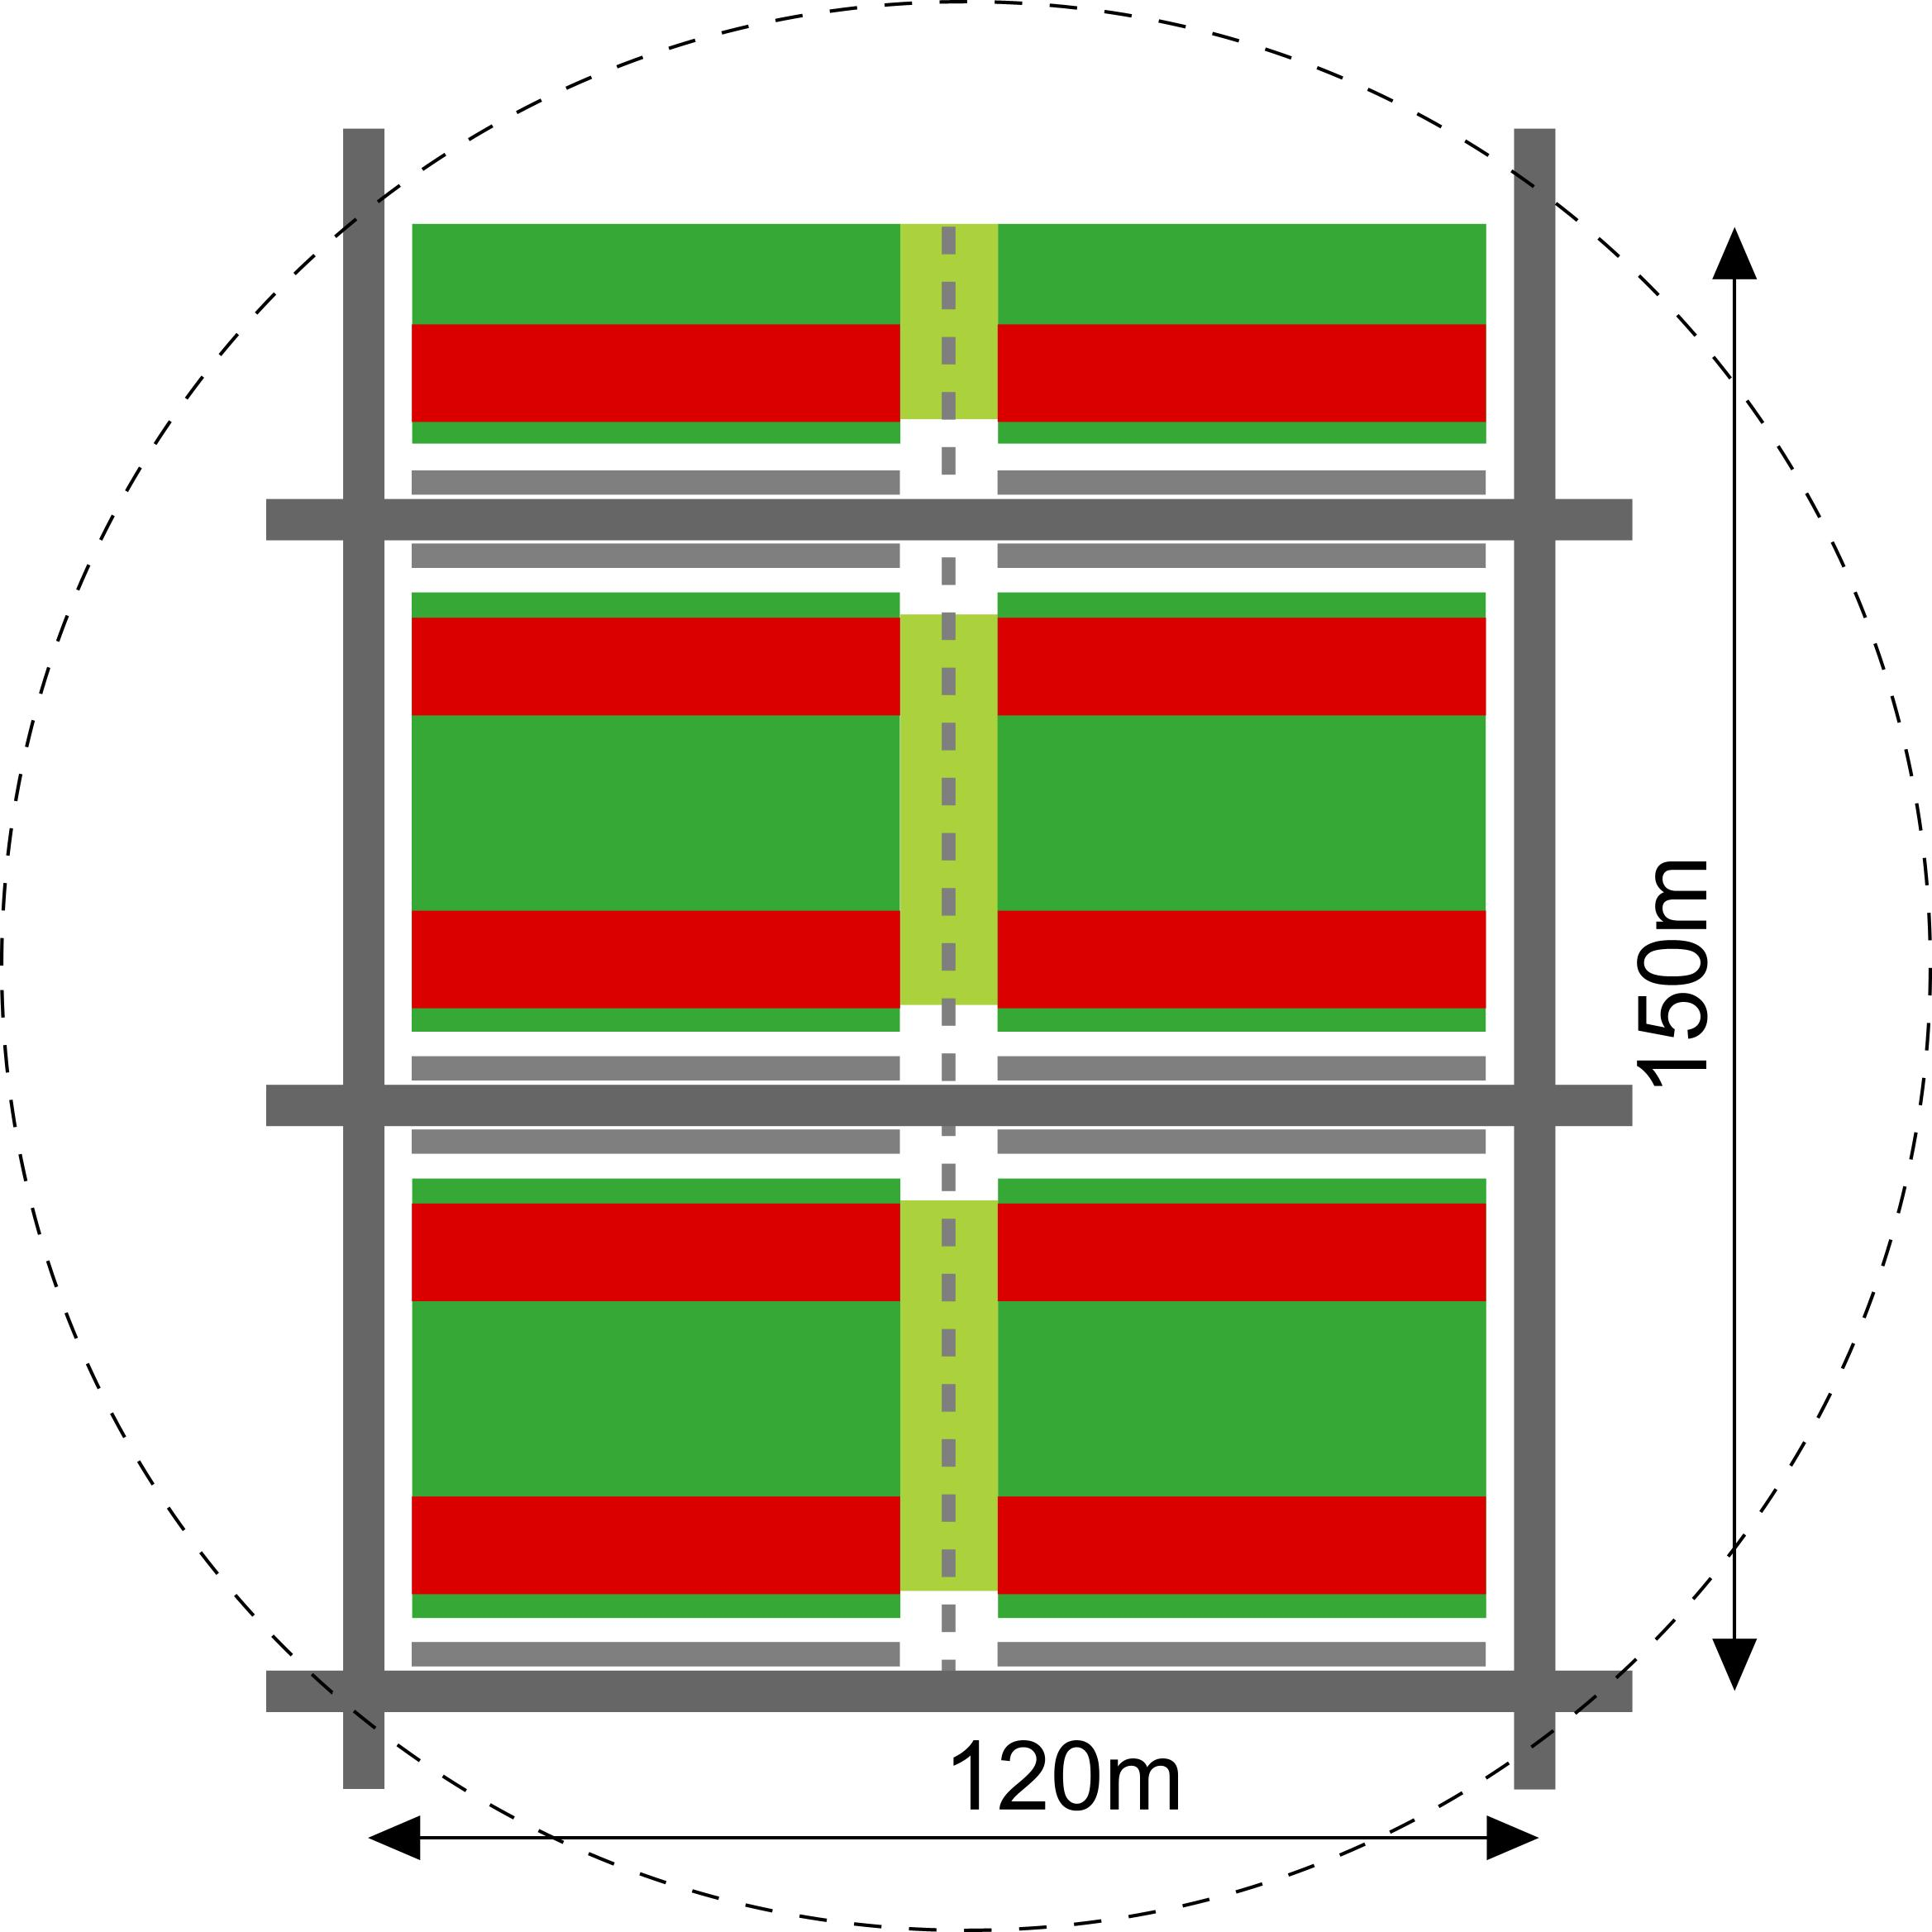
Fig. 13 100 dwellings along residential streets with parking in front of the house: 32% pavement, 6% green area
However, from the public space the proportion of pavement can be reduced in fabour of green. In Fig. 14 parking is concentrated at the boundaries. People have to walk 1 minute more than in Fig. 13 to reach their cars, partly living at residential paths, saving 45% of pavement (Fig. 15). However, vehicles should have incidental access through the green area by reduced pavement. The disadvantage is, you can not easily come close to your home with luggage, moving vans and other vehicles. And you can not see your car from your home.

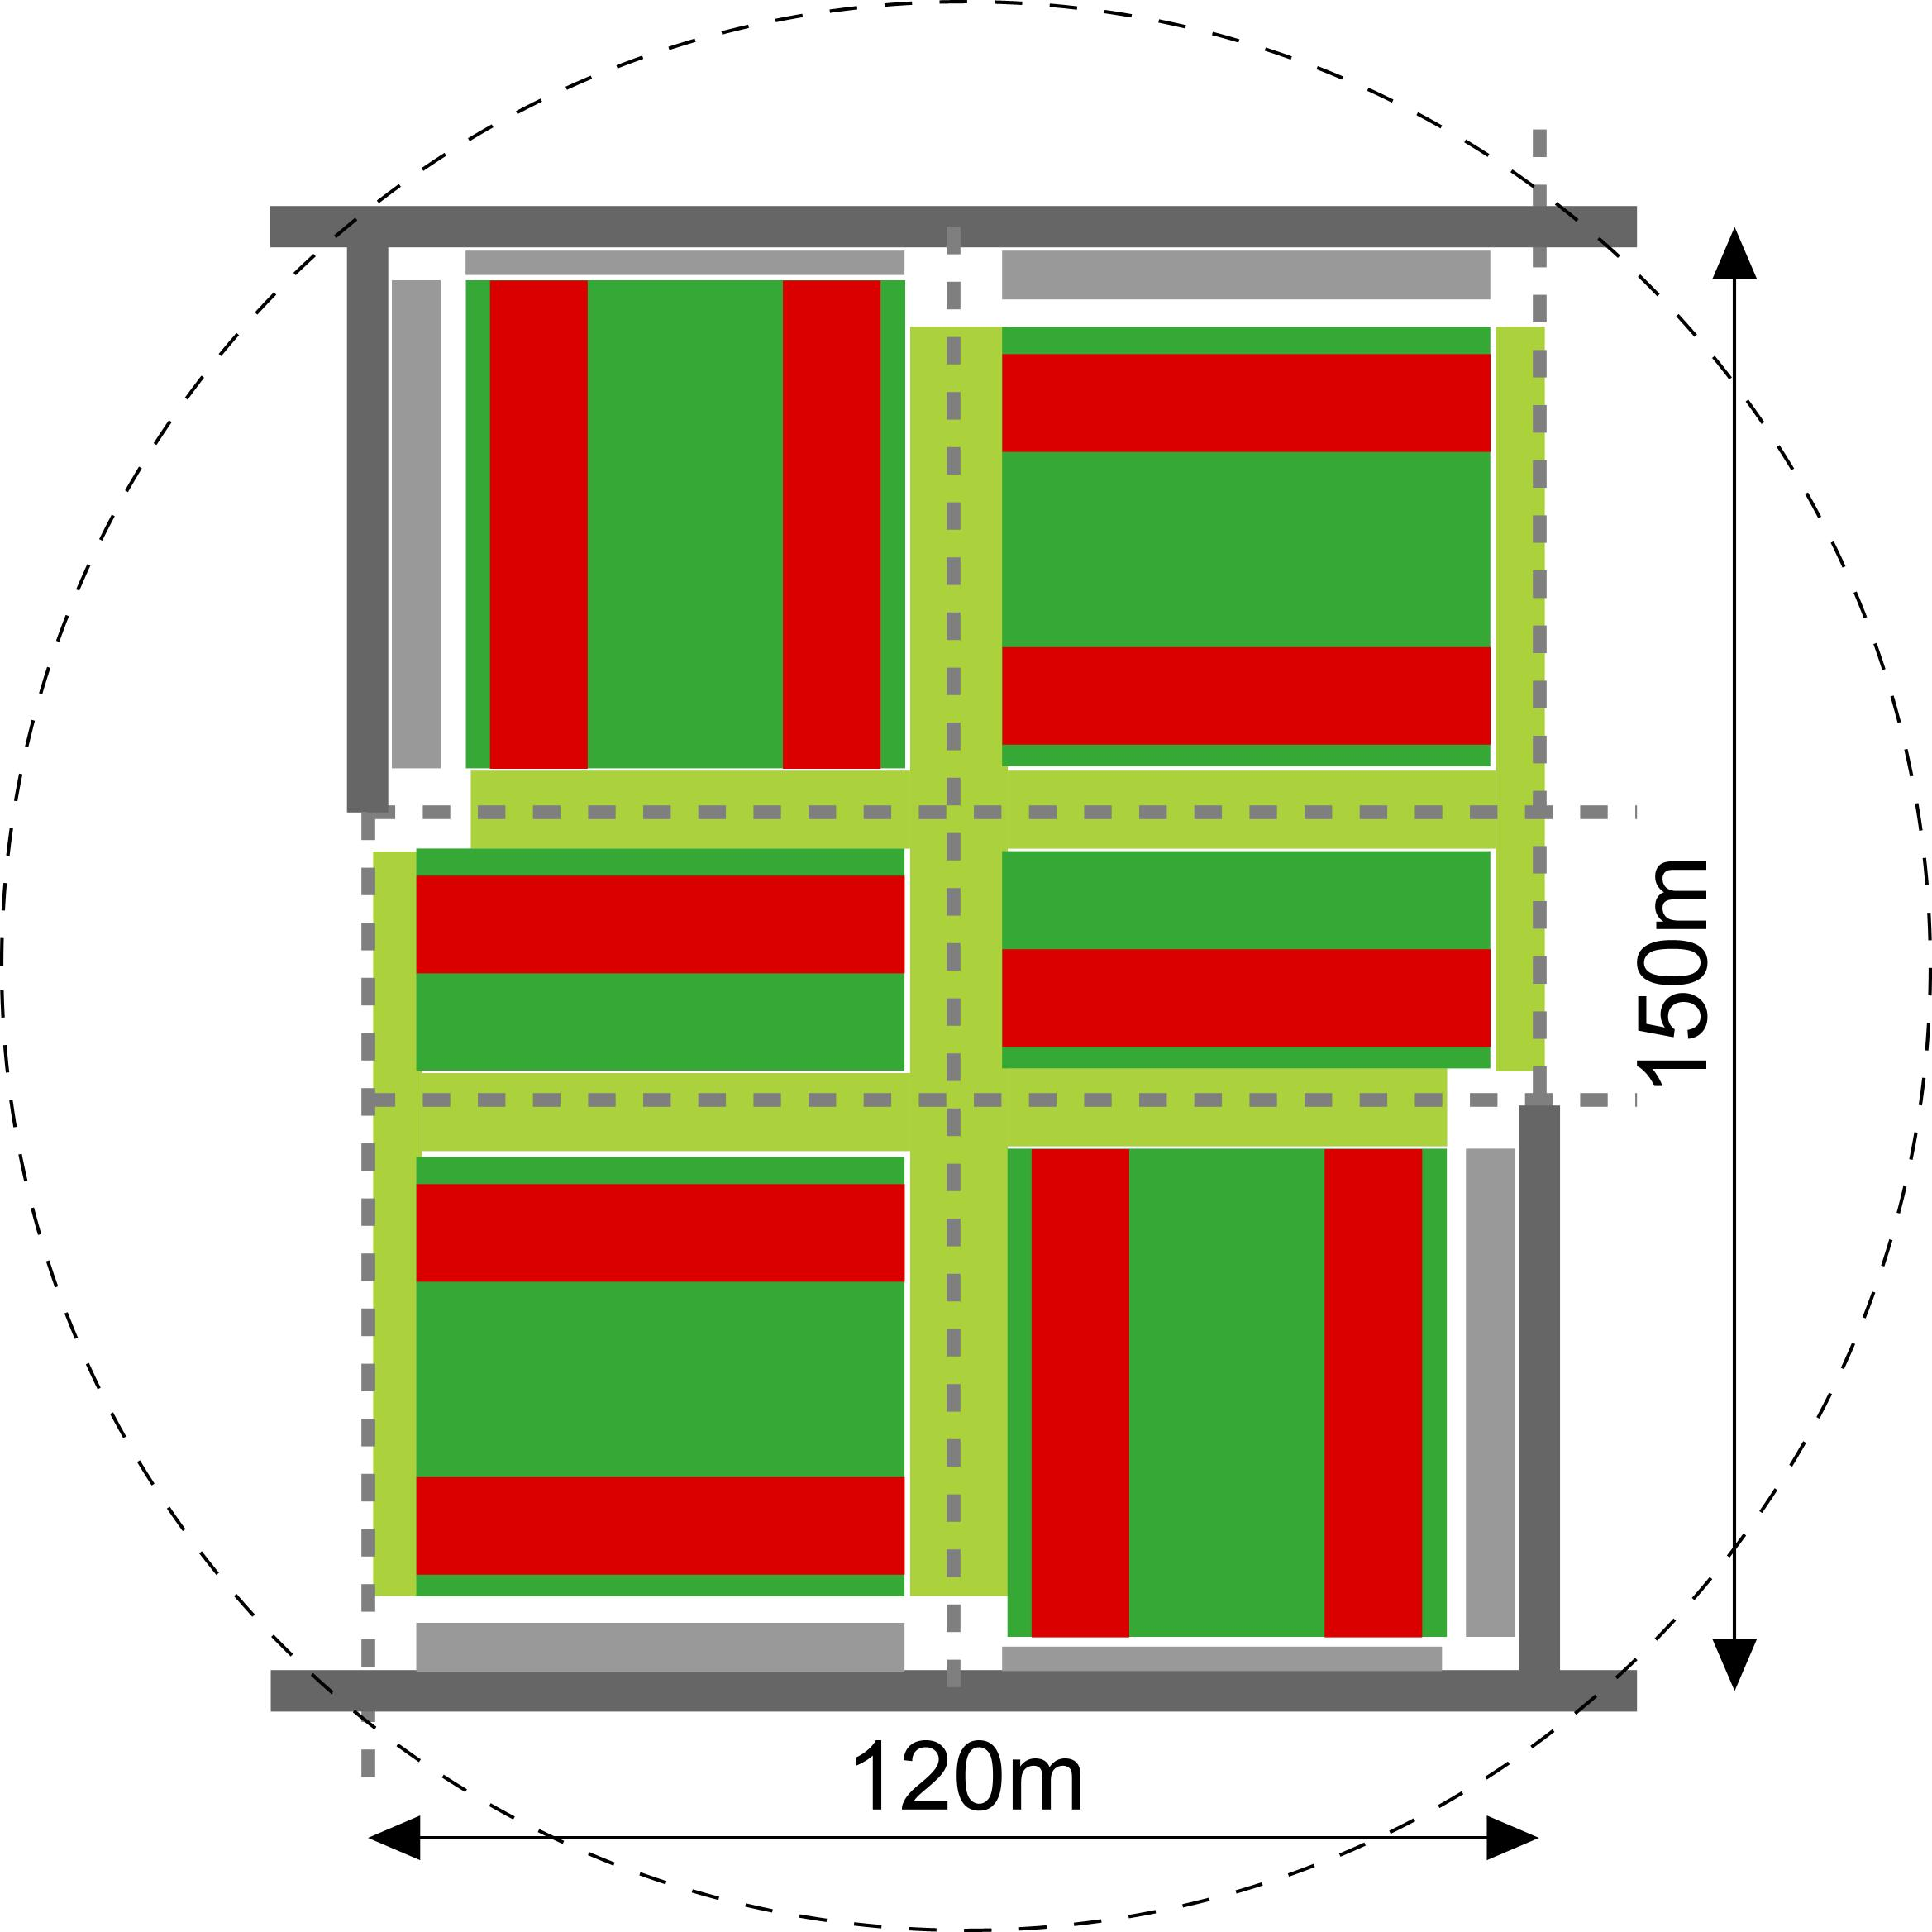
Fig. 14 Reduced pavement by residential paths, parking at 1 minute walk: saving 45% pavement, a profit of 350% green area
That reduces municipal costs (or ground prices and taxes for private persons) substantially. By doing so, there is ample 3 times more green area (20% green of total area), resulting in a much greener look without cars. Part of that area could also be sold reducing municipal costs again.
PPD-ZH(1970)
Fig. 15 Reduction of street pavement, increase of green area comparing Fig. 13 and Fig. 14

Neighbourhoods
Repeating a module like Fig. 14 by 8 around a centre, produces a neighbourhood of 1800 inhabitants, enough for some facilities like a primary school (1ha black square in Fig. 16 to Fig. 18), playgrounds, some shops and enterprises or public facilities.
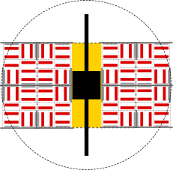
Fig. 16 300m central road
A central neighbourhood road costs least pavement, but it divides the neighbourhood and the school in two parts (Fig. 16).

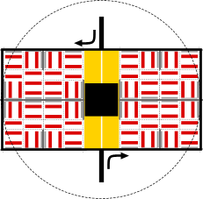
Fig. 17 1800m peripheral one way road substituting 600m residential street
A peripheral road costs much more road length, unless it is part of a grid used for adjacent neighbourhoods as well. A one way solution (Fig. 17) may half pavement and barrier effect but causes detours.

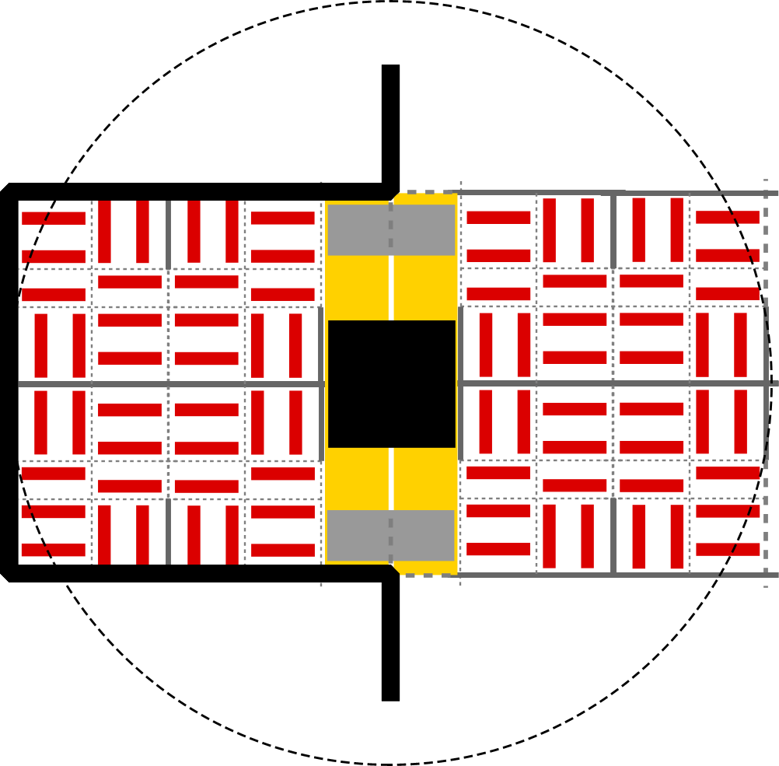
Fig. 18 900m peripheral road substituting 300m residential street, central parking
A one sided peripheral road (Fig. 18) leaves the other side open, but it causes long walking distances.
Locating parking spaces at the boundaries of the ensembles, at daytime some residential parking space can be used by users of the facilities, avoiding extra facility parking space.
Concentrated parking on neighbourhood level could mean a 10 minute walk to your car. However, these choices are often subordinate to the environment, mostly a district grid (Fig. 19).

Districts
Repeating the module from Fig. 16 by 4 (7200 inhabitants) the surface fits in a 1·1km grid of district roads (40m wide), leaving open a 30m surrounding margin and a centre (Fig. 19) in each district quarter. That centre can be used for additional district green, facilities or housing (4ha black square), utilizing concentrated residential parking in day time.
The grid permits to leave out 1200 m neighbourhood streets, but it will ask 8·90=720m extra residential roads to give access to all ensembles.
By doing so X-crossings are replaced by T-cossings giving access roads along the square a view on larger buildings. Berlage designing the Mercator square in Amsterdam called it the ‘turbine principle’. The resulting T-crossings refer to the ideas of Camillo Sitte.

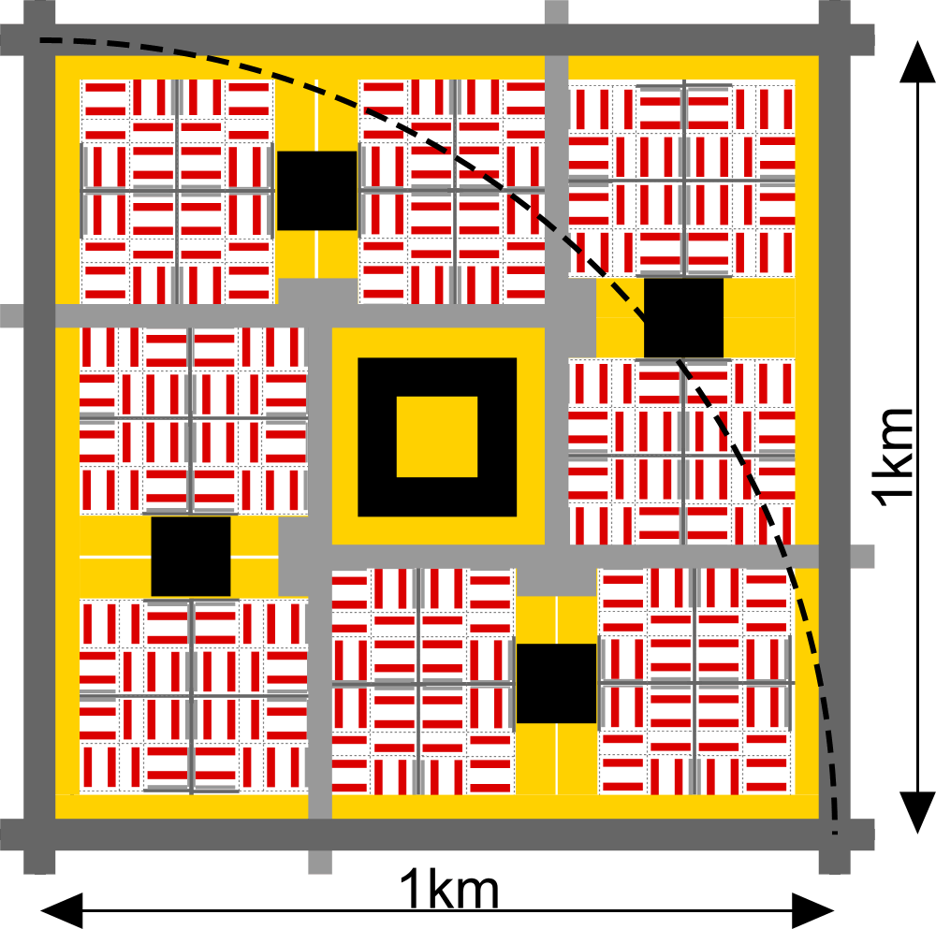
Fig. 19 A small district or district quarter
Fig. 20 shows the optical principle of leaving the centre open, applied in Fig. 19 on the level of the quarters and on the level of its centre: the same surface left (4·6=24) gives a more spacious effect located in the periphery (6·8-4·6=24). A positive effect is a better visual accessibility of the built-up area.

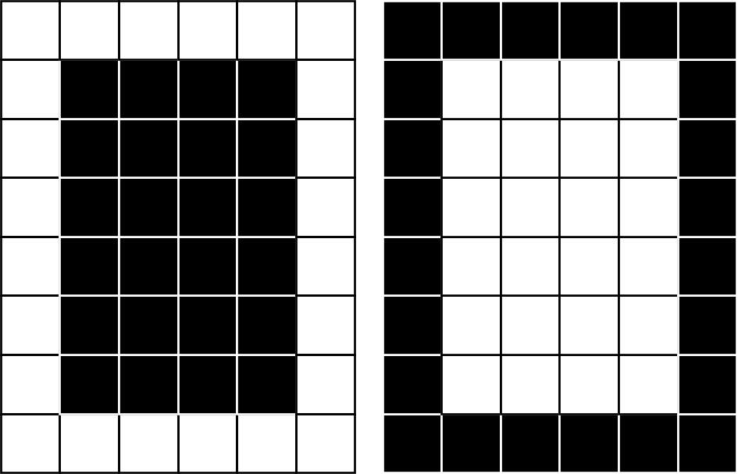
Fig. 20 Same built-up area optically full or empty

Conclusion
Reducing the surface of public pavement by urban design could have positive side effects without loosing accessibility substantially. The first measure is to increase the surface of urban islands improving the area/circumference ratio. Secondly concentrating parking space could produce a substantial reducton of paved surface, applied on a lager scale partly by double use. Thirdly, parts of a grid could be left out replacing X-crossings by T-crossings.

References

The computer programme is downloadable from http://team.bk.tudelft.nl > Publications 2003
Sitte, Camillo (1991) De stedebouw volgens zijn artistieke grondbeginselen (translation of the original 1889 publication Der Städtebau nach seine künstlerischen Grundsätzen (Rotterdam) Uitgeverij 010
Tummers, L. J. M. and J. M. Tummers-Zuurmond (1997). Het land in de stad; de stedebouw van de grote agglomeratie (Bussum) THOTH.

