Architecture at a University

Prof.dr.ir. Taeke M. de Jong 2009-07-03

Introduction
At a University of Technology, Faculties of Architecture often struggle with a scientific justification of their research and study. For example at UT Delft the issue of scientific justification of Architecture culminates every decade in a debate about the role of mathematics in its education. “Mathematics is the basic language of technology! The academic engineering title would devaluate without a proper mathematical background!” the other faculties argue. So, in my career at Delft University of Technology as a student of Urban Design and as a professor in Technical Ecology and Methods I witnessed the introduction of mathematical courses by the Faculty of Mathematics for the Faculty of Architecture three times, eroding by a gradual silent removal of its components within five years after introduction. “It’s useless for architecture! You never use it in practice! It takes too much time!” teachers of the Faculty (without that background themselves) complained.

A related kind of complaints caused the removal of three institutions for empirical research from the Delft Faculty of Architecture in the beginning of the nineties of the last century, concerning Architecture, Urbanism and Housing respectively. In general, these institutions did the research, the design chairs the education. Their libraries with a yearly increasing amount of research reports were dismantled. If a designer took the effort to read one of these reports, the reaction was: “Useless! The context any of my projects is different, always particular, never obeying these statistical generalisations!”. The approximately 100 research employees were dismissed or dispersed over the design chairs, on their turn forced to ‘research’. That raised a question of methodology.

Ways to study and research urban, architectural and technical design
So, I also witnessed the set up of a methodology committee at the Delft Faculty of Architecture twice (1990 and 2000). I experienced the honour to be the secretary of both. In 2002 assigned by the Dean to do so, I edited a book (see Fig. 1) together with an empirical scientist Theo van der Voordt, summarising the strikingly similar conclusions of both committees and collecting 48 examples of empirical research and design related study from the same Faculty. For five years it was prescribed literature in any year of the education.

In his preface to that book, the Rector of our University Fokkema concluded that an object of architectural, urban and management design is more context-sensitive than any other object of design at a University of Technology. It always entails different managerial, cultural, economic, technical, ecological and spatial contexts. That was an important statement for scientific justification of the many case studies made at our Faculty. Scientific generalisation is difficult if the majority of these studies are case studies in a variable context.

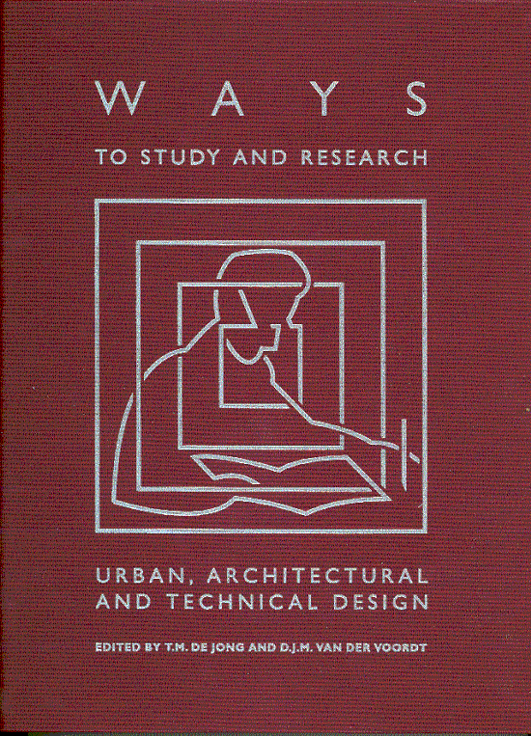 |  | determined | variable | OBJECT
 | determined | Design Research | Design Study
 | variable | Typological Research | Study by Design
 | CONTEXT
Fig. 1 Ways to study | Fig. 2 Design related research and study
Moreover, design related studies often have a variable object that does not yet exist before the study starts. It is variable in the head of the designer. It can not be restricted into a determined problem statement, aim statement, object and a hypothesis as empirical science forces to define. There is not one problem, but a dynamic field of problems according to a changing field of stakeholders and users. There is not one aim, but a dynamic field of aims of future generations of users to be covered. The object still has to be designed ending in always the the same, very general hidden sup-position (in Greek: hypo-thesis!) accompanying the drawing: “This will work”. Once the design is made, the object of study is determined, it can be evaluated (design research) or categorised (typology) by empirical research (the first column of Fig. 2). The rest is study (the second column of Fig. 2).

‘Research’ is a relatively new word emerging in the 19th century stemming from judicial inquiry for ‘truth’. Before that time any scientific or artistic inquiry was called ‘study’. Rembrandt and Chopin made also ‘studies’ (etudes) with objects of study in statu nascendi. Study is a useful English word including the narrower category of research. In the time Benjamin Franklin studied electricity the object of study was not determined either. Once it was determined the study of electricity became research.
So, the main scheme of the book became Fig. 2.

Probability supposes possibility
The difference between empirical research and technical design is primarily the difference between exploring probable and possible futures.
Taking a closer look at the difference between probable and possible futures before we have to descend into modal logic, we simply can conclude that anything probable is per definition possible, but not the reverse. If something is not possible, it can not be probable after all.

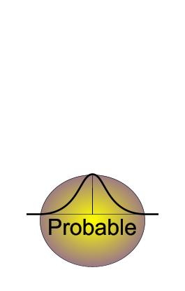 | 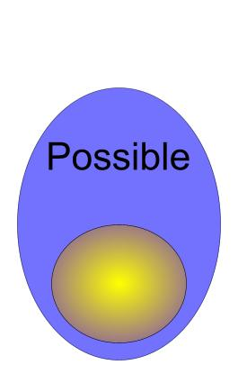 | 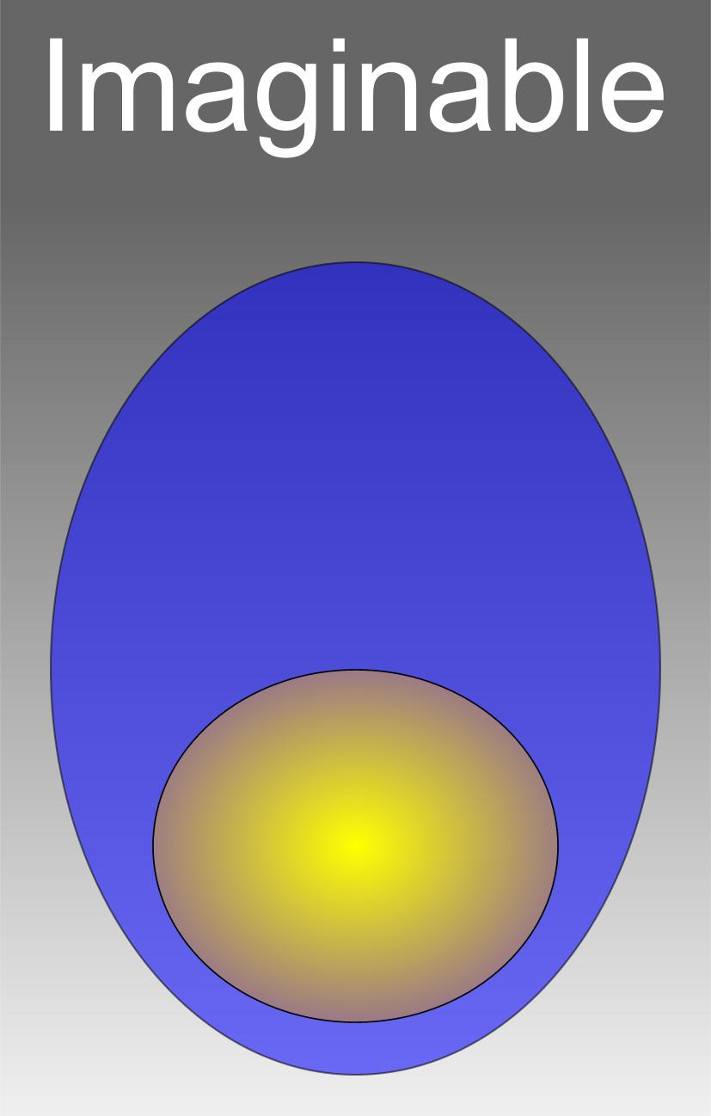
Fig. 3 The task of empirical research | Fig. 4 The task of technical design | Fig. 5 Art’s task
However, there are improbable possibilities. The probable ones can be predicted, explored by usual ways of empirical research simply because they are probable. But how to explore improbable possibilities? That is precisely the task of design. A designer imagines improbable possibilities that do not exist. If designs were probable they would be predictions, not designs. Designs are not ‘true’ or ‘probable’, but ‘imaginable’ and ‘possible’. Since empirical science aims at truth or at least probability, from that viewpoint a designer is a liar, drawing objects that do not exist. So, design cannot be empirical science. But, the other way round: science supposes a design. It is not a natural phenomenon, it is designed by humans on its turn supposing imagination.
And, imagination is the area of art.

Design uses empirical results but produces something else
That does not mean designers do not use the results of empirical research. Probability is part of possibility after all. It solely means it is not their competence to deliver such results. Their core business is developing unpredictable possibilities. The predictable components of design are delivered by former empirical research. Designers choose and use them on location balancing them in a context-sensitive composition by improbable combinations, components and details to create new possibilities.

Designers are not assigned to make predictions based on causal sup-positions (hypo-theses) as empirical scientists are. So, concluding causal relations eventually following statistics and probability calculus, based on existing data can not be the way of study they are assigned for. However, without knowing how that kind of conclusions are reached, designers are vulnerable in a team of specialists using these generally accepted scientific methods.
So, they have to study methods of empirical research to be able to criticise the results of empirical generalisations in the specific context at hand. That critical ability is needed to balance often contradictory empirical advices of many empirically educated specialists in a planning team to be integrated in a composition. That criticism nowadays fails between empirical specialisms.

Science supposes design
However, science itself is a conscious human creation. And a conscious human creation supposes design. So, science supposes design (imaginability and possibility), not the reverse.
Art supposes imaginability as such. But imaginability is necessary in any conscious practice.
For example policy supposes desirability, as far as the desires are imaginable and possible. Imaginability, desirability, possibility and probability are different modes of practice and reasoning. In design education and practice they appear as different modal futures to be distinguished properly. That distinction makes explicit the problems and aims motivating any practice. Probable futures as far as they are not desirable contain a field of problems for study and design, and desirable futures being not probable show a field of aims.

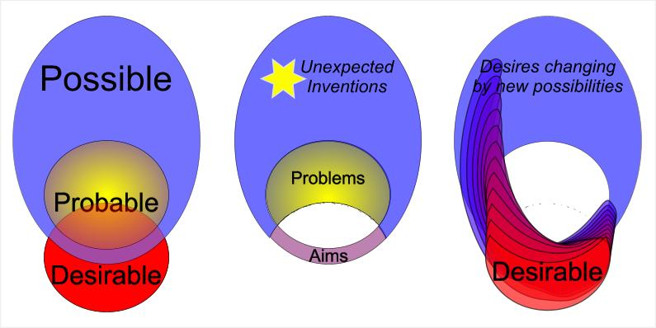
Fig. 6 Desirable futures determining fields of problems and aims, changing by new possibilities

Imaginations and designed instruments precede scientific progress
Anything true or probable is by definition possible and imaginable. If the content of a drawing or a text is not imaginable or possible, it cannot be probable let alone true. It cannot be object of science before it is made imaginable. Leonardo da Vinci and Vesalius had to draw our inner organs properly before Harvey could even imagine our blood circulation.

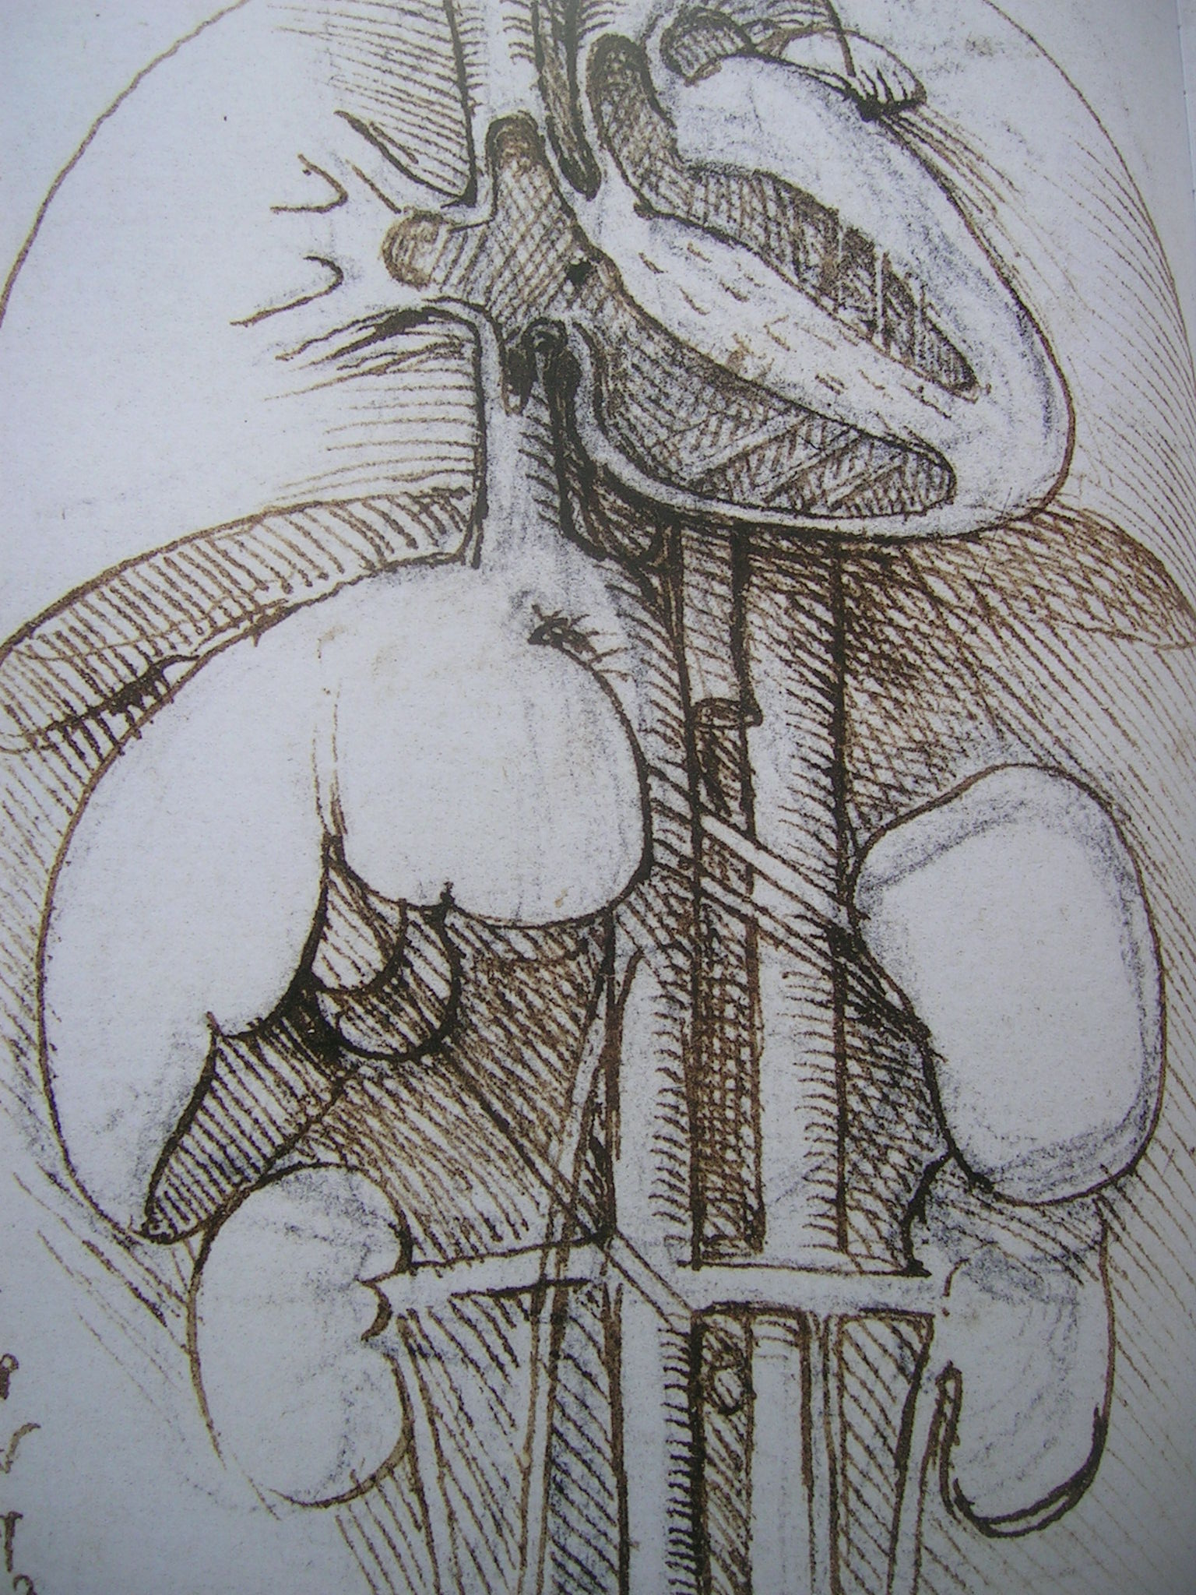 | 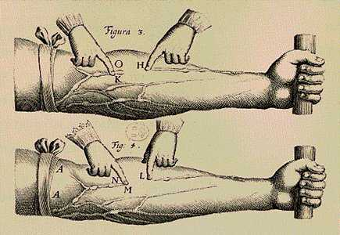
Fig. 7 The heart by Leonardo da Vinci in 1509 | Fig. 8 The proof of blood circulation by Harvey in 1628
The telescope had to be designed and realised before Galileï could see the moons of Venus and imagine they were continuously falling in a circular movement, confirming Copernicus’ assumptions and Kepler’s measurements. The steam engine had to be designed and realised before Clausius and Boltzmann could develop thermodynamics a century later imagining entropy as the key to its efficiency.

Science is not necessarily part of design but of its realisation
So, imaginability and possibility are preconditions for science. Design is supposed in science, be it often has a hidden supposition. Scientists themselves speak about the design of a research programme, the design of research tools like a telescope, a microscope, a cyclotron, an inquiry or even algorithms, the design of an organisation. So, if design could be part of science (and design education part of scientific education) is the wrong question. The right question is, if science (as a subset of design) always should be part of design. If not, the complementary question is, if there is still a task for design study beyond empirical science (probability study, research). If so, many questions emerge about that task. Let us first answer the question: ‘Should science always be part of design?’

If we look at the remarkable results of designers without any scientific education we are inclined to say “No!”. But, even designers without any scientific concern implicitly use the empirical experience of preceding examples (precedents) proving the possibility of design principles: types, concepts, models and programmes. Moreover, materialising and realising their designs these days, they use the scientific results of other people (for example: ‘this kind of brick will hold the required pressure’). So, the final answer is: “The results of empirical science are always part of realising designs, but not necessarily of design itself.”

Advantages of scientific education for design
So, design education does not always need a scientific input. Scientists defend that input because of the many avoidable design mistakes appearing in realised designs. However, in practice many empirically educated specialists judge the growing design in many stages, filtering out such mistakes beforehand. In that company the designer has an other task and no education can simulate all occasional specialist’s evaluations. So, avoiding mistakes hampering the very beginning of design is not a strong argument for science in design education. A better argument is: a designer without any scientific experience will be vulnerable in the middle of these specialists. (S)he cannot reject their arguments or ask the right questions about their hidden suppositions.

Natura Artis Magistra
However, there may be another advantage. Science activates our senses. It forces imagination into areas not accessible for the naked eyes, ears or the other senses, as they are used to, and shaped for everyday life. The exploration of microscopic and macroscopic scales unveils phenomena you could not imagine before. How rich our human imagination may be, it is poor compared to reality. In particular biology is an ongoing realm of surprise. “How is it possible? Could you imagine?” we exclaim in amazement. Many innovations nowadays are based on the incredible achievements of micro organisms, plants and animals.

There is no technical university able to design even a mosquito. Its achievements in flying, in coordinating and synchronising its functions, in adaptation to the environment, in reproducing its concept with many modifications into offspring for survival of the species in changing circumstances are still unconceivable, sometimes suggesting intelligent design. Our imagination of extraterrestrial life in science fiction is still caught in representations of what we know as terrifying enlarged insects or mutants of humans. Even in creating toys like ‘transformers’ we apparently need something to recognise from everyday life, otherwise our impression would fall into chaos. At the other hand, if we recognise too much we fall into boredom. Our neural system needs stimuli, not too little, not too much. Perhaps that dynamic balance between recognition and surprise we call beauty.

A design concept balances and integrates specialist’s advices
Education cannot offer all necessary evaluations by specialists on every student’s design.
In practice, a designer confronted with many of such arguments by the many evaluations will become gradually aware of design limits by experience. Avoiding mistakes (s)he will become more and more limited in formulating concepts. Without scientific background (s)he has to trust specialists’ advices without objection. However, a designer with some scientific understanding will put the advice into the perspective of a specific context. (S)he can weigh the advices related to each other and to the architectural quality to be reached.

Diverging specialisations result in an archipelago of sciences
Perhaps a designer even recognises the same structure in the advices, bringing different disciplines together in broader categories unknown in science and difficult to formulate. That broader interdisciplinary understanding by context sensitive design is urgently needed in science itself. Design has a message in the university context. Science increasingly breaks up in specialisations, increasingly inaccessible by their collective suppositions, jargon, instruments (paradigm), not criticized by their growing monopoly, their standards accepted by policy makers, convinced of their own generalizations, less and less aware of context, of each others’ object of study, their limitations. By lack of context awareness, fascinated by mathematical evidence, generalizations based on hidden suppositions, policy makers and designers get contradictory advices. So, they choose their specialists to support their opinions and decisions. Any decision can be supported by some specialist.

Science falls in public esteem
The audience of television programmes, paying their taxes for education and enactments for example on safety, health and environment based on ‘scientific research’, looks at debates between professors with contradictory advices, hired by opinion makers. Expensive earlier enactments are questioned. Where did they pay for? They feel ‘there is something rotten in the State of Science’, being increasingly inaccessible for external critics. The university is no longer universal but specialised, struggling for survival in mutual competition. Specialised ‘peers’, authorities, censor scientific publications in expensive specialised periodicals. Three centuries of debate on the topic of authority called ‘Enlightenment’ seem to fade. Mediaeval times are back. Authority is a scientific argument again. The audience looks at debates between authorities without distinction, be it scientists or populists. They do not choose for complex arguments but for the common sense stemming from the everyday scale of personal experience. For whom are they going to pay taxes in the future? Anyway, they are willing to pay for identity, uniqueness, imagination, possibility, and design. Design products sell better than scientific articles. But they contain results of science.

A demand for imagination
Design education remains attractive for students with imagination. And imagination is a prerequisite for science and policy. Architectural and urban design force to include managerial, cultural, economic, technological, ecological and spatial futures on different levels of scale, including but surpassing everyday scale. That is why they should include science within their education as a real university in itself, open for the depths of many specialisations, but broad, sensitive for context, putting them into perspective by the ability of proper criticism. Design extends science from exclusively probable futures into possible, imaginable futures. It offers hope in a world of depressing predictions. In their possible worlds designers make place for desires no one else could imagine before they were designed. Policy makers are freed from limiting suppositions about probable futures by possible futures imagined by design. The task of design education is to restore the University, not the accountancy of facts insufficient in the perspective of new, unexpected possibilities needed now.

Jong, T.M. de; Voordt, D.J.M. van der [eds.] (2002) Ways to study and research urban, architectural and technical design. (Delft) DUP Science
Windsor Castle, Royal Library RL19112r
Harvey (1628) Exercitatio Anatomica de Motu Cordis et Sanguinis in Animalibus

