Urban ecology, scale and identity
Taeke M. De Jong
Department of Architecture (Urbanism), Chair Technical Ecology
Delft University of Technology (TUD), Julianalaan 134 2628 BL Delft
THE NETHERLANDS
T.M.deJong@tudelft.nl http://team.bk.tudelft.nl

Introduction 2
Ecologies 4
Urban ecology including the human species and its artefacts 6
Scale and size: technically, scientifically, administratively 10
Identity: difference from the rest, continuity in itself 15
Conclusion 17
References 18
Questions 19

Abstract
This chapter takes identity (difference with the rest and continuity in itself) as a common ground for human and ecological urban development. So, compared to the previous chapter, the attention shifts from the systems into their boundaries. Any difference becomes visible at the boundaries and culminates in spatially sudden or gradually changing ecological conditions. So, this chapter removes the negative sound of ‘boundary’ as a separation, showing the landscape boundary as a very source of biodiversity. And, the urban landscape is boundary-rich.
However, to be successful the concept of identity requires further scale-articulation. So, this chapter also stresses the scale-paradox of diversity: conclusions drawn from one level of scale could turn into their opposite already at a factor 3 scale difference. That forces design, science and policy to distinguish more legend units, variables and agendas than they are used to. It reduces the ease of scientific and governmental generalisation, but it results in an optimistic view on urban life and living. This chapter takes the Netherlands as a reference, because of its boundary-richness and its availability of data about a millennium of civil engineering and urbanisation. Its nature of a river delta offers interesting points of departure to study other deltas in the world. Everywhere deltas are increasingly populated and urbanised, often comparable to different stages of Dutch history.
Introduction
Dutch reference as a starting point
In this chapter the Netherlands is a reference because of its (often artificial) boundary-richness and its availability of data. From mediaeval times onwards the Netherlands is a largely artificial and urbanised low peat and clay area gradually changing into the Eastern sandy higher parts more similar to the rest of Europe. It caused an interesting natural and scientific diversity. Its part below sealevel is artificial by a millennium of increasingly smart civil engineering, resulting in a biodiversity one would not expect from human impact. So, the Dutch urban ecology allows some optimism in a mainly depressing image of the human impact on global biodiversity. The biodiversity and its development of any Dutch km² is well documented. Maps and data are available about governmental, managerial, cultural, economic, technical and spatial developments for a long period of time at many levels of scale. That permits comparison with other increasingly populated delta areas in the world at different stages of development. It shows the potentials of an extended boundary between land and sea and of boudaries in general.
Human dominance
An urban area is dominated by the human species. So, its ecology, ‘the science of distribution and abundance of species’ (Andrewartha 1961 , Krebs 1994, Begon et al. 2006), should start with the dispersion and density of people and their artefacts. These artefacts (buildings, roads, canals, ‘selectors’ always combinating different kinds of separation or connection) accommodate not only people but also a surprising amount of other species adapting to the variety of sheltering or supplying conditions. Some species accept or even welcome human presence like step vegetation (for example greater plantain), mosquito’s or sparrows.
Intensity of use
Taking time into account, at average one square metre in the Netherlands is used by humans only 4 hours of the 8760 hours a year counts. The intensity of the human use of urban space is also remarkably low. Based on figures about time use and land use in the Netherlands 20 years ago I estimated that intensity to be highest in shops (135 hours/m²·year). After shops came offices, social-cultural facilities, schools and homes (homes together with its gardens count 48 hours/m²·year). If you divide the time spent in public paved space by its surface in the Netherlands at average it comes down to meeting a human on the road during a minute four times an hour. Most people live in suburban areas and most people are at home, in particular the youngest and the elderly. We are not aware of that quiet emptiness of public space, mainly caused by the large surface of quiet suburban areas, because we visit primarily busy places at busy periods. Some places like industrial estates, yards or roadside verges are even not accessible for the public. So, these places and the other hours of the year may be available for other species depending on the conditions the human species leaves them by design.
The urban treasury
The awareness of urban nature is considerably stimulated by local associations for nature study, present in nearly every Dutch municipality, often divided in specialised working groups studying birds, butterflies, plants and so on.
Some of them count species per km² every year (see Fig. 1 , Jong and Vos 2000).

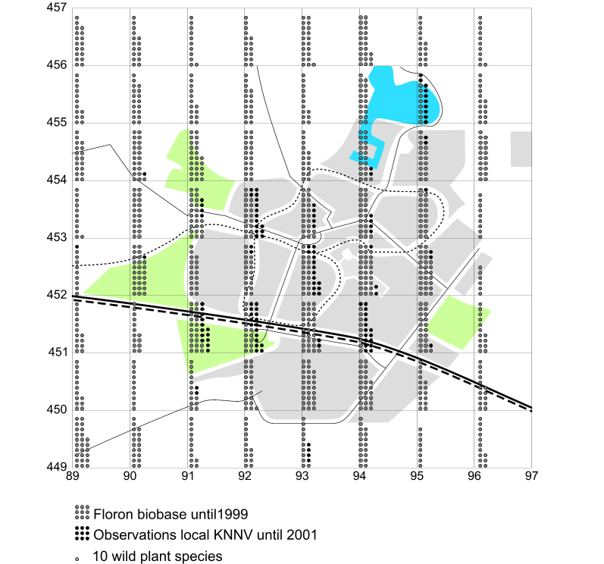
Fig. 1 Number of plant species per km² found in the new town Zoetermeer
They report the gains and losses of their city with remarkable results. Fig. 1 shows a map with the number of wild plant species in public space counted in any km² of the town of Zoetermeer (near The Hague) until 2001. Many of them are rare in the Netherlands and the central square kilometers count more species (ample 350 per km²) than many Dutch natural reserves do and many more than the surrounding countryside does. That kind of observations gradually reverses the idea of the city as the wrongdoer. A concentration of humans is an ecological advantage, even if it locally results in high rise buildings and completely paved surfaces.
Ecologies
Different paradigms
Jong (2002, not related to the author) describes in her thesis the strikingly separated Dutch development of different paradigms in ecology during the 20th century. The clearest controversy appears between the ‘holistic-vitalistic’ synecology (studying communities, the biotic relations of different species together, the basis of current Dutch nature preservation policy) and the ‘dynamic’ systems ecology (counting inputs and outputs at a clearly defined system boundary, mainly stressing abiotic conditions as elaborated in the previous chapter).
That controversy also represents a beautiful example of spatial differentiation causing scientific diversity of paradigms in a small country. Synecology primarily developed at the Catholic University of Nijmegen (Westhoff in the sixties and seventies) extending to the primarily autecological Wageningen University of Agriculture (mainly studying one species and its requirements at a time) in the higher East of The Netherlands, while ‘system dynamic’ ecology originated from the University of Leiden (Baas Becking in the thirties) in the lower, very artificial wet West area, a product of civil engineering during many centuries.

Six kinds of ecology
Fig. 2 locates environmental science (emphasising human society and health) as a kind of autecology at the top, chaos ecology (stressing unpredictability from minor initial physical events) at the bottom. However, the starting point of this chapter is cybernetic ecology (emphasising spatial and temporal variation at boundaries). In Fig. 2 it is located in between synecology and system dynamics ecology.

 | naming abiotics | naming biotics
environmental science | environment | human society
autecology | habitat | population
synecology | biotope | life community
cybernetic ecology | abiotic variation | biotic variation
system dynamics ecology | ecotope | ecological group
chaos ecology | opportunities | individual strategies for survival
Fig. 2 Ecologies
The sequence in Fig. 2 may reflect a decreasing human centered approach. In a perspective of urban ecology, it is important to understand the differences to avoid debates that paralysed thinking about nature preservation in the Netherlands for years. This book chooses system dynamics as a starting point. However, nature preservation in The Netherlands is primarily founded at synecological principles indicating target species and target communities. This chapter shifts from both sides into cybernetic ecology stressing conditional thinking rather than causal thinking as a principle of steering biodiversity.
Causal and conditional thinking
A house (in Greek: oikos) does not cause a household. It makes many households possible. It is not a machine with a predictable product, a result of operational engineering. Environmental design does not cause activity, it conditions free choice for future generations. And diversity is a first condition for choice. The (landscape)architect or urban designer has to shape new (unpredictable) possibilities. Empirical science clarifies existing truth or probability by unveiling returning apparently causal relations, repetition within the confusing diversity of nature. That is another mode of thinking. Within that frame a designer is a liar, drawing non-existing or at least not probable objects (otherwise designs were mere predictions). However, they may be possible. But how to explore possibility beyond scientific probability? Freedom of choice for future generations can not be planned with the well known targets of preceding generations alone. It should be conditioned by diversity, new possibilities from which the future course of history can select.
Diversity, a risk cover for life
And, that is what ecology needs as well. Diversity has proven to be a risk cover for life. In its evolution, life survived any catastrophe because there was always a species or specimen able to adapt to the new circumstances. So, decreasing biodiversity increases risk. Apart form the operational (necessarily causal) approach ecology needs conditional thinking: ‘Could you imagine A without B and not the reverse? Then you have to start with A’. You should not build a house starting by its ridge. You should start by its foundations as a first condition for the possibility of a house and the possibility of a household.
Vegetation as a first condition
I can not imagine animals without vegetation. The reverse I can. So, this chapter focuses primarily on the urban vegetation as the foundation of the food pyramid. The vegetation selects insects and other animals feeding birds and predators in an often unpredictable way. After all, that is what we appreciate in nature: the absence of human everyday time schedules and planning, unpredictable surprise embedded in timeless recognition.
Nature outdating targets
However, until now the Dutch preservation strategy is planning nature by preserving target species and target communities. They are listed in policy papers and local conservationists are held responsible for their presence. But preservation of what we know so well, what we expect, is now overtaken by global warming. Cities do have a warmer climate already and they seem to be the precursors and seed banks of our unpredictable future nature.
Conditions for possible nature by diversity
The longer I studied ecology because of my assignment in a department of urbanism, the more I became convinced we still know very little about nature. No ecologist has predicted the emergence of one of the important Dutch natural reserves, the Oostvaardersplassen: an area in a polder reclaimed from the sea after the Second World War, planned as an industrial estate. Unexpectedly it became an important refuge for European birds in the large freshwater IJsselmeer area after separating it from the Sea by a dike (Afsluitdijk) in the thirties. However, environmental measures between 1970 and 1990 reduced the amount of phosphates in the IJsselmeer area, reducing food supply for several bird species of European importance. That still has to be explained to experts at other levels of scale, protecting rareness at that level. If we can not predict ecological developments, then diversity is the best strategy. Diversity has always been the risk cover of evolution. So, we should shape possibilities by conditions for any kind of diversity, different at different levels of scale.
Urban ecology including the human species and its artefacts
Recent Dutch literature
The most comprehesive Dutch textbook on urban ecology until now (Zoest and Melchers 2006) is called ‘Leven in de stad’ (Life in the city). This standard work discusses and combines an overwhelming number of ample 500 international references. As far as I know for the first time it fully includes human life and health, paying extensive attention to the urban history and the policy of green areas within cities. An English summary (Zoest, 2007) covering a small part of that impressive work in the Dutch language has been published in a book entitled ‘Landscape ecology in the Dutch context; nature, town and infrastructure’ (Jong et al. 2007). A German peer reading the many contributions of authors in the section ‘town’ missed important German references. So, due to language barriers this view on urban ecology may be still limited mainly to sources in the English language.
Landscape heterogeneity
One of the many studies cited by Zoest (Honnay et al. 2003) triggered me in particular and I elaborated the accompanying graph (Fig. 3) relating the number of plant species to the number of land uses per surface unit (landscape heterogeneity).

Fig. 3 Number of species and landscape  heterogeneity in West Flanders | Fig. 4 Landscape heterogeneity and %built-up from Fig. 3
Along a rural-urban line in Phoenix metropolitan area (Jenerette and Wu 2001, Luck and Wu 2002) something similar was studied, but Honnay related the heterogeneity directly to the number of plant species. However, landscape heterogeneity is very dependent to the scale and the chosen categorisation of land use. But Honnay’s graph tells more than a very global relation in Fig. 3 (R² = 4.2).
It distinguishes the data in four classes of %built-up area, well known in urban design as GSI (Ground Space Index). So, I took the average heterogeneity (whatever that may mean) at the middle of each class relating it to the clear category of %built-up area (see Fig. 4). Four known points in a graph may be a poor evidence to proof that a built-up area offers positive diversity conditions to vegetation comparable with green areas with little built area, but it fits well in the observations of Fig. 1. So, it is worth the effort to further investigate that relation. It may offer an other view on urban fragmentation.
Urban fragmentation
Urban fragmentation of the land into smaller patches is usually associated with poor ecological conditions based on island theory (MacArthur and Wilson 1967). That theory states that larger islands count more species according to a logarithmic relation such as y(x)=a₀ + a₁·ln(x) where x is the surface and y the number of species. In Fig. 5 Fernandez-Juricic and Jokimaki (2001) give an example of an increasing number of bird species in urban parks all over Europe increasing by their surface according to that relation.

Fig. 5 Island theory predicting the number of birds in urban parks by size
Urban diversity
However, the parameters a₀ and a₁ are very different at different locations, for example resulting in a prediction for the same 100ha park of more than 50 birds in Bratislava and less than 10 in Rovaniemi (see Fig. 5). These very determining and variable parameters are dependent on many local factors difficult to generalise such as the diversity and variation in time of water supply, soil characteristics, exposure to sunlight, management and so on.
In contrast to larger animals, plants and many insects do not need large feeding areas, so they are less hindered by roads surrounding urban or rural ‘islands’ (see for example Zapparoli 1997). Their diversity primarily depend from the local diversity of physical conditions. It may be probable that this kind of physical diversity will increase by surface, but that is not self evident. If physical conditions are the same everywhere, a larger suface will not increase the number of plant species. Even very locally, urban areas offer different living conditions and that physical diversity can be influenced by design and maintenance.
The ecological value of boundaries
So, perhaps a more practical approach stresses the positive effect of these kinds of diversity, in particular at boundaries separating homogeneous areas (see Jong 2007: ‘Connecting is easy, separating is difficult’). Homogeneous areas are easier to categorise ecologically and in terms of policy than their boundaries, where many environmental characteristics change at a limited surface from one system into another. And, at these very boundaries you will often find rare species. There they can ‘choose’ the conditions precisely fitting their rare requirements. An urban environment is ‘boundary rich’ offering many different conditions to settle, in particular for plants.

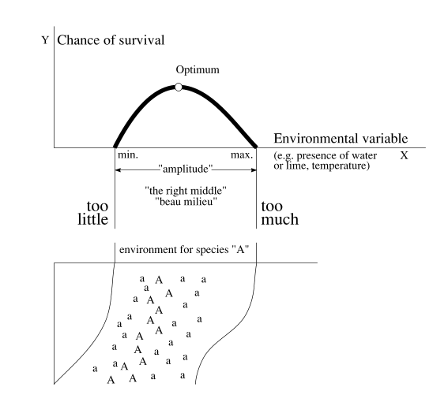
Fig. 6 Ecological tolerance in theory and reality.
Ecological tolerance
That principle is clarified in Fig. 6. The curve of ecological tolerance relates the chance of survival of a plant species to any environmental variable, for instance the presence of water. In that special case survival runs between drying out and drowning. Imagine the bottom picture as a slope from high and dry to low and wet. Species A will survive best in its optimum. Therefore we see flourishing specimens on the optimum line of moisture (A). Higher or lower there are marginally growing specimens of the same species (a). However, the marginal specimens are important for survival of the species as a whole.
Suppose for instance long-lasting showers: the lower, too wet standing marginal specimens die, the flourishing specimens become marginal, but the high and dry standing specimens start to flourish! Long-lasting dry weather results in the same in a reversed sense. Levelling the surface and water-supply for agricultural purposes in favour of one useful species means loss of other species and an increased risk for the remaining.
Scale and size: technically, scientifically, administratively
Temporal levels of scale
The change of urban landscapes at different time scales (see Fig. 7) cannot be understood without a selective study of human dynamics as the primary driving force behind it at different levels of temporal scale.

within last | changes in urban areas | within last | changes in urban areas
millenium | Mediaeval, Industrial, Modern towns | week | alternating work and weekend
century | economic development | day | intensity of use, transport
decade | groundworks, building activities | hour | sunlight and precipitation
year | seasons | minute | human activity
month | migrations, flowering periods, trade
Fig. 7 Urban dynamics on different time scales
Spatial levels of scale: frame and grain
Apart from these time scales, this section focuses in particular on spatial scales to find a sound structure of the discipline. The scale of a drawing can be named simply by a nominal radius R from the range {…1, 3, 10, 30m …} globally encompassing the drawing as a whole (frame) in reality, and the smallest drawn detail (grain), named by a nominal radius r from the same range. The distance between frame and grain determines the resolution of the drawing. If that distance is small, designers speak about a sketch, and if it is large about a blue print. However, any verbal argument has to be as precise about scale to avoid drawing conclusions at an other level of scale than the argument is valid (see Fig. 9). Any level of scale (combination of frame and grain) presupposes a specific legend, a specific vocabulary of the drawing and consequently technically, scientifically, and from a viewpoint of government and management, a different approach with scale sensitive categories and variables.
The technical relevance of scale
The level of scale is technically relevant. For example, if you aim for diversity in vegetation on different levels of scale, at every level of scale there are different technical means at your disposal (see Fig. 8). However, what causes diversity at one level, may cause homogeneity at another level of scale (scale paradox, see Fig. 9). Here the rule you can not extend conclusions from one level of scale into another without concern is demonstrated most strictly.

Operational variety conditions for vegetation | in a radius of approximately | 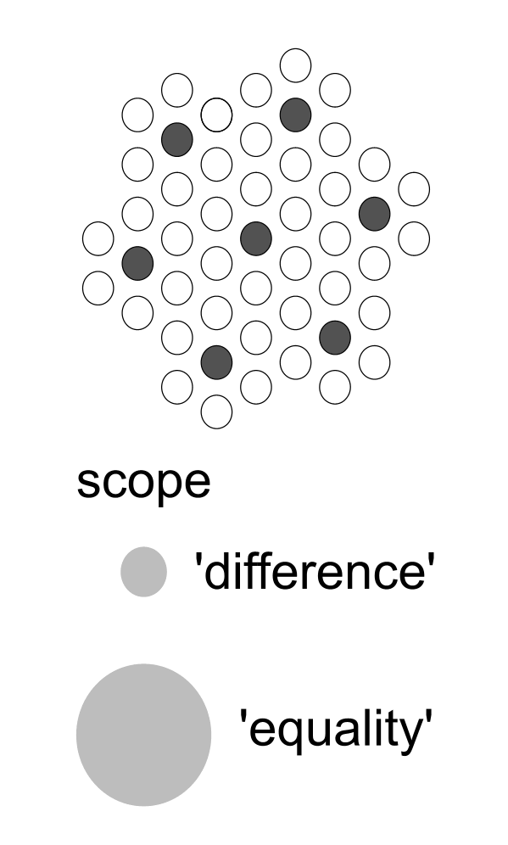
elevation, soil | 30km
soil, water management | 10km
seepage, drainage, water level, urban opening up | 3km
urban lay-out | 1km
allotment (dispersion of greenery) | 300m
pavement, treading, pet manuring, minerals | 100m
difference in height, mowing, disturbance | 30m
solar exposition, elevation | 10m
The radius should be interpreted elastically between adjacent radiuses.
The last four levels of scale hide from the usual view of observations per km².
Fig. 8 Operational variation per level of scale |  | Fig. 9 Scale paradox
Studying ‘states of dispersion’ of species and artefacts at different levels of scale in the same time systematically (see Jong and Paasman, 1998), you can compare designs (proposed form, dispersion of matter) mutually, such as variants R=100km for the Dutch Randstad (Jong and Achterberg, 1996) or judge local spatial visions R=10km ecologically based on rareness expressed in kilometers and replaceability in years (method Joosten, 1992, applied in Jong, 2001; Fig. 10).

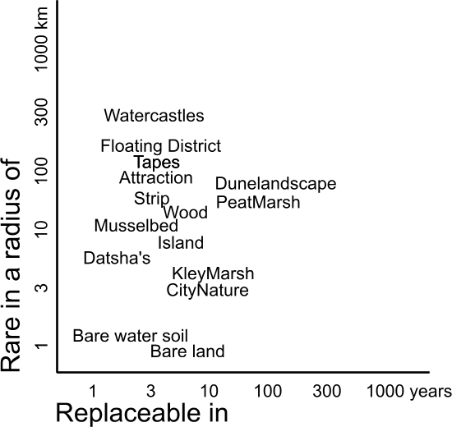
Fig. 10 Ecological evaluation of neighbourhoods named by designers (r=300m) according method Joosten (1992)
The scientific relevance of scale
The level of scale is scientifically relevant to avoid drawing conclusions at an other level of scale than the argument is valid. For example, the frame and grain of biotic and a-biotic categories are different at different levels of scale. All kinds of ecology (microbiology, biology, autecology, chaos ecology, systems ecology, synecology, landscape ecology, environmental science) are useful if arranged to the scale of their most appropriate application.
So, microbiology applies on levels of scale and size measurable in micrometers. Chaos ecology stressing individual opportunities and survival strategies or biology stressing cooperation and competition of specialised functions (organisms or organs) apply on levels measurable in millimetres, and so on. Fig. 11 shows my preliminary distinction of levels of scale and ecologies supposed to be most appropriate on each level of scale. However, that does not mean these ecologies always have to limit themselves to their primary level of scale as presented.

nominal | abiotic | biotic | ecology
kilometres radius
10000 | earth | biomes | environmental ecology
1000 | continent | areas of vegetation
100 | geomorfological unit | plant-geographical or flora-districts | landscape ecology
10 | landscape | formations
metres
1000 | hydrological unit, biotope | communities | synecology
100 | soil complex, ecotope | ecological groups | system dynamic
10 | soil unit and transition | symbiosis | cybernetic
millimetres
1000 | soil structure and ~profile | individual survival strategies | chaos ecology
100 | coarse gravel | specialisation | autecology
10 | gravel | integration | biology
1 | coarse sand 0,21-2 | differentiation
micrometres (μ)
100 | fine sand 50-210 | multi-celled organisms | micro biology
10 | silt 2-50 | single-celled organisms
1 | clay parts < 2 | bacteria
0,1 | molecule | virus
Fig. 11 Ecologies arranged to their primary supposed range of scale
(Jong, 2002)
But, at the level of the Earth (let us say 10 000km ‘nominal’ radius) we certainly have to consider other categories, variables and legend units than at the level of a grain of sand (let us say 1mm nominal radius). The ecological categories or legend units for the Earth as a whole are called ‘biomes’. They are mainly based on classes of different year-average temperature and precipitation. Within biomes, at a continental level, we may recognise areas of vegetation, mainly based on altitude and moist of soil. Within these areas of vegetation, - at a national level - we may distinguish plant-geographical~ or flora-districts and within these - at a regional level - landscape formations and so on. Different categorisations result in different kinds of ecology, different, often controversial, paradigmas. However, looking at Fig. 9, many of these controversies are not necessary if we are more precise about the range of scale where our conclusions are valid (scale-articulation). And, between the Earth and a grain of sand there are 10 decimals!
The governmental and managerial relevance of scale
The level of scale is administratively relevant. From a viewpoint of local government according to Fig. 10 a municipality could focus its policy on a specific scale of rareness and and replacebility (identity). For example focusing on global (R=10 000km), European (R=3000km, tables of Flora- and fauna legislation), national (R=300km, Dutch ‘Red List’ species), provincial (R=100km), regional (R=30km) or local (R=10km) rareness, are different policies. Large cities could focus on global identity, small ones on a regional identity. To value their nature, they have to add replacebility as a criterion. Early-successional vegetation needs less time to recover than mature vegetation such as forests. So, ‘replacebility’ could be expressed in years like ‘rareness’ is expressed in kilometers. These temporal and spatial measures could be applied to human artifacts as well. How much time does it take to build a mature airport and in which radius there is an airport with the same competence? So, these measures may help balancing natural and cultural interests.
From systems ecology into autecology (and back?)
Ecology plays an important role in Dutch spatial planning since the sixties of the last century. After an introduction in spatial planning of systems ecology (Baas Becking in Leiden, Odum in the U.S.) stressing sequences of succession, an emphasis on their boundaries emerged and on species rich gradients between systems (cybernetic ecology, Van Leeuwen in Delft), still particularly popular amongst designers. These paradigms were based on characteristics of an a-biotic context and the species rich transitions at their boundaries.
Then the national task of nature preservation was transmitted into the Ministry of Agriculture stressing synecology (Braun Blanquet, Westhoff). That paradigm empasised synergy of species in plant communities and accompanying fauna. After all, on equal subsoils different accidental successions, caused by different incidental histories could be observed. So, some 100 typically Dutch communities were distinguished for protection (Bal et al., 2001). Connection of fragmented communities in favour of animal populations requiring a larger surface became an issue (‘ecological infrastructure’). Current Dutch nature conservation policy still has a synecological character. According to Fig. 11 it is most appropriate to areas of 1km radius approximately, but it claims to offer tools of nature conservation at 3km, 300m and 100m as well (see Fig. 12). Now, the public appeal of caressable animal species and the European emphasis on protecting each rare species separately shifts scientific attention into autecology, the ecology of populations per species, naturally belonging to the attention of the University of Agriculture in Wageningen.
So, as we indicated earlier, there seems to be a ‘ecology of paradigms’ as well. The first paradigms based on a-biotic context were mainly studied at Universities in the lower Western part of the country (Leiden extending into Delft), the last in the higher Eastern part (Nijmegen extending into Wageningen). However, scale articulation could divide their tasks instead of opposing them. That brings me into the question of identity, introducing the interests of human species.

 | Main group 1 | Main group 2 | Main group 3 | Main group 4
Name | almost-naturally | supervised-naturally | half-naturally | multifunctional
Radius | 3km | 1km | 300m | 100m
STRATEGY
surface | Landscape thousands of ha. | Landscape > 500 ha. | ecotope/mosaic to approx. 100 ha. | ecotope mostly a few ha.
location | mostly process-determined | process and pattern-determined | process-, pattern- and species-determined | pattern- and species-determined
processes | not directed | directed integrally | directed in detail | directed in detail
patterns | not established | not established | established, perhaps a cyclical succession | established
directing variables | none | process-focused on landscape level | process- and pattern-focused up to ecotope level | process- and especially pattern-focused up to ecotope level
)
Fig. 12 The levels of scale in Dutch synecological nature conservation policy (Bal et al., 1995)
Identity: difference from the rest, continuity in itself
Connecting ecological and human interests
To connect ecological interests with human interests I am increasingly interested by the concept of identity (Jong 2007). That concept plays a remarkable and probably increasing role in the political, cultural, economic debate and in design, at different levels of scale. However, its meaning is not always properly defined. So, I choose: ‘difference from the rest and continuity in itself’. That definition has the same temporal and spatial roots of ‘descent and origin’ or ‘name and adress’ as the police(wo)man summarises them if (s)he asks for your ‘identity’.
Again at every level of scale anew
Even the concept of identity is scale-dependent. What is typical for Europe, for a nation within Europe, a region within a nation, a town, a neighbourhood? The parts of a neighbourhood need to have something in common, and that characteristics have to be different from ‘the rest’ to get identity. That is an impact of the scale paradox: internal homogeneity can be combined with external heterogeneity. However, the reverse is possible as well: internal heterogeneity combined with external homogeneity: the paradox of the ‘homogeneous mixture’ (Fig. 9), an impact of globalization. So, the scale paradox also shows directions of view. Identity covers the first direction, mixture the second. From thermodynamics we learn the second is most probable in physics. From architecture we learn the view from inside outwards is very different from the view from outside inwards. A ball is concave in the first view, but convex in the second.
Different variables to determine identity at different levels of scale
The identity of a town should not be hampered by an extravagant diversity of its neighbourhoods. These have to be different to get their own identity, but they should also have something in common to make the town recognisable as a town. That paradox is solved by choosing different variables to determine identitities at different levels of scale (for example Fig. 8). To start at the foundations, ecology can offer designers, planners and politicians many legends, categories and agendas at any level of scale. Globally, the differences of temperature and precipitation are given, determining ‘biomens’. Continentally there are different areas of vegetation, nationally there are different geomorphological units, regionally there are different landscape formations and so on (see Fig. 11) to reach an unexchangeable genius loci at any location at last. That diversity only has to be protected and utilised for governmental, cultural, economic, technical, ecological and spatial differentiation or specialisation. That will increase the freedom of choice for future generations, not in a deterministic causal, but in a conditional sense. If we continue that inference by design effort any place on Earth can be different from any other place. That uniqueness will force less to travel into ever further destinations our holidays require to escape boredom.
Beauty
Beauty or image quality is a dynamic balance between recognition and surprise. That is shown in Fig. 13 replacing the abscissa of the ecological tolerance in Fig. 6 by variety and the ordinate by image quality. Variety combines the concepts of difference and continuity, determining identy.
Too much difference or change results in an impression of chaos, overloading our senses and sense. Too little variety results in an impression of monotony and boredom. The neural system we inherted from evolution may have kept some of its unconcious ecological wisdom not to overdo in one or the other direction, but to keep the middle (mi-lieu) to experience beauty. How to make use of that capacity, eroding by the urge of equalising production since the neolithic revolution? That revolution is less than 1% away from the time we started to evolve as humans.
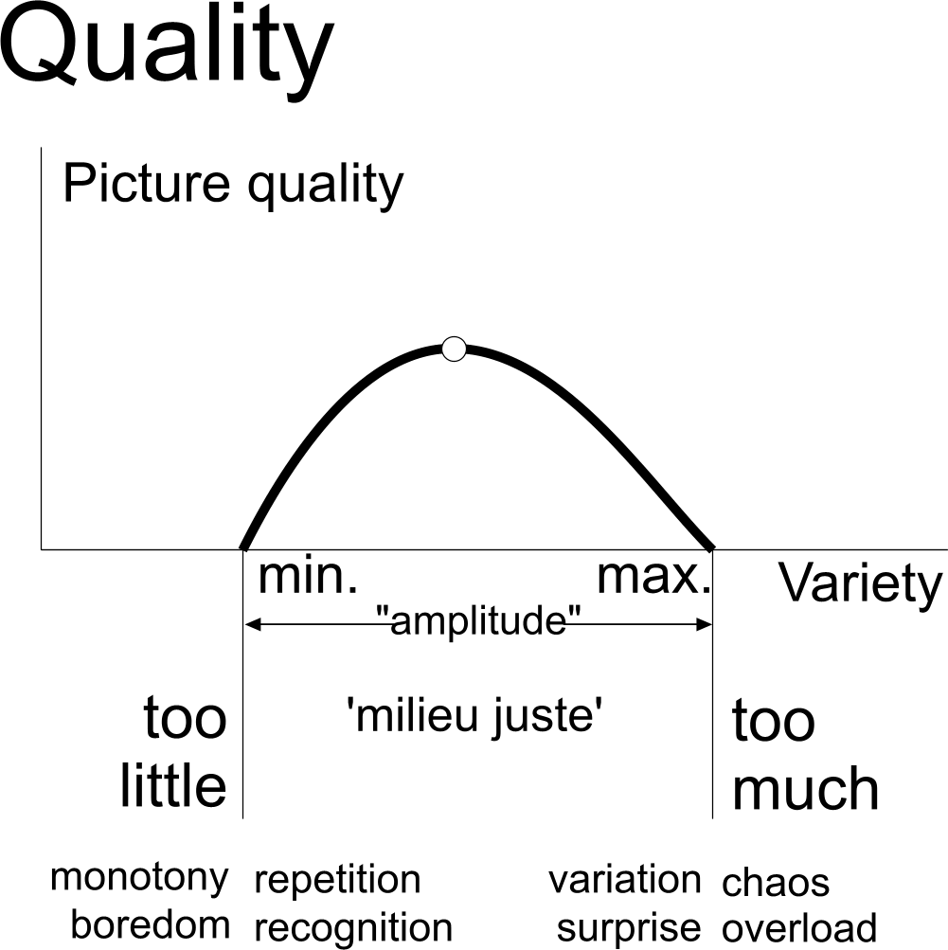
Fig. 13 Quality as a working of variety
What is the difference?
The identity of an area is recognisable by its difference with the rest and continuity in itself. Identity seems to be important for government or management, for culture, economy, technology and ecology. For example, the investor will ask “Why to invest just here?” To make every place unique, getting its own role within the urban, regional or global composition, the next questions should be answered:

What is the difference with other regions? (30km radius)
What is the difference with other conurbations? (10km)
What is the difference with other townships? (3km)
What is the difference with other districts? (1km)
What is the difference with other neighbourhoods? (300m)
What is the difference with other ensembles? (100m)

If an area succeeds in finding appropriate different variables on every level of scale to rule its human impact by civil engineering and architecture, biodiversity will follow, be it often in an unexpected way.
Conclusion
Human activity can be a useful condition of physical diversity if it does not result in uniformity or chaos. In the Netherlands urban areas sometimes appeared to count more species than their agricultural and sometimes even natural surroundings. Based on managerial, cultural, economic, technical, demographic and spatial diversity, differences in local identity emerge. That identity mainly should slighly change walking through the area to keep recognition and orientation. Small contrasts every 300m, larger ones every 1000m introduce welcome surprise, but too much contrasts will cause the impression of chaos. If that sensory balance for People is reached by design at any level of scale, any place on Earth will be different from every other place. And, that is the best opportunity for biodiversity humans can offer the Planet.

References

Andrewartha HG (1961) Introduction to the Study of Animal Populations. University of Chicago Press, Chicago
Baas Becking, L.G.M. (1934) Geobiologie of inleiding tot de milieukunde W.P. van Stockum&Zoon N.V., Den Haag
Bal D, Beije HM, Hoogeveen YR, Jansen SRJ, Reest PJvd (1995) Handboek natuurdoeltypen in Nederland. IKC Natuurbeheer, Wageningen
Bal D, Beije HM, Fellinger M, Haveman R, Opstal AJFMv, Zadelhoff FJv (2001) Handboek Natuurdoeltypen. Ministerie van Landbouw, Natuurbeheer en Visserij, Wageningen
Begon M, Harper JL, Townsend CR (2006) Ecology; From Individuals to Ecosystems. Blackwell Science, Oxford
Bobbink R, Ashmore M, Braun S, Flückiger W, Wyngaert IJJvd (2002) Empirical Nitrogen Critical Loads for Natural and Semi-natural Ecosystems: 2002 Update The expert workshop on empirical critical loads for nitrogen on [semi-]natural ecosystems, Berne, Switzerland
Braun-Blanquet, J. (1964) Pflanzensoziologie. Springer-verlag, Wien.
Fernandez-Juricic E, Jokimaki J (2001) A habitat island approach to conserving birds in urban landscapes: case studies from southern and northern Europe. Biodiversity and Conservation 10:2023-2043
Honnay O, et al. (2002) Satellite based land use and landscape complexity indices as predictors for regional plant species diversity. Landscape and Urban Planning 969:1-10
Jenerette GD, Wu J (2001) Analysis and simulation ofland-use change in the central Arizona - Phoenix region, USA. Landscape Ecology 16[7]:611-626
Jong, Mechtild D. Th. M. de (2002) Scheidslijnen in het denken over Natuurbeheer in Nederland. Een genealogie van vier ecologische theorieen. DUP Science, Delft
Jong TMd (2001) Ecologische toetsing van drie visies op Almere Pampus. Stichting MESO, Zoetermeer
Jong TMd (2002) Living with life. Paper presented at the conference Biotope City. Eindhoven
Jong TMd (2007) Connecting is easy, separating is difficult. In: Jong TMd, Dekker JNM, Posthoorn R (eds) Landscape ecology in the Dutch context: nature, town and infrastructure. KNNV-uitgeverij, Zeist
Jong TMd (2008) Increasing biodiversity. Report to Haskoning, GuiYang
Jong TMd, Achterberg J (1996) Het Metropolitane Debat. 25 Varianten voor 1mln inwoners. Stichting MESO, Zoetermeer
Jong TMd, Dekker JNM, Posthoorn R (eds) (2007) Landscape ecology in the Dutch context: nature, town and infrastructure. KNNV-uitgeverij, Zeist
Jong TMd, Paasman M (1998) Het Metropolitane Debat. Een vocabulaire voor besluitvorming over de kaart van Nederland Het Metropolitane Debat. Stichting Milieu en stedelijke ontwikkeling (MESO), Zoetermeer
Jong TMd, Vos J (eds) (2000) Kwartaalbericht KNNV Zoetermeer 21-30. KNNV Zoetermeer, Zoetermeer
Joosten JHJ, Noorden BPM (1992) De Groote Peel: leren waarderen. Een oefening in het waarderen van natuurelementen ten behoeve van het natuurbehoud. Natuurhistorisch maandblad 81:203 e.v.
Krebs CJ (1989) Ecological Methodology. Harper Collins College Publisher, New York
Leeuwen, C.G. van (1964) The open- and closed theory as a possible contribution to cybernetics Rijksinstituut voor Natuurbeheer, Leersum
Odum, E.P. (1971) Fundamentals of ecology, W.B. Saunders Co., Philadelphia/London/Toronto.
McArthur RH, Wilson EO (1967) The theory of island biogeography. Princeton Univ. Press, Princeton
Westhoff, V. and Held, A.J. den (1969) Plantengemeenschappen in Nederland, Thieme, Zutphen
Zapparoli M (1997) Urban development and insect biodiversity of the Rome area, Italy Landscape and Urban Planning 38:77-86
Zoest JV (2007) Driving forces in urban ecology. In: Jong TMd, Dekker JNM, Posthoorn R (eds) Landscape ecology in the Dutch context: nature, town and infrastructure. KNNV-uitgeverij, Zeist
Zoest Jv, Melchers M (2006) Leven in de stad; betekenis en toepassing van natuur in de stedelijke omgeving KNNV, Utrecht

Questions

How could ‘identity’ be defined to be useful in design questions?
Why could the urban landscape be a source of biodiversity?
If somebody disagrees about any kind of diversity, which kind of analysis you need first to clarify if you really disagree?
Why should units, variables and agendas be diversified?
What are the results of diversifying units, variables and agendas?
What is the definition of ‘ecology’ according to Andrewartha 1961 , Krebs 1994, Begon et al. 2006?
How could you quantify the intensity of human use of space compared to it’s use by nature?
Why is concentration of humans an ecological advantage?
How could an ecological paradigm be influenced by the location of a research institute?
Which kinds of ecological paradigms you can distinguish?
What is an essential difference in the way empirical scientists and designers think?
What is the role of diversity in evolution and in the way designers think?
Why should vegetation be the first concern in nature preservation?
What is the risk of preserving target species and target communities?
Give an example of conflict between environmental protection and nature preservation. Which strategy would you choose in that case?
Which barriers you have to take into account hearing ecologist’s advices?
What is the relation between %built-up area and biodiversity?
What is ‘island theory’?
Summarise some points of critique on island theory.
Summarise some arguments for designers to focus on boundaries instead of on areas, communities or ecosystems.
What is ‘ecological tolerance’ and which conclusions you can draw in terms of risk?
Which ecological variables you can distinguish at different time scales?
Why should designers and ecologists be precise about two boundaries of scale?
Why is the spatial level of scale technically relevant?
How could you compare cultural and natural values in terms of spatial and temporal levels of scale?
How could you distinguish different ecological views in terms of levels of scale?
Why is the spatial level of scale scientifically relevant?
Why is the spatial level of scale relevant in terms of administration and management ?
How could politics change scientific paradigms?
Give some examples how ‘identity’ could play a role in political, cultural, economic debates and in design.
Why is the concept of ‘identity’ scale-sensitive?
What is the problem shaping recogisable identities at different levels of scale and what is the solution?
What are the boundaries of ‘beauty’ in terms of variety?
Which questions have to be answered in design to reach unique identity at any place on Earth?

