Two processes increasing the urban surface
Liang Xiong and Taeke M. de Jong

Introduction
The urban surface of cities does not only increase by increasing population, but also by increasing prosperity. People can afford more space and the urban density becomes lower.
Fig. 1 shows the principle as it roughly happened in Europe. That history may be of interest for China.

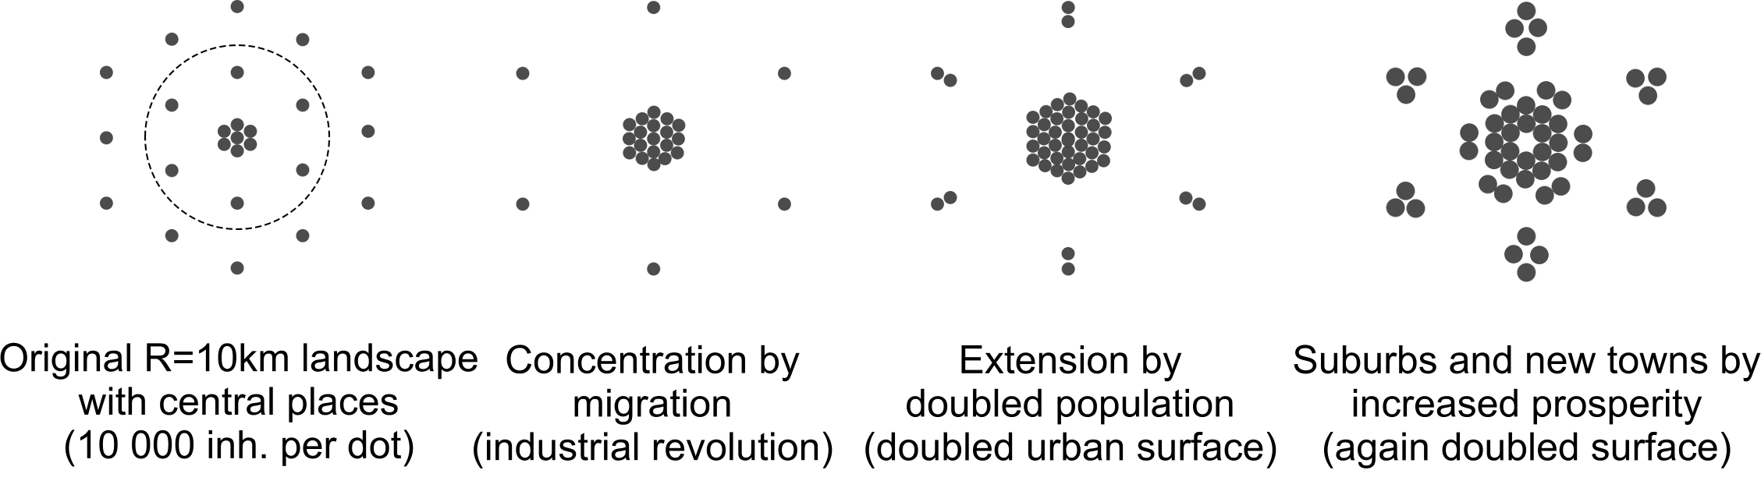
Fig. 1 Two processes increasing the urban surface

Regional scale
The history of urbanisation in the Rhine river Delta shows two phases: an increasing population migrating into the cities by its industrial revolution after 1850 and a growth of the regional economy after 1960 (see Fig. 2). Both developments have substantially increased the urban surface in a century. Both developments now happen in China in the same time within a decade.

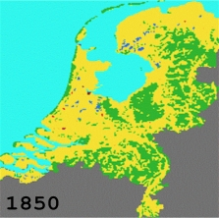 | 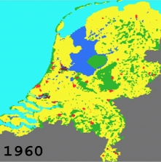 | 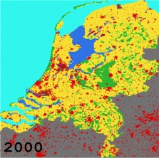
3 million inhabitants | 12 million inhabitants | 16 million inhabitants
Fig. 2 The urban history of The Netherlands

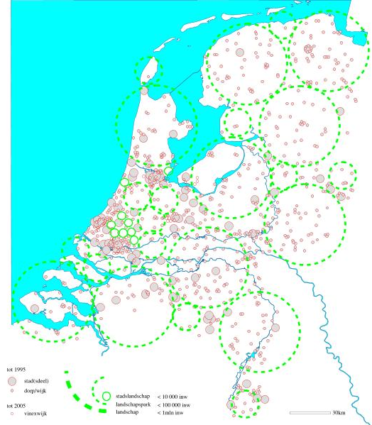 | 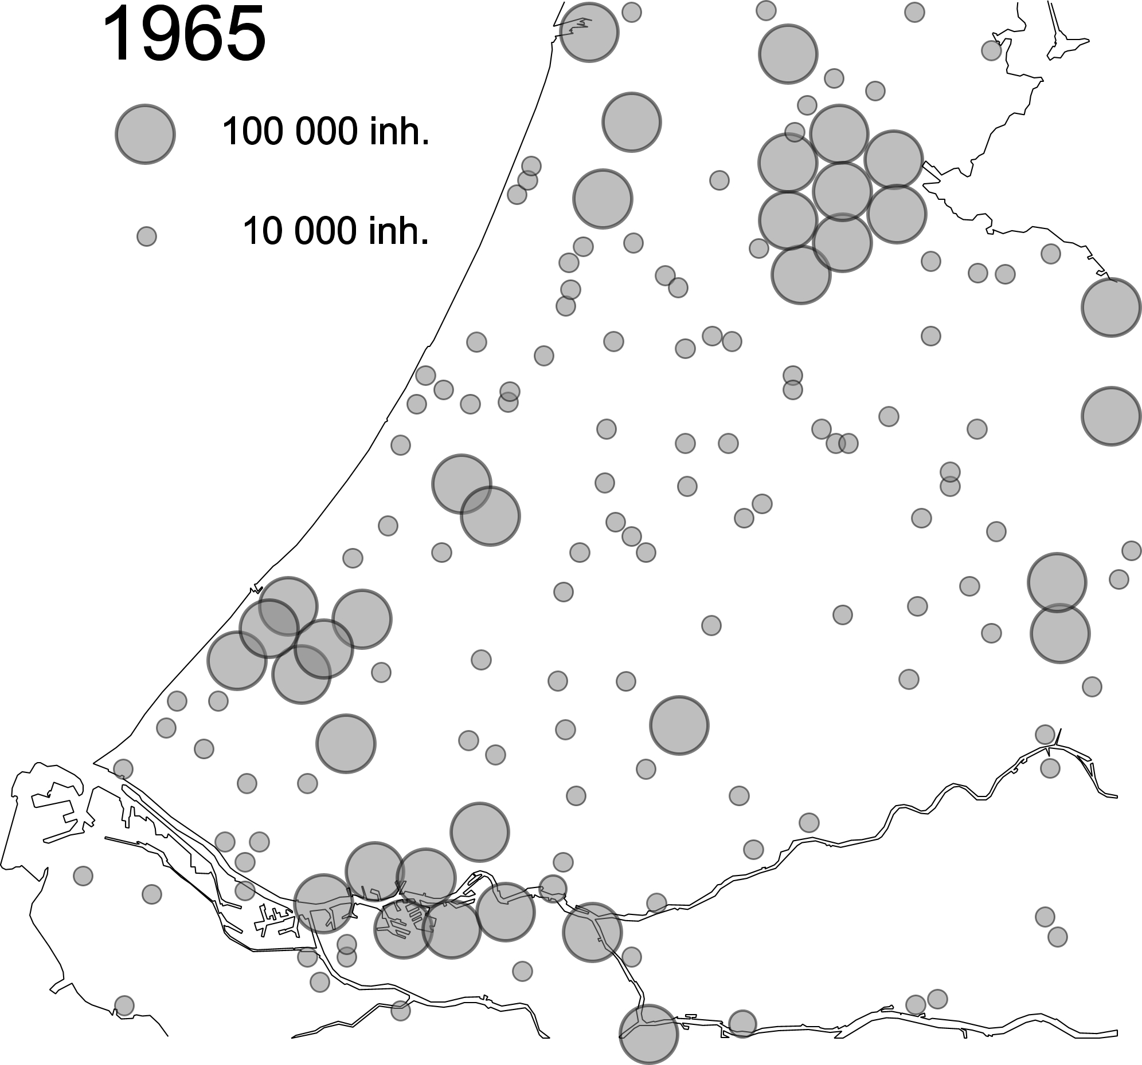  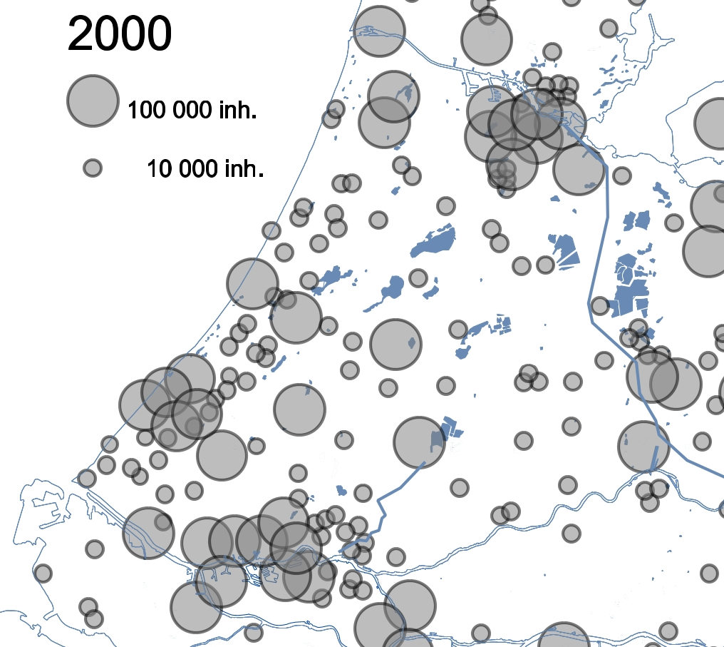
Fig. 3 The dispersion of inhabitants in 2000 | Fig. 4 Increasing surface/inhabitant in cities

Urban scale
For example the Amsterdam population (the Northern city in Fig. 4) increased until 1960 (see Fig. 5). Then people moved into suburbs and new towns, but nevertheless a substantial economic growth amply doubled the urban surface per inhabitant (see Fig. 6).

Fig. 5 Amsterdam population development | Fig. 6 Urban surface per inhabitant
So, the urban surface continued to increase (see Fig. 7) with lower densities in the inner city and the outskirts (see Fig. 8).

 | 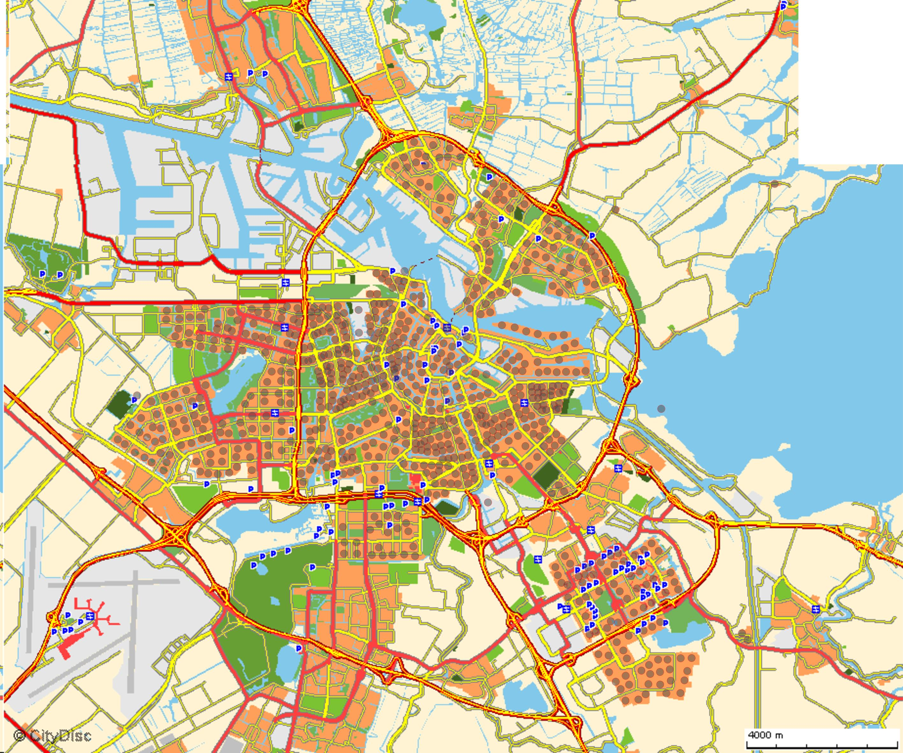
Fig. 7 Resulting urban surface | Fig. 8 Dispersion of inhabitants x 1000/dot
From 1960 onwards the increasing urban space threatens the green space outside the cities (for example Rotterdam, the Southern city in Fig. 4).

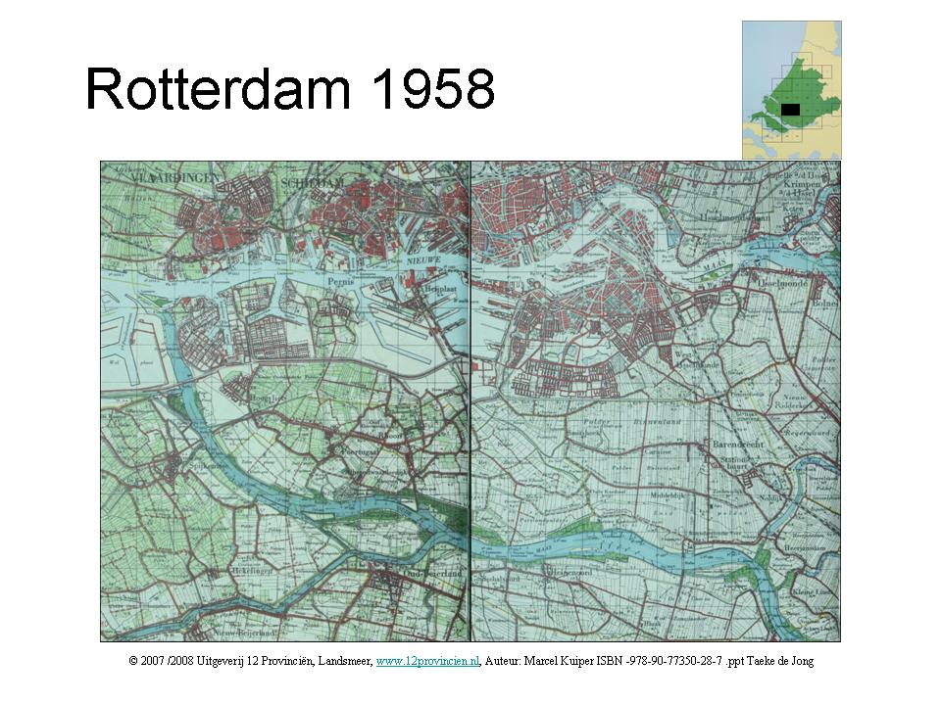 | 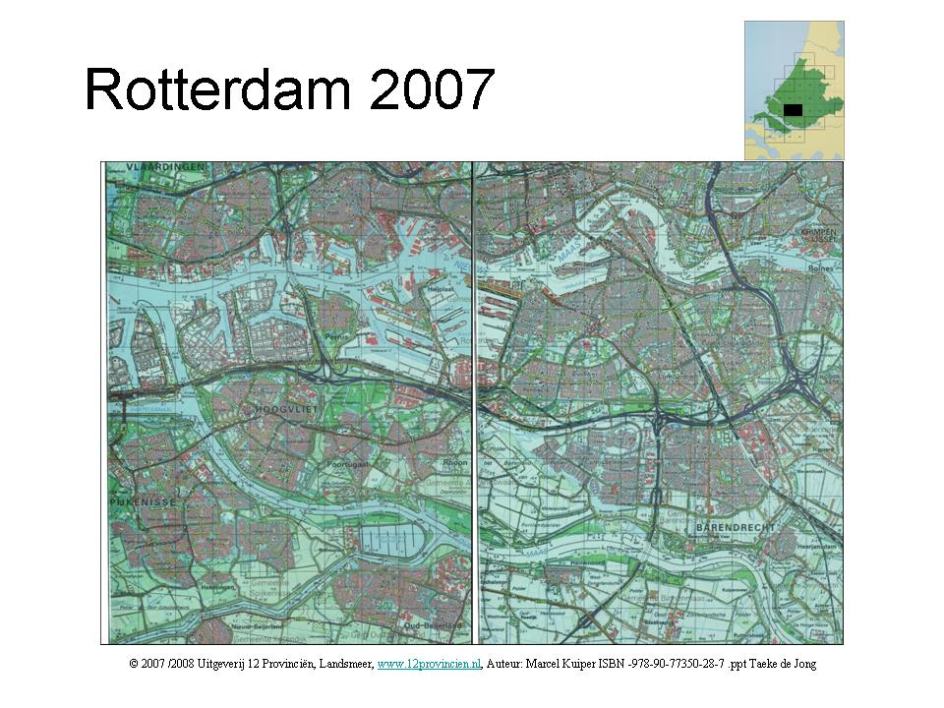
Fig. 9 Open space … | Fig. 10 … filled by urbanisation

China
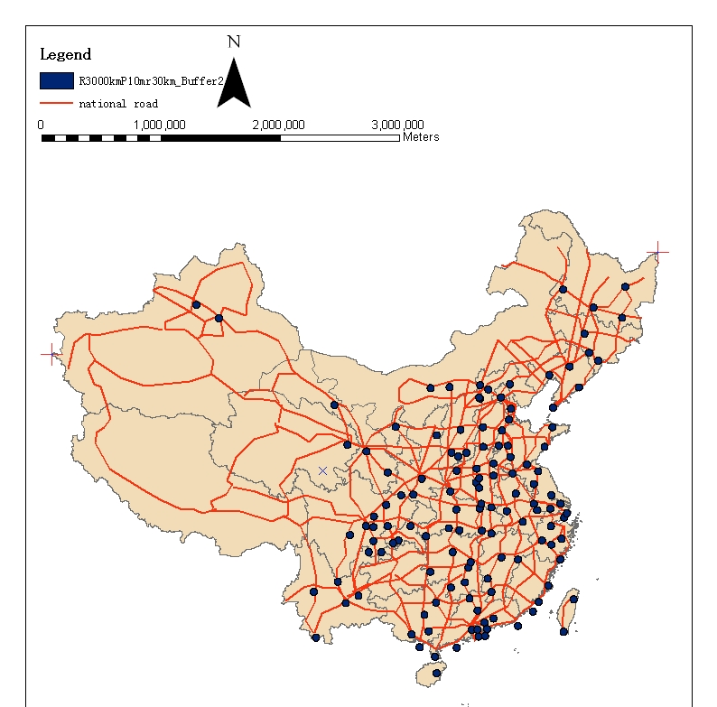 | 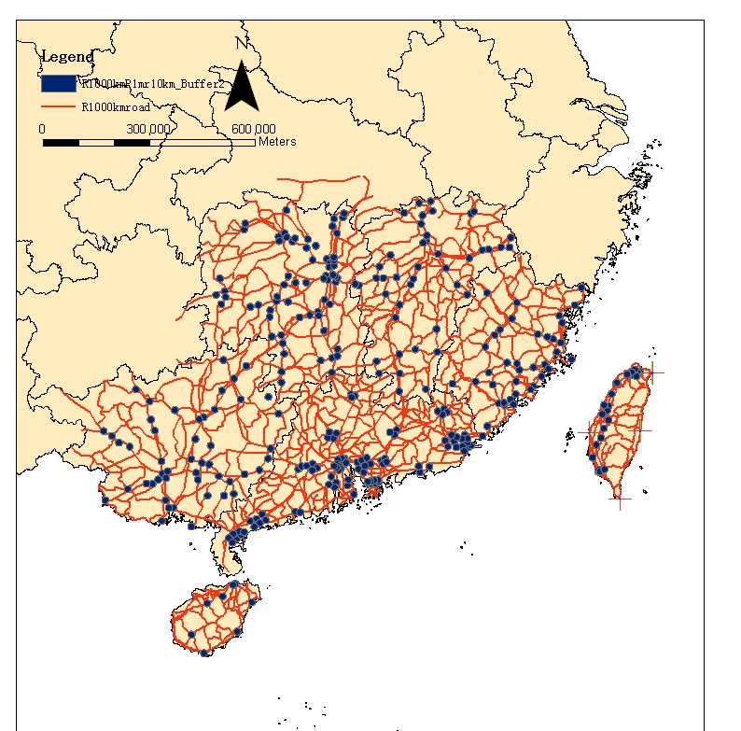
Fig. 11 National scale | Fig. 12 Subnational scale

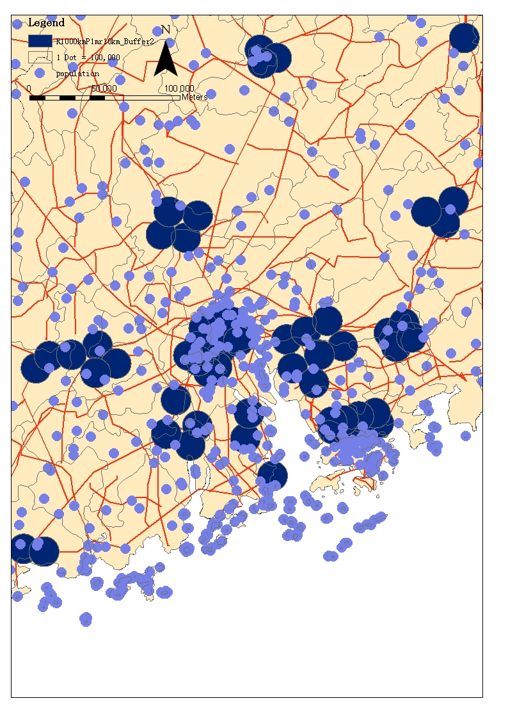
Fig. 13 Regional scale | Fig. 14 Subregional scale

